**OCR Computing F454 Project**

**Employee Tracker**

* **Tom Goodman**

Contents

Section 1 – Definition, Investigation and Analysis 8

Problem Definition – 8

Plan of the Investigation - 8

Interview 1 – Jonny Fishman - 9

Interview 1 – Analysis - 10

Interview 2 – Roscoe Marchland - 10

Interview 2 – Analysis – 11

Interview 3 – Edna Wescott - 11

Interview 3 – Analysis – 12

Questionnaire – 12

Process Model – Current System – 15

Data Flow Diagram – Current System 16

Issues with the Current System – 16

Requirements Specification – 17

Confirmation of the Acceptance of the Requirements Specification 17

Alternative Methods – 18

Method One – Improve the current paper-based system – 18

Method Two – Employ a Professional Programmer – 19

Method Three – Create a system using Python – 20

Hardware and Software Requirements – 20

Section 2 – Design Part 1, Nature of the Solution 22

Performance Criteria – 22

Storage Design – 24

Modular Design & Screen Hierachy – 25

Wireframes – 26

Initial Setup Wireframe – 27

Login Screen Wireframe – 28

Register Account Screen Wireframe – 28

Main Screen Wireframe – 29

Create Record Wireframe – 29

Search Screen Wireframe – 30

Popup Wireframe (Generic) : 30

Data Flow Diagram for the New System – 31

Confirmation of the acceptance of the Design – 32

Section 3 – Design Part 2 – Algorithm Design 32

Algorithm 1 – isFloat() : 32

Algorithm 2 – isInt() : 33

Algorithm 3 – isNone() : 34

Algorithm 4 – DOBCheck() : 35

Algorithm 5 - GenderCheck() : 36

Algorithm 6 – CreatePopup(): 37

Algorithm 7 – GenerateCode(): 38

Algorithm 8 – CreateRecord(self) : 40

Algorithm 9 – tryLogin(self) : 43

Algorithm 10 – TotalExpenditure(): 45

Algorithm 11 – BiannualExpenditure(): 45

Algorithm 12 – QuarterlyExpenditure(): 46

Algorithm 13 – MonthlyExpenditure(): 46

Algorithm 14 – WeeklyExpenditure(): 47

Algorithm 15 – DailyExpenditure(): 47

Algorithm 16 – SearchRecords(): 47

Algorithm 17 – CalculateTax(n): 48

Section 4 – Software Development 50

AddExpenditureScreen.py 50

AddExpenditureScreenStringsEnglish.py : 53

AddExpenditureScreenStringsGerman.py : 53

AmendEmployeeScreen.py : 53

AmendEmployeeScreenStringsEnglish.py : 57

AmendEmployeeScreenStringsGerman.py : 58

BaseModule.py : 58

CalculateTax.py : 61

Constants.py : 61

CreateEmployeeScreen.py : 62

CreateEmployeeScreenStringsEnglish.py : 70

CreateEmployeeScreenStringsGerman.py : 71

CreatePopup.py : 72

DeductExpenditureScreen.py : 72

DeductExpenditureScreenStringsEnglish.py : 76

DeductExpenditureScreenStringsGerman.py : 76

DeleteEmployeeScreen.py : 76

DeleteEmployeeScreenStringsEnglish.py : 79

DeleteEmployeeScreenStringsGerman.py : 79

DropdownMenuStringsEnglish.py : 79

DropdownMenuStringsGerman.py: 80

GenerateCode.py : 80

InitialSetup.py : 80

InitSetupPopup.py : 84

InitSetupPopupStringsEnglish.py : 86

InitSetupPopupStringsGerman.py : 87

LoggingStringsEnglish.py : 87

LoginForm.py : 90

LoginFormStringsEnglish.py : 94

LoginFormStringsGerman.py : 95

Main.py : 95

MainScreen.py : 96

MainScreenStringsEnglish.py : 103

MainScreenStringsGerman.py : 104

PasswordRecoveryScreen.py : 105

PasswordRecoveryScreenStringsEnglish.py : 108

PasswordRecoveryScreenStringsGerman.py : 109

PopupsStringsEnglish.py : 109

PopupsStringsGerman.py : 109

PortalDAGger.py : 109

RegisterScreen.py : 123

RegisterScreenStringsEnglish.py : 129

RegisterScreenStringsGerman.py : 130

SearchEmployeeScreen.py : 131

SearchEmployeeScreenStringsEnglish.py : 136

SearchEmployeeScreenStringsGerman.py : 136

SearchResultsScreen.py : 137

SearchResultsScreenStringsEnglish.py : 143

SearchResultsScreenStringsGerman.py : 143

StringsEnglish.py : 144

StringsGerman.py : 150

TimeStamp.py : 154

Section 5 – Testing : 155

Test Plan – 155

Main.py : 155

Main.pyc : 155

InitialSetup.py : 155

InitSetupPopup.py : 156

LoginForm.py : 157

RegisterScreen.py : 157

MainScreen.py : 159

CreateEmployeeScreen.py : 160

SearchEmployeeScreen.py : 161

SearchResultsScreen.py : 162

AmendEmployeeScreen.py : 163

DeleteEmployeeScreen.py : 163

AddExpenditureScreen.py : 163

DeductExpenditureScreen.py : 164

Test Evidence – 165

Main.py : 165

Main.pyc : 165

InitialSetup.py : 165

InitSetupPopup.py : 166

LoginForm.py : 167

RegisterScreen.py 170

MainScreen.py : 176

CreateEmployeeScreen.py : 181

SearchEmployeeScreen.py : 189

SearchResultsScreen.py : 196

AmendEmployeeScreen.py : 200

DeleteEmployeeScreen.py : 201

AddExpenditureScreen.py : 202

DeductExpenditureScreen.py : 204

Test Data & Testing Log - 205

Section 6 – Evaluation – 206

Degree of Success: 206

End User’s Response: 207

Desirable Extensions: 207

Bonuses: 207

National Insurance: 208

Further Languages: 208

More Extensive Testing: 208

Appendices – 209

Appendix I – Alpha Testing Log – 209

Appendix II – Test Data – 222

Appendix III – Testing Log – 226

Appendix IV – User Manual – 532

Contents: 532

(1) Initial Setup: 533

(2) The Login Screen: 534

(3) Registering an Employee Account: 535

(4) Logging in: 537

(5) The Main Screen: 539

(6) Typical Error Messages and On-Screen Help: 551

(7) Changing the Language: 553

(8) Backup: 554

Appendix V – Document Statistics: 555

# Section 1 – Definition, Investigation and Analysis

## Problem Definition –

My end user is the Douglas Jackson executive and managerial call centre, based in Lichfield. They employ a large number of employees, and they provide experienced recruitment consultants to businesses in order to aid them in a wide range of sectors, including, but not limited to: Finance, Banking, Insurance, IT, Telecommunications, Utilities, Online, Retail, Travel, Consumer Goods, Outsourcing and Public Sector/Not for Profit. They also attend a plethora of corporate events, and are often present to judge for some industry bodies and award programs.

The three managers are called Jonny Fishman, Roscoe Marchland and Edna Wescott. Regarding themselves (who are responsible for the filing system), they are neither computer-literate, nor do they currently have much exposure to technology – even in the office environment. Most of their work is still performed with pen and paper, and; moreover, it will be important to ensure that the new system is easy to navigate, well laid-out – providing a quick-to-use, simple interface that is easy to grasp.

The issue that I am investigating is the lethargic and archaic filing system of employee records. Due to the nature of the current system, there is an increasing lack of space to store the records, and records often become intertwined, damaged or lost. This consumes valuable time in the sorting, recreation and finding of records.

The current system relies on manual filing of physical, paper records, which are easily misplaced or damaged. This results in a slow system, and due to the large volume of records required (due to the large volume of employees), it has become time-consuming to find individual employees’ records. Currently, records are kept in filing cabinets, amongst hundreds of others, and in order to ‘update’ the records, that part of the file must be reprinted and rewritten.

Disposing of records also poses an issue, since they contain often confidential or personal information, which cannot just be thrown away as it is. Moreover, a significant amount of company time and resources are dedicated to shredding and disposing of said records. These could be more effectively allocated, were a new, computerised system to be developed.

Before I can begin work on a new system, I will need further details from the end users, regarding the current IT skills of employees, and the nature of the system required. I aim to conduct further investigation into this through the mediums of interviews, questionnaires and meetings, as well as the construction of a process model of the current system.

## Plan of the Investigation -

Firstly, I will create a Process Model of the current system. I will use this in order to fully gauge how the current system operates.

Following this, I will conduct three successive interviews, one with each of the Managers : Jonny Fishman; Roscoe Marchland and Edna Wescott respectively.

I plan to include the following questions:

*∙What is your role within the company itself?*

*∙How does the current filing system work?*

*∙What is your specific role regarding the filing system?*

*∙On average, how much exposure would you say you have to technology on a daily basis?*

*∙What do you like about the current filing system?*

*∙What could be improved about the current filing system?*

Through the interviews, I aim to ascertain specific details about what the problem with the current system is, and the pros and cons to it. It will also help me to understand what a new system should provide.

Following this, I aim to conduct a questionnaire on the employees that currently utilise the filing system, and I will further analysis the results of this in order to gauge the overall consensus on the system.

## Interview 1 – Jonny Fishman -

What is your role within the company itself?

*I am the Chief Executive Officer and Managing Director of the company. I oversee the entire company, and ensure that everything runs smoothly on all levels. This includes liaising with Roscoe and Edna on a daily basis, discussing important company matters and other such business. I also work alongside Edna during the interview process of new candidates for jobs, and I find this useful for creating and maintaining links with all of my staff.*

How does the current filing system work?

*Currently, new employee record templates are printed, and manually filled out by myself, Roscoe, Edna or one of our subordinates. The records are then filed in Chronological order in a series of filing cabinets on the ground floor.*

What is your specific role regarding the filing system?

*Sometimes I fill out new employee records, although my major involvement in the system is when I require an employee record, for example when I am reviewing an employee’s progress, or shortlisting employees for promotion. Other than that, my involvement with the filing system itself is minimal.*

On average, how much exposure would you say you have to technology on a daily basis?

*My only exposure to technology is my personal organiser, and my phone. I conduct a large amount of my work through pen and paper, and have always done so. It seems far simpler than using complicated technology to perform a simple task. I am; however, inclined to becoming more technologically versed in the near future.*

What do you like about the current filing system?

*The current system is easy to grasp and simple to use. Other than that, I don’t particularly entertain the idea of the current system.*

What could be improved about the current filing system?

*Currently, the system is chaotic, time and resource-consuming, and flawed. Records are often misplaced or damaged, and the transcription and recreation of records takes a lot of time and resources, which would be better allocated elsewhere in the company.*

## Interview 1 – Analysis -

Jonny is the CEO and Managing Director of the company, and; moreover, he has a lot of experience of the current system. There are a few flaws, or downfalls, that Jonny highlighted in the interview. They are as follows:

∙Each record must be manually printed when being created or amended. This is resource-consuming, and poses a potentially significant expenditure to the company per Annum, due the sheer number of required records.

∙When creating or amending a record, human transcription is also required, which is slow and somewhat unreliable. It also ties up a lot of employees’ time.

In the development of a new system, it will be imperative that I address both of these issues effectively.

Jonny indicated that he enjoyed the simplicity of the current system, and that his current exposure to technology on a daily basis was low, with him heavily relying on pen and paper. Hence, it will be important, should I develop a computer-based system, to keep it simple, and easy to use and understand.

The new system should also be resource-conservative, and both speed and ease-of-access should be considered by myself in its development.

## Interview 2 – Roscoe Marchland -

What is your role within the company itself?

*I am the Chief of Staff, Vice Chair and Financial Control Officer of the company, and; moreover, I am responsible for a large amount of the company’s duties. I ensure to keep a strong sense of communication between myself and the employees, and; moreover, I have a strong interpersonal connection with the entire staff-base. It is also my responsibility to manage all financial incoming and outgoings.*

How does the current filing system work?

*I am not wholly familiar with the current filing system, but from what I ascertain from the employees that work with it, it consists of a manual, paper-based system.*

What is your specific role regarding the filing system?

*I only ever use the filing system when I require an employee record, though this is seldom.*

On average, how much exposure would you say you have to technology on a daily basis?

*I consider myself quite technologically versed, and I utilise a wide range technology on a daily basis.*

What do you like about the current filing system?

*I can’t really comment on this, as I don’t use it much.*

What could be improved about the current filing system?

*Although I seldom utilise the current system, I may be more so inclined, were it to be computerised.*

## Interview 2 – Analysis –

Roscoe is the Chief of Staff, and this means that he has a strong link with the employee-base. Moreover, as with Jonny, he can provide a reasonably good insight into the system, despite seldom using it.

Since he has little interaction with the current filing system, the only issue with the system that Roscoe identified was that it wasn’t computerised. Following on from this, I feel that there would e quite a lot of potential in developing a computerised system in order to solve the problem, although a refined paper-based system is certainly not out of the question.

Roscoe is likely to be receptive to a computerised system, since he appears to have a large exposure to technology on a daily basis.

## Interview 3 – Edna Wescott -

What is your role within the company itself?

*I am the human resources manager, and I; hence, oversee all of the staff, ensuring that they are allocated suitable jobs, and perform their tasks successfully. I am also the chief interviewer, and, alongside Jonny, I am responsible for the recruitment of new employees.*

How does the current filing system work?

*The current filing system consists of a paper-based, manual filing system, heavily focussed on manual transcription of the records. When we need a new record, or need to change a record, we have to manually transcribe it onto a template.*

What is your specific role regarding the filing system?

*I oversee the team of subordinates that are responsible for the filing system, and occasionally, I need to find and utilise a record.*

On average, how much exposure would you say you have to technology on a daily basis?

*I have an average exposure to technology. I personally own a Smartphone, a Personal Organiser and a Laptop, all of which I rely upon on a daily basis. I would be more than happy to increase my exposure to technology further. My computer skills leave a lot to be desired, but I am more than capable of performing simple tasks.*

What do you like about the current filing system?

*I enjoy the simplicity of the system, but overall, that is about all I do like about it.*

What could be improved about the current filing system?

*The current system is very outdated and time-consuming. I have to dedicate of lot of resources to maintaining it, and even then, it is flawed in this way.*

## Interview 3 – Analysis –

As the Human Resources manager, Edna is responsible for a large proportion of the employees that manage the filing system. Moreover, she has been able to provide a valuable insight into the system.

She highlighted, as Jonny, a few flaws with the current system, but once again, enjoyed the simplicity of the system.

∙The system is outdated and time-consuming, both for herself and her subordinates. This results in lots of company resources being tied up.

∙The system is generally flawed in her eyes.

Following on from this, it will be important to develop a somewhat different system to the existing one, since there appear to be flaws throughout the current system. It will be important to make the new system quick and simple.

## Questionnaire –

Following the three interviews, I conducted a questionnaire, on 50 people that work with the Filing System on a daily basis.

The results of the first question are heavily skewed to the right, indicating that a significant number of employees feel that the current filing system is too time-consuming. Moreover, it is important to ensure that the new system is far more time-efficient.

The results of this question are much more varied than the previous one. On average, the employees rate themselves as around a 6 on a scale of 1-10, regarding their technological skills. This suggests that a computerised system may be a viable replacement for the current paper-based system. There are; however, 19 employees who scored themselves a 5 or less. Following consultation with these employees, I have ascertained that expansive User Documentation and a clear program would help them greatly, if a computerised system was developed. They would require help and guidance.

## 

|  |  |
| --- | --- |
| **Question 1** | Is the current system simple and easy to use? |
| **Question 2** | Is the current system organised? |
| **Question 3** | Is the current system too time-consuming? |
| **Question 4** | Is the current system too resource-consuming? |
| **Question 5** | Is the current system too manually-oriented? |
| **Question 6** | Do you like the current system? |

The results of these six questions are conclusive. They depict a general consensus, that the current filing system is, overall, disorganised, hard to use, too time and resource-consuming and too manually-oriented. Moreover, 90% of employees stated that they disliked the current system. Furthermore, it is important for me to now create a Requirements Specification, as a means of summation of my analysis.

Following the results of both my interviews and my Questionnaire, I feel that it would be important to physically observe the current system. Moreover, I have arranged to observe the team responsible for filing and managing the current system, a week on Tuesday. I will be spending a full day with the team, and I hope that I will be able to obtain some valuable, first-hand experience of the system.

## Process Model – Current System –

Amend Record

Dispose of Record

Do any more records need to be worked with?

File Record

Print Record Template

Reprint Record Template

Shred Record

Fill in new Record

Transcribe and Amend

Dispose of Record

Create Record

What needs to be done?

Start

Find Record

Yes

End

No

Following a day of observation, I have constructed a Process model (above) of the current system.

The Record is first found (if applicable), and then either a record is created, or an existing record is amended or destroyed. In order to create or amend a record, a blank template is printed, and filled in manually by hand. This record is then filed in a filing cabinet, in chronological order. In the case of disposing of a record, the record is found, shredded, and thrown into the bin.

## Data Flow Diagram – Current System

2

Calculations

M1 Filing Cabinet

Fetch Record Template

File Record

Record Fetched

Request Record

Manager

Fetch Record

Employee

1

Printing System

Print Record Template

Lost, Damaged or Destroyed Records

Record Lost, Damaged or Destroyed.

Figures

Results

## Issues with the Current System –

Following my investigation and analysis, I have identified the following as the issues that the current system possesses:

*∙ It is slow and time-consuming to locate/access records.*

*∙ It is completely manual, requiring a lot of transcription by hand – for example, when creating or amending a record.*

*∙ It takes up too much space (it is too space-consuming). Currently, the system occupies 4 Filing cabinets, with more being required each time this capacity is overflowed.*

*∙ Records are easily damaged or lost due to the large amount of records stored, and the physical nature of the filing system.*

*∙ It Requires a lot of maintenance (eg. printing/transcription/shredding)*

*∙ It is somewhat disorganised – Although the files are meant to be stored chronologically, this isn’t always adhered to*

*∙ There is no viable way of ‘backing up’ files – i.e. keeping copies. With the current system, this would require a large amount of photocopying, which is both time, and resource-consuming.*

## Requirements Specification –

The system itself must have a wide range of functionality in order to track employees, as well as calculating total salary and expenditure. The system will provide the following basic functionality:

*∙ Handle a basic login system.*

*∙ Create, Amend, Change and Delete Employee Records.*

*∙ Display all employee records simultaneously.*

*∙ Provide a basic record-searching functionality.*

*∙ Allow the user to append notes to an individual record.*

*∙ Track and display the total employee count.*

*∙ Track and display the total salary.*

*∙ Track and display the total expenditure, allowing for expenditure to be added and taken away.*

*∙ Process expenditure, giving daily, weekly, monthly and yearly expenditure.*

*∙ Provide format, presence and type checks, and support double-entry verification.*

*∙ Be simple and easy to grasp.*

*∙ Be quick to use, and time-efficient.*

## Confirmation of the Acceptance of the Requirements Specification

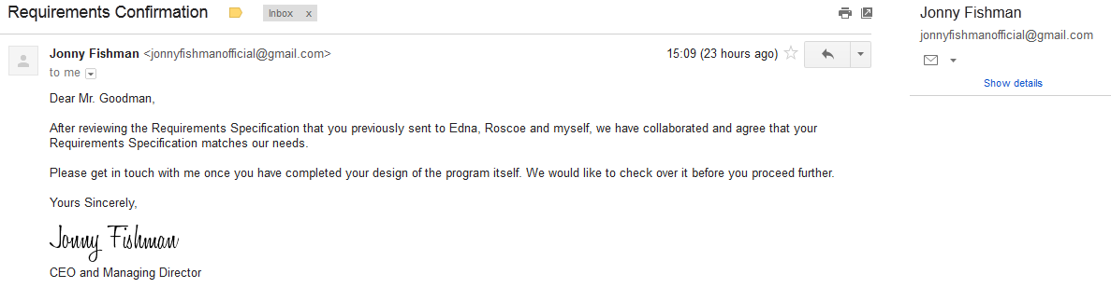

Above is confirmation from the end user that they agree with the Requirements specification that I laid out, and emailed to them.

## Alternative Methods –

### Method One – Improve the current paper-based system –

My first proposed method will be to improve the current system, which is a paper-based filing system. This would consist of more organised filing, and some form of ‘backup’ system, keeping backups of every record, in case of damage or their loss.

Moreover, there are a few advantages and disadvantages to this method:

|  |  |
| --- | --- |
| **Advantages** | **Disadvantages** |
| Very low cost to develop, since there will be no outgoings due to extra wages, nor for the maintenance of the system. | The current system is very manually-oriented, and the general consensus is that this requires far too much time and human resources to use. |
| The current system is already familiar to the end user(s), so they will require little to no training to grasp the system. Moreover, they are likely to operate at a high-efficiency from onset with a familiar system. | Records can be easily lost or damaged. |
|  | This system isn’t particularly secure. |

|  |  |  |
| --- | --- | --- |
| **Factor** | **Score (/10)** | **Justification** |
| Cost Efficiency | 8 | The system is already partially in place, and no extra workers need to be hired. |
| Speed of Production | 7 | As above, a similar system is partially in place, and; hence, the framework is present to improve upon. |
| Professionalism | 2 | A paper-based system is not a particularly professional approach to solving the problems with the current system. |
| **Total Score :** | **17/30** |

### Method Two – Employ a Professional Programmer –

My second proposed method is to employ a professional programmer to develop a program that will act as a solution to the problem.

Moreover, there are a few advantages and disadvantages to this method:

|  |  |
| --- | --- |
| **Advantages** | **Disadvantages** |
| The final system will be very professional and sleek. It is likely that a professional programmer will create an aesthetically pleasing, functional solution. | High cost – The company will incur quite a lot of expenditure through the hiring of a professional programmer. |
|  | It will take a lot of time for the programmer to develop a new system. |

|  |  |  |
| --- | --- | --- |
| **Factor** | **Score (/10)** | **Justification** |
| Cost Efficiency | 3 | It will cost a lot of money to hire a professional programmer. |
| Speed of Production | 3 | Developing a new system from scratch (via the spiral or waterfall models), takes a long time. |
| Professionalism | 9 | A professional programmer will almost certainly produce an elegant solution to the problem. |
| **Total Score :** | **15/30** |

### Method Three – Create a system using Python –

My final proposed method is to create a solution myself, in the Python programming language. This will consist of a basic menu-based system, guiding the user through the program. I would employ the RAD method of software development.

Moreover, there are a few advantages and disadvantages to this method:

|  |  |
| --- | --- |
| **Advantages** | **Disadvantages** |
| Time-efficient, since I would employ Rapid Application Development in order to quickly produce a fully-functional program. | The program is unlikely to be as efficient or as effective as one produced by a professional programmer. |
| The cost of this is far lower than hiring a professional programmer. | Python programs can be somewhat hard to distribute. |
| Previous experience with the company will allow for an effective solution to be created. |  |

|  |  |  |
| --- | --- | --- |
| **Factor** | **Score (/10)** | **Justification** |
| Cost Efficiency | 6 | It would cost significantly less to hire me than it would to hire a professional programmer. (I would still charge the company for my time, since I wouldn’t want to work for free). |
| Speed of Production | 8 | RAD produces a functional and effective program in a relatively short period of time. |
| Professionalism | 7 | This method would still produce a professional program. |
| **Total Score :** | **21/30** |

In conclusion, the overall most effective method to employ will be Method 3, and; moreover, I will create a system in Python in order to provide a solution to the problems that the current system poses.

## Hardware and Software Requirements –

|  |  |
| --- | --- |
| **Software Requirements (minimum)** | **Justification** |
| Windows XP/Vista/7/8 Operating System | Required to support the Python 2.7.x releases. |
| Python 2.7.x (Written in 2.7.5) | Software required to run the program. |
| easygui Python Module | Required at Runtime. The easygui module allows for the creation of a simplistic, menu-based interface. |
| EmpTrackerModule Custom Python Module | Contains all the procedures for the Program. This is a custom module which will be built by myself. |

|  |  |
| --- | --- |
| **Hardware Requirements (minimum)** | **Justification** |
| PC with a sufficient processor 1.0Ghz, 32-bit. | Required to run the program and the Windows 7 (recommended) operating system. |
| Sufficient Hard Disk Space – 20Gb | A 20Gb hard disk is sufficient to store the operating system, any required programs, and a large amount of employee records. |
| Monitor, such as the ACER S220HQLBBD Full HD 21.5" LED Monitor | Required to display the program. This monitor provides a large, high-resolution, crisp display, which would allow for high-quality output. |
| Mouse, such as the Logitech Wireless Performance Mouse mx | Required for input via a menu-based system. A good-performance mouse will allow for quicker, more accurate input. |
| Keyboard, such as the Microsoft Sculpt Comfort Keyboard | Required for user-input of details etc. during runtime. An ergonomic, well-performing keyboard will allow for quicker more accurate input, and make it easier and more comfortable to type for extended periods of time. |

# Section 2 – Design Part 1, Nature of the Solution

## Performance Criteria –

**Requirement One : Handle a basic login system–**

* The user must define an Administrator password when the system is first set up. This will be a universal password to access the system.
* There must be some form of recovery system in case the Administrator password is forgotten.
* Only three attempts can be made to access the system before the program shuts down.
* The Administrator password will be encrypted and stored in a text file.

**Requirement Two : Create, Amend, Change and Delete Employee Records –**

* The user must be able to create an employee record by entering credentials. This will be stored in a text file in a useful manner.
* The user must be able to edit employee records (eg. change the salary of an individual employee).
* The user must be able to completely delete an employee record.
* All of the above must be simple to use, and provide a sophisticated verification and validation system.
* There will be one text file to store all employee records (one per line), and each employee will also have an individual text file storing their personal details.

**Requirement Three : Display all employee records simultaneously –**

* The user must be able to view all employee records at once.
* The output must be in a useful format, and be easy to comprehend.
* A text file will be stored, containing all employee records, which can then be accessed in order to print all of the records simultaneously.

**Requirement Four : Provide a basic record-searching functionality –**

* There must be an option to search through all employee records to find an individual record.
* Indexed-Sequential file access may be beneficial, since that allows for all records to be accessed simultaneously, and for records to be accessed directly.
* Each employee will be assigned a unique employee code, which will be used to locate and identify the corresponding record.

**Requirement Five : Track and Display the total employee count –**

* The system should automatically track the total number of employees that the company employs.
* The end user should be able to view this value at any time.
* The value itself will be a variable, which is altered each time a new employee record is created or deleted.
* The value will be stored in an individual text file.

**Requirement Six : Track and Display the total salary –**

* This will work in a near-identical way to Requirement Six.
* The value will be altered when an employee salary is changed, or a new employee record is created.
* The value will be stored in an individual text file.

**Requirement Seven : Track and display the total expenditure, allowing for expenditure to be added and taken away –**

* The program should track the total expenditure (per annum), of the company. This will be stored as a variable in a text file.
* The end user will be able to view this data.
* The variable that the value will be assigned to will be altered automatically every time an employee record is created, amended or deleted.
* It will also be possible to for the end user to manually add and take away expenditure from the total.

**Requirement Eight : Process expenditure, giving daily, weekly, monthly and yearly expenditure –**

* The program will be able to calculate daily, weekly, monthly and yearly expenditure at the request of the end user.
* This will utilise the value outlined in Requirement Eight.

**Requirement Nine : Provide format, presence and type checks, and support double-entry verification –**

* The system must provide automatic validation and verification checks throughout.
* Values such as DOB will be checked to ensure that they are in the correct format (eg. DD/MM/YYYY), This will ensure that all values are uniformly formatted.
* Type checks will be utilised to ensure that inputted data is valid, i.e. Salary must be an integer.
* Type checks will also be used to prevent the system from crashing when a nonetype value is entered (i.e. when enter is pressed, but no real value is entered). This is basically a presence check, but it will be performed by checking the type.
* Double-entry verification will be implemented in order to ensure that records are accurately entered.
* Each check will be a predefined procedure in the module.

**Requirement Eleven: Be simple and easy to grasp –**

* The system must be suitable for all of the end users, and some of them are less exposed to technology than others. Moreover, a Menu-based interface will be used in order to help the end users navigate the program.
* There will be somewhat extensive user-documentation to accompany the program itself.
* The system will provide on-screen help.

**Requirement Twelve : Be quick to use, and time-efficient –**

* As with Requirement Ten, a menu-based interfaced will be utilised. This will ensure that the new system allows for quick navigation
* As Requirement Nine states, there will be extensive Validation and Verification. This will make the system Time-efficient by ensuring that as few as possible mistakes are made, and; moreover, little to no mistakes will need to be amended post-entry.

## Storage Design –

|  |  |  |  |
| --- | --- | --- | --- |
| **Field Name** | **Data type** | **Validation** | **Typical data** |
| Employee Name | String | Ensure that the entered value is a string. | John Doe |
| Unique Employee Code | String | No Validation required, this will be created by the program. | EMP1758374E |
| Department | String | Ensure that the entered value is a string. | Managerial |
| DOB | String | Must be in the format DD/MM/YYYY | 10/10/1990 |
| Gender | String | Must be M/F | M |
| Salary | Integer | Must be a positive integer. | 56932 |
| Employee Count | Integer | Must be a positive integer greater than 0. | 62 |
| Total Salary | Integer | Must be a positive integer. | 567890 |
| Total Expenditure | Integer | Must be a positive integer greater than or equal to the value of Total Salary. | 670810 |
| **Field Name** | **Data type** | **Validation** | **Typical data** |
| Admin Password | String (Will be hashed) | None | 0a4d55a8d778e502 |

## Modular Design & Screen Hierachy –

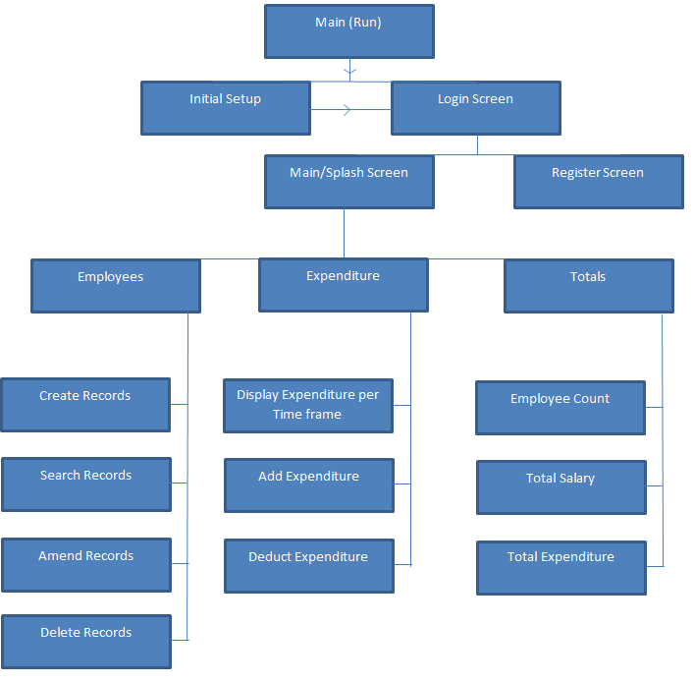

## Wireframes –

In order to properly convey my designs to the end users, I created a quick set of wireframes to demonstrate the basic structure and layout of the proposed system. These wireframes had no functionality, but they were interlinked, so that I could present them to the end users in a coherent manner.

I decided to take this approach to the design, because GUIs are relatively quick and easy to create, and I saw it as an effective way to visually convey my ideas.

### Initial Setup Wireframe –

This will be the first screen that the end user will be presented with. It will only be displayed once, and it allows for the Admin Password to be set up. Once this process has been completed, the program will default to the Login Screen on startup.

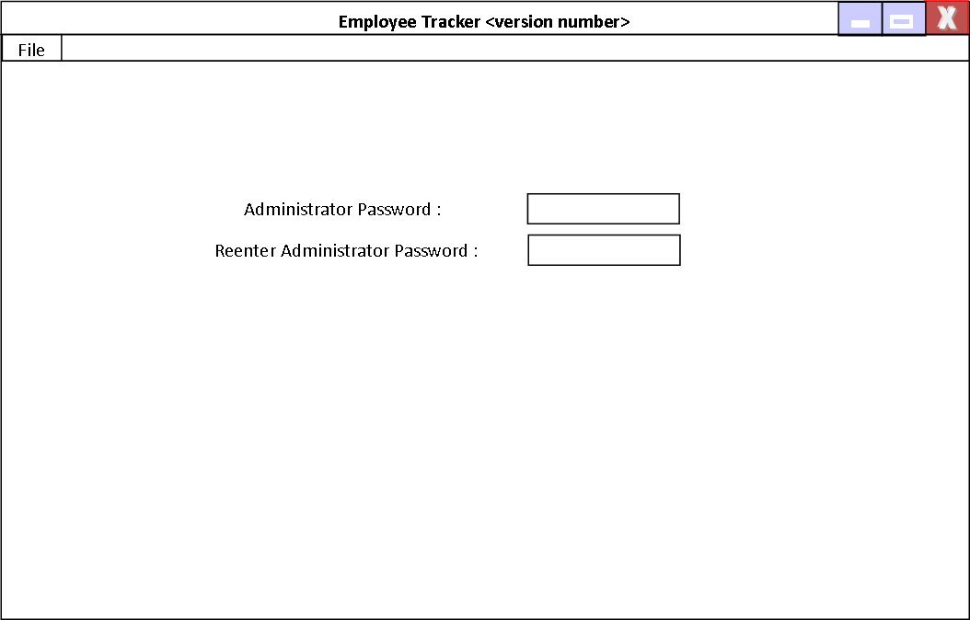

### Login Screen Wireframe –

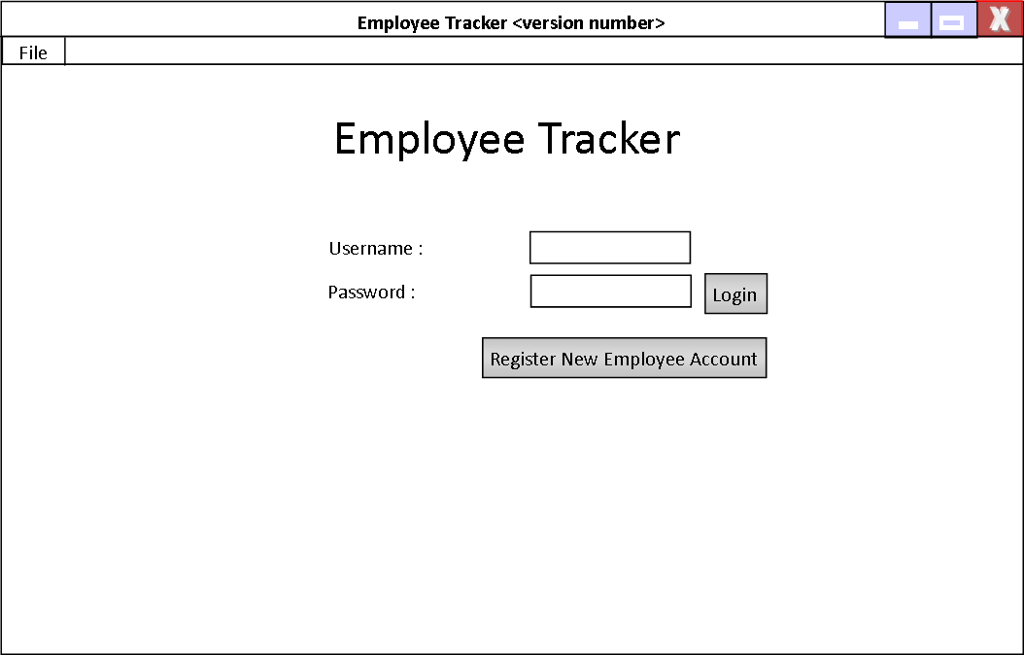This will serve as the Initial screen for the program once the initial setup has been completed. The Register New Employee Account button will transition to the Register Account Screen. Upon a Successful login, the Main Screen will open.

### Register Account Screen Wireframe –

From this screen, the Admin will be able to create Employee accounts. These will be used to log into the system.

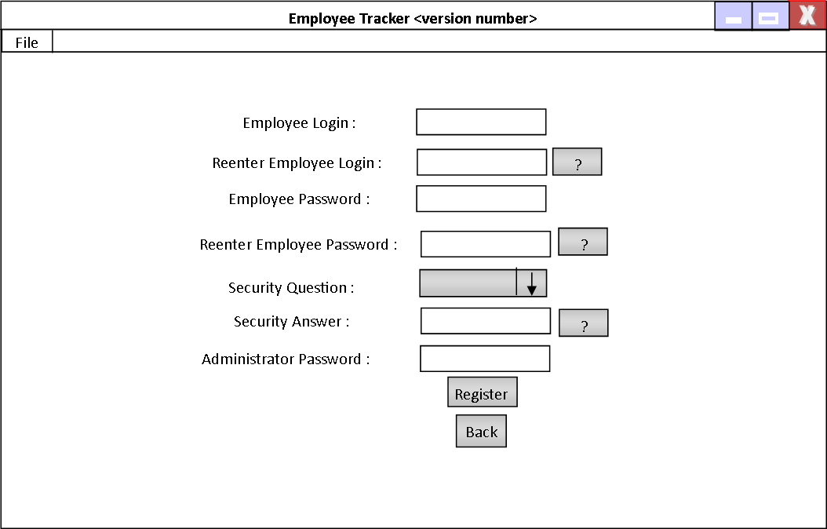

### Main Screen Wireframe –

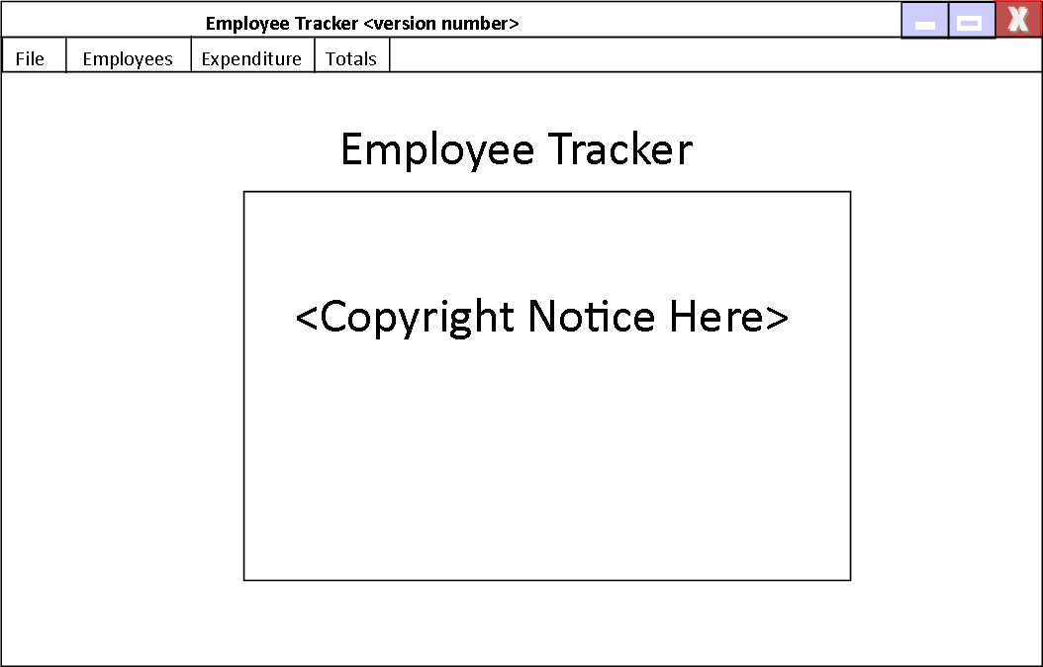From this screen, all of the user processes can be carried out. It will be the “Main Screen”.

### Create Record Wireframe –

From this screen, the user will be able to create Employee records.

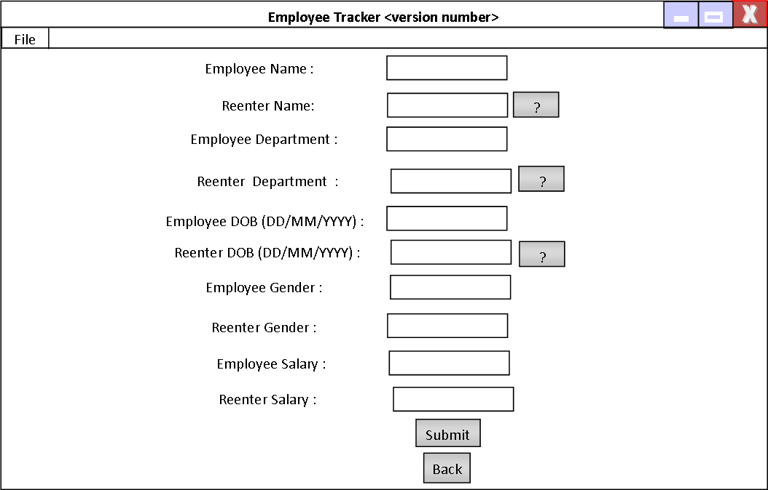

### Search Screen Wireframe –

From this screen, the user will be able to search for Employee Records. A similar screen will be used for deleting records.

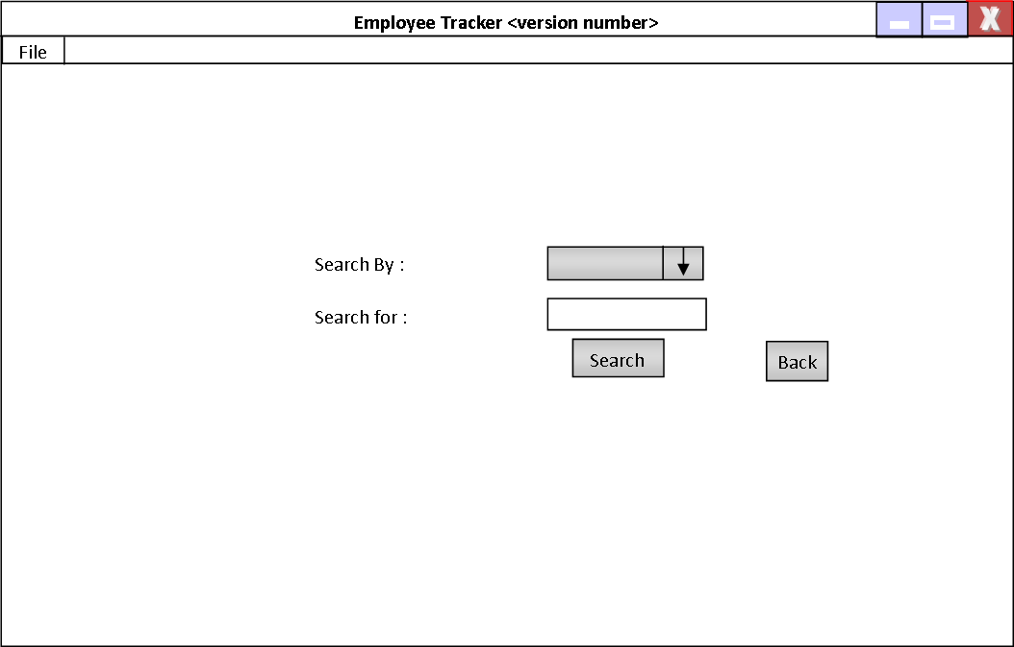

### Popup Wireframe (Generic) :

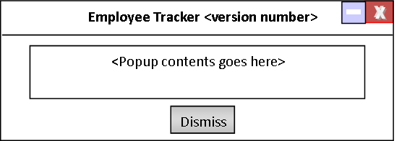

## Data Flow Diagram for the New System –

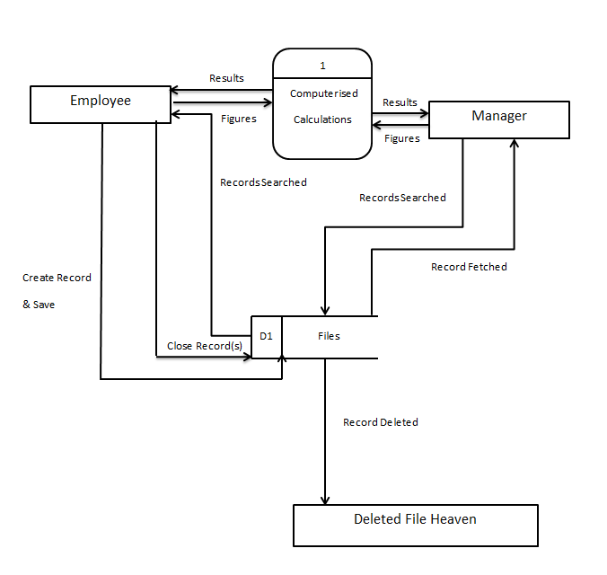

## Confirmation of the acceptance of the Design –

Above is confirmation from the end user that they agree with the Design that I laid out, and emailed to them.

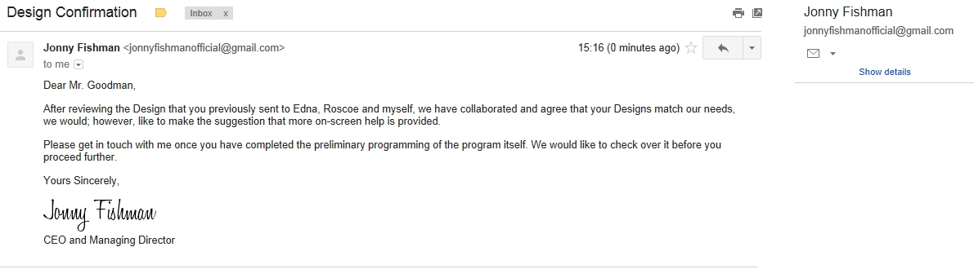

# Section 3 – Design Part 2 – Algorithm Design

## Algorithm 1 – isFloat() :

This algorithm will be used to verify whether a given input, n, is a Float.

1 DEF isFloat(n):

2 TRY:

3 FLOAT(n)

4 RETURN TRUE

5 EXCEPT VALUE_ERROR THEN

6 RETURN FALSE

|  |  |
| --- | --- |
| **n :** | **1** |
| **Line** | **Trace** |
| 1 |  |
| 2 |  |
| 3 | n = 1.00 |
| 4 | return True |

|  |  |
| --- | --- |
| **n :** | **6.23** |
| **Line** | **Trace** |
| 1 |  |
| 2 |  |
| 3 | n = 6.23 |
| 4 | return True |

|  |  |
| --- | --- |
| **n :** | **“Penguin”** |
| **Line** | **Trace** |
| 1 |  |
| 2 |  |
| 3 | Value Error |
| 5 |  |
| 6 | return False |

## Algorithm 2 – isInt() :

This algorithm will be used to verify whether a given input, n, is an Integer.

1 DEF isInt(n):

2 TRY:

3 INT(n)

4 RETURN TRUE

5 EXCEPT VALUE_ERROR THEN

6 RETURN FALSE

|  |  |
| --- | --- |
| **n :** | **1** |
| **Line** | **Trace** |
| 1 |  |
| 2 |  |
| 3 | n = 1.00 |
| 4 | return True |

|  |  |
| --- | --- |
| **n :** | **6.23** |
| **Line** | **Trace** |
| 1 |  |
| 2 |  |
| 3 | Value Error |
| 5 |  |
| 6 | return False |

|  |  |
| --- | --- |
| **n :** | **“Penguin”** |
| **Line** | **Trace** |
| 1 |  |
| 2 |  |
| 3 | Value Error |
| 5 |  |
| 6 | return False |

## Algorithm 3 – isNone() :

This algorithm will be used to verify whether a given input, n, is nonetype.

1 DEF isNone(n):

2 IF (n IS NONE) OR (LENGTH(n) == 0) THEN

3 RETURN TRUE

4 ELSE:

5 RETURN FALSE

6 END IF

|  |  |
| --- | --- |
| **n :** | **1** |
| **Line** | **Trace** |
| 1 |  |
| 2 | False |
| 4 |  |
| 5 | return False |

|  |  |
| --- | --- |
| **n :** | **“”** |
| **Line** | **Trace** |
| 1 |  |
| 2 | True |
| 3 | return True |

## Algorithm 4 – DOBCheck() :

This algorithm will be used to verify whether a given input, n, is in a valid DOB format.

1 DEF DOBCheck(n):

2 LIST MONTHSWITH30DAYS = [“04”,”06”,”09”,”11”]

3 IF n[0:2] isInt() AND n[3:5] isInt() AND n[6:] isInt() THEN

4 IF n[2] IS “/” AND n[5] IS “/” THEN

5 IF INT(n[3:5]) <= 12 THEN

6 IF INT(n[3:5]) IS “02” THEN

7 IF INT(n[6:]) MOD 4 IS 0 THEN

8 IF INT(n[0:2]) <= 29 THEN

9 RETURN TRUE

10 ELSE

11 RETURN FALSE

12 END IF

13 ELSE

14 IF INT(n[0:2]) <= 28 THEN

15 RETURN TRUE

16 ELSE

17 RETURN FALSE

18 END IF

19 END IF

20 ELSE

21 IF INT(n[3:5]) IS IN MONTHSWITH30DAYS THEN

22 IF INT(n[0:2]) <= 30 THEN

23 RETURN TRUE

24 ELSE

25 RETURN FALSE

26 END IF

27 ELSE

28 IF INT(n[0:2]) <= 31 THEN

29 RETURN TRUE

30 ELSE

31 RETURN FALSE

32 END IF

33 END IF

34 END IF

35 ELSE

36 RETURN FALSE

37 END IF

38 ELSE

39 RETURN FALSE

40 END IF

41 ELSE

42 RETURN FALSE

43 END IF

|  |  |
| --- | --- |
| **n :** | **10/10/1990** |
| **Line** | **Trace** |
| 1 |  |
| 2 | MONTHSWITH30DAYS = [“04”,”06”,”09”,”11”] |
| 3 | TRUE |
| 4 | TRUE |
| 5 | TRUE |
| 6 | FALSE |
| 20 |  |
| 21 | FALSE |
| 27 |  |
| 28 | TRUE |
| 29 | return TRUE |

|  |  |
| --- | --- |
| **n :** | **“Penguin”** |
| **Line** | **Trace** |
| 1 |  |
| 2 | MONTHSWITH30DAYS = [“04”,”06”,”09”,”11”] |
| 3 | FALSE |
| 41 |  |
| 42 | return FALSE |
| 43 |  |

## Algorithm 5 - GenderCheck() :

This algorithm will be used to verify whether a given input, x, is a valid gender in the context of the program.

1 DEF GenderCheck(x):

2 IF LOWER(x) IS “m” or LOWER(x) IS “f” THEN

3 RETURN TRUE

4 ELSE

5 RETURN FALSE

|  |  |
| --- | --- |
| **x :** | **“M”** |
| **Line** | **Trace** |
| 1 |  |
| 2 | True |
| 3 | return True |

|  |  |
| --- | --- |
| **x :** | **“Penguin”** |
| **Line** | **Trace** |
| 1 |  |
| 2 | False |
| 4 |  |
| 5 | return FALSE |

## Algorithm 6 – CreatePopup():

This Algorithm will be used to create a generic popup with a specified message, x.

1 DEF CreatePopup(x):

2 FROM Tkinter IMPORT *

3 FROM Constants IMPORT *

4 POPUP = Toplevel()

5 POPUP.title(WINDOW_TITLE)

6 MESSAGE = Message(POPUP, text=x, width=350, padx=10, pady=10)

7 MESSAGE.pack()

8 BUTTON = Button(POPUP, text=DISMISS_TEXT, command = POPUP.destroy()

9 BUTTON.pack()

Note : WINDOW_TITLE and DISMISS_TEXT are Constants imported from the Constants file at the start of the function.

|  |  |
| --- | --- |
| **x :** | **“Penguin”** |
| **Line** | **Trace** |
| 1 |  |
| 2 | imported Tkinter |
| 3 | imported Constants |
| 4 | Toplevel object created called POPUP |
| 5 | POPUP title set to WINDOW_TITLE |
| 6 | Message object created called MESSAGE, text is “Penguin”, width is 350, x and y padding is 10 in each dimension. |
| 7 | MESSAGE packed onto POPUP and rendered by GUI |
| 8 | Button object created called BUTTON, text is DISMISS_TEXT, command set to POPUP.destroy(). |
| 9 | BUTTON packed onto POPUP and rendered by GUI. |

## Algorithm 7 – GenerateCode():

This algorithm will be used to generate and return a unique Employee code.

1 DEF GenerateCode():

2 CodeCreated = FALSE

3 OPEN EMPLOYEE_DATABASE IN READ MODE

4 WHILE CodeCreated IS FALSE DO

5 EmpCode = “EMP”

6 FOR 7 TIMES DO

7 APPEND STRING(Random_Digit) TO EmpCode

8 IF EmpCode IS IN EMPLOYEE_DATABASE THEN

9 PASS

10 ELSE

11 CodeCreated = TRUE

12 RETURN EmpCode

|  |  |
| --- | --- |
| **Example where EmpCode created is UNIQUE (not in EMPLOYEE_DATABASE)** | |
| **Line** | **Trace** |
| 1 |  |
| 2 | CodeCreated set to False |
| 3 | EMPLOYEE_DATABASE opened in Read Mode |
| 4 | Iteration 0 |
| 5 | EmpCode set to “EMP” |
| 6 | Iteration 0 |
| 7 | Integer a appended to EmpCode |
| 6 | Iteration 1 |
| 7 | Integer b appended to EmpCode |
| 6 | Iteration 2 |
| 7 | Integer c appended to EmpCode |
| 6 | Iteration 3 |
| 7 | Integer d appended to EmpCode |
| 6 | Iteration 4 |
| 7 | Integer e appended to EmpCode |
| 6 | Iteration 5 |
| 7 | Integer f appended to EmpCode |
| 6 | Iteration 6 |
| 7 | Integer g appended to EmpCode |
| 8 | FALSE |
| 10 |  |
| 11 | CodeCreated set to TRUE, while loop ends. |
| 12 | RETURN EmpCode |

|  |  |
| --- | --- |
| **Example where First EmpCode created is NOT UNIQUE (in EMPLOYEE_DATABASE) and Second EmpCode is UNIQUE (not in EMPLOYEE_DATABASE)** | |
| **Line** | **Trace** |
| 1 |  |
| 2 | CodeCreated set to False |
| 3 | EMPLOYEE_DATABASE opened in Read Mode |
| 4 | Iteration 0 |
| 5 | EmpCode set to “EMP” |
| 6 | Iteration 0 |
| 7 | Integer a appended to EmpCode |
| 6 | Iteration 1 |
| 7 | Integer b appended to EmpCode |
| 6 | Iteration 2 |
| 7 | Integer c appended to EmpCode |
| 6 | Iteration 3 |
| 7 | Integer d appended to EmpCode |
| 6 | Iteration 4 |
| 7 | Integer e appended to EmpCode |
| 6 | Iteration 5 |
| 7 | Integer f appended to EmpCode |
| 6 | Iteration 6 |
| 7 | Integer g appended to EmpCode |
| 8 | TRUE |
| 9 | PASS |
| 4 | Iteration 1 |
| 5 | EmpCode set to “EMP” |
| 6 | Iteration 0 |
| 7 | Integer a appended to EmpCode |
| 6 | Iteration 1 |
| 7 | Integer b appended to EmpCode |
| 6 | Iteration 2 |
| 7 | Integer c appended to EmpCode |
| 6 | Iteration 3 |
| 7 | Integer d appended to EmpCode |
| 6 | Iteration 4 |
| 7 | Integer e appended to EmpCode |
| 6 | Iteration 5 |
| 7 | Integer f appended to EmpCode |
| 6 | Iteration 6 |
| 7 | Integer g appended to EmpCode |
| 8 | FALSE |
| 10 |  |
| 11 | CodeCreated set to TRUE, while loop ends. |
| 12 | RETURN EmpCode |

## Algorithm 8 – CreateRecord(self) :

This Algorithm will be used in order to create an Employee Record from given inputs from the user.

1 IF isNone(EMPLOYEE_NAME) IS TRUE OR isNone(EMPLOYEE_NAME_2) IS TRUE THEN

2 CreatePopup(NO_EMPLOYEE_NAME)

3 OPEN LOG_FILE IN APPEND MODE

4 APPEND NO_EMPLOYEE_NAME_ERROR

5 RETURN

6 ELSE IF EMPLOYEE_NAME DOES NOT EQUAL EMPLOYEE_NAME_2 THEN

7 CreatePopup(EMPLOYEE_NAMES_MISMATCH)

8 OPEN LOG_FILE IN APPEND MODE

9 APPEND EMPLOYEE_NAME_MISMATCH_ERROR

10 RETURN

11 ELSE IF isNone(EMPLOYEE_DEPARTMENT) OR isNone(EMPLOYEE_DEPARTMENT_2) IS

TRUE THEN

12 CreatePopup(NO_EMPLOYEE_DEPARTMENT)

13 OPEN LOG_FILE IN APPEND MODE

14 APPEND NO_EMPLOYEE_DEPARTMENT_ERROR

15 ELSE IF EMPLOYEE_DEPARMENT DOES NOT EQUAL EMPLOYEE_DEPARTMENT_2 THEN

16 CreatePopup(EMPLOYEE_DEPARTMENTS_MISMATCH)

17 OPEN LOG_FILE IN APPEND MODE

18 APPEND EMPLOYEE_DEPARTMENT_MISMATCH_ERROR

19 RETURN

20 IF isNone(EMPLOYEE_DOB) IS TRUE OR isNone(EMPLOYEE_DOB_2) IS TRUE

THEN

21 CreatePopup(NO_EMPLOYEE_DOB)

22 OPEN LOG_FILE IN APPEND MODE

23 APPEND NO_EMPLOYEE_DOB_ERROR

24 RETURN

25 ELSE IF EMPLOYEE_DOB DOES NOT EQUAL EMPLOYEE_DOB_2 THEN

26 CreatePopup(EMPLOYEE_DOB_MISMATCH)

27 OPEN LOG_FILE IN APPEND MODE

28 APPEND EMPLOYEE_DOB_MISMATCH_ERROR

29 RETURN

30 ELSE IF DOBCheck(EMPLOYEE_DOB) IS NOT TRUE THEN

31 CreatePopup(EMPLOYEE_DOB_INVALID)

32 OPEN LOG_FILE IN APPEND MODE

33 APPEND EMPLOYEE_DOB_INVALID

34 RETURN

35 IF isNone(EMPLOYEE_GENDER) IS TRUE OR isNone(EMPLOYEE_GENDER_2) IS TRUE

THEN

36 CreatePopup(NO_GENDER_ERROR)

37 OPEN LOG_FILE IN APPEND MODE

38 APPEND NO_EMPLOYEE_GENDER_ERROR

39 RETURN

40 ELSE IF EMPLOYEE_GENDER DOES NOT EQUAL EMPLOYEE_GENDER_2 THEN

41 CreatePopup(EMPLOYEE_GENDER_MISMATCH)

42 OPEN LOG_FILE IN APPEND MODE

43 APPEND EMPLOYEE_GENDER_MISMATCH_ERROR

44 RETURN

45 ELSE IF GenderCheck(EMPLOYEE_GENDER) IS NOT TRUE THEN

46 CreatePopup(EMPLOYEE_GENDER_INVALID)

47 OPEN LOG_FILE IN APPEND MODE

48 APPEND EMPLOYEE_GENDER_INVALID

49 RETURN

50 IF isNone(EMPLOYEE_SALARY) IS TRUE OR isNone(EMPLOYEE_SALARY_2) IS TRUE

THEN

51 CreatePopup(NO_EMPLOYEE_SALARY)

52 OPEN LOG_FILE IN APPEND MODE

53 APPEND NO_EMPLOYEE_SALARY_ERROR

54 RETURN

55 ELSE IF EMPLOYEE_SALARY DOES NOT EQUAL EMPLOYEE_SALARY_2 THEN

56 CreatePopup(EMPLOYEE_SALARY_MISMATCH)

57 OPEN LOG_FILE IN APPEND MODE

58 APPEND EMPLOYEE_SALARY_MISMATCH_ERROR

59 RETURN

60 ELSE IF isInt(EMPLOYEE_SALARY) IS NOT TRUE THEN

61 CreatePopup(EMPLOYEE_SALARY_INVALID)

62 OPEN LOG_FILE IN APPEND MODE

63 APPEND EMPLOYEE_SALARY_INVALID

64 RETURN

65 OPEN EMPLOYEE_DATABASE IN READ MODE

66 CURRENT_DATABASE = EVAL(DATA IN FILE)

67 EmpCode = GenerateCode()

68 OPEN EMPLOYEE_CODES IN APPEND MODE

69 APPEND EmpCode TO FILE

70 NEW_EMPLOYEE = {NAME : EMPLOYEE_NAME,

DEPARTMENT : EMPLOYEE_DEPARTMENT,

DOB : EMPLOYEE_DOB,

GENDER : EMPLOYEE_GENDER,

SALARY : EMPLOYEE_SALARY,

CODE : EMPLOYEE_CODE}

71 APPEND NEW_EMPLOYEE TO CURRENT_DATABASE

72 OPEN EMPLOYEE_DATABASE IN WRITE MODE

73 WRITE CURRENT_DATABASE TO FILE

74 OPEN EMPLOYEE_COUNT IN READ MODE

75 EmpCount = INT(DATA IN FILE)

76 EmpCount += 1

77 OPEN EMPLOYEE_COUNT IN WRITE MODE

78 WRITE EmpCount TO FILE

79 OPEN TOTAL_EXPENDITURE IN READ MODE

80 TotalExpenditure = INT(DATA IN FILE)

81 TotalExpenditure += EMPLOYEE_SALARY

82 OPEN TOTAL_EXPENDITURE IN WRITE MODE

83 WRITE TotalExpenditure TO FILE

84 RETURN

|  |  |
| --- | --- |
| **Line** | **Trace** |
| 1 | FALSE |
| 6 | FALSE |
| 11 | FALSE |
| 16 | FALSE |
| 20 | FALSE |
| 25 | FALSE |
| 30 | FALSE |
| 35 | FALSE |
| 40 | FALSE |
| 45 | FALSE |
| 50 | FALSE |
| 55 | FALSE |
| 60 | FALSE |
| 65 | EMPLOYEE_DATABASE opened in Read Mode |
| 66 | CURRENT_DATABASE set to the Data in the EMPLOYEE_DATABASE |
| 67 | EmpCode set to the code generated by the GenerateCode function |
| 68 | EMPLOYEE_CODES opened in Append Mode |
| 69 | EmpCode appended to EMPLOYEE_CODES |
| 70 | NEW_EMPLOYEE Dictionary set to  {NAME : EMPLOYEE_NAME,  DEPARTMENT : EMPLOYEE_DEPARTMENT,  DOB : EMPLOYEE_DOB,  GENDER : EMPLOYEE_GENDER,  SALARY : EMPLOYEE_SALARY,  CODE : EMPLOYEE_CODE} |
| 71 | NEW_EMPLOYEE appended to CURRENT_DATABASE |
| 72 | EMPLOYEE_DATABASE opened in Write Mode |
| 73 | CURRENT_DATABASE written to EMPLOYEE_DATABASE |
| 74 | EMPLOYEE_COUNT opened in Read Mode |
| 75 | EmpCount set to the integer of the data in the EMPLOYEE_COUNT file |
| 76 | EmpCount incremented by 1 |
| 77 | EMPLOYEE_COUNT opened in Write Mode |
| 78 | EmpCount written to EMPLOYEE_COUNT |
| 79 | TOTAL_EXPENDITURE opened in Read Mode |
| 80 | TotalExpenditure set to the integer of the data in the TOTAL_EXPENDITURE file |
| 81 | TotalExpenditure incremented by the EMPLOYEE_SALARY |
| 82 | TOTAL_EXPENDITURE opened in Write Mode |
| 83 | TotalExpenditure written to TOTAL_EXPENDITURE |
| 84 | Return |

## Algorithm 9 – tryLogin(self) :

This algoritm will be used on the Login Screen to process login attempts.

1 LoginAttempts = READ(LOGIN_ATTEMPTS FILE)

2 IF USERNAME IS IN RESERVED_NAMES THEN

3 OPEN ADMIN_PASS_FILE

4 AdminPass = READ(DATA IN FILE)

5 IF HASH(PASSWORD) = INT(AdminPass) THEN

6 LoginAttempts = 0

7 WRITE LoginAttempts to LOGIN_ATTEMPTS FILE

8 CLEAR ENTRY BOXES

9 RETURN

10 IF LoginAttempts >= 10 THEN

11 CreatePopup(SYSTEM_LOCKED)

12 RETURN

13 LoginDict = READ(LOGIN_DATA FILE)

14 IF HASH(USERNAME) IN LoginDict THEN

15 IF STR(LoginDict[HASH(USERNAME)]) = STR(HASH(PASSWORD)) THEN

16 GO TO MAIN SCREEN

17 ELSE

18 CreatePopup(INVALID_LOGIN)

19 LoginAttempts += 1

20 WRITE LoginAttempts to LOGIN_ATTEMPTS FILE

21 ELSE

22 CreatePopup(INVALID_LOGIN)

23 LoginAttempts +=1

24 WRTIE LoginAttempts to LOGIN_ATTEMPTS FILE

|  |  |
| --- | --- |
| **Example with a Valid username and password, with Less than 10 attempts.** | |
| **Line** | **Trace** |
| 1 | Login Attempts set to the Data in the LOGIN_ATTEMPTS File. |
| 2 | FALSE |
| 10 | FALSE |
| 13 | LoginDict set to the Dictionary stored in the LOGIN_DATA File. |
| 14 | TRUE |
| 15 | TRUE |
| 16 | Screen changes from Login Screen to Main Screen. |

|  |  |
| --- | --- |
| **Example with an invalid username and password, with Less than 10 attempts.** | |
| **Line** | **Trace** |
| 1 | Login Attempts set to the Data in the LOGIN_ATTEMPTS File. |
| 2 | FALSE |
| 10 | FALSE |
| 13 | LoginDict set to the Dictionary stored in the LOGIN_DATA File. |
| 14 | FALSE |
| 21 | TRUE |
| 22 | Popup Created with the Invalid Login message. |
| 23 | LoginAttempts incremented by 1 |
| 24 | LoginAttempts written to the LOGIN_ATTEMPTS File |

## Algorithm 10 – TotalExpenditure():

This Algorithm will be used to display Total Expenditure.

1 OPEN TOTAL_EXPENDITURE FILE

2 TotalExpenditure = READ(DATA IN FILE)

3 CreatePopup(TotalExpenditure)

|  |  |
| --- | --- |
| **Total Expenditure :** | **100000** |
| **Line** | **Trace** |
| 1 | TOTAL_EXPENDITURE FILE Opened |
| 2 | TotalExpenditure set to 100000 |
| 3 | Popup created with message : 100000 |

## Algorithm 11 – BiannualExpenditure():

This Algorithm will be used to display Biannual Expenditure.

1 OPEN TOTAL_EXPENDITURE FILE

2 TotalExpenditure = READ(DATA IN FILE)

3 BiannualExpenditure = ROUND(YearlyExpenditure/2)

4 CreatePopup(TotalExpenditure)

|  |  |
| --- | --- |
| **Total Expenditure :** | **100000** |
| **Line** | **Trace** |
| 1 | TOTAL_EXPENDITURE FILE Opened |
| 2 | TotalExpenditure set to 100000 |
| 3 | BiannualExpenditure set to 50000 |
| 4 | Popup created with message : 50000 |

## Algorithm 12 – QuarterlyExpenditure():

This Algorithm will be used to display Quarterly Expenditure.

1 OPEN TOTAL_EXPENDITURE FILE

2 TotalExpenditure = READ(DATA IN FILE)

3 QuarterlyExpenditure = ROUND(YearlyExpenditure/4)

4 CreatePopup(TotalExpenditure)

|  |  |
| --- | --- |
| **Total Expenditure :** | **100000** |
| **Line** | **Trace** |
| 1 | TOTAL_EXPENDITURE FILE Opened |
| 2 | TotalExpenditure set to 100000 |
| 3 | QuarterlyExpenditure set to 25000 |
| 4 | Popup created with message : 25000 |

## Algorithm 13 – MonthlyExpenditure():

This Algorithm will be used to display Monthly Expenditure.

1 OPEN TOTAL_EXPENDITURE FILE

2 TotalExpenditure = READ(DATA IN FILE)

3 MonthlyExpenditure = ROUND(YearlyExpenditure/12)

4 CreatePopup(TotalExpenditure)

|  |  |
| --- | --- |
| **Total Expenditure :** | **100000** |
| **Line** | **Trace** |
| 1 | TOTAL_EXPENDITURE FILE Opened |
| 2 | TotalExpenditure set to 100000 |
| 3 | MonthlyExpenditure set to 8333 |
| 4 | Popup created with message : 8333 |

## Algorithm 14 – WeeklyExpenditure():

This Algorithm will be used to display Weekly Expenditure.

1 OPEN TOTAL_EXPENDITURE FILE

2 TotalExpenditure = READ(DATA IN FILE)

3 WeeklyExpenditure = ROUND(YearlyExpenditure/52)

4 CreatePopup(TotalExpenditure)

|  |  |
| --- | --- |
| **Total Expenditure :** | **100000** |
| **Line** | **Trace** |
| 1 | TOTAL_EXPENDITURE FILE Opened |
| 2 | TotalExpenditure set to 100000 |
| 3 | WeeklyExpenditure set to 1923 |
| 4 | Popup created with message : 1923 |

## Algorithm 15 – DailyExpenditure():

This Algorithm will be used to display Daily Expenditure.

1 OPEN TOTAL_EXPENDITURE FILE

2 TotalExpenditure = READ(DATA IN FILE)

3 DailyExpenditure = ROUND(YearlyExpenditure/365.25)

4 CreatePopup(TotalExpenditure)

|  |  |
| --- | --- |
| **Total Expenditure :** | **100000** |
| **Line** | **Trace** |
| 1 | TOTAL_EXPENDITURE FILE Opened |
| 2 | TotalExpenditure set to 100000 |
| 3 | MonthlyExpenditure set to 274 |
| 4 | Popup created with message : 274 |

## Algorithm 16 – SearchRecords():

1 TRY

2 IF isNone(SEARCH CRITERIA) IS TRUE THEN

3 CreatePopup(NO SEARCH CRITERIA)

4 RETURN

5 LIST names = []

6 LIST departments = []

7 LIST DOBs = []

8 LIST genders = []

9 LIST salaries = []

10 LIST codes = []

11 searchIn = SEARCH_IN

12 searchFor = SEARCH_FOR

13 EmpDatabase = READ(EMP_DATABASE FILE)

14 IF searchIn IS NAME AND LEN(searchFor) IS 1 THEN

15 FOR Element IN EmpDatabase DO

16 IF Element[searchIn][FIRST] IS searchFor THEN

17 names.APPEND(Element[NAME])

18 departments.APPEND(Element[DEPARTMENT])

19 DOBs.APPEND(Element[DOB])

20 genders.APPEND(Element[GENDER])

21 salaries.APPEND(Element[SALARY])

22 codes.APPEND(Element[CODE])

23 ELSE

24 FOR Element IN EmpDatabase DO

25 IF Element[searchIn] IS searchFor THEN

26 names.APPEND(Element[NAME])

27 departments.APPEND(Element[DEPARTMENT])

28 DOBs.APPEND(Element[DOB])

29 genders.APPEND(Element[GENDER])

30 salaries.APPEND(Element[SALARY])

31 codes.APPEND(Element[CODE])

32 PASS DATA ON TO SEARCH DISPLAY SCREEN

Devising a trace table for this Algorithm would be tedious, and; moreover, not worthwhile, since a large amount of test data would be required. Hence, the trace for this Algorithm will be omitted.

## Algorithm 17 – CalculateTax(n):

This algorithm will be used to calculate the amount of tax that will be paid by an employee on a given salary, n.

1 DEF CalculateTax(n):

2 Tax = 0

3 n = INT(n) #Ensures that n is an integer before manipulating it.

4 IF n <= BAND_ZERO_TAX_LIMIT:

5 RETURN INT(Tax)

6 IF n > BAND_ZERO_TAX_LIMIT and n <= BAND_ONE_TAX_LIMIT:

7 AmountInBandZero = BAND_ZERO_TAX_LIMIT

8 AmountInBandOne = n - BAND_ZERO_TAX_LIMIT

9 Tax = AmountInBandOne * BAND_ONE_TAX

10 RETURN INT(Tax)

11 IF n > BAND_ONE_TAX_LIMIT and n <= BAND_TWO_TAX_LIMIT:

12 AmountInBandZero = BAND_ZERO_TAX_LIMIT

13 AmountInBandOne = BAND_ONE_TAX_LIMIT

14 AmountInBandTwo = n - BAND_ONE_TAX_LIMIT

15 Tax = AmountInBandOne * BAND_ONE_TAX

16 Tax += AmountInBandTwo * BAND_TWO_TAX

17 RETURN INT(Tax)

18 IF n > BAND_TWO_TAX_LIMIT:

19 AmountInBandZero = BAND_ZERO_TAX_LIMIT

20 AmountInBandOne = BAND_ONE_TAX_LIMIT

21 AmountInBandTwo = BAND_TWO_TAX_LIMIT

22 AmountInBandThree = n - BAND_TWO_TAX_LIMIT

23 Tax = AmountInBandOne * BAND_ONE_TAX

24 Tax += AmountInBandTwo * BAND_TWO_TAX

25 Tax += AmountInBandThree * BAND_THREE_TAX

26 RETURN INT(Tax)

|  |  |
| --- | --- |
| **n:**  **BAND_ZERO_TAX_LIMIT:**  **BAND_ONE_TAX_LIMIT:**  **BAND_TWO_TAX_LIMIT:**  **BAND_ONE_TAX:**  **BAND_TWO_TAX:**  **BAND_THREE_TAX:** | **17500**  **10000**  **31865**  **150000**  **0.2**  **0.4**  **0.45** |
| **Line** | **Trace** |
| 1 |  |
| 2 | Tax = 0 |
| 3 | n = 17500 |
| 4 | FALSE |
| 6 | TRUE |
| 7 | AmountInBandZero = 10000 |
| 8 | AmountInBandOne = 17500-10000 => 7500 |
| 9 | Tax = 7500 * 0.2 = 1500 |
| 10 | return 1500 |

# Section 4 – Software Development

I have developed this code in such a way that it should be somewhat readable as English. Hence, there are less comments included, but I will include a brief description of the purpose and workings of each module alongside each one.

## AddExpenditureScreen.py

#AddExpenditureScreen

from Tkinter import *

from Constants import *

from TimeStamp import *

from CreatePopup import *

from LoggingStringsEnglish import *

with open(LANGUAGE_FILENAME, READ_MODE) as f:

Language = f.readline()

if Language == "GERMAN":

from AddExpenditureScreenStringsGerman import *

from PopupsStringsGerman import *

from DropdownMenuStringsGerman import *

else:

from AddExpenditureScreenStringsEnglish import *

from PopupsStringsEnglish import *

from DropdownMenuStringsEnglish import *

import re

class AddExpenditureScreen(Frame):

def __init__(self, parent):

Frame.__init__(self, parent)

with open(LOG_FILENAME, APPEND_MODE) as f:

f.write(TimeStamp() + INSTANCE_OF_ADDEXPENDITURESCREEN_TEXT + str(self) + PARENT_TEXT + str(parent) + "\n")

self.parent = parent

self.initialiseUI()

def initialiseUI(self):

self.parent.title(WINDOW_TITLE)

menubar = Menu(self.parent)

self.parent.config(menu=menubar)

fileMenu = Menu(menubar)

fileMenu.add_command(label=DROPDOWN_BACK_TEXT, underline=0, command=self.onBack)

fileMenu.add_command(label=DROPDOWN_HELP_TEXT, underline=0, command=self.Help)

fileMenu.add_separator()

menubar.add_cascade(label=DROPDOWN_FILE_TEXT, underline=0, menu=fileMenu)

with open(LOG_FILENAME, APPEND_MODE) as f:

f.write(TimeStamp() + MENUBAR_INITIALISED_TEXT)

global ExpenditureEntry

global ExpenditureEntryTwo

global AdminPassEntry

global ReasonEntry

AnchorLabel = Label()

ExpenditureLabel = Label(text=EXPENDITURE_ONE_TEXT, anchor=CENTER)

ExpenditureEntry = Entry()

ExpenditureLabelTwo = Label(text=EXPENDITURE_TWO_TEXT, anchor=CENTER)

ExpenditureEntryTwo = Entry()

ReasonLabel = Label(text="Reason for Expenditure: ")

ReasonEntry = Entry()

AdminPassLabel = Label(text=ENTER_ADMIN_PASS_TEXT, anchor=CENTER)

AdminPassEntry = Entry(show="*")

with open(LOG_FILENAME, APPEND_MODE) as f:

f.write(TimeStamp() + LOADED_LABELS_TEXT)

SubmitButton = Button(text=SUBMIT_BUTTON_TEXT)

SubmitButton['command'] = lambda: self.AddExpenditure()

with open(LOG_FILENAME, APPEND_MODE) as f:

f.write(TimeStamp() + LOADED_BUTTONS_TEXT)

AnchorLabel.grid(pady=35,padx=130,row=0,column=0)

ExpenditureLabel.grid(row=1, column=1)

ExpenditureEntry.grid(row=1, column=2)

ExpenditureLabelTwo.grid(row=2, column=1)

ExpenditureEntryTwo.grid(row=2, column=2)

ReasonLabel.grid(row=3, column=1)

ReasonEntry.grid(row=3, column=2)

AdminPassLabel.grid(row=4, column=1)

AdminPassEntry.grid(row=4, column=2)

SubmitButton.grid(row=5, column=3)

with open(LOG_FILENAME, APPEND_MODE) as f:

f.write(TimeStamp() + INITIALISED_GRID_UI_TEXT)

def AddExpenditure(self):

with open(LOG_FILENAME, APPEND_MODE) as f:

f.write(TimeStamp() + "Add Expenditure Button Pressed. \n")

with open(ADMIN_PASS_FILENAME, READ_MODE) as f:

AdminPass = f.readline()

if str(AdminPass) == str(hash(AdminPassEntry.get())):

with open(TOTAL_EXPENDITURE_FILENAME, READ_MODE) as f:

TotalExpenditure = int(f.readline())

TotalExpenditure += int(ExpenditureEntryTwo.get())

with open(TOTAL_EXPENDITURE_FILENAME, WRITE_MODE) as f:

f.write("%s" %TotalExpenditure)

with open(LOG_FILENAME, APPEND_MODE) as f:

f.write(TimeStamp() + " Expenditure of %s added" %TotalExpenditure + " Reason: %s\n" %ReasonEntry.get())

self.parent.destroy()

with open(LOG_FILENAME, APPEND_MODE) as f:

f.write(TimeStamp() + WINDOW_TERMINATED_TEXT)

root =Tk()

root.geometry(WINDOW_GEOMETRY)

app = Splash(root)

root.mainloop()

else:

CreatePopup("The Administrator password was incorrect.")

return

def Help(self):

CreatePopup(ADD_EXPENDITURE_HELP_TEXT)

def onBack(self):

with open(LOG_FILENAME, APPEND_MODE) as f:

f.write(TimeStamp() + BACK_SELECTED_TEXT)

self.parent.destroy()

with open(LOG_FILENAME, APPEND_MODE) as f:

f.write(TimeStamp() + WINDOW_TERMINATED_TEXT)

root =Tk()

root.geometry(WINDOW_GEOMETRY)

app = Splash(root)

root.mainloop()

from MainScreen import *

## AddExpenditureScreenStringsEnglish.py :

#AddExpenditureScreenStringsEnglish

ADD_EXPENDITURE_HELP_TEXT = u"Here you can add expenditure to the total expenditure."

ENTER_ADMIN_PASS_TEXT = u"Administrator Password: "

EXPENDITURE_ONE_TEXT = u"Enter Expenditure to Add: "

EXPENDITURE_TWO_TEXT = u"Reenter Expenditure: "

SUBMIT_BUTTON_TEXT = u"Submit"

## AddExpenditureScreenStringsGerman.py :

# -*- coding: utf-8 -*-

#AddExpenditureScreenStringsGerman

ADD_EXPENDITURE_HELP_TEXT = u"Hier können Sie die Gesamtausgaben Ausgaben hinzufügen."

ENTER_ADMIN_PASS_TEXT = u"Administrator-Kennwort: "

EXPENDITURE_ONE_TEXT = u"Geben Sie Ausgaben hinzu: "

EXPENDITURE_TWO_TEXT = u"Geben Sie Ausgaben: "

SUBMIT_BUTTON_TEXT = u"Senden"

## AmendEmployeeScreen.py :

#AmendEmployeeScreen

from Constants import *

from CreatePopup import *

from Tkinter import *

from TimeStamp import *

from BaseModule import *

from LoggingStringsEnglish import *

with open(LANGUAGE_FILENAME, READ_MODE) as f:

Language = f.readline()

if Language == "GERMAN":

from AmendEmployeeScreenStringsGerman import *

from PopupsStringsGerman import *

from DropdownMenuStringsGerman import *

else:

from AmendEmployeeScreenStringsEnglish import *

from PopupsStringsEnglish import *

from DropdownMenuStringsEnglish import *

import pickle

import re

class AmendEmployeeScreen(Frame):

def __init__(self, parent):

Frame.__init__(self, parent)

with open(LOG_FILENAME, APPEND_MODE) as f:

f.write(TimeStamp() + INSTANCE_OF_AMENDLOGINSCREEN_TEXT + str(self) + PARENT_TEXT + str(parent) + "\n")

self.parent = parent

self.initialiseUI()

def initialiseUI(self):

global AmendTypeVar

global ValueEntry

global EmployeeCodeEntry

self.parent.title(WINDOW_TITLE)

menubar = Menu(self.parent)

self.parent.config(menu=menubar)

fileMenu = Menu(menubar)

fileMenu.add_command(label=DROPDOWN_BACK_TEXT, underline=0, command=self.onBack)

fileMenu.add_command(label=DROPDOWN_QUIT_TEXT, underline=0, command=self.onExit)

fileMenu.add_separator()

fileMenu.add_command(label=DROPDOWN_HELP_TEXT, underline=0, command=self.Help)

fileMenu.add_separator()

menubar.add_cascade(label=DROPDOWN_FILE_TEXT, underline=0, menu=fileMenu)

with open(LOG_FILENAME, APPEND_MODE) as f:

f.write(TimeStamp() + MENUBAR_INITIALISED_TEXT)

AnchorLabel = Label(padx=130, pady=70)

BlankLabel = Label(pady=5)

TitleLabel = Label(text=AMEND_FOR_EMPLOYEES_TEXT, font=("Purisa", 16))

AmendTypeLabel = Label(text=AMEND_BY_TEXT, anchor=E)

ValueLabel = Label(text=AMEND_FOR_TEXT, anchor=E)

ValueEntry = Entry()

EmployeeCodeLabel = Label(text=EMP_CODE_TEXT, anchor=E)

EmployeeCodeEntry = Entry()

AmendTypeVar = StringVar(self.parent)

AmendTypeVar.set(DROPDOWN_NAME_TEXT)

AmendTypeDropdown = OptionMenu(self.parent, AmendTypeVar,

DROPDOWN_NAME_TEXT,

DROPDOWN_DEPARTMENT_TEXT,

DROPDOWN_DOB_TEXT,

DROPDOWN_SALARY_TEXT)

with open(LOG_FILENAME, APPEND_MODE) as f:

f.write(TimeStamp() + AMENDTYPEDROWPDOWN_MENU_INITIALISED_TEXT)

BackButton = Button(text=BACK_BUTTON_TEXT)

BackButton['command'] = lambda: self.onBack()

AmendButton = Button(text=AMEND_BUTTON_TEXT)

AmendButton['command'] = lambda: self.onAmend()

with open(LOG_FILENAME, APPEND_MODE) as f:

f.write(TimeStamp() + LOADED_BUTTONS_TEXT)

AnchorLabel.grid(row=0, column=0)

TitleLabel.grid(row=1, column=2)

BlankLabel.grid(row=2, column=2)

EmployeeCodeLabel.grid(row=3, column=1)

EmployeeCodeEntry.grid(row=3, column=2)

AmendTypeLabel.grid(row=4, column=1)

AmendTypeDropdown.grid(row=4, column=2)

ValueLabel.grid(row=5, column=1)

ValueEntry.grid(row=5, column=2)

AmendButton.grid(row=6, column=2)

BackButton.grid(row=6, column=3)

with open(LOG_FILENAME, APPEND_MODE) as f:

f.write(TimeStamp() + INITIALISED_GRID_UI_TEXT)

def onAmend(self):

try:

with open(EMP_DATABASE_FILENAME, READ_MODE) as f:

Employees = eval(f.readline())

for Employee in Employees:

if Employee["Code"] == EmployeeCodeEntry.get():

if AmendTypeVar.get() == "DOB":

if DOBCheck(ValueEntry.get()) == True:

Employee[AmendTypeVar.get()] = ValueEntry.get()

else:

CreatePopup(INVALID_DOB_TEXT)

with open(EMP_DATABASE_FILENAME, WRITE_MODE) as f:

f.write("%s" %Employees)

except:

CreatePopup(NO_EMP_RECORDS_TEXT)

def onBack(self):

with open(LOG_FILENAME, APPEND_MODE) as f:

f.write(TimeStamp() + BACK_SELECTED_TEXT)

self.parent.destroy()

with open(LOG_FILENAME, APPEND_MODE) as f:

f.write(TimeStamp() + WINDOW_TERMINATED_TEXT)

root =Tk()

root.geometry(WINDOW_GEOMETRY)

app = Splash(root)

root.mainloop()

def onExit(self):

with open(LOG_FILENAME, APPEND_MODE) as f:

f.write(TimeStamp() + QUIT_SELECTED_TEXT)

self.parent.destroy()

with open(LOG_FILENAME, APPEND_MODE) as f:

f.write(TimeStamp() + WINDOW_TERMINATED_TEXT)

def Help(self):

with open(LOG_FILENAME, APPEND_MODE) as f:

f.write(TimeStamp() + HELP_SELECTED_TEXT)

CreatePopup(HELP_OPTION_TEXT)

from LoginForm import *

from MainScreen import *

## AmendEmployeeScreenStringsEnglish.py :

#AmendEmployeeScreen

ADMIN_PASS_INCORRECT = u"The Administrator password was incorrect."

AMEND_BUTTON_TEXT = u"Amend"

AMEND_BY_TEXT = u"Amend Field : "

AMEND_EMP_SCREEN_NONETYPE_ERROR_TEXT = u"Please enter Amendment Criteria."

AMEND_FOR_TEXT = u"Amend to : "

AMEND_FOR_EMPLOYEES_TEXT = u"Amend a Record : "

BACK_BUTTON_TEXT = u"Back"

CODE_TEXT = u"Code"

DEPARTMENT_TEXT = u"Department"

DOB_TEXT = u"DOB"

DROPDOWN_DEPARTMENT_TEXT = u"Department"

DROPDOWN_DOB_TEXT = u"DOB"

DROPDOWN_EMPCODE_TEXT = u"Employee Code"

DROPDOWN_NAME_TEXT = u"Name"

DROPDOWN_SALARY_TEXT = u"Salary"

EMP_CODE_TEXT = u"Employee Code"

GENDER_TEXT = u"Gender"

HELP_OPTION_TEXT = u"Here you can amend employee records by field."

INVALID_DOB_TEXT = u"Please enter a valid DOB (DD/MM/YYYY)"

NAME_TEXT = u"Name"

NO_EMP_RECORDS_TEXT = u"There are no employee records."

SALARY_TEXT = u"Salary"

## AmendEmployeeScreenStringsGerman.py :

# -*- coding: utf-8 -*-

#AmendEmployeeScreen

ADMIN_PASS_INCORRECT = u"Das Administrator-Passwort war falsch."

AMEND_BUTTON_TEXT = u"Änderung"

AMEND_BY_TEXT = u"Feld zu ändern: "

AMEND_EMP_SCREEN_NONETYPE_ERROR_TEXT = u"Bitte geben Sie die Änderung Kriterien."

AMEND_FOR_TEXT = u"Zu ändern:"

AMEND_EMPLOYEES_TEXT = u"Ändern eines Datensatzes: "

BACK_BUTTON_TEXT = u"Zurück"

CODE_TEXT = u"Code"

DEPARTMENT_TEXT = u"Abteilung"

DOB_TEXT = u"DOB"

DROPDOWN_DEPARTMENT_TEXT = u"Abteilung"

DROPDOWN_DOB_TEXT = u"DOB"

DROPDOWN_EMPCODE_TEXT = u"Mitarbeiter-Code"

DROPDOWN_NAME_TEXT = u"Name"

DROPDOWN_SALARY_TEXT = u"Gehalt"

EMP_CODE_TEXT = u"Mitarbeiter-Code"

GENDER_TEXT = u"Geschlecht"

HELP_OPTION_TEXT = u"Hier können Sie Mitarbeiterdaten durch Feld ändern."

NAME_TEXT = u"Name"

NO_EMP_RECORDS_TEXT = u"Es gibt keine Mitarbeiterdatensätzen."

REGISTER_BUTTON_TEXT = u"Benutzerkonto erstellen"

SALARY_TEXT = u"Gehalt"

## BaseModule.py :

#============================================================

#====================== Base Module =======================

#============================================================

#================= Author: T.A.Goodman 2014 =================

#=============== Copyright: T.A.Goodman 2014 ================

#============================================================

import datetime

#============================================================

#==================== Type Checks ====================

#============================================================

def isFloat(n): #Checks to see if a given input is a Float.

try:

float(n)

return True

except ValueError:

return False

def isInt(n): #Checks to see if a given input is an Integer.

try:

int(n)

return True

except ValueError:

return False

def isNone(n): #Checks to see if a given input is nonetype

if (n is None) or (len(n) == 0):

return True

else:

return False

#============================================================

#==================== Format Checks =====================

#============================================================

def DOBCheck(n):

#CurrentDate = str(datetime.date.today.day()) + "/" + str(datetime.date.today.month()) + "/" + str(datetime.date.today.year()

MonthsWith30Days = ["09","04","06","11"]

if isInt(n[0:2]) == True and isInt(n[3:5]) == True and isInt(n[6:]) == True:

if n[2] == "/" and n[5] == "/":

#if not(n > CurrentDate):

if int(n[3:5]) <= 12:

if int(n[3:5]) == 02: #If the month is February

if int(n[6:]) % 4 == 0: #If it is a Leap Year

if int(n[0:2]) <= 29: #29 Days in Feb in a Leap Year

return True

else:

return False

else: #If it isn't a Leap Year

if int(n[0:2]) <= 28: #28 Days in Feb in a 'Regular' Year

return True

else:

return False

else: #If it isn't February

if n[3:5] in MonthsWith30Days:

if int(n[0:2]) <= 30:

return True

else:

return False

else:

if int(n[0:2]) <= 31:

return True

else:

return False

else:

return False

#else:

return False

else:

return False

else:

return False

def GenderCheck(x):

if x.lower() == "m" or x.lower() == "f":

return True

else:

return False

def SalaryCheck(n):

if isInt(n) == True:

return True

else:

return False

#============================================================

#==================== Clear Screen ====================

#============================================================

def ClearScreen():

for i in range(50):

print("")

## CalculateTax.py :

#CalculateTax

from Constants import *

def CalculateTax(n):

Tax = 0

n = int(n)

if n <= BAND_ZERO_TAX_LIMIT :

return int(Tax)

if n > BAND_ZERO_TAX_LIMIT and n <= BAND_ONE_TAX_LIMIT:

AmountInBandZero = BAND_ZERO_TAX_LIMIT

AmountInBandOne = n - BAND_ZERO_TAX_LIMIT

Tax = AmountInBandOne * BAND_ONE_TAX

return int(Tax)

if n > BAND_ONE_TAX_LIMIT and n <= BAND_TWO_TAX_LIMIT:

AmountInBandZero = BAND_ZERO_TAX_LIMIT

AmountInBandOne = BAND_ONE_TAX_LIMIT

AmountInBandTwo = n - BAND_ONE_TAX_LIMIT

Tax = AmountInBandOne * BAND_ONE_TAX

Tax += AmountInBandTwo * BAND_TWO_TAX

return int(Tax)

if n > BAND_TWO_TAX_LIMIT:

AmountInBandZero = BAND_ZERO_TAX_LIMIT

AmountInBandOne = BAND_ONE_TAX_LIMIT

AmountInBandTwo = BAND_TWO_TAX_LIMIT

AmountInBandThree = n - BAND_TWO_TAX_LIMIT

Tax = AmountInBandOne * BAND_ONE_TAX

Tax += AmountInBandTwo * BAND_TWO_TAX

Tax += AmountInBandThree * BAND_THREE_TAX

return int(Tax)

'''values = [10000,20000,30000,40000,50000,60000,70000,80000,90000]

for value in values:

print str(value) + " " + str(CalculateTax(value))'''

## Constants.py :

#CONSTANTS

VERSION_NUMBER = "2.0.0"

WINDOW_GEOMETRY = "900x600+200+50"

WINDOW_TITLE = ""

RESERVED_NAMES = ["Administrator", "Admin"] #This will Disallow names.

HELP_SYMBOL = u"?"

#File Handling Methods

APPEND_MODE = "a"

APPEND_BINARY_MODE = "ab"

READ_MODE = "r"

READ_BINARY_MODE = "rb"

WRITE_MODE = "w"

WRITE_BINARY_MODE = "wb"

#File Names

ADMIN_PASS_FILENAME = "AdminPass.txt"

COPYRIGHT_IMAGE_FILENAME = "CopyrightNotice.gif"

CURRENT_EMP_FILENAME = "CurrentEmployee.txt"

EMPCODE_FILENAME = "EmpCodes.p"

EMP_COUNT_FILENAME = 'EmpCount.txt'

EMP_DATABASE_FILENAME = "EmpDatabase.txt"

INITIAL_SETUP_FILENAME = "InitialSetup.txt"

LANGUAGE_FILENAME = "Language.txt"

LOG_FILENAME = "Log.txt"

LOGIN_DATA_FILENAME = "LoginData.p"

LOGIN_SECURITY_FILENAME = "LoginAttempts.p"

LOGO_GIF_FILENAME = "EmpTrackerImage.gif"

TOTAL_EXPENDITURE_FILENAME = "TotalExpenditure.txt"

TOTAL_SALARY_FILENAME = "TotalSalary.txt"

#Time Periods

DAYS_IN_A_YEAR = 365.25

WEEKS_IN_A_YEAR = 52

MONTHS_IN_A_YEAR = 12

QUARTERLY_MONTHS = 4

BIANNUAL_MONTHS = 2

## CreateEmployeeScreen.py :

from Constants import *

from CreatePopup import *

from Tkinter import *

from MainScreen import *

from TimeStamp import *

from BaseModule import *

from GenerateCode import *

from LoggingStringsEnglish import *

with open(LANGUAGE_FILENAME, READ_MODE) as f:

Language = f.readline()

if Language == "GERMAN":

from CreateEmployeeScreenStringsGerman import *

from PopupsStringsGerman import *

from DropdownMenuStringsGerman import *

else:

from CreateEmployeeScreenStringsEnglish import *

from PopupsStringsEnglish import *

from DropdownMenuStringsEnglish import *

import pickle

import re

class CreateEmployeeScreen(Frame):

def __init__(self, parent):

Frame.__init__(self, parent)

with open(LOG_FILENAME, APPEND_MODE) as f:

f.write(TimeStamp() + INSTANCE_OF_CREATEEMPSCREEN_TEXT + str(self) + PARENT_TEXT + str(parent) + "\n")

self.parent = parent

self.initialiseUI()

def initialiseUI(self):

self.parent.title(WINDOW_TITLE)

menubar = Menu(self.parent)

self.parent.config(menu=menubar)

fileMenu = Menu(menubar)

fileMenu.add_command(label=DROPDOWN_BACK_TEXT, underline=0, command=self.onBack)

fileMenu.add_command(label=DROPDOWN_QUIT_TEXT, underline=0, command=self.onExit)

fileMenu.add_separator()

fileMenu.add_command(label=DROPDOWN_HELP_TEXT, underline=0, command=self.Help)

fileMenu.add_separator()

menubar.add_cascade(label=DROPDOWN_FILE_TEXT, underline=0, menu=fileMenu)

with open(LOG_FILENAME, APPEND_MODE) as f:

f.write(TimeStamp() + MENUBAR_INITIALISED_TEXT)

global EmployeeNameEntry

global EmployeeNameEntryTwo

global EmployeeDepartmentEntry

global EmployeeDepartmentEntryTwo

global EmployeeDOBEntry

global EmployeeDOBEntryTwo

global EmployeeGenderEntry

global EmployeeGenderEntryTwo

global EmployeeSalaryEntry

global EmployeeSalaryEntryTwo

AnchorLabel = Label()

EmployeeNameLabel = Label(text=EMP_NAME_LABEL_TEXT, anchor=E)

EmployeeNameEntry = Entry()

EmployeeNameLabelTwo = Label(text=EMP_NAME_LABEL_TWO_TEXT, anchor=E)

EmployeeNameEntryTwo = Entry()

EmployeeDepartmentLabel = Label(text=EMP_DEPARTMENT_LABEL_TEXT, anchor=E)

EmployeeDepartmentEntry = Entry()

EmployeeDepartmentLabelTwo = Label(text=EMP_DEPARTMENT_LABEL_TWO_TEXT, anchor=E)

EmployeeDepartmentEntryTwo = Entry()

EmployeeDOBLabel = Label(text=EMP_DOB_LABEL_TEXT, anchor=E)

EmployeeDOBEntry = Entry()

EmployeeDOBLabelTwo = Label(text=EMP_DOB_LABEL_TWO_TEXT, anchor=E)

EmployeeDOBEntryTwo = Entry()

EmployeeGenderLabel = Label(text=EMP_GENDER_LABEL_TEXT, anchor=E)

EmployeeGenderEntry = Entry()

EmployeeGenderLabelTwo = Label(text=EMP_GENDER_LABEL_TWO_TEXT, anchor=E)

EmployeeGenderEntryTwo = Entry()

EmployeeSalaryLabel = Label(text=EMP_SALARY_LABEL_TEXT, anchor=E)

EmployeeSalaryEntry = Entry()

EmployeeSalaryLabelTwo = Label(text=EMP_SALARY_LABEL_TWO_TEXT, anchor=E)

EmployeeSalaryEntryTwo = Entry()

with open(LOG_FILENAME, APPEND_MODE) as f:

f.write(TimeStamp() + LOADED_LABELS_TEXT)

SubmitButton = Button(text=CES_SUBMIT_BUTTON_TEXT)

SubmitButton['command'] = lambda: self.SubmitAndCreate()

EmployeeNameHelpButton = Button(text=HELP_SYMBOL)

EmployeeNameHelpButton['command'] = lambda: self.EmpNameHelp()

EmployeeDepartmentHelpButton = Button(text=HELP_SYMBOL)

EmployeeDepartmentHelpButton['command'] = lambda: self.EmpDepartmentHelp()

EmployeeDOBHelpButton = Button(text=HELP_SYMBOL)

EmployeeDOBHelpButton['command'] = lambda: self.EmpDOBHelp()

EmployeeGenderHelpButton = Button(text=HELP_SYMBOL)

EmployeeGenderHelpButton['command'] = lambda: self.EmpGenderHelp()

EmployeeSalaryHelpButton = Button(text=HELP_SYMBOL)

EmployeeSalaryHelpButton['command'] = lambda: self.EmpSalaryHelp()

BackButton = Button(text=CES_BACK_BUTTON_TEXT)

BackButton['command'] = lambda: self.onBack()

with open(LOG_FILENAME, APPEND_MODE) as f:

f.write(TimeStamp() + LOADED_BUTTONS_TEXT)

AnchorLabel.grid(pady=35,padx=130,row=0,column=0)

EmployeeNameLabel.grid(row=1, column=1)

EmployeeNameEntry.grid(row=1, column=2)

EmployeeNameHelpButton.grid(row=1, column=3)

EmployeeNameLabelTwo.grid(row=2, column=1)

EmployeeNameEntryTwo.grid(row=2, column=2)

EmployeeDepartmentLabel.grid(row=3, column=1)

EmployeeDepartmentEntry.grid(row=3, column=2)

EmployeeDepartmentHelpButton.grid(row=3, column=3)

EmployeeDepartmentLabelTwo.grid(row=4, column=1)

EmployeeDepartmentEntryTwo.grid(row=4, column=2)

EmployeeDOBLabel.grid(row=5, column=1)

EmployeeDOBEntry.grid(row=5, column=2)

EmployeeDOBHelpButton.grid(row=5, column=3)

EmployeeDOBLabelTwo.grid(row=6, column=1)

EmployeeDOBEntryTwo.grid(row=6, column=2)

EmployeeGenderLabel.grid(row=7, column=1)

EmployeeGenderEntry.grid(row=7, column=2)

EmployeeGenderHelpButton.grid(row=7, column=3)

EmployeeGenderLabelTwo.grid(row=8, column=1)

EmployeeGenderEntryTwo.grid(row=8, column=2)

EmployeeSalaryLabel.grid(row=9, column=1)

EmployeeSalaryEntry.grid(row=9, column=2)

EmployeeSalaryHelpButton.grid(row=9, column=3)

EmployeeSalaryLabelTwo.grid(row=10, column=1)

EmployeeSalaryEntryTwo.grid(row=10, column=2)

SubmitButton.grid(row=11, column=2)

BackButton.grid(row=11, column=3)

with open(LOG_FILENAME, APPEND_MODE) as f:

f.write(TimeStamp() + INITIALISED_GRID_UI_TEXT)

def SubmitAndCreate(self):

if isNone(EmployeeNameEntry.get()) == True or isNone(EmployeeNameEntryTwo.get()) == True:

CreatePopup(NO_EMP_NAME_TEXT)

with open(LOG_FILENAME, APPEND_MODE) as f:

f.write(TimeStamp() + LOG_NO_EMP_NAME_TEXT)

return

elif EmployeeNameEntry.get() != EmployeeNameEntryTwo.get():

CreatePopup(EMP_NAME_MISMATCH_TEXT)

with open(LOG_FILENAME, APPEND_MODE) as f:

f.write(TimeStamp() + LOG_EMP_NAME_MISMATCH_TEXT)

return

elif isNone(EmployeeDepartmentEntry.get()) == True or isNone(EmployeeDepartmentEntryTwo.get()) == True:

CreatePopup(NO_EMP_DEPARTMENT_TEXT)

with open(LOG_FILENAME, APPEND_MODE) as f:

f.write(TimeStamp() + LOG_NO_EMP_DEPARTMENT_TEXT)

return

elif EmployeeDepartmentEntry.get() != EmployeeDepartmentEntryTwo.get():

CreatePopup(EMP_DEPARTMENT_MISMATCH_TEXT)

with open(LOG_FILENAME, APPEND_MODE) as f:

f.write(TimeStamp() + LOG_EMP_DEPARTMENT_MISMATCH_TEXT)

return

elif isNone(EmployeeDOBEntry.get()) or isNone(EmployeeDOBEntryTwo.get()) == True:

CreatePopup(NO_EMP_DOB_TEXT)

with open(LOG_FILENAME, APPEND_MODE) as f:

f.write(TimeStamp() + LOG_NO_DOB_TEXT)

return

elif not DOBCheck(EmployeeDOBEntry.get()) == True:

CreatePopup(EMP_DOB_INVALID_TEXT)

with open(LOG_FILENAME, APPEND_MODE) as f:

f.write(TimeStamp() + LOG_INVALID_DOB_TEXT)

return

elif EmployeeDOBEntry.get() != EmployeeDOBEntry.get():

CreatePopup(EMP_DOB_MISMATCH_TEXT)

with open(LOG_FILENAME, APPEND_MODE) as f:

f.write(TimeStamp() + LOG_EMP_DOB_MISMATCH_TEXT)

return

elif isNone(EmployeeGenderEntry.get()) == True or isNone(EmployeeGenderEntryTwo.get()) == True:

CreatePopup(NO_EMP_GENDER_TEXT)

with open(LOG_FILENAME, APPEND_MODE) as f:

f.write(TimeStamp() + LOG_NO_EMP_GENDER_TEXT)

return

elif not GenderCheck(EmployeeGenderEntry.get()) == True:

CreatePopup(EMP_GENDER_INVALID_TEXT)

with open(LOG_FILENAME, APPEND_MODE) as f:

f.write(TimeStamp() + LOG_INVALID_GENDER_TEXT)

return

elif EmployeeGenderEntry.get() != EmployeeGenderEntryTwo.get():

CreatePopup(EMP_GENDER_MISMATCH_TEXT)

with open(LOG_FILENAME, APPEND_MODE) as f:

f.write(TimeStamp() + LOG_EMP_GENDER_MISMATCH_TEXT)

return

elif isNone(EmployeeSalaryEntry.get()) == True or isNone(EmployeeSalaryEntryTwo.get()) == True:

CreatePopup(NO_EMP_SALARY_TEXT)

with open(LOG_FILENAME, APPEND_MODE) as f:

f.write(TimeStamp() + LOG_NO_EMP_SALARY_TEXT)

return

elif not SalaryCheck(EmployeeSalaryEntry.get()) == True:

CreatePopup(EMP_SALARY_INVALID_TEXT)

with open(LOG_FILENAME, APPEND_MODE) as f:

f.write(TimeStamp() + LOG_INVALID_SALARY_TEXT)

return

elif EmployeeSalaryEntry.get() != EmployeeSalaryEntryTwo.get():

CreatePopup(EMP_SALARY_MISMATCH_TEXT)

with open(LOG_FILENAME, APPEND_MODE) as f:

f.write(TimeStamp() + LOG_EMP_SALARY_MISMATCH_TEXT)

return

with open(EMP_DATABASE_FILENAME, READ_MODE) as f:

CurrentDatabase = eval(f.readline())

EmpCode = GenerateCode()

EmpCodes = pickle.load(open( EMPCODE_FILENAME, READ_BINARY_MODE))

EmpCodes.append(EmpCode)

pickle.dump(EmpCodes, open(EMPCODE_FILENAME, APPEND_BINARY_MODE))

with open(LOG_FILENAME, APPEND_MODE) as f:

f.write(TimeStamp() + LOADED_EMP_DATABASE_TEXT)

NewEmployee = {CES_NAME_TEXT:EmployeeNameEntry.get(),

CES_DEPARTMENT_TEXT:EmployeeDepartmentEntry.get(),

CES_DOB_TEXT:EmployeeDOBEntry.get(),

CES_GENDER_TEXT:EmployeeGenderEntry.get(),

CES_SALARY_TEXT:EmployeeSalaryEntry.get(),

CES_CODE_TEXT:EmpCode}

CurrentDatabase.append(NewEmployee)

with open(LOG_FILENAME, APPEND_MODE) as f:

f.write(TimeStamp() + ADDED_TEXT %NewEmployee + " \n")

with open(EMP_DATABASE_FILENAME, WRITE_MODE) as f:

f.write("%s" %CurrentDatabase)

with open(LOG_FILENAME, APPEND_MODE) as f:

f.write(TimeStamp() + SAVED_NEW_DATABASE_TEXT)

with open(EMP_COUNT_FILENAME, READ_MODE) as f:

EmpCount = int(f.readline())

EmpCount += 1

with open(EMP_COUNT_FILENAME, WRITE_MODE) as f:

f.write("%s" % EmpCount)

with open(TOTAL_SALARY_FILENAME, READ_MODE) as f:

TotalSalary = int(f.readline())

TotalSalary += int(EmployeeSalaryEntry.get())

with open(TOTAL_SALARY_FILENAME, WRITE_MODE) as f:

f.write("%s" %TotalSalary)

with open(TOTAL_EXPENDITURE_FILENAME, READ_MODE) as f:

TotalExpenditure = int(f.readline())

TotalExpenditure += int(EmployeeSalaryEntry.get())

with open(TOTAL_EXPENDITURE_FILENAME, WRITE_MODE) as f:

f.write("%s" %TotalExpenditure)

self.onBack()

def Help(self):

with open(LOG_FILENAME, APPEND_MODE) as f:

f.write(TimeStamp() + HELP_SELECTED_TEXT)

CreatePopup(CES_HELP_TEXT)

def EmpNameHelp(self):

with open(LOG_FILENAME, APPEND_MODE) as f:

f.write(TimeStamp() + EMP_NAME_HELP_SELECTED_TEXT)

CreatePopup(CES_NAME_HELP_TEXT)

def EmpDepartmentHelp(self):

with open(LOG_FILENAME, APPEND_MODE) as f:

f.write(TimeStamp() + EMP_DEPARTMENT_HELP_SELECTED_TEXT)

CreatePopup(CES_DEPARTMENT_HELP_TEXT)

def EmpDOBHelp(self):

with open(LOG_FILENAME, APPEND_MODE) as f:

f.write(TimeStamp() + EMP_DOB_HELP_SELECTED_TEXT)

CreatePopup(CES_DOB_HELP_TEXT)

def EmpGenderHelp(self):

with open(LOG_FILENAME, APPEND_MODE) as f:

f.write(TimeStamp() + EMP_GENDER_HELP_SELECTED_TEXT)

CreatePopup(CES_GENDER_HELP_TEXT)

def EmpSalaryHelp(self):

with open(LOG_FILENAME, APPEND_MODE) as f:

f.write(TimeStamp() + EMP_SALARY_HELP_SELECTED_TEXT)

CreatePopup(CES_SALARY_HELP_TEXT)

def onBack(self):

with open(LOG_FILENAME, APPEND_MODE) as f:

f.write(TimeStamp() + BACK_SELECTED_TEXT)

self.parent.destroy()

with open(LOG_FILENAME, APPEND_MODE) as f:

f.write(TimeStamp() + WINDOW_TERMINATED_TEXT)

root =Tk()

root.geometry(WINDOW_GEOMETRY)

app = Splash(root)

root.mainloop()

def onExit(self):

with open(LOG_FILENAME, APPEND_MODE) as f:

f.write(TimeStamp() + QUIT_SELECTED_TEXT)

self.parent.destroy()

with open(LOG_FILENAME, APPEND_MODE) as f:

f.write(TimeStamp() + WINDOW_TERMINATED_TEXT)

from LoginForm import *

from MainScreen import *

## CreateEmployeeScreenStringsEnglish.py :

#CreateEmployeeScreen

CES_BACK_BUTTON_TEXT = u"Back"

CES_CODE_TEXT = u"Code"

CES_DEPARTMENT_TEXT = u"Department"

CES_DEPARTMENT_HELP_TEXT =u"This is the Employee's current Department"

CES_DOB_TEXT = u"DOB"

CES_DOB_HELP_TEXT = u"This is the Employee's Date of Birth"

CES_GENDER_TEXT = u"Gender"

CES_GENDER_HELP_TEXT = u"This is the Employee's Gender (M/F)"

CES_HELP_TEXT = u"Here you can create a new Employee Record. Fill in the fields, and click 'Submit' to do so."

CES_NAME_TEXT = u"Name"

CES_NAME_HELP_TEXT = u"This is the Employee's Name - Forename & Surname"

CES_SALARY_TEXT = u"Salary"

CES_SALARY_HELP_TEXT = u"This is the Employee's Salary per annum (Just a number : i.e. 23000)"

CES_SUBMIT_BUTTON_TEXT = u"Submit"

EMP_DEPARTMENT_LABEL_TEXT = u'Employee Department'

EMP_DEPARTMENT_LABEL_TWO_TEXT = u'Reenter Department'

EMP_DEPARTMENT_MISMATCH_TEXT = u"The Employee Departments didn't match."

EMP_DOB_INVALID_TEXT = u"Please enter a valid DOB."

EMP_DOB_LABEL_TEXT = u'Employee DOB (DD/MM/YYYY)'

EMP_DOB_LABEL_TWO_TEXT = u'Reenter DOB (DD/MM/YYYY)'

EMP_DOB_MISMATCH_TEXT = u"The Employee DOB's didn't match."

EMP_GENDER_INVALID_TEXT = u"Please enter a valid gender."

EMP_GENDER_LABEL_TEXT = u'Employee Gender'

EMP_GENDER_LABEL_TWO_TEXT = u'Reenter Gender'

EMP_GENDER_MISMATCH_TEXT = u"The Employee Genders didn't match."

EMP_NAME_LABEL_TEXT = u'Employee Name'

EMP_NAME_LABEL_TWO_TEXT = u'Reenter Name'

EMP_NAME_MISMATCH_TEXT = u"The Employee Names didn't match."

EMP_SALARY_INVALID_TEXT = u"Please enter a valid Salary."

EMP_SALARY_LABEL_TEXT = u'Employee Salary'

EMP_SALARY_LABEL_TWO_TEXT = u'Reenter Salary'

EMP_SALARY_MISMATCH_TEXT = u"The Employee Salaries didn't match."

NO_EMP_DEPARTMENT_TEXT = u"Please Enter/Confirm the Employee's Department."

NO_EMP_DOB_TEXT = u"Please Enter/Confirm the Employee's DOB"

NO_EMP_GENDER_TEXT = u"Please Enter/Confirm the Employee's Gender."

NO_EMP_NAME_TEXT = u"Please Enter/Confirm the Employee's Name."

NO_EMP_SALARY_TEXT = u"Please Enter/Confirm the Employee's Salary."

## CreateEmployeeScreenStringsGerman.py :

# -*- coding: utf-8 -*-

#CreateEmployeeScreen

CES_BACK_BUTTON_TEXT = u"Zurück"

CES_CODE_TEXT = u"Code"

CES_DEPARTMENT_TEXT = u"Abteilung"

CES_DEPARTMENT_HELP_TEXT =u"Das ist aktuelle Abteilung des Mitarbeiters"

CES_DOB_TEXT = u"DOB"

CES_DOB_HELP_TEXT = u"Dies ist der Mitarbeiter Geburtsdatum"

CES_GENDER_TEXT = u"Geschlecht"

CES_GENDER_HELP_TEXT = u"Dies ist die Mitarbeiter-Geschlecht (M/F)"

CES_HELP_TEXT = u"Hier können Sie eine neue Mitarbeiterdatensatz erstellen. Füllen Sie die Felder aus und klicken Sie auf 'einreichenn', um dies zu tun."

CES_NAME_TEXT = u"Name"

CES_NAME_HELP_TEXT = u"Dies ist den Namen des Mitarbeiters - Vorname & Name"

CES_SALARY_TEXT = u"Gehalt"

CES_SALARY_HELP_TEXT = u"Dies ist die Mitarbeiter-Gehalt pro Jahr (nur eine Nummer: 23000)"

CES_SUBMIT_BUTTON_TEXT = u"einreichen"

EMP_DEPARTMENT_LABEL_TEXT = u'Mitarbeiter Abteilung'

EMP_DEPARTMENT_LABEL_TWO_TEXT = u'Erneute Abteilung'

EMP_DEPARTMENT_MISMATCH_TEXT = u"Der Mitarbeiter Abteilungen nicht überein."

EMP_DOB_INVALID_TEXT = u"Bitte geben Sie eine gültige DOB."

EMP_DOB_LABEL_TEXT = u'Mitarbeiter DOB (TT/MM/JJJJ)'

EMP_DOB_LABEL_TWO_TEXT = u'Erneute DOB (TT/MM/JJJJ)'

EMP_DOB_MISMATCH_TEXT = u"Der Mitarbeiter DOB nicht überein."

EMP_GENDER_INVALID_TEXT = u"Bitte geben Sie eine gültige Geschlecht."

EMP_GENDER_LABEL_TEXT = u'Mitarbeiter Geschlecht'

EMP_GENDER_LABEL_TWO_TEXT = u'Erneute Geschlecht'

EMP_GENDER_MISMATCH_TEXT = u"Der Mitarbeiter Genders nicht überein."

EMP_NAME_LABEL_TEXT = u'Name des Mitarbeiters'

EMP_NAME_LABEL_TWO_TEXT = u'Erneute Namens'

EMP_NAME_MISMATCH_TEXT = u"Die Mitarbeiternamen stimmen nicht überein."

EMP_SALARY_INVALID_TEXT = u"Bitte geben Sie eine gültige Gehalt."

EMP_SALARY_LABEL_TEXT = u'Mitarbeiter Gehalts'

EMP_SALARY_LABEL_TWO_TEXT = u'Erneute Gehalts'

EMP_SALARY_MISMATCH_TEXT = u"Die Gehälter der Beschäftigten nicht überein."

NO_EMP_DEPARTMENT_TEXT = u"Bitte eingeben / Bestätigen des Mitarbeiters Abteilung."

NO_EMP_DOB_TEXT = u"Bitte eingeben / Bestätigen des Mitarbeiters DOB"

NO_EMP_GENDER_TEXT = u"Bitte eingeben / Bestätigen des Arbeitnehmers Geschlecht."

NO_EMP_NAME_TEXT = u"Bitte eingeben / bestätigen den Namen des Mitarbeiters."

NO_EMP_SALARY_TEXT = u"Bitte eingeben / Bestätigen des Mitarbeiters Gehalt."

## CreatePopup.py :

from Tkinter import *

from Constants import *

with open(LANGUAGE_FILENAME, READ_MODE) as f:

Language = f.readline()

if Language == "GERMAN":

from PopupsStringsGerman import *

from DropdownMenuStringsGerman import *

else:

from PopupsStringsEnglish import *

from DropdownMenuStringsEnglish import *

def CreatePopup(message):

Popup = Toplevel()

Popup.title(WINDOW_TITLE)

msg = Message(Popup, text=message, width=350, justify=CENTER, padx=10, pady=10)

msg.pack()

button = Button(Popup, text=POPUP_DISMISS_TEXT, command=Popup.destroy)

button.pack()

## DeductExpenditureScreen.py :

#DeleteEmployeeScreen

from Tkinter import *

from Constants import *

from TimeStamp import *

from CreatePopup import *

from LoggingStringsEnglish import *

with open(LANGUAGE_FILENAME, READ_MODE) as f:

Language = f.readline()

if Language == "GERMAN":

from DeductExpenditureScreenStringsGerman import *

from PopupsStringsGerman import *

from DropdownMenuStringsGerman import *

else:

from DeductExpenditureScreenStringsEnglish import *

from PopupsStringsEnglish import *

from DropdownMenuStringsEnglish import *

import re

class DeductExpenditureScreen(Frame):

def __init__(self, parent):

Frame.__init__(self, parent)

with open(LOG_FILENAME, APPEND_MODE) as f:

f.write(TimeStamp() + INSTANCE_OF_DEDUCTEXPENDITURESCREEN_TEXT + str(self) + PARENT_TEXT + str(parent) + "\n")

self.parent = parent

self.initialiseUI()

def initialiseUI(self):

self.parent.title(WINDOW_TITLE)

menubar = Menu(self.parent)

self.parent.config(menu=menubar)

fileMenu = Menu(menubar)

fileMenu.add_command(label=DROPDOWN_BACK_TEXT, underline=0, command=self.onBack)

fileMenu.add_command(label=DROPDOWN_HELP_TEXT, underline=0, command=self.Help)

fileMenu.add_separator()

menubar.add_cascade(label=DROPDOWN_FILE_TEXT, underline=0, menu=fileMenu)

with open(LOG_FILENAME, APPEND_MODE) as f:

f.write(TimeStamp() + MENUBAR_INITIALISED_TEXT)

global ExpenditureEntry

global ExpenditureEntryTwo

global AdminPassEntry

global ReasonEntry

AnchorLabel = Label()

ExpenditureLabel = Label(text=DEDUCT_EXPENDITURE_ONE_TEXT, anchor=CENTER)

ExpenditureEntry = Entry()

ExpenditureLabelTwo = Label(text=DEDUCT_EXPENDITURE_TWO_TEXT, anchor=CENTER)

print DEDUCT_EXPENDITURE_TWO_TEXT

ExpenditureEntryTwo = Entry()

ReasonLabel = Label(text="Reason for Expenditure: ")

ReasonEntry = Entry()

AdminPassLabel = Label(text=ENTER_ADMIN_PASS_TEXT, anchor=CENTER)

AdminPassEntry = Entry(show="*")

with open(LOG_FILENAME, APPEND_MODE) as f:

f.write(TimeStamp() + LOADED_LABELS_TEXT)

SubmitButton = Button(text=SUBMIT_BUTTON_TEXT)

SubmitButton['command'] = lambda: self.Submit()

with open(LOG_FILENAME, APPEND_MODE) as f:

f.write(TimeStamp() + LOADED_BUTTONS_TEXT)

AnchorLabel.grid(pady=35,padx=130,row=0,column=0)

ExpenditureLabel.grid(row=1, column=1)

ExpenditureEntry.grid(row=1, column=2)

ExpenditureLabelTwo.grid(row=2, column=1)

ExpenditureEntryTwo.grid(row=2, column=2)

ReasonLabel.grid(row=3, column=1)

ReasonEntry.grid(row=3, column=2)

AdminPassLabel.grid(row=4, column=1)

AdminPassEntry.grid(row=4, column=2)

SubmitButton.grid(row=5, column=3)

with open(LOG_FILENAME, APPEND_MODE) as f:

f.write(TimeStamp() + INITIALISED_GRID_UI_TEXT)

def Submit(self):

with open(LOG_FILENAME, APPEND_MODE) as f:

f.write(TimeStamp() + "Deduct Expenditure Button Pressed. \n")

with open(ADMIN_PASS_FILENAME, READ_MODE) as f:

AdminPass = f.readline()

if str(AdminPass) == str(hash(AdminPassEntry.get())):

if ExpenditureEntry.get() == ExpenditureEntryTwo.get():

with open(TOTAL_EXPENDITURE_FILENAME, READ_MODE) as f:

TotalExpenditure = int(f.readline())

TotalExpenditure -= int(ExpenditureEntry.get())

with open(TOTAL_EXPENDITURE_FILENAME, WRITE_MODE) as f:

f.write("%s" %TotalExpenditure)

with open(LOG_FILENAME, APPEND_MODE) as f:

f.write(TimeStamp() + " Expenditure of %s deducted" %TotalExpenditure + " Reason: %s\n" %ReasonEntry.get())

self.parent.destroy()

with open(LOG_FILENAME, APPEND_MODE) as f:

f.write(TimeStamp() + WINDOW_TERMINATED_TEXT)

root =Tk()

root.geometry(WINDOW_GEOMETRY)

app = Splash(root)

root.mainloop()

else:

CreatePopup("The Expenditures didn't match.")

else:

CreatePopup("The Administrator password was incorrect.")

return

def Help(self):

CreatePopup(DEDUCT_EXPENDITURE_HELP_TEXT)

def onBack(self):

with open(LOG_FILENAME, APPEND_MODE) as f:

f.write(TimeStamp() + BACK_SELECTED_TEXT)

self.parent.destroy()

with open(LOG_FILENAME, APPEND_MODE) as f:

f.write(TimeStamp() + WINDOW_TERMINATED_TEXT)

root =Tk()

root.geometry(WINDOW_GEOMETRY)

app = Splash(root)

root.mainloop()

from MainScreen import *

## DeductExpenditureScreenStringsEnglish.py :

#DeductExpenditureScreenStringsEnglish

DEDUCT_EXPENDITURE_HELP_TEXT = u"Here you can deduct expenditure from the total expenditure."

ENTER_ADMIN_PASS_TEXT = u"Administrator Password: "

DEDUCT_EXPENDITURE_ONE_TEXT = u"Enter Expenditure to Deduct: "

DEDUCT_EXPENDITURE_TWO_TEXT = u"Reenter Expenditure: "

SUBMIT_BUTTON_TEXT = u"Submit"

## DeductExpenditureScreenStringsGerman.py :

# -*- coding: utf-8 -*-

#DeductExpenditureScreenStringsGerman

DEDUCT_EXPENDITURE_HELP_TEXT = u"Hier können Sie die Ausgaben bei den Gesamtausgaben abziehen."

ENTER_ADMIN_PASS_TEXT = u"Administrator-Kennwort: "

EXPENDITURE_ONE_TEXT = u"Geben Sie Ausgaben abziehen: "

EXPENDITURE_TWO_TEXT = u"Geben Sie Ausgaben: "

SUBMIT_BUTTON_TEXT = u"Senden"

## DeleteEmployeeScreen.py :

#DeleteEmployeeScreen

from Tkinter import *

from Constants import *

from TimeStamp import *

from CreatePopup import *

from LoggingStringsEnglish import *

with open(LANGUAGE_FILENAME, READ_MODE) as f:

Language = f.readline()

if Language == "GERMAN":

from DeleteEmployeeScreenStringsGerman import *

from PopupsStringsGerman import *

from DropdownMenuStringsGerman import *

else:

from DeleteEmployeeScreenStringsEnglish import *

from PopupsStringsEnglish import *

from DropdownMenuStringsEnglish import *

import re

class DeleteEmployeeScreen(Frame):

def __init__(self, parent):

Frame.__init__(self, parent)

with open(LOG_FILENAME, APPEND_MODE) as f:

f.write(TimeStamp() + INSTANCE_OF_DELETEEMPLOYEESCREEN_TEXT + str(self) + PARENT_TEXT + str(parent) + "\n")

self.parent = parent

self.initialiseUI()

def initialiseUI(self):

self.parent.title(WINDOW_TITLE)

menubar = Menu(self.parent)

self.parent.config(menu=menubar)

fileMenu = Menu(menubar)

fileMenu.add_command(label=DROPDOWN_BACK_TEXT, underline=0, command=self.onBack)

fileMenu.add_command(label=DROPDOWN_HELP_TEXT, underline=0, command=self.Help)

fileMenu.add_separator()

menubar.add_cascade(label=DROPDOWN_FILE_TEXT, underline=0, menu=fileMenu)

with open(LOG_FILENAME, APPEND_MODE) as f:

f.write(TimeStamp() + MENUBAR_INITIALISED_TEXT)

global EmployeeCodeEntry

global EmployeeCodeEntryTwo

global AdminPassEntry

AnchorLabel = Label()

EmployeeCodeLabel = Label(text=CODE_ONE_TEXT, anchor=CENTER)

EmployeeCodeEntry = Entry()

EmployeeCodeLabelTwo = Label(text=CODE_TWO_TEXT, anchor=CENTER)

EmployeeCodeEntryTwo = Entry()

AdminPassLabel = Label(text=ENTER_ADMIN_PASS_TEXT, anchor=CENTER)

AdminPassEntry = Entry(show="*")

with open(LOG_FILENAME, APPEND_MODE) as f:

f.write(TimeStamp() + LOADED_LABELS_TEXT)

SubmitButton = Button(text=SUBMIT_BUTTON_TEXT)

SubmitButton['command'] = lambda: self.Submit()

with open(LOG_FILENAME, APPEND_MODE) as f:

f.write(TimeStamp() + LOADED_BUTTONS_TEXT)

AnchorLabel.grid(pady=35,padx=130,row=0,column=0)

EmployeeCodeLabel.grid(row=1, column=1)

EmployeeCodeEntry.grid(row=1, column=2)

EmployeeCodeLabelTwo.grid(row=2, column=1)

EmployeeCodeEntryTwo.grid(row=2, column=2)

AdminPassLabel.grid(row=3, column=1)

AdminPassEntry.grid(row=3, column=2)

SubmitButton.grid(row=4, column=3)

with open(LOG_FILENAME, APPEND_MODE) as f:

f.write(TimeStamp() + INITIALISED_GRID_UI_TEXT)

def Submit(self):

with open(EMP_DATABASE_FILENAME, READ_MODE) as f:

Employees = eval(f.readline())

AmendedEmployees = []

with open(ADMIN_PASS_FILENAME, READ_MODE) as f:

AdminPass = eval(f.readline())

if str(AdminPass) == str(hash(AdminPassEntry.get())):

if EmployeeCodeEntry.get() == EmployeeCodeEntryTwo.get():

for Employee in Employees:

if Employee["Code"] == EmployeeCodeEntry.get():

pass

else:

AmendedEmployees.append(Employee)

else:

CreatePopup(EMP_CODE_MISMATCH_TEXT)

else:

CreatePopup(ADMIN_PASS_INCORRECT)

with open(EMP_DATABASE_FILENAME, WRITE_MODE) as f:

f.write("%s" %AmendedEmployees)

def Help(self):

CreatePopup(ADD_EXPENDITURE_HELP_TEXT)

def onBack(self):

with open(LOG_FILENAME, APPEND_MODE) as f:

f.write(TimeStamp() + BACK_SELECTED_TEXT)

self.parent.destroy()

with open(LOG_FILENAME, APPEND_MODE) as f:

f.write(TimeStamp() + WINDOW_TERMINATED_TEXT)

root =Tk()

root.geometry(WINDOW_GEOMETRY)

app = Splash(root)

root.mainloop()

from MainScreen import *

## DeleteEmployeeScreenStringsEnglish.py :

#DeleteEmployeeScreenStringsEnglish

ADD_EXPENDITURE_HELP_TEXT = u"Here you can add expenditure to the total expenditure."

ADMIN_PASS_INCORRECT = u"The Administrator password was incorrect."

EMP_CODE_MISMATCH_TEXT = u"The Employee codes don't match."

ENTER_ADMIN_PASS_TEXT = u"Administrator Password: "

CODE_ONE_TEXT = u"Enter Employee Code: "

CODE_TWO_TEXT = u"Reenter Employee Code: "

SUBMIT_BUTTON_TEXT = u"Submit"

## DeleteEmployeeScreenStringsGerman.py :

# -*- coding: utf-8 -*-

#DeleteEmployeeScreenStringsGerman

ADMIN_PASS_INCORRECT = u"Das Administrator-Passwort war falsch."

EMP_CODE_MISMATCH_TEXT = u"Die Mitarbeiter-Codes stimmen nicht überein."

ENTER_ADMIN_PASS_TEXT = u"Administrator-Kennwort: "

CODE_ONE_TEXT = u"Mitarbeiter-Code eingeben: "

CODE_TWO_TEXT = u"Mitarbeiter-Code eingeben: "

SUBMIT_BUTTON_TEXT = u"Senden"

## DropdownMenuStringsEnglish.py :

#Dropdown Menus

DROPDOWN_BACK_TEXT = u"Back"

DROPDOWN_FILE_TEXT = u"File"

DROPDOWN_HELP_TEXT = u"Help"

DROPDOWN_LOGOUT_TEXT = u"Logout"

DROPDOWN_QUIT_TEXT = u"Quit"

## DropdownMenuStringsGerman.py:

# -*- coding: utf-8 -*-

#Dropdown Menus

DROPDOWN_BACK_TEXT = u"Zurück"

DROPDOWN_FILE_TEXT = u"Datei"

DROPDOWN_HELP_TEXT = u"Hilfe"

DROPDOWN_LOGOUT_TEXT = u"Abmelden"

DROPDOWN_QUIT_TEXT = u"Verlassen"

DROPDOWN_STATS_TEXT = u"Statistik"

## GenerateCode.py :

#============================================================

#====================== Code Gen. ==========================

#============================================================

#================= Author: T.A.Goodman 2014 =================

#=============== Copyright: T.A.Goodman 2014 ================

#============================================================

from Constants import *

import random

import pickle

def GenerateCode():

CodeCreated = False

with open(EMP_DATABASE_FILENAME, READ_MODE) as f:

EmpDatabase = eval(f.readline())

while not CodeCreated:

EmpCode = "EMP" + str(random.randint(1,9)) + \

str(random.randint(1,9)) + str(random.randint(1,9)) + \

str(random.randint(1,9)) + str(random.randint(1,9)) + \

str(random.randint(1,9)) + str(random.randint(1,9)) + "E"

if EmpCode in EmpDatabase:

pass

else:

CodeCreated = True

return EmpCode

## InitialSetup.py :

#============================================================

#===================== Initial Setup ======================

#============================================================

#================= Author: T.A.Goodman 2014 =================

#=============== Copyright: T.A.Goodman 2014 ================

#============================================================

from Constants import *

from TimeStamp import *

from Tkinter import *

from InitSetupPopup import *

import pickle

def Setup(): #Procedure defining the Initial Setup for EmpTracker.

global empCount

global totalExpenditure

global array

Setup = False

array = [] #Creates a blank array, which is used to store employee's data-dictionaries.

with open(CURRENT_EMP_FILENAME, WRITE_MODE) as f:

f.write("")

with open(LOG_FILENAME, APPEND_MODE) as f:

f.write(TimeStamp() + RESTART_TEXT)

with open(LOG_FILENAME, APPEND_MODE) as f:

f.write(TimeStamp() + CREATED_OR_WIPED_CURRENT_EMP_TEXT)

f = open(INITIAL_SETUP_FILENAME, APPEND_MODE) #Ensures that the file "InitialSetup.txt" exists.

f = open(INITIAL_SETUP_FILENAME, READ_MODE)

searchlines = f.readlines() #Creates a second definition of the function f.readlines()

for i, line in enumerate(searchlines): #Searches the file

if "True" in line:

Setup = True

if Setup == True:

with open(LOG_FILENAME, APPEND_MODE) as f:

f.write(TimeStamp() + LOADING_VARIABLES_TEXT)

f = open(EMP_COUNT_FILENAME, READ_MODE)

with open(EMP_COUNT_FILENAME, READ_MODE) as f:

empCountList = f.readlines()

empCount = int(empCountList[0])

with open(LOG_FILENAME, APPEND_MODE) as f:

f.write(TimeStamp() + LOADED_EMP_COUNT_TEXT)

with open(LOG_FILENAME, APPEND_MODE) as f:

f.write(TimeStamp() + LOADED_TOTAL_SALARY_TEXT)

f = open(TOTAL_EXPENDITURE_FILENAME, READ_MODE)

with open(TOTAL_EXPENDITURE_FILENAME, READ_MODE) as f:

totalExpenditureList = f.readlines()

totalExpenditure = int(totalExpenditureList[0])

with open(LOG_FILENAME, APPEND_MODE) as f:

f.write(TimeStamp() + LOADED_TOTAL_EXPENDITURE_TEXT)

with open(CURRENT_EMP_FILENAME, WRITE_MODE) as f:

f.write("")

with open(LOG_FILENAME, APPEND_MODE) as f:

f.write(TimeStamp() + CREATED_OR_WIPED_CURRENT_EMP_TEXT)

else:

LoginData = {}

pickle.dump( LoginData, open(LOGIN_DATA_FILENAME, WRITE_BINARY_MODE ) )

EmpDatabase = []

with open(EMP_DATABASE_FILENAME, WRITE_MODE) as f:

f.write("%s" %EmpDatabase)

pickle.dump(0, open(LOGIN_SECURITY_FILENAME, WRITE_BINARY_MODE))

EmpCodes = []

pickle.dump( EmpCodes, open(EMPCODE_FILENAME, WRITE_BINARY_MODE) )

with open(LOG_FILENAME, APPEND_MODE) as f:

f.write(TimeStamp() + INITIATING_FIRST_TIME_SETUP_TEXT)

with open(LOG_FILENAME, APPEND_MODE) as f:

f.write(TimeStamp() + CREATED_LOGINNAMES_TEXT)

with open(LANGUAGE_FILENAME, WRITE_MODE) as f:

f.write("ENGLISH")

with open(LOG_FILENAME, APPEND_MODE) as f:

f.write(TimeStamp() + CREATED_LANGUAGE_FILE_TEXT)

empCount = 0

totalExpenditure = 0

f = open(EMP_COUNT_FILENAME, WRITE_MODE)

with open(EMP_COUNT_FILENAME, WRITE_MODE) as f:

f.write("%s\n" %empCount)

f.close()

with open(LOG_FILENAME, APPEND_MODE) as f:

f.write(TimeStamp() + CREATED_EMPCOUNT_TEXT)

f = open(TOTAL_SALARY_FILENAME, WRITE_MODE)

with open(LOG_FILENAME, APPEND_MODE) as f:

f.write(TimeStamp() + CREATED_TOTALSALARY_TEXT)

f = open(TOTAL_EXPENDITURE_FILENAME, WRITE_MODE)

with open(TOTAL_EXPENDITURE_FILENAME, WRITE_MODE) as f:

f.write("%s\n" %totalExpenditure)

f.close()

with open(LOG_FILENAME, APPEND_MODE) as f:

f.write(TimeStamp() + CREATED_TOTALEXPENDITURE_TEXT)

with open(LOG_FILENAME, APPEND_MODE) as f:

f.write(TimeStamp() + FIRST_TIME_ADMIN_PASS_SETUP_TEXT)

root = Tk()

root.geometry(WINDOW_GEOMETRY)

with open(LOG_FILENAME, APPEND_MODE) as f:

f.write(TimeStamp() + INITIALISING_INITSETUPPOPUP_TEXT)

app = InitSetupPopup(root)

root.mainloop()

f = open(INITIAL_SETUP_FILENAME, WRITE_MODE) #Creates the file "InitialSetup.txt"

with open(INITIAL_SETUP_FILENAME, WRITE_MODE) as f:

f.write("True") #Writes "True" to the file "InitialSetup.txt", which will be used to check whether setup is complete.

f.close()

with open(LOG_FILENAME, APPEND_MODE) as f:

f.write(TimeStamp() + CREATED_INITIALSETUP_TEXT)

## InitSetupPopup.py :

from Tkinter import *

from Constants import *

from TimeStamp import *

from CreatePopup import *

from LoggingStringsEnglish import *

with open(LANGUAGE_FILENAME, READ_MODE) as f:

Language = f.readline()

if Language == "GERMAN":

from InitSetupPopupStringsGerman import *

from PopupsStringsGerman import *

from DropdownMenuStringsGerman import *

else:

from InitSetupPopupStringsEnglish import *

from PopupsStringsEnglish import *

from DropdownMenuStringsEnglish import *

import re

class InitSetupPopup(Frame):

def __init__(self, parent):

Frame.__init__(self, parent)

with open(LOG_FILENAME, APPEND_MODE) as f:

f.write(TimeStamp() + INSTANCE_OF_INITSETUPPOPUP_TEXT + str(self) + PARENT_TEXT + str(parent) + "\n")

self.parent = parent

self.parent.protocol("WM_DELETE_WINDOW", self.onExit)

self.initialiseUI()

def initialiseUI(self):

self.parent.title(WINDOW_TITLE)

menubar = Menu(self.parent)

self.parent.config(menu=menubar)

fileMenu = Menu(menubar)

fileMenu.add_command(label=DROPDOWN_HELP_TEXT, underline=0, command=self.Help)

fileMenu.add_separator()

menubar.add_cascade(label=DROPDOWN_FILE_TEXT, underline=0, menu=fileMenu)

with open(LOG_FILENAME, APPEND_MODE) as f:

f.write(TimeStamp() + MENUBAR_INITIALISED_TEXT)

global AdminPassEntry

global AdminPassEntryTwo

AnchorLabel = Label()

AdminPassLabel = Label(text=ENTER_ADMIN_PASS_TEXT, anchor=CENTER)

AdminPassEntry = Entry(show="*")

AdminPassLabelTwo = Label(text=REENTER_ADMIN_PASS_TEXT, anchor=CENTER)

AdminPassEntryTwo = Entry(show="*")

with open(LOG_FILENAME, APPEND_MODE) as f:

f.write(TimeStamp() + LOADED_LABELS_TEXT)

SubmitButton = Button(text=SUBMIT_BUTTON_TEXT)

SubmitButton['command'] = lambda: self.PasswordSubmit()

with open(LOG_FILENAME, APPEND_MODE) as f:

f.write(TimeStamp() + LOADED_BUTTONS_TEXT)

AnchorLabel.grid(pady=35,padx=130,row=0,column=0)

AdminPassLabel.grid(row=1, column=1)

AdminPassEntry.grid(row=1, column=2)

AdminPassLabelTwo.grid(row=2, column=1)

AdminPassEntryTwo.grid(row=2, column=2)

SubmitButton.grid(row=2, column=3)

with open(LOG_FILENAME, APPEND_MODE) as f:

f.write(TimeStamp() + INITIALISED_GRID_UI_TEXT)

def PasswordSubmit(self):

with open(LOG_FILENAME, APPEND_MODE) as f:

f.write(TimeStamp() + SUBMIT_BUTTON_PRESSED_TEXT)

if AdminPassEntry.get() == AdminPassEntryTwo.get():

if re.search(r'\d', AdminPassEntry.get()):

if re.search(r'[A-Z]', AdminPassEntry.get()):

if re.search(r'[a-z]', AdminPassEntry.get()):

if len(AdminPassEntry.get()) >= 8:

with open(ADMIN_PASS_FILENAME , WRITE_MODE) as f:

f.write("%s" %hash(AdminPassEntry.get()))

with open(LOG_FILENAME, APPEND_MODE) as f:

f.write(TimeStamp() + ADMIN_PASS_CREATED_TEXT)

self.parent.destroy()

else:

CreatePopup(PASS_TOO_SHORT_TEXT)

return

else:

CreatePopup(PASS_LOWERCASE_TEXT)

return

else:

CreatePopup(PASS_UPPERCASE_TEXT)

return

else:

CreatePopup(PASS_DIGIT_TEXT)

return

else:

CreatePopup(PASS_MISMATCH_TEXT)

with open(LOG_FILENAME, APPEND_MODE) as f:

f.write(TimeStamp() + ADMIN_PASS_CREATION_MISMATCH)

return

def Help(self):

CreatePopup(ADMIN_PASS_CREATION_HELP_TEXT)

def onExit(self):

with open(LOG_FILENAME, APPEND_MODE) as f:

f.write(TimeStamp() + QUIT_SELECTED_TEXT)

CreatePopup(CREATE_ADMIN_PASS_TEXT)

from LoginForm import *

## InitSetupPopupStringsEnglish.py :

#InitSetupPopup

ADMIN_PASS_CREATION_HELP_TEXT = u"Please create an Administrator Password. This will be used to perform sensitive operations in the program."

CREATE_ADMIN_PASS_TEXT = u"Please create an Administrator Password."

ENTER_ADMIN_PASS_TEXT = u'Enter an Administrator Password'

PASS_DIGIT_TEXT = u"Your password must contain at least 1 Digit."

PASS_LOWERCASE_TEXT = u"Your password must contain at least 1 Lowercase letter."

PASS_MISMATCH_TEXT = u"The Password Fields didn't match."

PASS_TOO_SHORT_TEXT = u"Your password must contain at least 8 characters."

PASS_UPPERCASE_TEXT = u"Your password must contain at least 1 Uppercase letter."

REENTER_ADMIN_PASS_TEXT = u'Reenter Administrator Password'

SUBMIT_BUTTON_TEXT = u"Submit"

## InitSetupPopupStringsGerman.py :

# -*- coding: utf-8 -*-

#InitSetupPopup

ADMIN_PASS_CREATION_HELP_TEXT = u"Bitte erstellen Sie ein Administrator-Passwort. Dies wird verwendet, um sensible Operationen im Programm durchzuführen."

CREATE_ADMIN_PASS_TEXT = u"Bitte erstellen Sie ein Administrator-Passwort."

ENTER_ADMIN_PASS_TEXT = u'Geben Sie einen Administrator-Passwort'

PASS_DIGIT_TEXT = u"Ihr Passwort muss mindestens 1 Ziffer enthalten."

PASS_LOWERCASE_TEXT = u"Ihr Passwort muss mindestens 1 Kleinbuchstaben enthalten."

PASS_MISMATCH_TEXT = u"Die Felder Passwort stimmen nicht überein."

PASS_TOO_SHORT_TEXT = u"Ihr Passwort muss mindestens 8 Zeichen enthalten."

PASS_UPPERCASE_TEXT = u"Ihr Passwort muss mindestens 1 Großbuchstaben enthalten."

REENTER_ADMIN_PASS_TEXT = u'Administrator-Passwort erneut eingeben'

SUBMIT_BUTTON_TEXT = u"Einreichen"

## LoggingStringsEnglish.py :

#Logging

ACCOUNT_CREATION_INITIATED_TEXT = u" Account Creation initiated \n"

ACCOUNT_CREATION_PASSWORD_MISMATCH_TEXT = u" Account Creation - Password Mismatch. \n"

ADD_EXPENDITURE_SELECTED_TEXT = u"Add expenditure selected. \n"

ADDED_TEXT = u" Added %s "

ADMIN_PASS_CREATED_TEXT = u" Admin Password created. \n"

ADMIN_PASS_HASH_LOADED_TEXT = u" Admin Pass Hash loaded. \n"

ADMIN_PASS_CREATION_MISMATCH = u" Admin Pass Creation - Password Mismatch. \n"

AMEND_SELECTED_TEXT = u" Amend Selected."

AMEND_EMPLOYEE_SELECTED_TEXT = u" Amend Employee Selected. \n"

AMENDTYPEDROWPDOWN_MENU_INITIALISED_TEXT = u" Amend Dropdown Menu initialised.\n"

ATTEMPTED_LOGIN_USERNAME_TEXT = u" Attempted Login: Username = "

ATTEMPTED_LOGIN_PASSWORD_TEXT = u" Attempted Login: Password = "

BACK_SELECTED_TEXT = u" Back Selected \n"

BACK_BUTTON_PRESSED_TEXT = u" Back Button Pressed\n"

CREATE_EMPLOYEE_SELECTED_TEXT = u" Create Employee Selected"

CREATED_EMPCOUNT_TEXT = u" Created EmpCount.txt\n"

CREATED_LANGUAGE_FILE_TEXT = u" Created Language.txt\n"

CREATED_INITIALSETUP_TEXT = u" Created InitialSetup.txt\n"

CREATED_LOGINNAMES_TEXT = u" Created LoginNames.txt \n"

CREATED_OR_WIPED_CURRENT_EMP_TEXT = u"Created/Wiped CurrentEmployee.txt\n"

CREATED_TEXT = u" created. \n"

CREATED_TOTALSALARY_TEXT = u" Created TotalSalary.txt\n"

CREATED_TOTALEXPENDITURE_TEXT = u" Created TotalExpenditure.txt\n"

CURRENT_EMPLOYEE_WIPED_TEXT = " wiped\n"

DEDUCT_EXPENDITURE_SELECTED_TEXT = u"Deduct Expenditure Selected \n"

DELETE_RECORD_SELECTED_TEXT = u" Delete Record Created \n"

EMP_DEPARTMENT_HELP_SELECTED_TEXT = u" EmpDepartment Help Selected \n"

EMP_DOB_HELP_SELECTED_TEXT = u" EmpDOB Help Selected \n"

EMP_GENDER_HELP_SELECTED_TEXT = u" EmpGender Help Selected \n"

EMP_NAME_HELP_SELECTED_TEXT = u" EmpName Help Selected \n"

EMP_PASS_HELP_PRESSED_TEXT = u" Emp Pass Help Button Pressed\n"

EMP_SALARY_HELP_SELECTED_TEXT = u" EmpSalary Help Selected \n"

FIRST_TIME_ADMIN_PASS_SETUP_TEXT = u" First time Admin password Setup\n"

FORGOTTEN_PASS_PRESSED_TEXT = u" Forgotten Password Pressed\n"

GOT_MAIN_EXCEPTION = u" Got exception on main handler \n"

HELP_SELECTED_TEXT = u" Help Selected \n"

INCORRECT_ADMIN_PASS_LOG_TEXT = u" Account Creation - Incorrect Admin pass. \n"

INITIALISED_GRID_UI_TEXT = u" Initialised Grid. UI Initialisation Complete. \n"

INITIALISING_INITSETUPPOPUP_TEXT = u" Initialising InitSetupPopup window.\n"

INITIALISING_LOGINSCREEN_TEXT = u" Initialising LoginScreen UI \n"

INITIALISING_WINDOW_TEXT = u" Initialising window with geometry: "

INITIATING_FIRST_TIME_SETUP_TEXT = u" Initiating first-time setup\n"

INSTANCE_OF_ADDEXPENDITURESCREEN_TEXT = u" Instance of AddExpenditureScreen Class initialised. Self : "

INSTANCE_OF_AMENDLOGINSCREEN_TEXT = u" Instance of AmendEmployeeScreen Class initialised. Self : "

INSTANCE_OF_CREATELOGINSCREEN_TEXT = u" Instance of CreateEmployeeScreen Class initialised. Self : "

INSTANCE_OF_CREATEEMPSCREEN_TEXT = u" Instance of CreateEmployeeScreen Class initialised. Self : "

INSTANCE_OF_DEDUCTEXPENDITURESCREEN_TEXT = u" Instance of DeductLoginScreen Class initialised. Self : "

INSTANCE_OF_DELETEEMPLOYEESCREEN_TEXT = u"Instance of DeleteEmployeeScreen Class initialised. Self: "

INSTANCE_OF_INITSETUPPOPUP_TEXT = u" Instance of InitSetupPopup Class initialised. Self : "

INSTANCE_OF_SEARCHRESULTSSCREEN_TEXT = u" Instance of InitSetupPopup Class initialised. Self : "

LOADED_BUTTONS_TEXT = u" Loaded Buttons \n"

LOADED_EMP_COUNT_TEXT = u" Loaded Employee Count\n"

LOADED_EMP_DATABASE_TEXT = u" Loaded EmpDatabase.p \n"

LOADED_LABELS_TEXT = u" Loaded Labels \n"

LOADED_LOGIN_DICT_TEXT = u" Loaded LoginData.p \n"

LOADED_TOTAL_EXPENDITURE_TEXT = u" Loaded Total Expenditure\n"

LOADED_TOTAL_SALARY_TEXT = u" Loaded Total Salary\n"

LOADING_VARIABLES_TEXT = u" Loading variables\n"

LOGIN_BUTTON_PRESSED_TEXT = u" Login Button Pressed\n"

LOGIN_HELP_PRESSED_TEXT = u" Login Help Option Pressed\n"

LOGINSCREEN_INITIALISED_TEXT_ONE = u" Instance of LoginScreen Class initialised. Self : "

LOGINSCREEN_INITIALISED_TEXT_TWO = u" Parent: "

LOGIN_WINDOW_TERMINATED_TEXT = u" Login Window Terminated\n"

LOGOUT_SELECTED_TEXT = u" Logout selected\n"

LOG_EMP_DEPARTMENT_MISMATCH_TEXT = u" Create Emp Issue: Department Mismatch \n"

LOG_EMP_DOB_MISMATCH_TEXT = u" Create Emp Issue: DOB Mismatch \n"

LOG_EMP_GENDER_MISMATCH_TEXT = u" Create Emp Issue: Gender Mismatch \n"

LOG_EMP_NAME_MISMATCH_TEXT = u" Create Emp Issue: Name Mismatch \n"

LOG_EMP_SALARY_MISMATCH_TEXT = u" Create Emp Issue: Salary Mismatch \n"

LOG_INVALID_DOB_TEXT = u" Create Emp Issue: Invalid DOB \n"

LOG_INVALID_GENDER_TEXT = u" Create Emp Issue: Invalid Gender \n"

LOG_INVALID_SALARY_TEXT = u" Create Emp Issue: Invalid Salary \n"

LOG_NO_EMP_DEPARTMENT_TEXT = u" Create Emp Issue: No Department \n"

LOG_NO_DOB_TEXT = u" Create Emp Issue: No DOB \n"

LOG_NO_EMP_GENDER_TEXT = u" Create Emp Issue: No Gender \n"

LOG_NO_EMP_NAME_TEXT = u" Create Employee Issue: No Name \n"

LOG_NO_EMP_SALARY_TEXT = u" Create Emp Issue: No Salary \n"

MAIN_SCREEN_HELP_SELECTED_TEXT = u" Login Help Option Pressed\n"

MAIN_WINDOW_TERMINATED_TEXT = u" Main Window Terminated\n"

MENUBAR_INITIALISED_TEXT = u" Menubar Initialised \n"

NEW_EMPLOYEE_ACCOUNT_TEXT = u" New Employee Account : "

PARENT_TEXT = u" Parent: "

PASSWORD_RECOVERY_WINDOW_INSTANCE_TEXT = u" Instance of PasswordRecoveryWindow Class initialised. Self : "

QUIT_SELECTED_TEXT = u" Quit Selected \n"

RECOVER_ACCOUNT_BUTTON_PRESSED = u" Recover Account Button Pressed\n"

REGISTER_BUTTON_PRESSED_TEXT = u" Register Button Pressed\n"

REGISTERSCREEN_INSTANCE_CREATED_TEXT = u" Instance of RegisterScreen Class initialised. Self : "

REGISTER_WINDOW_TERMINATED_TEXT = u" Register Window Terminated\n"

RESTART_TEXT = u" =====RESTART=====\n"

SAVED_NEW_DATABASE_TEXT = u" Saved new Database \n"

SEARCHTYPEDROWPDOWN_MENU_INITIALISED_TEXT = u" SearchTypeDropdown Menu Initialised \n"

SEARCH_EMPLOYEE_SELECTED_TEXT = u" Search Employees Selected\n"

SEARCH_FOR_TEXT = u"Search for : '"

SEARCH_FOR_END_TEXT = u"'"

SEARCH_FOR_IN_TEXT = u"' in '"

SEARCH_SELECTED_TEXT = u" Search Selected \n"

SECURITY_HELP_BUTTON_PRESSED_TEXT = u" Security Help Button Pressed\n"

SUBMIT_BUTTON_PRESSED_TEXT = u" Submit button pressed \n"

SUCCESSFUL_LOGIN_TEXT = u" Successful Login. \n"

UPDATED_CURRENT_EMPLOYEE_TEXT = u" Updated Current Employee.txt \n"

WINDOW_TERMINATED_TEXT = u" Window Terminated \n"

## LoginForm.py :

from Tkinter import *

from Constants import *

from TimeStamp import *

from CreatePopup import *

from LoggingStringsEnglish import *

with open(LANGUAGE_FILENAME, READ_MODE) as f:

Language = f.readline()

if Language == "GERMAN":

from LoginFormStringsGerman import *

from PopupsStringsGerman import *

from DropdownMenuStringsGerman import *

else:

from LoginFormStringsEnglish import *

from PopupsStringsEnglish import *

from DropdownMenuStringsEnglish import *

import pickle

class LoginScreen(Frame):

def __init__(self, parent):

Frame.__init__(self, parent)

with open(LOG_FILENAME, APPEND_MODE) as f:

f.write(TimeStamp() + LOGINSCREEN_INITIALISED_TEXT_ONE + str(self) + LOGINSCREEN_INITIALISED_TEXT_TWO + str(parent) + "\n")

self.parent = parent

self.initialiseUI()

def initialiseUI(self):

with open(LOG_FILENAME, APPEND_MODE) as f:

f.write(TimeStamp() + INITIALISING_LOGINSCREEN_TEXT)

menubar = Menu(self.parent)

self.parent.config(menu=menubar)

fileMenu = Menu(menubar)

fileMenu.add_command(label=DROPDOWN_QUIT_TEXT, underline=0, command=self.onExit)

fileMenu.add_separator()

fileMenu.add_command(label=DROPDOWN_HELP_TEXT, underline=0, command = self.loginHelp)

fileMenu.add_separator()

menubar.add_cascade(label=DROPDOWN_FILE_TEXT, underline=0, menu=fileMenu)

with open(LOG_FILENAME, APPEND_MODE) as f:

f.write(TimeStamp() + MENUBAR_INITIALISED_TEXT)

self.parent.title(WINDOW_TITLE)

global UsernameEntry

global PasswordEntry

AnchorLabel = Label()

TitleLabelLeft = Label(text=TITLE_LABEL_LEFT_TEXT, font=("Purisa", 26))

TitleLabelRight = Label(text=VERSION_NUMBER + TITLE_LABEL_RIGHT_TEXT, font=("Purisa", 26))

UsernameLabel = Label(text=USERNAME_LABEL_TEXT)

UsernameEntry = Entry()

PasswordLabel = Label(text=PASSWORD_LABEL_TEXT)

PasswordEntry = Entry(show="*")

with open(LOG_FILENAME, APPEND_MODE) as f:

f.write(TimeStamp() + LOADED_LABELS_TEXT)

LoginButton = Button(text=LOGIN_BUTTON_TEXT)

LoginButton['command'] = lambda: self.tryLogin()

RegisterButton = Button(text=LF_REGISTER_BUTTON_TEXT)

RegisterButton['command'] = lambda: self.registerAccount()

ForgottenPassButton = Button(text=FORGOTTEN_PASS_BUTTON_TEXT)

ForgottenPassButton['command'] = lambda: self.ForgottenPass()

with open(LOG_FILENAME, APPEND_MODE) as f:

f.write(TimeStamp() + LOADED_BUTTONS_TEXT)

AnchorLabel.grid(pady=35,padx=110,row=0,column=0)

TitleLabelLeft.grid(pady=20, row=1, column=6)

TitleLabelRight.grid(pady=20, row=1, column=7)

UsernameLabel.grid(row=2, column=6)

UsernameEntry.grid(row=2, column=7)

PasswordLabel.grid(row=3, column=6)

PasswordEntry.grid(row=3, column=7)

LoginButton.grid(row=4, column=8)

RegisterButton.grid(row=6, column=7)

ForgottenPassButton.grid(row=7, column=7)

#HelpButton.grid(row=7, column=9)

self.bind('<Return>', self.tryLogin)

with open(LOG_FILENAME, APPEND_MODE) as f:

f.write(TimeStamp() + INITIALISED_GRID_UI_TEXT)

def onExit(self):

with open(LOG_FILENAME, APPEND_MODE) as f:

f.write(TimeStamp() + QUIT_SELECTED_TEXT)

self.parent.destroy()

with open(LOG_FILENAME, APPEND_MODE) as f:

f.write(TimeStamp() + WINDOW_TERMINATED_TEXT)

def loginHelp(self):

with open(LOG_FILENAME, APPEND_MODE) as f:

f.write(TimeStamp() + LOGIN_HELP_PRESSED_TEXT)

CreatePopup(LOGIN_HELP_TEXT)

def tryLogin(self):

with open(LOG_FILENAME, APPEND_MODE) as f:

f.write(TimeStamp() + LOGIN_BUTTON_PRESSED_TEXT)

LoginAttempts = pickle.load( open(LOGIN_SECURITY_FILENAME, READ_BINARY_MODE))

if UsernameEntry.get() in RESERVED_NAMES:

with open(ADMIN_PASS_FILENAME, READ_MODE) as f:

AdminPass = f.readline()

if hash(PasswordEntry.get()) == int(AdminPass):

LoginAttempts = 0

pickle.dump(LoginAttempts, open(LOGIN_SECURITY_FILENAME, WRITE_BINARY_MODE))

CreatePopup(LOGIN_ATTEMPTS_RESET_TEXT)

UsernameEntry.delete(0, END)

PasswordEntry.delete(0, END)

return

if LoginAttempts >= 10:

CreatePopup(SYSTEM_LOCKED_TEXT)

return

with open(LOG_FILENAME, APPEND_MODE) as f:

f.write(TimeStamp() + ATTEMPTED_LOGIN_USERNAME_TEXT + str(UsernameEntry.get()) + "\n")

with open(LOG_FILENAME, APPEND_MODE) as f:

f.write(TimeStamp() + ATTEMPTED_LOGIN_PASSWORD_TEXT + str(hash(PasswordEntry.get())) + "\n")

LoginDict = pickle.load(open( LOGIN_DATA_FILENAME, READ_BINARY_MODE))

if hash(UsernameEntry.get()) in LoginDict:

if str(LoginDict[hash(UsernameEntry.get())]) == str(hash(PasswordEntry.get())):

with open(LOG_FILENAME, APPEND_MODE) as f:

f.write(TimeStamp() + SUCCESSFUL_LOGIN_TEXT)

with open(LOG_FILENAME, APPEND_MODE) as f:

f.write(TimeStamp() + UPDATED_CURRENT_EMPLOYEE_TEXT)

with open(CURRENT_EMP_FILENAME, WRITE_MODE) as f:

f.write(UsernameEntry.get())

self.parent.destroy()

root = Tk()

root.geometry(WINDOW_GEOMETRY)

with open(LOG_FILENAME, APPEND_MODE) as f:

f.write(TimeStamp() + INITIALISING_WINDOW_TEXT + WINDOW_GEOMETRY + "\n")

app = Splash(root)

root.mainloop()

else:

CreatePopup(INVALID_LOGIN_TEXT)

LoginAttempts += 1

pickle.dump(LoginAttempts, open(LOGIN_SECURITY_FILENAME, WRITE_BINARY_MODE))

else:

CreatePopup(INVALID_LOGIN_TEXT)

LoginAttempts += 1

pickle.dump(LoginAttempts, open(LOGIN_SECURITY_FILENAME, WRITE_BINARY_MODE))

def registerAccount(self):

with open(LOG_FILENAME, APPEND_MODE) as f:

f.write(TimeStamp() + REGISTER_BUTTON_PRESSED_TEXT)

self.parent.destroy()

with open(LOG_FILENAME, APPEND_MODE) as f:

f.write(TimeStamp() + LOGIN_WINDOW_TERMINATED_TEXT)

root = Tk()

root.geometry(WINDOW_GEOMETRY)

with open(LOG_FILENAME, APPEND_MODE) as f:

f.write(TimeStamp() + INITIALISING_WINDOW_TEXT + WINDOW_GEOMETRY + "\n")

app = RegisterScreen(root)

root.mainloop()

def ForgottenPass(self):

with open(LOG_FILENAME, APPEND_MODE) as f:

f.write(TimeStamp() + FORGOTTEN_PASS_PRESSED_TEXT)

self.parent.destroy()

with open(LOG_FILENAME, APPEND_MODE) as f:

f.write(TimeStamp() + REGISTER_WINDOW_TERMINATED_TEXT)

root = Tk()

root.geometry(WINDOW_GEOMETRY)

with open(LOG_FILENAME, APPEND_MODE) as f:

f.write(TimeStamp() + INITIALISING_WINDOW_TEXT + WINDOW_GEOMETRY + "\n")

app = PasswordRecoveryWindow(root)

root.mainloop()

from RegisterScreen import *

from MainScreen import *

from PasswordRecoveryScreen import *

## LoginFormStringsEnglish.py :

#LoginForm

FORGOTTEN_PASS_BUTTON_TEXT = u"Forgotten Password"

INVALID_LOGIN_TEXT = u"Invalid Username/Password"

LOGIN_ATTEMPTS_RESET_TEXT = u"Login Attempts Reset."

LOGIN_BUTTON_TEXT = u"Login"

LOGIN_HELP_TEXT = u"From here, you can log into your employee account. Both usernames, and passwords are case sensitive. To use the software, you will need to create an account."

PASSWORD_LABEL_TEXT = u"Password"

LF_REGISTER_BUTTON_TEXT = u"Register new Employee account"

SYSTEM_LOCKED_TEXT = u"System Locked"

TITLE_LABEL_LEFT_TEXT = u" Employee \nTracker "

TITLE_LABEL_RIGHT_TEXT = u"\nBETA"

USERNAME_LABEL_TEXT = u"Username"

## LoginFormStringsGerman.py :

# -*- coding: utf-8 -*-

#LoginForm

FORGOTTEN_PASS_BUTTON_TEXT = u"Passwort vergessen"

INVALID_LOGIN_TEXT = u"Benutzername / Kennwort ungültig"

LOGIN_ATTEMPTS_RESET_TEXT = u"Login Versuche zurücksetzen."

LOGIN_BUTTON_TEXT = u"Login"

LOGIN_HELP_TEXT = u"Von hier können Sie aus in Ihre Mitarbeiter-Account einloggen. Beide Benutzernamen, Passwörter und Kleinschreibung. Um die Software zu nutzen, müssen Sie ein Konto erstellen."

PASSWORD_LABEL_TEXT = u"Passwort"

LF_REGISTER_BUTTON_TEXT = u"Registrieren Neuer Mitarbeiter Konto"

SYSTEM_LOCKED_TEXT = u"System gesperrt"

TITLE_LABEL_LEFT_TEXT = u" Mitarbeiter \nTracker "

TITLE_LABEL_RIGHT_TEXT = u"\nBETA"

USERNAME_LABEL_TEXT = u"Benutzername"

## Main.py :

#============================================================

#========================= Main ===========================

#============================================================

#================= Author: T.A.Goodman 2014 =================

#=============== Copyright: T.A.Goodman 2014 ================

#============================================================

from Tkinter import *

from BaseModule import *

from LoginForm import *

from InitialSetup import *

from Constants import *

from logging import *

from TimeStamp import *

from InitSetupPopup import *

from CreatePopup import *

import pickle

from LoggingStringsEnglish import *

basicConfig(filename=LOG_FILENAME,level=DEBUG,)

def main():

try:

Setup()

root = Tk()

root.geometry(WINDOW_GEOMETRY)

with open(LOG_FILENAME, APPEND_MODE) as f:

f.write(TimeStamp() + INITIALISING_WINDOW_TEXT + WINDOW_GEOMETRY + "\n")

app = LoginScreen(root)

root.mainloop()

except:

with open(LOG_FILENAME, APPEND_MODE) as f:

f.write(TimeStamp(),)

exception(GOT_MAIN_EXCEPTION)

raise

if __name__ == '__main__':

main()

## MainScreen.py :

from Tkinter import *

from TimeStamp import *

from logging import *

from Constants import *

from CreatePopup import *

from LoggingStringsEnglish import *

import os

with open(LANGUAGE_FILENAME, READ_MODE) as f:

Language = f.readline()

if Language == "GERMAN":

from MainScreenStringsGerman import *

from PopupsStringsGerman import *

from DropdownMenuStringsGerman import *

else:

from MainScreenStringsEnglish import *

from PopupsStringsEnglish import *

from DropdownMenuStringsEnglish import *

class Splash(Frame):

def __init__(self, parent):

Frame.__init__(self, parent)

self.parent = parent

self.initialiseUI()

def initialiseUI(self):

global pressedAlready

pressedAlready = False

Image = PhotoImage(file=LOGO_GIF_FILENAME)

global label

label = Label(self.parent, image=Image, relief=RAISED)

label.image = Image

label.pack()

Image2 = PhotoImage(file=COPYRIGHT_IMAGE_FILENAME)

global label2

label2 = Label(self.parent, image=Image2)

label2.image = Image2

label2.pack()

self.parent.title(WINDOW_TITLE)

menubar = Menu(self.parent)

self.parent.config(menu=menubar)

fileMenu = Menu(menubar)

fileMenu.add_command(label=DROPDOWN_LOGOUT_TEXT, underline=0, command=self.Logout)

fileMenu.add_command(label=DROPDOWN_QUIT_TEXT, underline=0, command=self.Quit)

fileMenu.add_separator()

fileMenu.add_command(label=DROPDOWN_HELP_TEXT, underline=0, command=self.Help)

fileMenu.add_separator()

empMenu = Menu(menubar)

empSubMenu = Menu(empMenu)

empMenu.add_command(label=EMP_MENU_CREATE_TEXT, command=self.CreateEmployee)

empMenu.add_command(label=EMP_MENU_SEARCH_TEXT, command=self.SearchEmployees)

empMenu.add_command(label=EMP_MENU_AMEND_TEXT, underline=0, command=self.AmendRecord)

empMenu.add_command(label=EMP_MENU_DELETE_TEXT, underline=0, command=self.DeleteRecord)

empMenu.add_separator()

expMenu = Menu(menubar)

expSubMenu = Menu(expMenu)

expSubMenu.add_command(label=EXP_SUBMENU_YEARLY_TEXT, command=self.YearlyExpenditure)

expSubMenu.add_command(label=EXP_SUBMENU_BIANNUAL_TEXT, command=self.BiannualExpenditure)

expSubMenu.add_command(label=EXP_SUBMENU_QUARTERLY_TEXT, command=self.QuarterlyExpenditure)

expSubMenu.add_command(label=EXP_SUBMENU_MONTHLY_TEXT, command=self.MonthlyExpenditure)

expSubMenu.add_command(label=EXP_SUBMENU_WEEKLY_TEXT, command=self.WeeklyExpenditure)

expSubMenu.add_command(label=EXP_SUBMENU_DAILY_TEXT, command=self.DailyExpenditure)

expSubMenu.add_separator()

totalsMenu = Menu(menubar)

totalsMenu.add_command(label=EMP_COUNT_TEXT,command=self.EmpCount)

totalsMenu.add_command(label=TOTAL_SALARY_TEXT,command=self.TotalSalary)

totalsMenu.add_command(label=TOTAL_EXP_TEXT,command=self.TotalExpenditure)

totalsMenu.add_separator()

menubar.add_cascade(label=MENUBAR_FILE_TEXT, underline=0, menu=fileMenu)

menubar.add_cascade(label=MENUBAR_EMPLOYEES_TEXT, underline=0, menu=empMenu)

menubar.add_cascade(label=MENUBAR_EXPENDITURE_TEXT, underline=0, menu=expMenu)

menubar.add_cascade(label=TOTALS_MENU_TEXT, underline=0, menu=totalsMenu)

menubar.add_cascade(label=" ", command=self.ChocolateyEgg)

expMenu.add_cascade(label=EXP_MENU_TOTAL_TEXT, underline=0, menu=expSubMenu)

expMenu.add_command(label=EXP_MENU_ADD_EXP_TEXT, command=self.addExpenditure)

expMenu.add_command(label=EXP_MENU_DEDUCT_EXP_TEXT, command=self.deductExpenditure)

expMenu.add_separator()

global TotalSalary

self.LoadSalary()

with open(LOG_FILENAME, APPEND_MODE) as f:

f.write(TimeStamp() + TOTAL_SALARY_LOADED_TEXT)

def Logout(self):

with open(LOG_FILENAME, APPEND_MODE) as f:

f.write(TimeStamp() + LOGOUT_SELECTED_TEXT)

self.parent.destroy()

with open(LOG_FILENAME, APPEND_MODE) as f:

f.write(TimeStamp() + MAIN_WINDOW_TERMINATED_TEXT)

with open(CURRENT_EMP_FILENAME, WRITE_MODE) as f:

f.write("")

with open(LOG_FILENAME, APPEND_MODE) as f:

f.write(TimeStamp() + CURRENT_EMP_FILENAME + CURRENT_EMPLOYEE_WIPED_TEXT)

root = Tk()

root.geometry(WINDOW_GEOMETRY)

with open(LOG_FILENAME, APPEND_MODE) as f:

f.write(TimeStamp() + INITIALISING_WINDOW_TEXT + WINDOW_GEOMETRY + "\n")

app = LoginScreen(root)

root.mainloop()

def Quit(self):

with open(LOG_FILENAME, APPEND_MODE) as f:

f.write(TimeStamp() + QUIT_SELECTED_TEXT)

self.parent.destroy()

with open(LOG_FILENAME, APPEND_MODE) as f:

f.write(TimeStamp() + WINDOW_TERMINATED_TEXT)

def Help(self):

with open(LOG_FILENAME, APPEND_MODE) as f:

f.write(TimeStamp() + MAIN_SCREEN_HELP_SELECTED_TEXT)

CreatePopup(MAIN_SCREEN_HELP_TEXT)

def LoadSalary(self):

global TotalSalary

TotalSalary = 0

with open(EMP_DATABASE_FILENAME, READ_MODE) as f:

Employees = eval(f.readline())

for Employee in Employees:

TotalSalary += int(Employee["Salary"])

def CreateEmployee(self):

with open(LOG_FILENAME, APPEND_MODE) as f:

f.write(TimeStamp() + CREATE_EMPLOYEE_SELECTED_TEXT)

self.parent.destroy()

with open(LOG_FILENAME, APPEND_MODE) as f:

f.write(TimeStamp() + MAIN_WINDOW_TERMINATED_TEXT)

root = Tk()

root.geometry(WINDOW_GEOMETRY)

with open(LOG_FILENAME, APPEND_MODE) as f:

f.write(TimeStamp() + INITIALISING_WINDOW_TEXT + WINDOW_GEOMETRY + "\n")

app = CreateEmployeeScreen(root)

root.mainloop()

def SearchEmployees(self):

with open(LOG_FILENAME, APPEND_MODE) as f:

f.write(TimeStamp() + SEARCH_EMPLOYEE_SELECTED_TEXT)

self.parent.destroy()

with open(LOG_FILENAME, APPEND_MODE) as f:

f.write(TimeStamp() + MAIN_WINDOW_TERMINATED_TEXT)

root = Tk()

root.geometry(WINDOW_GEOMETRY)

with open(LOG_FILENAME, APPEND_MODE) as f:

f.write(TimeStamp() + INITIALISING_WINDOW_TEXT + WINDOW_GEOMETRY + "\n")

app = SearchEmployeeScreen(root)

root.mainloop()

def EmpCount(self):

with open(EMP_DATABASE_FILENAME, READ_MODE) as f:

Employees = eval(f.readline())

EmpCount = len(Employees)

CreatePopup(EMP_COUNT_POPUP_TEXT %EmpCount)

def TotalSalary(self):

global TotalSalary

CreatePopup(TOTAL_SALARY_POPUP_TEXT %TotalSalary)

def TotalExpenditure(self):

global TotalSalary

with open(TOTAL_EXPENDITURE_FILENAME, READ_MODE) as f:

TotalExpenditure = int(f.readline()) + TotalSalary

CreatePopup(TOTAL_EXPENDITURE_POPUP_TEXT %TotalExpenditure)

def YearlyExpenditure(self):

global TotalSalary

with open(TOTAL_EXPENDITURE_FILENAME, READ_MODE) as f:

YearlyExpenditure = int(f.readline()) + TotalSalary

CreatePopup(YEARLY_EXPENDITURE_POPUP_TEXT %YearlyExpenditure)

def BiannualExpenditure(self):

global TotalSalary

with open(TOTAL_EXPENDITURE_FILENAME, READ_MODE) as f:

YearlyExpenditure = int(f.readline()) + TotalSalary

BiannualExpenditure = YearlyExpenditure/BIANNUAL_MONTHS

CreatePopup(BIANNUAL_EXPENDITURE_POPUP_TEXT %BiannualExpenditure)

def QuarterlyExpenditure(self):

global TotalSalary

with open(TOTAL_EXPENDITURE_FILENAME, READ_MODE) as f:

YearlyExpenditure = int(f.readline()) + TotalSalary

QuarterlyExpenditure = YearlyExpenditure/QUARTERLY_MONTHS

CreatePopup(QUARTERLY_EXPENDITURE_POPUP_TEXT %QuarterlyExpenditure)

def MonthlyExpenditure(self):

global TotalSalary

with open(TOTAL_EXPENDITURE_FILENAME, READ_MODE) as f:

YearlyExpenditure = int(f.readline()) + TotalSalary

MonthlyExpenditure = YearlyExpenditure/MONTHS_IN_A_YEAR

CreatePopup(MONTHLY_EXPENDITURE_POPUP_TEXT %MonthlyExpenditure)

def WeeklyExpenditure(self):

global TotalSalary

with open(TOTAL_EXPENDITURE_FILENAME, READ_MODE) as f:

YearlyExpenditure = int(f.readline()) + TotalSalary

WeeklyExpenditure = YearlyExpenditure/WEEKS_IN_A_YEAR

CreatePopup(WEEKLY_EXPENDITURE_POPUP_TEXT %WeeklyExpenditure)

def DailyExpenditure(self):

global TotalSalary

with open(TOTAL_EXPENDITURE_FILENAME, READ_MODE) as f:

YearlyExpenditure = int(f.readline()) + TotalSalary

DailyExpenditure = int(round(YearlyExpenditure/DAYS_IN_A_YEAR,-1))

CreatePopup(DAILY_EXPENDITURE_POPUP_TEXT %DailyExpenditure)

def ChocolateyEgg(self):

global pressedAlready

import PortalDAGger

if pressedAlready != True:

pressedAlready = True

else:

reload(PortalDAGger)

def AmendRecord(self):

with open(LOG_FILENAME, APPEND_MODE) as f:

f.write(TimeStamp() + AMEND_EMPLOYEE_SELECTED_TEXT)

self.parent.destroy()

with open(LOG_FILENAME, APPEND_MODE) as f:

f.write(TimeStamp() + MAIN_WINDOW_TERMINATED_TEXT)

root = Tk()

root.geometry(WINDOW_GEOMETRY)

with open(LOG_FILENAME, APPEND_MODE) as f:

f.write(TimeStamp() + INITIALISING_WINDOW_TEXT + WINDOW_GEOMETRY + "\n")

app = AmendEmployeeScreen(root)

root.mainloop()

def addExpenditure(self):

with open(LOG_FILENAME, APPEND_MODE) as f:

f.write(TimeStamp() + ADD_EXPENDITURE_SELECTED_TEXT)

self.parent.destroy()

with open(LOG_FILENAME, APPEND_MODE) as f:

f.write(TimeStamp() + MAIN_WINDOW_TERMINATED_TEXT)

root = Tk()

root.geometry(WINDOW_GEOMETRY)

with open(LOG_FILENAME, APPEND_MODE) as f:

f.write(TimeStamp() + INITIALISING_WINDOW_TEXT + WINDOW_GEOMETRY + "\n")

app = AddExpenditureScreen(root)

root.mainloop()

def deductExpenditure(self):

with open(LOG_FILENAME, APPEND_MODE) as f:

f.write(TimeStamp() + DEDUCT_EXPENDITURE_SELECTED_TEXT)

self.parent.destroy()

with open(LOG_FILENAME, APPEND_MODE) as f:

f.write(TimeStamp() + MAIN_WINDOW_TERMINATED_TEXT)

root = Tk()

root.geometry(WINDOW_GEOMETRY)

with open(LOG_FILENAME, APPEND_MODE) as f:

f.write(TimeStamp() + INITIALISING_WINDOW_TEXT + WINDOW_GEOMETRY + "\n")

app = DeductExpenditureScreen(root)

root.mainloop()

def DeleteRecord(self):

with open(LOG_FILENAME, APPEND_MODE) as f:

f.write(TimeStamp() + DELETE_RECORD_SELECTED_TEXT)

self.parent.destroy()

with open(LOG_FILENAME, APPEND_MODE) as f:

f.write(TimeStamp() + MAIN_WINDOW_TERMINATED_TEXT)

root = Tk()

root.geometry(WINDOW_GEOMETRY)

with open(LOG_FILENAME, APPEND_MODE) as f:

f.write(TimeStamp() + INITIALISING_WINDOW_TEXT + WINDOW_GEOMETRY + "\n")

app = DeleteEmployeeScreen(root)

root.mainloop()

from LoginForm import *

from CreateEmployeeScreen import *

from SearchEmployeeScreen import *

from AmendEmployeeScreen import *

from Constants import *

from AddExpenditureScreen import *

from DeductExpenditureScreen import *

from DeleteEmployeeScreen import *

## MainScreenStringsEnglish.py :

#MainScreen

EMP_COUNT_POPUP_TEXT = u"Employee Count : %s"

EMP_COUNT_TEXT = u"Display Total Employee Count"

EMP_MENU_AMEND_TEXT = u"Amend a Field in a Record"

EMP_MENU_CREATE_TEXT = u"Create new Employee Record"

EMP_MENU_DELETE_TEXT = u"Delete an Employee Record"

EMP_MENU_SEARCH_TEXT = u"Search for an Employee Record"

EMP_SUBMENU_DEPARTMENT_TEXT = u"Department"

EMP_SUBMENU_DOB_TEXT = u"DOB"

EMP_SUBMENU_GENDER_TEXT = u"Gender"

EMP_SUBMENU_NAME_TEXT = u"Name"

EMP_SUBMENU_SALARY_TEXT = u"Salary"

EXP_MENU_ADD_EXP_TEXT = u"Add Expenditure"

EXP_MENU_DEDUCT_EXP_TEXT = u"Deduct Expenditure"

EXP_MENU_TOTAL_TEXT = u"Total"

EXP_SUBMENU_BIANNUAL_TEXT = u"Biannual"

EXP_SUBMENU_DAILY_TEXT = u"Daily"

EXP_SUBMENU_MONTHLY_TEXT = u"Monthly"

EXP_SUBMENU_QUARTERLY_TEXT = u"Quarterly"

EXP_SUBMENU_WEEKLY_TEXT = u"Weekly"

EXP_SUBMENU_YEARLY_TEXT = u"Yearly"

MAIN_SCREEN_HELP_TEXT = u"This is the main screen. From here, you can perform numerous operations. Use the menu bar to find them."

MENUBAR_EMPLOYEES_TEXT = u"Employees"

MENUBAR_EXPENDITURE_TEXT = u"Expenditure"

MENUBAR_FILE_TEXT = u"File"

TOTAL_EXP_TEXT = u"Display Total Expenditure"

TOTAL_EXPENDITURE_POPUP_TEXT = u"Total Expenditure : %s"

TOTAL_SALARY_TEXT = u"Display Total Salary"

TOTAL_SALARY_POPUP_TEXT = u"Total Salary : %s"

TOTALS_MENU_TEXT = u"Totals"

#Expenditure Functions

BIANNUAL_EXPENDITURE_POPUP_TEXT = u"Biannual Expenditure : %s"

DAILY_EXPENDITURE_POPUP_TEXT = u"Daily Expenditure : %s"

MONTHLY_EXPENDITURE_POPUP_TEXT = u"Monthly Expenditure : %s"

QUARTERLY_EXPENDITURE_POPUP_TEXT = u"Quarterly Expenditure : %s"

WEEKLY_EXPENDITURE_POPUP_TEXT = u"Weekly Expenditure : %s"

YEARLY_EXPENDITURE_POPUP_TEXT = u"Yearly Expenditure : %s"

## MainScreenStringsGerman.py :

# -*- coding: utf-8 -*-

#MainScreen

EMP_COUNT_POPUP_TEXT = u"Anzahl der Mitarbeiter: %s"

EMP_COUNT_TEXT = u"Display Total Mitarbeiterzahl"

EMP_MENU_AMEND_TEXT = u"Änderung eines Feld in einem Datensatz"

EMP_MENU_CREATE_TEXT = u"Neue Mitarbeiterdatensatz"

EMP_MENU_DELETE_TEXT = u"Löschen eines Mitarbeiterdatensatz"

EMP_MENU_SEARCH_TEXT = u"Nach einem Mitarbeiter Rekord"

EMP_SUBMENU_DEPARTMENT_TEXT = u"Abteilung"

EMP_SUBMENU_DOB_TEXT = u"DOB"

EMP_SUBMENU_GENDER_TEXT = u"Geschlecht"

EMP_SUBMENU_NAME_TEXT = u"Name"

EMP_SUBMENU_SALARY_TEXT = u"Gehalt"

EXP_MENU_ADD_EXP_TEXT = u"Ausgaben hinzufügen"

EXP_MENU_DEDUCT_EXP_TEXT = u"Ausgaben abziehen"

EXP_MENU_TOTAL_TEXT = u"Gesamt"

EXP_SUBMENU_BIANNUAL_TEXT = u"Alle zwei Jahre"

EXP_SUBMENU_DAILY_TEXT = u"Täglich"

EXP_SUBMENU_MONTHLY_TEXT = u"Monatlich"

EXP_SUBMENU_WEEKLY_TEXT = u"Wöchentlich"

EXP_SUBMENU_YEARLY_TEXT = u"Jährlich"

MAIN_SCREEN_HELP_TEXT = u"Dies ist der Hauptbildschirm . Von hier aus können zahlreiche Operationen durchführen können. Verwenden Sie die Menüleiste, um sie zu finden."

MENUBAR_EMPLOYEES_TEXT = u"Mitarbeiter"

MENUBAR_EXPENDITURE_TEXT = u"Ausgaben"

MENUBAR_FILE_TEXT = u"Datei"

TOTAL_EXP_TEXT = u"Display-Gesamtausgaben"

TOTAL_EXPENDITURE_POPUP_TEXT = u"Gesamtausgaben: %s"

TOTAL_SALARY_TEXT = u"Zeigen Gesamt Gehalt an"

TOTAL_SALARY_POPUP_TEXT = u"Gesamt-Gehalt : %s"

TOTALS_MENU_TEXT = u"Summen"

#Expenditure Functions

BIANNUAL_EXPENDITURE_POPUP_TEXT = u"Alle zwei Jahre stattfindende Ausgaben: %s"

DAILY_EXPENDITURE_POPUP_TEXT = u"Tägliche Ausgaben: %s"

MONTHLY_EXPENDITURE_POPUP_TEXT = u"Monatlichen Ausgaben: %s"

QUARTERLY_EXPENDITURE_POPUP_TEXT = u"Vierteljährlichen Ausgaben: %s"

WEEKLY_EXPENDITURE_POPUP_TEXT = u"Pro Ausgaben: %s"

YEARLY_EXPENDITURE_POPUP_TEXT = u"Jährliche Ausgaben: %s"

## PasswordRecoveryScreen.py :

from Tkinter import *

from Constants import *

from TimeStamp import *

from CreatePopup import *

from LoggingStringsEnglish import *

with open(LANGUAGE_FILENAME, READ_MODE) as f:

Language = f.readline()

if Language == "GERMAN":

from PasswordRecoveryScreenStringsGerman import *

from PopupsStringsGerman import *

from DropdownMenuStringsGerman import *

else:

from PasswordRecoveryScreenStringsEnglish import *

from PopupsStringsEnglish import *

from DropdownMenuStringsEnglish import *

import pickle

import re

class PasswordRecoveryWindow(Frame):

def __init__(self, parent):

Frame.__init__(self, parent)

with open(LOG_FILENAME, APPEND_MODE) as f:

f.write(TimeStamp() + PASSWORD_RECOVERY_WINDOW_INSTANCE_TEXT + str(self) + PARENT_TEXT + str(parent) + "\n")

self.parent = parent

self.initialiseUI()

def initialiseUI(self):

self.parent.title(WINDOW_TITLE)

menubar = Menu(self.parent)

self.parent.config(menu=menubar)

fileMenu = Menu(menubar)

fileMenu.add_command(label=DROPDOWN_BACK_TEXT, underline=0, command=self.onBack)

fileMenu.add_separator()

fileMenu.add_command(label=DROPDOWN_HELP_TEXT, underline=0, command=self.Help)

fileMenu.add_separator()

menubar.add_cascade(label=DROPDOWN_FILE_TEXT, underline=0, menu=fileMenu)

with open(LOG_FILENAME, APPEND_MODE) as f:

f.write(TimeStamp() + MENUBAR_INITIALISED_TEXT)

global SecurityQuestionDropdown

global UsernameEntry

global SecurityQuestionAnswerEntry

global NewPassEntry

global NewPassEntryTwo

AnchorLabel = Label()

UsernameLabel = Label(text=EMPLOYEE_USERNAME_TEXT, anchor=CENTER)

UsernameEntry = Entry()

SecurityQuestionLabel = Label(text=SECURITY_QUESTION_TEXT)

SecurityQuestionAnswerLabel = Label(text=SECURITY_ANSWER_TEXT)

SecurityQuestionAnswerEntry = Entry()

NewPassLabel = Label(text=NEW_PASSWORD_TEXT)

NewPassEntry = Entry()

NewPassLabelTwo = Label(text=REENTER_PASSWORD_TEXT)

NewPassEntryTwo = Entry()

with open(LOG_FILENAME, APPEND_MODE) as f:

f.write(TimeStamp() + LOADED_LABELS_TEXT)

SubmitButton = Button(text=RECOVER_PASSWORD_TEXT)

SubmitButton['command'] = lambda: self.RecoverPassword()

BackButton = Button(text=BACK_BUTTON_TEXT)

BackButton['command'] = lambda: self.onBack()

with open(LOG_FILENAME, APPEND_MODE) as f:

f.write(TimeStamp() + LOADED_BUTTONS_TEXT)

SecurityVar = StringVar(self.parent)

SecurityVar.set(MOTHER_MAIDEN_NAME_TEXT)

SecurityQuestionDropdown = OptionMenu(self.parent, SecurityVar,

MOTHER_MAIDEN_NAME_TEXT,

MEMORABLE_PLACE_TEXT,

FIRST_PET_TEXT,

FIRST_STREET_TEXT)

AnchorLabel.grid(pady=35,padx=130,row=0,column=0)

UsernameLabel.grid(row=1, column=1)

UsernameEntry.grid(row=1, column=2)

SecurityQuestionLabel.grid(row=2, column=1)

SecurityQuestionDropdown.grid(row=2, column=2)

SecurityQuestionAnswerLabel.grid(row=3, column=1)

SecurityQuestionAnswerEntry.grid(row=3, column=2)

NewPassLabel.grid(row=4, column=1)

NewPassEntry.grid(row=4, column=2)

NewPassLabelTwo.grid(row=5, column=1)

NewPassEntryTwo.grid(row=5, column=2)

SubmitButton.grid(row=6, column=2)

BackButton.grid(row=7, column=2)

with open(LOG_FILENAME, APPEND_MODE) as f:

f.write(TimeStamp() + INITIALISED_GRID_UI_TEXT)

def RecoverPassword(self):

with open(LOG_FILENAME, APPEND_MODE) as f:

f.write(TimeStamp() + RECOVER_ACCOUNT_BUTTON_PRESSED)

pass

def Help(self):

CreatePopup(HELP_TEXT)

def onBack(self):

with open(LOG_FILENAME, APPEND_MODE) as f:

f.write(TimeStamp() + BACK_SELECTED_TEXT)

self.parent.destroy()

with open(LOG_FILENAME, APPEND_MODE) as f:

f.write(TimeStamp() + WINDOW_TERMINATED_TEXT)

root = Tk()

root.geometry(WINDOW_GEOMETRY)

with open(LOG_FILENAME, APPEND_MODE) as f:

f.write(TimeStamp() + INITIALISING_WINDOW_TEXT + WINDOW_GEOMETRY + "\n")

app = LoginScreen(root)

root.mainloop()

from LoginForm import *

## PasswordRecoveryScreenStringsEnglish.py :

#PasswordRecoveryScreen

BACK_BUTTON_TEXT = u"Back"

EMPLOYEE_USERNAME_TEXT = u"Employee Username"

FIRST_PET_TEXT = u"Name of First Pet"

FIRST_STREET_TEXT = u"Street you first lived in"

HELP_TEXT = u"Here, you can recover your Account password."

MEMORABLE_PLACE_TEXT = u"Memorable Place"

MOTHER_MAIDEN_NAME_TEXT = u"Mother's Maiden Name"

NEW_PASSWORD_TEXT = u'New Password'

RECOVER_PASSWORD_TEXT = u"Recover Password"

REENTER_PASSWORD_TEXT = u'Reenter New Password'

SECURITY_ANSWER_TEXT = u"Security Question Answer"

SECURITY_QUESTION_TEXT = u'Security Question'

## PasswordRecoveryScreenStringsGerman.py :

# -*- coding: utf-8 -*-

#PasswordRecoveryScreen

BACK_BUTTON_TEXT = u"Zurück"

EMPLOYEE_USERNAME_TEXT = u"Benutzername Mitarbeiter"

FIRST_PET_TEXT = u"Name des ersten Haustieres"

FIRST_STREET_TEXT = u"Straße zunächst in gelebt"

HELP_TEXT = u"Hier können Sie Ihr Konto-Passwort wiederherzustellen."

MEMORABLE_PLACE_TEXT = u"Denkwürdige Platz"

MOTHER_MAIDEN_NAME_TEXT = u"Mädchenname der Mutter"

NEW_PASSWORD_TEXT = u'Neues Passwort'

RECOVER_PASSWORD_TEXT = u"Passwort wiederherstellen"

REENTER_PASSWORD_TEXT = u'Neues Passwort erneut'

SECURITY_ANSWER_TEXT = u"Sicherheitsfrage beantworten"

SECURITY_QUESTION_TEXT = u'Sicherheitsfrage'

## PopupsStringsEnglish.py :

#Popups

POPUP_DISMISS_TEXT = u"Dismiss"

## PopupsStringsGerman.py :

# -*- coding: utf-8 -*-

#Popups

POPUP_DISMISS_TEXT = u"Entlassen"

## PortalDAGger.py :

#!/usr/bin/env python2 --

import math, os, random, time

import pygame

pygame.init()

music = pygame.mixer.music.load("dat/music.ogg")

WIDTH = 320

HEIGHT = 200

SCALE = 3

FPS = 60.0

SPF = 1.0/FPS

CAMBORDER = 64

real_camx = WIDTH//2

real_camy = HEIGHT//2

# Set up display

pygame.display.set_caption("Portal DAGger")

screen_real = pygame.display.set_mode((WIDTH*SCALE, HEIGHT*SCALE), 0, 0)

screen = pygame.Surface((WIDTH, HEIGHT), 0, screen_real.get_bitsize()).convert(screen_real)

def subtile(img, w, h, cx, cy):

"""

Gets a tile-indexed w by h subsurface from the tilemap "img".

"""

return img.subsurface((cx*w, cy*h, w, h))

# Load some images

img_tiles = pygame.image.load(os.path.join("dat", "tiles.tga"))

#img_tiles.set_colorkey(0, pygame.RLEACCEL)

img_tiles = img_tiles.convert(screen)

img_tiles_floor = subtile(img_tiles, 16, 16, 0, 1)

img_tiles_portal = subtile(img_tiles, 16, 16, 0, 2)

img_tiles_wall = subtile(img_tiles, 16, 16, 0, 3)

img_tiles_doorno = subtile(img_tiles, 16, 16, 0, 4)

img_tiles_dooryes = subtile(img_tiles, 16, 16, 0, 5)

img_tiles_portal_nextlv = subtile(img_tiles, 16, 16, 0, 6)

img_tiles_portal_firstlv = subtile(img_tiles, 16, 16, 0, 7)

def rgb(r, g, b):

"""

Turns an RGB tuple into a colour value.

"""

return screen.map_rgb((r, g, b))

def flip_screen():

"""

Push the back buffer to the front buffer.

That is, actually draw what you were drawing to the screen.

"""

pygame.transform.scale(screen,

(screen_real.get_width(), screen_real.get_height()),

screen_real)

pygame.display.flip()

class BaseCell:

color = rgb(255, 0, 255)

imgs = None

solid = True

def draw(self, surf, x, y, world):

"""

Draws the cell to the surface "surf".

"""

if self.imgs == None:

# No image - draw a rect

pass

#pygame.draw.rect(surf, self.color, (x, y, 16, 16))

elif type(self.imgs) in (list, tuple,):

# Indexable sequence - pick an image

# TODO: do more than just the first image

surf.blit(self.imgs[0], (x, y))

else:

# Assuming this is a single image

surf.blit(self.imgs, (x, y))

def on_enter(self, ent):

"""

CALLBACK: Handles entry of an entity.

"""

pass

def on_exit(self, ent):

"""

CALLBACK: Handles exit of an entity.

"""

pass

def is_solid(self, world=None):

"""

Determines if this cell is solid or not.

"""

return self.solid

class BaseEnt:

color = rgb(255, 0, 255)

rect = (4, 4, 8, 8)

world = 0

def __init__(self, lvl, cx, cy):

"""

Places an entity on level "lvl" at cell cx, cy.

"""

self.lvl = lvl

self.cx, self.cy = cx, cy

self.ox, self.oy = 0, 0

def draw(self, surf, x, y, world):

"""

Draws the entity at pixel position x, y.

"""

rx, ry, rw, rh = self.rect

rx += x + self.cx*16 + self.ox

ry += y + self.cy*16 + self.oy

pygame.draw.rect(surf, self.color, (rx, ry, rw, rh))

def tick(self):

"""

Logic update for entity.

"""

# To be overrided by subclasses.

pass

class PlayerEnt(BaseEnt):

color = rgb(0, 255, 255)

# TODO: Move this function to a better spot eventually

def cell_is_walkable(self, cx, cy, world=None):

"""

Determine if we can walk onto a given cell.

"""

# Get the relevant "world" we're checking this for

if world == None:

world = self.world

# Get cell

cell = self.lvl.get_cell(cx, cy)

# Check if None

if cell == None:

return False # NEVER WALKABLE!

# Check if solid

return not cell.is_solid(world=world)

def tick(self):

# Move to relevant cell if need be

if not(self.ox == 0 and self.oy == 0):

if self.ox != 0:

self.ox += (1 if self.ox < 0 else -1)

if self.oy != 0:

self.oy += (1 if self.oy < 0 else -1)

# If we've just entered the cell, call on_enter

if self.ox == 0 and self.oy == 0:

self.lvl.get_cell(self.cx, self.cy).on_enter(self)

# Set camera

rx = self.cx*16 + self.ox + 8

ry = self.cy*16 + self.oy + 8

global real_camx

global real_camy

if rx - real_camx < -(WIDTH//2 - CAMBORDER):

real_camx = (WIDTH//2 - CAMBORDER) + rx

if rx - real_camx > (WIDTH//2 - CAMBORDER):

real_camx = -(WIDTH//2 - CAMBORDER) + rx

if ry - real_camy < -(HEIGHT//2 - CAMBORDER):

real_camy = (HEIGHT//2 - CAMBORDER) + ry

if ry - real_camy > (HEIGHT//2 - CAMBORDER):

real_camy = -(HEIGHT//2 - CAMBORDER) + ry

if self.ox == 0 and self.oy == 0:

# Work out movement

vx, vy = 0, 0

if newkeys[pygame.K_LEFT]:

vx -= 1

if newkeys[pygame.K_RIGHT]:

vx += 1

if newkeys[pygame.K_UP]:

vy -= 1

if newkeys[pygame.K_DOWN]:

vy += 1

# Bail if we're not moving anywhere

if vx == 0 and vy == 0:

return

# Work out if anything is in that cell

if self.cell_is_walkable(self.cx + vx, self.cy + vy):

self.lvl.get_cell(self.cx, self.cy).on_exit(self)

self.cx += vx

self.cy += vy

self.ox -= 16*vx

self.oy -= 16*vy

elif self.cell_is_walkable(self.cx + vx, self.cy):

self.lvl.get_cell(self.cx, self.cy).on_exit(self)

self.cx += vx

self.ox -= 16*vx

elif self.cell_is_walkable(self.cx, self.cy + vy):

self.lvl.get_cell(self.cx, self.cy).on_exit(self)

self.cy += vy

self.oy -= 16*vy

#

'''

TODO:

Add in a check to see if the player is in a SetLevelCell AND levelPos == totalLevels

Then add in an endgame sequence etc. :)

> will be making a FinishCell for this purpose --Ben

'''

class FloorCell(BaseCell):

color = rgb(170, 100, 85)

imgs = img_tiles_floor

solid = False

class WallCell(BaseCell):

color = rgb(55, 55, 55)

imgs = img_tiles_wall

solid = True

class SetLevelCell(BaseCell):

color = rgb(170, 100, 85)

imgs = img_tiles_portal_nextlv

solid = False

def __init__(self, transfer):

self.transfer = transfer

assert transfer in ["next", "first",]

if transfer == "next":

self.imgs = img_tiles_portal_nextlv

elif transfer == "first":

self.imgs = img_tiles_portal_firstlv

def on_enter(self, ent):

global levelPos

oldLevelPos = levelPos

if self.transfer == "next":

levelPos = (levelPos + 1) % totalLevels

elif self.transfer == "first":

levelPos = 0

else:

raise Exception("EDOOFUS: Invalid transfer type for SetLevelCell")

levelList[levelPos].player.world = levelList[oldLevelPos].player.world

levelList[levelPos].respawn_player()

class WorldAcceptCell(BaseCell):

def __init__(self, worlds):

self.worlds = worlds

def is_solid(self, world=None):

return not (world in self.worlds)

def draw(self, surf, x, y, world):

surf.blit(

(img_tiles_dooryes if world in self.worlds else img_tiles_doorno),

(x, y))

"""

pygame.draw.rect(surf,

(rgb(0, 255, 0) if world in self.worlds else rgb(255, 0, 0)),

(x, y, 16, 16))

"""

class WorldChangeCell(BaseCell):

solid = False

def __init__(self, change_map):

self.change_map = change_map

def on_enter(self, ent):

if ent.world in self.change_map:

ent.world = self.change_map[ent.world]

def draw(self, surf, x, y, world):

surf.blit(

(img_tiles_portal if world in self.change_map else img_tiles_floor),

(x, y))

"""

pygame.draw.rect(surf,

(rgb(40, 0, 64) if world in self.change_map else rgb(170, 100, 85)),

(x, y, 16, 16))

"""

class Level:

"""

A Level contains all the logic and stuff for a, well, level.

"""

def __init__(self, data):

# Allocate entity list

self.ents = []

self.player = None

self.player_spawn = None

# Allocate grid

self.g = [[None for x in xrange(len(data[0]))]

for y in xrange(len(data))]

# Put stuff into grid

for l, y in zip(data, xrange(len(data))):

for c, x in zip(l, xrange(len(l))):

self.g[y][x] = self.translate_level_char(c, x, y)

def respawn_player(self):

self.player.cx, self.player.cy = self.player_spawn

self.player.ox, self.player.oy = (0, 0)

global real_camx

global real_camy

real_camx, real_camy = map(lambda v: v*16+8, self.player_spawn)

def get_cell(self, x, y):

"""

Gets a cell from the level for inspection or mutilation.

"""

if y < 0 or y >= len(self.g): return None

if x < 0 or x >= len(self.g[y]): return None

return self.g[y][x]

def tick(self):

"""

Logic update for level.

"""

# Update entities

for ent in self.ents:

ent.tick()

def draw(self, surf, camx, camy, world):

"""

Draws the level at (-camx, -camy) on surface "surf", using world "world".

"""

# Draw cells

for y in xrange(len(self.g)):

for x in xrange(len(self.g[0])):

cell = self.g[y][x]

if cell != None:

cell.draw(surf, x*16-camx, y*16-camy, world)

# Draw entities

for ent in self.ents:

ent.draw(surf, -camx, -camy, world)

def translate_level_char(self, c, x, y):

"""

Maps a character from the source level to an actual class.

"""

if c == ".":

return None

elif c == ",":

return FloorCell()

elif c == "#":

return WallCell()

elif c == "0":

return WorldAcceptCell(set((0,)))

elif c == "1":

return WorldChangeCell({0:2})

elif c == "2":

return WorldAcceptCell(set((2,)))

elif c == "3":

return WorldChangeCell({2:4})

elif c == "4":

return WorldAcceptCell(set((4,)))

elif c == "5":

return WorldChangeCell({4:0})

elif c == "@":

return SetLevelCell("next")

elif c == "$":

return SetLevelCell("first")

elif c == "P":

assert self.player == None

self.player_spawn = (x, y)

self.player = PlayerEnt(self, x, y)

self.ents.append(self.player)

return FloorCell()

else:

raise Exception("invalid level char: %s" % repr(c))

'''

-----Tom's Nooby guide to help him create maps---

0 is open at the start.

1 changes the state of 2.

2 is locked until 1 is entered.

3 changes the state of 4.

4 is locked until 3 is entered.

5 changes the state of 0.

@ is the end of the level.

$ is a portal back to the first level.

P is the Player's starting position.

'''

# Create levels

LVL_STRINGS = [

"""

.........................

...####################..

.###,,,,,,,,,,,,,,,,,,#..

.#@#00###############,#..

.#2#,5#######....####0###

.#,444###,,,######,,,,,,#

.#,,,5444,P,2,,,,,3,,,,,#

.#,#2##3#,,,######4##0,,#

.#,#2##2#,,,#....#,#@0,,#

.#,0,01,#000#....#,#,0,,#

.###2####,,,#....#,###22#

...#,####,,,######,#.#,,#

...#,,,,2,1,4,,,,,,#.####

...######,,,########.....

........##,##............

.........#4#.............

........##,##............

........#,,,#............

........#,@,#............

........#,,,#............

........#####............

""".split("\n")[1:-1],

"""

...........................

........#####..............

........#,,,#..............

........#,@,#..............

........#,,,#..............

#########444##...#####.....

#,,013450,,,,#####,,,#.....

#,,######,,,,0,1,2,@,#.....

#,P235012,,,,#####,,,#.....

#,,######,,,##...#####.....

#,,451234,,,#..............

##4######,,,#..............

.#5#....#,,,#..............

.#0#....#2#4#..............

.#@#....#3#,#..............

.###....#,,,#..............

........##,##..............

.........#5#...............

.......###0###.............

.......#,,,,,#.............

.......#,,,$,#.............

.......#######.............

...........................

""".split("\n")[1:-1],

"""

..#####.#####..#########...

....#...#......#,,,,,,,###.

....#...#..###.##,,@,,,####

....#...#####...##,,,,,####

########........##,,,,,,###

#,,,,,#........####0#######

#,,,,,##########,,,,,,,,,##

#,,,,,,,0,,5,,,4,,,3,,,,,##

#,,@,,,,########222222222##

#,,,,,,##......#,,,,,,,,,##

##,,,,##.......#,,1,,,,###.

.##,###........#,,,,,,##...

###,####.......##00#####...

.#,,,,,########,P,,#.......

.#,,,,,4,,3,,,2,,4########.

.#,,,,,#########,450,,,,$#.

.#######.......####01#####.

.................#####.....

""".split("\n")[1:-1],

"""

...........................

...#####################...

...#,,,,,,4,,P,,2,,,,,,#...

...#,,,,,###,,,###,,,,,#...

...#,,,,#,,##,##,,#,,,,#...

...#,,,#,,,,#,#,,,,#,,,#...

...#,,###,,##,##,,###,,#...

...##,,#,,##0,2##,,#,,##...

....##,#,##,0#2,##,#,##....

.....#5###1,###,3###1#.....

....##,#,#4,2#0,4#,#,##....

...##,,#@,4423044,@#,,##...

...#,,###,,##4##,,###,,#...

...#,,,#,,,,#$#,,,,#,,,#...

...#,,,,#,,#####,,#,,,,#...

...#,,,,,###,,,###,,,,,#...

...#,,,,,0,,,,,,,0,,,,,#...

...#####################...

...........................

""".split("\n")[1:-1],

"""

.............#.............

............###............

...........#,0,#...........

..........#,,#,,#..........

.........#,,###,,#.........

........#,1,,2,,3,#........

.......#,,#######,,#.......

......#,,,,#,5,#,,,,#......

......#,,,,4,#,0,,,,#......

.....####4#######4####.....

.......#,,,,0,1,2,#........

.####...#,,,#####,#........

.#,,####,,,#....#,######...

.#P,,,,,,,#....#,,,,,,##...

.#,,####,,,#....##,,,######

.####..##,,###.###0#52,,,,#

......###,,,,###,,,###,,@,#

......#,,,,,,,,,,###.##,,,#

......############....#####

""".split("\n")[1:-1],

"""

...........................

...........................

.#######..##....#..#####...

.#........#.#...#..#....#..

.#######..#..#..#..#....#..

.########################..

.#,,,,,,,,,,,P,,,,,,,,,,#..

.########################..

.#........#...#.#..#....#..

.#######..#....##..#####...

...........................

...........................

...........................

...........................

...........................

...........................

...........................

...........................

...........................

""".split("\n")[1:-1],

]

# Test levels, NOT USED

'''

"""

##################

#5,32,,,2,@##,,,,#

#,###,5,#####,1,,#

#4###,,,0,,,0,,,,#

#,,,##44########2#

#,,,32P,#,1,#,,#,#

######,,0,,,2,,#,#

.#,1,2,,#####,,#,#

.#,,,#,54,,,2,,#,#

.#,######,3,####,#

.#,543210,,,0,,,1#

.#################

""".split("\n")[1:-1],

"""

#####

#2,P#

#30,#

#@50#

#####

""".split("\n")[1:-1],

'''

#One list to rule them all

levelList = map(Level, LVL_STRINGS)

#Calculates total levels (will be used to display an end-game message)

totalLevels = len(levelList)

#Used to determine what level the player is on

levelPos = 0

# Main loop

quitflag = False

oldkeys = pygame.key.get_pressed()

newkeys = pygame.key.get_pressed()

tick_next = time.time()

pygame.mixer.music.play(-1)

while not quitflag:

# Handle timing

tick_current = time.time()

if tick_current < tick_next:

# Draw screen

screen.fill(rgb(0,0,170))

levelList[levelPos].draw(screen,

real_camx - WIDTH//2,

real_camy - HEIGHT//2,

levelList[levelPos].player.world)

flip_screen()

# Prevent CPU fires

time.sleep(0.01)

else:

# Poll events

pygame.event.pump()

newkeys = pygame.key.get_pressed()

if oldkeys[pygame.K_ESCAPE] and not newkeys[pygame.K_ESCAPE]:

quitflag = True

# Update logic

levelList[levelPos].tick()

# Transfer newkeys to oldkeys

oldkeys = newkeys

# Update tick counter

tick_next += SPF

# Clean up

pygame.quit()

## RegisterScreen.py :

from Tkinter import *

from TimeStamp import *

from CreatePopup import *

from BaseModule import *

from Constants import *

from LoggingStringsEnglish import *

with open(LANGUAGE_FILENAME, READ_MODE) as f:

Language = f.readline()

if Language == "GERMAN":

from RegisterScreenStringsGerman import *

from PopupsStringsGerman import *

from DropdownMenuStringsGerman import *

else:

from RegisterScreenStringsEnglish import *

from PopupsStringsEnglish import *

from DropdownMenuStringsEnglish import *

import re

class RegisterScreen(Frame):

def __init__(self, parent):

Frame.__init__(self, parent)

with open(LOG_FILENAME, APPEND_MODE) as f:

f.write(TimeStamp() + REGISTERSCREEN_INSTANCE_CREATED_TEXT + str(self) + PARENT_TEXT + str(parent) + "\n")

self.parent = parent

self.initialiseUI()

def initialiseUI(self):

with open(LOG_FILENAME, APPEND_MODE) as f:

f.write(TimeStamp() + INITIALISING_LOGINSCREEN_TEXT)

menubar = Menu(self.parent)

self.parent.config(menu=menubar)

fileMenu = Menu(menubar)

fileMenu.add_command(label=DROPDOWN_BACK_TEXT, underline=0, command=self.onBack)

fileMenu.add_separator()

fileMenu.add_command(label=DROPDOWN_HELP_TEXT, underline=0, command=self.Help)

fileMenu.add_separator()

menubar.add_cascade(label=DROPDOWN_FILE_TEXT, underline=0, menu=fileMenu)

with open(LOG_FILENAME, APPEND_MODE) as f:

f.write(TimeStamp() + MENUBAR_INITIALISED_TEXT)

self.parent.title(WINDOW_TITLE)

global EmpLoginEntry

global EmpLoginEntryTwo

global EmpPassEntry

global EmpPassEntryTwo

global AdminPassEntry

global SecurityDropdown

global SecurityAnswerEntry

global SecurityVar

AnchorLabel = Label()

EmpLoginLabel = Label(text=EMP_LOGIN_LABEL_TEXT, anchor=CENTER)

EmpLoginEntry = Entry()

EmpLoginLabelTwo = Label(text=EMP_LOGIN_LABEL_TWO_TEXT, anchor=CENTER)

EmpLoginEntryTwo = Entry()

EmpPassLabel = Label(text=EMP_PASS_LABEL_TEXT, anchor=CENTER)

EmpPassEntry = Entry(show="*")

EmpPassLabelTwo = Label(text=EMP_PASS_LABEL_TWO_TEXT, anchor=CENTER)

EmpPassEntryTwo = Entry(show="*")

SecurityLabel = Label(text=SECURITY_LABEL_TEXT)

SecurityAnswerLabel = Label(text=SECURITY_ANSWER_LABEL_TEXT)

SecurityAnswerEntry = Entry()

AdminPassLabel = Label(text=ADMIN_PASS_LABEL_TEXT, anchor=CENTER)

AdminPassEntry = Entry(show="*")

with open(LOG_FILENAME, APPEND_MODE) as f:

f.write(TimeStamp() + LOADED_LABELS_TEXT)

RegisterButton = Button(text=REGISTER_BUTTON_TEXT)

RegisterButton['command'] = lambda: self.createAccount()

BackButton = Button(text=BACK_BUTTON_TEXT)

BackButton['command'] = lambda: self.onBack()

EmpLoginHelpButton = Button(text=HELP_SYMBOL)

EmpLoginHelpButton['command'] = lambda: self.displayEmpLoginHelp()

EmpPassHelpButton = Button(text=HELP_SYMBOL)

EmpPassHelpButton['command'] = lambda: self.displayEmpPassHelp()

SecurityVarHelpButton = Button(text=HELP_SYMBOL)

SecurityVarHelpButton['command'] = lambda: self.displaySecurityHelp()

with open(LOG_FILENAME, APPEND_MODE) as f:

f.write(TimeStamp() + LOADED_BUTTONS_TEXT)

SecurityVar = StringVar(self.parent)

SecurityVar.set(SECURITY_VAR_MAIDEN_NAME_TEXT)

SecurityDropdown = OptionMenu(self.parent, SecurityVar,

SECURITY_VAR_MAIDEN_NAME_TEXT,

SECURITY_VAR_MEMORABLE_TEXT,

SECURITY_VAR_FIRST_PET_TEXT,

SECURITY_VAR_FIRST_STREET_TEXT)

AnchorLabel.grid(pady=35,padx=130,row=0,column=0)

EmpLoginLabel.grid(row=2, column=6)

EmpLoginEntry.grid(row=2, column=7)

EmpLoginLabelTwo.grid(row=3, column=6)

EmpLoginEntryTwo.grid(row=3, column=7)

EmpPassLabel.grid(row=4, column=6)

EmpPassEntry.grid(row=4, column=7)

EmpPassLabelTwo.grid(row=5, column=6)

EmpPassEntryTwo.grid(row=5, column=7)

SecurityLabel.grid(row=6, column=6)

SecurityDropdown.grid(row=6, column=7)

SecurityAnswerLabel.grid(row=7, column=6)

SecurityAnswerEntry.grid(row=7, column=7)

SecurityVarHelpButton.grid(row=7, column=8)

AdminPassLabel.grid(row=8, column=6)

AdminPassEntry.grid(row=8, column=7)

EmpLoginHelpButton.grid(row=3, column=8)

EmpPassHelpButton.grid(row=5, column=8)

RegisterButton.grid(row=10, column=7)

BackButton.grid(row=11, column=7)

with open(LOG_FILENAME, APPEND_MODE) as f:

f.write(TimeStamp() + INITIALISED_GRID_UI_TEXT)

def onBack(self):

with open(LOG_FILENAME, APPEND_MODE) as f:

f.write(TimeStamp() + BACK_BUTTON_PRESSED_TEXT)

self.parent.destroy()

with open(LOG_FILENAME, APPEND_MODE) as f:

f.write(TimeStamp() + REGISTER_WINDOW_TERMINATED_TEXT)

root = Tk()

root.geometry(WINDOW_GEOMETRY)

with open(LOG_FILENAME, APPEND_MODE) as f:

f.write(TimeStamp() + INITIALISING_WINDOW_TEXT + WINDOW_GEOMETRY + "\n")

app = LoginScreen(root)

root.mainloop()

def Help(self):

with open(LOG_FILENAME, APPEND_MODE) as f:

f.write(TimeStamp() + HELP_SELECTED_TEXT)

CreatePopup(REGISTER_SCREEN_HELP_POPUP_TEXT)

def displayEmpPassHelp(self):

with open(LOG_FILENAME, APPEND_MODE) as f:

f.write(TimeStamp() + EMP_PASS_HELP_PRESSED_TEXT)

CreatePopup(EMP_PASS_HELP_TEXT)

return

def displayEmpLoginHelp(self):

with open(LOG_FILENAME, APPEND_MODE) as f:

f.write(TimeStamp() + EMP_PASS_HELP_PRESSED_TEXT)

CreatePopup(EMP_LOGIN_HELP_TEXT)

return

def displaySecurityHelp(self):

with open(LOG_FILENAME, APPEND_MODE) as f:

f.write(TimeStamp() + SECURITY_HELP_BUTTON_PRESSED_TEXT)

CreatePopup(SECURITY_HELP_TEXT)

return

def createAccount(self):

LoginDict = pickle.load(open( LOGIN_DATA_FILENAME, READ_BINARY_MODE))

with open(LOG_FILENAME, APPEND_MODE) as f:

f.write(TimeStamp() + LOADED_LOGIN_DICT_TEXT)

with open(LOG_FILENAME, APPEND_MODE) as f:

f.write(TimeStamp() + ACCOUNT_CREATION_INITIATED_TEXT)

if not isNone(EmpLoginEntry.get()) == True:

if EmpLoginEntry.get() == EmpLoginEntryTwo.get():

if EmpLoginEntry.get() in LoginDict:

CreatePopup(USERNAME_IN_USE_TEXT)

return

elif EmpLoginEntry.get() in RESERVED_NAMES:

CreatePopup(USERNAME_RESERVED_TEXT)

return

else:

CreatePopup(LOGIN_FIELD_MISMATCH_TEXT)

return

else:

CreatePopup(LOGIN_FIELD_MISSING_TEXT)

return

if EmpPassEntry.get() == EmpPassEntryTwo.get():

if re.search(r'\d', EmpPassEntry.get()):

if re.search(r'[A-Z]', EmpPassEntry.get()):

if re.search(r'[a-z]', EmpPassEntry.get()):

if len(EmpPassEntry.get()) >= 8:

with open(ADMIN_PASS_FILENAME, READ_MODE) as f:

AdminPassHash = f.readline()

with open(LOG_FILENAME, APPEND_MODE) as f:

f.write(TimeStamp() + ADMIN_PASS_HASH_LOADED_TEXT)

if str(hash(AdminPassEntry.get())) == str(AdminPassHash):

LoginDict.update({hash(EmpLoginEntry.get()):hash(EmpPassEntry.get()),

hash(SECURITY_QUESTION_TEXT):hash(SecurityVar.get()),

hash(SECURITY_QUESTION_ANSWER_TEXT):hash(SecurityAnswerEntry.get())})

pickle.dump( LoginDict, open(LOGIN_DATA_FILENAME, WRITE_BINARY_MODE) )

CreatePopup(EMP_ACCOUNT_CREATED_TEXT)

with open(LOG_FILENAME, APPEND_MODE) as f:

f.write(TimeStamp() + NEW_EMPLOYEE_ACCOUNT_TEXT + str(EmpLoginEntry.get()) + CREATED_TEXT)

self.onBack()

else:

CreatePopup(INCORRECT_ADMIN_PASS_TEXT)

with open(LOG_FILENAME, APPEND_MODE) as f:

f.write(TimeStamp() + INCORRECT_ADMIN_PASS_LOG_TEXT)

return

else:

CreatePopup(PASS_LENGTH_TEXT)

return

else:

CreatePopup(PASS_LOWERCASE_TEXT)

return

else:

CreatePopup(PASS_UPPERCASE_TEXT)

return

else:

CreatePopup(PASS_DIGIT_TEXT)

return

else:

CreatePopup(PASS_MISMATCH_TEXT)

with open(LOG_FILENAME, APPEND_MODE) as f:

f.write(TimeStamp() + ACCOUNT_CREATION_PASSWORD_MISMATCH_TEXT)

return

from Constants import *

from LoginForm import *

## RegisterScreenStringsEnglish.py :

#RegisterScreen

ADMIN_PASS_LABEL_TEXT = u'Administrator Password'

BACK_BUTTON_TEXT = u"Back"

EMP_ACCOUNT_CREATED_TEXT = u"Employee Account Created."

EMP_LOGIN_HELP_TEXT = u"This is the Employee's unique login."

EMP_LOGIN_LABEL_TEXT = u'Employee Login'

EMP_LOGIN_LABEL_TWO_TEXT = u'Reenter Employee Login'

EMP_PASS_HELP_TEXT = u"Employee Passwords must be 8 Characters Long, and contain at least 1 uppercase character, 1 lowercase character and 1 digit."

EMP_PASS_LABEL_TEXT = u'Employee Password'

EMP_PASS_LABEL_TWO_TEXT = u'Reenter Employee Password'

HELP_OPTION_TEXT = u"Here you can create a new Employee Account. Fill in the fields, and click 'Submit' to do so."

INCORRECT_ADMIN_PASS_TEXT = u"Incorrect Admin Password."

LOGIN_FIELD_MISMATCH_TEXT = u"The Login fields didn't match."

LOGIN_FIELD_MISSING_TEXT = u"Please Enter an Employee Login"

PASS_DIGIT_TEXT = u"Your password must contain at least 1 Digit."

PASS_LENGTH_TEXT = u"Your password must contain at least 8 characters."

PASS_LOWERCASE_TEXT = u"Your password must contain at least 1 Lowercase letter."

PASS_MISMATCH_TEXT = u"The Password Fields didn't match."

PASS_UPPERCASE_TEXT = u"Your password must contain at least 1 Uppercase letter."

REGISTER_BUTTON_TEXT = u"Register"

REGISTER_SCREEN_HELP_POPUP_TEXT = u"Here you can create your Employee account. You will require the administrator password to do so."

SECURITY_LABEL_TEXT = u"Security Question : "

SECURITY_ANSWER_LABEL_TEXT = u"Security Answer : "

SECURITY_HELP_TEXT = u"This is used to recover your password."

SECURITY_QUESTION_TEXT = u"Security Question"

SECURITY_QUESTION_ANSWER_TEXT = u"Security Answer"

SECURITY_VAR_FIRST_PET_TEXT = u"Name of First Pet"

SECURITY_VAR_FIRST_STREET_TEXT = u"Street you first lived in"

SECURITY_VAR_MAIDEN_NAME_TEXT = u"Mother's Maiden Name"

SECURITY_VAR_MEMORABLE_TEXT = u"Memorable Place"

USERNAME_IN_USE_TEXT = u"That Employee Login is already in use."

USERNAME_RESERVED_TEXT = u"That Employee Login is reserved."

## RegisterScreenStringsGerman.py :

# -*- coding: utf-8 -*-

#RegisterScreen

ADMIN_PASS_LABEL_TEXT = u'Administrator-Passwort'

BACK_BUTTON_TEXT = u"Zurück"

EMP_ACCOUNT_CREATED_TEXT = u"Mitarbeiter Konto erstellt."

EMP_LOGIN_HELP_TEXT = u"Dies ist die Mitarbeiter-Login einmalig."

EMP_LOGIN_LABEL_TEXT = u'Mitarbeiter-Login'

EMP_LOGIN_LABEL_TWO_TEXT = u'Erneute Mitarbeiter Login'

EMP_PASS_HELP_TEXT = u"Mitarbeiter Passwörter müssen 8 Zeichen lang sein und mindestens 1 Großbuchstaben, 1 Kleinbuchstaben und 1 Digit."

EMP_PASS_LABEL_TEXT = u'Mitarbeiter Passwort'

EMP_PASS_LABEL_TWO_TEXT = u'Erneute Mitarbeiter-Passwort'

HELP_OPTION_TEXT = u"Hier können Sie ein neues Mitarbeiterkonto erstellen. Füllen Sie die Felder aus und klicken Sie auf 'Einreichen', um dies zu tun."

INCORRECT_ADMIN_PASS_TEXT = u"Falsche Admin-Kennwort"

LOGIN_FIELD_MISMATCH_TEXT = u"Die Login-Felder stimmen nicht überein."

LOGIN_FIELD_MISSING_TEXT = u"Bitte geben Sie eine Mitarbeiter Login"

PASS_DIGIT_TEXT = u"Ihr Passwort muss mindestens 1 Ziffer enthalten."

PASS_LENGTH_TEXT = u"Ihr Passwort muss mindestens 8 Zeichen enthalten."

PASS_LOWERCASE_TEXT = u"Ihr Passwort muss mindestens 1 Kleinbuchstaben enthalten."

PASS_MISMATCH_TEXT = u"Die Felder Passwort stimmen nicht überein."

PASS_UPPERCASE_TEXT = u"Ihr Passwort muss mindestens 1 Großbuchstaben enthalten."

REGISTER_BUTTON_TEXT = u"Register"

REGISTER_SCREEN_HELP_POPUP_TEXT = u"Hier können Sie Ihre Mitarbeiter Konto zu erstellen. Sie werden das Administrator-Passwort benötigen, um dies zu tun."

SECURITY_LABEL_TEXT = u"Sicherheitsfrage : "

SECURITY_ANSWER_LABEL_TEXT = u"Sicherheits Antwort : "

SECURITY_HELP_TEXT = u"Diese wird verwendet, um Ihr Passwort wiederherzustellen."

SECURITY_QUESTION_TEXT = u"Sicherheitsfrage"

SECURITY_QUESTION_ANSWER_TEXT = u"Sicherheits Antwort"

SECURITY_VAR_FIRST_PET_TEXT = u"Name des ersten Haustieres"

SECURITY_VAR_FIRST_STREET_TEXT = u"Straße zunächst in gelebt"

SECURITY_VAR_MAIDEN_NAME_TEXT = u"Mädchenname der Mutter"

SECURITY_VAR_MEMORABLE_TEXT = u"Denkwürdige Platz"

USERNAME_IN_USE_TEXT = u"Dass Mitarbeiter Login ist bereits im Einsatz."

USERNAME_RESERVED_TEXT = u"Dass Mitarbeiter Login ist reserviert."

## SearchEmployeeScreen.py :

from Constants import *

from CreatePopup import *

from Tkinter import *

from MainScreen import *

from TimeStamp import *

from BaseModule import *

from SearchResultsScreen import *

from LoggingStringsEnglish import *

with open(LANGUAGE_FILENAME, READ_MODE) as f:

Language = f.readline()

if Language == "GERMAN":

from SearchEmployeeScreenStringsGerman import *

from PopupsStringsGerman import *

from DropdownMenuStringsGerman import *

else:

from SearchEmployeeScreenStringsEnglish import *

from PopupsStringsEnglish import *

from DropdownMenuStringsEnglish import *

import pickle

import re

class SearchEmployeeScreen(Frame):

def __init__(self, parent):

Frame.__init__(self, parent)

with open(LOG_FILENAME, APPEND_MODE) as f:

f.write(TimeStamp() + INSTANCE_OF_CREATELOGINSCREEN_TEXT + str(self) + PARENT_TEXT + str(parent) + "\n")

self.parent = parent

self.initialiseUI()

def initialiseUI(self):

global SearchTypeVar

global ValueEntry

self.parent.title(WINDOW_TITLE)

menubar = Menu(self.parent)

self.parent.config(menu=menubar)

fileMenu = Menu(menubar)

fileMenu.add_command(label=DROPDOWN_BACK_TEXT, underline=0, command=self.onBack)

fileMenu.add_command(label=DROPDOWN_QUIT_TEXT, underline=0, command=self.onExit)

fileMenu.add_separator()

fileMenu.add_command(label=DROPDOWN_HELP_TEXT, underline=0, command=self.Help)

fileMenu.add_separator()

menubar.add_cascade(label=DROPDOWN_FILE_TEXT, underline=0, menu=fileMenu)

with open(LOG_FILENAME, APPEND_MODE) as f:

f.write(TimeStamp() + MENUBAR_INITIALISED_TEXT)

AnchorLabel = Label(padx=130, pady=70)

BlankLabel = Label(pady=5)

TitleLabel = Label(text=SEARCH_FOR_EMPLOYEES_TEXT, font=("Purisa", 16))

SearchTypeLabel = Label(text=SEARCH_BY_TEXT, anchor=E)

ValueLabel = Label(text=SEARCH_FOR_TEXT, anchor=E)

ValueEntry = Entry()

SearchTypeVar = StringVar(self.parent)

SearchTypeVar.set(DROPDOWN_NAME_TEXT)

SearchTypeDropdown = OptionMenu(self.parent, SearchTypeVar,

DROPDOWN_NAME_TEXT,

DROPDOWN_DEPARTMENT_TEXT,

DROPDOWN_DOB_TEXT,

DROPDOWN_SALARY_TEXT,

DROPDOWN_EMPCODE_TEXT)

with open(LOG_FILENAME, APPEND_MODE) as f:

f.write(TimeStamp() + SEARCHTYPEDROWPDOWN_MENU_INITIALISED_TEXT)

BackButton = Button(text=BACK_BUTTON_TEXT)

BackButton['command'] = lambda: self.onBack()

SearchButton = Button(text=SEARCH_BUTTON_TEXT)

SearchButton['command'] = lambda: self.onSearch()

with open(LOG_FILENAME, APPEND_MODE) as f:

f.write(TimeStamp() + LOADED_BUTTONS_TEXT)

AnchorLabel.grid(row=0, column=0)

TitleLabel.grid(row=1, column=2)

BlankLabel.grid(row=2, column=2)

SearchTypeLabel.grid(row=3, column=1)

SearchTypeDropdown.grid(row=3, column=2)

ValueLabel.grid(row=4, column=1)

ValueEntry.grid(row=4, column=2)

SearchButton.grid(row=5, column=2)

BackButton.grid(row=5, column=3)

with open(LOG_FILENAME, APPEND_MODE) as f:

f.write(TimeStamp() + INITIALISED_GRID_UI_TEXT)

def onSearch(self):

try:

if isNone(ValueEntry.get()) == True:

CreatePopup(SEARCH_EMP_SCREEN_NONETYPE_ERROR_TEXT)

return

names = []

departments = []

DOBs = []

genders = []

salaries = []

codes = []

searchIn = SearchTypeVar.get()

if searchIn == "Employee Code":

searchIn = CODE_TEXT

searchFor = ValueEntry.get()

with open(LOG_FILENAME, APPEND_MODE) as f:

f.write(TimeStamp() + SEARCH_SELECTED_TEXT)

with open(EMP_DATABASE_FILENAME, READ_MODE) as f:

EmpDatabase = eval(f.readline())

#If you are searching for a name, and the search criteria

#is one character in length

if searchIn == NAME_TEXT and len(searchFor) == 1:

for i in EmpDatabase:

if i[searchIn][0] == searchFor:

names.append(i[NAME_TEXT])

departments.append(i[DEPARTMENT_TEXT])

DOBs.append(i[DOB_TEXT])

genders.append(i[GENDER_TEXT])

salaries.append(i[SALARY_TEXT])

codes.append(i[CODE_TEXT])

#If you are searching for a Salary, display salaries with a

#value greater than or equal to the search criteria.

if searchIn == SALARY_TEXT:

for i in EmpDatabase:

if i[searchIn] >= searchFor:

names.append(i[NAME_TEXT])

departments.append(i[DEPARTMENT_TEXT])

DOBs.append(i[DOB_TEXT])

genders.append(i[GENDER_TEXT])

salaries.append(i[SALARY_TEXT])

codes.append(i[CODE_TEXT])

#All other search cases

else:

for i in EmpDatabase:

if searchFor in i[searchIn]:

names.append(i[NAME_TEXT])

departments.append(i[DEPARTMENT_TEXT])

DOBs.append(i[DOB_TEXT])

genders.append(i[GENDER_TEXT])

salaries.append(i[SALARY_TEXT])

codes.append(i[CODE_TEXT])

self.parent.destroy()

root = Tk()

root.geometry(WINDOW_GEOMETRY)

app = SearchResultsScreen(root, names, departments, DOBs,

genders, salaries, codes, searchIn, searchFor)

root.mainloop()

except:

CreatePopup(NO_EMP_RECORDS_TEXT)

def onBack(self):

with open(LOG_FILENAME, APPEND_MODE) as f:

f.write(TimeStamp() + BACK_SELECTED_TEXT)

self.parent.destroy()

with open(LOG_FILENAME, APPEND_MODE) as f:

f.write(TimeStamp() + WINDOW_TERMINATED_TEXT)

root =Tk()

root.geometry(WINDOW_GEOMETRY)

app = Splash(root)

root.mainloop()

def onExit(self):

with open(LOG_FILENAME, APPEND_MODE) as f:

f.write(TimeStamp() + QUIT_SELECTED_TEXT)

self.parent.destroy()

with open(LOG_FILENAME, APPEND_MODE) as f:

f.write(TimeStamp() + WINDOW_TERMINATED_TEXT)

def Help(self):

with open(LOG_FILENAME, APPEND_MODE) as f:

f.write(TimeStamp() + HELP_SELECTED_TEXT)

CreatePopup(HELP_OPTION_TEXT)

from LoginForm import *

from MainScreen import *

## SearchEmployeeScreenStringsEnglish.py :

#SearchEmployeeScreen

BACK_BUTTON_TEXT = u"Back"

CODE_TEXT = u"Code"

DEPARTMENT_TEXT = u"Department"

DOB_TEXT = u"DOB"

DROPDOWN_DEPARTMENT_TEXT = u"Department"

DROPDOWN_DOB_TEXT = u"DOB"

DROPDOWN_EMPCODE_TEXT = u"Employee Code"

DROPDOWN_NAME_TEXT = u"Name"

DROPDOWN_SALARY_TEXT = u"Salary"

GENDER_TEXT = u"Gender"

HELP_OPTION_TEXT = u"Here you can search for employee records by field."

NAME_TEXT = u"Name"

NO_EMP_RECORDS_TEXT = u"There are no employee records."

REGISTER_BUTTON_TEXT = u"Create Account"

SALARY_TEXT = u"Salary"

SEARCH_BUTTON_TEXT = u"Search"

SEARCH_BY_TEXT = u"Search By: "

SEARCH_EMP_SCREEN_NONETYPE_ERROR_TEXT = u"Please enter Search Criteria."

SEARCH_FOR_TEXT = u"Search For: "

SEARCH_FOR_EMPLOYEES_TEXT = u"Search for Employees : "

SPACE_TEXT = u"------------------------"

## SearchEmployeeScreenStringsGerman.py :

# -*- coding: utf-8 -*-

#SearchEmployeeScreen

BACK_BUTTON_TEXT = u"Zurück"

CODE_TEXT = u"Code"

DEPARTMENT_TEXT = u"Abteilung"

DOB_TEXT = u"DOB"

DROPDOWN_DEPARTMENT_TEXT = u"Abteilung"

DROPDOWN_DOB_TEXT = u"DOB"

DROPDOWN_EMPCODE_TEXT = u"Mitarbeiter-Code"

DROPDOWN_NAME_TEXT = u"Name"

DROPDOWN_SALARY_TEXT = u"Gehalt"

GENDER_TEXT = u"Geschlecht"

HELP_OPTION_TEXT = u"Hier können Sie für Mitarbeiterdaten durch Feld suchen."

NAME_TEXT = u"Name"

NO_EMP_RECORDS_TEXT = u"Es gibt keine Mitarbeiterdatensätzen."

REGISTER_BUTTON_TEXT = u"Benutzerkonto erstellen"

SALARY_TEXT = u"Gehalt"

SEARCH_BUTTON_TEXT = u"Suche"

SEARCH_BY_TEXT = u"Suchen nach:"

SEARCH_EMP_SCREEN_NONETYPE_ERROR_TEXT = u"Bitte geben Sie die Suchkriterien."

SEARCH_FOR_TEXT = u"Suche Für: "

SEARCH_FOR_EMPLOYEES_TEXT = u"Suche nach Mitarbeitern: "

SPACE_TEXT = u"------------------------"

## SearchResultsScreen.py :

#SearchResultsScreen

from Tkinter import *

from Constants import *

from TimeStamp import *

from CreatePopup import *

from MainScreen import *

from CalculateTax import *

from LoggingStringsEnglish import *

import random

with open(LANGUAGE_FILENAME, READ_MODE) as f:

Language = f.readline()

if Language == "GERMAN":

from SearchResultsScreenStringsGerman import *

from PopupsStringsGerman import *

from DropdownMenuStringsGerman import *

else:

from SearchResultsScreenStringsEnglish import *

from PopupsStringsEnglish import *

from DropdownMenuStringsEnglish import *

import re

class SearchResultsScreen(Frame):

def __init__(self, parent, names, departments, DOBs, genders,

salaries, codes, searchIn, searchFor):

Frame.__init__(self, parent)

with open(LOG_FILENAME, APPEND_MODE) as f:

f.write(TimeStamp() + INSTANCE_OF_SEARCHRESULTSSCREEN_TEXT + str(self) + PARENT_TEXT + str(parent) + "\n")

self.parent = parent

self.names = names

self.departments = departments

self.DOBs = DOBs

self.genders = genders

self.salaries = salaries

self.codes = codes

self.searchIn = searchIn

self.searchFor = searchFor

self.initialiseUI()

def initialiseUI(self):

global listboxOne

global listboxTwo

global listboxThree

global listboxFour

global listboxFive

global listboxSix

self.parent.title(WINDOW_TITLE)

menubar = Menu(self.parent)

self.parent.config(menu=menubar)

fileMenu = Menu(menubar)

fileMenu.add_command(label=DROPDOWN_BACK_TEXT, underline=0, command=self.onBack)

fileMenu.add_separator()

fileMenu.add_command(label=DROPDOWN_HELP_TEXT, underline=0, command=self.Help)

fileMenu.add_separator()

statsMenu = Menu(menubar)

statsMenu.add_command(label=STATS_TOTAL_EMP_TEXT, underline=0, command=self.TotalEmployees)

statsMenu.add_command(label=STATS_TOTAL_MALE_TEXT, underline=0, command=self.TotalMale)

statsMenu.add_command(label=STATS_TOTAL_FEMALE_TEXT, underline=0, command=self.TotalFemale)

statsMenu.add_command(label=STATS_TOTAL_SALARY_TEXT, underline=0, command=self.TotalSalary)

statsMenu.add_command(label=STATS_TOTAL_TAX_TEXT, underline=0, command=self.TotalTax)

statsMenu.add_command(label=STATS_AVERAGE_SALARY_TEXT, underline=0, command=self.AverageSalary)

statsMenu.add_command(label=STATS_AVERAGE_TAX_TEXT, underline=0, command=self.AverageTax)

statsMenu.add_separator()

menubar.add_cascade(label=DROPDOWN_FILE_TEXT, underline=0, menu=fileMenu)

menubar.add_cascade(label=DROPDOWN_STATS_TEXT, underline=0, menu=statsMenu)

with open(LOG_FILENAME, APPEND_MODE) as f:

f.write(TimeStamp() + MENUBAR_INITIALISED_TEXT)

TitleLabel = Label(text=SEARCH_FOR_TEXT + str(self.searchFor)

+ SEARCH_FOR_IN_TEXT + str(self.searchIn) + SEARCH_FOR_END_TEXT, font=("Purisa", 16))

TitleLabel.pack()

AnchorLabel = Label(width=9)

AnchorLabel.pack(side=LEFT)

scrollbar = Scrollbar(self.parent)

scrollbar.pack(side=RIGHT, fill=Y)

listboxOne = Listbox(self.parent, yscrollcommand=scrollbar.set)

listboxOne.insert(END, NAME_TEXT)

listboxOne.insert(END, SPACE_TEXT)

for i in range(len(self.names)):

listboxOne.insert(END, self.names[i])

listboxOne.pack(side=LEFT, fill=BOTH)

listboxOne.insert(END, SPACE_TEXT)

listboxTwo = Listbox(self.parent, yscrollcommand=scrollbar.set)

listboxTwo.insert(END, DEPARTMENT_TEXT)

listboxTwo.insert(END, SPACE_TEXT)

for i in range(len(self.departments)):

listboxTwo.insert(END, self.departments[i])

listboxTwo.pack(side=LEFT, fill=BOTH)

listboxTwo.insert(END, SPACE_TEXT)

listboxThree = Listbox(self.parent, yscrollcommand=scrollbar.set)

listboxThree.insert(END, DOB_TEXT)

listboxThree.insert(END, SPACE_TEXT)

for i in range(len(self.DOBs)):

listboxThree.insert(END, self.DOBs[i])

listboxThree.pack(side=LEFT, fill=BOTH)

listboxThree.insert(END, SPACE_TEXT)

listboxFour = Listbox(self.parent, yscrollcommand=scrollbar.set)

listboxFour.insert(END, GENDER_TEXT)

listboxFour.insert(END, SPACE_TEXT)

for i in range(len(self.genders)):

if self.genders[i] == MALE_SINGLE_TEXT:

listboxFour.insert(END, MALE_TEXT)

else:

listboxFour.insert(END, FEMALE_TEXT)

listboxFour.pack(side=LEFT, fill=BOTH)

listboxFour.insert(END, SPACE_TEXT)

listboxFive = Listbox(self.parent, yscrollcommand=scrollbar.set)

listboxFive.insert(END, SALARY_TEXT)

listboxFive.insert(END, SPACE_TEXT)

for i in range(len(self.salaries)):

Salary = str(self.salaries[i])

Tax = str(CalculateTax(Salary))

SalaryAndTax = Salary + " [" + Tax + "]"

listboxFive.insert(END, SalaryAndTax )

listboxFive.pack(side=LEFT, fill=BOTH)

listboxFive.insert(END, SPACE_TEXT)

listboxSix = Listbox(self.parent, yscrollcommand=scrollbar.set)

listboxSix.insert(END, EMP_CODE_TEXT)

listboxSix.insert(END, SPACE_TEXT)

for i in range(len(self.codes)):

listboxSix.insert(END, self.codes[i])

listboxSix.pack(side=LEFT, fill=BOTH)

listboxSix.insert(END, SPACE_TEXT)

with open(LOG_FILENAME, APPEND_MODE) as f:

f.write(TimeStamp() + INITIALISED_GRID_UI_TEXT)

scrollbar.config(command= self.yview)

def TotalEmployees(self):

CreatePopup(STAT_TOTAL_EMP_TEXT + str(len(self.codes)))

def TotalFemale(self):

TotalFemales = 0

for i in range(len(self.genders)):

if self.genders[i] == FEMALE_SINGLE_TEXT:

TotalFemales += 1

CreatePopup(STAT_TOTAL_FEMALE_TEXT + str(TotalFemales))

def TotalMale(self):

TotalMales = 0

for i in range(len(self.genders)):

if self.genders[i] == MALE_SINGLE_TEXT:

TotalMales += 1

CreatePopup(STAT_TOTAL_MALE_TEXT + str(TotalMales))

def TotalSalary(self):

TotalSalary = 0

for salary in self.salaries:

TotalSalary += int(salary)

CreatePopup(STAT_TOTAL_SALARY_TEXT + str(TotalSalary))

def TotalTax(self):

TotalTax = 0

for salary in self.salaries:

TotalTax += CalculateTax(salary)

CreatePopup(STAT_TOTAL_TAX_TEXT + str(TotalTax))

def AverageSalary(self):

TotalSalary = 0

for salary in self.salaries:

TotalSalary += int(salary)

AverageSalary = TotalSalary/len(self.salaries)

CreatePopup(STAT_AVERAGE_SALARY_TEXT + str(AverageSalary))

def AverageTax(self):

TotalTax = 0

for salary in self.salaries:

TotalTax += CalculateTax(salary)

AverageTax = TotalTax/len(self.salaries)

CreatePopup(STAT_AVERAGE_TAX_TEXT + str(AverageTax))

def yview(self, *args):

apply(listboxOne.yview, args)

apply(listboxTwo.yview, args)

apply(listboxThree.yview, args)

apply(listboxFour.yview, args)

apply(listboxFive.yview, args)

apply(listboxSix.yview, args)

def onBack(self):

with open(LOG_FILENAME, APPEND_MODE) as f:

f.write(TimeStamp() + BACK_SELECTED_TEXT)

self.parent.destroy()

with open(LOG_FILENAME, APPEND_MODE) as f:

f.write(TimeStamp() + WINDOW_TERMINATED_TEXT)

root =Tk()

root.geometry(WINDOW_GEOMETRY)

app = Splash(root)

root.mainloop()

def Help(self):

pass

'''

This section is used for testing the GUI.

It passes generic results in to ensure

that everything is formated as it should

be.

=========================================

alphabet = ['q','w','e','r','t','y','u','i','o','p','a','s','d','f','g','h','j','k','l','z','x','c','v','b','n','m']

names = []

departments = []

DOBs = []

genders = []

salaries = []

codes = []

SearchFor = "Meow"

SearchIn = "Cake"

for i in range(50):

name = ""

for i in range(random.randint(5,17)):

name += alphabet[random.randint(0,25)]

names.append(name)

departments.append(random.randint(0,100000))

DOBs.append(str(random.randint(1,31)) + "/" + str(random.randint(1,12)) + "/" + str(random.randint(1900,2014)))

if random.randint(0,1) == 0:

genders.append("M")

else:

genders.append("F")

salaries.append(random.randint(0,10000000))

codes.append("EMP" + str(random.randint(1000000,9999999)) + "E")

root = Tk()

root.geometry(WINDOW_GEOMETRY)

app = SearchResultsScreen(root, names, departments, DOBs, genders, salaries, codes, SearchIn, SearchFor)

root.mainloop()

## SearchResultsScreenStringsEnglish.py :

#SearchResultsScreenStringsEnglish

NAME_TEXT = u"Name: "

DEPARTMENT_TEXT = u"Department: "

DOB_TEXT = u"DOB: "

EMP_CODE_TEXT = u"Employee Code: "

FEMALE_TEXT = u"Female"

FEMALE_SINGLE_TEXT = u"F"

GENDER_TEXT = u"Gender: "

HELP_TEXT = u"This is the results screen for your search."

MALE_TEXT = u"Male"

MALE_SINGLE_TEXT = u"M"

SALARY_TEXT = u"Salary: "

SPACE_TEXT = u"------------------------"

## SearchResultsScreenStringsGerman.py :

# -*- coding: utf-8 -*-

#SearchResultsScreenStringsGerman

NAME_TEXT = u"Name: "

DEPARTMENT_TEXT = u"Abteilung: "

DOB_TEXT = u"DOB: "

EMP_CODE_TEXT = u"Mitarbeiter-Code: "

FEMALE_TEXT = u"Weiblich"

FEMALE_SINGLE_TEXT = u"F"

GENDER_TEXT = u"Gehalt: "

HELP_TEXT = u"Dies ist der Bildschirm Ergebnisse für Ihre Suche."

MALE_TEXT = u"Männchen"

MALE_SINGLE_TEXT = u"M"

SALARY_TEXT = u"Gehalt: "

SPACE_TEXT = u"------------------------"

STAT_AVERAGE_SALARY_TEXT = u"Durchschnittsgehalt : "

STAT_AVERAGE_TAX_TEXT = u"Durchschnittliche Gebühr : "

STAT_TOTAL_EMP_TEXT = u"Gesamtzahl der Beschäftigten : "

STAT_TOTAL_FEMALE_TEXT = u"Gesamt Frauen : "

STAT_TOTAL_MALE_TEXT = u"Gesamt Männer : "

STATS_AVERAGE_SALARY_TEXT = u"Durchschnittsgehalt"

STATS_AVERAGE_TAX_TEXT = u"Durchschnittliche Steuer"

STATS_TOTAL_EMP_TEXT = u"Gesamtzahl der Beschäftigten"

STATS_TOTAL_FEMALE_TEXT = u"Gesamt Frauen"

STATS_TOTAL_MALE_TEXT = u"Gesamt Männer"

## StringsEnglish.py :

#CreateEmployeeScreen

CES_BACK_BUTTON_TEXT = u"Back"

CES_CODE_TEXT = u"Code"

CES_DEPARTMENT_TEXT = u"Department"

CES_DEPARTMENT_HELP_TEXT =u"This is the Employee's current Department"

CES_DOB_TEXT = u"DOB"

CES_DOB_HELP_TEXT = u"This is the Employee's Date of Birth"

CES_GENDER_TEXT = u"Gender"

CES_GENDER_HELP_TEXT = u"This is the Employee's Gender (M/F)"

CES_HELP_TEXT = u"Here you can create a new Employee Record. Fill in the fields, and click 'Submit' to do so."

CES_NAME_TEXT = u"Name"

CES_NAME_HELP_TEXT = u"This is the Employee's Name - Forename & Surname"

CES_SALARY_TEXT = u"Salary"

CES_SALARY_HELP_TEXT = u"This is the Employee's Salary per annum (Just a number : i.e. 23000)"

CES_SUBMIT_BUTTON_TEXT = u"Submit"

EMP_DEPARTMENT_LABEL_TEXT = u'Employee Department'

EMP_DEPARTMENT_LABEL_TWO_TEXT = u'Reenter Department'

EMP_DEPARTMENT_MISMATCH_TEXT = u"The Employee Departments didn't match."

EMP_DOB_INVALID_TEXT = u"Please enter a valid DOB."

EMP_DOB_LABEL_TEXT = u'Employee DOB (DD/MM/YYYY)'

EMP_DOB_LABEL_TWO_TEXT = u'Reenter DOB (DD/MM/YYYY)'

EMP_DOB_MISMATCH_TEXT = u"The Employee DOB's didn't match."

EMP_GENDER_INVALID_TEXT = u"Please enter a valid gender."

EMP_GENDER_LABEL_TEXT = u'Employee Gender'

EMP_GENDER_LABEL_TWO_TEXT = u'Reenter Gender'

EMP_GENDER_MISMATCH_TEXT = u"The Employee Genders didn't match."

EMP_NAME_LABEL_TEXT = u'Employee Name'

EMP_NAME_LABEL_TWO_TEXT = u'Reenter Name'

EMP_NAME_MISMATCH_TEXT = u"The Employee Names didn't match."

EMP_SALARY_INVALID_TEXT = u"Please enter a valid Salary."

EMP_SALARY_LABEL_TEXT = u'Employee Salary'

EMP_SALARY_LABEL_TWO_TEXT = u'Reenter Salary'

EMP_SALARY_MISMATCH_TEXT = u"The Employee Salaries didn't match."

NO_EMP_DEPARTMENT_TEXT = u"Please Enter/Confirm the Employee's Department."

NO_EMP_DOB_TEXT = u"Please Enter/Confirm the Employee's DOB"

NO_EMP_GENDER_TEXT = u"Please Enter/Confirm the Employee's Gender."

NO_EMP_NAME_TEXT = u"Please Enter/Confirm the Employee's Name."

NO_EMP_SALARY_TEXT = u"Please Enter/Confirm the Employee's Salary."

#Dropdown Menus

DROPDOWN_BACK_TEXT = u"Back"

DROPDOWN_FILE_TEXT = u"File"

DROPDOWN_HELP_TEXT = u"Help"

DROPDOWN_LOGOUT_TEXT = u"Logout"

DROPDOWN_QUIT_TEXT = u"Quit"

#InitSetupPopup

ADMIN_PASS_CREATION_HELP_TEXT = u"Please create an Administrator Password. This will be used to perform sensitive operations in the program."

CREATE_ADMIN_PASS_TEXT = u"Please create an Administrator Password."

ENTER_ADMIN_PASS_TEXT = u'Enter an Administrator Password'

PASS_DIGIT_TEXT = u"Your password must contain at least 1 Digit."

PASS_LOWERCASE_TEXT = u"Your password must contain at least 1 Lowercase letter."

PASS_MISMATCH_TEXT = u"The Password Fields didn't match."

PASS_TOO_SHORT_TEXT = u"Your password must contain at least 8 characters."

PASS_UPPERCASE_TEXT = u"Your password must contain at least 1 Uppercase letter."

REENTER_ADMIN_PASS_TEXT = u'Reenter Administrator Password'

SUBMIT_BUTTON_TEXT = u"Submit"

#Logging

ACCOUNT_CREATION_INITIATED_TEXT = u" Account Creation initiated \n"

ACCOUNT_CREATION_PASSWORD_MISMATCH_TEXT = u" Account Creation - Password Mismatch. \n"

ADDED_TEXT = u" Added %s "

ADMIN_PASS_CREATED_TEXT = u" Admin Password created. \n"

ADMIN_PASS_HASH_LOADED_TEXT = u" Admin Pass Hash loaded. \n"

ADMIN_PASS_CREATION_MISMATCH = u" Admin Pass Creation - Password Mismatch. \n"

ATTEMPTED_LOGIN_USERNAME_TEXT = u" Attempted Login: Username = "

ATTEMPTED_LOGIN_PASSWORD_TEXT = u" Attempted Login: Password = "

BACK_SELECTED_TEXT = u" Back Selected \n"

BACK_BUTTON_PRESSED_TEXT = u" Back Button Pressed\n"

CREATE_EMPLOYEE_SELECTED_TEXT = u" Create Employee Selected"

CREATED_EMPCOUNT_TEXT = u" Created EmpCount.txt\n"

CREATED_LANGUAGE_FILE_TEXT = u" Created Language.txt\n"

CREATED_INITIALSETUP_TEXT = u" Created InitialSetup.txt\n"

CREATED_LOGINNAMES_TEXT = u" Created LoginNames.txt \n"

CREATED_OR_WIPED_CURRENT_EMP_TEXT = u"Created/Wiped CurrentEmployee.txt\n"

CREATED_TEXT = u" created. \n"

CREATED_TOTALSALARY_TEXT = u" Created TotalSalary.txt\n"

CREATED_TOTALEXPENDITURE_TEXT = u" Created TotalExpenditure.txt\n"

CURRENT_EMPLOYEE_WIPED_TEXT = " wiped\n"

EMP_DEPARTMENT_HELP_SELECTED_TEXT = u" EmpDepartment Help Selected \n"

EMP_DOB_HELP_SELECTED_TEXT = u" EmpDOB Help Selected \n"

EMP_GENDER_HELP_SELECTED_TEXT = u" EmpGender Help Selected \n"

EMP_NAME_HELP_SELECTED_TEXT = u" EmpName Help Selected \n"

EMP_PASS_HELP_PRESSED_TEXT = u" Emp Pass Help Button Pressed\n"

EMP_SALARY_HELP_SELECTED_TEXT = u" EmpSalary Help Selected \n"

FIRST_TIME_ADMIN_PASS_SETUP_TEXT = u" First time Admin password Setup\n"

FORGOTTEN_PASS_PRESSED_TEXT = u" Forgotten Password Pressed\n"

GOT_MAIN_EXCEPTION = u" Got exception on main handler \n"

HELP_SELECTED_TEXT = u" Help Selected \n"

INCORRECT_ADMIN_PASS_LOG_TEXT = u" Account Creation - Incorrect Admin pass. \n"

INITIALISED_GRID_UI_TEXT = u" Initialised Grid. UI Initialisation Complete. \n"

INITIALISING_INITSETUPPOPUP_TEXT = u" Initialising InitSetupPopup window.\n"

INITIALISING_LOGINSCREEN_TEXT = u" Initialising LoginScreen UI \n"

INITIALISING_WINDOW_TEXT = u" Initialising window with geometry: "

INITIATING_FIRST_TIME_SETUP_TEXT = u" Initiating first-time setup\n"

INSTANCE_OF_CREATELOGINSCREEN_TEXT = u" Instance of CreateEmployeeScreen Class initialised. Self : "

INSTANCE_OF_CREATEEMPSCREEN_TEXT = u" Instance of CreateEmployeeScreen Class initialised. Self : "

INSTANCE_OF_INITSETUPPOPUP_TEXT = u" Instance of InitSetupPopup Class initialised. Self : "

LOADED_BUTTONS_TEXT = u" Loaded Buttons \n"

LOADED_EMP_COUNT_TEXT = u" Loaded Employee Count\n"

LOADED_EMP_DATABASE_TEXT = u" Loaded EmpDatabase.p \n"

LOADED_LABELS_TEXT = u" Loaded Labels \n"

LOADED_LOGIN_DICT_TEXT = u" Loaded LoginData.p \n"

LOADED_TOTAL_EXPENDITURE_TEXT = u" Loaded Total Expenditure\n"

LOADED_TOTAL_SALARY_TEXT = u" Loaded Total Salary\n"

LOADING_VARIABLES_TEXT = u" Loading variables\n"

LOGIN_BUTTON_PRESSED_TEXT = u" Login Button Pressed\n"

LOGIN_HELP_PRESSED_TEXT = u" Login Help Option Pressed\n"

LOGIN_HELP_TEXT = u"From here, you can log into your employee account. Both usernames, and passwords are case sensitive. To use the software, you will need to create an account."

LOGINSCREEN_INITIALISED_TEXT_ONE = u" Instance of LoginScreen Class initialised. Self : "

LOGINSCREEN_INITIALISED_TEXT_TWO = u" Parent: "

LOGIN_WINDOW_TERMINATED_TEXT = u" Login Window Terminated\n"

LOGOUT_SELECTED_TEXT = u" Logout selected\n"

LOG_EMP_DEPARTMENT_MISMATCH_TEXT = u" Create Emp Issue: Department Mismatch \n"

LOG_EMP_DOB_MISMATCH_TEXT = u" Create Emp Issue: DOB Mismatch \n"

LOG_EMP_GENDER_MISMATCH_TEXT = u" Create Emp Issue: Gender Mismatch \n"

LOG_EMP_NAME_MISMATCH_TEXT = u" Create Emp Issue: Name Mismatch \n"

LOG_EMP_SALARY_MISMATCH_TEXT = u" Create Emp Issue: Salary Mismatch \n"

LOG_INVALID_DOB_TEXT = u" Create Emp Issue: Invalid DOB \n"

LOG_INVALID_GENDER_TEXT = u" Create Emp Issue: Invalid Gender \n"

LOG_INVALID_SALARY_TEXT = u" Create Emp Issue: Invalid Salary \n"

LOG_NO_EMP_DEPARTMENT_TEXT = u" Create Emp Issue: No Department \n"

LOG_NO_DOB_TEXT = u" Create Emp Issue: No DOB \n"

LOG_NO_EMP_GENDER_TEXT = u" Create Emp Issue: No Gender \n"

LOG_NO_EMP_NAME_TEXT = u" Create Employee Issue: No Name \n"

LOG_NO_EMP_SALARY_TEXT = u" Create Emp Issue: No Salary \n"

MAIN_SCREEN_HELP_SELECTED_TEXT = u" Login Help Option Pressed\n"

MAIN_WINDOW_TERMINATED_TEXT = u" Main Window Terminated\n"

MENUBAR_INITIALISED_TEXT = u" Menubar Initialised \n"

NEW_EMPLOYEE_ACCOUNT_TEXT = u" New Employee Account : "

PARENT_TEXT = u" Parent: "

PASSWORD_RECOVERY_WINDOW_INSTANCE_TEXT = u" Instance of PasswordRecoveryWindow Class initialised. Self : "

QUIT_SELECTED_TEXT = u" Quit Selected \n"

RECOVER_ACCOUNT_BUTTON_PRESSED = u" Recover Account Button Pressed\n"

REGISTER_BUTTON_PRESSED_TEXT = u" Register Button Pressed\n"

REGISTER_SCREEN_HELP_POPUP_TEXT = u"Here you can create your Employee account. You will require the administrator password to do so."

REGISTERSCREEN_INSTANCE_CREATED_TEXT = u" Instance of RegisterScreen Class initialised. Self : "

REGISTER_WINDOW_TERMINATED_TEXT = u" Register Window Terminated\n"

RESTART_TEXT = u" =====RESTART=====\n"

SAVED_NEW_DATABASE_TEXT = u" Saved new Database \n"

SEARCHTYPEDROWPDOWN_MENU_INITIALISED_TEXT = u" SearchTypeDropdown Menu Initialised \n"

SEARCH_EMPLOYEE_SELECTED_TEXT = u" Search Employees Selected\n"

SEARCH_SELECTED_TEXT = u" Search Selected \n"

SECURITY_HELP_BUTTON_PRESSED_TEXT = u" Security Help Button Pressed\n"

SUBMIT_BUTTON_PRESSED_TEXT = u" Submit button pressed \n"

SUCCESSFUL_LOGIN_TEXT = u" Successful Login. \n"

UPDATED_CURRENT_EMPLOYEE_TEXT = u" Updated Current Employee.txt \n"

WINDOW_TERMINATED_TEXT = u" Window Terminated \n"

#LoginForm

FORGOTTEN_PASS_BUTTON_TEXT = u"Forgotten Password"

INVALID_LOGIN_TEXT = u"Invalid Username/Password"

LOGIN_BUTTON_TEXT = u"Login"

PASSWORD_LABEL_TEXT = u"Password"

REGISTER_BUTTON_TEXT = u"Register New Employee Account"

TITLE_LABEL_LEFT_TEXT = u" Employee \nTracker "

TITLE_LABEL_RIGHT_TEXT = u"\nALPHA"

USERNAME_LABEL_TEXT = u"Username"

#MainScreen

EMP_MENU_AMEND_TEXT = u"Amend a Field in a Record"

EMP_MENU_CREATE_TEXT = u"Create new Employee Record"

EMP_MENU_DELETE_TEXT = u"Delete an Employee Record"

EMP_MENU_SEARCH_TEXT = u"Search for an Employee Record"

EMP_SUBMENU_DEPARTMENT_TEXT = u"Department"

EMP_SUBMENU_DOB_TEXT = u"DOB"

EMP_SUBMENU_GENDER_TEXT = u"Gender"

EMP_SUBMENU_NAME_TEXT = u"Name"

EMP_SUBMENU_SALARY_TEXT = u"Salary"

EXP_MENU_ADD_EXP_TEXT = u"Add Expenditure"

EXP_MENU_DEDUCT_EXP_TEXT = u"Deduct Expenditure"

EXP_MENU_TOTAL_TEXT = u"Total"

EXP_SUBMENU_DAILY_TEXT = u"Daily"

EXP_SUBMENU_MONTHLY_TEXT = u"Monthly"

EXP_SUBMENU_WEEKLY_TEXT = u"Weekly"

EXP_SUBMENU_YEARLY_TEXT = u"Yearly"

MAIN_SCREEN_HELP_TEXT = u"This is the main screen. From here, you can perform numerous operations. Use the menu bar to find them."

MENUBAR_EMPLOYEES_TEXT = u"Employees"

MENUBAR_EXPENDITURE_TEXT = u"Expenditure"

MENUBAR_FILE_TEXT = u"File"

#PasswordRecoveryScreen

BACK_BUTTON_TEXT = u"Back"

EMPLOYEE_USERNAME_TEXT = u"Employee Username"

FIRST_PET_TEXT = u"Name of First Pet"

FIRST_STREET_TEXT = u"Street you first lived in"

HELP_TEXT = u"Here, you can recover your Account password."

MEMORABLE_PLACE_TEXT = u"Memorable Place"

MOTHER_MAIDEN_NAME_TEXT = u"Mother's Maiden Name"

NEW_PASSWORD_TEXT = u'New Password'

RECOVER_PASSWORD_TEXT = u"Recover Password"

REENTER_PASSWORD_TEXT = u'Reenter New Password'

SECURITY_ANSWER_TEXT = u"Security Question Answer"

SECURITY_QUESTION_TEXT = u'Security Question'

#Popups

POPUP_DISMISS_TEXT = u"Dismiss"

#RegisterScreen

ADMIN_PASS_LABEL_TEXT = u'Administrator Password'

EMP_ACCOUNT_CREATED_TEXT = u"Employee Account Created."

EMP_LOGIN_HELP_TEXT = u"This is the Employee's unique login."

EMP_LOGIN_LABEL_TEXT = u'Employee Login'

EMP_LOGIN_LABEL_TWO_TEXT = u'Reenter Employee Login'

EMP_PASS_HELP_TEXT = u"Employee Passwords must be 8 Characters Long, and contain at least 1 uppercase character, 1 lowercase character and 1 digit."

EMP_PASS_LABEL_TEXT = u'Employee Password'

EMP_PASS_LABEL_TWO_TEXT = u'Reenter Employee Password'

HELP_OPTION_TEXT = u"Here you can create a new Employee Account. Fill in the fields, and click 'Submit' to do so."

INCORRECT_ADMIN_PASS_TEXT = u"Incorrect Admin Password"

LOGIN_FIELD_MISMATCH_TEXT = u"The Login fields didn't match."

LOGIN_FIELD_MISSING_TEXT = u"Please Enter an Employee Login"

PASS_DIGIT_TEXT = u"Your password must contain at least 1 Digit."

PASS_LENGTH_TEXT = u"Your password must contain at least 8 characters."

PASS_LOWERCASE_TEXT = u"Your password must contain at least 1 Lowercase letter."

PASS_MISMATCH_TEXT = u"The Password Fields didn't match."

PASS_UPPERCASE_TEXT = u"Your password must contain at least 1 Uppercase letter."

SECURITY_LABEL_TEXT = u"Security Question : "

SECURITY_ANSWER_LABEL_TEXT = u"Security Answer : "

SECURITY_HELP_TEXT = u"This is used to recover your password."

SECURITY_QUESTION_TEXT = u"Security Question"

SECURITY_QUESTION_ANSWER_TEXT = u"Security Answer"

SECURITY_VAR_FIRST_PET_TEXT = u"Name of First Pet"

SECURITY_VAR_FIRST_STREET_TEXT = u"Street you first lived in"

SECURITY_VAR_MAIDEN_NAME_TEXT = u"Mother's Maiden Name"

SECURITY_VAR_MEMORABLE_TEXT = u"Memorable Place"

USERNAME_IN_USE_TEXT = u"That Employee Login is already in use."

USERNAME_RESERVED_TEXT = u"That Employee Login is reserved."

#SearchEmployeeScreen

BACK_BUTTON_TEXT = u"Back"

DROPDOWN_DEPARTMENT_TEXT = u"Department"

DROPDOWN_DOB_TEXT = u"DOB"

DROPDOWN_EMPCODE_TEXT = u"Employee Code"

DROPDOWN_NAME_TEXT = u"Name"

DROPDOWN_SALARY_TEXT = u"Salary"

REGISTER_BUTTON_TEXT = u"Create Account"

SEARCH_BUTTON_TEXT = u"Search"

SEARCH_BY_TEXT = u"Search By: "

SEARCH_FOR_TEXT = u"Search For: "

SEARCH_FOR_EMPLOYEES_TEXT = u"Search for Employees : "

## StringsGerman.py :

# -*- coding: utf-8 -*-

#CreateEmployeeScreen

CES_BACK_BUTTON_TEXT = u"Zurück"

CES_CODE_TEXT = u"Code"

CES_DEPARTMENT_TEXT = u"Abteilung"

CES_DEPARTMENT_HELP_TEXT =u"Das ist aktuelle Abteilung des Mitarbeiters"

CES_DOB_TEXT = u"DOB"

CES_DOB_HELP_TEXT = u"Dies ist der Mitarbeiter Geburtsdatum"

CES_GENDER_TEXT = u"Geschlecht"

CES_GENDER_HELP_TEXT = u"Dies ist die Mitarbeiter-Geschlecht (M/F)"

CES_HELP_TEXT = u"Hier können Sie eine neue Mitarbeiterdatensatz erstellen. Füllen Sie die Felder aus und klicken Sie auf 'einreichenn', um dies zu tun."

CES_NAME_TEXT = u"Name"

CES_NAME_HELP_TEXT = u"Dies ist den Namen des Mitarbeiters - Vorname & Name"

CES_SALARY_TEXT = u"Gehalt"

CES_SALARY_HELP_TEXT = u"Dies ist die Mitarbeiter-Gehalt pro Jahr (nur eine Nummer: 23000)"

CES_SUBMIT_BUTTON_TEXT = u"einreichen"

EMP_DEPARTMENT_LABEL_TEXT = u'Mitarbeiter Abteilung'

EMP_DEPARTMENT_LABEL_TWO_TEXT = u'Erneute Abteilung'

EMP_DEPARTMENT_MISMATCH_TEXT = u"Der Mitarbeiter Abteilungen nicht überein."

EMP_DOB_INVALID_TEXT = u"Bitte geben Sie eine gültige DOB."

EMP_DOB_LABEL_TEXT = u'Mitarbeiter DOB (TT/MM/JJJJ)'

EMP_DOB_LABEL_TWO_TEXT = u'Erneute DOB (TT/MM/JJJJ)'

EMP_DOB_MISMATCH_TEXT = u"Der Mitarbeiter DOB nicht überein."

EMP_GENDER_INVALID_TEXT = u"Bitte geben Sie eine gültige Geschlecht."

EMP_GENDER_LABEL_TEXT = u'Mitarbeiter Geschlecht'

EMP_GENDER_LABEL_TWO_TEXT = u'Erneute Geschlecht'

EMP_GENDER_MISMATCH_TEXT = u"Der Mitarbeiter Genders nicht überein."

EMP_NAME_LABEL_TEXT = u'Name des Mitarbeiters'

EMP_NAME_LABEL_TWO_TEXT = u'Erneute Namens'

EMP_NAME_MISMATCH_TEXT = u"Die Mitarbeiternamen stimmen nicht überein."

EMP_SALARY_INVALID_TEXT = u"Bitte geben Sie eine gültige Gehalt."

EMP_SALARY_LABEL_TEXT = u'Mitarbeiter Gehalts'

EMP_SALARY_LABEL_TWO_TEXT = u'Erneute Gehalts'

EMP_SALARY_MISMATCH_TEXT = u"Die Gehälter der Beschäftigten nicht überein."

NO_EMP_DEPARTMENT_TEXT = u"Bitte eingeben / Bestätigen des Mitarbeiters Abteilung."

NO_EMP_DOB_TEXT = u"Bitte eingeben / Bestätigen des Mitarbeiters DOB"

NO_EMP_GENDER_TEXT = u"Bitte eingeben / Bestätigen des Arbeitnehmers Geschlecht."

NO_EMP_NAME_TEXT = u"Bitte eingeben / bestätigen den Namen des Mitarbeiters."

NO_EMP_SALARY_TEXT = u"Bitte eingeben / Bestätigen des Mitarbeiters Gehalt."

#Dropdown Menus

DROPDOWN_BACK_TEXT = u"Zurück"

DROPDOWN_FILE_TEXT = u"Datei"

DROPDOWN_HELP_TEXT = u"Hilfe"

DROPDOWN_LOGOUT_TEXT = u"Abmelden"

DROPDOWN_QUIT_TEXT = u"Verlassen"

#InitSetupPopup

ADMIN_PASS_CREATION_HELP_TEXT = u"Bitte erstellen Sie ein Administrator-Passwort. Dies wird verwendet, um sensible Operationen im Programm durchzuführen."

CREATE_ADMIN_PASS_TEXT = u"Bitte erstellen Sie ein Administrator-Passwort."

ENTER_ADMIN_PASS_TEXT = u'Geben Sie einen Administrator-Passwort'

PASS_DIGIT_TEXT = u"Ihr Passwort muss mindestens 1 Ziffer enthalten."

PASS_LOWERCASE_TEXT = u"Ihr Passwort muss mindestens 1 Kleinbuchstaben enthalten."

PASS_MISMATCH_TEXT = u"Die Felder Passwort stimmen nicht überein."

PASS_TOO_SHORT_TEXT = u"Ihr Passwort muss mindestens 8 Zeichen enthalten."

PASS_UPPERCASE_TEXT = u"Ihr Passwort muss mindestens 1 Großbuchstaben enthalten."

REENTER_ADMIN_PASS_TEXT = u'Administrator-Passwort erneut eingeben'

SUBMIT_BUTTON_TEXT = u"Einreichen"

#LoginForm

FORGOTTEN_PASS_BUTTON_TEXT = u"Passwort vergessen"

INVALID_LOGIN_TEXT = u"Benutzername / Kennwort ungültig"

LOGIN_BUTTON_TEXT = u"Login"

LOGIN_HELP_TEXT = u"Von hier aus können Sie in Ihre Mitarbeiter-Account einloggen. Beide Benutzernamen, Passwörter und Kleinschreibung. Um die Software zu nutzen, müssen Sie ein Konto erstellen."

PASSWORD_LABEL_TEXT = u"Passwort"

REGISTER_BUTTON_TEXT = u"Registrieren Neuer Mitarbeiter Konto"

TITLE_LABEL_LEFT_TEXT = u" Mitarbeiter \nTracker "

TITLE_LABEL_RIGHT_TEXT = u"\nALPHA"

USERNAME_LABEL_TEXT = u"Benutzername"

#MainScreen

EMP_MENU_AMEND_TEXT = u"Änderung eines Feld in einem Datensatz"

EMP_MENU_CREATE_TEXT = u"Neue Mitarbeiterdatensatz"

EMP_MENU_DELETE_TEXT = u"Löschen eines Mitarbeiterdatensatz"

EMP_MENU_SEARCH_TEXT = u"Nach einem Mitarbeiter Rekord"

EMP_SUBMENU_DEPARTMENT_TEXT = u"Abteilung"

EMP_SUBMENU_DOB_TEXT = u"DOB"

EMP_SUBMENU_GENDER_TEXT = u"Geschlecht"

EMP_SUBMENU_NAME_TEXT = u"Name"

EMP_SUBMENU_SALARY_TEXT = u"Gehalt"

EXP_MENU_ADD_EXP_TEXT = u"Ausgaben hinzufügen"

EXP_MENU_DEDUCT_EXP_TEXT = u"Ausgaben abziehen"

EXP_MENU_TOTAL_TEXT = u"Gesamt"

EXP_SUBMENU_DAILY_TEXT = u"Täglich"

EXP_SUBMENU_MONTHLY_TEXT = u"Monatlich"

EXP_SUBMENU_WEEKLY_TEXT = u"Wöchentlich"

EXP_SUBMENU_YEARLY_TEXT = u"Jährlich"

MAIN_SCREEN_HELP_TEXT = u"Dies ist der Hauptbildschirm . Von hier aus können zahlreiche Operationen durchführen können. Verwenden Sie die Menüleiste, um sie zu finden."

MENUBAR_EMPLOYEES_TEXT = u"Mitarbeiter"

MENUBAR_EXPENDITURE_TEXT = u"Ausgaben"

MENUBAR_FILE_TEXT = u"Datei"

#PasswordRecoveryScreen

BACK_BUTTON_TEXT = u"Zurück"

EMPLOYEE_USERNAME_TEXT = u"Benutzername Mitarbeiter"

FIRST_PET_TEXT = u"Name des ersten Haustieres"

FIRST_STREET_TEXT = u"Straße zunächst in gelebt"

HELP_TEXT = u"Hier können Sie Ihr Konto-Passwort wiederherzustellen."

MEMORABLE_PLACE_TEXT = u"Denkwürdige Platz"

MOTHER_MAIDEN_NAME_TEXT = u"Mädchenname der Mutter"

NEW_PASSWORD_TEXT = u'Neues Passwort'

RECOVER_PASSWORD_TEXT = u"Passwort wiederherstellen"

REENTER_PASSWORD_TEXT = u'Neues Passwort erneut'

SECURITY_ANSWER_TEXT = u"Sicherheitsfrage beantworten"

SECURITY_QUESTION_TEXT = u'Sicherheitsfrage'

#Popups

POPUP_DISMISS_TEXT = u"Entlassen"

#RegisterScreen

ADMIN_PASS_LABEL_TEXT = u'Administrator-Passwort'

EMP_ACCOUNT_CREATED_TEXT = u"Mitarbeiter Konto erstellt."

EMP_LOGIN_HELP_TEXT = u"Dies ist die Mitarbeiter-Login einmalig."

EMP_LOGIN_LABEL_TEXT = u'Mitarbeiter-Login'

EMP_LOGIN_LABEL_TWO_TEXT = u'Erneute Mitarbeiter Login'

EMP_PASS_HELP_TEXT = u"Mitarbeiter Passwörter müssen 8 Zeichen lang sein und mindestens 1 Großbuchstaben, 1 Kleinbuchstaben und 1 Digit."

EMP_PASS_LABEL_TEXT = u'Mitarbeiter Passwort'

EMP_PASS_LABEL_TWO_TEXT = u'Erneute Mitarbeiter-Passwort'

HELP_OPTION_TEXT = u"Hier können Sie ein neues Mitarbeiterkonto erstellen. Füllen Sie die Felder aus und klicken Sie auf 'Einreichen', um dies zu tun."

INCORRECT_ADMIN_PASS_TEXT = u"Falsche Admin-Kennwort"

GIN_FIELD_MISMATCH_TEXT = u"Die Login-Felder stimmen nicht überein."

LOGIN_FIELD_MISSING_TEXT = u"Bitte geben Sie eine Mitarbeiter Login"

PASS_DIGIT_TEXT = u"Ihr Passwort muss mindestens 1 Ziffer enthalten."

PASS_LENGTH_TEXT = u"Ihr Passwort muss mindestens 8 Zeichen enthalten."

PASS_LOWERCASE_TEXT = u"Ihr Passwort muss mindestens 1 Kleinbuchstaben enthalten."

PASS_MISMATCH_TEXT = u"Die Felder Passwort stimmen nicht überein."

PASS_UPPERCASE_TEXT = u"Ihr Passwort muss mindestens 1 Großbuchstaben enthalten."

SECURITY_LABEL_TEXT = u"Sicherheitsfrage : "

SECURITY_ANSWER_LABEL_TEXT = u"Sicherheits Antwort : "

SECURITY_HELP_TEXT = u"Diese wird verwendet, um Ihr Passwort wiederherzustellen."

SECURITY_QUESTION_TEXT = u"Sicherheitsfrage"

SECURITY_QUESTION_ANSWER_TEXT = u"Sicherheits Antwort"

SECURITY_VAR_FIRST_PET_TEXT = u"Name des ersten Haustieres"

SECURITY_VAR_FIRST_STREET_TEXT = u"Straße zunächst in gelebt"

SECURITY_VAR_MAIDEN_NAME_TEXT = u"Mädchenname der Mutter"

SECURITY_VAR_MEMORABLE_TEXT = u"Denkwürdige Platz"

USERNAME_IN_USE_TEXT = u"Dass Mitarbeiter Login ist bereits im Einsatz."

USERNAME_RESERVED_TEXT = u"Dass Mitarbeiter Login ist reserviert."

#SearchEmployeeScreen

BACK_BUTTON_TEXT = u"Zurück"

DROPDOWN_DEPARTMENT_TEXT = u"Abteilung"

DROPDOWN_DOB_TEXT = u"DOB"

DROPDOWN_EMPCODE_TEXT = u"Mitarbeiter-Code"

DROPDOWN_NAME_TEXT = u"Name"

DROPDOWN_SALARY_TEXT = u"Gehalt"

REGISTER_BUTTON_TEXT = u"Benutzerkonto erstellen"

SEARCH_BUTTON_TEXT = u"Suche"

SEARCH_BY_TEXT = u"Suchen nach:"

SEARCH_FOR_TEXT = u"Suche Für: "

SEARCH_FOR_EMPLOYEES_TEXT = u"Suche nach Mitarbeitern: "

## TimeStamp.py :

from Constants import *

import datetime

import time

def TimeStamp():

with open(CURRENT_EMP_FILENAME, READ_MODE) as f:

Username = f.readline()

ts = time.time()

return "[" + str(datetime.datetime.fromtimestamp(ts).strftime('%Y-%m-%d %H:%M:%S')) + "]" + " [" + Username + "]"

# Section 5 – Testing :

## Test Plan –

### Main.py :

|  |  |  |  |
| --- | --- | --- | --- |
| **Test  number** | **What is being tested?** | **Test data** | **Expected result** |
| 1 | Mainloop | No errors, ran as is. (normal test data) | Program runs as normal. |
| 2 | Mainloop (try except clause and logging) | Deliberate runtime error included in program (erroneous test data) | Program continues to run to whatever extent, but logs an error. |

### Main.pyc :

|  |  |  |  |
| --- | --- | --- | --- |
| **Test  number** | **What is being tested?** | **Test data** | **Expected result** |
| 1 | Mainloop | No errors, ran as is.  (normal test data) | Program runs as normal, but without a console window appearing. |

### InitialSetup.py :

|  |  |  |  |
| --- | --- | --- | --- |
| **Test  number** | **What is being tested?** | **Test data** | **Expected result** |
| 1 | File Creation | Ran as is. InitialSetup.txt does not exist.  (normal test data) | Creates the relevant files, and writes the correct values to the respective files.  Creates InitialSetup.txt and writes the value True |
| 2 | Initialisation of InitSetupPopup | Ran as is. InitialSetup.txt does not exist.  (normal test data) | InitSetupPopup window is initialised without error. |
| 3 | Setup | Ran as is. InitialSetup.txt contains the value, True.  (normal test data) | Initial setup is ‘bypassed’ and passes control to LoginForm. InitSetupPopup isn’t initialised. |

### InitSetupPopup.py :

|  |  |  |  |
| --- | --- | --- | --- |
| **Test  number** | **What is being tested?** | **Test data** | **Expected result** |
| 1 | The protocol upon attempting to close the window | Pressing the close button in the top right  (normal test data) | Popup explaining that the window cannot be closed until an administrator password has been created. |
| 2 | The protocol upon attempting to close the window | Alt + F4  (normal test data) | Popup explaining that the window cannot be closed until an administrator password has been created. |
| 3 | The protocol upon attempting to close the window | Closing the process through process manager (ctrl + alt + del)  (normal test data) | Popup explaining that the window cannot be closed until an administrator password has been created. |

### LoginForm.py :

|  |  |  |  |
| --- | --- | --- | --- |
| **Test  number** | **What is being tested?** | **Test data** | **Expected result** |
| 1 | The login system | Username = “User”, pw = “test” (normal test data) | The user should be logged in. Screen transitions to MainScreen. |
| 2 | The login system | Username = “User”, pw = “incorrect” (erroneous test data) | The password is wrong so the user should see an error message. Popup created with the CreatePopup function. This popup should be dismissable. |
| 3 | The login system | Username = “Admin”, pw = adminpass (normal test data) | The Admin password is correct, The number of unsuccessful login attempts should be reset, and a popup should be created to confirm this. |

### RegisterScreen.py :

|  |  |  |  |
| --- | --- | --- | --- |
| **Test  number** | **What is being tested?** | **Test data** | **Expected result** |
| 1 | Validation & Verification | Name : “Bob” Reenter : “Bob”  (normal test data) | No error returned regarding name. |
| 2 | Validation & Verification | Name: “Bob”  Reenter: “John”  (erroneous test data) | Verification error, names didn’t match. Popup created to inform user. |
| 3 | Validation & Verification | Name : “”  Reender : “”  (erroneous test data) | Validation error, user must enter a name. Popup created to inform user. |
| 4 | Validation & Verification | Password : “ilovecats”  Reenter Password : “ilovecats”  (erroneous test data) | Validation error, Password must contain one or more digits, capital and lowercase letters, and be at least 8 characters in length. Popup created to inform user. |
| 5 | Validation & Verification | Password : “Password999”  Reenter Password : “Password999”  (normal test data) | No error returned. |
| 6 | Validation & Verification | Password: “”  Reenter Password : “”  (erroneous test data) | Validation error, user must enter a password. Popup created to inform user. |
| 7 | Validation & Verification | Password : “Password999”  Reenter Password : “Penguin”  (erroneous test data) | Verification error, Passwords didn’t match. Popup created to inform user. |
| 8 | Validation & Verification | Admin Password : “”  (erroneous test data) | Validation error, user must enter the admin password. Popup created to inform user, |
| 9 | Validation & Verification | Admin Password : “admin password”  (normal test data) | No error returned. Account created, and LoginForm initialised from root. RegisterScreen destroyed. |

### MainScreen.py :

|  |  |  |  |
| --- | --- | --- | --- |
| **Test  number** | **What is being tested?** | **Test data** | **Expected result** |
| 1 | Yearly Expenditure Function | Menu option selected  (normal ‘test data’) | Yearly Expenditure Displayed in a popup box. |
| 2 | Biannual Expenditure Function | Menu option selected  (normal ‘test data’) | Biannual Expenditure Displayed in a popup box. |
| 3 | Quarterly Expenditure Function | Menu option selected  (normal ‘test data’) | Quarterly Expenditure Displayed in a popup box. |
| 4 | Monthly Expenditure  Function | Menu option selected  (normal ‘test data’) | Monthly Expenditure Displayed in a popup box. |
| 5 | Weekly Expenditure Function | Menu option selected  (normal ‘test data’) | Weekly Expenditure Displayed in a popup box. |
| 6 | Daily Expenditure Function | Menu option selected  (normal ‘test data’) | Daily Expenditure Displayed in a popup box. |
| 7 | Employee Count Function | Menu option selected  (normal ‘test data’) | Employee Count Displayed in a popup box. |
| 8 | Total Expenditure Function | Menu option selected  (normal ‘test data’) | Total Expenditure Displayed in a popup box. |
| 9 | Total Salary Function | Menu option selected  (normal ‘test data’) | Total Salary Displayed in a popup box. |

### CreateEmployeeScreen.py :

|  |  |  |  |
| --- | --- | --- | --- |
| **Test  number** | **What is being tested?** | **Test data** | **Expected result** |
| 1 | Validation & Verification | Employee Name : “Bob”  Reenter Name : “Bob”  (normal test data) | No error thrown up regarding name. |
| 2 | Validation & Verification | Employee Name : “Bob” Reenter Name : “John”  (erroneous test data) | Names mismatch, error displayed in Popup box. |
| 3 | Validation & Verification | Employee Department : “IT” Reenter Department : “IT”  (normal test data) | No error thrown up regarding department. |
| 4 | Validation & Verification | Employee Department : “IT”  Reenter Department :  “Management” (erroneous test data) | Departments mismatch, error displayed in Popup box. |
| 5 | Validation & Verification | Employee DOB :  “10/10/1990” Reenter DOB : “10/10/1990”  (normal test data) | No error thrown up regarding department. |
| 6 | Validation & Verification | Employee DOB : “10/10/1990” Reenter DOB : “11/10/1990”  (erroneous test data) | DOB mismatch, error displayed in popup box. |
| 7 | Validation & Verification | Employee DOB:  “10/31/2015”  Reenter DOB :  “10/31/2015”  (erroneous test data) | DOB invalid, error displayed in popup box. |
| 8 | Validation & Verification | Employee Gender :  “M”  Reenter Gender :  “M”  (normal test data) | No error thrown up regarding gender. |
| 9 | Validation & Verification | Employee Gender :  “M”  Reenter Gender :  “F”  (erroneous test data) | Genders mismatch, error displayed in popup box. |
| 10 | Validation & Verification | Employee Gender : “X”  Reenter Gender : “X”  (erroneous test data) | Gender invalid, error displayed in popup box. |
| 11 | Validation & Verification | Employee Salary : “1000”  Reenter Salary : “1000”  (normal test data) | No error thrown up regarding Salary. |
| 12 | Validation & Verification | Employee Salary : “1000”  Reenter Salary : “10343”  (erroneous test data) | Salary mismatch, error displayed in popup box. |
| 13 | Validation & Verification | Employee Salary : “penguin”  Reenter Salary : “penguin”  (erroneous test data) | Salary invalid, error displayed in popup box. |

### SearchEmployeeScreen.py :

|  |  |  |  |
| --- | --- | --- | --- |
| **Test  number** | **What is being tested?** | **Test data** | **Expected result** |
| 1 | Validation & Verification | Dropdown : <Name>  Search for : Dave  (normal test data) | No error regarding search criteria. |
| 2 | Validation & Verification | Dropdown : <Department>  Search for : “IT”  (normal test data) | No error regarding search criteria. |
| 3 | Validation & Verification | Dropdown : <DOB>  Search for : “10/10/1990”  (normal test data) | No error regarding search criteria. |
| 4 | Validation & Verification | Dropdown : <Salary>  Search for:  “10000”  (normal test data) | No error regarding search criteria. |
| 5 | Validation & Verification | Dropdown : <Employee Code>  Search for:  “EMP2765736E”  (normal test data) | No error regarding search criteria. |
| 6 | Validation & Verification | Dropdown : <Employee Code>  Search for:  “E”  (normal test data) | ALL employee records should be displayed on the results screen. |

### 

### SearchResultsScreen.py :

|  |  |  |  |
| --- | --- | --- | --- |
| **Test  number** | **What is being tested?** | **Test data** | **Expected result** |
| 1 | Statistics Menu | Total Employees  (normal test data) | Popup displaying Total Employee count. |
| 2 | Statistics Menu | Total Male  (normal test data) | Popup displaying Total Male count. |
| 3 | Statistics Menu | Total Female  (normal test data) | Popup displaying Total Female count. |
| 4 | Statistics Menu | Total Salary  (normal test data) | Popup displaying Total Salary. |
| 5 | Statistics Menu | Total Tax  (normal test data) | Popup displaying Total Tax. |
| 6 | Statistics Menu | Average Salary  (normal test data) | Popup displaying Average Salary. |
| 7 | Statistics Menu | Average Tax  (normal test data) | Popup displaying Average Tax. |

### AmendEmployeeScreen.py :

|  |  |  |  |
| --- | --- | --- | --- |
| **Test  number** | **What is being tested?** | **Test data** | **Expected result** |
| 1 | Functionality | Employee Code : <Valid Employee Code>  Dropdown : <Name>  Amend to : “Bob”  (normal test data) | No error should be thrown up. Employee record should have the current name field replaced with “Bob” |

*Only one test is required because each amendment follows the same algorithm. Hence, if one case works, all cases will work.

### DeleteEmployeeScreen.py :

|  |  |  |  |
| --- | --- | --- | --- |
| **Test  number** | **What is being tested?** | **Test data** | **Expected result** |
| 1 | Functionality | Employee Code : <Valid Employee Code>  Reenter Employee Code: <Valid Employee Code>  Administrator Password : <Admin Password>  (normal test data) | No error should be thrown up. Employee record should have the been deleted. Total expenditure will account for the change in salary, and Employee count will be decremented by 1. |

*Only one test is required because each amendment follows the same algorithm. Hence, if one case works, all cases will work.

### AddExpenditureScreen.py :

|  |  |  |  |
| --- | --- | --- | --- |
| **Test  number** | **What is being tested?** | **Test data** | **Expected result** |
| 1 | Functionality | Expenditure to Add : “10000”  Reenter Expenditure :  “10000”  Reason :  “Test”  Administrator Password : <Admin Password>  (normal test data) | No error should be thrown up. Total Expenditure will be incremented by 10000, and the reason will be logged in the log file. |
| 2 | Functionality | Expenditure to Add : “10000”  Reenter Expenditure :  “10000”  Reason :  “Test”  Administrator Password : < Wrong Password>  (erroneous test data) | Invalid admin password. Error displayed in popup box. |

*Only two tests are required because each amendment follows the same algorithm. Hence, if the two cases work, all cases will work.

### DeductExpenditureScreen.py :

|  |  |  |  |
| --- | --- | --- | --- |
| **Test  number** | **What is being tested?** | **Test data** | **Expected result** |
| 1 | Functionality | Expenditure to Deduct : “10000”  Reenter Expenditure :  “10000”  Reason :  “Test”  Administrator Password : <Admin Password>  (normal test data) | No error should be thrown up. Total Expenditure will be decremented by 10000, and the reason will be logged in the log file. |
| 2 | Functionality | Expenditure to Deduct : “10000”  Reenter Expenditure :  “10000”  Reason :  “Test”  Administrator Password : < Wrong Password>  (erroneous test data) | Invalid admin password. Error displayed in popup box. |

*Only two tests are required because each amendment follows the same algorithm. Hence, if the two cases work, all cases will work.

## Test Evidence –

### Main.py :

#### Test 1 –

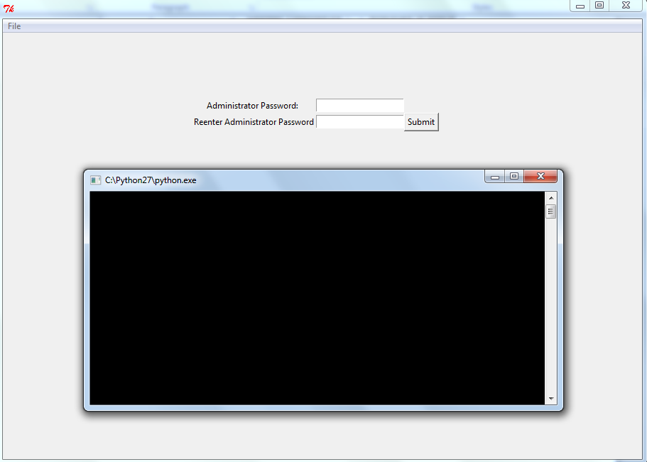

#### Test 2 –

### Main.pyc :

### InitialSetup.py :

Test 1 – No evidence can be shown for these tests, but InitSetupPopup is synonymous of the success of InitialSetup.

### InitSetupPopup.py :

#### Test 1 –

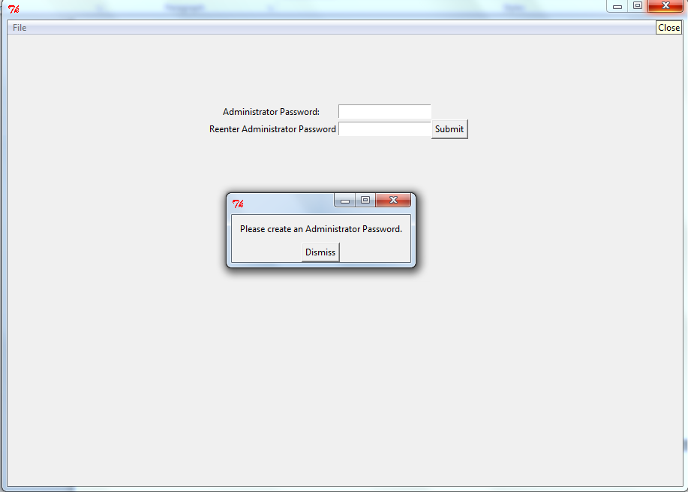

The success of Tests 2 and 3 is implied by the success of Test 1.

### LoginForm.py :

#### Test 1 –

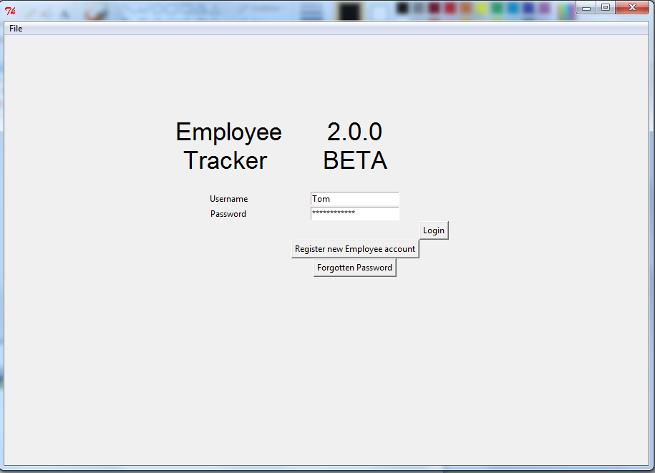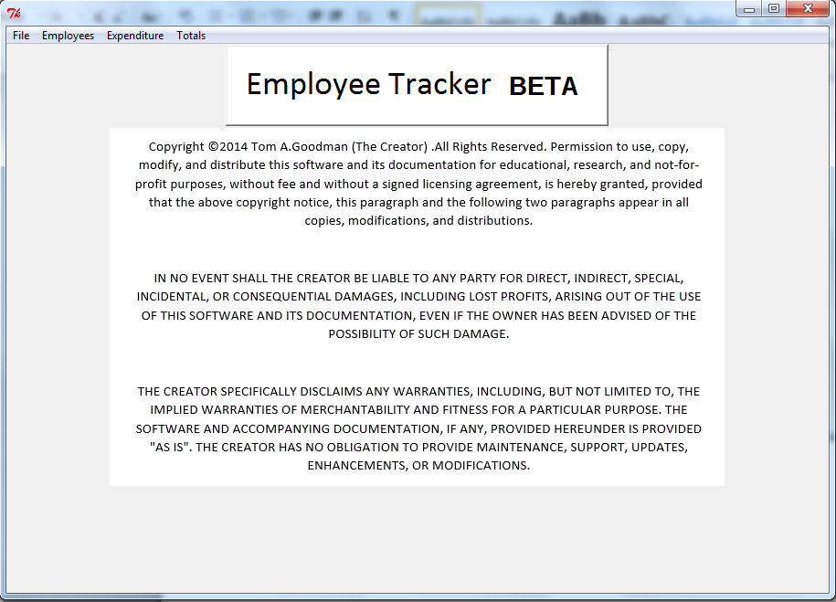

#### Test 2 –

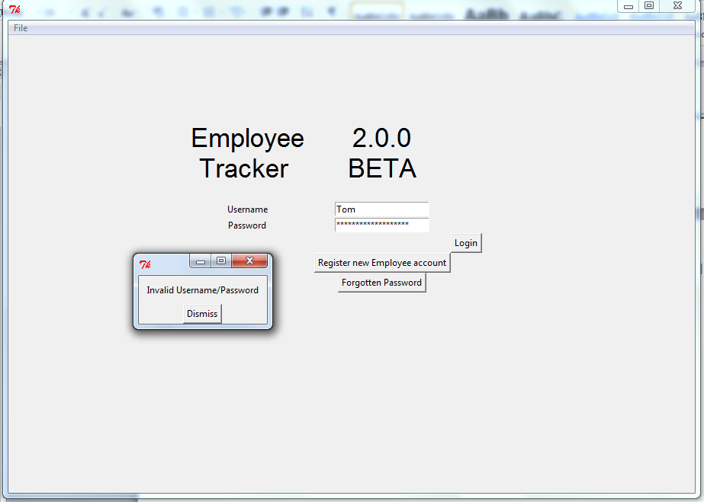

#### Test 3 –

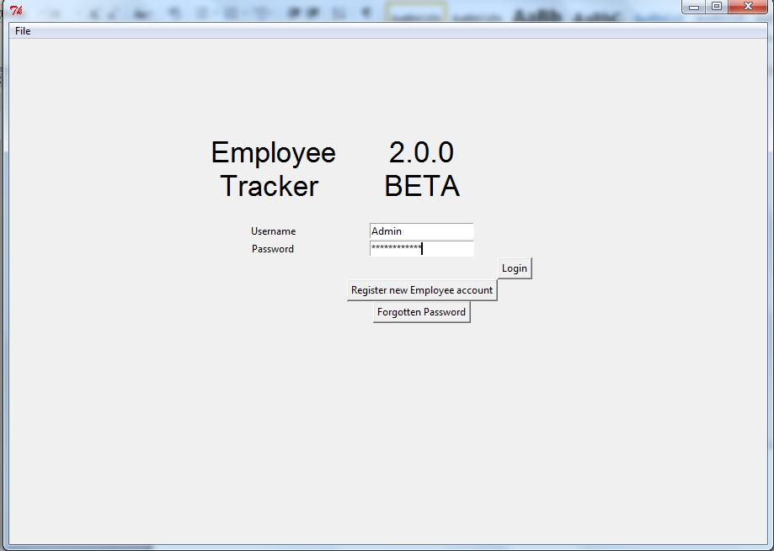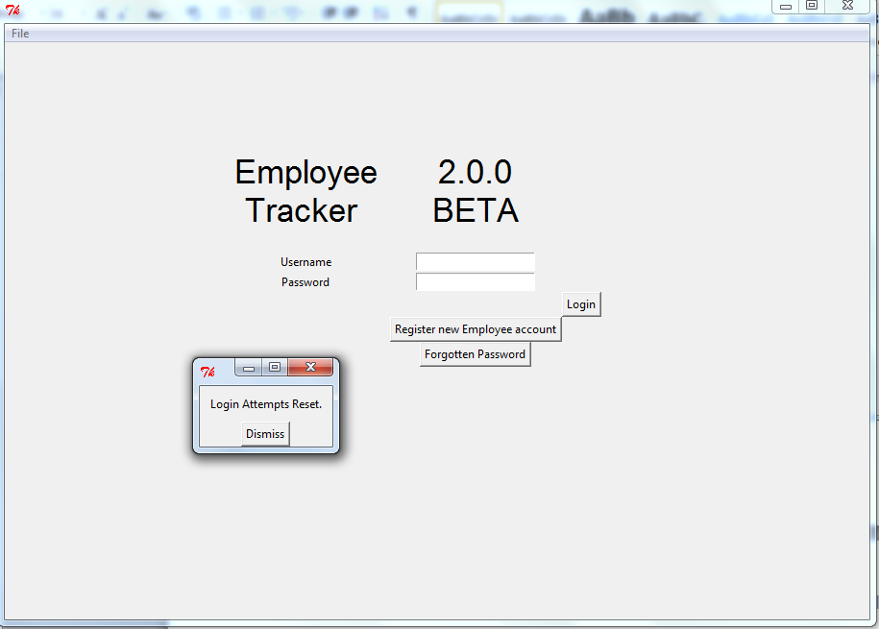

### RegisterScreen.py

#### Test 1 –

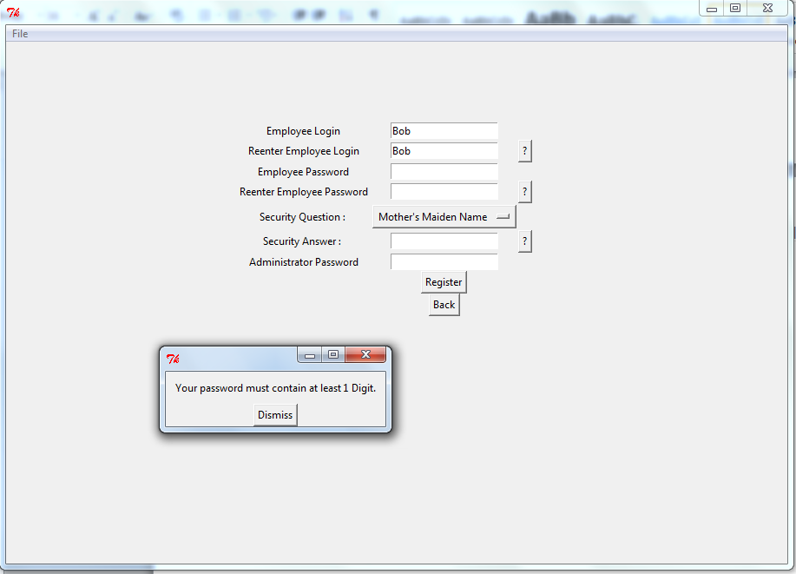

#### Test 2 –

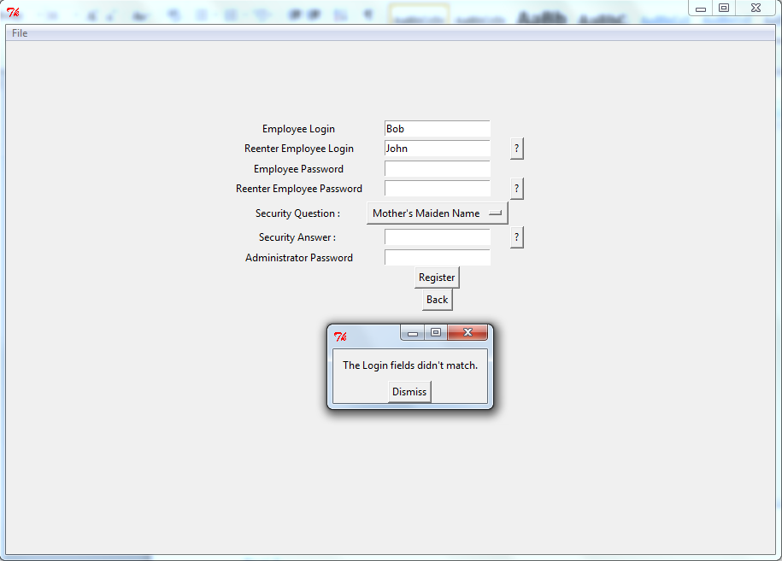

#### Test 3 –

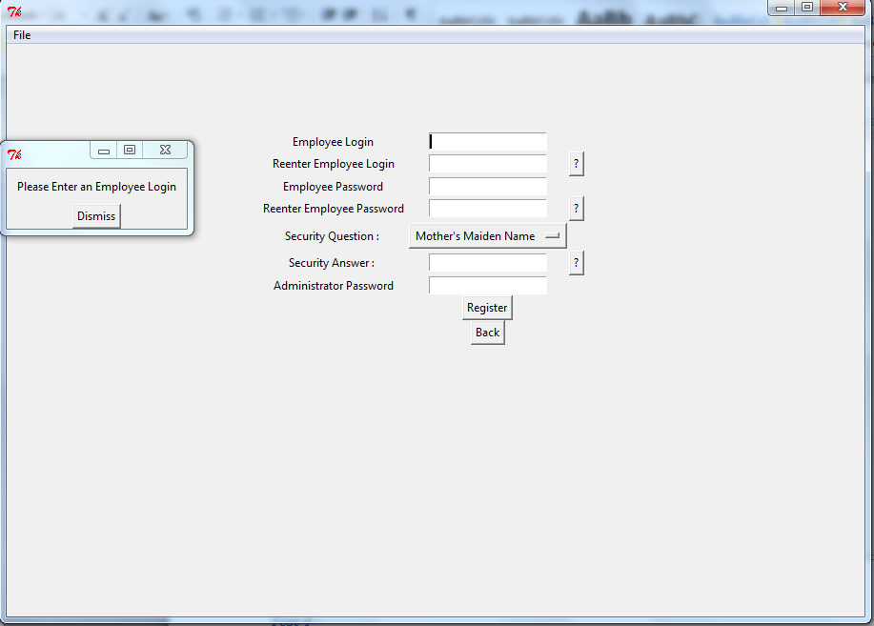

#### Test 4 –

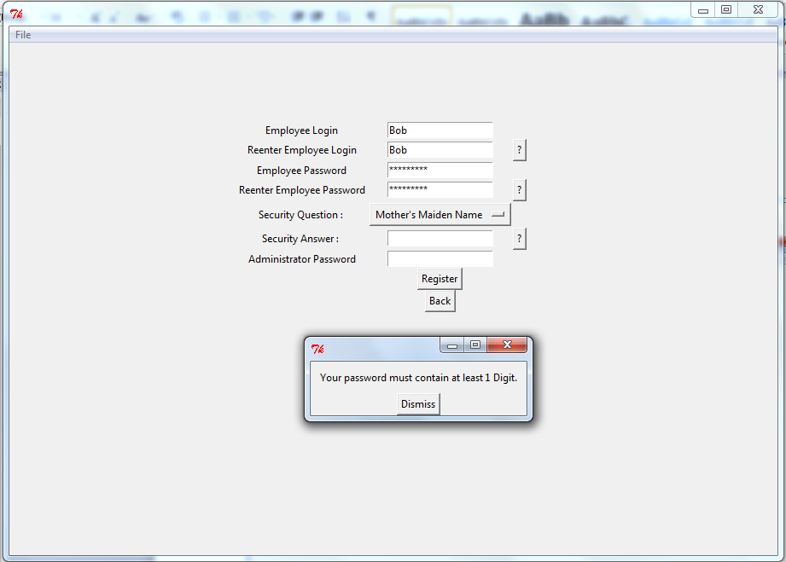

#### Test 5 –

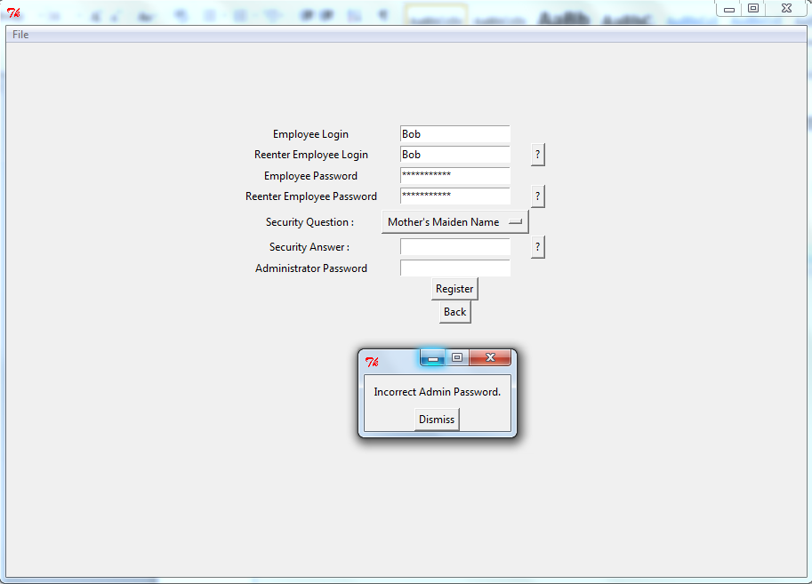

#### Test 6 –

#### Test 7–

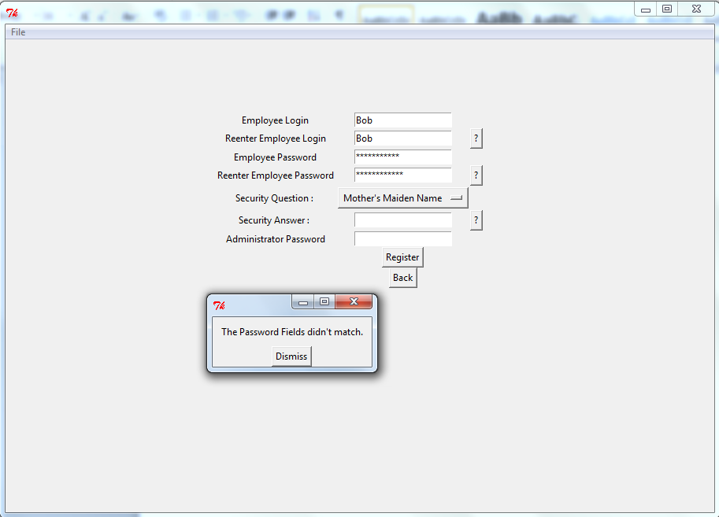

#### Test 8 –

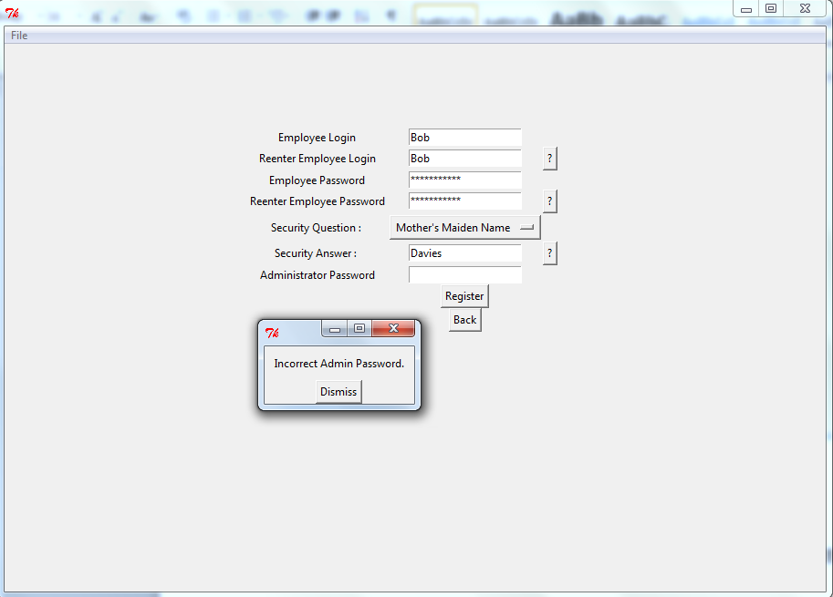

#### Test 9 –

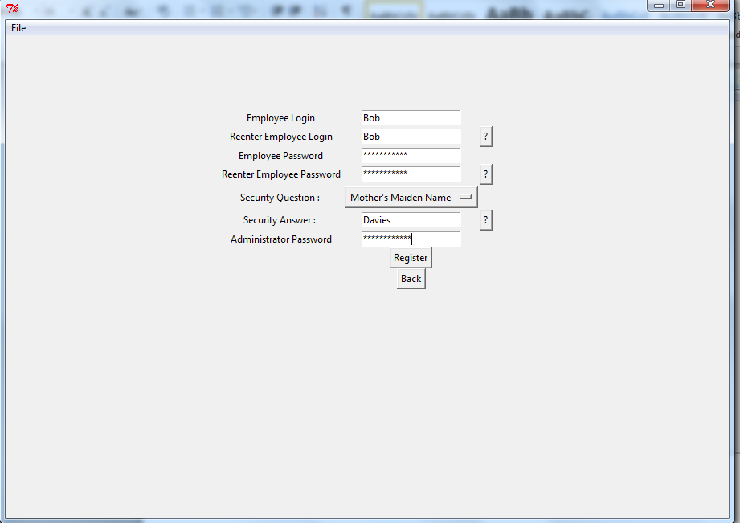

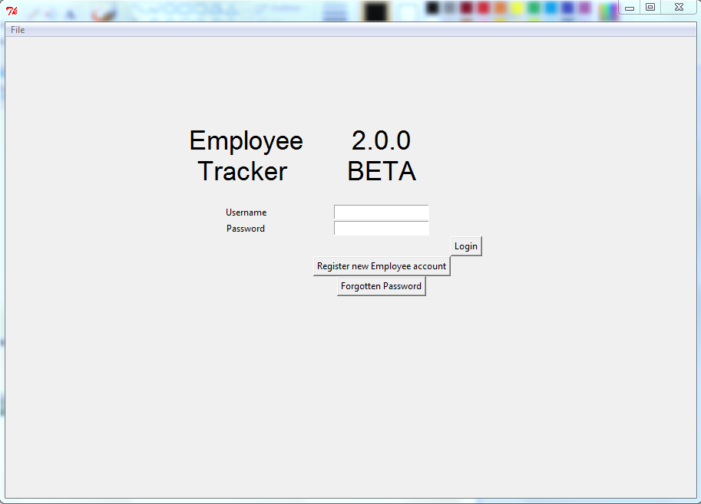

### MainScreen.py :

#### Test 1 –

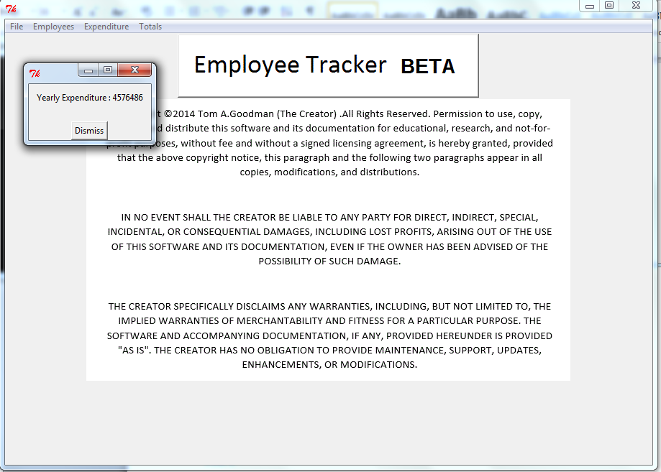

#### Test 2 –

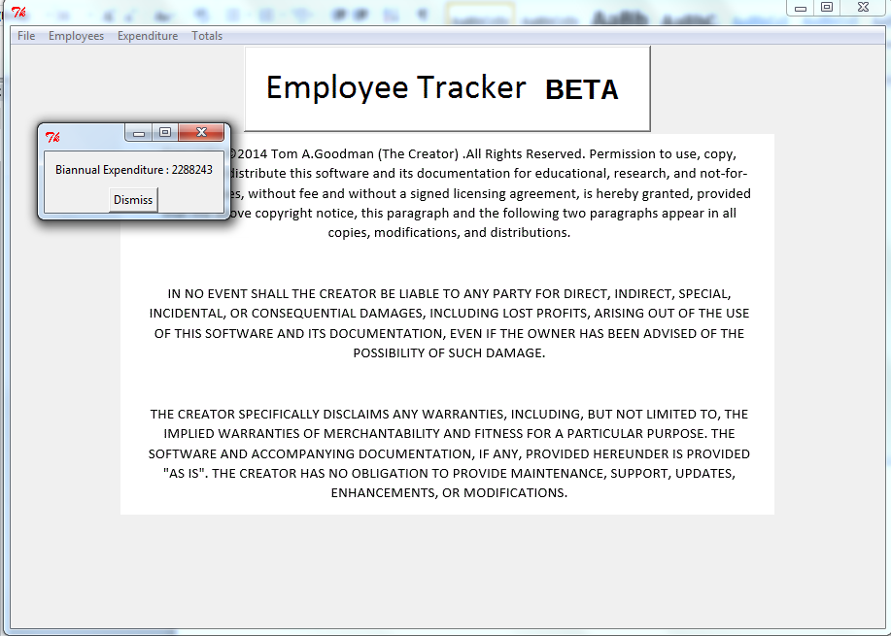

#### Test 3 –

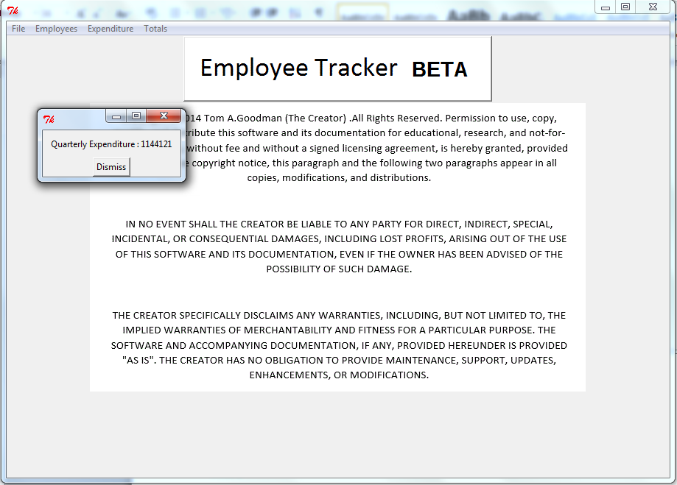

#### Test 4 –

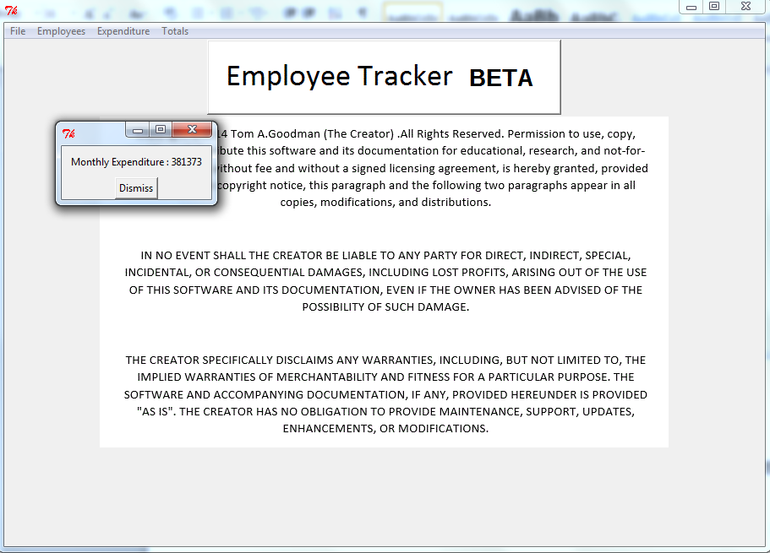

#### Test 5 –

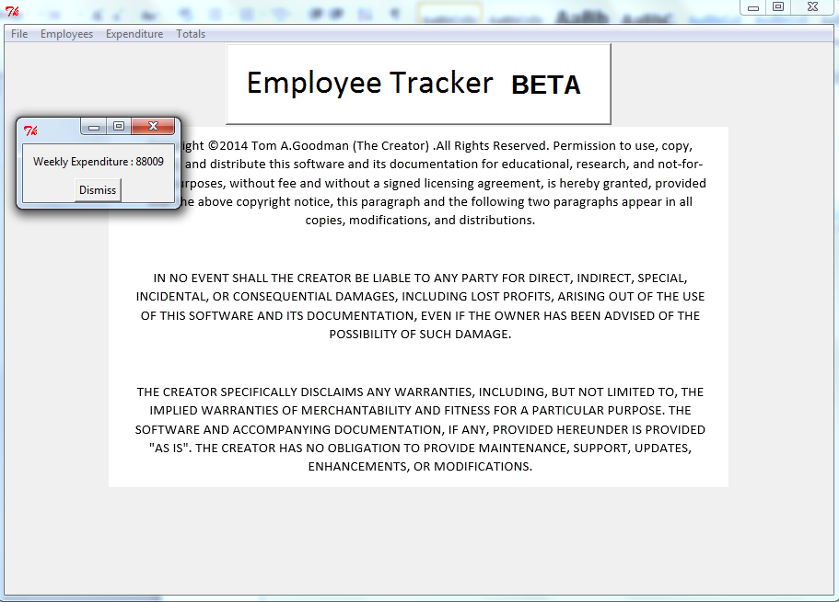

#### Test 6 –

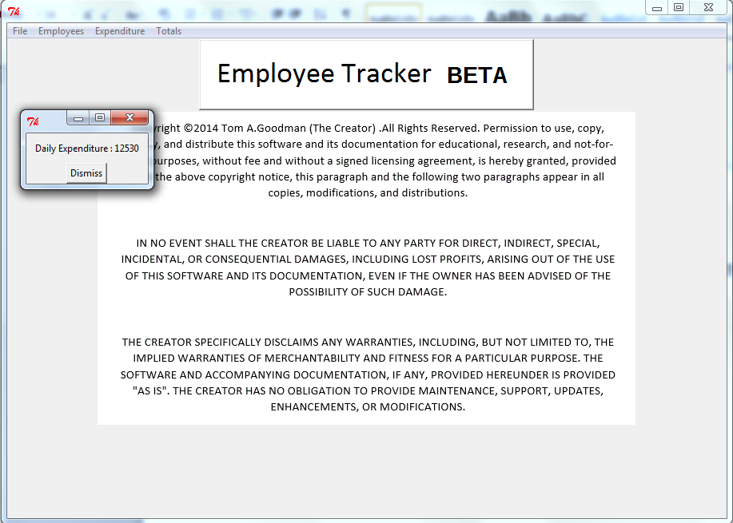

#### Test 7 –

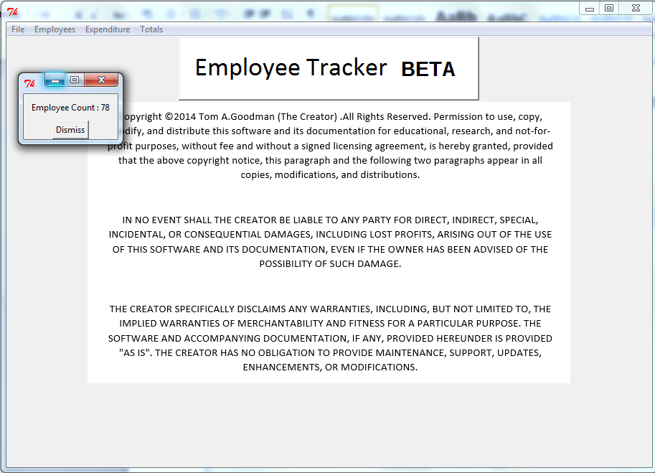

#### Test 8 –

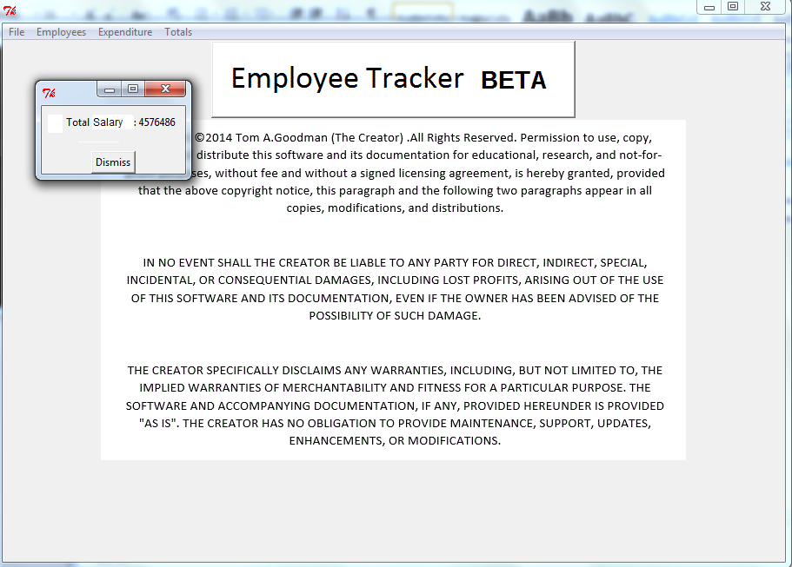

#### Test 9 –

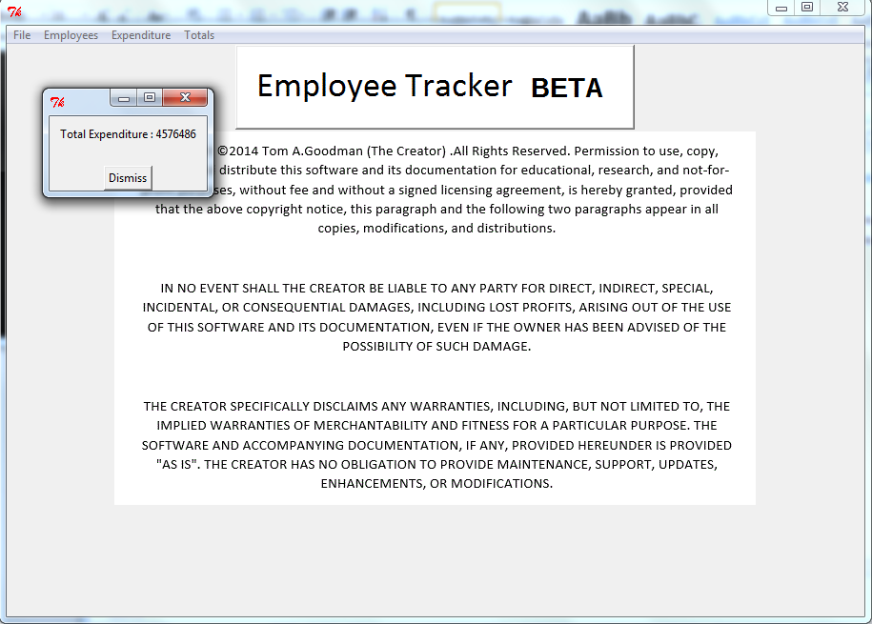

### CreateEmployeeScreen.py :

#### Test 1 –

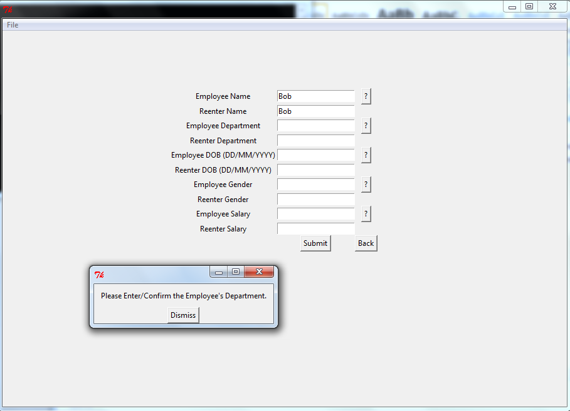

#### Test 2 –

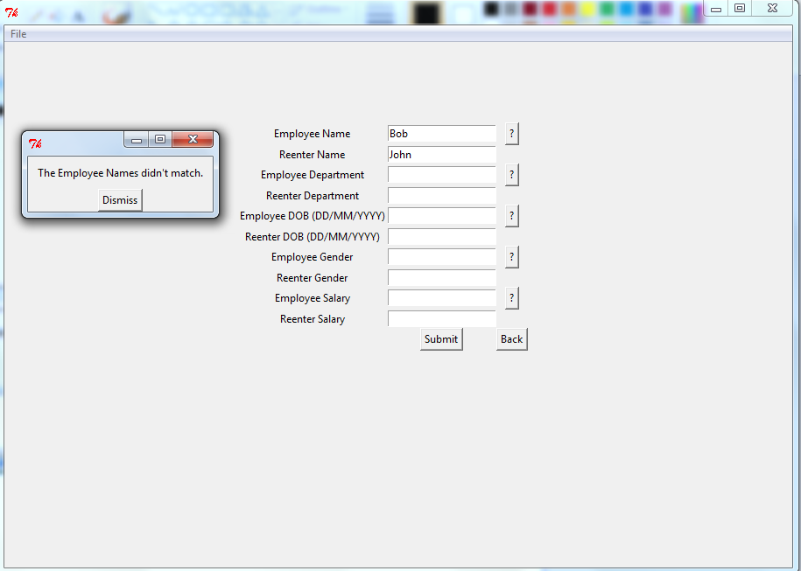

#### Test 3 –

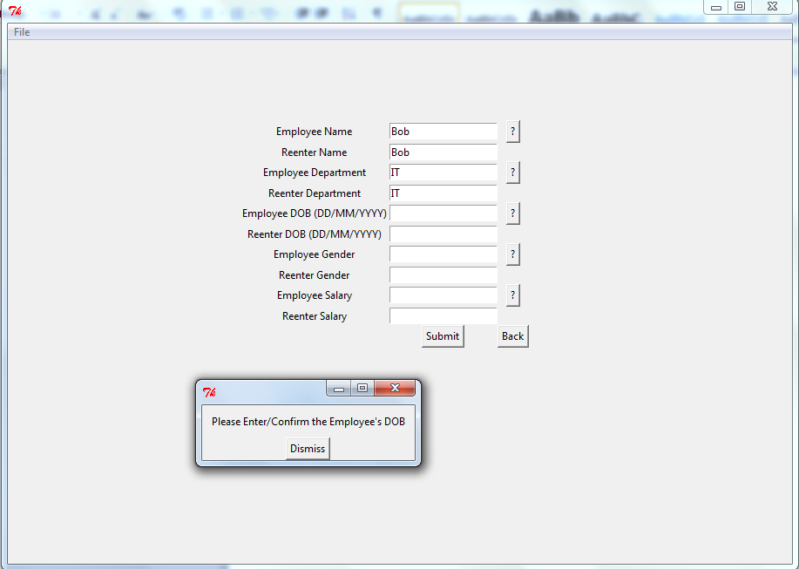

#### Test 4 –

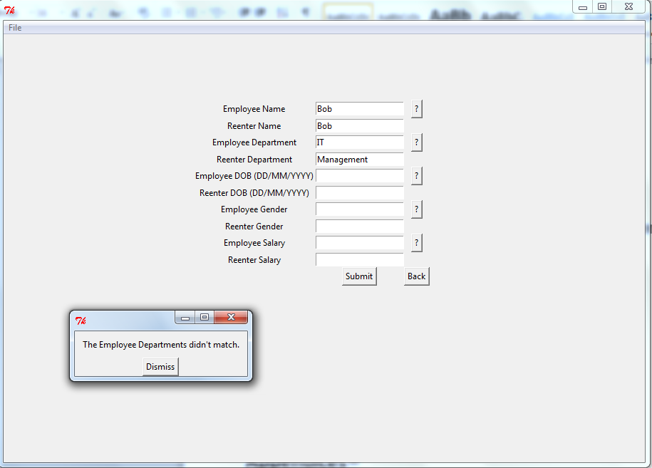

#### Test 5 –

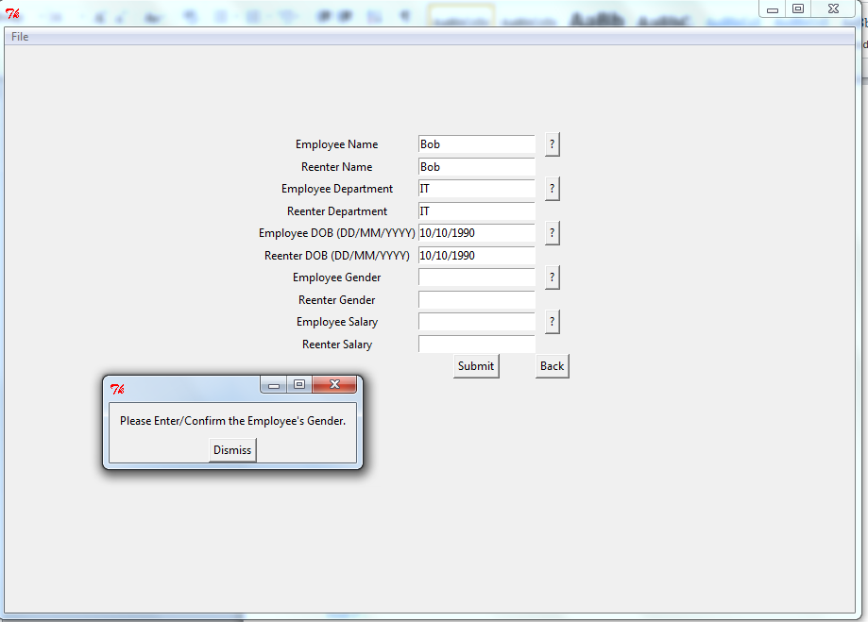

#### Test 6 –

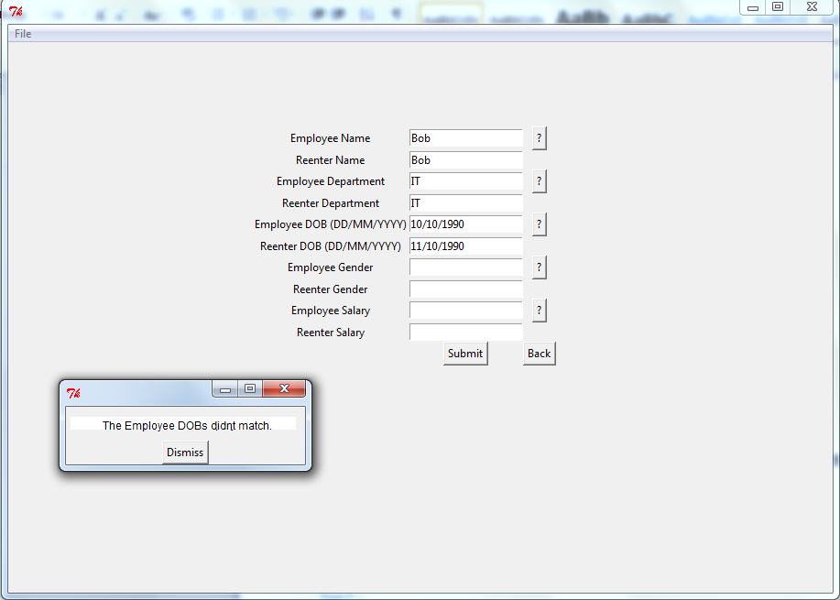

#### Test 7 –

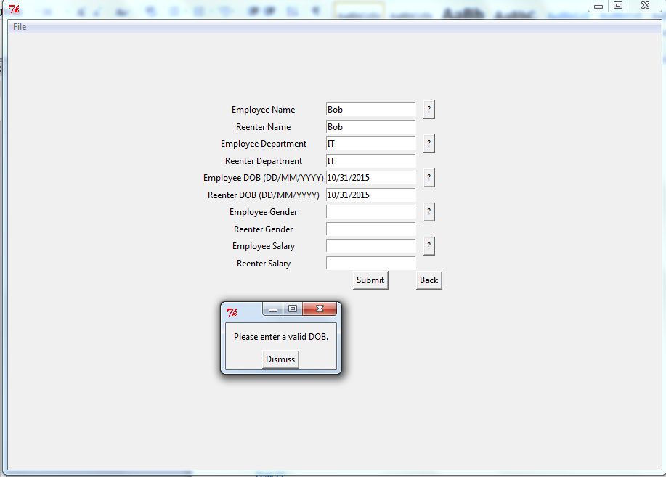

#### Test 8 –

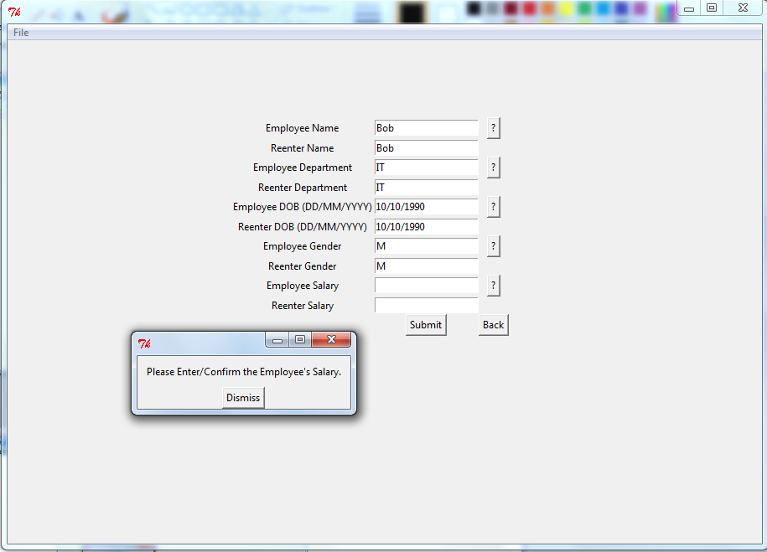

#### Test 9 –

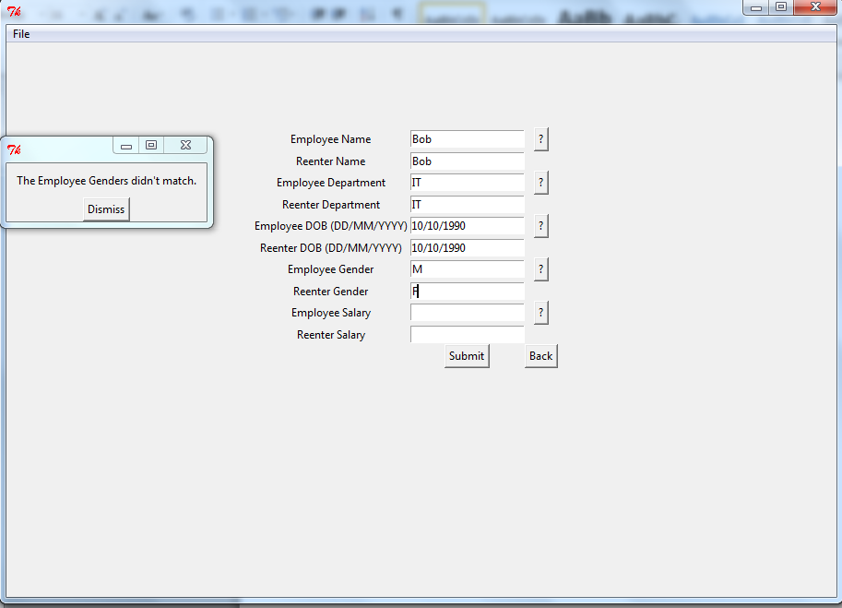

#### Test 10 –

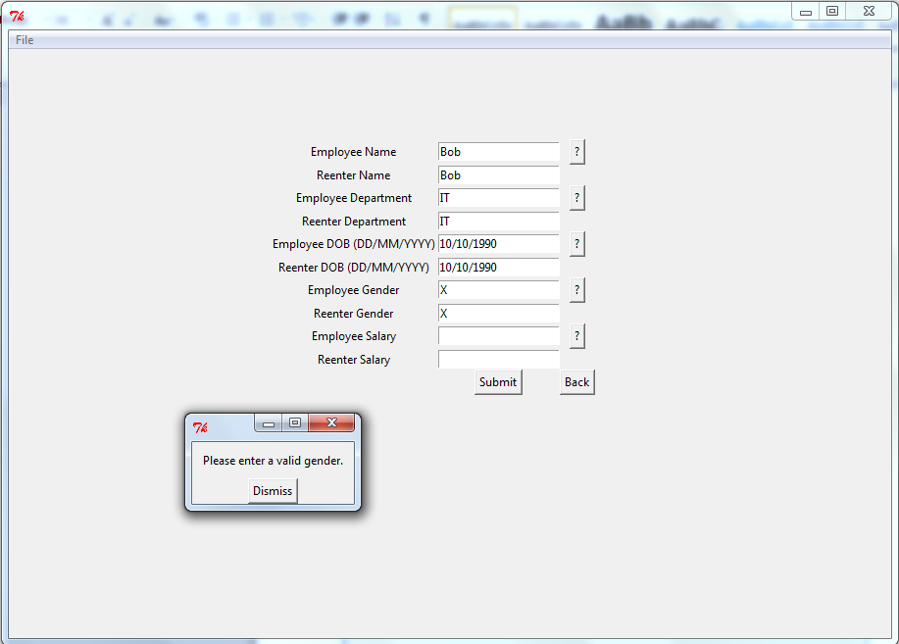

#### Test 11 –

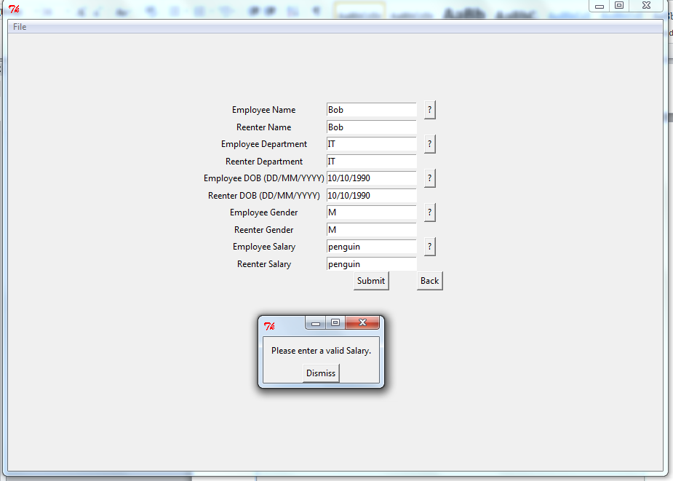

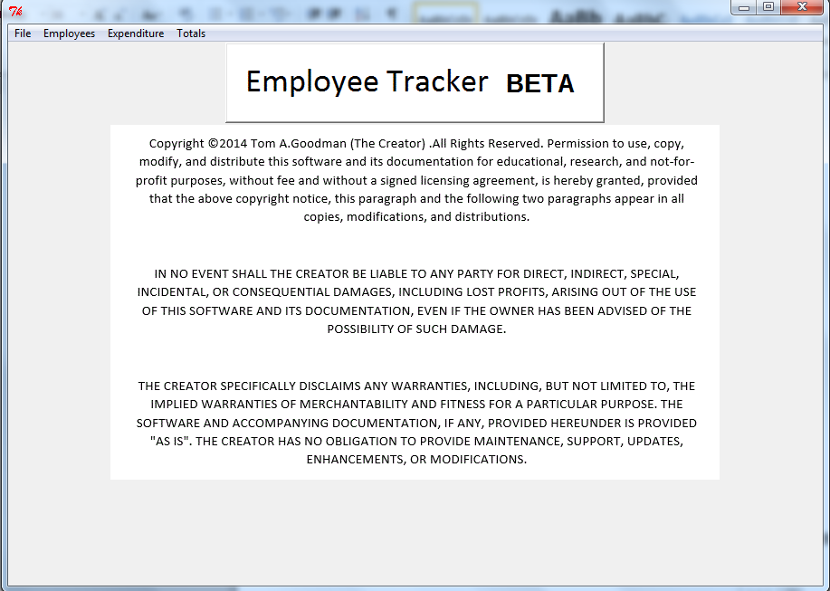

#### Test 12 –

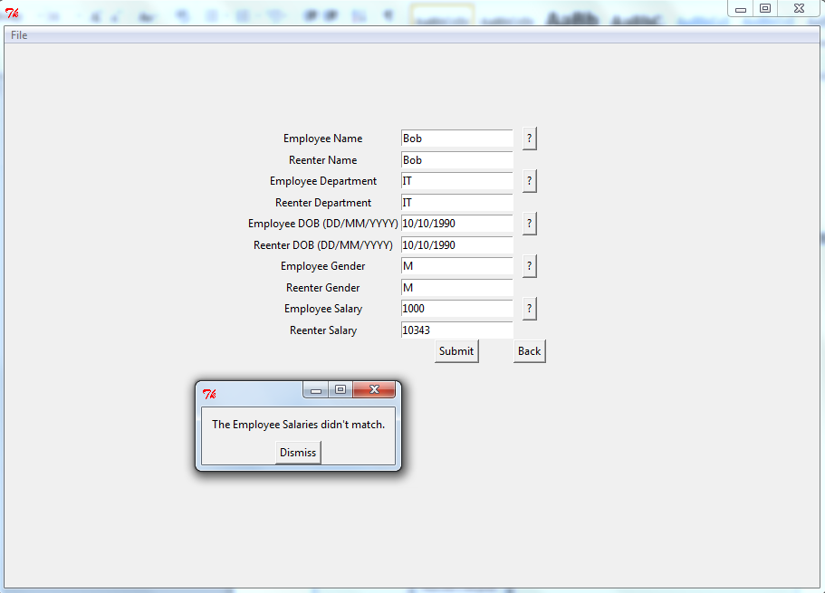

#### Test 13 –

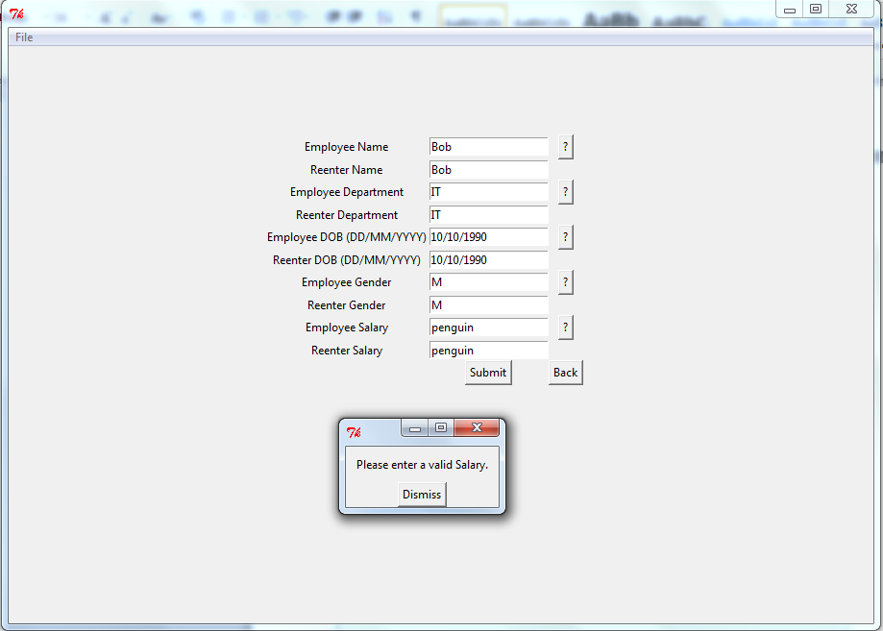

### SearchEmployeeScreen.py :

#### Test 1 –

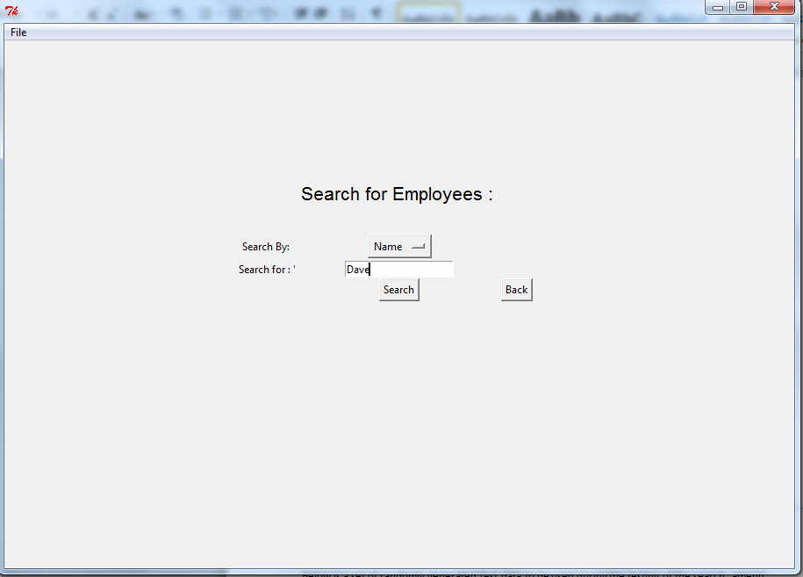

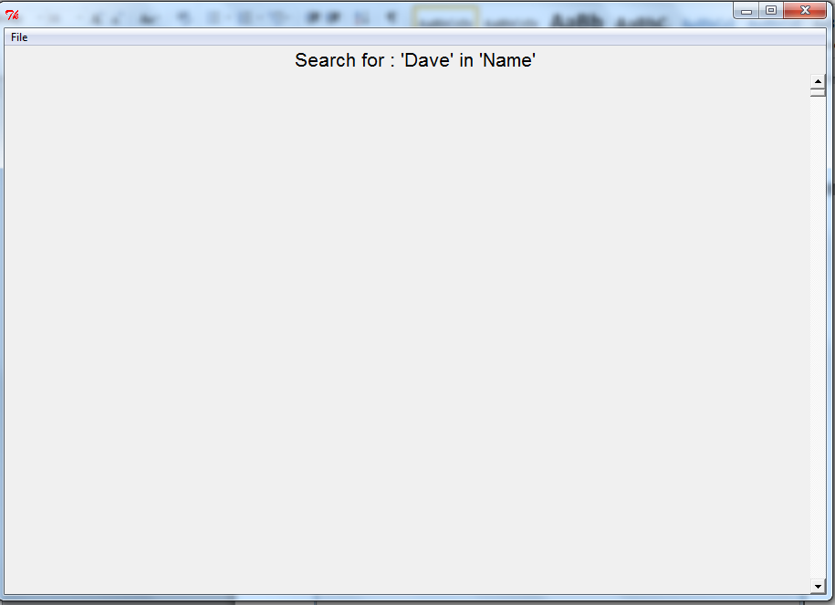

#### Test 2 –

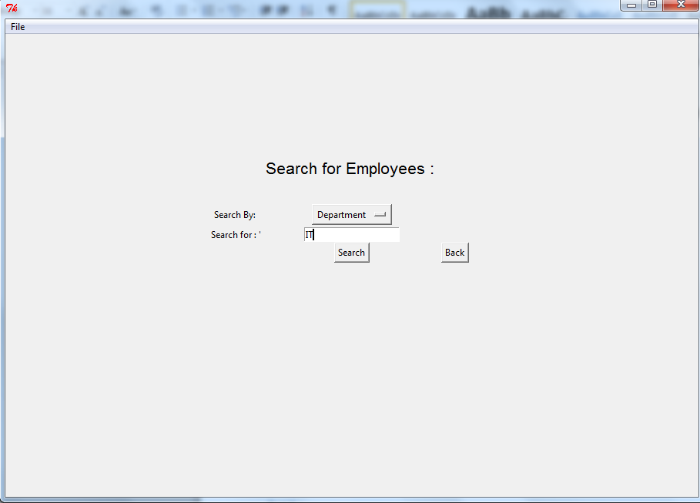

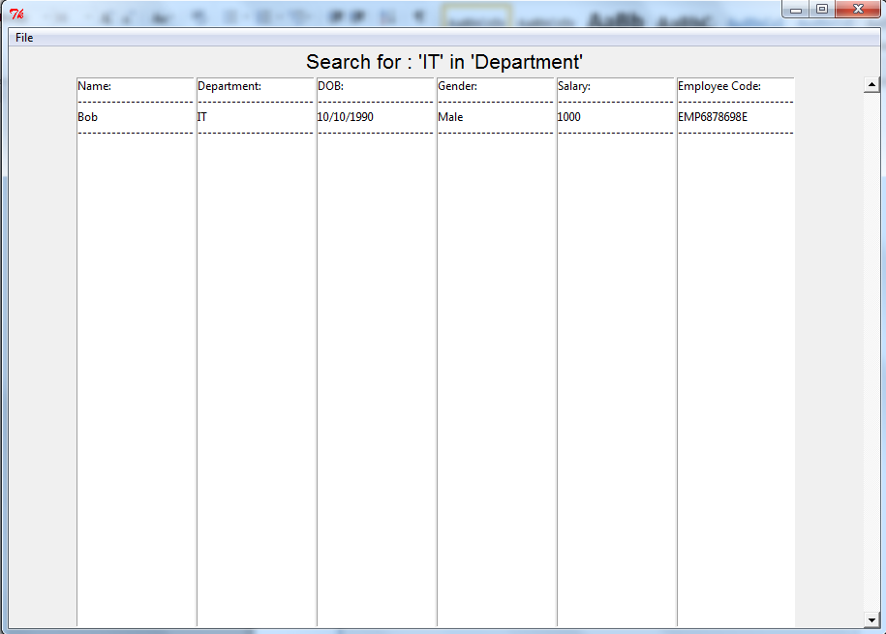

#### Test 3 –

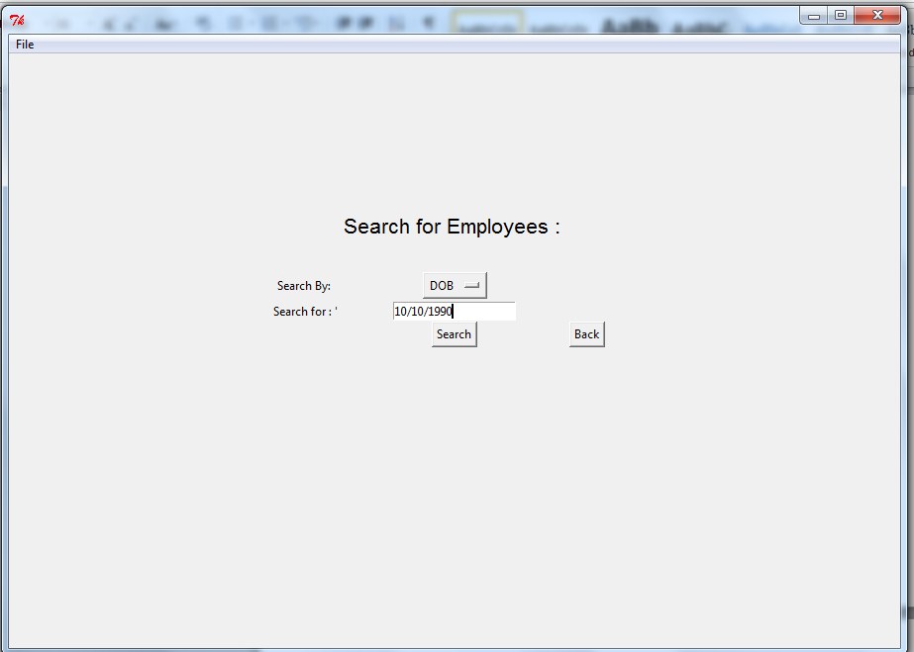

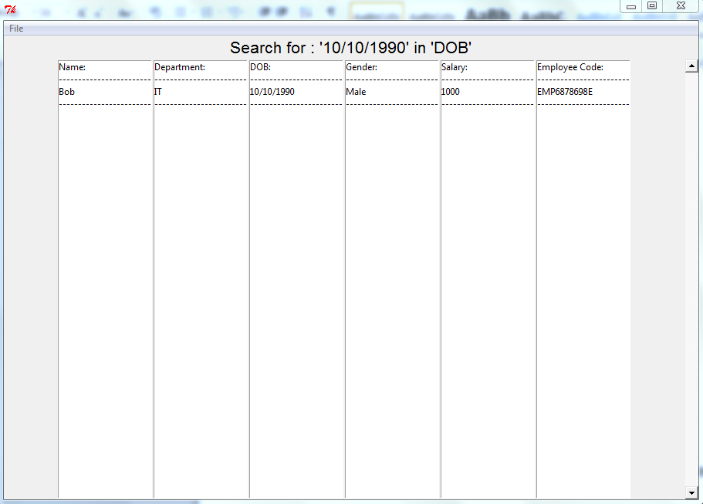

#### Test 4 –

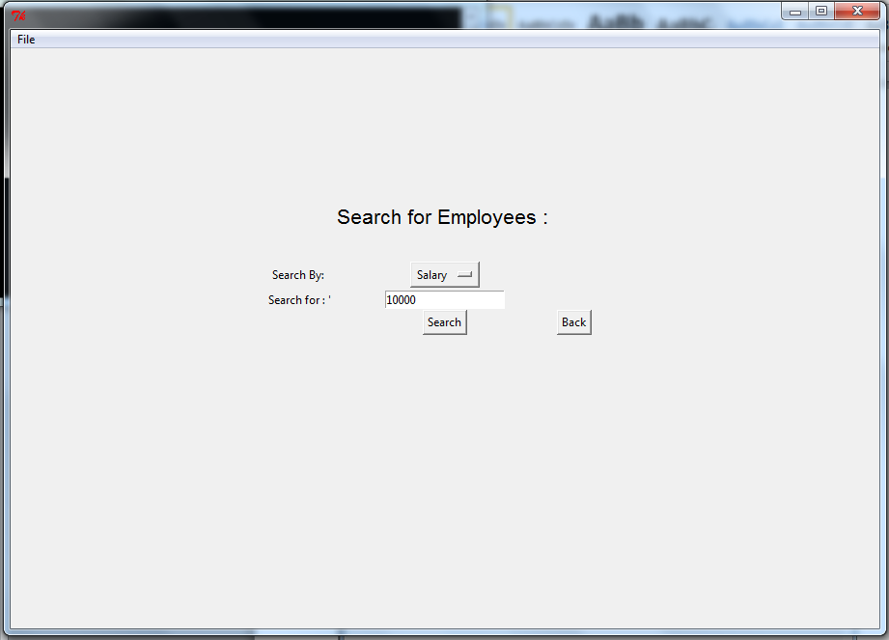

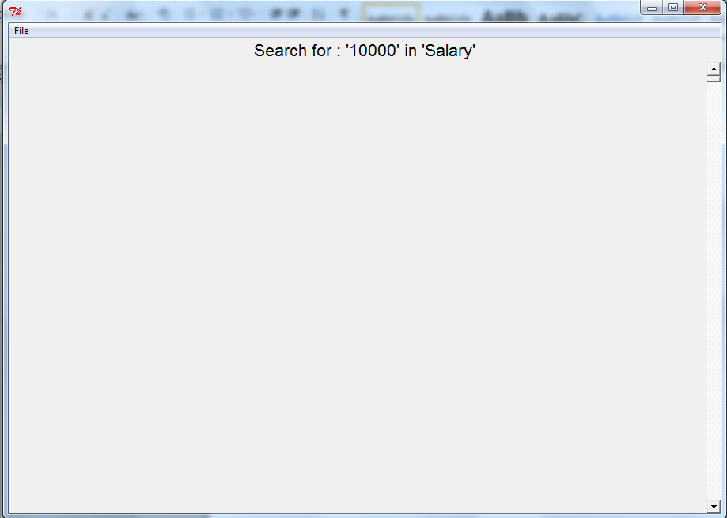

#### Test 5 –

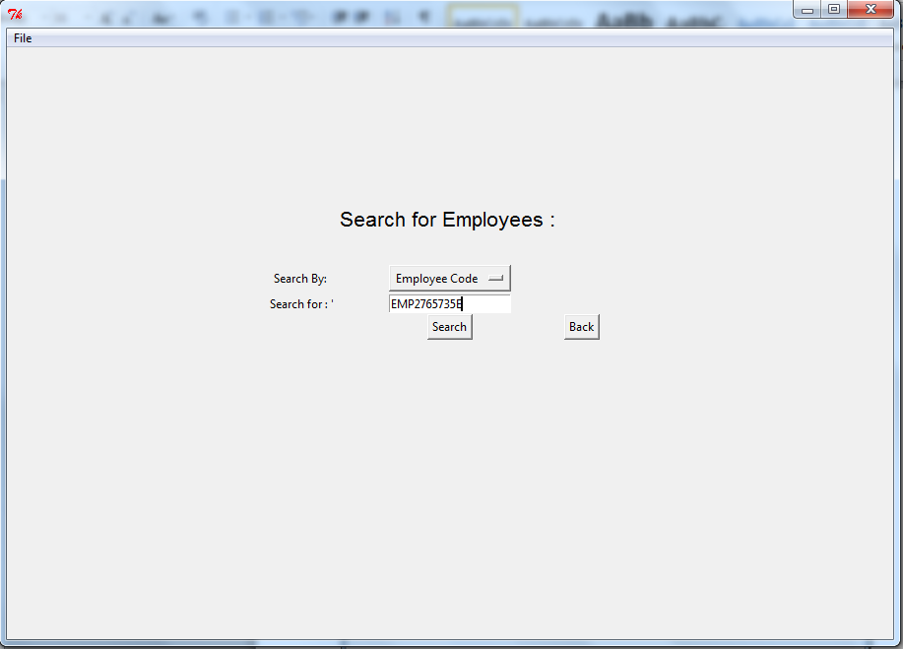

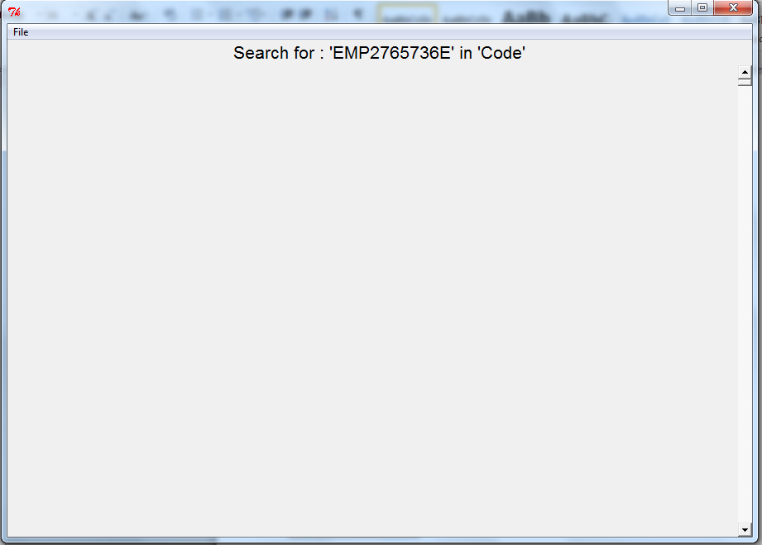

#### Test 6 –

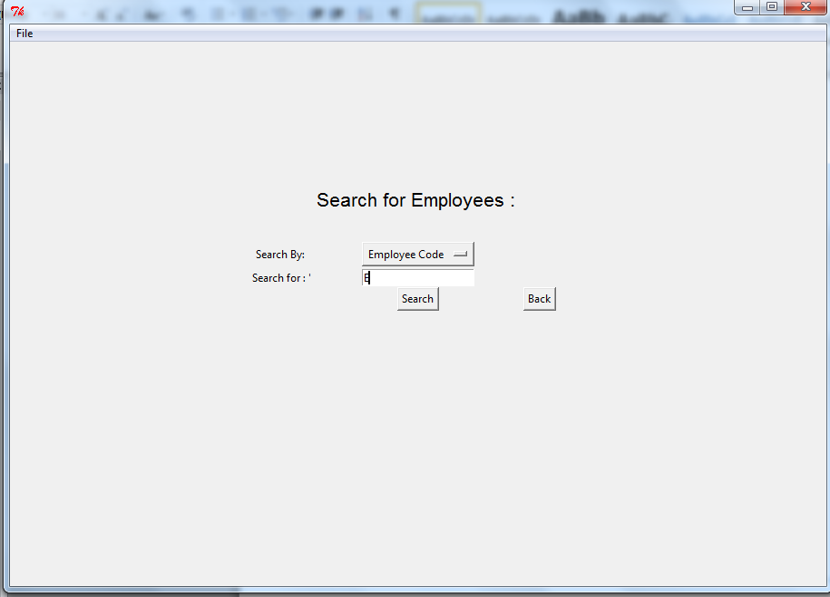

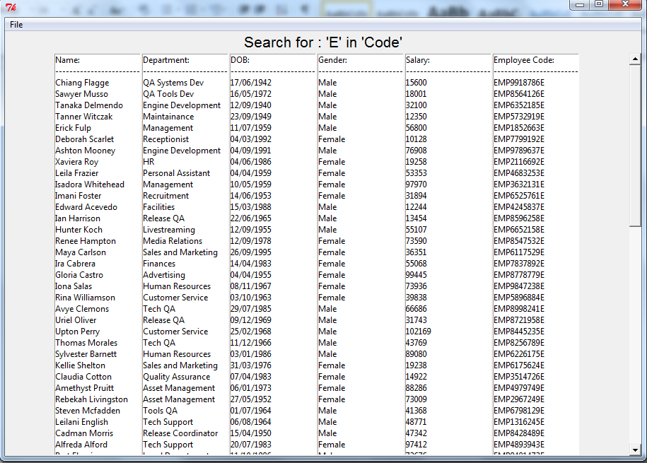

### SearchResultsScreen.py :

#### Test 1 –

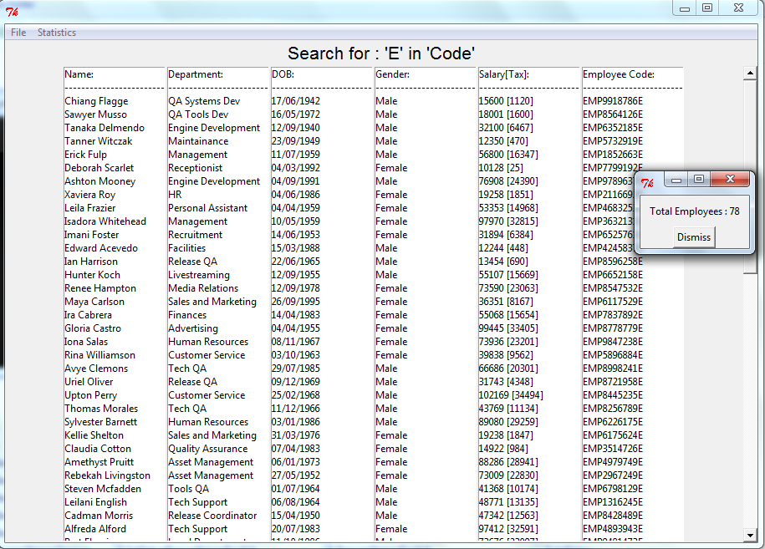

#### Test 2 –

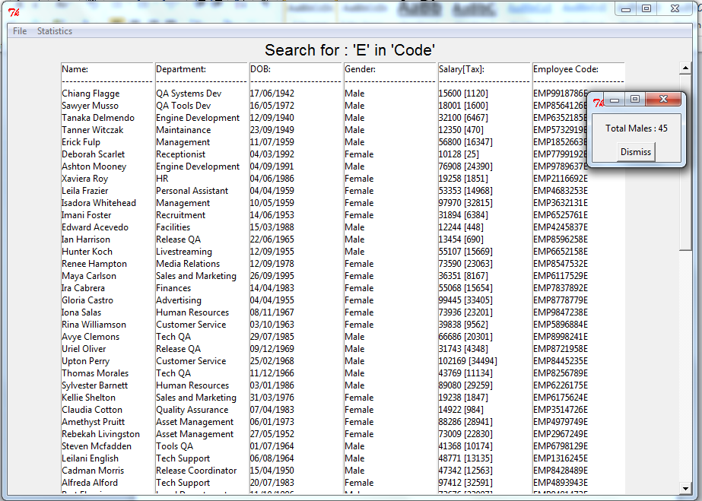

#### Test 3 –

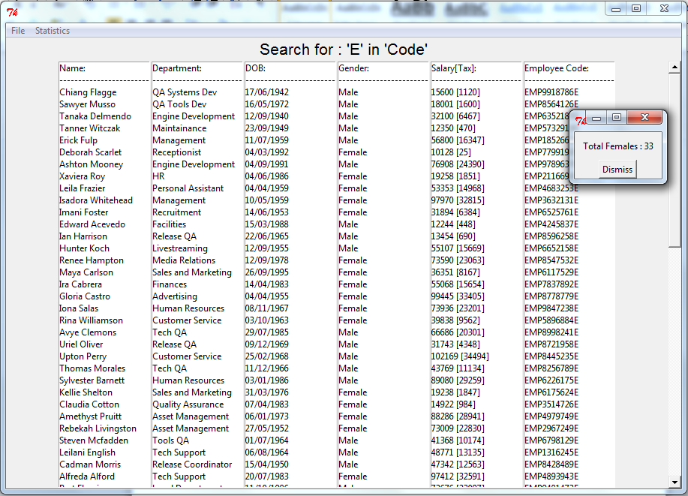

#### Test 4 –

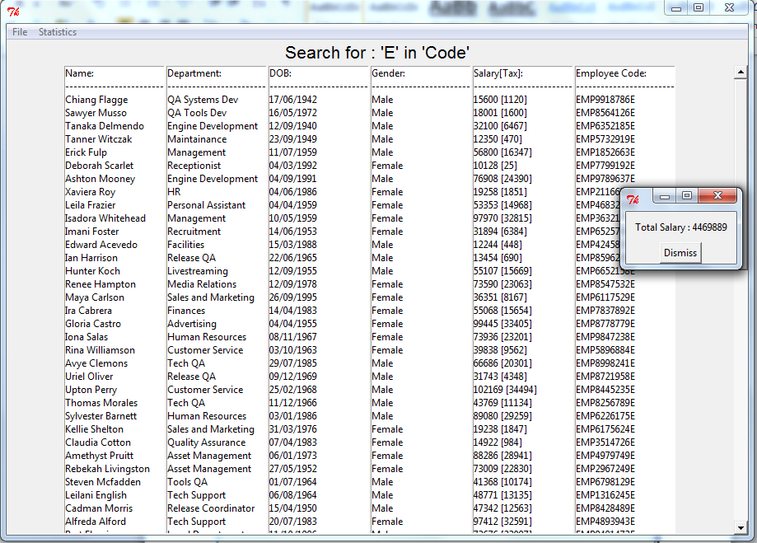

#### Test 5 –

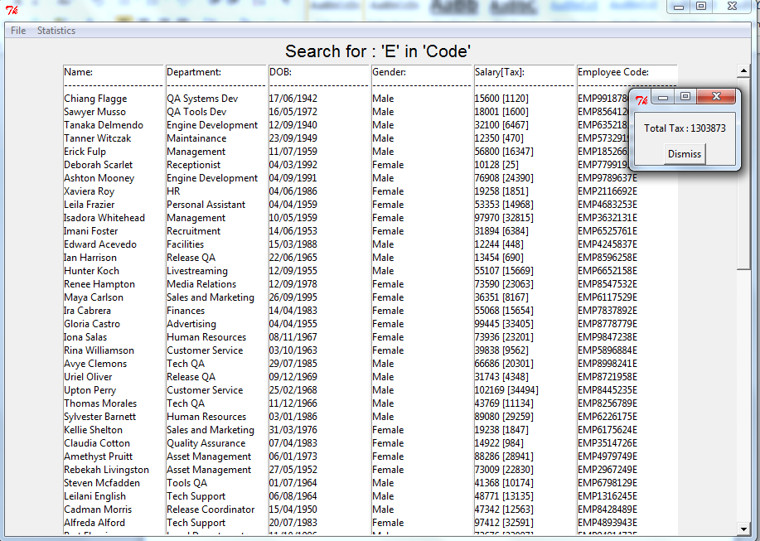

#### Test 6 –

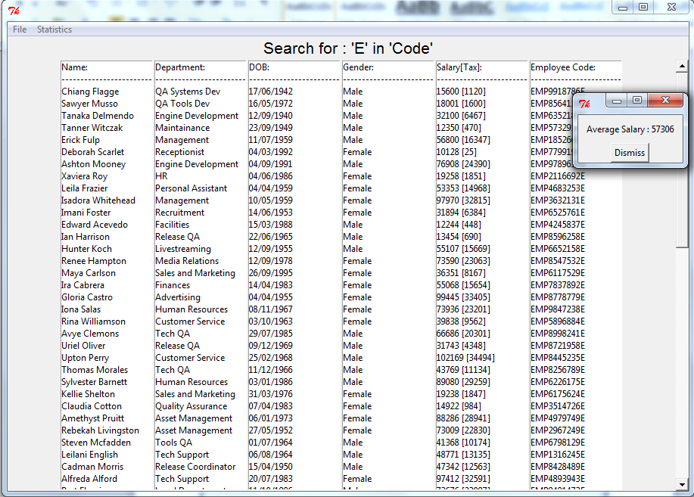

#### Test 7 –

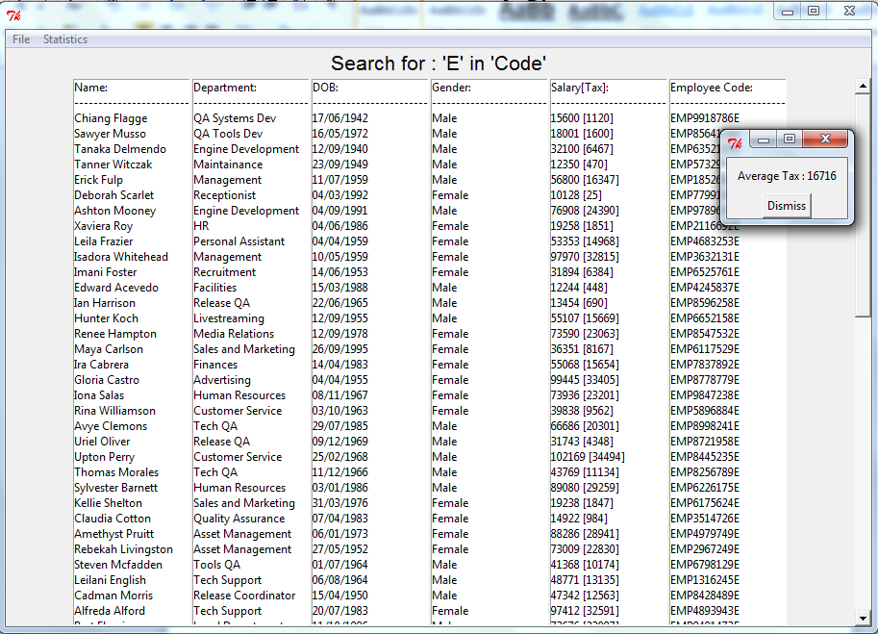

### AmendEmployeeScreen.py :

#### Test 1 -

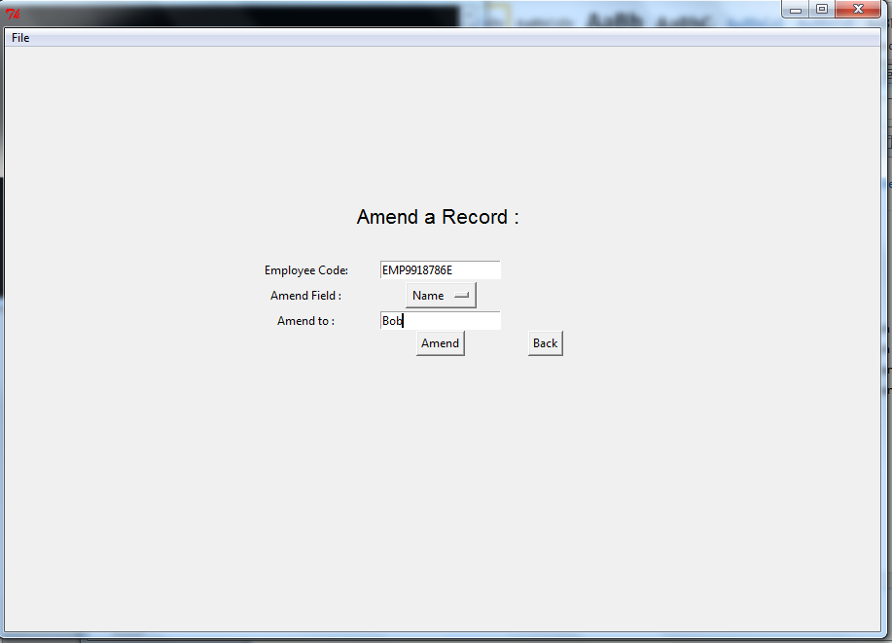

### DeleteEmployeeScreen.py :

#### Test 1 -

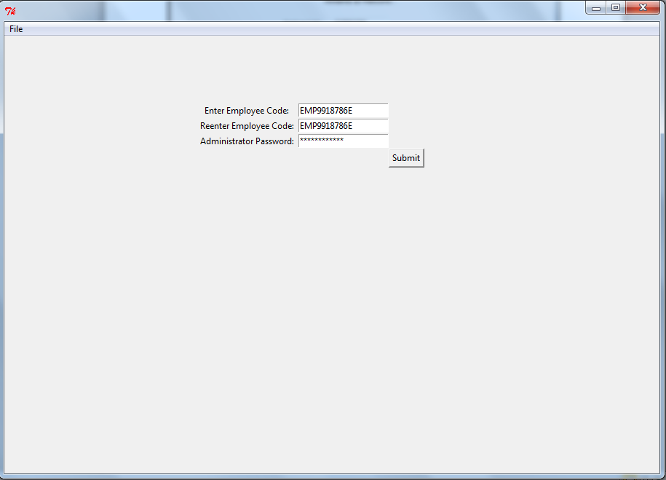

### AddExpenditureScreen.py :

#### Test 1 -

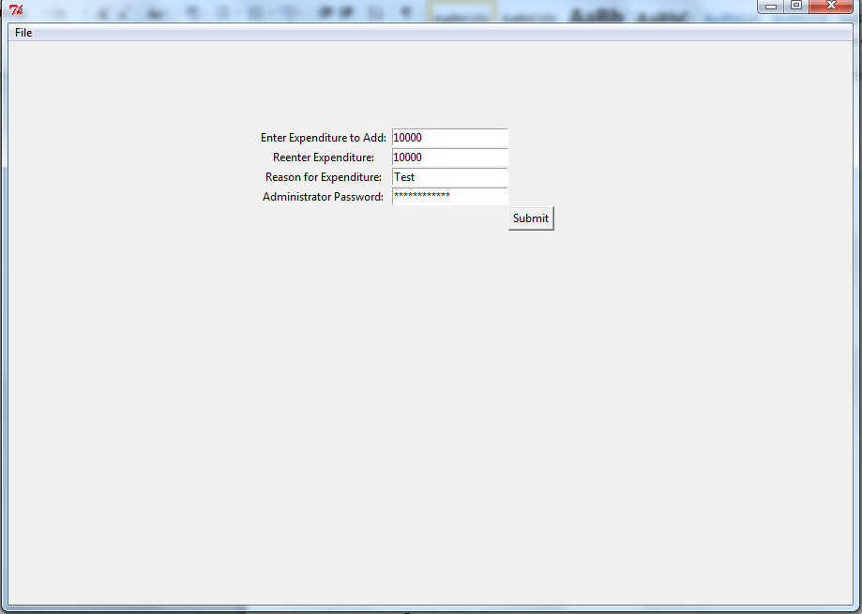

#### Test 2 –

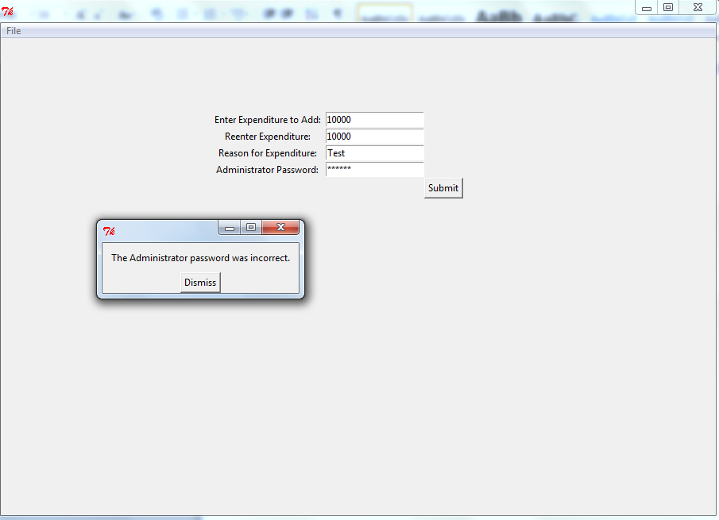

### DeductExpenditureScreen.py :

#### Test 1 –

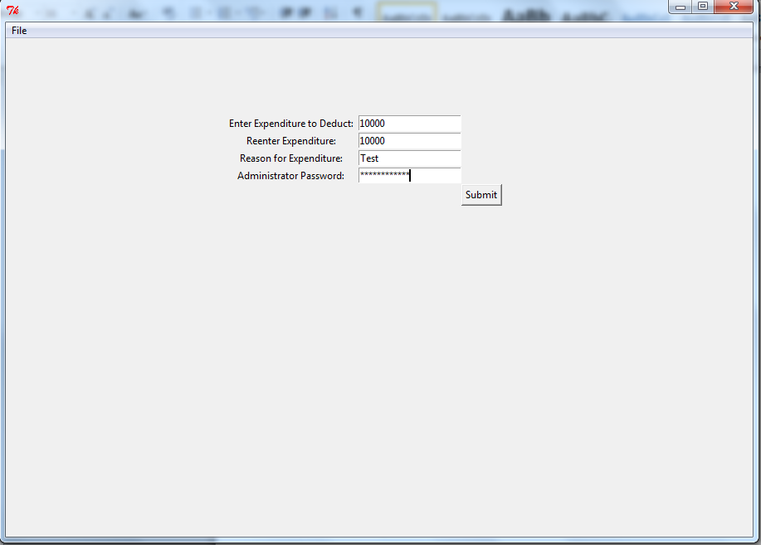

#### Test 2 –

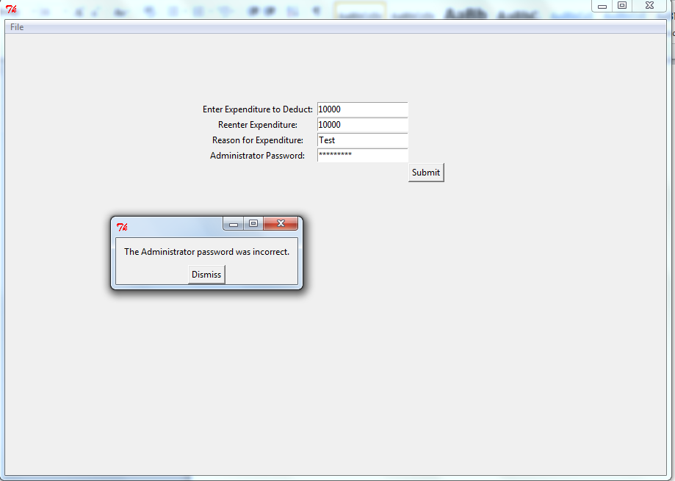

## Test Data & Testing Log -

Both of the above are contained within Appendix I and II respectively. They contain detailed information regarding the tests performed, and the test data used.

# Section 6 – Evaluation –

## Degree of Success:

**Requirement One : Handle a basic login system–**

My program handles a login system, that stores and accesses multiple user logins, with additional logins being possible to be created. As well as this, it features security via hashing and also storage in a binary format. As well as this, it handles a system lock function, which will automatically lock the system after 10 failed login attempts. This can be reset by the Administrator. This requirement has been met fully.

**Requirement Two : Create, Amend, Change and Delete Employee Records –**

My program allows the user to create, amend and delete employee records, and each of these is handled successfully by the program. This requirement has been met fully.

**Requirement Three : Display all employee records simultaneously –**

The search function in my program allows the user to display all record simultaneously by searching the “Employee Code” field for “E”. This requirement has been met fully.

**Requirement Four : Provide a basic record-searching functionality –**

There is a search function in my program that allows the user to search the employee database for all fields. There are numerous different ways to search. This requirement has been met fully.

**Requirement Five : Track and Display the total employee count –**

The total employee count is tracked by my program, and can be displayed via the main screen. It is stored in a text file in the program directory. This requirement has been met fully.

**Requirement Six : Track and Display the total salary –**

The total salary is tracked by my program, and can be displayed via the main screen. It is calculated every time the salary is requested. This requirement has been met fully.

**Requirement Seven : Track and display the total expenditure, allowing for expenditure to be added and taken away –**

The total expenditure is tracked by my program, and can be displayed via the main screen. It is calculated every time it is requested, and the expenditure (salary noninclusive) is stored in a text file. This requirement has been met fully.

**Requirement Eight : Process expenditure, giving daily, weekly, monthly and yearly expenditure –**

Expenditure can be displayed as Daily, weekly, monthly, quarterly, biannually and yearly. This requirement has been met fully.

**Requirement Nine : Provide format, presence and type checks, and support double-entry verification –**

Every entry required by my program is thoroughly validated, being checked for presence, type and format validation, as well as double-entry verification as and when required. This requirement has been met fully.

**Requirement Eleven: Be simple and easy to grasp –**

My program utilises a simple GUI, which can be easily picked up by the end user. There is a plethora of on-screen help and troubleshooting, should an issue arise during the course of using the program. The GUI also hinges somewhat off of common GUIs, utilising a File menu, as well as other such things. This allows the user to This is sufficient to make the program simple and easy to grasp and use. This requirement has been met fully.

**Requirement Twelve : Be quick to use, and time-efficient –**

As stated with the evaluation of requirement eleven, my program utilises a user-friendly GUI, that allows for quick and efficient use of the system. Moreover, I feel that this requirement has been met fully.

## End User’s Response:

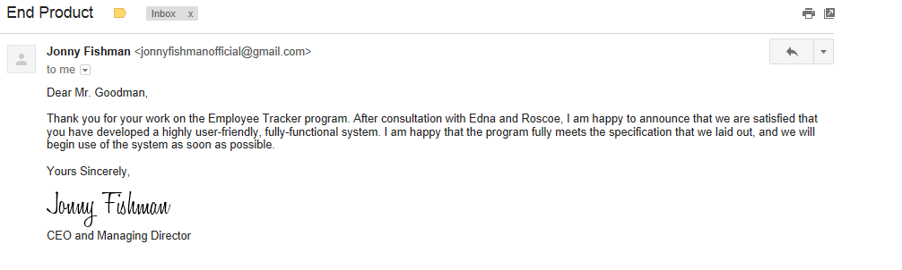

Above is the End-user’s response to the system that I created. Thankfully, they have confirmed that they are happy with the end-product, and can see no further improvements that require implementation before the system can be put into use.

## Desirable Extensions:

Although the system fully meets the End user’s specification, and they are satisfied with the outcome, there are a few desirable extensions that I would implement if I had the time.

### Bonuses:

It would be useful if the system were able to track, display, and amend bonuses to an individual employee. I would do this by adding a new field to employee records, which would default to 0, but could be changed by the administrator. This is a downfall of the system at the moment, as bonuses would currently have to be added to the individual’s salary.

### National Insurance:

Although the program handles income tax effectively, As well as considering income tax, it would be useful if the system could also consider National insurance. This could be done by adding in a function to calculate it.

### Further Languages:

Unfortunately there was only time to implement English and German into the program. Were there more time, I would translate the program into further languages, such as French, Spanish, Italian, Dutch etc. . This would be simple and easy to do, because the system is already designed to handle more than one language.

### More Extensive Testing:

Due to the complexity of the program, there are likely to be obscure bugs and glitches that regular testing will not have uncovered. Moreover, it would be desirable to conduct further, more thorough and extensive testing of the system in the future.

# Appendices –

## Appendix I – Alpha Testing Log –

The Alpha testing log contains details about the development process, more specifically exactly what lines of code were added and removed at each point. This is a brief overview, but the Alpha Testing log can be viewed in much greater detail at the following URL :

<https://github.com/TauOmicronMu/Y13Computing/commits/master>

Here is an example of the basic layout of a commit :

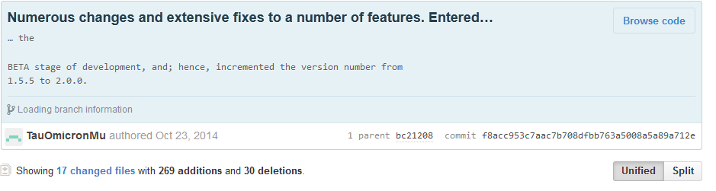

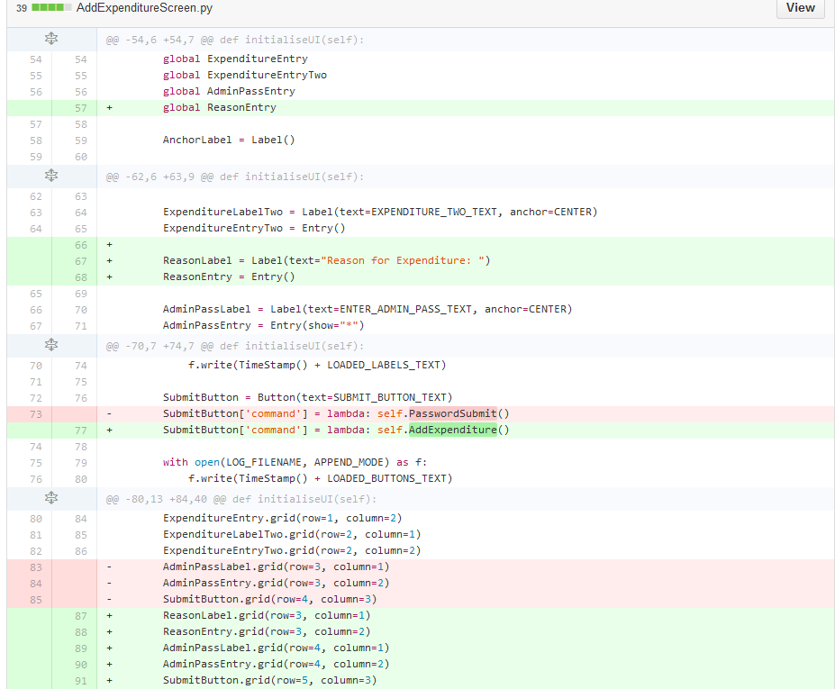

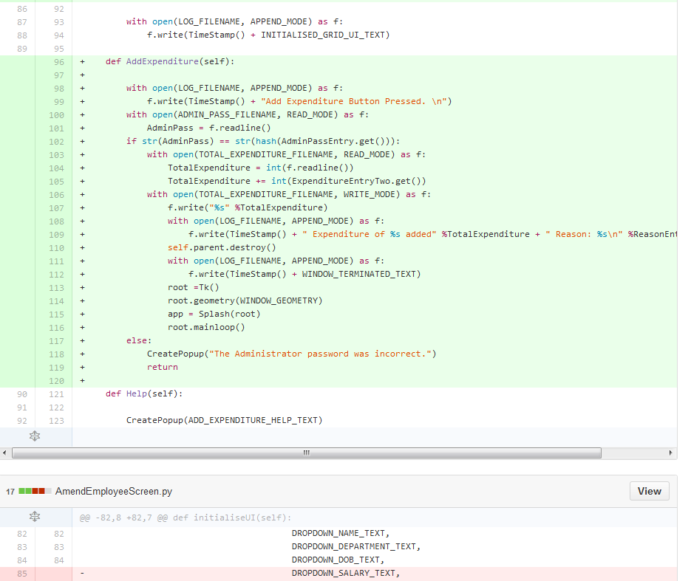

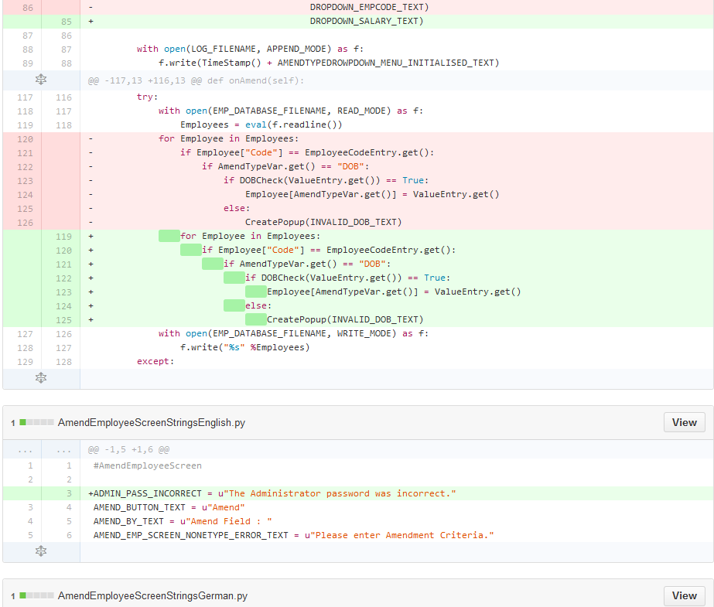

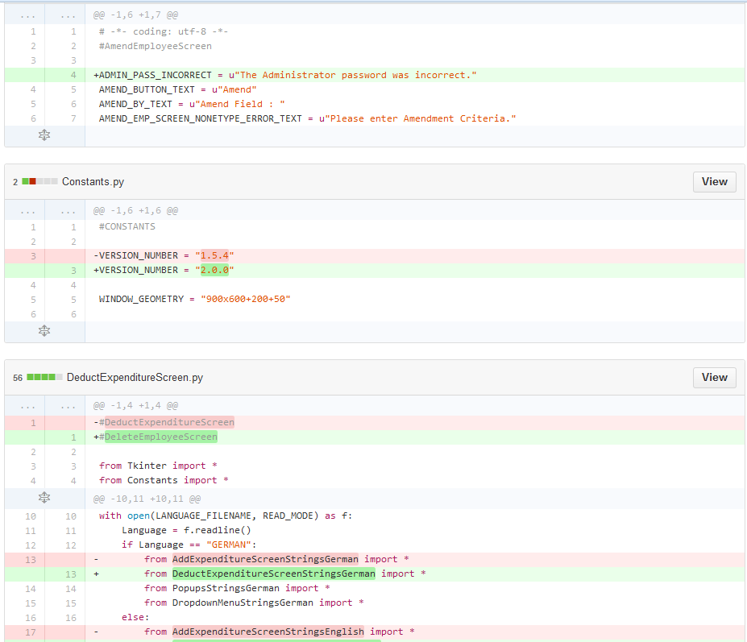

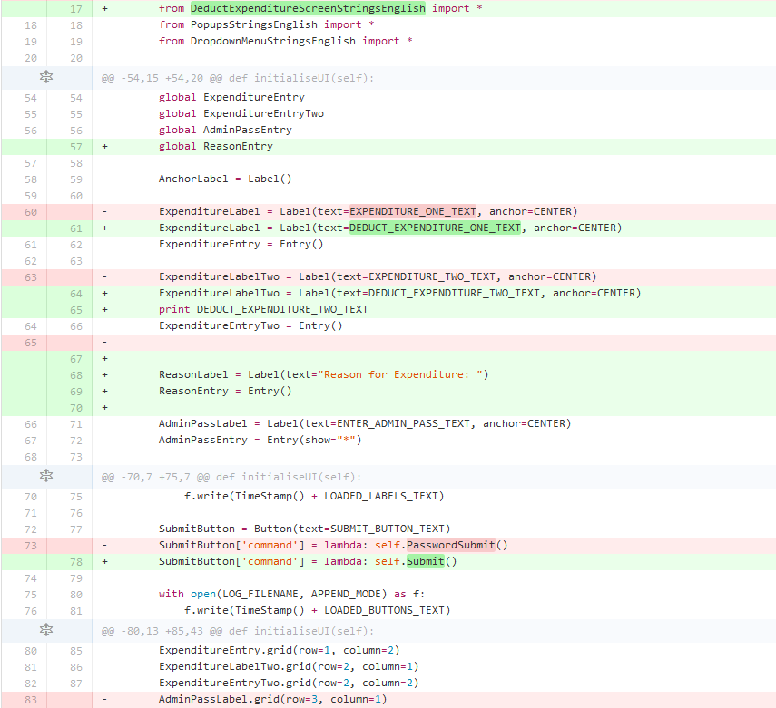



Etc.

This provides a comprehensive view of every single change to the codebase, as well as a short comment at the start to accompany the commit.

**MOST RECENT**

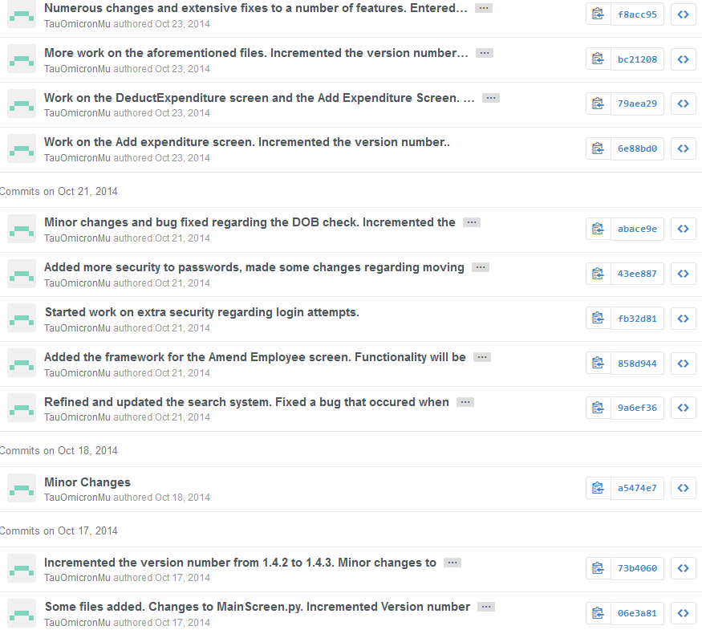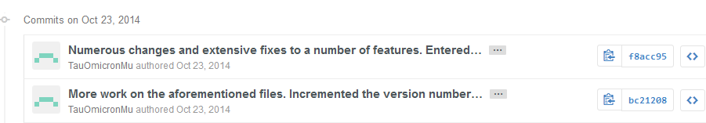

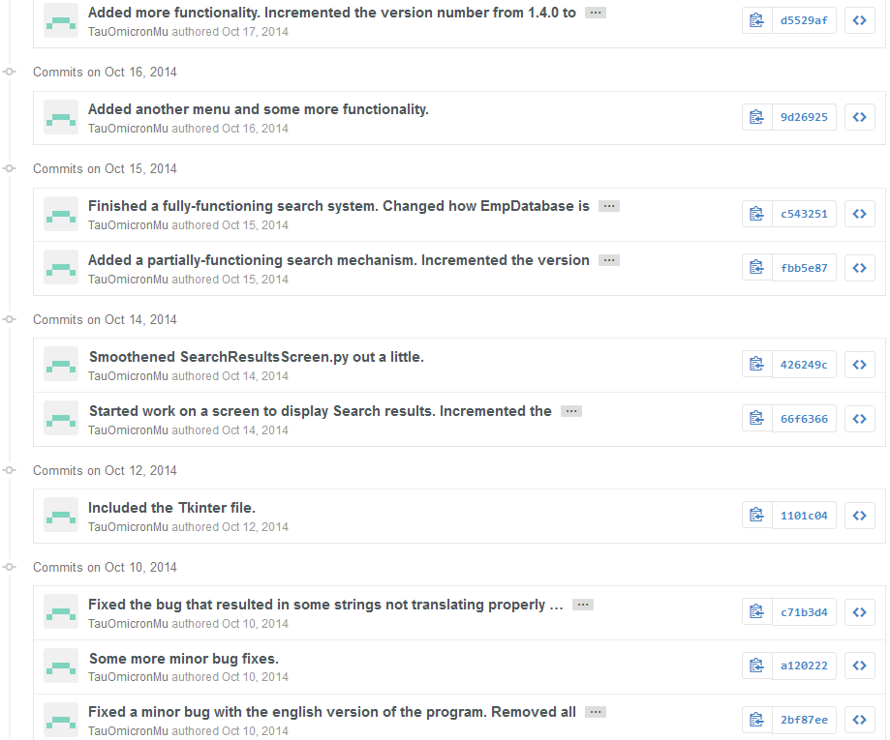

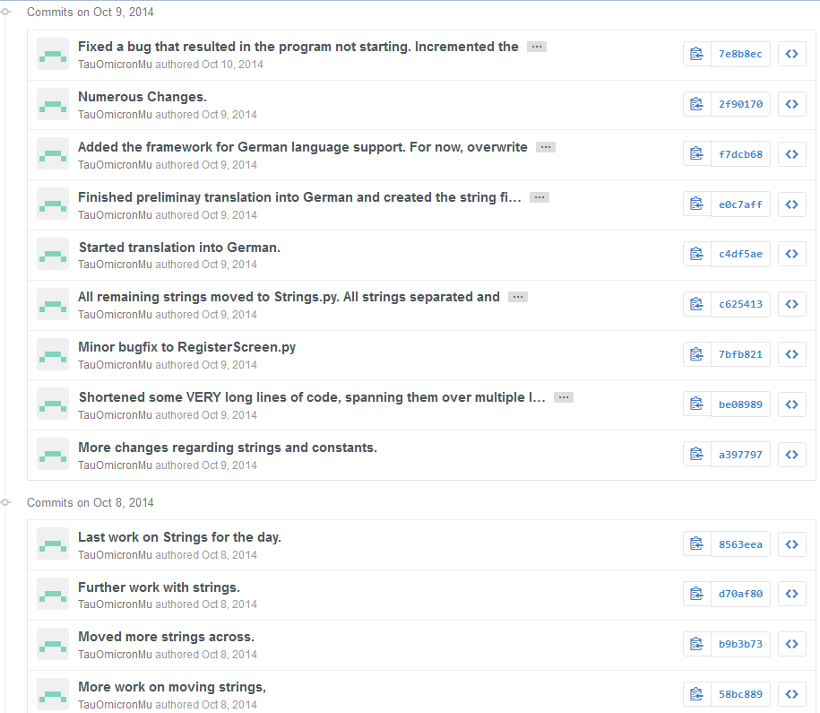

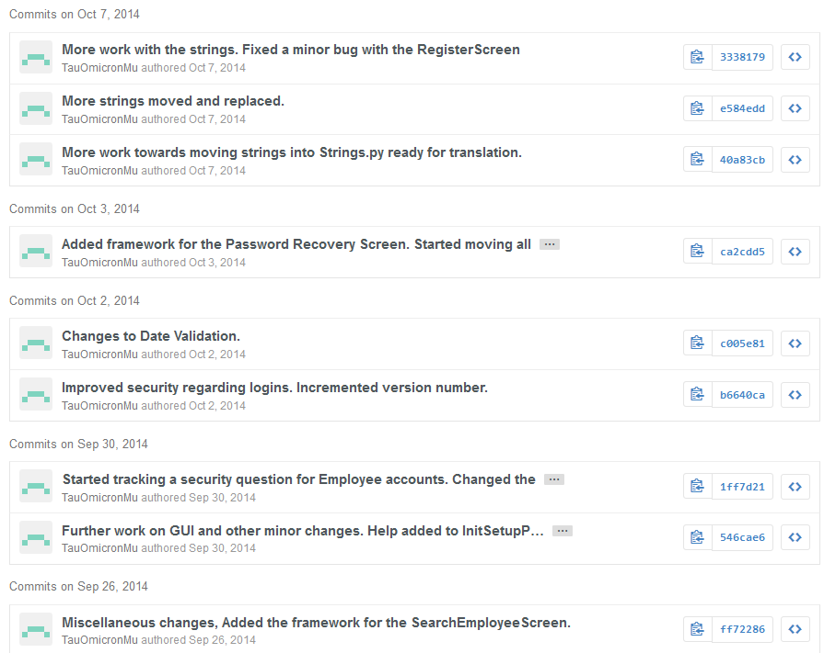

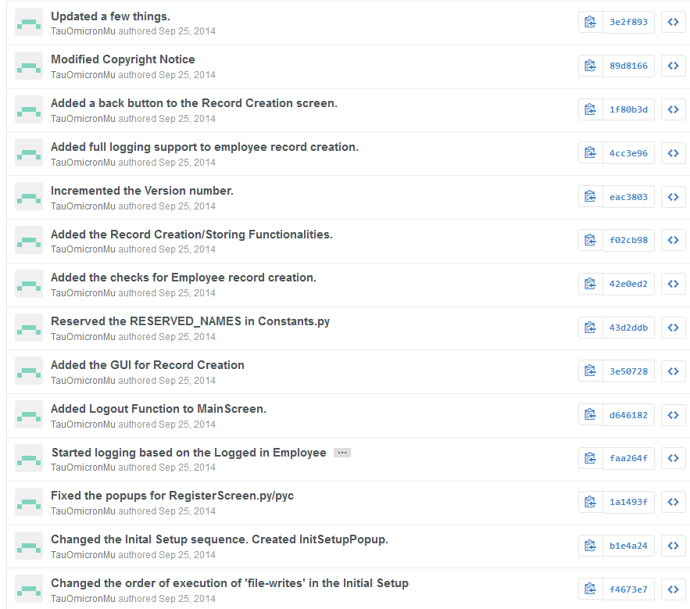

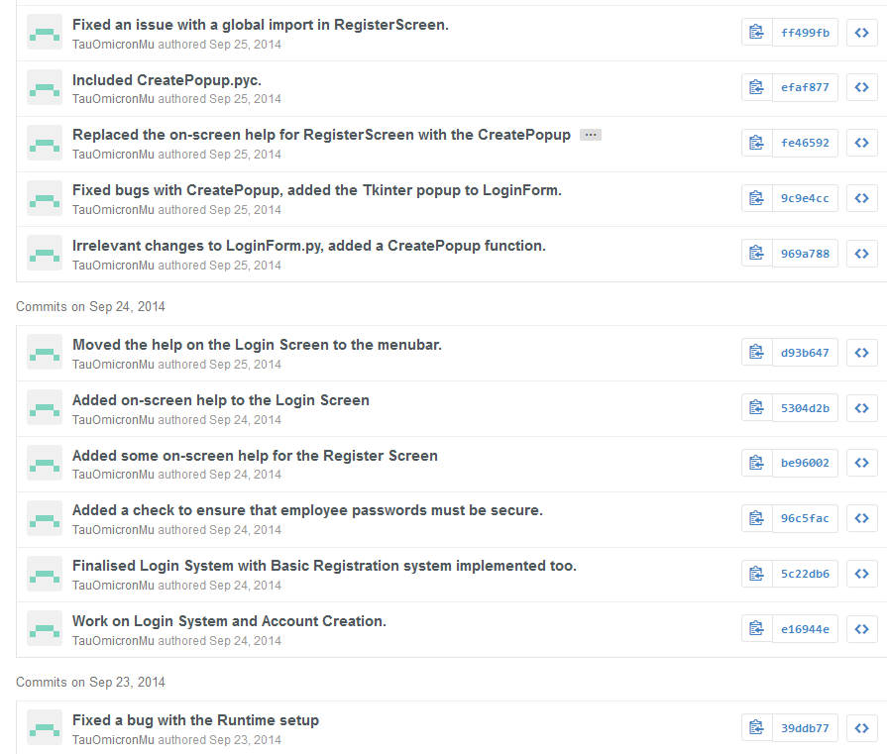

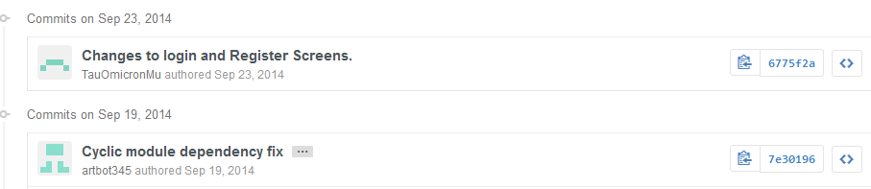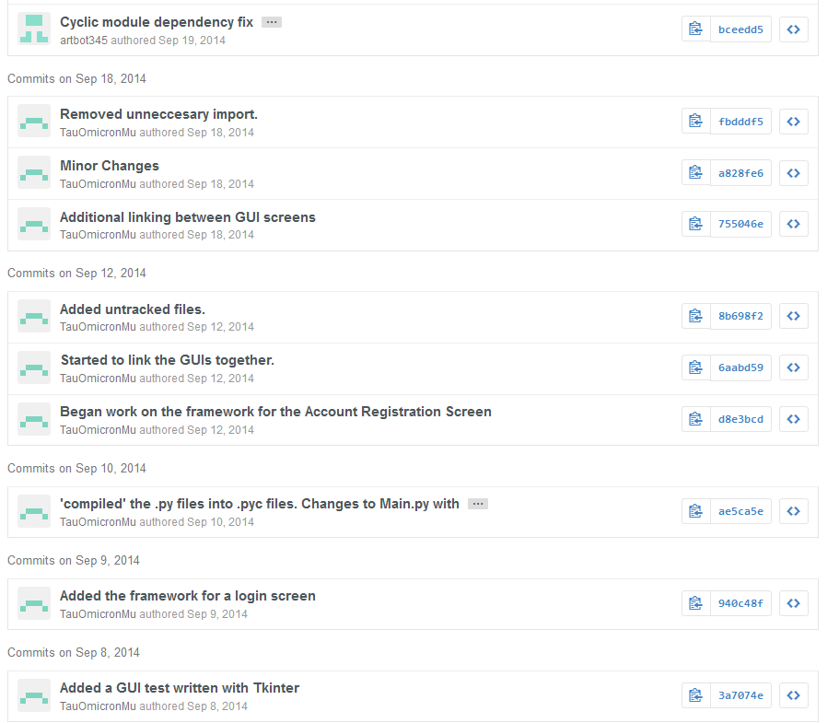

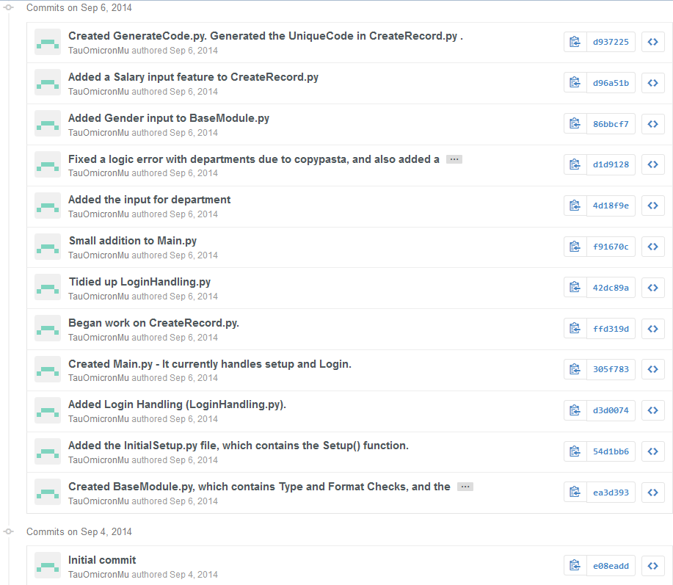

**OLDEST**

## Appendix II – Test Data –

Below is a set of randomly generated Test data to be used during the testing of the search, amend and delete record functions of the program.

[{u'Salary': '15600', u'Code': 'EMP9918786E', u'Name': 'Chiang Flagge', u'DOB': '17/06/1942', u'Gender': 'M', u'Department': 'QA Systems Dev'}, {u'Salary': '18001', u'Code': 'EMP8564126E', u'Name': 'Sawyer Musso', u'DOB': '16/05/1972', u'Gender': 'M', u'Department': 'QA Tools Dev'}, {u'Salary': '32100', u'Code': 'EMP6352185E', u'Name': 'Tanaka Delmendo', u'DOB': '12/09/1940', u'Gender': 'M', u'Department': 'Engine Development'}, {u'Salary': '12350', u'Code': 'EMP5732919E', u'Name': 'Tanner Witczak', u'DOB': '23/09/1949', u'Gender': 'M', u'Department': 'Maintainance'}, {u'Salary': '56800', u'Code': 'EMP1852663E', u'Name': 'Erick Fulp', u'DOB': '11/07/1959', u'Gender': 'M', u'Department': 'Management'}, {u'Salary': '10128', u'Code': 'EMP7799192E', u'Name': 'Deborah Scarlet', u'DOB': '04/03/1992', u'Gender': 'F', u'Department': 'Receptionist'}, {u'Salary': '76908', u'Code': 'EMP9789637E', u'Name': 'Ashton Mooney', u'DOB': '04/09/1991', u'Gender': 'M', u'Department': 'Engine Development'}, {u'Salary': '19258', u'Code': 'EMP2116692E', u'Name': 'Xaviera Roy', u'DOB': '04/06/1986', u'Gender': 'F', u'Department': 'HR'}, {u'Salary': '53353', u'Code': 'EMP4683253E', u'Name': 'Leila Frazier', u'DOB': '04/04/1959', u'Gender': 'F', u'Department': 'Personal Assistant'}, {u'Salary': '97970', u'Code': 'EMP3632131E', u'Name': 'Isadora Whitehead', u'DOB': '10/05/1959', u'Gender': 'F', u'Department': 'Management'}, {u'Salary': '31894', u'Code': 'EMP6525761E', u'Name': 'Imani Foster', u'DOB': '14/06/1953', u'Gender': 'F', u'Department': 'Recruitment'}, {u'Salary': '12244', u'Code': 'EMP4245837E', u'Name': 'Edward Acevedo', u'DOB': '15/03/1988', u'Gender': 'M', u'Department': 'Facilities'}, {u'Salary': '13454', u'Code': 'EMP8596258E', u'Name': 'Ian Harrison', u'DOB': '22/06/1965', u'Gender': 'M', u'Department': 'Release QA'}, {u'Salary': '55107', u'Code': 'EMP6652158E', u'Name': 'Hunter Koch', u'DOB': '12/09/1955', u'Gender': 'M', u'Department': 'Livestreaming'}, {u'Salary': '73590', u'Code': 'EMP8547532E', u'Name': 'Renee Hampton', u'DOB': '12/09/1978', u'Gender': 'F', u'Department': 'Media Relations'}, {u'Salary': '36351', u'Code': 'EMP6117529E', u'Name': 'Maya Carlson', u'DOB': '26/09/1995', u'Gender': 'F', u'Department': 'Sales and Marketing'}, {u'Salary': '55068', u'Code': 'EMP7837892E', u'Name': 'Ira Cabrera', u'DOB': '14/04/1983', u'Gender': 'F', u'Department': 'Finances'}, {u'Salary': '99445', u'Code': 'EMP8778779E', u'Name': 'Gloria Castro', u'DOB': '04/04/1955', u'Gender': 'F', u'Department': 'Advertising'}, {u'Salary': '73936', u'Code': 'EMP9847238E', u'Name': 'Iona Salas', u'DOB': '08/11/1967', u'Gender': 'F', u'Department': 'Human Resources'}, {u'Salary': '39838', u'Code': 'EMP5896884E', u'Name': 'Rina Williamson', u'DOB': '03/10/1963', u'Gender': 'F', u'Department': 'Customer Service'}, {u'Salary': '66686', u'Code': 'EMP8998241E', u'Name': 'Avye Clemons', u'DOB': '29/07/1985', u'Gender': 'M', u'Department': 'Tech QA'}, {u'Salary': '31743', u'Code': 'EMP8721958E', u'Name': 'Uriel Oliver', u'DOB': '09/12/1969', u'Gender': 'M', u'Department': 'Release QA'}, {u'Salary': '102169', u'Code': 'EMP8445235E', u'Name': 'Upton Perry', u'DOB': '25/02/1968', u'Gender': 'M', u'Department': 'Customer Service'}, {u'Salary': '43769', u'Code': 'EMP8256789E', u'Name': 'Thomas Morales', u'DOB': '11/12/1966', u'Gender': 'M', u'Department': 'Tech QA'}, {u'Salary': '89080', u'Code': 'EMP6226175E', u'Name': 'Sylvester Barnett', u'DOB': '03/01/1986', u'Gender': 'M', u'Department': 'Human Resources'}, {u'Salary': '19238', u'Code': 'EMP6175624E', u'Name': 'Kellie Shelton', u'DOB': '31/03/1976', u'Gender': 'F', u'Department': 'Sales and Marketing'}, {u'Salary': '14922', u'Code': 'EMP3514726E', u'Name': 'Claudia Cotton', u'DOB': '07/04/1983', u'Gender': 'F', u'Department': 'Quality Assurance'}, {u'Salary': '88286', u'Code': 'EMP4979749E', u'Name': 'Amethyst Pruitt', u'DOB': '06/01/1973', u'Gender': 'F', u'Department': 'Asset Management'}, {u'Salary': '73009', u'Code': 'EMP2967249E', u'Name': 'Rebekah Livingston', u'DOB': '27/05/1952', u'Gender': 'F', u'Department': 'Asset Management'}, {u'Salary': '41368', u'Code': 'EMP6798129E', u'Name': 'Steven Mcfadden', u'DOB': '01/07/1964', u'Gender': 'M', u'Department': 'Tools QA'}, {u'Salary': '48771', u'Code': 'EMP1316245E', u'Name': 'Leilani English', u'DOB': '06/08/1964', u'Gender': 'M', u'Department': 'Tech Support'}, {u'Salary': '47342', u'Code': 'EMP8428489E', u'Name': 'Cadman Morris', u'DOB': '15/04/1950', u'Gender': 'M', u'Department': 'Release Coordinator'}, {u'Salary': '97412', u'Code': 'EMP4893943E', u'Name': 'Alfreda Alford', u'DOB': '20/07/1983', u'Gender': 'F', u'Department': 'Tech Support'}, {u'Salary': '73676', u'Code': 'EMP9481473E', u'Name': 'Bert Fleming', u'DOB': '11/10/1986', u'Gender': 'M', u'Department': 'Legal Department'}, {u'Salary': '88146', u'Code': 'EMP8157842E', u'Name': 'Anne Bennett', u'DOB': '18/04/1975', u'Gender': 'F', u'Department': 'Payroll'}, {u'Salary': '49934', u'Code': 'EMP3168349E', u'Name': 'Hayley Blake', u'DOB': '01/02/1997', u'Gender': 'F', u'Department': 'Legal Department'}, {u'Salary': '60379', u'Code': 'EMP4184669E', u'Name': 'Brennan Duran', u'DOB': '21/06/1989', u'Gender': 'M', u'Department': 'Engine Development'}, {u'Salary': '10488', u'Code': 'EMP5286428E', u'Name': 'Ian Hayden', u'DOB': '11/10/1997', u'Gender': 'M', u'Department': 'Media Relations'}, {u'Salary': '67889', u'Code': 'EMP5593259E', u'Name': 'Phillip Beard', u'DOB': '20/01/1993', u'Gender': 'M', u'Department': 'Accounting'}, {u'Salary': '113246', u'Code': 'EMP6568174E', u'Name': 'Melanie Reid', u'DOB': '08/10/1986', u'Gender': 'F', u'Department': 'Management'}, {u'Salary': '88216', u'Code': 'EMP2973557E', u'Name': 'Chava Weiss', u'DOB': '22/08/1971', u'Gender': 'F', u'Department': 'Asset Management'}, {u'Salary': '46898', u'Code': 'EMP1555963E', u'Name': 'Lee Rios', u'DOB': '15/03/1997', u'Gender': 'M', u'Department': 'Concept Design'}, {u'Salary': '22165', u'Code': 'EMP4939288E', u'Name': 'Solomon Randolph', u'DOB': '27/03/1976', u'Gender': 'M', u'Department': 'Sys Admin'}, {u'Salary': '107912', u'Code': 'EMP6464345E', u'Name': 'Lael Guerra', u'DOB': '16/11/1971', u'Gender': 'M', u'Department': 'ICU'}, {u'Salary': '31378', u'Code': 'EMP5475883E', u'Name': 'Grant Lynch', u'DOB': '31/01/1993', u'Gender': 'M', u'Department': 'Advertising'}, {u'Salary': '52378', u'Code': 'EMP1778566E', u'Name': 'Isadora Meadows', u'DOB': '12/12/1963', u'Gender': 'F', u'Department': 'Web QA'}, {u'Salary': '86827', u'Code': 'EMP2446652E', u'Name': 'Jillian Mendez', u'DOB': '24/04/1993', u'Gender': 'F', u'Department': 'Business Intelligence'}, {u'Salary': '99375', u'Code': 'EMP8575126E', u'Name': 'Lev Hernandez', u'DOB': '14/08/1959', u'Gender': 'M', u'Department': 'Research and Development'}, {u'Salary': '91903', u'Code': 'EMP9997626E', u'Name': 'Vladimir Farrell', u'DOB': '20/06/1975', u'Gender': 'M', u'Department': 'ICU'}, {u'Salary': '23101', u'Code': 'EMP4621114E', u'Name': 'Quemby Carver', u'DOB': '10/10/1986', u'Gender': 'M', u'Department': 'Accounting'}, {u'Salary': '10122', u'Code': 'EMP9133391E', u'Name': 'Charissa Woodard', u'DOB': '23/01/1993', u'Gender': 'F', u'Department': 'Web QA'}, {u'Salary': '26540', u'Code': 'EMP2126118E', u'Name': 'Cooper Wilson', u'DOB': '17/02/1956', u'Gender': 'M', u'Department': 'Content Development'}, {u'Salary': '69257', u'Code': 'EMP9766512E', u'Name': 'Dennis Rosario', u'DOB': '25/02/1990', u'Gender': 'M', u'Department': 'UNIX Sys Admin'}, {u'Salary': '69162', u'Code': 'EMP1238738E', u'Name': 'Dorian Cooper', u'DOB': '09/09/1971', u'Gender': 'F', u'Department': 'Content Development'}, {u'Salary': '13026', u'Code': 'EMP9563111E', u'Name': 'Idola Clements', u'DOB': '11/05/1974', u'Gender': 'F', u'Department': 'Livestreaming'}, {u'Salary': '33939', u'Code': 'EMP8741129E', u'Name': 'Stacey Prince', u'DOB': '12/01/1996', u'Gender': 'F', u'Department': 'Advertising'}, {u'Salary': '75410', u'Code': 'EMP7117651E', u'Name': 'Mari Schultz', u'DOB': '13/12/1962', u'Gender': 'F', u'Department': 'Sales and Marketing'}, {u'Salary': '24533', u'Code': 'EMP2356399E', u'Name': 'Amir Pena', u'DOB': '15/09/1987', u'Gender': 'M', u'Department': 'Web QA'}, {u'Salary': '79612', u'Code': 'EMP9283742E', u'Name': 'Rudyard Holloway', u'DOB': '11/04/1955', u'Gender': 'M', u'Department': 'Media Relations'}, {u'Salary': '63886', u'Code': 'EMP5916496E', u'Name': 'Thomas Reeves', u'DOB': '24/08/1963', u'Gender': 'M', u'Department': 'Quality Assurance'}, {u'Salary': '83300', u'Code': 'EMP7774216E', u'Name': 'Cara Ray', u'DOB': '25/07/1984', u'Gender': 'F', u'Department': 'Human Resources'}, {u'Salary': '84835', u'Code': 'EMP5152739E', u'Name': 'Candice Ballard', u'DOB': '29/07/1952', u'Gender': 'F', u'Department': 'Tools QA'}, {u'Salary': '65081', u'Code': 'EMP4816628E', u'Name': 'Carly Wilkins', u'DOB': '08/03/1970', u'Gender': 'F', u'Department': 'Content Development'}, {u'Salary': '80463', u'Code': 'EMP4418462E', u'Name': 'Hamish Moss', u'DOB': '18/12/1996', u'Gender': 'M', u'Department': 'Tools QA'}, {u'Salary': '17294', u'Code': 'EMP8589142E', u'Name': 'Talon Webster', u'DOB': '04/06/1976', u'Gender': 'M', u'Department': 'Lead QA'}, {u'Salary': '111278', u'Code': 'EMP4283816E', u'Name': 'Slade Massey', u'DOB': '11/02/1966', u'Gender': 'M', u'Department': 'Sys Admin'}, {u'Salary': '82262', u'Code': 'EMP3598174E', u'Name': 'Yardley Spencer', u'DOB': '12/03/1980', u'Gender': 'M', u'Department': 'Business Intelligence'}, {u'Salary': '109887', u'Code': 'EMP1747922E', u'Name': 'Katell Steele', u'DOB': '18/10/1987', u'Gender': 'M', u'Department': 'Web QA'}, {u'Salary': '87140', u'Code': 'EMP7455599E', u'Name': 'Addison Waters', u'DOB': '25/05/1978', u'Gender': 'M', u'Department': 'ICU'}, {u'Salary': '62918', u'Code': 'EMP3814869E', u'Name': 'Tashya Davidson', u'DOB': '22/08/1986', u'Gender': 'F', u'Department': 'Customer Service'}, {u'Salary': '61612', u'Code': 'EMP5115519E', u'Name': 'Beck Ingram', u'DOB': '21/06/1953', u'Gender': 'M', u'Department': 'Sys Admin'}, {u'Salary': '27312', u'Code': 'EMP3132398E', u'Name': 'Emery Mathis', u'DOB': '09/02/1972', u'Gender': 'F', u'Department': 'Commercial Publishing'}, {u'Salary': '27196', u'Code': 'EMP9877948E', u'Name': 'Hedley Adams', u'DOB': '29/03/1957', u'Gender': 'M', u'Department': 'Engine Development'}, {u'Salary': '15724', u'Code': 'EMP7479482E', u'Name': 'Barclay Pace', u'DOB': '07/06/1972', u'Gender': 'M', u'Department': 'Web Design'}, {u'Salary': '59995', u'Code': 'EMP2499823E', u'Name': 'Cara Carlson', u'DOB': '21/05/1973', u'Gender': 'F', u'Department': 'Lead QA'}, {u'Salary': '74362', u'Code': 'EMP4972615E', u'Name': 'Lenore Blackwell', u'DOB': '19/11/1975', u'Gender': 'M', u'Department': 'Web Design'}, {u'Salary': '78603', u'Code': 'EMP8715355E', u'Name': 'Jamal Davidson', u'DOB': '04/04/1993', u'Gender': 'M', u'Department': 'Concept Design'}, {u'Salary': '114039', u'Code': 'EMP9472775E', u'Name': 'Brenden Holloway', u'DOB': '14/10/1974', u'Gender': 'M', u'Department': 'Facilities'}]

## Appendix III – Testing Log –

[2014-10-23 15:57:47] [] =====RESTART=====

[2014-10-23 15:57:47] []Created/Wiped CurrentEmployee.txt

[2014-10-23 15:57:47] [] Initiating first-time setup

[2014-10-23 15:57:47] [] Created LoginNames.txt

[2014-10-23 15:57:47] [] Created Language.txt

[2014-10-23 15:57:47] [] Created EmpCount.txt

[2014-10-23 15:57:47] [] Created TotalSalary.txt

[2014-10-23 15:57:47] [] Created TotalExpenditure.txt

[2014-10-23 15:57:47] [] First time Admin password Setup

[2014-10-23 15:57:47] []ERROR:root: Got exception on main handler

Traceback (most recent call last):

File "N:\Y13Computing\Main.py", line 27, in main

Setup()

File "N:\Y13Computing\InitialSetup.py", line 130, in Setup

root = Tk()

File "C:\Python27\lib\lib-tk\Tkinter.py", line 1745, in __init__

self.tk = _tkinter.create(screenName, baseName, className, interactive, wantobjects, useTk, sync, use)

TclError: Can't find a usable init.tcl in the following directories:

{C:\Python27\tcl\tcl8.5} C:/Python27/lib/tcl8.5 C:/lib/tcl8.5 C:/lib/tcl8.5 C:/library C:/library C:/tcl8.5.15/library C:/tcl8.5.15/library

C:/Python27/tcl/tcl8.5/init.tcl: version conflict for package "Tcl": have 8.5.15, need exactly 8.5.2

version conflict for package "Tcl": have 8.5.15, need exactly 8.5.2

while executing

"package require -exact Tcl 8.5.2"

(file "C:/Python27/tcl/tcl8.5/init.tcl" line 20)

invoked from within

"source C:/Python27/tcl/tcl8.5/init.tcl"

("uplevel" body line 1)

invoked from within

"uplevel #0 [list source $tclfile]"

This probably means that Tcl wasn't installed properly.

[2014-10-23 15:57:52] [] =====RESTART=====

[2014-10-23 15:57:52] []Created/Wiped CurrentEmployee.txt

[2014-10-23 15:57:52] [] Initiating first-time setup

[2014-10-23 15:57:52] [] Created LoginNames.txt

[2014-10-23 15:57:52] [] Created Language.txt

[2014-10-23 15:57:52] [] Created EmpCount.txt

[2014-10-23 15:57:52] [] Created TotalSalary.txt

[2014-10-23 15:57:52] [] Created TotalExpenditure.txt

[2014-10-23 15:57:52] [] First time Admin password Setup

[2014-10-23 15:57:52] []ERROR:root: Got exception on main handler

Traceback (most recent call last):

File "N:\Y13Computing\Main.py", line 27, in main

Setup()

File "N:\Y13Computing\InitialSetup.py", line 130, in Setup

root = Tk()

File "C:\Python27\lib\lib-tk\Tkinter.py", line 1745, in __init__

self.tk = _tkinter.create(screenName, baseName, className, interactive, wantobjects, useTk, sync, use)

TclError: Can't find a usable init.tcl in the following directories:

{C:\Python27\tcl\tcl8.5} C:/Python27/lib/tcl8.5 C:/lib/tcl8.5 C:/lib/tcl8.5 C:/library C:/library C:/tcl8.5.15/library C:/tcl8.5.15/library

C:/Python27/tcl/tcl8.5/init.tcl: version conflict for package "Tcl": have 8.5.15, need exactly 8.5.2

version conflict for package "Tcl": have 8.5.15, need exactly 8.5.2

while executing

"package require -exact Tcl 8.5.2"

(file "C:/Python27/tcl/tcl8.5/init.tcl" line 20)

invoked from within

"source C:/Python27/tcl/tcl8.5/init.tcl"

("uplevel" body line 1)

invoked from within

"uplevel #0 [list source $tclfile]"

This probably means that Tcl wasn't installed properly.

[2014-10-23 15:58:12] [] =====RESTART=====

[2014-10-23 15:58:12] []Created/Wiped CurrentEmployee.txt

[2014-10-23 15:58:12] [] Initiating first-time setup

[2014-10-23 15:58:12] [] Created LoginNames.txt

[2014-10-23 15:58:12] [] Created Language.txt

[2014-10-23 15:58:12] [] Created EmpCount.txt

[2014-10-23 15:58:12] [] Created TotalSalary.txt

[2014-10-23 15:58:12] [] Created TotalExpenditure.txt

[2014-10-23 15:58:12] [] First time Admin password Setup

[2014-10-23 15:58:12] []ERROR:root: Got exception on main handler

Traceback (most recent call last):

File "N:\Y13Computing\Main.py", line 27, in main

Setup()

File "N:\Y13Computing\InitialSetup.py", line 130, in Setup

root = Tk()

File "C:\Python27\lib\lib-tk\Tkinter.py", line 1745, in __init__

self.tk = _tkinter.create(screenName, baseName, className, interactive, wantobjects, useTk, sync, use)

TclError: Can't find a usable init.tcl in the following directories:

{C:\Python27\tcl\tcl8.5} C:/Python27/lib/tcl8.5 C:/lib/tcl8.5 C:/lib/tcl8.5 C:/library C:/library C:/tcl8.5.15/library C:/tcl8.5.15/library

C:/Python27/tcl/tcl8.5/init.tcl: version conflict for package "Tcl": have 8.5.15, need exactly 8.5.2

version conflict for package "Tcl": have 8.5.15, need exactly 8.5.2

while executing

"package require -exact Tcl 8.5.2"

(file "C:/Python27/tcl/tcl8.5/init.tcl" line 20)

invoked from within

"source C:/Python27/tcl/tcl8.5/init.tcl"

("uplevel" body line 1)

invoked from within

"uplevel #0 [list source $tclfile]"

This probably means that Tcl wasn't installed properly.

[2014-10-23 16:00:26] [] =====RESTART=====

[2014-10-23 16:00:26] []Created/Wiped CurrentEmployee.txt

[2014-10-23 16:00:26] [] Initiating first-time setup

[2014-10-23 16:00:26] [] Created LoginNames.txt

[2014-10-23 16:00:26] [] Created Language.txt

[2014-10-23 16:00:26] [] Created EmpCount.txt

[2014-10-23 16:00:26] [] Created TotalSalary.txt

[2014-10-23 16:00:26] [] Created TotalExpenditure.txt

[2014-10-23 16:00:26] [] First time Admin password Setup

[2014-10-23 16:00:26] []ERROR:root: Got exception on main handler

Traceback (most recent call last):

File "N:\Y13Computing\Main.py", line 27, in main

Setup()

File "N:\Y13Computing\InitialSetup.py", line 130, in Setup

root = Tk()

File "C:\Python27\lib\lib-tk\Tkinter.py", line 1745, in __init__

self.tk = _tkinter.create(screenName, baseName, className, interactive, wantobjects, useTk, sync, use)

TclError: Can't find a usable init.tcl in the following directories:

{C:\Python27\tcl\tcl8.5} C:/Python27/lib/tcl8.5 C:/lib/tcl8.5 C:/lib/tcl8.5 C:/library C:/library C:/tcl8.5.15/library C:/tcl8.5.15/library

C:/Python27/tcl/tcl8.5/init.tcl: version conflict for package "Tcl": have 8.5.15, need exactly 8.5.2

version conflict for package "Tcl": have 8.5.15, need exactly 8.5.2

while executing

"package require -exact Tcl 8.5.2"

(file "C:/Python27/tcl/tcl8.5/init.tcl" line 20)

invoked from within

"source C:/Python27/tcl/tcl8.5/init.tcl"

("uplevel" body line 1)

invoked from within

"uplevel #0 [list source $tclfile]"

This probably means that Tcl wasn't installed properly.

[2014-10-23 16:33:11] [] =====RESTART=====

[2014-10-23 16:33:11] []Created/Wiped CurrentEmployee.txt

[2014-10-23 16:33:11] [] Initiating first-time setup

[2014-10-23 16:33:11] [] Created LoginNames.txt

[2014-10-23 16:33:11] [] Created Language.txt

[2014-10-23 16:33:11] [] Created EmpCount.txt

[2014-10-23 16:33:11] [] Created TotalSalary.txt

[2014-10-23 16:33:11] [] Created TotalExpenditure.txt

[2014-10-23 16:33:11] [] First time Admin password Setup

[2014-10-23 16:33:11] [] Initialising InitSetupPopup window.

[2014-10-23 16:33:11] [] Instance of InitSetupPopup Class initialised. Self : .28224008 Parent: .

[2014-10-23 16:33:11] [] Menubar Initialised

[2014-10-23 16:33:11] [] Loaded Labels

[2014-10-23 16:33:11] [] Loaded Buttons

[2014-10-23 16:33:11] [] Initialised Grid. UI Initialisation Complete.

[2014-10-23 16:33:26] [] Submit button pressed

[2014-10-23 16:33:26] [] Admin Password created.

[2014-10-23 16:33:26] [] Created InitialSetup.txt

[2014-10-23 16:33:26] [] Initialising window with geometry: 900x600+200+50

[2014-10-23 16:33:26] [] Instance of LoginScreen Class initialised. Self : .28224048 Parent: .

[2014-10-23 16:33:26] [] Initialising LoginScreen UI

[2014-10-23 16:33:26] [] Menubar Initialised

[2014-10-23 16:33:26] [] Loaded Labels

[2014-10-23 16:33:26] [] Loaded Buttons

[2014-10-23 16:33:26] [] Initialised Grid. UI Initialisation Complete.

[2014-10-23 16:36:18] [Tom] Logout selected

sed

[2014-10-23 16:35:39] [] Login Window Terminated

[2014-10-23 16:35:39] [] Initialising window with geometry: 900x600+200+50

[2014-10-23 16:35:39] [] Instance of RegisterScreen Class initialised. Self : .28224368 Parent: .

[2014-10-23 16:35:39] [] Initialising LoginScreen UI

[2014-10-23 16:35:39] [] Menubar Initialised

[2014-10-23 16:35:39] [] Loaded Labels

[2014-10-23 16:35:39] [] Loaded Buttons

[2014-10-23 16:35:39] [] Initialised Grid. UI Initialisation Complete.

[2014-10-23 16:35:58] [] Loaded LoginData.p

[2014-10-23 16:35:58] [] Account Creation initiated

[2014-10-23 16:35:58] [] Account Creation - Password Mismatch.

[2014-10-23 16:36:06] [] Loaded LoginData.p

[2014-10-23 16:36:06] [] Account Creation initiated

[2014-10-23 16:36:06] [] Admin Pass Hash loaded.

[2014-10-23 16:36:06] [] New Employee Account : Tom created.

[2014-10-23 16:36:06] [] Back Button Pressed

[2014-10-23 16:36:06] [] Register Window Terminated

[2014-10-23 16:36:06] [] Initialising window with geometry: 900x600+200+50

[2014-10-23 16:36:06] [] Instance of LoginScreen Class initialised. Self : .28224128 Parent: .

[2014-10-23 16:36:06] [] Initialising LoginScreen UI

[2014-10-23 16:36:06] [] Menubar Initialised

[2014-10-23 16:36:06] [] Loaded Labels

[2014-10-23 16:36:06] [] Loaded Buttons

[2014-10-23 16:36:06] [] Initialised Grid. UI Initialisation Complete.

[2014-10-23 16:36:11] [] Login Button Pressed

[2014-10-23 16:36:11] [] Attempted Login: Username = Tom

[2014-10-23 16:36:11] [] Attempted Login: Password = -547305839

[2014-10-23 16:36:11] [] Successful Login.

[2014-10-23 16:36:11] [] Updated Current Employee.txt

[2014-10-23 16:36:11] [Tom] Initialising window with geometry: 900x600+200+50

[2014-10-23 16:36:18] [Tom] Main Window Terminated

[2014-10-23 16:36:18] []CurrentEmployee.txt wiped

[2014-10-23 16:36:18] [] Initialising window with geometry: 900x600+200+50

[2014-10-23 16:36:18] [] Instance of LoginScreen Class initialised. Self : .28249864 Parent: .

[2014-10-23 16:36:18] [] Initialising LoginScreen UI

[2014-10-23 16:36:18] [] Menubar Initialised

[2014-10-23 16:36:18] [] Loaded Labels

[2014-10-23 16:36:18] [] Loaded Buttons

[2014-10-23 16:36:18] [] Initialised Grid. UI Initialisation Complete.

[2014-10-23 16:36:19] [] Quit Selected

[2014-10-23 16:36:19] [] Window Terminated

[2014-10-23 16:40:04] [] =====RESTART=====

[2014-10-23 16:40:04] []Created/Wiped CurrentEmployee.txt

[2014-10-23 16:40:04] [] Loading variables

[2014-10-23 16:40:04] [] Loaded Employee Count

[2014-10-23 16:40:04] [] Loaded Total Salary

[2014-10-23 16:40:04] [] Loaded Total Expenditure

[2014-10-23 16:40:04] []Created/Wiped CurrentEmployee.txt

[2014-10-23 16:40:04] [] Initialising window with geometry: 900x600+200+50

[2014-10-23 16:40:04] [] Instance of LoginScreen Class initialised. Self : .35147208 Parent: .

[2014-10-23 16:40:04] [] Initialising LoginScreen UI

[2014-10-23 16:40:04] [] Menubar Initialised

[2014-10-23 16:40:04] [] Loaded Labels

[2014-10-23 16:40:04] [] Loaded Buttons

[2014-10-23 16:40:04] [] Initialised Grid. UI Initialisation Complete.

[2014-10-23 16:40:09] [] Login Button Pressed

[2014-10-23 16:40:09] [] Attempted Login: Username =

[2014-10-23 16:40:09] [] Attempted Login: Password = 0

[2014-10-23 16:41:38] [] =====RESTART=====

[2014-10-23 16:41:38] []Created/Wiped CurrentEmployee.txt

[2014-10-23 16:41:38] [] Loading variables

[2014-10-23 16:41:38] [] Loaded Employee Count

[2014-10-23 16:41:38] [] Loaded Total Salary

[2014-10-23 16:41:38] [] Loaded Total Expenditure

[2014-10-23 16:41:38] []Created/Wiped CurrentEmployee.txt

[2014-10-23 16:41:38] [] Initialising window with geometry: 900x600+200+50

[2014-10-23 16:41:38] [] Instance of LoginScreen Class initialised. Self : .27699560 Parent: .

[2014-10-23 16:41:38] [] Initialising LoginScreen UI

[2014-10-23 16:41:38] [] Menubar Initialised

[2014-10-23 16:41:38] [] Loaded Labels

[2014-10-23 16:41:38] [] Loaded Buttons

[2014-10-23 16:41:38] [] Initialised Grid. UI Initialisation Complete.

[2014-10-23 16:42:02] [] =====RESTART=====

[2014-10-23 16:42:02] []Created/Wiped CurrentEmployee.txt

[2014-10-23 16:42:02] [] Loading variables

[2014-10-23 16:42:02] [] Loaded Employee Count

[2014-10-23 16:42:02] [] Loaded Total Salary

[2014-10-23 16:42:02] [] Loaded Total Expenditure

[2014-10-23 16:42:02] []Created/Wiped CurrentEmployee.txt

[2014-10-23 16:42:02] [] Initialising window with geometry: 900x600+200+50

[2014-10-23 16:42:02] [] Instance of LoginScreen Class initialised. Self : .26782056 Parent: .

[2014-10-23 16:42:02] [] Initialising LoginScreen UI

[2014-10-23 16:42:02] [] Menubar Initialised

[2014-10-23 16:42:02] [] Loaded Labels

[2014-10-23 16:42:02] []ERROR:root: Got exception on main handler

Traceback (most recent call last):

File "N:\Y13Computing\Main.py", line 32, in main

app = LoginScreen(root)

File "N:\Y13Computing\LoginForm.py", line 30, in __init__

self.initialiseUI()

File "N:\Y13Computing\LoginForm.py", line 76, in initialiseUI

LoginButton.bind('<Return>', tryLogin)

NameError: global name 'tryLogin' is not defined

[2014-10-23 16:42:03] [] =====RESTART=====

[2014-10-23 16:42:03] []Created/Wiped CurrentEmployee.txt

[2014-10-23 16:42:03] [] Loading variables

[2014-10-23 16:42:03] [] Loaded Employee Count

[2014-10-23 16:42:03] [] Loaded Total Salary

[2014-10-23 16:42:03] [] Loaded Total Expenditure

[2014-10-23 16:42:03] []Created/Wiped CurrentEmployee.txt

[2014-10-23 16:42:03] [] Initialising window with geometry: 900x600+200+50

[2014-10-23 16:42:03] [] Instance of LoginScreen Class initialised. Self : .27765096 Parent: .

[2014-10-23 16:42:03] [] Initialising LoginScreen UI

[2014-10-23 16:42:03] [] Menubar Initialised

[2014-10-23 16:42:03] [] Loaded Labels

[2014-10-23 16:42:03] []ERROR:root: Got exception on main handler

Traceback (most recent call last):

File "N:\Y13Computing\Main.py", line 32, in main

app = LoginScreen(root)

File "N:\Y13Computing\LoginForm.py", line 30, in __init__

self.initialiseUI()

File "N:\Y13Computing\LoginForm.py", line 76, in initialiseUI

LoginButton.bind('<Return>', tryLogin)

NameError: global name 'tryLogin' is not defined

[2014-10-23 16:42:04] [] =====RESTART=====

[2014-10-23 16:42:04] []Created/Wiped CurrentEmployee.txt

[2014-10-23 16:42:04] [] Loading variables

[2014-10-23 16:42:04] [] Loaded Employee Count

[2014-10-23 16:42:04] [] Loaded Total Salary

[2014-10-23 16:42:04] [] Loaded Total Expenditure

[2014-10-23 16:42:04] []Created/Wiped CurrentEmployee.txt

[2014-10-23 16:42:04] [] Initialising window with geometry: 900x600+200+50

[2014-10-23 16:42:04] [] Instance of LoginScreen Class initialised. Self : .27044200 Parent: .

[2014-10-23 16:42:04] [] Initialising LoginScreen UI

[2014-10-23 16:42:04] [] Menubar Initialised

[2014-10-23 16:42:04] [] Loaded Labels

[2014-10-23 16:42:04] []ERROR:root: Got exception on main handler

Traceback (most recent call last):

File "N:\Y13Computing\Main.py", line 32, in main

app = LoginScreen(root)

File "N:\Y13Computing\LoginForm.py", line 30, in __init__

self.initialiseUI()

File "N:\Y13Computing\LoginForm.py", line 76, in initialiseUI

LoginButton.bind('<Return>', tryLogin)

NameError: global name 'tryLogin' is not defined

[2014-10-23 16:42:17] [] =====RESTART=====

[2014-10-23 16:42:17] []Created/Wiped CurrentEmployee.txt

[2014-10-23 16:42:17] [] Loading variables

[2014-10-23 16:42:17] [] Loaded Employee Count

[2014-10-23 16:42:17] [] Loaded Total Salary

[2014-10-23 16:42:17] [] Loaded Total Expenditure

[2014-10-23 16:42:17] []Created/Wiped CurrentEmployee.txt

[2014-10-23 16:42:17] [] Initialising window with geometry: 900x600+200+50

[2014-10-23 16:42:17] [] Instance of LoginScreen Class initialised. Self : .25868728 Parent: .

[2014-10-23 16:42:17] [] Initialising LoginScreen UI

[2014-10-23 16:42:17] [] Menubar Initialised

[2014-10-23 16:42:17] [] Loaded Labels

[2014-10-23 16:42:17] [] Loaded Buttons

[2014-10-23 16:42:17] [] Initialised Grid. UI Initialisation Complete.

[2014-10-23 16:42:23] [] Login Button Pressed

[2014-10-23 16:42:23] [] Attempted Login: Username = Tom

[2014-10-23 16:42:23] [] Attempted Login: Password = -547305839

[2014-10-23 16:42:23] [] Successful Login.

[2014-10-23 16:42:23] [] Updated Current Employee.txt

[2014-10-23 16:42:23] [Tom] Initialising window with geometry: 900x600+200+50

[2014-10-23 16:42:39] [Tom] Amend Employee Selected.

[2014-10-23 16:42:39] [Tom] Main Window Terminated

[2014-10-23 16:42:39] [Tom] Initialising window with geometry: 900x600+200+50

[2014-10-23 16:42:39] [Tom] Instance of AmendEmployeeScreen Class initialised. Self : .25870208 Parent: .

[2014-10-23 16:42:39] [Tom] Menubar Initialised

[2014-10-23 16:42:39] [Tom] Amend Dropdown Menu initialised.

[2014-10-23 16:42:39] [Tom] Loaded Buttons

[2014-10-23 16:42:39] [Tom] Initialised Grid. UI Initialisation Complete.

[2014-10-23 16:42:49] [Tom] Back Selected

[2014-10-23 16:42:49] [Tom] Window Terminated

[2014-10-23 16:42:51] [Tom] Quit Selected

[2014-10-23 16:42:51] [Tom] Window Terminated

[2014-10-23 16:43:43] [] =====RESTART=====

[2014-10-23 16:43:43] []Created/Wiped CurrentEmployee.txt

[2014-10-23 16:43:43] [] Loading variables

[2014-10-23 16:43:43] [] Loaded Employee Count

[2014-10-23 16:43:43] [] Loaded Total Salary

[2014-10-23 16:43:43] [] Loaded Total Expenditure

[2014-10-23 16:43:43] []Created/Wiped CurrentEmployee.txt

[2014-10-23 16:43:43] [] Initialising window with geometry: 900x600+200+50

[2014-10-23 16:43:43] [] Instance of LoginScreen Class initialised. Self : .26454376 Parent: .

[2014-10-23 16:43:43] [] Initialising LoginScreen UI

[2014-10-23 16:43:43] [] Menubar Initialised

[2014-10-23 16:43:43] [] Loaded Labels

[2014-10-23 16:43:43] [] Loaded Buttons

[2014-10-23 16:43:43] [] Initialised Grid. UI Initialisation Complete.

[2014-10-23 16:44:01] [] =====RESTART=====

[2014-10-23 16:44:01] []Created/Wiped CurrentEmployee.txt

[2014-10-23 16:44:01] [] Loading variables

[2014-10-23 16:44:01] [] Loaded Employee Count

[2014-10-23 16:44:01] [] Loaded Total Salary

[2014-10-23 16:44:01] [] Loaded Total Expenditure

[2014-10-23 16:44:01] []Created/Wiped CurrentEmployee.txt

[2014-10-23 16:44:01] [] Initialising window with geometry: 900x600+200+50

[2014-10-23 16:44:01] [] Instance of LoginScreen Class initialised. Self : .26011848 Parent: .

[2014-10-23 16:44:01] [] Initialising LoginScreen UI

[2014-10-23 16:44:01] [] Menubar Initialised

[2014-10-23 16:44:01] [] Loaded Labels

[2014-10-23 16:44:01] [] Loaded Buttons

[2014-10-23 16:44:01] [] Initialised Grid. UI Initialisation Complete.

[2014-10-23 16:45:26] [] =====RESTART=====

[2014-10-23 16:45:26] []Created/Wiped CurrentEmployee.txt

[2014-10-23 16:45:26] [] Loading variables

[2014-10-23 16:45:26] [] Loaded Employee Count

[2014-10-23 16:45:26] [] Loaded Total Salary

[2014-10-23 16:45:26] [] Loaded Total Expenditure

[2014-10-23 16:45:26] []Created/Wiped CurrentEmployee.txt

[2014-10-23 16:45:26] [] Initialising window with geometry: 900x600+200+50

[2014-10-23 16:45:26] [] Instance of LoginScreen Class initialised. Self : .26601672 Parent: .

[2014-10-23 16:45:26] [] Initialising LoginScreen UI

[2014-10-23 16:45:26] [] Menubar Initialised

[2014-10-23 16:45:26] [] Loaded Labels

[2014-10-23 16:45:26] [] Loaded Buttons

[2014-10-23 16:45:26] [] Initialised Grid. UI Initialisation Complete.

[2014-10-23 16:45:30] [] Login Button Pressed

[2014-10-23 16:45:30] [] Attempted Login: Username = Tom

[2014-10-23 16:45:30] [] Attempted Login: Password = 865703889

[2014-10-23 16:45:37] [] Login Button Pressed

[2014-10-23 16:45:37] [] Attempted Login: Username = Tom

[2014-10-23 16:45:37] [] Attempted Login: Password = -547305839

[2014-10-23 16:45:37] [] Successful Login.

[2014-10-23 16:45:37] [] Updated Current Employee.txt

[2014-10-23 16:45:37] [Tom] Initialising window with geometry: 900x600+200+50

[2014-10-23 16:45:38] [Tom] Create Employee Selected[2014-10-23 16:45:38] [Tom] Main Window Terminated

[2014-10-23 16:45:38] [Tom] Initialising window with geometry: 900x600+200+50

[2014-10-23 16:45:38] [Tom] Instance of CreateEmployeeScreen Class initialised. Self : .26602152 Parent: .

[2014-10-23 16:45:38] [Tom] Menubar Initialised

[2014-10-23 16:45:38] [Tom] Loaded Labels

[2014-10-23 16:45:38] [Tom] Loaded Buttons

[2014-10-23 16:45:38] [Tom] Initialised Grid. UI Initialisation Complete.

[2014-10-23 16:45:47] [Tom] Back Selected

[2014-10-23 16:45:47] [Tom] Window Terminated

[2014-10-23 16:46:23] [Tom] Create Employee Selected[2014-10-23 16:46:23] [Tom] Main Window Terminated

[2014-10-23 16:46:24] [Tom] Initialising window with geometry: 900x600+200+50

[2014-10-23 16:46:24] [Tom] Instance of CreateEmployeeScreen Class initialised. Self : .26603312 Parent: .

[2014-10-23 16:46:24] [Tom] Menubar Initialised

[2014-10-23 16:46:24] [Tom] Loaded Labels

[2014-10-23 16:46:24] [Tom] Loaded Buttons

[2014-10-23 16:46:24] [Tom] Initialised Grid. UI Initialisation Complete.

[2014-10-23 16:46:56] [Tom] Create Emp Issue: Invalid DOB

[2014-10-23 16:47:13] [Tom] Loaded EmpDatabase.p

[2014-10-23 16:47:13] [Tom] Added [{u'Salary': '15600', u'Code': 'EMP9918786E', u'Name': 'Chiang Flagge', u'DOB': '17/06/1942', u'Gender': 'M', u'Department': 'QA Systems Dev'}]

[2014-10-23 16:47:13] [Tom] Saved new Database

[2014-10-23 16:47:13] [Tom] Back Selected

[2014-10-23 16:47:13] [Tom] Window Terminated

[2014-10-23 16:47:15] [Tom] Create Employee Selected[2014-10-23 16:47:15] [Tom] Main Window Terminated

[2014-10-23 16:47:15] [Tom] Initialising window with geometry: 900x600+200+50

[2014-10-23 16:47:15] [Tom] Instance of CreateEmployeeScreen Class initialised. Self : .26630944 Parent: .

[2014-10-23 16:47:15] [Tom] Menubar Initialised

[2014-10-23 16:47:15] [Tom] Loaded Labels

[2014-10-23 16:47:15] [Tom] Loaded Buttons

[2014-10-23 16:47:15] [Tom] Initialised Grid. UI Initialisation Complete.

[2014-10-23 16:49:10] [Tom] Loaded EmpDatabase.p

[2014-10-23 16:49:10] [Tom] Added [{u'Salary': '15600', u'Code': 'EMP9918786E', u'Name': 'Chiang Flagge', u'DOB': '17/06/1942', u'Gender': 'M', u'Department': 'QA Systems Dev'}, {u'Salary': '18001', u'Code': 'EMP8564126E', u'Name': 'Sawyer Musso', u'DOB': '16/05/1972', u'Gender': 'M', u'Department': 'QA Tools Dev'}]

[2014-10-23 16:49:10] [Tom] Saved new Database

[2014-10-23 16:49:10] [Tom] Back Selected

[2014-10-23 16:49:10] [Tom] Window Terminated

[2014-10-23 16:49:11] [Tom] Create Employee Selected[2014-10-23 16:49:11] [Tom] Main Window Terminated

[2014-10-23 16:49:11] [Tom] Initialising window with geometry: 900x600+200+50

[2014-10-23 16:49:11] [Tom] Instance of CreateEmployeeScreen Class initialised. Self : .26631064 Parent: .

[2014-10-23 16:49:11] [Tom] Menubar Initialised

[2014-10-23 16:49:11] [Tom] Loaded Labels

[2014-10-23 16:49:11] [Tom] Loaded Buttons

[2014-10-23 16:49:11] [Tom] Initialised Grid. UI Initialisation Complete.

[2014-10-23 16:49:56] [Tom] Loaded EmpDatabase.p

[2014-10-23 16:49:56] [Tom] Added [{u'Salary': '15600', u'Code': 'EMP9918786E', u'Name': 'Chiang Flagge', u'DOB': '17/06/1942', u'Gender': 'M', u'Department': 'QA Systems Dev'}, {u'Salary': '18001', u'Code': 'EMP8564126E', u'Name': 'Sawyer Musso', u'DOB': '16/05/1972', u'Gender': 'M', u'Department': 'QA Tools Dev'}, {u'Salary': '32100', u'Code': 'EMP6352185E', u'Name': 'Tanaka Delmendo', u'DOB': '12/09/1940', u'Gender': 'M', u'Department': 'Engine Development'}]

[2014-10-23 16:49:56] [Tom] Saved new Database

[2014-10-23 16:49:56] [Tom] Back Selected

[2014-10-23 16:49:56] [Tom] Window Terminated

[2014-10-23 16:49:57] [Tom] Create Employee Selected[2014-10-23 16:49:57] [Tom] Main Window Terminated

[2014-10-23 16:49:57] [Tom] Initialising window with geometry: 900x600+200+50

[2014-10-23 16:49:57] [Tom] Instance of CreateEmployeeScreen Class initialised. Self : .26630304 Parent: .

[2014-10-23 16:49:57] [Tom] Menubar Initialised

[2014-10-23 16:49:57] [Tom] Loaded Labels

[2014-10-23 16:49:57] [Tom] Loaded Buttons

[2014-10-23 16:49:57] [Tom] Initialised Grid. UI Initialisation Complete.

[2014-10-23 16:50:20] [Tom] Back Selected

[2014-10-23 16:50:20] [Tom] Window Terminated

[2014-10-23 16:50:22] [Tom] Create Employee Selected[2014-10-23 16:50:22] [Tom] Main Window Terminated

[2014-10-23 16:50:22] [Tom] Initialising window with geometry: 900x600+200+50

[2014-10-23 16:50:22] [Tom] Instance of CreateEmployeeScreen Class initialised. Self : .26630424 Parent: .

[2014-10-23 16:50:22] [Tom] Menubar Initialised

[2014-10-23 16:50:22] [Tom] Loaded Labels

[2014-10-23 16:50:22] [Tom] Loaded Buttons

[2014-10-23 16:50:22] [Tom] Initialised Grid. UI Initialisation Complete.

[2014-10-23 16:51:25] [Tom] Loaded EmpDatabase.p

[2014-10-23 16:51:25] [Tom] Added [{u'Salary': '15600', u'Code': 'EMP9918786E', u'Name': 'Chiang Flagge', u'DOB': '17/06/1942', u'Gender': 'M', u'Department': 'QA Systems Dev'}, {u'Salary': '18001', u'Code': 'EMP8564126E', u'Name': 'Sawyer Musso', u'DOB': '16/05/1972', u'Gender': 'M', u'Department': 'QA Tools Dev'}, {u'Salary': '32100', u'Code': 'EMP6352185E', u'Name': 'Tanaka Delmendo', u'DOB': '12/09/1940', u'Gender': 'M', u'Department': 'Engine Development'}, {u'Salary': '12350', u'Code': 'EMP5732919E', u'Name': 'Tanner Witczak', u'DOB': '23/09/1949', u'Gender': 'M', u'Department': 'Maintainance'}]

[2014-10-23 16:51:25] [Tom] Saved new Database

[2014-10-23 16:51:25] [Tom] Back Selected

[2014-10-23 16:51:25] [Tom] Window Terminated

[2014-10-23 16:51:27] [Tom] Create Employee Selected[2014-10-23 16:51:27] [Tom] Main Window Terminated

[2014-10-23 16:51:27] [Tom] Initialising window with geometry: 900x600+200+50

[2014-10-23 16:51:27] [Tom] Instance of CreateEmployeeScreen Class initialised. Self : .26629824 Parent: .

[2014-10-23 16:51:27] [Tom] Menubar Initialised

[2014-10-23 16:51:27] [Tom] Loaded Labels

[2014-10-23 16:51:27] [Tom] Loaded Buttons

[2014-10-23 16:51:27] [Tom] Initialised Grid. UI Initialisation Complete.

[2014-10-23 16:52:00] [Tom] Loaded EmpDatabase.p

[2014-10-23 16:52:00] [Tom] Added [{u'Salary': '15600', u'Code': 'EMP9918786E', u'Name': 'Chiang Flagge', u'DOB': '17/06/1942', u'Gender': 'M', u'Department': 'QA Systems Dev'}, {u'Salary': '18001', u'Code': 'EMP8564126E', u'Name': 'Sawyer Musso', u'DOB': '16/05/1972', u'Gender': 'M', u'Department': 'QA Tools Dev'}, {u'Salary': '32100', u'Code': 'EMP6352185E', u'Name': 'Tanaka Delmendo', u'DOB': '12/09/1940', u'Gender': 'M', u'Department': 'Engine Development'}, {u'Salary': '12350', u'Code': 'EMP5732919E', u'Name': 'Tanner Witczak', u'DOB': '23/09/1949', u'Gender': 'M', u'Department': 'Maintainance'}, {u'Salary': '56800', u'Code': 'EMP1852663E', u'Name': 'Erick Fulp', u'DOB': '11/07/1959', u'Gender': 'M', u'Department': 'Management'}]

[2014-10-23 16:52:00] [Tom] Saved new Database

[2014-10-23 16:52:00] [Tom] Back Selected

[2014-10-23 16:52:00] [Tom] Window Terminated

[2014-10-23 16:52:11] [Tom] Create Employee Selected[2014-10-23 16:52:11] [Tom] Main Window Terminated

[2014-10-23 16:52:11] [Tom] Initialising window with geometry: 900x600+200+50

[2014-10-23 16:52:11] [Tom] Instance of CreateEmployeeScreen Class initialised. Self : .26646448 Parent: .

[2014-10-23 16:52:11] [Tom] Menubar Initialised

[2014-10-23 16:52:11] [Tom] Loaded Labels

[2014-10-23 16:52:11] [Tom] Loaded Buttons

[2014-10-23 16:52:11] [Tom] Initialised Grid. UI Initialisation Complete.

[2014-10-23 16:52:45] [Tom] Loaded EmpDatabase.p

[2014-10-23 16:52:45] [Tom] Added [{u'Salary': '15600', u'Code': 'EMP9918786E', u'Name': 'Chiang Flagge', u'DOB': '17/06/1942', u'Gender': 'M', u'Department': 'QA Systems Dev'}, {u'Salary': '18001', u'Code': 'EMP8564126E', u'Name': 'Sawyer Musso', u'DOB': '16/05/1972', u'Gender': 'M', u'Department': 'QA Tools Dev'}, {u'Salary': '32100', u'Code': 'EMP6352185E', u'Name': 'Tanaka Delmendo', u'DOB': '12/09/1940', u'Gender': 'M', u'Department': 'Engine Development'}, {u'Salary': '12350', u'Code': 'EMP5732919E', u'Name': 'Tanner Witczak', u'DOB': '23/09/1949', u'Gender': 'M', u'Department': 'Maintainance'}, {u'Salary': '56800', u'Code': 'EMP1852663E', u'Name': 'Erick Fulp', u'DOB': '11/07/1959', u'Gender': 'M', u'Department': 'Management'}, {u'Salary': '10128', u'Code': 'EMP7799192E', u'Name': 'Deborah Scarlet', u'DOB': '04/03/1992', u'Gender': 'F', u'Department': 'Receptionist'}]

[2014-10-23 16:52:46] [Tom] Saved new Database

[2014-10-23 16:52:46] [Tom] Back Selected

[2014-10-23 16:52:46] [Tom] Window Terminated

[2014-10-23 16:52:47] [Tom] Create Employee Selected[2014-10-23 16:52:47] [Tom] Main Window Terminated

[2014-10-23 16:52:47] [Tom] Initialising window with geometry: 900x600+200+50

[2014-10-23 16:52:47] [Tom] Instance of CreateEmployeeScreen Class initialised. Self : .26644888 Parent: .

[2014-10-23 16:52:47] [Tom] Menubar Initialised

[2014-10-23 16:52:47] [Tom] Loaded Labels

[2014-10-23 16:52:47] [Tom] Loaded Buttons

[2014-10-23 16:52:47] [Tom] Initialised Grid. UI Initialisation Complete.

[2014-10-23 17:00:06] [Tom] Loaded EmpDatabase.p

[2014-10-23 17:00:06] [Tom] Added [{u'Salary': '15600', u'Code': 'EMP9918786E', u'Name': 'Chiang Flagge', u'DOB': '17/06/1942', u'Gender': 'M', u'Department': 'QA Systems Dev'}, {u'Salary': '18001', u'Code': 'EMP8564126E', u'Name': 'Sawyer Musso', u'DOB': '16/05/1972', u'Gender': 'M', u'Department': 'QA Tools Dev'}, {u'Salary': '32100', u'Code': 'EMP6352185E', u'Name': 'Tanaka Delmendo', u'DOB': '12/09/1940', u'Gender': 'M', u'Department': 'Engine Development'}, {u'Salary': '12350', u'Code': 'EMP5732919E', u'Name': 'Tanner Witczak', u'DOB': '23/09/1949', u'Gender': 'M', u'Department': 'Maintainance'}, {u'Salary': '56800', u'Code': 'EMP1852663E', u'Name': 'Erick Fulp', u'DOB': '11/07/1959', u'Gender': 'M', u'Department': 'Management'}, {u'Salary': '10128', u'Code': 'EMP7799192E', u'Name': 'Deborah Scarlet', u'DOB': '04/03/1992', u'Gender': 'F', u'Department': 'Receptionist'}, {u'Salary': '76908', u'Code': 'EMP9789637E', u'Name': 'Ashton Mooney', u'DOB': '04/09/1991', u'Gender': 'M', u'Department': 'Engine Development'}]

[2014-10-23 17:00:06] [Tom] Saved new Database

[2014-10-23 17:00:06] [Tom] Back Selected

[2014-10-23 17:00:06] [Tom] Window Terminated

[2014-10-23 17:00:07] [Tom] Create Employee Selected[2014-10-23 17:00:07] [Tom] Main Window Terminated

[2014-10-23 17:00:07] [Tom] Initialising window with geometry: 900x600+200+50

[2014-10-23 17:00:07] [Tom] Instance of CreateEmployeeScreen Class initialised. Self : .67725352 Parent: .

[2014-10-23 17:00:07] [Tom] Menubar Initialised

[2014-10-23 17:00:07] [Tom] Loaded Labels

[2014-10-23 17:00:07] [Tom] Loaded Buttons

[2014-10-23 17:00:07] [Tom] Initialised Grid. UI Initialisation Complete.

[2014-10-23 17:00:47] [Tom] Loaded EmpDatabase.p

[2014-10-23 17:00:47] [Tom] Added [{u'Salary': '15600', u'Code': 'EMP9918786E', u'Name': 'Chiang Flagge', u'DOB': '17/06/1942', u'Gender': 'M', u'Department': 'QA Systems Dev'}, {u'Salary': '18001', u'Code': 'EMP8564126E', u'Name': 'Sawyer Musso', u'DOB': '16/05/1972', u'Gender': 'M', u'Department': 'QA Tools Dev'}, {u'Salary': '32100', u'Code': 'EMP6352185E', u'Name': 'Tanaka Delmendo', u'DOB': '12/09/1940', u'Gender': 'M', u'Department': 'Engine Development'}, {u'Salary': '12350', u'Code': 'EMP5732919E', u'Name': 'Tanner Witczak', u'DOB': '23/09/1949', u'Gender': 'M', u'Department': 'Maintainance'}, {u'Salary': '56800', u'Code': 'EMP1852663E', u'Name': 'Erick Fulp', u'DOB': '11/07/1959', u'Gender': 'M', u'Department': 'Management'}, {u'Salary': '10128', u'Code': 'EMP7799192E', u'Name': 'Deborah Scarlet', u'DOB': '04/03/1992', u'Gender': 'F', u'Department': 'Receptionist'}, {u'Salary': '76908', u'Code': 'EMP9789637E', u'Name': 'Ashton Mooney', u'DOB': '04/09/1991', u'Gender': 'M', u'Department': 'Engine Development'}, {u'Salary': '19258', u'Code': 'EMP2116692E', u'Name': 'Xaviera Roy', u'DOB': '04/06/1986', u'Gender': 'F', u'Department': 'HR'}]

[2014-10-23 17:00:47] [Tom] Saved new Database

[2014-10-23 17:00:47] [Tom] Back Selected

[2014-10-23 17:00:47] [Tom] Window Terminated

[2014-10-23 17:00:48] [Tom] Create Employee Selected[2014-10-23 17:00:48] [Tom] Main Window Terminated

[2014-10-23 17:00:48] [Tom] Initialising window with geometry: 900x600+200+50

[2014-10-23 17:00:48] [Tom] Instance of CreateEmployeeScreen Class initialised. Self : .67725392 Parent: .

[2014-10-23 17:00:48] [Tom] Menubar Initialised

[2014-10-23 17:00:48] [Tom] Loaded Labels

[2014-10-23 17:00:48] [Tom] Loaded Buttons

[2014-10-23 17:00:48] [Tom] Initialised Grid. UI Initialisation Complete.

[2014-10-23 17:01:18] [Tom] Loaded EmpDatabase.p

[2014-10-23 17:01:18] [Tom] Added [{u'Salary': '15600', u'Code': 'EMP9918786E', u'Name': 'Chiang Flagge', u'DOB': '17/06/1942', u'Gender': 'M', u'Department': 'QA Systems Dev'}, {u'Salary': '18001', u'Code': 'EMP8564126E', u'Name': 'Sawyer Musso', u'DOB': '16/05/1972', u'Gender': 'M', u'Department': 'QA Tools Dev'}, {u'Salary': '32100', u'Code': 'EMP6352185E', u'Name': 'Tanaka Delmendo', u'DOB': '12/09/1940', u'Gender': 'M', u'Department': 'Engine Development'}, {u'Salary': '12350', u'Code': 'EMP5732919E', u'Name': 'Tanner Witczak', u'DOB': '23/09/1949', u'Gender': 'M', u'Department': 'Maintainance'}, {u'Salary': '56800', u'Code': 'EMP1852663E', u'Name': 'Erick Fulp', u'DOB': '11/07/1959', u'Gender': 'M', u'Department': 'Management'}, {u'Salary': '10128', u'Code': 'EMP7799192E', u'Name': 'Deborah Scarlet', u'DOB': '04/03/1992', u'Gender': 'F', u'Department': 'Receptionist'}, {u'Salary': '76908', u'Code': 'EMP9789637E', u'Name': 'Ashton Mooney', u'DOB': '04/09/1991', u'Gender': 'M', u'Department': 'Engine Development'}, {u'Salary': '19258', u'Code': 'EMP2116692E', u'Name': 'Xaviera Roy', u'DOB': '04/06/1986', u'Gender': 'F', u'Department': 'HR'}, {u'Salary': '53353', u'Code': 'EMP4683253E', u'Name': 'Leila Frazier', u'DOB': '04/04/1959', u'Gender': 'F', u'Department': 'Personal Assistant'}]

[2014-10-23 17:01:18] [Tom] Saved new Database

[2014-10-23 17:01:18] [Tom] Back Selected

[2014-10-23 17:01:18] [Tom] Window Terminated

[2014-10-23 17:01:20] [Tom] Create Employee Selected[2014-10-23 17:01:20] [Tom] Main Window Terminated

[2014-10-23 17:01:20] [Tom] Initialising window with geometry: 900x600+200+50

[2014-10-23 17:01:20] [Tom] Instance of CreateEmployeeScreen Class initialised. Self : .67724232 Parent: .

[2014-10-23 17:01:20] [Tom] Menubar Initialised

[2014-10-23 17:01:20] [Tom] Loaded Labels

[2014-10-23 17:01:20] [Tom] Loaded Buttons

[2014-10-23 17:01:20] [Tom] Initialised Grid. UI Initialisation Complete.

[2014-10-23 17:01:47] [Tom] Loaded EmpDatabase.p

[2014-10-23 17:01:47] [Tom] Added [{u'Salary': '15600', u'Code': 'EMP9918786E', u'Name': 'Chiang Flagge', u'DOB': '17/06/1942', u'Gender': 'M', u'Department': 'QA Systems Dev'}, {u'Salary': '18001', u'Code': 'EMP8564126E', u'Name': 'Sawyer Musso', u'DOB': '16/05/1972', u'Gender': 'M', u'Department': 'QA Tools Dev'}, {u'Salary': '32100', u'Code': 'EMP6352185E', u'Name': 'Tanaka Delmendo', u'DOB': '12/09/1940', u'Gender': 'M', u'Department': 'Engine Development'}, {u'Salary': '12350', u'Code': 'EMP5732919E', u'Name': 'Tanner Witczak', u'DOB': '23/09/1949', u'Gender': 'M', u'Department': 'Maintainance'}, {u'Salary': '56800', u'Code': 'EMP1852663E', u'Name': 'Erick Fulp', u'DOB': '11/07/1959', u'Gender': 'M', u'Department': 'Management'}, {u'Salary': '10128', u'Code': 'EMP7799192E', u'Name': 'Deborah Scarlet', u'DOB': '04/03/1992', u'Gender': 'F', u'Department': 'Receptionist'}, {u'Salary': '76908', u'Code': 'EMP9789637E', u'Name': 'Ashton Mooney', u'DOB': '04/09/1991', u'Gender': 'M', u'Department': 'Engine Development'}, {u'Salary': '19258', u'Code': 'EMP2116692E', u'Name': 'Xaviera Roy', u'DOB': '04/06/1986', u'Gender': 'F', u'Department': 'HR'}, {u'Salary': '53353', u'Code': 'EMP4683253E', u'Name': 'Leila Frazier', u'DOB': '04/04/1959', u'Gender': 'F', u'Department': 'Personal Assistant'}, {u'Salary': '97970', u'Code': 'EMP3632131E', u'Name': 'Isadora Whitehead', u'DOB': '10/05/1959', u'Gender': 'F', u'Department': 'Management'}]

[2014-10-23 17:01:47] [Tom] Saved new Database

[2014-10-23 17:01:47] [Tom] Back Selected

[2014-10-23 17:01:47] [Tom] Window Terminated

[2014-10-23 17:01:49] [Tom] Create Employee Selected[2014-10-23 17:01:49] [Tom] Main Window Terminated

[2014-10-23 17:01:49] [Tom] Initialising window with geometry: 900x600+200+50

[2014-10-23 17:01:49] [Tom] Instance of CreateEmployeeScreen Class initialised. Self : .26648368 Parent: .

[2014-10-23 17:01:49] [Tom] Menubar Initialised

[2014-10-23 17:01:49] [Tom] Loaded Labels

[2014-10-23 17:01:49] [Tom] Loaded Buttons

[2014-10-23 17:01:49] [Tom] Initialised Grid. UI Initialisation Complete.

[2014-10-23 17:02:17] [Tom] Loaded EmpDatabase.p

[2014-10-23 17:02:17] [Tom] Added [{u'Salary': '15600', u'Code': 'EMP9918786E', u'Name': 'Chiang Flagge', u'DOB': '17/06/1942', u'Gender': 'M', u'Department': 'QA Systems Dev'}, {u'Salary': '18001', u'Code': 'EMP8564126E', u'Name': 'Sawyer Musso', u'DOB': '16/05/1972', u'Gender': 'M', u'Department': 'QA Tools Dev'}, {u'Salary': '32100', u'Code': 'EMP6352185E', u'Name': 'Tanaka Delmendo', u'DOB': '12/09/1940', u'Gender': 'M', u'Department': 'Engine Development'}, {u'Salary': '12350', u'Code': 'EMP5732919E', u'Name': 'Tanner Witczak', u'DOB': '23/09/1949', u'Gender': 'M', u'Department': 'Maintainance'}, {u'Salary': '56800', u'Code': 'EMP1852663E', u'Name': 'Erick Fulp', u'DOB': '11/07/1959', u'Gender': 'M', u'Department': 'Management'}, {u'Salary': '10128', u'Code': 'EMP7799192E', u'Name': 'Deborah Scarlet', u'DOB': '04/03/1992', u'Gender': 'F', u'Department': 'Receptionist'}, {u'Salary': '76908', u'Code': 'EMP9789637E', u'Name': 'Ashton Mooney', u'DOB': '04/09/1991', u'Gender': 'M', u'Department': 'Engine Development'}, {u'Salary': '19258', u'Code': 'EMP2116692E', u'Name': 'Xaviera Roy', u'DOB': '04/06/1986', u'Gender': 'F', u'Department': 'HR'}, {u'Salary': '53353', u'Code': 'EMP4683253E', u'Name': 'Leila Frazier', u'DOB': '04/04/1959', u'Gender': 'F', u'Department': 'Personal Assistant'}, {u'Salary': '97970', u'Code': 'EMP3632131E', u'Name': 'Isadora Whitehead', u'DOB': '10/05/1959', u'Gender': 'F', u'Department': 'Management'}, {u'Salary': '31894', u'Code': 'EMP6525761E', u'Name': 'Imani Foster', u'DOB': '14/06/1953', u'Gender': 'F', u'Department': 'Recruitment'}]

[2014-10-23 17:02:17] [Tom] Saved new Database

[2014-10-23 17:02:18] [Tom] Back Selected

[2014-10-23 17:02:18] [Tom] Window Terminated

[2014-10-23 17:02:20] [Tom] Create Employee Selected[2014-10-23 17:02:20] [Tom] Main Window Terminated

[2014-10-23 17:02:20] [Tom] Initialising window with geometry: 900x600+200+50

[2014-10-23 17:02:20] [Tom] Instance of CreateEmployeeScreen Class initialised. Self : .67757960 Parent: .

[2014-10-23 17:02:20] [Tom] Menubar Initialised

[2014-10-23 17:02:20] [Tom] Loaded Labels

[2014-10-23 17:02:20] [Tom] Loaded Buttons

[2014-10-23 17:02:20] [Tom] Initialised Grid. UI Initialisation Complete.

[2014-10-23 17:02:23] [Tom] Back Selected

[2014-10-23 17:02:23] [Tom] Window Terminated

[2014-10-23 17:02:37] [Tom] Create Employee Selected[2014-10-23 17:02:37] [Tom] Main Window Terminated

[2014-10-23 17:02:37] [Tom] Initialising window with geometry: 900x600+200+50

[2014-10-23 17:02:37] [Tom] Instance of CreateEmployeeScreen Class initialised. Self : .67797240 Parent: .

[2014-10-23 17:02:37] [Tom] Menubar Initialised

[2014-10-23 17:02:37] [Tom] Loaded Labels

[2014-10-23 17:02:37] [Tom] Loaded Buttons

[2014-10-23 17:02:37] [Tom] Initialised Grid. UI Initialisation Complete.

[2014-10-23 17:03:17] [Tom] Loaded EmpDatabase.p

[2014-10-23 17:03:17] [Tom] Added [{u'Salary': '15600', u'Code': 'EMP9918786E', u'Name': 'Chiang Flagge', u'DOB': '17/06/1942', u'Gender': 'M', u'Department': 'QA Systems Dev'}, {u'Salary': '18001', u'Code': 'EMP8564126E', u'Name': 'Sawyer Musso', u'DOB': '16/05/1972', u'Gender': 'M', u'Department': 'QA Tools Dev'}, {u'Salary': '32100', u'Code': 'EMP6352185E', u'Name': 'Tanaka Delmendo', u'DOB': '12/09/1940', u'Gender': 'M', u'Department': 'Engine Development'}, {u'Salary': '12350', u'Code': 'EMP5732919E', u'Name': 'Tanner Witczak', u'DOB': '23/09/1949', u'Gender': 'M', u'Department': 'Maintainance'}, {u'Salary': '56800', u'Code': 'EMP1852663E', u'Name': 'Erick Fulp', u'DOB': '11/07/1959', u'Gender': 'M', u'Department': 'Management'}, {u'Salary': '10128', u'Code': 'EMP7799192E', u'Name': 'Deborah Scarlet', u'DOB': '04/03/1992', u'Gender': 'F', u'Department': 'Receptionist'}, {u'Salary': '76908', u'Code': 'EMP9789637E', u'Name': 'Ashton Mooney', u'DOB': '04/09/1991', u'Gender': 'M', u'Department': 'Engine Development'}, {u'Salary': '19258', u'Code': 'EMP2116692E', u'Name': 'Xaviera Roy', u'DOB': '04/06/1986', u'Gender': 'F', u'Department': 'HR'}, {u'Salary': '53353', u'Code': 'EMP4683253E', u'Name': 'Leila Frazier', u'DOB': '04/04/1959', u'Gender': 'F', u'Department': 'Personal Assistant'}, {u'Salary': '97970', u'Code': 'EMP3632131E', u'Name': 'Isadora Whitehead', u'DOB': '10/05/1959', u'Gender': 'F', u'Department': 'Management'}, {u'Salary': '31894', u'Code': 'EMP6525761E', u'Name': 'Imani Foster', u'DOB': '14/06/1953', u'Gender': 'F', u'Department': 'Recruitment'}, {u'Salary': '12244', u'Code': 'EMP4245837E', u'Name': 'Edward Acevedo', u'DOB': '15/03/1988', u'Gender': 'M', u'Department': 'Facilities'}]

[2014-10-23 17:03:17] [Tom] Saved new Database

[2014-10-23 17:03:17] [Tom] Back Selected

[2014-10-23 17:03:17] [Tom] Window Terminated

[2014-10-23 17:03:22] [Tom] Create Employee Selected[2014-10-23 17:03:22] [Tom] Main Window Terminated

[2014-10-23 17:03:22] [Tom] Initialising window with geometry: 900x600+200+50

[2014-10-23 17:03:22] [Tom] Instance of CreateEmployeeScreen Class initialised. Self : .92180392 Parent: .

[2014-10-23 17:03:22] [Tom] Menubar Initialised

[2014-10-23 17:03:22] [Tom] Loaded Labels

[2014-10-23 17:03:22] [Tom] Loaded Buttons

[2014-10-23 17:03:22] [Tom] Initialised Grid. UI Initialisation Complete.

[2014-10-23 17:03:49] [Tom] Loaded EmpDatabase.p

[2014-10-23 17:03:49] [Tom] Added [{u'Salary': '15600', u'Code': 'EMP9918786E', u'Name': 'Chiang Flagge', u'DOB': '17/06/1942', u'Gender': 'M', u'Department': 'QA Systems Dev'}, {u'Salary': '18001', u'Code': 'EMP8564126E', u'Name': 'Sawyer Musso', u'DOB': '16/05/1972', u'Gender': 'M', u'Department': 'QA Tools Dev'}, {u'Salary': '32100', u'Code': 'EMP6352185E', u'Name': 'Tanaka Delmendo', u'DOB': '12/09/1940', u'Gender': 'M', u'Department': 'Engine Development'}, {u'Salary': '12350', u'Code': 'EMP5732919E', u'Name': 'Tanner Witczak', u'DOB': '23/09/1949', u'Gender': 'M', u'Department': 'Maintainance'}, {u'Salary': '56800', u'Code': 'EMP1852663E', u'Name': 'Erick Fulp', u'DOB': '11/07/1959', u'Gender': 'M', u'Department': 'Management'}, {u'Salary': '10128', u'Code': 'EMP7799192E', u'Name': 'Deborah Scarlet', u'DOB': '04/03/1992', u'Gender': 'F', u'Department': 'Receptionist'}, {u'Salary': '76908', u'Code': 'EMP9789637E', u'Name': 'Ashton Mooney', u'DOB': '04/09/1991', u'Gender': 'M', u'Department': 'Engine Development'}, {u'Salary': '19258', u'Code': 'EMP2116692E', u'Name': 'Xaviera Roy', u'DOB': '04/06/1986', u'Gender': 'F', u'Department': 'HR'}, {u'Salary': '53353', u'Code': 'EMP4683253E', u'Name': 'Leila Frazier', u'DOB': '04/04/1959', u'Gender': 'F', u'Department': 'Personal Assistant'}, {u'Salary': '97970', u'Code': 'EMP3632131E', u'Name': 'Isadora Whitehead', u'DOB': '10/05/1959', u'Gender': 'F', u'Department': 'Management'}, {u'Salary': '31894', u'Code': 'EMP6525761E', u'Name': 'Imani Foster', u'DOB': '14/06/1953', u'Gender': 'F', u'Department': 'Recruitment'}, {u'Salary': '12244', u'Code': 'EMP4245837E', u'Name': 'Edward Acevedo', u'DOB': '15/03/1988', u'Gender': 'M', u'Department': 'Facilities'}, {u'Salary': '13454', u'Code': 'EMP8596258E', u'Name': 'Ian Harrison', u'DOB': '22/06/1965', u'Gender': 'M', u'Department': 'Release QA'}]

[2014-10-23 17:03:49] [Tom] Saved new Database

[2014-10-23 17:03:49] [Tom] Back Selected

[2014-10-23 17:03:49] [Tom] Window Terminated

[2014-10-23 17:03:51] [Tom] Create Employee Selected[2014-10-23 17:03:51] [Tom] Main Window Terminated

[2014-10-23 17:03:51] [Tom] Initialising window with geometry: 900x600+200+50

[2014-10-23 17:03:51] [Tom] Instance of CreateEmployeeScreen Class initialised. Self : .67820360 Parent: .

[2014-10-23 17:03:51] [Tom] Menubar Initialised

[2014-10-23 17:03:51] [Tom] Loaded Labels

[2014-10-23 17:03:51] [Tom] Loaded Buttons

[2014-10-23 17:03:51] [Tom] Initialised Grid. UI Initialisation Complete.

[2014-10-23 17:04:49] [Tom] Loaded EmpDatabase.p

[2014-10-23 17:04:49] [Tom] Added [{u'Salary': '15600', u'Code': 'EMP9918786E', u'Name': 'Chiang Flagge', u'DOB': '17/06/1942', u'Gender': 'M', u'Department': 'QA Systems Dev'}, {u'Salary': '18001', u'Code': 'EMP8564126E', u'Name': 'Sawyer Musso', u'DOB': '16/05/1972', u'Gender': 'M', u'Department': 'QA Tools Dev'}, {u'Salary': '32100', u'Code': 'EMP6352185E', u'Name': 'Tanaka Delmendo', u'DOB': '12/09/1940', u'Gender': 'M', u'Department': 'Engine Development'}, {u'Salary': '12350', u'Code': 'EMP5732919E', u'Name': 'Tanner Witczak', u'DOB': '23/09/1949', u'Gender': 'M', u'Department': 'Maintainance'}, {u'Salary': '56800', u'Code': 'EMP1852663E', u'Name': 'Erick Fulp', u'DOB': '11/07/1959', u'Gender': 'M', u'Department': 'Management'}, {u'Salary': '10128', u'Code': 'EMP7799192E', u'Name': 'Deborah Scarlet', u'DOB': '04/03/1992', u'Gender': 'F', u'Department': 'Receptionist'}, {u'Salary': '76908', u'Code': 'EMP9789637E', u'Name': 'Ashton Mooney', u'DOB': '04/09/1991', u'Gender': 'M', u'Department': 'Engine Development'}, {u'Salary': '19258', u'Code': 'EMP2116692E', u'Name': 'Xaviera Roy', u'DOB': '04/06/1986', u'Gender': 'F', u'Department': 'HR'}, {u'Salary': '53353', u'Code': 'EMP4683253E', u'Name': 'Leila Frazier', u'DOB': '04/04/1959', u'Gender': 'F', u'Department': 'Personal Assistant'}, {u'Salary': '97970', u'Code': 'EMP3632131E', u'Name': 'Isadora Whitehead', u'DOB': '10/05/1959', u'Gender': 'F', u'Department': 'Management'}, {u'Salary': '31894', u'Code': 'EMP6525761E', u'Name': 'Imani Foster', u'DOB': '14/06/1953', u'Gender': 'F', u'Department': 'Recruitment'}, {u'Salary': '12244', u'Code': 'EMP4245837E', u'Name': 'Edward Acevedo', u'DOB': '15/03/1988', u'Gender': 'M', u'Department': 'Facilities'}, {u'Salary': '13454', u'Code': 'EMP8596258E', u'Name': 'Ian Harrison', u'DOB': '22/06/1965', u'Gender': 'M', u'Department': 'Release QA'}, {u'Salary': '55107', u'Code': 'EMP6652158E', u'Name': 'Hunter Koch', u'DOB': '12/09/1955', u'Gender': 'M', u'Department': 'Livestreaming'}]

[2014-10-23 17:04:49] [Tom] Saved new Database

[2014-10-23 17:04:49] [Tom] Back Selected

[2014-10-23 17:04:49] [Tom] Window Terminated

[2014-10-23 17:04:51] [Tom] Search Employees Selected

[2014-10-23 17:04:51] [Tom] Main Window Terminated

[2014-10-23 17:04:51] [Tom] Initialising window with geometry: 900x600+200+50

[2014-10-23 17:04:51] [Tom] Instance of CreateEmployeeScreen Class initialised. Self : .26645408 Parent: .

[2014-10-23 17:04:51] [Tom] Menubar Initialised

[2014-10-23 17:04:51] [Tom] SearchTypeDropdown Menu Initialised

[2014-10-23 17:04:51] [Tom] Loaded Buttons

[2014-10-23 17:04:51] [Tom] Initialised Grid. UI Initialisation Complete.

[2014-10-23 17:04:55] [Tom] Search Selected

[2014-10-23 17:04:55] [Tom] Instance of InitSetupPopup Class initialised. Self : .67798120 Parent: .

[2014-10-23 17:04:55] [Tom] Menubar Initialised

[2014-10-23 17:04:55] [Tom] Initialised Grid. UI Initialisation Complete.

[2014-10-23 17:05:05] [Tom] Back Selected

[2014-10-23 17:05:05] [Tom] Window Terminated

[2014-10-23 17:05:07] [Tom] Create Employee Selected[2014-10-23 17:05:07] [Tom] Main Window Terminated

[2014-10-23 17:05:07] [Tom] Initialising window with geometry: 900x600+200+50

[2014-10-23 17:05:07] [Tom] Instance of CreateEmployeeScreen Class initialised. Self : .92197632 Parent: .

[2014-10-23 17:05:07] [Tom] Menubar Initialised

[2014-10-23 17:05:07] [Tom] Loaded Labels

[2014-10-23 17:05:07] [Tom] Loaded Buttons

[2014-10-23 17:05:07] [Tom] Initialised Grid. UI Initialisation Complete.

[2014-10-23 17:09:00] [Tom] Loaded EmpDatabase.p

[2014-10-23 17:09:00] [Tom] Added [{u'Salary': '15600', u'Code': 'EMP9918786E', u'Name': 'Chiang Flagge', u'DOB': '17/06/1942', u'Gender': 'M', u'Department': 'QA Systems Dev'}, {u'Salary': '18001', u'Code': 'EMP8564126E', u'Name': 'Sawyer Musso', u'DOB': '16/05/1972', u'Gender': 'M', u'Department': 'QA Tools Dev'}, {u'Salary': '32100', u'Code': 'EMP6352185E', u'Name': 'Tanaka Delmendo', u'DOB': '12/09/1940', u'Gender': 'M', u'Department': 'Engine Development'}, {u'Salary': '12350', u'Code': 'EMP5732919E', u'Name': 'Tanner Witczak', u'DOB': '23/09/1949', u'Gender': 'M', u'Department': 'Maintainance'}, {u'Salary': '56800', u'Code': 'EMP1852663E', u'Name': 'Erick Fulp', u'DOB': '11/07/1959', u'Gender': 'M', u'Department': 'Management'}, {u'Salary': '10128', u'Code': 'EMP7799192E', u'Name': 'Deborah Scarlet', u'DOB': '04/03/1992', u'Gender': 'F', u'Department': 'Receptionist'}, {u'Salary': '76908', u'Code': 'EMP9789637E', u'Name': 'Ashton Mooney', u'DOB': '04/09/1991', u'Gender': 'M', u'Department': 'Engine Development'}, {u'Salary': '19258', u'Code': 'EMP2116692E', u'Name': 'Xaviera Roy', u'DOB': '04/06/1986', u'Gender': 'F', u'Department': 'HR'}, {u'Salary': '53353', u'Code': 'EMP4683253E', u'Name': 'Leila Frazier', u'DOB': '04/04/1959', u'Gender': 'F', u'Department': 'Personal Assistant'}, {u'Salary': '97970', u'Code': 'EMP3632131E', u'Name': 'Isadora Whitehead', u'DOB': '10/05/1959', u'Gender': 'F', u'Department': 'Management'}, {u'Salary': '31894', u'Code': 'EMP6525761E', u'Name': 'Imani Foster', u'DOB': '14/06/1953', u'Gender': 'F', u'Department': 'Recruitment'}, {u'Salary': '12244', u'Code': 'EMP4245837E', u'Name': 'Edward Acevedo', u'DOB': '15/03/1988', u'Gender': 'M', u'Department': 'Facilities'}, {u'Salary': '13454', u'Code': 'EMP8596258E', u'Name': 'Ian Harrison', u'DOB': '22/06/1965', u'Gender': 'M', u'Department': 'Release QA'}, {u'Salary': '55107', u'Code': 'EMP6652158E', u'Name': 'Hunter Koch', u'DOB': '12/09/1955', u'Gender': 'M', u'Department': 'Livestreaming'}, {u'Salary': '73590', u'Code': 'EMP8547532E', u'Name': 'Renee Hampton', u'DOB': '12/09/78', u'Gender': 'F', u'Department': 'Media Relations'}]

[2014-10-23 17:09:00] [Tom] Saved new Database

[2014-10-23 17:09:00] [Tom] Back Selected

[2014-10-23 17:09:00] [Tom] Window Terminated

[2014-10-23 17:09:02] [Tom] Create Employee Selected[2014-10-23 17:09:02] [Tom] Main Window Terminated

[2014-10-23 17:09:02] [Tom] Initialising window with geometry: 900x600+200+50

[2014-10-23 17:09:02] [Tom] Instance of CreateEmployeeScreen Class initialised. Self : .92198992 Parent: .

[2014-10-23 17:09:02] [Tom] Menubar Initialised

[2014-10-23 17:09:02] [Tom] Loaded Labels

[2014-10-23 17:09:02] [Tom] Loaded Buttons

[2014-10-23 17:09:02] [Tom] Initialised Grid. UI Initialisation Complete.

[2014-10-23 17:09:24] [Tom] Back Selected

[2014-10-23 17:09:24] [Tom] Window Terminated

[2014-10-23 17:09:33] [Tom] Search Employees Selected

[2014-10-23 17:09:33] [Tom] Main Window Terminated

[2014-10-23 17:09:33] [Tom] Initialising window with geometry: 900x600+200+50

[2014-10-23 17:09:33] [Tom] Instance of CreateEmployeeScreen Class initialised. Self : .92197552 Parent: .

[2014-10-23 17:09:33] [Tom] Menubar Initialised

[2014-10-23 17:09:33] [Tom] SearchTypeDropdown Menu Initialised

[2014-10-23 17:09:33] [Tom] Loaded Buttons

[2014-10-23 17:09:33] [Tom] Initialised Grid. UI Initialisation Complete.

[2014-10-23 17:09:36] [Tom] Search Selected

[2014-10-23 17:09:36] [Tom] Instance of InitSetupPopup Class initialised. Self : .92197592 Parent: .

[2014-10-23 17:09:36] [Tom] Menubar Initialised

[2014-10-23 17:09:36] [Tom] Initialised Grid. UI Initialisation Complete.

[2014-10-23 17:13:25] [Tom] Back Selected

[2014-10-23 17:13:25] [Tom] Window Terminated

[2014-10-23 17:13:28] [Tom] Create Employee Selected[2014-10-23 17:13:28] [Tom] Main Window Terminated

[2014-10-23 17:13:28] [Tom] Initialising window with geometry: 900x600+200+50

[2014-10-23 17:13:28] [Tom] Instance of CreateEmployeeScreen Class initialised. Self : .92613328 Parent: .

[2014-10-23 17:13:28] [Tom] Menubar Initialised

[2014-10-23 17:13:28] [Tom] Loaded Labels

[2014-10-23 17:13:28] [Tom] Loaded Buttons

[2014-10-23 17:13:28] [Tom] Initialised Grid. UI Initialisation Complete.

[2014-10-23 17:13:51] [Tom] Loaded EmpDatabase.p

[2014-10-23 17:13:51] [Tom] Added [{u'Salary': '15600', u'Code': 'EMP9918786E', u'Name': 'Chiang Flagge', u'DOB': '17/06/1942', u'Gender': 'M', u'Department': 'QA Systems Dev'}, {u'Salary': '18001', u'Code': 'EMP8564126E', u'Name': 'Sawyer Musso', u'DOB': '16/05/1972', u'Gender': 'M', u'Department': 'QA Tools Dev'}, {u'Salary': '32100', u'Code': 'EMP6352185E', u'Name': 'Tanaka Delmendo', u'DOB': '12/09/1940', u'Gender': 'M', u'Department': 'Engine Development'}, {u'Salary': '12350', u'Code': 'EMP5732919E', u'Name': 'Tanner Witczak', u'DOB': '23/09/1949', u'Gender': 'M', u'Department': 'Maintainance'}, {u'Salary': '56800', u'Code': 'EMP1852663E', u'Name': 'Erick Fulp', u'DOB': '11/07/1959', u'Gender': 'M', u'Department': 'Management'}, {u'Salary': '10128', u'Code': 'EMP7799192E', u'Name': 'Deborah Scarlet', u'DOB': '04/03/1992', u'Gender': 'F', u'Department': 'Receptionist'}, {u'Salary': '76908', u'Code': 'EMP9789637E', u'Name': 'Ashton Mooney', u'DOB': '04/09/1991', u'Gender': 'M', u'Department': 'Engine Development'}, {u'Salary': '19258', u'Code': 'EMP2116692E', u'Name': 'Xaviera Roy', u'DOB': '04/06/1986', u'Gender': 'F', u'Department': 'HR'}, {u'Salary': '53353', u'Code': 'EMP4683253E', u'Name': 'Leila Frazier', u'DOB': '04/04/1959', u'Gender': 'F', u'Department': 'Personal Assistant'}, {u'Salary': '97970', u'Code': 'EMP3632131E', u'Name': 'Isadora Whitehead', u'DOB': '10/05/1959', u'Gender': 'F', u'Department': 'Management'}, {u'Salary': '31894', u'Code': 'EMP6525761E', u'Name': 'Imani Foster', u'DOB': '14/06/1953', u'Gender': 'F', u'Department': 'Recruitment'}, {u'Salary': '12244', u'Code': 'EMP4245837E', u'Name': 'Edward Acevedo', u'DOB': '15/03/1988', u'Gender': 'M', u'Department': 'Facilities'}, {u'Salary': '13454', u'Code': 'EMP8596258E', u'Name': 'Ian Harrison', u'DOB': '22/06/1965', u'Gender': 'M', u'Department': 'Release QA'}, {u'Salary': '55107', u'Code': 'EMP6652158E', u'Name': 'Hunter Koch', u'DOB': '12/09/1955', u'Gender': 'M', u'Department': 'Livestreaming'}, {u'Salary': '73590', u'Code': 'EMP8547532E', u'Name': 'Renee Hampton', u'DOB': '12/09/1978', u'Gender': 'F', u'Department': 'Media Relations'}, {u'Salary': '36351', u'Code': 'EMP6117529E', u'Name': 'Maya Carlson', u'DOB': '26/09/1995', u'Gender': 'F', u'Department': 'Sales and Marketing'}]

[2014-10-23 17:13:51] [Tom] Saved new Database

[2014-10-23 17:13:51] [Tom] Back Selected

[2014-10-23 17:13:51] [Tom] Window Terminated

[2014-10-23 17:13:52] [Tom] Create Employee Selected[2014-10-23 17:13:52] [Tom] Main Window Terminated

[2014-10-23 17:13:52] [Tom] Initialising window with geometry: 900x600+200+50

[2014-10-23 17:13:52] [Tom] Instance of CreateEmployeeScreen Class initialised. Self : .92612848 Parent: .

[2014-10-23 17:13:52] [Tom] Menubar Initialised

[2014-10-23 17:13:52] [Tom] Loaded Labels

[2014-10-23 17:13:52] [Tom] Loaded Buttons

[2014-10-23 17:13:53] [Tom] Initialised Grid. UI Initialisation Complete.

[2014-10-23 17:14:10] [Tom] Loaded EmpDatabase.p

[2014-10-23 17:14:10] [Tom] Added [{u'Salary': '15600', u'Code': 'EMP9918786E', u'Name': 'Chiang Flagge', u'DOB': '17/06/1942', u'Gender': 'M', u'Department': 'QA Systems Dev'}, {u'Salary': '18001', u'Code': 'EMP8564126E', u'Name': 'Sawyer Musso', u'DOB': '16/05/1972', u'Gender': 'M', u'Department': 'QA Tools Dev'}, {u'Salary': '32100', u'Code': 'EMP6352185E', u'Name': 'Tanaka Delmendo', u'DOB': '12/09/1940', u'Gender': 'M', u'Department': 'Engine Development'}, {u'Salary': '12350', u'Code': 'EMP5732919E', u'Name': 'Tanner Witczak', u'DOB': '23/09/1949', u'Gender': 'M', u'Department': 'Maintainance'}, {u'Salary': '56800', u'Code': 'EMP1852663E', u'Name': 'Erick Fulp', u'DOB': '11/07/1959', u'Gender': 'M', u'Department': 'Management'}, {u'Salary': '10128', u'Code': 'EMP7799192E', u'Name': 'Deborah Scarlet', u'DOB': '04/03/1992', u'Gender': 'F', u'Department': 'Receptionist'}, {u'Salary': '76908', u'Code': 'EMP9789637E', u'Name': 'Ashton Mooney', u'DOB': '04/09/1991', u'Gender': 'M', u'Department': 'Engine Development'}, {u'Salary': '19258', u'Code': 'EMP2116692E', u'Name': 'Xaviera Roy', u'DOB': '04/06/1986', u'Gender': 'F', u'Department': 'HR'}, {u'Salary': '53353', u'Code': 'EMP4683253E', u'Name': 'Leila Frazier', u'DOB': '04/04/1959', u'Gender': 'F', u'Department': 'Personal Assistant'}, {u'Salary': '97970', u'Code': 'EMP3632131E', u'Name': 'Isadora Whitehead', u'DOB': '10/05/1959', u'Gender': 'F', u'Department': 'Management'}, {u'Salary': '31894', u'Code': 'EMP6525761E', u'Name': 'Imani Foster', u'DOB': '14/06/1953', u'Gender': 'F', u'Department': 'Recruitment'}, {u'Salary': '12244', u'Code': 'EMP4245837E', u'Name': 'Edward Acevedo', u'DOB': '15/03/1988', u'Gender': 'M', u'Department': 'Facilities'}, {u'Salary': '13454', u'Code': 'EMP8596258E', u'Name': 'Ian Harrison', u'DOB': '22/06/1965', u'Gender': 'M', u'Department': 'Release QA'}, {u'Salary': '55107', u'Code': 'EMP6652158E', u'Name': 'Hunter Koch', u'DOB': '12/09/1955', u'Gender': 'M', u'Department': 'Livestreaming'}, {u'Salary': '73590', u'Code': 'EMP8547532E', u'Name': 'Renee Hampton', u'DOB': '12/09/1978', u'Gender': 'F', u'Department': 'Media Relations'}, {u'Salary': '36351', u'Code': 'EMP6117529E', u'Name': 'Maya Carlson', u'DOB': '26/09/1995', u'Gender': 'F', u'Department': 'Sales and Marketing'}, {u'Salary': '55068', u'Code': 'EMP7837892E', u'Name': 'Ira Cabrera', u'DOB': '14/04/1983', u'Gender': 'F', u'Department': 'Finances'}]

[2014-10-23 17:14:10] [Tom] Saved new Database

[2014-10-23 17:14:10] [Tom] Back Selected

[2014-10-23 17:14:10] [Tom] Window Terminated

[2014-10-23 17:14:13] [Tom] Create Employee Selected[2014-10-23 17:14:13] [Tom] Main Window Terminated

[2014-10-23 17:14:14] [Tom] Initialising window with geometry: 900x600+200+50

[2014-10-23 17:14:14] [Tom] Instance of CreateEmployeeScreen Class initialised. Self : .92613568 Parent: .

[2014-10-23 17:14:14] [Tom] Menubar Initialised

[2014-10-23 17:14:14] [Tom] Loaded Labels

[2014-10-23 17:14:14] [Tom] Loaded Buttons

[2014-10-23 17:14:14] [Tom] Initialised Grid. UI Initialisation Complete.

[2014-10-23 17:14:31] [Tom] Loaded EmpDatabase.p

[2014-10-23 17:14:31] [Tom] Added [{u'Salary': '15600', u'Code': 'EMP9918786E', u'Name': 'Chiang Flagge', u'DOB': '17/06/1942', u'Gender': 'M', u'Department': 'QA Systems Dev'}, {u'Salary': '18001', u'Code': 'EMP8564126E', u'Name': 'Sawyer Musso', u'DOB': '16/05/1972', u'Gender': 'M', u'Department': 'QA Tools Dev'}, {u'Salary': '32100', u'Code': 'EMP6352185E', u'Name': 'Tanaka Delmendo', u'DOB': '12/09/1940', u'Gender': 'M', u'Department': 'Engine Development'}, {u'Salary': '12350', u'Code': 'EMP5732919E', u'Name': 'Tanner Witczak', u'DOB': '23/09/1949', u'Gender': 'M', u'Department': 'Maintainance'}, {u'Salary': '56800', u'Code': 'EMP1852663E', u'Name': 'Erick Fulp', u'DOB': '11/07/1959', u'Gender': 'M', u'Department': 'Management'}, {u'Salary': '10128', u'Code': 'EMP7799192E', u'Name': 'Deborah Scarlet', u'DOB': '04/03/1992', u'Gender': 'F', u'Department': 'Receptionist'}, {u'Salary': '76908', u'Code': 'EMP9789637E', u'Name': 'Ashton Mooney', u'DOB': '04/09/1991', u'Gender': 'M', u'Department': 'Engine Development'}, {u'Salary': '19258', u'Code': 'EMP2116692E', u'Name': 'Xaviera Roy', u'DOB': '04/06/1986', u'Gender': 'F', u'Department': 'HR'}, {u'Salary': '53353', u'Code': 'EMP4683253E', u'Name': 'Leila Frazier', u'DOB': '04/04/1959', u'Gender': 'F', u'Department': 'Personal Assistant'}, {u'Salary': '97970', u'Code': 'EMP3632131E', u'Name': 'Isadora Whitehead', u'DOB': '10/05/1959', u'Gender': 'F', u'Department': 'Management'}, {u'Salary': '31894', u'Code': 'EMP6525761E', u'Name': 'Imani Foster', u'DOB': '14/06/1953', u'Gender': 'F', u'Department': 'Recruitment'}, {u'Salary': '12244', u'Code': 'EMP4245837E', u'Name': 'Edward Acevedo', u'DOB': '15/03/1988', u'Gender': 'M', u'Department': 'Facilities'}, {u'Salary': '13454', u'Code': 'EMP8596258E', u'Name': 'Ian Harrison', u'DOB': '22/06/1965', u'Gender': 'M', u'Department': 'Release QA'}, {u'Salary': '55107', u'Code': 'EMP6652158E', u'Name': 'Hunter Koch', u'DOB': '12/09/1955', u'Gender': 'M', u'Department': 'Livestreaming'}, {u'Salary': '73590', u'Code': 'EMP8547532E', u'Name': 'Renee Hampton', u'DOB': '12/09/1978', u'Gender': 'F', u'Department': 'Media Relations'}, {u'Salary': '36351', u'Code': 'EMP6117529E', u'Name': 'Maya Carlson', u'DOB': '26/09/1995', u'Gender': 'F', u'Department': 'Sales and Marketing'}, {u'Salary': '55068', u'Code': 'EMP7837892E', u'Name': 'Ira Cabrera', u'DOB': '14/04/1983', u'Gender': 'F', u'Department': 'Finances'}, {u'Salary': '99445', u'Code': 'EMP8778779E', u'Name': 'Gloria Castro', u'DOB': '04/04/1955', u'Gender': 'F', u'Department': 'Advertising'}]

[2014-10-23 17:14:31] [Tom] Saved new Database

[2014-10-23 17:14:31] [Tom] Back Selected

[2014-10-23 17:14:31] [Tom] Window Terminated

[2014-10-23 17:14:42] [Tom] Create Employee Selected[2014-10-23 17:14:42] [Tom] Main Window Terminated

[2014-10-23 17:14:42] [Tom] Initialising window with geometry: 900x600+200+50

[2014-10-23 17:14:42] [Tom] Instance of CreateEmployeeScreen Class initialised. Self : .92646416 Parent: .

[2014-10-23 17:14:42] [Tom] Menubar Initialised

[2014-10-23 17:14:42] [Tom] Loaded Labels

[2014-10-23 17:14:42] [Tom] Loaded Buttons

[2014-10-23 17:14:42] [Tom] Initialised Grid. UI Initialisation Complete.

[2014-10-23 17:15:00] [Tom] Loaded EmpDatabase.p

[2014-10-23 17:15:00] [Tom] Added [{u'Salary': '15600', u'Code': 'EMP9918786E', u'Name': 'Chiang Flagge', u'DOB': '17/06/1942', u'Gender': 'M', u'Department': 'QA Systems Dev'}, {u'Salary': '18001', u'Code': 'EMP8564126E', u'Name': 'Sawyer Musso', u'DOB': '16/05/1972', u'Gender': 'M', u'Department': 'QA Tools Dev'}, {u'Salary': '32100', u'Code': 'EMP6352185E', u'Name': 'Tanaka Delmendo', u'DOB': '12/09/1940', u'Gender': 'M', u'Department': 'Engine Development'}, {u'Salary': '12350', u'Code': 'EMP5732919E', u'Name': 'Tanner Witczak', u'DOB': '23/09/1949', u'Gender': 'M', u'Department': 'Maintainance'}, {u'Salary': '56800', u'Code': 'EMP1852663E', u'Name': 'Erick Fulp', u'DOB': '11/07/1959', u'Gender': 'M', u'Department': 'Management'}, {u'Salary': '10128', u'Code': 'EMP7799192E', u'Name': 'Deborah Scarlet', u'DOB': '04/03/1992', u'Gender': 'F', u'Department': 'Receptionist'}, {u'Salary': '76908', u'Code': 'EMP9789637E', u'Name': 'Ashton Mooney', u'DOB': '04/09/1991', u'Gender': 'M', u'Department': 'Engine Development'}, {u'Salary': '19258', u'Code': 'EMP2116692E', u'Name': 'Xaviera Roy', u'DOB': '04/06/1986', u'Gender': 'F', u'Department': 'HR'}, {u'Salary': '53353', u'Code': 'EMP4683253E', u'Name': 'Leila Frazier', u'DOB': '04/04/1959', u'Gender': 'F', u'Department': 'Personal Assistant'}, {u'Salary': '97970', u'Code': 'EMP3632131E', u'Name': 'Isadora Whitehead', u'DOB': '10/05/1959', u'Gender': 'F', u'Department': 'Management'}, {u'Salary': '31894', u'Code': 'EMP6525761E', u'Name': 'Imani Foster', u'DOB': '14/06/1953', u'Gender': 'F', u'Department': 'Recruitment'}, {u'Salary': '12244', u'Code': 'EMP4245837E', u'Name': 'Edward Acevedo', u'DOB': '15/03/1988', u'Gender': 'M', u'Department': 'Facilities'}, {u'Salary': '13454', u'Code': 'EMP8596258E', u'Name': 'Ian Harrison', u'DOB': '22/06/1965', u'Gender': 'M', u'Department': 'Release QA'}, {u'Salary': '55107', u'Code': 'EMP6652158E', u'Name': 'Hunter Koch', u'DOB': '12/09/1955', u'Gender': 'M', u'Department': 'Livestreaming'}, {u'Salary': '73590', u'Code': 'EMP8547532E', u'Name': 'Renee Hampton', u'DOB': '12/09/1978', u'Gender': 'F', u'Department': 'Media Relations'}, {u'Salary': '36351', u'Code': 'EMP6117529E', u'Name': 'Maya Carlson', u'DOB': '26/09/1995', u'Gender': 'F', u'Department': 'Sales and Marketing'}, {u'Salary': '55068', u'Code': 'EMP7837892E', u'Name': 'Ira Cabrera', u'DOB': '14/04/1983', u'Gender': 'F', u'Department': 'Finances'}, {u'Salary': '99445', u'Code': 'EMP8778779E', u'Name': 'Gloria Castro', u'DOB': '04/04/1955', u'Gender': 'F', u'Department': 'Advertising'}, {u'Salary': '73936', u'Code': 'EMP9847238E', u'Name': 'Iona Salas', u'DOB': '08/11/1967', u'Gender': 'F', u'Department': 'Human Resources'}]

[2014-10-23 17:15:00] [Tom] Saved new Database

[2014-10-23 17:15:00] [Tom] Back Selected

[2014-10-23 17:15:00] [Tom] Window Terminated

[2014-10-23 17:15:05] [Tom] Create Employee Selected[2014-10-23 17:15:05] [Tom] Main Window Terminated

[2014-10-23 17:15:05] [Tom] Initialising window with geometry: 900x600+200+50

[2014-10-23 17:15:05] [Tom] Instance of CreateEmployeeScreen Class initialised. Self : .92646216 Parent: .

[2014-10-23 17:15:05] [Tom] Menubar Initialised

[2014-10-23 17:15:05] [Tom] Loaded Labels

[2014-10-23 17:15:05] [Tom] Loaded Buttons

[2014-10-23 17:15:05] [Tom] Initialised Grid. UI Initialisation Complete.

[2014-10-23 17:15:20] [Tom] Loaded EmpDatabase.p

[2014-10-23 17:15:20] [Tom] Added [{u'Salary': '15600', u'Code': 'EMP9918786E', u'Name': 'Chiang Flagge', u'DOB': '17/06/1942', u'Gender': 'M', u'Department': 'QA Systems Dev'}, {u'Salary': '18001', u'Code': 'EMP8564126E', u'Name': 'Sawyer Musso', u'DOB': '16/05/1972', u'Gender': 'M', u'Department': 'QA Tools Dev'}, {u'Salary': '32100', u'Code': 'EMP6352185E', u'Name': 'Tanaka Delmendo', u'DOB': '12/09/1940', u'Gender': 'M', u'Department': 'Engine Development'}, {u'Salary': '12350', u'Code': 'EMP5732919E', u'Name': 'Tanner Witczak', u'DOB': '23/09/1949', u'Gender': 'M', u'Department': 'Maintainance'}, {u'Salary': '56800', u'Code': 'EMP1852663E', u'Name': 'Erick Fulp', u'DOB': '11/07/1959', u'Gender': 'M', u'Department': 'Management'}, {u'Salary': '10128', u'Code': 'EMP7799192E', u'Name': 'Deborah Scarlet', u'DOB': '04/03/1992', u'Gender': 'F', u'Department': 'Receptionist'}, {u'Salary': '76908', u'Code': 'EMP9789637E', u'Name': 'Ashton Mooney', u'DOB': '04/09/1991', u'Gender': 'M', u'Department': 'Engine Development'}, {u'Salary': '19258', u'Code': 'EMP2116692E', u'Name': 'Xaviera Roy', u'DOB': '04/06/1986', u'Gender': 'F', u'Department': 'HR'}, {u'Salary': '53353', u'Code': 'EMP4683253E', u'Name': 'Leila Frazier', u'DOB': '04/04/1959', u'Gender': 'F', u'Department': 'Personal Assistant'}, {u'Salary': '97970', u'Code': 'EMP3632131E', u'Name': 'Isadora Whitehead', u'DOB': '10/05/1959', u'Gender': 'F', u'Department': 'Management'}, {u'Salary': '31894', u'Code': 'EMP6525761E', u'Name': 'Imani Foster', u'DOB': '14/06/1953', u'Gender': 'F', u'Department': 'Recruitment'}, {u'Salary': '12244', u'Code': 'EMP4245837E', u'Name': 'Edward Acevedo', u'DOB': '15/03/1988', u'Gender': 'M', u'Department': 'Facilities'}, {u'Salary': '13454', u'Code': 'EMP8596258E', u'Name': 'Ian Harrison', u'DOB': '22/06/1965', u'Gender': 'M', u'Department': 'Release QA'}, {u'Salary': '55107', u'Code': 'EMP6652158E', u'Name': 'Hunter Koch', u'DOB': '12/09/1955', u'Gender': 'M', u'Department': 'Livestreaming'}, {u'Salary': '73590', u'Code': 'EMP8547532E', u'Name': 'Renee Hampton', u'DOB': '12/09/1978', u'Gender': 'F', u'Department': 'Media Relations'}, {u'Salary': '36351', u'Code': 'EMP6117529E', u'Name': 'Maya Carlson', u'DOB': '26/09/1995', u'Gender': 'F', u'Department': 'Sales and Marketing'}, {u'Salary': '55068', u'Code': 'EMP7837892E', u'Name': 'Ira Cabrera', u'DOB': '14/04/1983', u'Gender': 'F', u'Department': 'Finances'}, {u'Salary': '99445', u'Code': 'EMP8778779E', u'Name': 'Gloria Castro', u'DOB': '04/04/1955', u'Gender': 'F', u'Department': 'Advertising'}, {u'Salary': '73936', u'Code': 'EMP9847238E', u'Name': 'Iona Salas', u'DOB': '08/11/1967', u'Gender': 'F', u'Department': 'Human Resources'}, {u'Salary': '39838', u'Code': 'EMP5896884E', u'Name': 'Rina Williamson', u'DOB': '03/10/1963', u'Gender': 'F', u'Department': 'Customer Service'}]

[2014-10-23 17:15:20] [Tom] Saved new Database

[2014-10-23 17:15:20] [Tom] Back Selected

[2014-10-23 17:15:20] [Tom] Window Terminated

[2014-10-23 17:15:23] [Tom] Create Employee Selected[2014-10-23 17:15:24] [Tom] Main Window Terminated

[2014-10-23 17:15:24] [Tom] Initialising window with geometry: 900x600+200+50

[2014-10-23 17:15:24] [Tom] Instance of CreateEmployeeScreen Class initialised. Self : .92646256 Parent: .

[2014-10-23 17:15:24] [Tom] Menubar Initialised

[2014-10-23 17:15:24] [Tom] Loaded Labels

[2014-10-23 17:15:24] [Tom] Loaded Buttons

[2014-10-23 17:15:24] [Tom] Initialised Grid. UI Initialisation Complete.

[2014-10-23 17:15:47] [Tom] Loaded EmpDatabase.p

[2014-10-23 17:15:47] [Tom] Added [{u'Salary': '15600', u'Code': 'EMP9918786E', u'Name': 'Chiang Flagge', u'DOB': '17/06/1942', u'Gender': 'M', u'Department': 'QA Systems Dev'}, {u'Salary': '18001', u'Code': 'EMP8564126E', u'Name': 'Sawyer Musso', u'DOB': '16/05/1972', u'Gender': 'M', u'Department': 'QA Tools Dev'}, {u'Salary': '32100', u'Code': 'EMP6352185E', u'Name': 'Tanaka Delmendo', u'DOB': '12/09/1940', u'Gender': 'M', u'Department': 'Engine Development'}, {u'Salary': '12350', u'Code': 'EMP5732919E', u'Name': 'Tanner Witczak', u'DOB': '23/09/1949', u'Gender': 'M', u'Department': 'Maintainance'}, {u'Salary': '56800', u'Code': 'EMP1852663E', u'Name': 'Erick Fulp', u'DOB': '11/07/1959', u'Gender': 'M', u'Department': 'Management'}, {u'Salary': '10128', u'Code': 'EMP7799192E', u'Name': 'Deborah Scarlet', u'DOB': '04/03/1992', u'Gender': 'F', u'Department': 'Receptionist'}, {u'Salary': '76908', u'Code': 'EMP9789637E', u'Name': 'Ashton Mooney', u'DOB': '04/09/1991', u'Gender': 'M', u'Department': 'Engine Development'}, {u'Salary': '19258', u'Code': 'EMP2116692E', u'Name': 'Xaviera Roy', u'DOB': '04/06/1986', u'Gender': 'F', u'Department': 'HR'}, {u'Salary': '53353', u'Code': 'EMP4683253E', u'Name': 'Leila Frazier', u'DOB': '04/04/1959', u'Gender': 'F', u'Department': 'Personal Assistant'}, {u'Salary': '97970', u'Code': 'EMP3632131E', u'Name': 'Isadora Whitehead', u'DOB': '10/05/1959', u'Gender': 'F', u'Department': 'Management'}, {u'Salary': '31894', u'Code': 'EMP6525761E', u'Name': 'Imani Foster', u'DOB': '14/06/1953', u'Gender': 'F', u'Department': 'Recruitment'}, {u'Salary': '12244', u'Code': 'EMP4245837E', u'Name': 'Edward Acevedo', u'DOB': '15/03/1988', u'Gender': 'M', u'Department': 'Facilities'}, {u'Salary': '13454', u'Code': 'EMP8596258E', u'Name': 'Ian Harrison', u'DOB': '22/06/1965', u'Gender': 'M', u'Department': 'Release QA'}, {u'Salary': '55107', u'Code': 'EMP6652158E', u'Name': 'Hunter Koch', u'DOB': '12/09/1955', u'Gender': 'M', u'Department': 'Livestreaming'}, {u'Salary': '73590', u'Code': 'EMP8547532E', u'Name': 'Renee Hampton', u'DOB': '12/09/1978', u'Gender': 'F', u'Department': 'Media Relations'}, {u'Salary': '36351', u'Code': 'EMP6117529E', u'Name': 'Maya Carlson', u'DOB': '26/09/1995', u'Gender': 'F', u'Department': 'Sales and Marketing'}, {u'Salary': '55068', u'Code': 'EMP7837892E', u'Name': 'Ira Cabrera', u'DOB': '14/04/1983', u'Gender': 'F', u'Department': 'Finances'}, {u'Salary': '99445', u'Code': 'EMP8778779E', u'Name': 'Gloria Castro', u'DOB': '04/04/1955', u'Gender': 'F', u'Department': 'Advertising'}, {u'Salary': '73936', u'Code': 'EMP9847238E', u'Name': 'Iona Salas', u'DOB': '08/11/1967', u'Gender': 'F', u'Department': 'Human Resources'}, {u'Salary': '39838', u'Code': 'EMP5896884E', u'Name': 'Rina Williamson', u'DOB': '03/10/1963', u'Gender': 'F', u'Department': 'Customer Service'}, {u'Salary': '66686', u'Code': 'EMP8998241E', u'Name': 'Avye Clemons', u'DOB': '29/07/1985', u'Gender': 'M', u'Department': 'Tech QA'}]

[2014-10-23 17:15:47] [Tom] Saved new Database

[2014-10-23 17:15:47] [Tom] Back Selected

[2014-10-23 17:15:48] [Tom] Window Terminated

[2014-10-23 17:15:49] [Tom] Create Employee Selected[2014-10-23 17:15:49] [Tom] Main Window Terminated

[2014-10-23 17:15:49] [Tom] Initialising window with geometry: 900x600+200+50

[2014-10-23 17:15:49] [Tom] Instance of CreateEmployeeScreen Class initialised. Self : .92645336 Parent: .

[2014-10-23 17:15:49] [Tom] Menubar Initialised

[2014-10-23 17:15:49] [Tom] Loaded Labels

[2014-10-23 17:15:49] [Tom] Loaded Buttons

[2014-10-23 17:15:49] [Tom] Initialised Grid. UI Initialisation Complete.

[2014-10-23 17:16:23] [Tom] Loaded EmpDatabase.p

[2014-10-23 17:16:23] [Tom] Added [{u'Salary': '15600', u'Code': 'EMP9918786E', u'Name': 'Chiang Flagge', u'DOB': '17/06/1942', u'Gender': 'M', u'Department': 'QA Systems Dev'}, {u'Salary': '18001', u'Code': 'EMP8564126E', u'Name': 'Sawyer Musso', u'DOB': '16/05/1972', u'Gender': 'M', u'Department': 'QA Tools Dev'}, {u'Salary': '32100', u'Code': 'EMP6352185E', u'Name': 'Tanaka Delmendo', u'DOB': '12/09/1940', u'Gender': 'M', u'Department': 'Engine Development'}, {u'Salary': '12350', u'Code': 'EMP5732919E', u'Name': 'Tanner Witczak', u'DOB': '23/09/1949', u'Gender': 'M', u'Department': 'Maintainance'}, {u'Salary': '56800', u'Code': 'EMP1852663E', u'Name': 'Erick Fulp', u'DOB': '11/07/1959', u'Gender': 'M', u'Department': 'Management'}, {u'Salary': '10128', u'Code': 'EMP7799192E', u'Name': 'Deborah Scarlet', u'DOB': '04/03/1992', u'Gender': 'F', u'Department': 'Receptionist'}, {u'Salary': '76908', u'Code': 'EMP9789637E', u'Name': 'Ashton Mooney', u'DOB': '04/09/1991', u'Gender': 'M', u'Department': 'Engine Development'}, {u'Salary': '19258', u'Code': 'EMP2116692E', u'Name': 'Xaviera Roy', u'DOB': '04/06/1986', u'Gender': 'F', u'Department': 'HR'}, {u'Salary': '53353', u'Code': 'EMP4683253E', u'Name': 'Leila Frazier', u'DOB': '04/04/1959', u'Gender': 'F', u'Department': 'Personal Assistant'}, {u'Salary': '97970', u'Code': 'EMP3632131E', u'Name': 'Isadora Whitehead', u'DOB': '10/05/1959', u'Gender': 'F', u'Department': 'Management'}, {u'Salary': '31894', u'Code': 'EMP6525761E', u'Name': 'Imani Foster', u'DOB': '14/06/1953', u'Gender': 'F', u'Department': 'Recruitment'}, {u'Salary': '12244', u'Code': 'EMP4245837E', u'Name': 'Edward Acevedo', u'DOB': '15/03/1988', u'Gender': 'M', u'Department': 'Facilities'}, {u'Salary': '13454', u'Code': 'EMP8596258E', u'Name': 'Ian Harrison', u'DOB': '22/06/1965', u'Gender': 'M', u'Department': 'Release QA'}, {u'Salary': '55107', u'Code': 'EMP6652158E', u'Name': 'Hunter Koch', u'DOB': '12/09/1955', u'Gender': 'M', u'Department': 'Livestreaming'}, {u'Salary': '73590', u'Code': 'EMP8547532E', u'Name': 'Renee Hampton', u'DOB': '12/09/1978', u'Gender': 'F', u'Department': 'Media Relations'}, {u'Salary': '36351', u'Code': 'EMP6117529E', u'Name': 'Maya Carlson', u'DOB': '26/09/1995', u'Gender': 'F', u'Department': 'Sales and Marketing'}, {u'Salary': '55068', u'Code': 'EMP7837892E', u'Name': 'Ira Cabrera', u'DOB': '14/04/1983', u'Gender': 'F', u'Department': 'Finances'}, {u'Salary': '99445', u'Code': 'EMP8778779E', u'Name': 'Gloria Castro', u'DOB': '04/04/1955', u'Gender': 'F', u'Department': 'Advertising'}, {u'Salary': '73936', u'Code': 'EMP9847238E', u'Name': 'Iona Salas', u'DOB': '08/11/1967', u'Gender': 'F', u'Department': 'Human Resources'}, {u'Salary': '39838', u'Code': 'EMP5896884E', u'Name': 'Rina Williamson', u'DOB': '03/10/1963', u'Gender': 'F', u'Department': 'Customer Service'}, {u'Salary': '66686', u'Code': 'EMP8998241E', u'Name': 'Avye Clemons', u'DOB': '29/07/1985', u'Gender': 'M', u'Department': 'Tech QA'}, {u'Salary': '31743', u'Code': 'EMP8721958E', u'Name': 'Uriel Oliver', u'DOB': '09/12/1969', u'Gender': 'M', u'Department': 'Release QA'}]

[2014-10-23 17:16:23] [Tom] Saved new Database

[2014-10-23 17:16:23] [Tom] Back Selected

[2014-10-23 17:16:23] [Tom] Window Terminated

[2014-10-23 17:16:29] [Tom] Create Employee Selected[2014-10-23 17:16:29] [Tom] Main Window Terminated

[2014-10-23 17:16:29] [Tom] Initialising window with geometry: 900x600+200+50

[2014-10-23 17:16:29] [Tom] Instance of CreateEmployeeScreen Class initialised. Self : .92699264 Parent: .

[2014-10-23 17:16:29] [Tom] Menubar Initialised

[2014-10-23 17:16:29] [Tom] Loaded Labels

[2014-10-23 17:16:29] [Tom] Loaded Buttons

[2014-10-23 17:16:29] [Tom] Initialised Grid. UI Initialisation Complete.

[2014-10-23 17:17:00] [Tom] Loaded EmpDatabase.p

[2014-10-23 17:17:00] [Tom] Added [{u'Salary': '15600', u'Code': 'EMP9918786E', u'Name': 'Chiang Flagge', u'DOB': '17/06/1942', u'Gender': 'M', u'Department': 'QA Systems Dev'}, {u'Salary': '18001', u'Code': 'EMP8564126E', u'Name': 'Sawyer Musso', u'DOB': '16/05/1972', u'Gender': 'M', u'Department': 'QA Tools Dev'}, {u'Salary': '32100', u'Code': 'EMP6352185E', u'Name': 'Tanaka Delmendo', u'DOB': '12/09/1940', u'Gender': 'M', u'Department': 'Engine Development'}, {u'Salary': '12350', u'Code': 'EMP5732919E', u'Name': 'Tanner Witczak', u'DOB': '23/09/1949', u'Gender': 'M', u'Department': 'Maintainance'}, {u'Salary': '56800', u'Code': 'EMP1852663E', u'Name': 'Erick Fulp', u'DOB': '11/07/1959', u'Gender': 'M', u'Department': 'Management'}, {u'Salary': '10128', u'Code': 'EMP7799192E', u'Name': 'Deborah Scarlet', u'DOB': '04/03/1992', u'Gender': 'F', u'Department': 'Receptionist'}, {u'Salary': '76908', u'Code': 'EMP9789637E', u'Name': 'Ashton Mooney', u'DOB': '04/09/1991', u'Gender': 'M', u'Department': 'Engine Development'}, {u'Salary': '19258', u'Code': 'EMP2116692E', u'Name': 'Xaviera Roy', u'DOB': '04/06/1986', u'Gender': 'F', u'Department': 'HR'}, {u'Salary': '53353', u'Code': 'EMP4683253E', u'Name': 'Leila Frazier', u'DOB': '04/04/1959', u'Gender': 'F', u'Department': 'Personal Assistant'}, {u'Salary': '97970', u'Code': 'EMP3632131E', u'Name': 'Isadora Whitehead', u'DOB': '10/05/1959', u'Gender': 'F', u'Department': 'Management'}, {u'Salary': '31894', u'Code': 'EMP6525761E', u'Name': 'Imani Foster', u'DOB': '14/06/1953', u'Gender': 'F', u'Department': 'Recruitment'}, {u'Salary': '12244', u'Code': 'EMP4245837E', u'Name': 'Edward Acevedo', u'DOB': '15/03/1988', u'Gender': 'M', u'Department': 'Facilities'}, {u'Salary': '13454', u'Code': 'EMP8596258E', u'Name': 'Ian Harrison', u'DOB': '22/06/1965', u'Gender': 'M', u'Department': 'Release QA'}, {u'Salary': '55107', u'Code': 'EMP6652158E', u'Name': 'Hunter Koch', u'DOB': '12/09/1955', u'Gender': 'M', u'Department': 'Livestreaming'}, {u'Salary': '73590', u'Code': 'EMP8547532E', u'Name': 'Renee Hampton', u'DOB': '12/09/1978', u'Gender': 'F', u'Department': 'Media Relations'}, {u'Salary': '36351', u'Code': 'EMP6117529E', u'Name': 'Maya Carlson', u'DOB': '26/09/1995', u'Gender': 'F', u'Department': 'Sales and Marketing'}, {u'Salary': '55068', u'Code': 'EMP7837892E', u'Name': 'Ira Cabrera', u'DOB': '14/04/1983', u'Gender': 'F', u'Department': 'Finances'}, {u'Salary': '99445', u'Code': 'EMP8778779E', u'Name': 'Gloria Castro', u'DOB': '04/04/1955', u'Gender': 'F', u'Department': 'Advertising'}, {u'Salary': '73936', u'Code': 'EMP9847238E', u'Name': 'Iona Salas', u'DOB': '08/11/1967', u'Gender': 'F', u'Department': 'Human Resources'}, {u'Salary': '39838', u'Code': 'EMP5896884E', u'Name': 'Rina Williamson', u'DOB': '03/10/1963', u'Gender': 'F', u'Department': 'Customer Service'}, {u'Salary': '66686', u'Code': 'EMP8998241E', u'Name': 'Avye Clemons', u'DOB': '29/07/1985', u'Gender': 'M', u'Department': 'Tech QA'}, {u'Salary': '31743', u'Code': 'EMP8721958E', u'Name': 'Uriel Oliver', u'DOB': '09/12/1969', u'Gender': 'M', u'Department': 'Release QA'}, {u'Salary': '102169', u'Code': 'EMP8445235E', u'Name': 'Upton Perry', u'DOB': '25/02/1968', u'Gender': 'M', u'Department': 'Customer Service'}]

[2014-10-23 17:17:00] [Tom] Saved new Database

[2014-10-23 17:17:00] [Tom] Back Selected

[2014-10-23 17:17:00] [Tom] Window Terminated

[2014-10-23 17:17:03] [Tom] Create Employee Selected[2014-10-23 17:17:03] [Tom] Main Window Terminated

[2014-10-23 17:17:03] [Tom] Initialising window with geometry: 900x600+200+50

[2014-10-23 17:17:03] [Tom] Instance of CreateEmployeeScreen Class initialised. Self : .92699944 Parent: .

[2014-10-23 17:17:03] [Tom] Menubar Initialised

[2014-10-23 17:17:03] [Tom] Loaded Labels

[2014-10-23 17:17:03] [Tom] Loaded Buttons

[2014-10-23 17:17:03] [Tom] Initialised Grid. UI Initialisation Complete.

[2014-10-23 17:17:32] [Tom] Create Emp Issue: Gender Mismatch

[2014-10-23 17:17:36] [Tom] Loaded EmpDatabase.p

[2014-10-23 17:17:36] [Tom] Added [{u'Salary': '15600', u'Code': 'EMP9918786E', u'Name': 'Chiang Flagge', u'DOB': '17/06/1942', u'Gender': 'M', u'Department': 'QA Systems Dev'}, {u'Salary': '18001', u'Code': 'EMP8564126E', u'Name': 'Sawyer Musso', u'DOB': '16/05/1972', u'Gender': 'M', u'Department': 'QA Tools Dev'}, {u'Salary': '32100', u'Code': 'EMP6352185E', u'Name': 'Tanaka Delmendo', u'DOB': '12/09/1940', u'Gender': 'M', u'Department': 'Engine Development'}, {u'Salary': '12350', u'Code': 'EMP5732919E', u'Name': 'Tanner Witczak', u'DOB': '23/09/1949', u'Gender': 'M', u'Department': 'Maintainance'}, {u'Salary': '56800', u'Code': 'EMP1852663E', u'Name': 'Erick Fulp', u'DOB': '11/07/1959', u'Gender': 'M', u'Department': 'Management'}, {u'Salary': '10128', u'Code': 'EMP7799192E', u'Name': 'Deborah Scarlet', u'DOB': '04/03/1992', u'Gender': 'F', u'Department': 'Receptionist'}, {u'Salary': '76908', u'Code': 'EMP9789637E', u'Name': 'Ashton Mooney', u'DOB': '04/09/1991', u'Gender': 'M', u'Department': 'Engine Development'}, {u'Salary': '19258', u'Code': 'EMP2116692E', u'Name': 'Xaviera Roy', u'DOB': '04/06/1986', u'Gender': 'F', u'Department': 'HR'}, {u'Salary': '53353', u'Code': 'EMP4683253E', u'Name': 'Leila Frazier', u'DOB': '04/04/1959', u'Gender': 'F', u'Department': 'Personal Assistant'}, {u'Salary': '97970', u'Code': 'EMP3632131E', u'Name': 'Isadora Whitehead', u'DOB': '10/05/1959', u'Gender': 'F', u'Department': 'Management'}, {u'Salary': '31894', u'Code': 'EMP6525761E', u'Name': 'Imani Foster', u'DOB': '14/06/1953', u'Gender': 'F', u'Department': 'Recruitment'}, {u'Salary': '12244', u'Code': 'EMP4245837E', u'Name': 'Edward Acevedo', u'DOB': '15/03/1988', u'Gender': 'M', u'Department': 'Facilities'}, {u'Salary': '13454', u'Code': 'EMP8596258E', u'Name': 'Ian Harrison', u'DOB': '22/06/1965', u'Gender': 'M', u'Department': 'Release QA'}, {u'Salary': '55107', u'Code': 'EMP6652158E', u'Name': 'Hunter Koch', u'DOB': '12/09/1955', u'Gender': 'M', u'Department': 'Livestreaming'}, {u'Salary': '73590', u'Code': 'EMP8547532E', u'Name': 'Renee Hampton', u'DOB': '12/09/1978', u'Gender': 'F', u'Department': 'Media Relations'}, {u'Salary': '36351', u'Code': 'EMP6117529E', u'Name': 'Maya Carlson', u'DOB': '26/09/1995', u'Gender': 'F', u'Department': 'Sales and Marketing'}, {u'Salary': '55068', u'Code': 'EMP7837892E', u'Name': 'Ira Cabrera', u'DOB': '14/04/1983', u'Gender': 'F', u'Department': 'Finances'}, {u'Salary': '99445', u'Code': 'EMP8778779E', u'Name': 'Gloria Castro', u'DOB': '04/04/1955', u'Gender': 'F', u'Department': 'Advertising'}, {u'Salary': '73936', u'Code': 'EMP9847238E', u'Name': 'Iona Salas', u'DOB': '08/11/1967', u'Gender': 'F', u'Department': 'Human Resources'}, {u'Salary': '39838', u'Code': 'EMP5896884E', u'Name': 'Rina Williamson', u'DOB': '03/10/1963', u'Gender': 'F', u'Department': 'Customer Service'}, {u'Salary': '66686', u'Code': 'EMP8998241E', u'Name': 'Avye Clemons', u'DOB': '29/07/1985', u'Gender': 'M', u'Department': 'Tech QA'}, {u'Salary': '31743', u'Code': 'EMP8721958E', u'Name': 'Uriel Oliver', u'DOB': '09/12/1969', u'Gender': 'M', u'Department': 'Release QA'}, {u'Salary': '102169', u'Code': 'EMP8445235E', u'Name': 'Upton Perry', u'DOB': '25/02/1968', u'Gender': 'M', u'Department': 'Customer Service'}, {u'Salary': '43769', u'Code': 'EMP8256789E', u'Name': 'Thomas Morales', u'DOB': '11/12/1966', u'Gender': 'M', u'Department': 'Tech QA'}]

[2014-10-23 17:17:36] [Tom] Saved new Database

[2014-10-23 17:17:36] [Tom] Back Selected

[2014-10-23 17:17:36] [Tom] Window Terminated

[2014-10-23 17:17:39] [Tom] Create Employee Selected[2014-10-23 17:17:39] [Tom] Main Window Terminated

[2014-10-23 17:17:39] [Tom] Initialising window with geometry: 900x600+200+50

[2014-10-23 17:17:39] [Tom] Instance of CreateEmployeeScreen Class initialised. Self : .92735208 Parent: .

[2014-10-23 17:17:39] [Tom] Menubar Initialised

[2014-10-23 17:17:39] [Tom] Loaded Labels

[2014-10-23 17:17:39] [Tom] Loaded Buttons

[2014-10-23 17:17:39] [Tom] Initialised Grid. UI Initialisation Complete.

[2014-10-23 17:18:00] [Tom] Loaded EmpDatabase.p

[2014-10-23 17:18:00] [Tom] Added [{u'Salary': '15600', u'Code': 'EMP9918786E', u'Name': 'Chiang Flagge', u'DOB': '17/06/1942', u'Gender': 'M', u'Department': 'QA Systems Dev'}, {u'Salary': '18001', u'Code': 'EMP8564126E', u'Name': 'Sawyer Musso', u'DOB': '16/05/1972', u'Gender': 'M', u'Department': 'QA Tools Dev'}, {u'Salary': '32100', u'Code': 'EMP6352185E', u'Name': 'Tanaka Delmendo', u'DOB': '12/09/1940', u'Gender': 'M', u'Department': 'Engine Development'}, {u'Salary': '12350', u'Code': 'EMP5732919E', u'Name': 'Tanner Witczak', u'DOB': '23/09/1949', u'Gender': 'M', u'Department': 'Maintainance'}, {u'Salary': '56800', u'Code': 'EMP1852663E', u'Name': 'Erick Fulp', u'DOB': '11/07/1959', u'Gender': 'M', u'Department': 'Management'}, {u'Salary': '10128', u'Code': 'EMP7799192E', u'Name': 'Deborah Scarlet', u'DOB': '04/03/1992', u'Gender': 'F', u'Department': 'Receptionist'}, {u'Salary': '76908', u'Code': 'EMP9789637E', u'Name': 'Ashton Mooney', u'DOB': '04/09/1991', u'Gender': 'M', u'Department': 'Engine Development'}, {u'Salary': '19258', u'Code': 'EMP2116692E', u'Name': 'Xaviera Roy', u'DOB': '04/06/1986', u'Gender': 'F', u'Department': 'HR'}, {u'Salary': '53353', u'Code': 'EMP4683253E', u'Name': 'Leila Frazier', u'DOB': '04/04/1959', u'Gender': 'F', u'Department': 'Personal Assistant'}, {u'Salary': '97970', u'Code': 'EMP3632131E', u'Name': 'Isadora Whitehead', u'DOB': '10/05/1959', u'Gender': 'F', u'Department': 'Management'}, {u'Salary': '31894', u'Code': 'EMP6525761E', u'Name': 'Imani Foster', u'DOB': '14/06/1953', u'Gender': 'F', u'Department': 'Recruitment'}, {u'Salary': '12244', u'Code': 'EMP4245837E', u'Name': 'Edward Acevedo', u'DOB': '15/03/1988', u'Gender': 'M', u'Department': 'Facilities'}, {u'Salary': '13454', u'Code': 'EMP8596258E', u'Name': 'Ian Harrison', u'DOB': '22/06/1965', u'Gender': 'M', u'Department': 'Release QA'}, {u'Salary': '55107', u'Code': 'EMP6652158E', u'Name': 'Hunter Koch', u'DOB': '12/09/1955', u'Gender': 'M', u'Department': 'Livestreaming'}, {u'Salary': '73590', u'Code': 'EMP8547532E', u'Name': 'Renee Hampton', u'DOB': '12/09/1978', u'Gender': 'F', u'Department': 'Media Relations'}, {u'Salary': '36351', u'Code': 'EMP6117529E', u'Name': 'Maya Carlson', u'DOB': '26/09/1995', u'Gender': 'F', u'Department': 'Sales and Marketing'}, {u'Salary': '55068', u'Code': 'EMP7837892E', u'Name': 'Ira Cabrera', u'DOB': '14/04/1983', u'Gender': 'F', u'Department': 'Finances'}, {u'Salary': '99445', u'Code': 'EMP8778779E', u'Name': 'Gloria Castro', u'DOB': '04/04/1955', u'Gender': 'F', u'Department': 'Advertising'}, {u'Salary': '73936', u'Code': 'EMP9847238E', u'Name': 'Iona Salas', u'DOB': '08/11/1967', u'Gender': 'F', u'Department': 'Human Resources'}, {u'Salary': '39838', u'Code': 'EMP5896884E', u'Name': 'Rina Williamson', u'DOB': '03/10/1963', u'Gender': 'F', u'Department': 'Customer Service'}, {u'Salary': '66686', u'Code': 'EMP8998241E', u'Name': 'Avye Clemons', u'DOB': '29/07/1985', u'Gender': 'M', u'Department': 'Tech QA'}, {u'Salary': '31743', u'Code': 'EMP8721958E', u'Name': 'Uriel Oliver', u'DOB': '09/12/1969', u'Gender': 'M', u'Department': 'Release QA'}, {u'Salary': '102169', u'Code': 'EMP8445235E', u'Name': 'Upton Perry', u'DOB': '25/02/1968', u'Gender': 'M', u'Department': 'Customer Service'}, {u'Salary': '43769', u'Code': 'EMP8256789E', u'Name': 'Thomas Morales', u'DOB': '11/12/1966', u'Gender': 'M', u'Department': 'Tech QA'}, {u'Salary': '89080', u'Code': 'EMP6226175E', u'Name': 'Sylvester Barnett', u'DOB': '03/01/1986', u'Gender': 'M', u'Department': 'Human Resources'}]

[2014-10-23 17:18:01] [Tom] Saved new Database

[2014-10-23 17:18:01] [Tom] Back Selected

[2014-10-23 17:18:01] [Tom] Window Terminated

[2014-10-23 17:18:02] [Tom] Create Employee Selected[2014-10-23 17:18:02] [Tom] Main Window Terminated

[2014-10-23 17:18:02] [Tom] Initialising window with geometry: 900x600+200+50

[2014-10-23 17:18:02] [Tom] Instance of CreateEmployeeScreen Class initialised. Self : .92734928 Parent: .

[2014-10-23 17:18:02] [Tom] Menubar Initialised

[2014-10-23 17:18:02] [Tom] Loaded Labels

[2014-10-23 17:18:02] [Tom] Loaded Buttons

[2014-10-23 17:18:02] [Tom] Initialised Grid. UI Initialisation Complete.

[2014-10-23 17:18:19] [Tom] Loaded EmpDatabase.p

[2014-10-23 17:18:19] [Tom] Added [{u'Salary': '15600', u'Code': 'EMP9918786E', u'Name': 'Chiang Flagge', u'DOB': '17/06/1942', u'Gender': 'M', u'Department': 'QA Systems Dev'}, {u'Salary': '18001', u'Code': 'EMP8564126E', u'Name': 'Sawyer Musso', u'DOB': '16/05/1972', u'Gender': 'M', u'Department': 'QA Tools Dev'}, {u'Salary': '32100', u'Code': 'EMP6352185E', u'Name': 'Tanaka Delmendo', u'DOB': '12/09/1940', u'Gender': 'M', u'Department': 'Engine Development'}, {u'Salary': '12350', u'Code': 'EMP5732919E', u'Name': 'Tanner Witczak', u'DOB': '23/09/1949', u'Gender': 'M', u'Department': 'Maintainance'}, {u'Salary': '56800', u'Code': 'EMP1852663E', u'Name': 'Erick Fulp', u'DOB': '11/07/1959', u'Gender': 'M', u'Department': 'Management'}, {u'Salary': '10128', u'Code': 'EMP7799192E', u'Name': 'Deborah Scarlet', u'DOB': '04/03/1992', u'Gender': 'F', u'Department': 'Receptionist'}, {u'Salary': '76908', u'Code': 'EMP9789637E', u'Name': 'Ashton Mooney', u'DOB': '04/09/1991', u'Gender': 'M', u'Department': 'Engine Development'}, {u'Salary': '19258', u'Code': 'EMP2116692E', u'Name': 'Xaviera Roy', u'DOB': '04/06/1986', u'Gender': 'F', u'Department': 'HR'}, {u'Salary': '53353', u'Code': 'EMP4683253E', u'Name': 'Leila Frazier', u'DOB': '04/04/1959', u'Gender': 'F', u'Department': 'Personal Assistant'}, {u'Salary': '97970', u'Code': 'EMP3632131E', u'Name': 'Isadora Whitehead', u'DOB': '10/05/1959', u'Gender': 'F', u'Department': 'Management'}, {u'Salary': '31894', u'Code': 'EMP6525761E', u'Name': 'Imani Foster', u'DOB': '14/06/1953', u'Gender': 'F', u'Department': 'Recruitment'}, {u'Salary': '12244', u'Code': 'EMP4245837E', u'Name': 'Edward Acevedo', u'DOB': '15/03/1988', u'Gender': 'M', u'Department': 'Facilities'}, {u'Salary': '13454', u'Code': 'EMP8596258E', u'Name': 'Ian Harrison', u'DOB': '22/06/1965', u'Gender': 'M', u'Department': 'Release QA'}, {u'Salary': '55107', u'Code': 'EMP6652158E', u'Name': 'Hunter Koch', u'DOB': '12/09/1955', u'Gender': 'M', u'Department': 'Livestreaming'}, {u'Salary': '73590', u'Code': 'EMP8547532E', u'Name': 'Renee Hampton', u'DOB': '12/09/1978', u'Gender': 'F', u'Department': 'Media Relations'}, {u'Salary': '36351', u'Code': 'EMP6117529E', u'Name': 'Maya Carlson', u'DOB': '26/09/1995', u'Gender': 'F', u'Department': 'Sales and Marketing'}, {u'Salary': '55068', u'Code': 'EMP7837892E', u'Name': 'Ira Cabrera', u'DOB': '14/04/1983', u'Gender': 'F', u'Department': 'Finances'}, {u'Salary': '99445', u'Code': 'EMP8778779E', u'Name': 'Gloria Castro', u'DOB': '04/04/1955', u'Gender': 'F', u'Department': 'Advertising'}, {u'Salary': '73936', u'Code': 'EMP9847238E', u'Name': 'Iona Salas', u'DOB': '08/11/1967', u'Gender': 'F', u'Department': 'Human Resources'}, {u'Salary': '39838', u'Code': 'EMP5896884E', u'Name': 'Rina Williamson', u'DOB': '03/10/1963', u'Gender': 'F', u'Department': 'Customer Service'}, {u'Salary': '66686', u'Code': 'EMP8998241E', u'Name': 'Avye Clemons', u'DOB': '29/07/1985', u'Gender': 'M', u'Department': 'Tech QA'}, {u'Salary': '31743', u'Code': 'EMP8721958E', u'Name': 'Uriel Oliver', u'DOB': '09/12/1969', u'Gender': 'M', u'Department': 'Release QA'}, {u'Salary': '102169', u'Code': 'EMP8445235E', u'Name': 'Upton Perry', u'DOB': '25/02/1968', u'Gender': 'M', u'Department': 'Customer Service'}, {u'Salary': '43769', u'Code': 'EMP8256789E', u'Name': 'Thomas Morales', u'DOB': '11/12/1966', u'Gender': 'M', u'Department': 'Tech QA'}, {u'Salary': '89080', u'Code': 'EMP6226175E', u'Name': 'Sylvester Barnett', u'DOB': '03/01/1986', u'Gender': 'M', u'Department': 'Human Resources'}, {u'Salary': '19238', u'Code': 'EMP6175624E', u'Name': 'Kellie Shelton', u'DOB': '31/03/1976', u'Gender': 'F', u'Department': 'Sales and Marketing'}]

[2014-10-23 17:18:19] [Tom] Saved new Database

[2014-10-23 17:18:19] [Tom] Back Selected

[2014-10-23 17:18:19] [Tom] Window Terminated

[2014-10-23 17:18:21] [Tom] Create Employee Selected[2014-10-23 17:18:21] [Tom] Main Window Terminated

[2014-10-23 17:18:21] [Tom] Initialising window with geometry: 900x600+200+50

[2014-10-23 17:18:21] [Tom] Instance of CreateEmployeeScreen Class initialised. Self : .92696824 Parent: .

[2014-10-23 17:18:21] [Tom] Menubar Initialised

[2014-10-23 17:18:21] [Tom] Loaded Labels

[2014-10-23 17:18:21] [Tom] Loaded Buttons

[2014-10-23 17:18:21] [Tom] Initialised Grid. UI Initialisation Complete.

[2014-10-23 17:18:57] [Tom] Loaded EmpDatabase.p

[2014-10-23 17:18:57] [Tom] Added [{u'Salary': '15600', u'Code': 'EMP9918786E', u'Name': 'Chiang Flagge', u'DOB': '17/06/1942', u'Gender': 'M', u'Department': 'QA Systems Dev'}, {u'Salary': '18001', u'Code': 'EMP8564126E', u'Name': 'Sawyer Musso', u'DOB': '16/05/1972', u'Gender': 'M', u'Department': 'QA Tools Dev'}, {u'Salary': '32100', u'Code': 'EMP6352185E', u'Name': 'Tanaka Delmendo', u'DOB': '12/09/1940', u'Gender': 'M', u'Department': 'Engine Development'}, {u'Salary': '12350', u'Code': 'EMP5732919E', u'Name': 'Tanner Witczak', u'DOB': '23/09/1949', u'Gender': 'M', u'Department': 'Maintainance'}, {u'Salary': '56800', u'Code': 'EMP1852663E', u'Name': 'Erick Fulp', u'DOB': '11/07/1959', u'Gender': 'M', u'Department': 'Management'}, {u'Salary': '10128', u'Code': 'EMP7799192E', u'Name': 'Deborah Scarlet', u'DOB': '04/03/1992', u'Gender': 'F', u'Department': 'Receptionist'}, {u'Salary': '76908', u'Code': 'EMP9789637E', u'Name': 'Ashton Mooney', u'DOB': '04/09/1991', u'Gender': 'M', u'Department': 'Engine Development'}, {u'Salary': '19258', u'Code': 'EMP2116692E', u'Name': 'Xaviera Roy', u'DOB': '04/06/1986', u'Gender': 'F', u'Department': 'HR'}, {u'Salary': '53353', u'Code': 'EMP4683253E', u'Name': 'Leila Frazier', u'DOB': '04/04/1959', u'Gender': 'F', u'Department': 'Personal Assistant'}, {u'Salary': '97970', u'Code': 'EMP3632131E', u'Name': 'Isadora Whitehead', u'DOB': '10/05/1959', u'Gender': 'F', u'Department': 'Management'}, {u'Salary': '31894', u'Code': 'EMP6525761E', u'Name': 'Imani Foster', u'DOB': '14/06/1953', u'Gender': 'F', u'Department': 'Recruitment'}, {u'Salary': '12244', u'Code': 'EMP4245837E', u'Name': 'Edward Acevedo', u'DOB': '15/03/1988', u'Gender': 'M', u'Department': 'Facilities'}, {u'Salary': '13454', u'Code': 'EMP8596258E', u'Name': 'Ian Harrison', u'DOB': '22/06/1965', u'Gender': 'M', u'Department': 'Release QA'}, {u'Salary': '55107', u'Code': 'EMP6652158E', u'Name': 'Hunter Koch', u'DOB': '12/09/1955', u'Gender': 'M', u'Department': 'Livestreaming'}, {u'Salary': '73590', u'Code': 'EMP8547532E', u'Name': 'Renee Hampton', u'DOB': '12/09/1978', u'Gender': 'F', u'Department': 'Media Relations'}, {u'Salary': '36351', u'Code': 'EMP6117529E', u'Name': 'Maya Carlson', u'DOB': '26/09/1995', u'Gender': 'F', u'Department': 'Sales and Marketing'}, {u'Salary': '55068', u'Code': 'EMP7837892E', u'Name': 'Ira Cabrera', u'DOB': '14/04/1983', u'Gender': 'F', u'Department': 'Finances'}, {u'Salary': '99445', u'Code': 'EMP8778779E', u'Name': 'Gloria Castro', u'DOB': '04/04/1955', u'Gender': 'F', u'Department': 'Advertising'}, {u'Salary': '73936', u'Code': 'EMP9847238E', u'Name': 'Iona Salas', u'DOB': '08/11/1967', u'Gender': 'F', u'Department': 'Human Resources'}, {u'Salary': '39838', u'Code': 'EMP5896884E', u'Name': 'Rina Williamson', u'DOB': '03/10/1963', u'Gender': 'F', u'Department': 'Customer Service'}, {u'Salary': '66686', u'Code': 'EMP8998241E', u'Name': 'Avye Clemons', u'DOB': '29/07/1985', u'Gender': 'M', u'Department': 'Tech QA'}, {u'Salary': '31743', u'Code': 'EMP8721958E', u'Name': 'Uriel Oliver', u'DOB': '09/12/1969', u'Gender': 'M', u'Department': 'Release QA'}, {u'Salary': '102169', u'Code': 'EMP8445235E', u'Name': 'Upton Perry', u'DOB': '25/02/1968', u'Gender': 'M', u'Department': 'Customer Service'}, {u'Salary': '43769', u'Code': 'EMP8256789E', u'Name': 'Thomas Morales', u'DOB': '11/12/1966', u'Gender': 'M', u'Department': 'Tech QA'}, {u'Salary': '89080', u'Code': 'EMP6226175E', u'Name': 'Sylvester Barnett', u'DOB': '03/01/1986', u'Gender': 'M', u'Department': 'Human Resources'}, {u'Salary': '19238', u'Code': 'EMP6175624E', u'Name': 'Kellie Shelton', u'DOB': '31/03/1976', u'Gender': 'F', u'Department': 'Sales and Marketing'}, {u'Salary': '14922', u'Code': 'EMP3514726E', u'Name': 'Claudia Cotton', u'DOB': '07/04/1983', u'Gender': 'F', u'Department': 'Quality Assurance'}]

[2014-10-23 17:18:57] [Tom] Saved new Database

[2014-10-23 17:18:57] [Tom] Back Selected

[2014-10-23 17:18:57] [Tom] Window Terminated

[2014-10-23 17:19:01] [Tom] Create Employee Selected[2014-10-23 17:19:01] [Tom] Main Window Terminated

[2014-10-23 17:19:01] [Tom] Initialising window with geometry: 900x600+200+50

[2014-10-23 17:19:01] [Tom] Instance of CreateEmployeeScreen Class initialised. Self : .92775648 Parent: .

[2014-10-23 17:19:01] [Tom] Menubar Initialised

[2014-10-23 17:19:01] [Tom] Loaded Labels

[2014-10-23 17:19:01] [Tom] Loaded Buttons

[2014-10-23 17:19:01] [Tom] Initialised Grid. UI Initialisation Complete.

[2014-10-23 17:19:21] [Tom] Loaded EmpDatabase.p

[2014-10-23 17:19:21] [Tom] Added [{u'Salary': '15600', u'Code': 'EMP9918786E', u'Name': 'Chiang Flagge', u'DOB': '17/06/1942', u'Gender': 'M', u'Department': 'QA Systems Dev'}, {u'Salary': '18001', u'Code': 'EMP8564126E', u'Name': 'Sawyer Musso', u'DOB': '16/05/1972', u'Gender': 'M', u'Department': 'QA Tools Dev'}, {u'Salary': '32100', u'Code': 'EMP6352185E', u'Name': 'Tanaka Delmendo', u'DOB': '12/09/1940', u'Gender': 'M', u'Department': 'Engine Development'}, {u'Salary': '12350', u'Code': 'EMP5732919E', u'Name': 'Tanner Witczak', u'DOB': '23/09/1949', u'Gender': 'M', u'Department': 'Maintainance'}, {u'Salary': '56800', u'Code': 'EMP1852663E', u'Name': 'Erick Fulp', u'DOB': '11/07/1959', u'Gender': 'M', u'Department': 'Management'}, {u'Salary': '10128', u'Code': 'EMP7799192E', u'Name': 'Deborah Scarlet', u'DOB': '04/03/1992', u'Gender': 'F', u'Department': 'Receptionist'}, {u'Salary': '76908', u'Code': 'EMP9789637E', u'Name': 'Ashton Mooney', u'DOB': '04/09/1991', u'Gender': 'M', u'Department': 'Engine Development'}, {u'Salary': '19258', u'Code': 'EMP2116692E', u'Name': 'Xaviera Roy', u'DOB': '04/06/1986', u'Gender': 'F', u'Department': 'HR'}, {u'Salary': '53353', u'Code': 'EMP4683253E', u'Name': 'Leila Frazier', u'DOB': '04/04/1959', u'Gender': 'F', u'Department': 'Personal Assistant'}, {u'Salary': '97970', u'Code': 'EMP3632131E', u'Name': 'Isadora Whitehead', u'DOB': '10/05/1959', u'Gender': 'F', u'Department': 'Management'}, {u'Salary': '31894', u'Code': 'EMP6525761E', u'Name': 'Imani Foster', u'DOB': '14/06/1953', u'Gender': 'F', u'Department': 'Recruitment'}, {u'Salary': '12244', u'Code': 'EMP4245837E', u'Name': 'Edward Acevedo', u'DOB': '15/03/1988', u'Gender': 'M', u'Department': 'Facilities'}, {u'Salary': '13454', u'Code': 'EMP8596258E', u'Name': 'Ian Harrison', u'DOB': '22/06/1965', u'Gender': 'M', u'Department': 'Release QA'}, {u'Salary': '55107', u'Code': 'EMP6652158E', u'Name': 'Hunter Koch', u'DOB': '12/09/1955', u'Gender': 'M', u'Department': 'Livestreaming'}, {u'Salary': '73590', u'Code': 'EMP8547532E', u'Name': 'Renee Hampton', u'DOB': '12/09/1978', u'Gender': 'F', u'Department': 'Media Relations'}, {u'Salary': '36351', u'Code': 'EMP6117529E', u'Name': 'Maya Carlson', u'DOB': '26/09/1995', u'Gender': 'F', u'Department': 'Sales and Marketing'}, {u'Salary': '55068', u'Code': 'EMP7837892E', u'Name': 'Ira Cabrera', u'DOB': '14/04/1983', u'Gender': 'F', u'Department': 'Finances'}, {u'Salary': '99445', u'Code': 'EMP8778779E', u'Name': 'Gloria Castro', u'DOB': '04/04/1955', u'Gender': 'F', u'Department': 'Advertising'}, {u'Salary': '73936', u'Code': 'EMP9847238E', u'Name': 'Iona Salas', u'DOB': '08/11/1967', u'Gender': 'F', u'Department': 'Human Resources'}, {u'Salary': '39838', u'Code': 'EMP5896884E', u'Name': 'Rina Williamson', u'DOB': '03/10/1963', u'Gender': 'F', u'Department': 'Customer Service'}, {u'Salary': '66686', u'Code': 'EMP8998241E', u'Name': 'Avye Clemons', u'DOB': '29/07/1985', u'Gender': 'M', u'Department': 'Tech QA'}, {u'Salary': '31743', u'Code': 'EMP8721958E', u'Name': 'Uriel Oliver', u'DOB': '09/12/1969', u'Gender': 'M', u'Department': 'Release QA'}, {u'Salary': '102169', u'Code': 'EMP8445235E', u'Name': 'Upton Perry', u'DOB': '25/02/1968', u'Gender': 'M', u'Department': 'Customer Service'}, {u'Salary': '43769', u'Code': 'EMP8256789E', u'Name': 'Thomas Morales', u'DOB': '11/12/1966', u'Gender': 'M', u'Department': 'Tech QA'}, {u'Salary': '89080', u'Code': 'EMP6226175E', u'Name': 'Sylvester Barnett', u'DOB': '03/01/1986', u'Gender': 'M', u'Department': 'Human Resources'}, {u'Salary': '19238', u'Code': 'EMP6175624E', u'Name': 'Kellie Shelton', u'DOB': '31/03/1976', u'Gender': 'F', u'Department': 'Sales and Marketing'}, {u'Salary': '14922', u'Code': 'EMP3514726E', u'Name': 'Claudia Cotton', u'DOB': '07/04/1983', u'Gender': 'F', u'Department': 'Quality Assurance'}, {u'Salary': '88286', u'Code': 'EMP4979749E', u'Name': 'Amethyst Pruitt', u'DOB': '06/01/1973', u'Gender': 'F', u'Department': 'Asset Management'}]

[2014-10-23 17:19:21] [Tom] Saved new Database

[2014-10-23 17:19:21] [Tom] Back Selected

[2014-10-23 17:19:21] [Tom] Window Terminated

[2014-10-23 17:19:23] [Tom] Create Employee Selected[2014-10-23 17:19:23] [Tom] Main Window Terminated

[2014-10-23 17:19:23] [Tom] Initialising window with geometry: 900x600+200+50

[2014-10-23 17:19:23] [Tom] Instance of CreateEmployeeScreen Class initialised. Self : .92696784 Parent: .

[2014-10-23 17:19:23] [Tom] Menubar Initialised

[2014-10-23 17:19:23] [Tom] Loaded Labels

[2014-10-23 17:19:23] [Tom] Loaded Buttons

[2014-10-23 17:19:23] [Tom] Initialised Grid. UI Initialisation Complete.

[2014-10-23 17:19:47] [Tom] Loaded EmpDatabase.p

[2014-10-23 17:19:47] [Tom] Added [{u'Salary': '15600', u'Code': 'EMP9918786E', u'Name': 'Chiang Flagge', u'DOB': '17/06/1942', u'Gender': 'M', u'Department': 'QA Systems Dev'}, {u'Salary': '18001', u'Code': 'EMP8564126E', u'Name': 'Sawyer Musso', u'DOB': '16/05/1972', u'Gender': 'M', u'Department': 'QA Tools Dev'}, {u'Salary': '32100', u'Code': 'EMP6352185E', u'Name': 'Tanaka Delmendo', u'DOB': '12/09/1940', u'Gender': 'M', u'Department': 'Engine Development'}, {u'Salary': '12350', u'Code': 'EMP5732919E', u'Name': 'Tanner Witczak', u'DOB': '23/09/1949', u'Gender': 'M', u'Department': 'Maintainance'}, {u'Salary': '56800', u'Code': 'EMP1852663E', u'Name': 'Erick Fulp', u'DOB': '11/07/1959', u'Gender': 'M', u'Department': 'Management'}, {u'Salary': '10128', u'Code': 'EMP7799192E', u'Name': 'Deborah Scarlet', u'DOB': '04/03/1992', u'Gender': 'F', u'Department': 'Receptionist'}, {u'Salary': '76908', u'Code': 'EMP9789637E', u'Name': 'Ashton Mooney', u'DOB': '04/09/1991', u'Gender': 'M', u'Department': 'Engine Development'}, {u'Salary': '19258', u'Code': 'EMP2116692E', u'Name': 'Xaviera Roy', u'DOB': '04/06/1986', u'Gender': 'F', u'Department': 'HR'}, {u'Salary': '53353', u'Code': 'EMP4683253E', u'Name': 'Leila Frazier', u'DOB': '04/04/1959', u'Gender': 'F', u'Department': 'Personal Assistant'}, {u'Salary': '97970', u'Code': 'EMP3632131E', u'Name': 'Isadora Whitehead', u'DOB': '10/05/1959', u'Gender': 'F', u'Department': 'Management'}, {u'Salary': '31894', u'Code': 'EMP6525761E', u'Name': 'Imani Foster', u'DOB': '14/06/1953', u'Gender': 'F', u'Department': 'Recruitment'}, {u'Salary': '12244', u'Code': 'EMP4245837E', u'Name': 'Edward Acevedo', u'DOB': '15/03/1988', u'Gender': 'M', u'Department': 'Facilities'}, {u'Salary': '13454', u'Code': 'EMP8596258E', u'Name': 'Ian Harrison', u'DOB': '22/06/1965', u'Gender': 'M', u'Department': 'Release QA'}, {u'Salary': '55107', u'Code': 'EMP6652158E', u'Name': 'Hunter Koch', u'DOB': '12/09/1955', u'Gender': 'M', u'Department': 'Livestreaming'}, {u'Salary': '73590', u'Code': 'EMP8547532E', u'Name': 'Renee Hampton', u'DOB': '12/09/1978', u'Gender': 'F', u'Department': 'Media Relations'}, {u'Salary': '36351', u'Code': 'EMP6117529E', u'Name': 'Maya Carlson', u'DOB': '26/09/1995', u'Gender': 'F', u'Department': 'Sales and Marketing'}, {u'Salary': '55068', u'Code': 'EMP7837892E', u'Name': 'Ira Cabrera', u'DOB': '14/04/1983', u'Gender': 'F', u'Department': 'Finances'}, {u'Salary': '99445', u'Code': 'EMP8778779E', u'Name': 'Gloria Castro', u'DOB': '04/04/1955', u'Gender': 'F', u'Department': 'Advertising'}, {u'Salary': '73936', u'Code': 'EMP9847238E', u'Name': 'Iona Salas', u'DOB': '08/11/1967', u'Gender': 'F', u'Department': 'Human Resources'}, {u'Salary': '39838', u'Code': 'EMP5896884E', u'Name': 'Rina Williamson', u'DOB': '03/10/1963', u'Gender': 'F', u'Department': 'Customer Service'}, {u'Salary': '66686', u'Code': 'EMP8998241E', u'Name': 'Avye Clemons', u'DOB': '29/07/1985', u'Gender': 'M', u'Department': 'Tech QA'}, {u'Salary': '31743', u'Code': 'EMP8721958E', u'Name': 'Uriel Oliver', u'DOB': '09/12/1969', u'Gender': 'M', u'Department': 'Release QA'}, {u'Salary': '102169', u'Code': 'EMP8445235E', u'Name': 'Upton Perry', u'DOB': '25/02/1968', u'Gender': 'M', u'Department': 'Customer Service'}, {u'Salary': '43769', u'Code': 'EMP8256789E', u'Name': 'Thomas Morales', u'DOB': '11/12/1966', u'Gender': 'M', u'Department': 'Tech QA'}, {u'Salary': '89080', u'Code': 'EMP6226175E', u'Name': 'Sylvester Barnett', u'DOB': '03/01/1986', u'Gender': 'M', u'Department': 'Human Resources'}, {u'Salary': '19238', u'Code': 'EMP6175624E', u'Name': 'Kellie Shelton', u'DOB': '31/03/1976', u'Gender': 'F', u'Department': 'Sales and Marketing'}, {u'Salary': '14922', u'Code': 'EMP3514726E', u'Name': 'Claudia Cotton', u'DOB': '07/04/1983', u'Gender': 'F', u'Department': 'Quality Assurance'}, {u'Salary': '88286', u'Code': 'EMP4979749E', u'Name': 'Amethyst Pruitt', u'DOB': '06/01/1973', u'Gender': 'F', u'Department': 'Asset Management'}, {u'Salary': '73009', u'Code': 'EMP2967249E', u'Name': 'Rebekah Livingston', u'DOB': '27/05/1952', u'Gender': 'F', u'Department': 'Asset Management'}]

[2014-10-23 17:19:48] [Tom] Saved new Database

[2014-10-23 17:19:48] [Tom] Back Selected

[2014-10-23 17:19:48] [Tom] Window Terminated

[2014-10-23 17:19:51] [Tom] Create Employee Selected[2014-10-23 17:19:51] [Tom] Main Window Terminated

[2014-10-23 17:19:51] [Tom] Initialising window with geometry: 900x600+200+50

[2014-10-23 17:19:51] [Tom] Instance of CreateEmployeeScreen Class initialised. Self : .92808136 Parent: .

[2014-10-23 17:19:51] [Tom] Menubar Initialised

[2014-10-23 17:19:51] [Tom] Loaded Labels

[2014-10-23 17:19:51] [Tom] Loaded Buttons

[2014-10-23 17:19:51] [Tom] Initialised Grid. UI Initialisation Complete.

[2014-10-23 17:20:16] [Tom] Loaded EmpDatabase.p

[2014-10-23 17:20:16] [Tom] Added [{u'Salary': '15600', u'Code': 'EMP9918786E', u'Name': 'Chiang Flagge', u'DOB': '17/06/1942', u'Gender': 'M', u'Department': 'QA Systems Dev'}, {u'Salary': '18001', u'Code': 'EMP8564126E', u'Name': 'Sawyer Musso', u'DOB': '16/05/1972', u'Gender': 'M', u'Department': 'QA Tools Dev'}, {u'Salary': '32100', u'Code': 'EMP6352185E', u'Name': 'Tanaka Delmendo', u'DOB': '12/09/1940', u'Gender': 'M', u'Department': 'Engine Development'}, {u'Salary': '12350', u'Code': 'EMP5732919E', u'Name': 'Tanner Witczak', u'DOB': '23/09/1949', u'Gender': 'M', u'Department': 'Maintainance'}, {u'Salary': '56800', u'Code': 'EMP1852663E', u'Name': 'Erick Fulp', u'DOB': '11/07/1959', u'Gender': 'M', u'Department': 'Management'}, {u'Salary': '10128', u'Code': 'EMP7799192E', u'Name': 'Deborah Scarlet', u'DOB': '04/03/1992', u'Gender': 'F', u'Department': 'Receptionist'}, {u'Salary': '76908', u'Code': 'EMP9789637E', u'Name': 'Ashton Mooney', u'DOB': '04/09/1991', u'Gender': 'M', u'Department': 'Engine Development'}, {u'Salary': '19258', u'Code': 'EMP2116692E', u'Name': 'Xaviera Roy', u'DOB': '04/06/1986', u'Gender': 'F', u'Department': 'HR'}, {u'Salary': '53353', u'Code': 'EMP4683253E', u'Name': 'Leila Frazier', u'DOB': '04/04/1959', u'Gender': 'F', u'Department': 'Personal Assistant'}, {u'Salary': '97970', u'Code': 'EMP3632131E', u'Name': 'Isadora Whitehead', u'DOB': '10/05/1959', u'Gender': 'F', u'Department': 'Management'}, {u'Salary': '31894', u'Code': 'EMP6525761E', u'Name': 'Imani Foster', u'DOB': '14/06/1953', u'Gender': 'F', u'Department': 'Recruitment'}, {u'Salary': '12244', u'Code': 'EMP4245837E', u'Name': 'Edward Acevedo', u'DOB': '15/03/1988', u'Gender': 'M', u'Department': 'Facilities'}, {u'Salary': '13454', u'Code': 'EMP8596258E', u'Name': 'Ian Harrison', u'DOB': '22/06/1965', u'Gender': 'M', u'Department': 'Release QA'}, {u'Salary': '55107', u'Code': 'EMP6652158E', u'Name': 'Hunter Koch', u'DOB': '12/09/1955', u'Gender': 'M', u'Department': 'Livestreaming'}, {u'Salary': '73590', u'Code': 'EMP8547532E', u'Name': 'Renee Hampton', u'DOB': '12/09/1978', u'Gender': 'F', u'Department': 'Media Relations'}, {u'Salary': '36351', u'Code': 'EMP6117529E', u'Name': 'Maya Carlson', u'DOB': '26/09/1995', u'Gender': 'F', u'Department': 'Sales and Marketing'}, {u'Salary': '55068', u'Code': 'EMP7837892E', u'Name': 'Ira Cabrera', u'DOB': '14/04/1983', u'Gender': 'F', u'Department': 'Finances'}, {u'Salary': '99445', u'Code': 'EMP8778779E', u'Name': 'Gloria Castro', u'DOB': '04/04/1955', u'Gender': 'F', u'Department': 'Advertising'}, {u'Salary': '73936', u'Code': 'EMP9847238E', u'Name': 'Iona Salas', u'DOB': '08/11/1967', u'Gender': 'F', u'Department': 'Human Resources'}, {u'Salary': '39838', u'Code': 'EMP5896884E', u'Name': 'Rina Williamson', u'DOB': '03/10/1963', u'Gender': 'F', u'Department': 'Customer Service'}, {u'Salary': '66686', u'Code': 'EMP8998241E', u'Name': 'Avye Clemons', u'DOB': '29/07/1985', u'Gender': 'M', u'Department': 'Tech QA'}, {u'Salary': '31743', u'Code': 'EMP8721958E', u'Name': 'Uriel Oliver', u'DOB': '09/12/1969', u'Gender': 'M', u'Department': 'Release QA'}, {u'Salary': '102169', u'Code': 'EMP8445235E', u'Name': 'Upton Perry', u'DOB': '25/02/1968', u'Gender': 'M', u'Department': 'Customer Service'}, {u'Salary': '43769', u'Code': 'EMP8256789E', u'Name': 'Thomas Morales', u'DOB': '11/12/1966', u'Gender': 'M', u'Department': 'Tech QA'}, {u'Salary': '89080', u'Code': 'EMP6226175E', u'Name': 'Sylvester Barnett', u'DOB': '03/01/1986', u'Gender': 'M', u'Department': 'Human Resources'}, {u'Salary': '19238', u'Code': 'EMP6175624E', u'Name': 'Kellie Shelton', u'DOB': '31/03/1976', u'Gender': 'F', u'Department': 'Sales and Marketing'}, {u'Salary': '14922', u'Code': 'EMP3514726E', u'Name': 'Claudia Cotton', u'DOB': '07/04/1983', u'Gender': 'F', u'Department': 'Quality Assurance'}, {u'Salary': '88286', u'Code': 'EMP4979749E', u'Name': 'Amethyst Pruitt', u'DOB': '06/01/1973', u'Gender': 'F', u'Department': 'Asset Management'}, {u'Salary': '73009', u'Code': 'EMP2967249E', u'Name': 'Rebekah Livingston', u'DOB': '27/05/1952', u'Gender': 'F', u'Department': 'Asset Management'}, {u'Salary': '41368', u'Code': 'EMP6798129E', u'Name': 'Steven Mcfadden', u'DOB': '01/07/1964', u'Gender': 'M', u'Department': 'Tools QA'}]

[2014-10-23 17:20:16] [Tom] Saved new Database

[2014-10-23 17:20:16] [Tom] Back Selected

[2014-10-23 17:20:16] [Tom] Window Terminated

[2014-10-23 17:20:19] [Tom] Create Employee Selected[2014-10-23 17:20:19] [Tom] Main Window Terminated

[2014-10-23 17:20:19] [Tom] Initialising window with geometry: 900x600+200+50

[2014-10-23 17:20:19] [Tom] Instance of CreateEmployeeScreen Class initialised. Self : .92838768 Parent: .

[2014-10-23 17:20:20] [Tom] Menubar Initialised

[2014-10-23 17:20:20] [Tom] Loaded Labels

[2014-10-23 17:20:20] [Tom] Loaded Buttons

[2014-10-23 17:20:20] [Tom] Initialised Grid. UI Initialisation Complete.

[2014-10-23 17:20:39] [Tom] Loaded EmpDatabase.p

[2014-10-23 17:20:39] [Tom] Added [{u'Salary': '15600', u'Code': 'EMP9918786E', u'Name': 'Chiang Flagge', u'DOB': '17/06/1942', u'Gender': 'M', u'Department': 'QA Systems Dev'}, {u'Salary': '18001', u'Code': 'EMP8564126E', u'Name': 'Sawyer Musso', u'DOB': '16/05/1972', u'Gender': 'M', u'Department': 'QA Tools Dev'}, {u'Salary': '32100', u'Code': 'EMP6352185E', u'Name': 'Tanaka Delmendo', u'DOB': '12/09/1940', u'Gender': 'M', u'Department': 'Engine Development'}, {u'Salary': '12350', u'Code': 'EMP5732919E', u'Name': 'Tanner Witczak', u'DOB': '23/09/1949', u'Gender': 'M', u'Department': 'Maintainance'}, {u'Salary': '56800', u'Code': 'EMP1852663E', u'Name': 'Erick Fulp', u'DOB': '11/07/1959', u'Gender': 'M', u'Department': 'Management'}, {u'Salary': '10128', u'Code': 'EMP7799192E', u'Name': 'Deborah Scarlet', u'DOB': '04/03/1992', u'Gender': 'F', u'Department': 'Receptionist'}, {u'Salary': '76908', u'Code': 'EMP9789637E', u'Name': 'Ashton Mooney', u'DOB': '04/09/1991', u'Gender': 'M', u'Department': 'Engine Development'}, {u'Salary': '19258', u'Code': 'EMP2116692E', u'Name': 'Xaviera Roy', u'DOB': '04/06/1986', u'Gender': 'F', u'Department': 'HR'}, {u'Salary': '53353', u'Code': 'EMP4683253E', u'Name': 'Leila Frazier', u'DOB': '04/04/1959', u'Gender': 'F', u'Department': 'Personal Assistant'}, {u'Salary': '97970', u'Code': 'EMP3632131E', u'Name': 'Isadora Whitehead', u'DOB': '10/05/1959', u'Gender': 'F', u'Department': 'Management'}, {u'Salary': '31894', u'Code': 'EMP6525761E', u'Name': 'Imani Foster', u'DOB': '14/06/1953', u'Gender': 'F', u'Department': 'Recruitment'}, {u'Salary': '12244', u'Code': 'EMP4245837E', u'Name': 'Edward Acevedo', u'DOB': '15/03/1988', u'Gender': 'M', u'Department': 'Facilities'}, {u'Salary': '13454', u'Code': 'EMP8596258E', u'Name': 'Ian Harrison', u'DOB': '22/06/1965', u'Gender': 'M', u'Department': 'Release QA'}, {u'Salary': '55107', u'Code': 'EMP6652158E', u'Name': 'Hunter Koch', u'DOB': '12/09/1955', u'Gender': 'M', u'Department': 'Livestreaming'}, {u'Salary': '73590', u'Code': 'EMP8547532E', u'Name': 'Renee Hampton', u'DOB': '12/09/1978', u'Gender': 'F', u'Department': 'Media Relations'}, {u'Salary': '36351', u'Code': 'EMP6117529E', u'Name': 'Maya Carlson', u'DOB': '26/09/1995', u'Gender': 'F', u'Department': 'Sales and Marketing'}, {u'Salary': '55068', u'Code': 'EMP7837892E', u'Name': 'Ira Cabrera', u'DOB': '14/04/1983', u'Gender': 'F', u'Department': 'Finances'}, {u'Salary': '99445', u'Code': 'EMP8778779E', u'Name': 'Gloria Castro', u'DOB': '04/04/1955', u'Gender': 'F', u'Department': 'Advertising'}, {u'Salary': '73936', u'Code': 'EMP9847238E', u'Name': 'Iona Salas', u'DOB': '08/11/1967', u'Gender': 'F', u'Department': 'Human Resources'}, {u'Salary': '39838', u'Code': 'EMP5896884E', u'Name': 'Rina Williamson', u'DOB': '03/10/1963', u'Gender': 'F', u'Department': 'Customer Service'}, {u'Salary': '66686', u'Code': 'EMP8998241E', u'Name': 'Avye Clemons', u'DOB': '29/07/1985', u'Gender': 'M', u'Department': 'Tech QA'}, {u'Salary': '31743', u'Code': 'EMP8721958E', u'Name': 'Uriel Oliver', u'DOB': '09/12/1969', u'Gender': 'M', u'Department': 'Release QA'}, {u'Salary': '102169', u'Code': 'EMP8445235E', u'Name': 'Upton Perry', u'DOB': '25/02/1968', u'Gender': 'M', u'Department': 'Customer Service'}, {u'Salary': '43769', u'Code': 'EMP8256789E', u'Name': 'Thomas Morales', u'DOB': '11/12/1966', u'Gender': 'M', u'Department': 'Tech QA'}, {u'Salary': '89080', u'Code': 'EMP6226175E', u'Name': 'Sylvester Barnett', u'DOB': '03/01/1986', u'Gender': 'M', u'Department': 'Human Resources'}, {u'Salary': '19238', u'Code': 'EMP6175624E', u'Name': 'Kellie Shelton', u'DOB': '31/03/1976', u'Gender': 'F', u'Department': 'Sales and Marketing'}, {u'Salary': '14922', u'Code': 'EMP3514726E', u'Name': 'Claudia Cotton', u'DOB': '07/04/1983', u'Gender': 'F', u'Department': 'Quality Assurance'}, {u'Salary': '88286', u'Code': 'EMP4979749E', u'Name': 'Amethyst Pruitt', u'DOB': '06/01/1973', u'Gender': 'F', u'Department': 'Asset Management'}, {u'Salary': '73009', u'Code': 'EMP2967249E', u'Name': 'Rebekah Livingston', u'DOB': '27/05/1952', u'Gender': 'F', u'Department': 'Asset Management'}, {u'Salary': '41368', u'Code': 'EMP6798129E', u'Name': 'Steven Mcfadden', u'DOB': '01/07/1964', u'Gender': 'M', u'Department': 'Tools QA'}, {u'Salary': '48771', u'Code': 'EMP1316245E', u'Name': 'Leilani English', u'DOB': '06/08/1964', u'Gender': 'M', u'Department': 'Tech Support'}]

[2014-10-23 17:20:39] [Tom] Saved new Database

[2014-10-23 17:20:39] [Tom] Back Selected

[2014-10-23 17:20:40] [Tom] Window Terminated

[2014-10-23 17:20:41] [Tom] Create Employee Selected[2014-10-23 17:20:41] [Tom] Main Window Terminated

[2014-10-23 17:20:41] [Tom] Initialising window with geometry: 900x600+200+50

[2014-10-23 17:20:41] [Tom] Instance of CreateEmployeeScreen Class initialised. Self : .92810976 Parent: .

[2014-10-23 17:20:41] [Tom] Menubar Initialised

[2014-10-23 17:20:41] [Tom] Loaded Labels

[2014-10-23 17:20:41] [Tom] Loaded Buttons

[2014-10-23 17:20:41] [Tom] Initialised Grid. UI Initialisation Complete.

[2014-10-23 17:21:04] [Tom] Loaded EmpDatabase.p

[2014-10-23 17:21:04] [Tom] Added [{u'Salary': '15600', u'Code': 'EMP9918786E', u'Name': 'Chiang Flagge', u'DOB': '17/06/1942', u'Gender': 'M', u'Department': 'QA Systems Dev'}, {u'Salary': '18001', u'Code': 'EMP8564126E', u'Name': 'Sawyer Musso', u'DOB': '16/05/1972', u'Gender': 'M', u'Department': 'QA Tools Dev'}, {u'Salary': '32100', u'Code': 'EMP6352185E', u'Name': 'Tanaka Delmendo', u'DOB': '12/09/1940', u'Gender': 'M', u'Department': 'Engine Development'}, {u'Salary': '12350', u'Code': 'EMP5732919E', u'Name': 'Tanner Witczak', u'DOB': '23/09/1949', u'Gender': 'M', u'Department': 'Maintainance'}, {u'Salary': '56800', u'Code': 'EMP1852663E', u'Name': 'Erick Fulp', u'DOB': '11/07/1959', u'Gender': 'M', u'Department': 'Management'}, {u'Salary': '10128', u'Code': 'EMP7799192E', u'Name': 'Deborah Scarlet', u'DOB': '04/03/1992', u'Gender': 'F', u'Department': 'Receptionist'}, {u'Salary': '76908', u'Code': 'EMP9789637E', u'Name': 'Ashton Mooney', u'DOB': '04/09/1991', u'Gender': 'M', u'Department': 'Engine Development'}, {u'Salary': '19258', u'Code': 'EMP2116692E', u'Name': 'Xaviera Roy', u'DOB': '04/06/1986', u'Gender': 'F', u'Department': 'HR'}, {u'Salary': '53353', u'Code': 'EMP4683253E', u'Name': 'Leila Frazier', u'DOB': '04/04/1959', u'Gender': 'F', u'Department': 'Personal Assistant'}, {u'Salary': '97970', u'Code': 'EMP3632131E', u'Name': 'Isadora Whitehead', u'DOB': '10/05/1959', u'Gender': 'F', u'Department': 'Management'}, {u'Salary': '31894', u'Code': 'EMP6525761E', u'Name': 'Imani Foster', u'DOB': '14/06/1953', u'Gender': 'F', u'Department': 'Recruitment'}, {u'Salary': '12244', u'Code': 'EMP4245837E', u'Name': 'Edward Acevedo', u'DOB': '15/03/1988', u'Gender': 'M', u'Department': 'Facilities'}, {u'Salary': '13454', u'Code': 'EMP8596258E', u'Name': 'Ian Harrison', u'DOB': '22/06/1965', u'Gender': 'M', u'Department': 'Release QA'}, {u'Salary': '55107', u'Code': 'EMP6652158E', u'Name': 'Hunter Koch', u'DOB': '12/09/1955', u'Gender': 'M', u'Department': 'Livestreaming'}, {u'Salary': '73590', u'Code': 'EMP8547532E', u'Name': 'Renee Hampton', u'DOB': '12/09/1978', u'Gender': 'F', u'Department': 'Media Relations'}, {u'Salary': '36351', u'Code': 'EMP6117529E', u'Name': 'Maya Carlson', u'DOB': '26/09/1995', u'Gender': 'F', u'Department': 'Sales and Marketing'}, {u'Salary': '55068', u'Code': 'EMP7837892E', u'Name': 'Ira Cabrera', u'DOB': '14/04/1983', u'Gender': 'F', u'Department': 'Finances'}, {u'Salary': '99445', u'Code': 'EMP8778779E', u'Name': 'Gloria Castro', u'DOB': '04/04/1955', u'Gender': 'F', u'Department': 'Advertising'}, {u'Salary': '73936', u'Code': 'EMP9847238E', u'Name': 'Iona Salas', u'DOB': '08/11/1967', u'Gender': 'F', u'Department': 'Human Resources'}, {u'Salary': '39838', u'Code': 'EMP5896884E', u'Name': 'Rina Williamson', u'DOB': '03/10/1963', u'Gender': 'F', u'Department': 'Customer Service'}, {u'Salary': '66686', u'Code': 'EMP8998241E', u'Name': 'Avye Clemons', u'DOB': '29/07/1985', u'Gender': 'M', u'Department': 'Tech QA'}, {u'Salary': '31743', u'Code': 'EMP8721958E', u'Name': 'Uriel Oliver', u'DOB': '09/12/1969', u'Gender': 'M', u'Department': 'Release QA'}, {u'Salary': '102169', u'Code': 'EMP8445235E', u'Name': 'Upton Perry', u'DOB': '25/02/1968', u'Gender': 'M', u'Department': 'Customer Service'}, {u'Salary': '43769', u'Code': 'EMP8256789E', u'Name': 'Thomas Morales', u'DOB': '11/12/1966', u'Gender': 'M', u'Department': 'Tech QA'}, {u'Salary': '89080', u'Code': 'EMP6226175E', u'Name': 'Sylvester Barnett', u'DOB': '03/01/1986', u'Gender': 'M', u'Department': 'Human Resources'}, {u'Salary': '19238', u'Code': 'EMP6175624E', u'Name': 'Kellie Shelton', u'DOB': '31/03/1976', u'Gender': 'F', u'Department': 'Sales and Marketing'}, {u'Salary': '14922', u'Code': 'EMP3514726E', u'Name': 'Claudia Cotton', u'DOB': '07/04/1983', u'Gender': 'F', u'Department': 'Quality Assurance'}, {u'Salary': '88286', u'Code': 'EMP4979749E', u'Name': 'Amethyst Pruitt', u'DOB': '06/01/1973', u'Gender': 'F', u'Department': 'Asset Management'}, {u'Salary': '73009', u'Code': 'EMP2967249E', u'Name': 'Rebekah Livingston', u'DOB': '27/05/1952', u'Gender': 'F', u'Department': 'Asset Management'}, {u'Salary': '41368', u'Code': 'EMP6798129E', u'Name': 'Steven Mcfadden', u'DOB': '01/07/1964', u'Gender': 'M', u'Department': 'Tools QA'}, {u'Salary': '48771', u'Code': 'EMP1316245E', u'Name': 'Leilani English', u'DOB': '06/08/1964', u'Gender': 'M', u'Department': 'Tech Support'}, {u'Salary': '47342', u'Code': 'EMP8428489E', u'Name': 'Cadman Morris', u'DOB': '15/04/1950', u'Gender': 'M', u'Department': 'Release Coordinator'}]

[2014-10-23 17:21:04] [Tom] Saved new Database

[2014-10-23 17:21:04] [Tom] Back Selected

[2014-10-23 17:21:04] [Tom] Window Terminated

[2014-10-23 17:21:09] [Tom] Search Employees Selected

[2014-10-23 17:21:09] [Tom] Main Window Terminated

[2014-10-23 17:21:09] [Tom] Initialising window with geometry: 900x600+200+50

[2014-10-23 17:21:09] [Tom] Instance of CreateEmployeeScreen Class initialised. Self : .177570280 Parent: .

[2014-10-23 17:21:09] [Tom] Menubar Initialised

[2014-10-23 17:21:09] [Tom] SearchTypeDropdown Menu Initialised

[2014-10-23 17:21:09] [Tom] Loaded Buttons

[2014-10-23 17:21:09] [Tom] Initialised Grid. UI Initialisation Complete.

[2014-10-23 17:21:13] [Tom] Search Selected

[2014-10-23 17:21:13] [Tom] Instance of InitSetupPopup Class initialised. Self : .92837528 Parent: .

[2014-10-23 17:21:13] [Tom] Menubar Initialised

[2014-10-23 17:21:13] [Tom] Initialised Grid. UI Initialisation Complete.

[2014-10-23 17:21:20] [Tom] Back Selected

[2014-10-23 17:21:20] [Tom] Window Terminated

[2014-10-23 17:21:22] [Tom] Search Employees Selected

[2014-10-23 17:21:22] [Tom] Main Window Terminated

[2014-10-23 17:21:22] [Tom] Initialising window with geometry: 900x600+200+50

[2014-10-23 17:21:22] [Tom] Instance of CreateEmployeeScreen Class initialised. Self : .92839008 Parent: .

[2014-10-23 17:21:22] [Tom] Menubar Initialised

[2014-10-23 17:21:22] [Tom] SearchTypeDropdown Menu Initialised

[2014-10-23 17:21:22] [Tom] Loaded Buttons

[2014-10-23 17:21:22] [Tom] Initialised Grid. UI Initialisation Complete.

[2014-10-23 17:21:25] [Tom] Search Selected

[2014-10-23 17:21:25] [Tom] Instance of InitSetupPopup Class initialised. Self : .92199872 Parent: .

[2014-10-23 17:21:25] [Tom] Menubar Initialised

[2014-10-23 17:21:25] [Tom] Initialised Grid. UI Initialisation Complete.

[2014-10-23 17:21:38] [Tom] Back Selected

[2014-10-23 17:21:38] [Tom] Window Terminated

[2014-10-23 17:21:41] [Tom] Create Employee Selected[2014-10-23 17:21:41] [Tom] Main Window Terminated

[2014-10-23 17:21:41] [Tom] Initialising window with geometry: 900x600+200+50

[2014-10-23 17:21:41] [Tom] Instance of CreateEmployeeScreen Class initialised. Self : .92199792 Parent: .

[2014-10-23 17:21:41] [Tom] Menubar Initialised

[2014-10-23 17:21:41] [Tom] Loaded Labels

[2014-10-23 17:21:41] [Tom] Loaded Buttons

[2014-10-23 17:21:41] [Tom] Initialised Grid. UI Initialisation Complete.

[2014-10-23 17:22:59] [Tom] Loaded EmpDatabase.p

[2014-10-23 17:22:59] [Tom] Added [{u'Salary': '15600', u'Code': 'EMP9918786E', u'Name': 'Chiang Flagge', u'DOB': '17/06/1942', u'Gender': 'M', u'Department': 'QA Systems Dev'}, {u'Salary': '18001', u'Code': 'EMP8564126E', u'Name': 'Sawyer Musso', u'DOB': '16/05/1972', u'Gender': 'M', u'Department': 'QA Tools Dev'}, {u'Salary': '32100', u'Code': 'EMP6352185E', u'Name': 'Tanaka Delmendo', u'DOB': '12/09/1940', u'Gender': 'M', u'Department': 'Engine Development'}, {u'Salary': '12350', u'Code': 'EMP5732919E', u'Name': 'Tanner Witczak', u'DOB': '23/09/1949', u'Gender': 'M', u'Department': 'Maintainance'}, {u'Salary': '56800', u'Code': 'EMP1852663E', u'Name': 'Erick Fulp', u'DOB': '11/07/1959', u'Gender': 'M', u'Department': 'Management'}, {u'Salary': '10128', u'Code': 'EMP7799192E', u'Name': 'Deborah Scarlet', u'DOB': '04/03/1992', u'Gender': 'F', u'Department': 'Receptionist'}, {u'Salary': '76908', u'Code': 'EMP9789637E', u'Name': 'Ashton Mooney', u'DOB': '04/09/1991', u'Gender': 'M', u'Department': 'Engine Development'}, {u'Salary': '19258', u'Code': 'EMP2116692E', u'Name': 'Xaviera Roy', u'DOB': '04/06/1986', u'Gender': 'F', u'Department': 'HR'}, {u'Salary': '53353', u'Code': 'EMP4683253E', u'Name': 'Leila Frazier', u'DOB': '04/04/1959', u'Gender': 'F', u'Department': 'Personal Assistant'}, {u'Salary': '97970', u'Code': 'EMP3632131E', u'Name': 'Isadora Whitehead', u'DOB': '10/05/1959', u'Gender': 'F', u'Department': 'Management'}, {u'Salary': '31894', u'Code': 'EMP6525761E', u'Name': 'Imani Foster', u'DOB': '14/06/1953', u'Gender': 'F', u'Department': 'Recruitment'}, {u'Salary': '12244', u'Code': 'EMP4245837E', u'Name': 'Edward Acevedo', u'DOB': '15/03/1988', u'Gender': 'M', u'Department': 'Facilities'}, {u'Salary': '13454', u'Code': 'EMP8596258E', u'Name': 'Ian Harrison', u'DOB': '22/06/1965', u'Gender': 'M', u'Department': 'Release QA'}, {u'Salary': '55107', u'Code': 'EMP6652158E', u'Name': 'Hunter Koch', u'DOB': '12/09/1955', u'Gender': 'M', u'Department': 'Livestreaming'}, {u'Salary': '73590', u'Code': 'EMP8547532E', u'Name': 'Renee Hampton', u'DOB': '12/09/1978', u'Gender': 'F', u'Department': 'Media Relations'}, {u'Salary': '36351', u'Code': 'EMP6117529E', u'Name': 'Maya Carlson', u'DOB': '26/09/1995', u'Gender': 'F', u'Department': 'Sales and Marketing'}, {u'Salary': '55068', u'Code': 'EMP7837892E', u'Name': 'Ira Cabrera', u'DOB': '14/04/1983', u'Gender': 'F', u'Department': 'Finances'}, {u'Salary': '99445', u'Code': 'EMP8778779E', u'Name': 'Gloria Castro', u'DOB': '04/04/1955', u'Gender': 'F', u'Department': 'Advertising'}, {u'Salary': '73936', u'Code': 'EMP9847238E', u'Name': 'Iona Salas', u'DOB': '08/11/1967', u'Gender': 'F', u'Department': 'Human Resources'}, {u'Salary': '39838', u'Code': 'EMP5896884E', u'Name': 'Rina Williamson', u'DOB': '03/10/1963', u'Gender': 'F', u'Department': 'Customer Service'}, {u'Salary': '66686', u'Code': 'EMP8998241E', u'Name': 'Avye Clemons', u'DOB': '29/07/1985', u'Gender': 'M', u'Department': 'Tech QA'}, {u'Salary': '31743', u'Code': 'EMP8721958E', u'Name': 'Uriel Oliver', u'DOB': '09/12/1969', u'Gender': 'M', u'Department': 'Release QA'}, {u'Salary': '102169', u'Code': 'EMP8445235E', u'Name': 'Upton Perry', u'DOB': '25/02/1968', u'Gender': 'M', u'Department': 'Customer Service'}, {u'Salary': '43769', u'Code': 'EMP8256789E', u'Name': 'Thomas Morales', u'DOB': '11/12/1966', u'Gender': 'M', u'Department': 'Tech QA'}, {u'Salary': '89080', u'Code': 'EMP6226175E', u'Name': 'Sylvester Barnett', u'DOB': '03/01/1986', u'Gender': 'M', u'Department': 'Human Resources'}, {u'Salary': '19238', u'Code': 'EMP6175624E', u'Name': 'Kellie Shelton', u'DOB': '31/03/1976', u'Gender': 'F', u'Department': 'Sales and Marketing'}, {u'Salary': '14922', u'Code': 'EMP3514726E', u'Name': 'Claudia Cotton', u'DOB': '07/04/1983', u'Gender': 'F', u'Department': 'Quality Assurance'}, {u'Salary': '88286', u'Code': 'EMP4979749E', u'Name': 'Amethyst Pruitt', u'DOB': '06/01/1973', u'Gender': 'F', u'Department': 'Asset Management'}, {u'Salary': '73009', u'Code': 'EMP2967249E', u'Name': 'Rebekah Livingston', u'DOB': '27/05/1952', u'Gender': 'F', u'Department': 'Asset Management'}, {u'Salary': '41368', u'Code': 'EMP6798129E', u'Name': 'Steven Mcfadden', u'DOB': '01/07/1964', u'Gender': 'M', u'Department': 'Tools QA'}, {u'Salary': '48771', u'Code': 'EMP1316245E', u'Name': 'Leilani English', u'DOB': '06/08/1964', u'Gender': 'M', u'Department': 'Tech Support'}, {u'Salary': '47342', u'Code': 'EMP8428489E', u'Name': 'Cadman Morris', u'DOB': '15/04/1950', u'Gender': 'M', u'Department': 'Release Coordinator'}, {u'Salary': '97412', u'Code': 'EMP4893943E', u'Name': 'Alfreda Alford', u'DOB': '20/07/1983', u'Gender': 'F', u'Department': 'Tech Support'}]

[2014-10-23 17:22:59] [Tom] Saved new Database

[2014-10-23 17:22:59] [Tom] Back Selected

[2014-10-23 17:22:59] [Tom] Window Terminated

[2014-10-23 17:28:03] [Tom] Create Employee Selected[2014-10-23 17:28:03] [Tom] Main Window Terminated

[2014-10-23 17:28:03] [Tom] Initialising window with geometry: 900x600+200+50

[2014-10-23 17:28:03] [Tom] Instance of CreateEmployeeScreen Class initialised. Self : .177599352 Parent: .

[2014-10-23 17:28:03] [Tom] Menubar Initialised

[2014-10-23 17:28:03] [Tom] Loaded Labels

[2014-10-23 17:28:03] [Tom] Loaded Buttons

[2014-10-23 17:28:03] [Tom] Initialised Grid. UI Initialisation Complete.

[2014-10-23 17:28:21] [Tom] Loaded EmpDatabase.p

[2014-10-23 17:28:21] [Tom] Added [{u'Salary': '15600', u'Code': 'EMP9918786E', u'Name': 'Chiang Flagge', u'DOB': '17/06/1942', u'Gender': 'M', u'Department': 'QA Systems Dev'}, {u'Salary': '18001', u'Code': 'EMP8564126E', u'Name': 'Sawyer Musso', u'DOB': '16/05/1972', u'Gender': 'M', u'Department': 'QA Tools Dev'}, {u'Salary': '32100', u'Code': 'EMP6352185E', u'Name': 'Tanaka Delmendo', u'DOB': '12/09/1940', u'Gender': 'M', u'Department': 'Engine Development'}, {u'Salary': '12350', u'Code': 'EMP5732919E', u'Name': 'Tanner Witczak', u'DOB': '23/09/1949', u'Gender': 'M', u'Department': 'Maintainance'}, {u'Salary': '56800', u'Code': 'EMP1852663E', u'Name': 'Erick Fulp', u'DOB': '11/07/1959', u'Gender': 'M', u'Department': 'Management'}, {u'Salary': '10128', u'Code': 'EMP7799192E', u'Name': 'Deborah Scarlet', u'DOB': '04/03/1992', u'Gender': 'F', u'Department': 'Receptionist'}, {u'Salary': '76908', u'Code': 'EMP9789637E', u'Name': 'Ashton Mooney', u'DOB': '04/09/1991', u'Gender': 'M', u'Department': 'Engine Development'}, {u'Salary': '19258', u'Code': 'EMP2116692E', u'Name': 'Xaviera Roy', u'DOB': '04/06/1986', u'Gender': 'F', u'Department': 'HR'}, {u'Salary': '53353', u'Code': 'EMP4683253E', u'Name': 'Leila Frazier', u'DOB': '04/04/1959', u'Gender': 'F', u'Department': 'Personal Assistant'}, {u'Salary': '97970', u'Code': 'EMP3632131E', u'Name': 'Isadora Whitehead', u'DOB': '10/05/1959', u'Gender': 'F', u'Department': 'Management'}, {u'Salary': '31894', u'Code': 'EMP6525761E', u'Name': 'Imani Foster', u'DOB': '14/06/1953', u'Gender': 'F', u'Department': 'Recruitment'}, {u'Salary': '12244', u'Code': 'EMP4245837E', u'Name': 'Edward Acevedo', u'DOB': '15/03/1988', u'Gender': 'M', u'Department': 'Facilities'}, {u'Salary': '13454', u'Code': 'EMP8596258E', u'Name': 'Ian Harrison', u'DOB': '22/06/1965', u'Gender': 'M', u'Department': 'Release QA'}, {u'Salary': '55107', u'Code': 'EMP6652158E', u'Name': 'Hunter Koch', u'DOB': '12/09/1955', u'Gender': 'M', u'Department': 'Livestreaming'}, {u'Salary': '73590', u'Code': 'EMP8547532E', u'Name': 'Renee Hampton', u'DOB': '12/09/1978', u'Gender': 'F', u'Department': 'Media Relations'}, {u'Salary': '36351', u'Code': 'EMP6117529E', u'Name': 'Maya Carlson', u'DOB': '26/09/1995', u'Gender': 'F', u'Department': 'Sales and Marketing'}, {u'Salary': '55068', u'Code': 'EMP7837892E', u'Name': 'Ira Cabrera', u'DOB': '14/04/1983', u'Gender': 'F', u'Department': 'Finances'}, {u'Salary': '99445', u'Code': 'EMP8778779E', u'Name': 'Gloria Castro', u'DOB': '04/04/1955', u'Gender': 'F', u'Department': 'Advertising'}, {u'Salary': '73936', u'Code': 'EMP9847238E', u'Name': 'Iona Salas', u'DOB': '08/11/1967', u'Gender': 'F', u'Department': 'Human Resources'}, {u'Salary': '39838', u'Code': 'EMP5896884E', u'Name': 'Rina Williamson', u'DOB': '03/10/1963', u'Gender': 'F', u'Department': 'Customer Service'}, {u'Salary': '66686', u'Code': 'EMP8998241E', u'Name': 'Avye Clemons', u'DOB': '29/07/1985', u'Gender': 'M', u'Department': 'Tech QA'}, {u'Salary': '31743', u'Code': 'EMP8721958E', u'Name': 'Uriel Oliver', u'DOB': '09/12/1969', u'Gender': 'M', u'Department': 'Release QA'}, {u'Salary': '102169', u'Code': 'EMP8445235E', u'Name': 'Upton Perry', u'DOB': '25/02/1968', u'Gender': 'M', u'Department': 'Customer Service'}, {u'Salary': '43769', u'Code': 'EMP8256789E', u'Name': 'Thomas Morales', u'DOB': '11/12/1966', u'Gender': 'M', u'Department': 'Tech QA'}, {u'Salary': '89080', u'Code': 'EMP6226175E', u'Name': 'Sylvester Barnett', u'DOB': '03/01/1986', u'Gender': 'M', u'Department': 'Human Resources'}, {u'Salary': '19238', u'Code': 'EMP6175624E', u'Name': 'Kellie Shelton', u'DOB': '31/03/1976', u'Gender': 'F', u'Department': 'Sales and Marketing'}, {u'Salary': '14922', u'Code': 'EMP3514726E', u'Name': 'Claudia Cotton', u'DOB': '07/04/1983', u'Gender': 'F', u'Department': 'Quality Assurance'}, {u'Salary': '88286', u'Code': 'EMP4979749E', u'Name': 'Amethyst Pruitt', u'DOB': '06/01/1973', u'Gender': 'F', u'Department': 'Asset Management'}, {u'Salary': '73009', u'Code': 'EMP2967249E', u'Name': 'Rebekah Livingston', u'DOB': '27/05/1952', u'Gender': 'F', u'Department': 'Asset Management'}, {u'Salary': '41368', u'Code': 'EMP6798129E', u'Name': 'Steven Mcfadden', u'DOB': '01/07/1964', u'Gender': 'M', u'Department': 'Tools QA'}, {u'Salary': '48771', u'Code': 'EMP1316245E', u'Name': 'Leilani English', u'DOB': '06/08/1964', u'Gender': 'M', u'Department': 'Tech Support'}, {u'Salary': '47342', u'Code': 'EMP8428489E', u'Name': 'Cadman Morris', u'DOB': '15/04/1950', u'Gender': 'M', u'Department': 'Release Coordinator'}, {u'Salary': '97412', u'Code': 'EMP4893943E', u'Name': 'Alfreda Alford', u'DOB': '20/07/1983', u'Gender': 'F', u'Department': 'Tech Support'}, {u'Salary': '73676', u'Code': 'EMP9481473E', u'Name': 'Bert Fleming', u'DOB': '11/10/1986', u'Gender': 'M', u'Department': 'Legal Department'}]

[2014-10-23 17:28:21] [Tom] Saved new Database

[2014-10-23 17:28:21] [Tom] Back Selected

[2014-10-23 17:28:21] [Tom] Window Terminated

[2014-10-23 17:28:23] [Tom] Create Employee Selected[2014-10-23 17:28:23] [Tom] Main Window Terminated

[2014-10-23 17:28:23] [Tom] Initialising window with geometry: 900x600+200+50

[2014-10-23 17:28:23] [Tom] Instance of CreateEmployeeScreen Class initialised. Self : .177662352 Parent: .

[2014-10-23 17:28:23] [Tom] Menubar Initialised

[2014-10-23 17:28:23] [Tom] Loaded Labels

[2014-10-23 17:28:23] [Tom] Loaded Buttons

[2014-10-23 17:28:23] [Tom] Initialised Grid. UI Initialisation Complete.

[2014-10-23 17:28:42] [Tom] Loaded EmpDatabase.p

[2014-10-23 17:28:42] [Tom] Added [{u'Salary': '15600', u'Code': 'EMP9918786E', u'Name': 'Chiang Flagge', u'DOB': '17/06/1942', u'Gender': 'M', u'Department': 'QA Systems Dev'}, {u'Salary': '18001', u'Code': 'EMP8564126E', u'Name': 'Sawyer Musso', u'DOB': '16/05/1972', u'Gender': 'M', u'Department': 'QA Tools Dev'}, {u'Salary': '32100', u'Code': 'EMP6352185E', u'Name': 'Tanaka Delmendo', u'DOB': '12/09/1940', u'Gender': 'M', u'Department': 'Engine Development'}, {u'Salary': '12350', u'Code': 'EMP5732919E', u'Name': 'Tanner Witczak', u'DOB': '23/09/1949', u'Gender': 'M', u'Department': 'Maintainance'}, {u'Salary': '56800', u'Code': 'EMP1852663E', u'Name': 'Erick Fulp', u'DOB': '11/07/1959', u'Gender': 'M', u'Department': 'Management'}, {u'Salary': '10128', u'Code': 'EMP7799192E', u'Name': 'Deborah Scarlet', u'DOB': '04/03/1992', u'Gender': 'F', u'Department': 'Receptionist'}, {u'Salary': '76908', u'Code': 'EMP9789637E', u'Name': 'Ashton Mooney', u'DOB': '04/09/1991', u'Gender': 'M', u'Department': 'Engine Development'}, {u'Salary': '19258', u'Code': 'EMP2116692E', u'Name': 'Xaviera Roy', u'DOB': '04/06/1986', u'Gender': 'F', u'Department': 'HR'}, {u'Salary': '53353', u'Code': 'EMP4683253E', u'Name': 'Leila Frazier', u'DOB': '04/04/1959', u'Gender': 'F', u'Department': 'Personal Assistant'}, {u'Salary': '97970', u'Code': 'EMP3632131E', u'Name': 'Isadora Whitehead', u'DOB': '10/05/1959', u'Gender': 'F', u'Department': 'Management'}, {u'Salary': '31894', u'Code': 'EMP6525761E', u'Name': 'Imani Foster', u'DOB': '14/06/1953', u'Gender': 'F', u'Department': 'Recruitment'}, {u'Salary': '12244', u'Code': 'EMP4245837E', u'Name': 'Edward Acevedo', u'DOB': '15/03/1988', u'Gender': 'M', u'Department': 'Facilities'}, {u'Salary': '13454', u'Code': 'EMP8596258E', u'Name': 'Ian Harrison', u'DOB': '22/06/1965', u'Gender': 'M', u'Department': 'Release QA'}, {u'Salary': '55107', u'Code': 'EMP6652158E', u'Name': 'Hunter Koch', u'DOB': '12/09/1955', u'Gender': 'M', u'Department': 'Livestreaming'}, {u'Salary': '73590', u'Code': 'EMP8547532E', u'Name': 'Renee Hampton', u'DOB': '12/09/1978', u'Gender': 'F', u'Department': 'Media Relations'}, {u'Salary': '36351', u'Code': 'EMP6117529E', u'Name': 'Maya Carlson', u'DOB': '26/09/1995', u'Gender': 'F', u'Department': 'Sales and Marketing'}, {u'Salary': '55068', u'Code': 'EMP7837892E', u'Name': 'Ira Cabrera', u'DOB': '14/04/1983', u'Gender': 'F', u'Department': 'Finances'}, {u'Salary': '99445', u'Code': 'EMP8778779E', u'Name': 'Gloria Castro', u'DOB': '04/04/1955', u'Gender': 'F', u'Department': 'Advertising'}, {u'Salary': '73936', u'Code': 'EMP9847238E', u'Name': 'Iona Salas', u'DOB': '08/11/1967', u'Gender': 'F', u'Department': 'Human Resources'}, {u'Salary': '39838', u'Code': 'EMP5896884E', u'Name': 'Rina Williamson', u'DOB': '03/10/1963', u'Gender': 'F', u'Department': 'Customer Service'}, {u'Salary': '66686', u'Code': 'EMP8998241E', u'Name': 'Avye Clemons', u'DOB': '29/07/1985', u'Gender': 'M', u'Department': 'Tech QA'}, {u'Salary': '31743', u'Code': 'EMP8721958E', u'Name': 'Uriel Oliver', u'DOB': '09/12/1969', u'Gender': 'M', u'Department': 'Release QA'}, {u'Salary': '102169', u'Code': 'EMP8445235E', u'Name': 'Upton Perry', u'DOB': '25/02/1968', u'Gender': 'M', u'Department': 'Customer Service'}, {u'Salary': '43769', u'Code': 'EMP8256789E', u'Name': 'Thomas Morales', u'DOB': '11/12/1966', u'Gender': 'M', u'Department': 'Tech QA'}, {u'Salary': '89080', u'Code': 'EMP6226175E', u'Name': 'Sylvester Barnett', u'DOB': '03/01/1986', u'Gender': 'M', u'Department': 'Human Resources'}, {u'Salary': '19238', u'Code': 'EMP6175624E', u'Name': 'Kellie Shelton', u'DOB': '31/03/1976', u'Gender': 'F', u'Department': 'Sales and Marketing'}, {u'Salary': '14922', u'Code': 'EMP3514726E', u'Name': 'Claudia Cotton', u'DOB': '07/04/1983', u'Gender': 'F', u'Department': 'Quality Assurance'}, {u'Salary': '88286', u'Code': 'EMP4979749E', u'Name': 'Amethyst Pruitt', u'DOB': '06/01/1973', u'Gender': 'F', u'Department': 'Asset Management'}, {u'Salary': '73009', u'Code': 'EMP2967249E', u'Name': 'Rebekah Livingston', u'DOB': '27/05/1952', u'Gender': 'F', u'Department': 'Asset Management'}, {u'Salary': '41368', u'Code': 'EMP6798129E', u'Name': 'Steven Mcfadden', u'DOB': '01/07/1964', u'Gender': 'M', u'Department': 'Tools QA'}, {u'Salary': '48771', u'Code': 'EMP1316245E', u'Name': 'Leilani English', u'DOB': '06/08/1964', u'Gender': 'M', u'Department': 'Tech Support'}, {u'Salary': '47342', u'Code': 'EMP8428489E', u'Name': 'Cadman Morris', u'DOB': '15/04/1950', u'Gender': 'M', u'Department': 'Release Coordinator'}, {u'Salary': '97412', u'Code': 'EMP4893943E', u'Name': 'Alfreda Alford', u'DOB': '20/07/1983', u'Gender': 'F', u'Department': 'Tech Support'}, {u'Salary': '73676', u'Code': 'EMP9481473E', u'Name': 'Bert Fleming', u'DOB': '11/10/1986', u'Gender': 'M', u'Department': 'Legal Department'}, {u'Salary': '88146', u'Code': 'EMP8157842E', u'Name': 'Anne Bennett', u'DOB': '18/04/1975', u'Gender': 'F', u'Department': 'Payroll'}]

[2014-10-23 17:28:42] [Tom] Saved new Database

[2014-10-23 17:28:42] [Tom] Back Selected

[2014-10-23 17:28:42] [Tom] Window Terminated

[2014-10-23 17:28:44] [Tom] Create Employee Selected[2014-10-23 17:28:44] [Tom] Main Window Terminated

[2014-10-23 17:28:44] [Tom] Initialising window with geometry: 900x600+200+50

[2014-10-23 17:28:44] [Tom] Instance of CreateEmployeeScreen Class initialised. Self : .177661552 Parent: .

[2014-10-23 17:28:44] [Tom] Menubar Initialised

[2014-10-23 17:28:44] [Tom] Loaded Labels

[2014-10-23 17:28:44] [Tom] Loaded Buttons

[2014-10-23 17:28:44] [Tom] Initialised Grid. UI Initialisation Complete.

[2014-10-23 17:29:06] [Tom] Loaded EmpDatabase.p

[2014-10-23 17:29:06] [Tom] Added [{u'Salary': '15600', u'Code': 'EMP9918786E', u'Name': 'Chiang Flagge', u'DOB': '17/06/1942', u'Gender': 'M', u'Department': 'QA Systems Dev'}, {u'Salary': '18001', u'Code': 'EMP8564126E', u'Name': 'Sawyer Musso', u'DOB': '16/05/1972', u'Gender': 'M', u'Department': 'QA Tools Dev'}, {u'Salary': '32100', u'Code': 'EMP6352185E', u'Name': 'Tanaka Delmendo', u'DOB': '12/09/1940', u'Gender': 'M', u'Department': 'Engine Development'}, {u'Salary': '12350', u'Code': 'EMP5732919E', u'Name': 'Tanner Witczak', u'DOB': '23/09/1949', u'Gender': 'M', u'Department': 'Maintainance'}, {u'Salary': '56800', u'Code': 'EMP1852663E', u'Name': 'Erick Fulp', u'DOB': '11/07/1959', u'Gender': 'M', u'Department': 'Management'}, {u'Salary': '10128', u'Code': 'EMP7799192E', u'Name': 'Deborah Scarlet', u'DOB': '04/03/1992', u'Gender': 'F', u'Department': 'Receptionist'}, {u'Salary': '76908', u'Code': 'EMP9789637E', u'Name': 'Ashton Mooney', u'DOB': '04/09/1991', u'Gender': 'M', u'Department': 'Engine Development'}, {u'Salary': '19258', u'Code': 'EMP2116692E', u'Name': 'Xaviera Roy', u'DOB': '04/06/1986', u'Gender': 'F', u'Department': 'HR'}, {u'Salary': '53353', u'Code': 'EMP4683253E', u'Name': 'Leila Frazier', u'DOB': '04/04/1959', u'Gender': 'F', u'Department': 'Personal Assistant'}, {u'Salary': '97970', u'Code': 'EMP3632131E', u'Name': 'Isadora Whitehead', u'DOB': '10/05/1959', u'Gender': 'F', u'Department': 'Management'}, {u'Salary': '31894', u'Code': 'EMP6525761E', u'Name': 'Imani Foster', u'DOB': '14/06/1953', u'Gender': 'F', u'Department': 'Recruitment'}, {u'Salary': '12244', u'Code': 'EMP4245837E', u'Name': 'Edward Acevedo', u'DOB': '15/03/1988', u'Gender': 'M', u'Department': 'Facilities'}, {u'Salary': '13454', u'Code': 'EMP8596258E', u'Name': 'Ian Harrison', u'DOB': '22/06/1965', u'Gender': 'M', u'Department': 'Release QA'}, {u'Salary': '55107', u'Code': 'EMP6652158E', u'Name': 'Hunter Koch', u'DOB': '12/09/1955', u'Gender': 'M', u'Department': 'Livestreaming'}, {u'Salary': '73590', u'Code': 'EMP8547532E', u'Name': 'Renee Hampton', u'DOB': '12/09/1978', u'Gender': 'F', u'Department': 'Media Relations'}, {u'Salary': '36351', u'Code': 'EMP6117529E', u'Name': 'Maya Carlson', u'DOB': '26/09/1995', u'Gender': 'F', u'Department': 'Sales and Marketing'}, {u'Salary': '55068', u'Code': 'EMP7837892E', u'Name': 'Ira Cabrera', u'DOB': '14/04/1983', u'Gender': 'F', u'Department': 'Finances'}, {u'Salary': '99445', u'Code': 'EMP8778779E', u'Name': 'Gloria Castro', u'DOB': '04/04/1955', u'Gender': 'F', u'Department': 'Advertising'}, {u'Salary': '73936', u'Code': 'EMP9847238E', u'Name': 'Iona Salas', u'DOB': '08/11/1967', u'Gender': 'F', u'Department': 'Human Resources'}, {u'Salary': '39838', u'Code': 'EMP5896884E', u'Name': 'Rina Williamson', u'DOB': '03/10/1963', u'Gender': 'F', u'Department': 'Customer Service'}, {u'Salary': '66686', u'Code': 'EMP8998241E', u'Name': 'Avye Clemons', u'DOB': '29/07/1985', u'Gender': 'M', u'Department': 'Tech QA'}, {u'Salary': '31743', u'Code': 'EMP8721958E', u'Name': 'Uriel Oliver', u'DOB': '09/12/1969', u'Gender': 'M', u'Department': 'Release QA'}, {u'Salary': '102169', u'Code': 'EMP8445235E', u'Name': 'Upton Perry', u'DOB': '25/02/1968', u'Gender': 'M', u'Department': 'Customer Service'}, {u'Salary': '43769', u'Code': 'EMP8256789E', u'Name': 'Thomas Morales', u'DOB': '11/12/1966', u'Gender': 'M', u'Department': 'Tech QA'}, {u'Salary': '89080', u'Code': 'EMP6226175E', u'Name': 'Sylvester Barnett', u'DOB': '03/01/1986', u'Gender': 'M', u'Department': 'Human Resources'}, {u'Salary': '19238', u'Code': 'EMP6175624E', u'Name': 'Kellie Shelton', u'DOB': '31/03/1976', u'Gender': 'F', u'Department': 'Sales and Marketing'}, {u'Salary': '14922', u'Code': 'EMP3514726E', u'Name': 'Claudia Cotton', u'DOB': '07/04/1983', u'Gender': 'F', u'Department': 'Quality Assurance'}, {u'Salary': '88286', u'Code': 'EMP4979749E', u'Name': 'Amethyst Pruitt', u'DOB': '06/01/1973', u'Gender': 'F', u'Department': 'Asset Management'}, {u'Salary': '73009', u'Code': 'EMP2967249E', u'Name': 'Rebekah Livingston', u'DOB': '27/05/1952', u'Gender': 'F', u'Department': 'Asset Management'}, {u'Salary': '41368', u'Code': 'EMP6798129E', u'Name': 'Steven Mcfadden', u'DOB': '01/07/1964', u'Gender': 'M', u'Department': 'Tools QA'}, {u'Salary': '48771', u'Code': 'EMP1316245E', u'Name': 'Leilani English', u'DOB': '06/08/1964', u'Gender': 'M', u'Department': 'Tech Support'}, {u'Salary': '47342', u'Code': 'EMP8428489E', u'Name': 'Cadman Morris', u'DOB': '15/04/1950', u'Gender': 'M', u'Department': 'Release Coordinator'}, {u'Salary': '97412', u'Code': 'EMP4893943E', u'Name': 'Alfreda Alford', u'DOB': '20/07/1983', u'Gender': 'F', u'Department': 'Tech Support'}, {u'Salary': '73676', u'Code': 'EMP9481473E', u'Name': 'Bert Fleming', u'DOB': '11/10/1986', u'Gender': 'M', u'Department': 'Legal Department'}, {u'Salary': '88146', u'Code': 'EMP8157842E', u'Name': 'Anne Bennett', u'DOB': '18/04/1975', u'Gender': 'F', u'Department': 'Payroll'}, {u'Salary': '49934', u'Code': 'EMP3168349E', u'Name': 'Hayley Blake', u'DOB': '01/02/1997', u'Gender': 'F', u'Department': 'Legal Department'}]

[2014-10-23 17:29:06] [Tom] Saved new Database

[2014-10-23 17:29:06] [Tom] Back Selected

[2014-10-23 17:29:06] [Tom] Window Terminated

[2014-10-23 17:29:08] [Tom] Create Employee Selected[2014-10-23 17:29:08] [Tom] Main Window Terminated

[2014-10-23 17:29:08] [Tom] Initialising window with geometry: 900x600+200+50

[2014-10-23 17:29:08] [Tom] Instance of CreateEmployeeScreen Class initialised. Self : .177688488 Parent: .

[2014-10-23 17:29:08] [Tom] Menubar Initialised

[2014-10-23 17:29:08] [Tom] Loaded Labels

[2014-10-23 17:29:08] [Tom] Loaded Buttons

[2014-10-23 17:29:08] [Tom] Initialised Grid. UI Initialisation Complete.

[2014-10-23 17:29:36] [Tom] Loaded EmpDatabase.p

[2014-10-23 17:29:36] [Tom] Added [{u'Salary': '15600', u'Code': 'EMP9918786E', u'Name': 'Chiang Flagge', u'DOB': '17/06/1942', u'Gender': 'M', u'Department': 'QA Systems Dev'}, {u'Salary': '18001', u'Code': 'EMP8564126E', u'Name': 'Sawyer Musso', u'DOB': '16/05/1972', u'Gender': 'M', u'Department': 'QA Tools Dev'}, {u'Salary': '32100', u'Code': 'EMP6352185E', u'Name': 'Tanaka Delmendo', u'DOB': '12/09/1940', u'Gender': 'M', u'Department': 'Engine Development'}, {u'Salary': '12350', u'Code': 'EMP5732919E', u'Name': 'Tanner Witczak', u'DOB': '23/09/1949', u'Gender': 'M', u'Department': 'Maintainance'}, {u'Salary': '56800', u'Code': 'EMP1852663E', u'Name': 'Erick Fulp', u'DOB': '11/07/1959', u'Gender': 'M', u'Department': 'Management'}, {u'Salary': '10128', u'Code': 'EMP7799192E', u'Name': 'Deborah Scarlet', u'DOB': '04/03/1992', u'Gender': 'F', u'Department': 'Receptionist'}, {u'Salary': '76908', u'Code': 'EMP9789637E', u'Name': 'Ashton Mooney', u'DOB': '04/09/1991', u'Gender': 'M', u'Department': 'Engine Development'}, {u'Salary': '19258', u'Code': 'EMP2116692E', u'Name': 'Xaviera Roy', u'DOB': '04/06/1986', u'Gender': 'F', u'Department': 'HR'}, {u'Salary': '53353', u'Code': 'EMP4683253E', u'Name': 'Leila Frazier', u'DOB': '04/04/1959', u'Gender': 'F', u'Department': 'Personal Assistant'}, {u'Salary': '97970', u'Code': 'EMP3632131E', u'Name': 'Isadora Whitehead', u'DOB': '10/05/1959', u'Gender': 'F', u'Department': 'Management'}, {u'Salary': '31894', u'Code': 'EMP6525761E', u'Name': 'Imani Foster', u'DOB': '14/06/1953', u'Gender': 'F', u'Department': 'Recruitment'}, {u'Salary': '12244', u'Code': 'EMP4245837E', u'Name': 'Edward Acevedo', u'DOB': '15/03/1988', u'Gender': 'M', u'Department': 'Facilities'}, {u'Salary': '13454', u'Code': 'EMP8596258E', u'Name': 'Ian Harrison', u'DOB': '22/06/1965', u'Gender': 'M', u'Department': 'Release QA'}, {u'Salary': '55107', u'Code': 'EMP6652158E', u'Name': 'Hunter Koch', u'DOB': '12/09/1955', u'Gender': 'M', u'Department': 'Livestreaming'}, {u'Salary': '73590', u'Code': 'EMP8547532E', u'Name': 'Renee Hampton', u'DOB': '12/09/1978', u'Gender': 'F', u'Department': 'Media Relations'}, {u'Salary': '36351', u'Code': 'EMP6117529E', u'Name': 'Maya Carlson', u'DOB': '26/09/1995', u'Gender': 'F', u'Department': 'Sales and Marketing'}, {u'Salary': '55068', u'Code': 'EMP7837892E', u'Name': 'Ira Cabrera', u'DOB': '14/04/1983', u'Gender': 'F', u'Department': 'Finances'}, {u'Salary': '99445', u'Code': 'EMP8778779E', u'Name': 'Gloria Castro', u'DOB': '04/04/1955', u'Gender': 'F', u'Department': 'Advertising'}, {u'Salary': '73936', u'Code': 'EMP9847238E', u'Name': 'Iona Salas', u'DOB': '08/11/1967', u'Gender': 'F', u'Department': 'Human Resources'}, {u'Salary': '39838', u'Code': 'EMP5896884E', u'Name': 'Rina Williamson', u'DOB': '03/10/1963', u'Gender': 'F', u'Department': 'Customer Service'}, {u'Salary': '66686', u'Code': 'EMP8998241E', u'Name': 'Avye Clemons', u'DOB': '29/07/1985', u'Gender': 'M', u'Department': 'Tech QA'}, {u'Salary': '31743', u'Code': 'EMP8721958E', u'Name': 'Uriel Oliver', u'DOB': '09/12/1969', u'Gender': 'M', u'Department': 'Release QA'}, {u'Salary': '102169', u'Code': 'EMP8445235E', u'Name': 'Upton Perry', u'DOB': '25/02/1968', u'Gender': 'M', u'Department': 'Customer Service'}, {u'Salary': '43769', u'Code': 'EMP8256789E', u'Name': 'Thomas Morales', u'DOB': '11/12/1966', u'Gender': 'M', u'Department': 'Tech QA'}, {u'Salary': '89080', u'Code': 'EMP6226175E', u'Name': 'Sylvester Barnett', u'DOB': '03/01/1986', u'Gender': 'M', u'Department': 'Human Resources'}, {u'Salary': '19238', u'Code': 'EMP6175624E', u'Name': 'Kellie Shelton', u'DOB': '31/03/1976', u'Gender': 'F', u'Department': 'Sales and Marketing'}, {u'Salary': '14922', u'Code': 'EMP3514726E', u'Name': 'Claudia Cotton', u'DOB': '07/04/1983', u'Gender': 'F', u'Department': 'Quality Assurance'}, {u'Salary': '88286', u'Code': 'EMP4979749E', u'Name': 'Amethyst Pruitt', u'DOB': '06/01/1973', u'Gender': 'F', u'Department': 'Asset Management'}, {u'Salary': '73009', u'Code': 'EMP2967249E', u'Name': 'Rebekah Livingston', u'DOB': '27/05/1952', u'Gender': 'F', u'Department': 'Asset Management'}, {u'Salary': '41368', u'Code': 'EMP6798129E', u'Name': 'Steven Mcfadden', u'DOB': '01/07/1964', u'Gender': 'M', u'Department': 'Tools QA'}, {u'Salary': '48771', u'Code': 'EMP1316245E', u'Name': 'Leilani English', u'DOB': '06/08/1964', u'Gender': 'M', u'Department': 'Tech Support'}, {u'Salary': '47342', u'Code': 'EMP8428489E', u'Name': 'Cadman Morris', u'DOB': '15/04/1950', u'Gender': 'M', u'Department': 'Release Coordinator'}, {u'Salary': '97412', u'Code': 'EMP4893943E', u'Name': 'Alfreda Alford', u'DOB': '20/07/1983', u'Gender': 'F', u'Department': 'Tech Support'}, {u'Salary': '73676', u'Code': 'EMP9481473E', u'Name': 'Bert Fleming', u'DOB': '11/10/1986', u'Gender': 'M', u'Department': 'Legal Department'}, {u'Salary': '88146', u'Code': 'EMP8157842E', u'Name': 'Anne Bennett', u'DOB': '18/04/1975', u'Gender': 'F', u'Department': 'Payroll'}, {u'Salary': '49934', u'Code': 'EMP3168349E', u'Name': 'Hayley Blake', u'DOB': '01/02/1997', u'Gender': 'F', u'Department': 'Legal Department'}, {u'Salary': '60379', u'Code': 'EMP4184669E', u'Name': 'Brennan Duran', u'DOB': '21/06/1989', u'Gender': 'M', u'Department': 'Engine Development'}]

[2014-10-23 17:29:36] [Tom] Saved new Database

[2014-10-23 17:29:36] [Tom] Back Selected

[2014-10-23 17:29:36] [Tom] Window Terminated

[2014-10-23 17:29:38] [Tom] Create Employee Selected[2014-10-23 17:29:38] [Tom] Main Window Terminated

[2014-10-23 17:29:38] [Tom] Initialising window with geometry: 900x600+200+50

[2014-10-23 17:29:38] [Tom] Instance of CreateEmployeeScreen Class initialised. Self : .177662992 Parent: .

[2014-10-23 17:29:38] [Tom] Menubar Initialised

[2014-10-23 17:29:38] [Tom] Loaded Labels

[2014-10-23 17:29:38] [Tom] Loaded Buttons

[2014-10-23 17:29:38] [Tom] Initialised Grid. UI Initialisation Complete.

[2014-10-23 17:29:56] [Tom] Loaded EmpDatabase.p

[2014-10-23 17:29:56] [Tom] Added [{u'Salary': '15600', u'Code': 'EMP9918786E', u'Name': 'Chiang Flagge', u'DOB': '17/06/1942', u'Gender': 'M', u'Department': 'QA Systems Dev'}, {u'Salary': '18001', u'Code': 'EMP8564126E', u'Name': 'Sawyer Musso', u'DOB': '16/05/1972', u'Gender': 'M', u'Department': 'QA Tools Dev'}, {u'Salary': '32100', u'Code': 'EMP6352185E', u'Name': 'Tanaka Delmendo', u'DOB': '12/09/1940', u'Gender': 'M', u'Department': 'Engine Development'}, {u'Salary': '12350', u'Code': 'EMP5732919E', u'Name': 'Tanner Witczak', u'DOB': '23/09/1949', u'Gender': 'M', u'Department': 'Maintainance'}, {u'Salary': '56800', u'Code': 'EMP1852663E', u'Name': 'Erick Fulp', u'DOB': '11/07/1959', u'Gender': 'M', u'Department': 'Management'}, {u'Salary': '10128', u'Code': 'EMP7799192E', u'Name': 'Deborah Scarlet', u'DOB': '04/03/1992', u'Gender': 'F', u'Department': 'Receptionist'}, {u'Salary': '76908', u'Code': 'EMP9789637E', u'Name': 'Ashton Mooney', u'DOB': '04/09/1991', u'Gender': 'M', u'Department': 'Engine Development'}, {u'Salary': '19258', u'Code': 'EMP2116692E', u'Name': 'Xaviera Roy', u'DOB': '04/06/1986', u'Gender': 'F', u'Department': 'HR'}, {u'Salary': '53353', u'Code': 'EMP4683253E', u'Name': 'Leila Frazier', u'DOB': '04/04/1959', u'Gender': 'F', u'Department': 'Personal Assistant'}, {u'Salary': '97970', u'Code': 'EMP3632131E', u'Name': 'Isadora Whitehead', u'DOB': '10/05/1959', u'Gender': 'F', u'Department': 'Management'}, {u'Salary': '31894', u'Code': 'EMP6525761E', u'Name': 'Imani Foster', u'DOB': '14/06/1953', u'Gender': 'F', u'Department': 'Recruitment'}, {u'Salary': '12244', u'Code': 'EMP4245837E', u'Name': 'Edward Acevedo', u'DOB': '15/03/1988', u'Gender': 'M', u'Department': 'Facilities'}, {u'Salary': '13454', u'Code': 'EMP8596258E', u'Name': 'Ian Harrison', u'DOB': '22/06/1965', u'Gender': 'M', u'Department': 'Release QA'}, {u'Salary': '55107', u'Code': 'EMP6652158E', u'Name': 'Hunter Koch', u'DOB': '12/09/1955', u'Gender': 'M', u'Department': 'Livestreaming'}, {u'Salary': '73590', u'Code': 'EMP8547532E', u'Name': 'Renee Hampton', u'DOB': '12/09/1978', u'Gender': 'F', u'Department': 'Media Relations'}, {u'Salary': '36351', u'Code': 'EMP6117529E', u'Name': 'Maya Carlson', u'DOB': '26/09/1995', u'Gender': 'F', u'Department': 'Sales and Marketing'}, {u'Salary': '55068', u'Code': 'EMP7837892E', u'Name': 'Ira Cabrera', u'DOB': '14/04/1983', u'Gender': 'F', u'Department': 'Finances'}, {u'Salary': '99445', u'Code': 'EMP8778779E', u'Name': 'Gloria Castro', u'DOB': '04/04/1955', u'Gender': 'F', u'Department': 'Advertising'}, {u'Salary': '73936', u'Code': 'EMP9847238E', u'Name': 'Iona Salas', u'DOB': '08/11/1967', u'Gender': 'F', u'Department': 'Human Resources'}, {u'Salary': '39838', u'Code': 'EMP5896884E', u'Name': 'Rina Williamson', u'DOB': '03/10/1963', u'Gender': 'F', u'Department': 'Customer Service'}, {u'Salary': '66686', u'Code': 'EMP8998241E', u'Name': 'Avye Clemons', u'DOB': '29/07/1985', u'Gender': 'M', u'Department': 'Tech QA'}, {u'Salary': '31743', u'Code': 'EMP8721958E', u'Name': 'Uriel Oliver', u'DOB': '09/12/1969', u'Gender': 'M', u'Department': 'Release QA'}, {u'Salary': '102169', u'Code': 'EMP8445235E', u'Name': 'Upton Perry', u'DOB': '25/02/1968', u'Gender': 'M', u'Department': 'Customer Service'}, {u'Salary': '43769', u'Code': 'EMP8256789E', u'Name': 'Thomas Morales', u'DOB': '11/12/1966', u'Gender': 'M', u'Department': 'Tech QA'}, {u'Salary': '89080', u'Code': 'EMP6226175E', u'Name': 'Sylvester Barnett', u'DOB': '03/01/1986', u'Gender': 'M', u'Department': 'Human Resources'}, {u'Salary': '19238', u'Code': 'EMP6175624E', u'Name': 'Kellie Shelton', u'DOB': '31/03/1976', u'Gender': 'F', u'Department': 'Sales and Marketing'}, {u'Salary': '14922', u'Code': 'EMP3514726E', u'Name': 'Claudia Cotton', u'DOB': '07/04/1983', u'Gender': 'F', u'Department': 'Quality Assurance'}, {u'Salary': '88286', u'Code': 'EMP4979749E', u'Name': 'Amethyst Pruitt', u'DOB': '06/01/1973', u'Gender': 'F', u'Department': 'Asset Management'}, {u'Salary': '73009', u'Code': 'EMP2967249E', u'Name': 'Rebekah Livingston', u'DOB': '27/05/1952', u'Gender': 'F', u'Department': 'Asset Management'}, {u'Salary': '41368', u'Code': 'EMP6798129E', u'Name': 'Steven Mcfadden', u'DOB': '01/07/1964', u'Gender': 'M', u'Department': 'Tools QA'}, {u'Salary': '48771', u'Code': 'EMP1316245E', u'Name': 'Leilani English', u'DOB': '06/08/1964', u'Gender': 'M', u'Department': 'Tech Support'}, {u'Salary': '47342', u'Code': 'EMP8428489E', u'Name': 'Cadman Morris', u'DOB': '15/04/1950', u'Gender': 'M', u'Department': 'Release Coordinator'}, {u'Salary': '97412', u'Code': 'EMP4893943E', u'Name': 'Alfreda Alford', u'DOB': '20/07/1983', u'Gender': 'F', u'Department': 'Tech Support'}, {u'Salary': '73676', u'Code': 'EMP9481473E', u'Name': 'Bert Fleming', u'DOB': '11/10/1986', u'Gender': 'M', u'Department': 'Legal Department'}, {u'Salary': '88146', u'Code': 'EMP8157842E', u'Name': 'Anne Bennett', u'DOB': '18/04/1975', u'Gender': 'F', u'Department': 'Payroll'}, {u'Salary': '49934', u'Code': 'EMP3168349E', u'Name': 'Hayley Blake', u'DOB': '01/02/1997', u'Gender': 'F', u'Department': 'Legal Department'}, {u'Salary': '60379', u'Code': 'EMP4184669E', u'Name': 'Brennan Duran', u'DOB': '21/06/1989', u'Gender': 'M', u'Department': 'Engine Development'}, {u'Salary': '10488', u'Code': 'EMP5286428E', u'Name': 'Ian Hayden', u'DOB': '11/10/1997', u'Gender': 'M', u'Department': 'Media Relations'}]

[2014-10-23 17:29:56] [Tom] Saved new Database

[2014-10-23 17:29:56] [Tom] Back Selected

[2014-10-23 17:29:56] [Tom] Window Terminated

[2014-10-23 17:29:58] [Tom] Create Employee Selected[2014-10-23 17:29:58] [Tom] Main Window Terminated

[2014-10-23 17:29:58] [Tom] Initialising window with geometry: 900x600+200+50

[2014-10-23 17:29:58] [Tom] Instance of CreateEmployeeScreen Class initialised. Self : .177715280 Parent: .

[2014-10-23 17:29:58] [Tom] Menubar Initialised

[2014-10-23 17:29:58] [Tom] Loaded Labels

[2014-10-23 17:29:58] [Tom] Loaded Buttons

[2014-10-23 17:29:58] [Tom] Initialised Grid. UI Initialisation Complete.

[2014-10-23 17:30:19] [Tom] Create Emp Issue: Gender Mismatch

[2014-10-23 17:30:22] [Tom] Loaded EmpDatabase.p

[2014-10-23 17:30:22] [Tom] Added [{u'Salary': '15600', u'Code': 'EMP9918786E', u'Name': 'Chiang Flagge', u'DOB': '17/06/1942', u'Gender': 'M', u'Department': 'QA Systems Dev'}, {u'Salary': '18001', u'Code': 'EMP8564126E', u'Name': 'Sawyer Musso', u'DOB': '16/05/1972', u'Gender': 'M', u'Department': 'QA Tools Dev'}, {u'Salary': '32100', u'Code': 'EMP6352185E', u'Name': 'Tanaka Delmendo', u'DOB': '12/09/1940', u'Gender': 'M', u'Department': 'Engine Development'}, {u'Salary': '12350', u'Code': 'EMP5732919E', u'Name': 'Tanner Witczak', u'DOB': '23/09/1949', u'Gender': 'M', u'Department': 'Maintainance'}, {u'Salary': '56800', u'Code': 'EMP1852663E', u'Name': 'Erick Fulp', u'DOB': '11/07/1959', u'Gender': 'M', u'Department': 'Management'}, {u'Salary': '10128', u'Code': 'EMP7799192E', u'Name': 'Deborah Scarlet', u'DOB': '04/03/1992', u'Gender': 'F', u'Department': 'Receptionist'}, {u'Salary': '76908', u'Code': 'EMP9789637E', u'Name': 'Ashton Mooney', u'DOB': '04/09/1991', u'Gender': 'M', u'Department': 'Engine Development'}, {u'Salary': '19258', u'Code': 'EMP2116692E', u'Name': 'Xaviera Roy', u'DOB': '04/06/1986', u'Gender': 'F', u'Department': 'HR'}, {u'Salary': '53353', u'Code': 'EMP4683253E', u'Name': 'Leila Frazier', u'DOB': '04/04/1959', u'Gender': 'F', u'Department': 'Personal Assistant'}, {u'Salary': '97970', u'Code': 'EMP3632131E', u'Name': 'Isadora Whitehead', u'DOB': '10/05/1959', u'Gender': 'F', u'Department': 'Management'}, {u'Salary': '31894', u'Code': 'EMP6525761E', u'Name': 'Imani Foster', u'DOB': '14/06/1953', u'Gender': 'F', u'Department': 'Recruitment'}, {u'Salary': '12244', u'Code': 'EMP4245837E', u'Name': 'Edward Acevedo', u'DOB': '15/03/1988', u'Gender': 'M', u'Department': 'Facilities'}, {u'Salary': '13454', u'Code': 'EMP8596258E', u'Name': 'Ian Harrison', u'DOB': '22/06/1965', u'Gender': 'M', u'Department': 'Release QA'}, {u'Salary': '55107', u'Code': 'EMP6652158E', u'Name': 'Hunter Koch', u'DOB': '12/09/1955', u'Gender': 'M', u'Department': 'Livestreaming'}, {u'Salary': '73590', u'Code': 'EMP8547532E', u'Name': 'Renee Hampton', u'DOB': '12/09/1978', u'Gender': 'F', u'Department': 'Media Relations'}, {u'Salary': '36351', u'Code': 'EMP6117529E', u'Name': 'Maya Carlson', u'DOB': '26/09/1995', u'Gender': 'F', u'Department': 'Sales and Marketing'}, {u'Salary': '55068', u'Code': 'EMP7837892E', u'Name': 'Ira Cabrera', u'DOB': '14/04/1983', u'Gender': 'F', u'Department': 'Finances'}, {u'Salary': '99445', u'Code': 'EMP8778779E', u'Name': 'Gloria Castro', u'DOB': '04/04/1955', u'Gender': 'F', u'Department': 'Advertising'}, {u'Salary': '73936', u'Code': 'EMP9847238E', u'Name': 'Iona Salas', u'DOB': '08/11/1967', u'Gender': 'F', u'Department': 'Human Resources'}, {u'Salary': '39838', u'Code': 'EMP5896884E', u'Name': 'Rina Williamson', u'DOB': '03/10/1963', u'Gender': 'F', u'Department': 'Customer Service'}, {u'Salary': '66686', u'Code': 'EMP8998241E', u'Name': 'Avye Clemons', u'DOB': '29/07/1985', u'Gender': 'M', u'Department': 'Tech QA'}, {u'Salary': '31743', u'Code': 'EMP8721958E', u'Name': 'Uriel Oliver', u'DOB': '09/12/1969', u'Gender': 'M', u'Department': 'Release QA'}, {u'Salary': '102169', u'Code': 'EMP8445235E', u'Name': 'Upton Perry', u'DOB': '25/02/1968', u'Gender': 'M', u'Department': 'Customer Service'}, {u'Salary': '43769', u'Code': 'EMP8256789E', u'Name': 'Thomas Morales', u'DOB': '11/12/1966', u'Gender': 'M', u'Department': 'Tech QA'}, {u'Salary': '89080', u'Code': 'EMP6226175E', u'Name': 'Sylvester Barnett', u'DOB': '03/01/1986', u'Gender': 'M', u'Department': 'Human Resources'}, {u'Salary': '19238', u'Code': 'EMP6175624E', u'Name': 'Kellie Shelton', u'DOB': '31/03/1976', u'Gender': 'F', u'Department': 'Sales and Marketing'}, {u'Salary': '14922', u'Code': 'EMP3514726E', u'Name': 'Claudia Cotton', u'DOB': '07/04/1983', u'Gender': 'F', u'Department': 'Quality Assurance'}, {u'Salary': '88286', u'Code': 'EMP4979749E', u'Name': 'Amethyst Pruitt', u'DOB': '06/01/1973', u'Gender': 'F', u'Department': 'Asset Management'}, {u'Salary': '73009', u'Code': 'EMP2967249E', u'Name': 'Rebekah Livingston', u'DOB': '27/05/1952', u'Gender': 'F', u'Department': 'Asset Management'}, {u'Salary': '41368', u'Code': 'EMP6798129E', u'Name': 'Steven Mcfadden', u'DOB': '01/07/1964', u'Gender': 'M', u'Department': 'Tools QA'}, {u'Salary': '48771', u'Code': 'EMP1316245E', u'Name': 'Leilani English', u'DOB': '06/08/1964', u'Gender': 'M', u'Department': 'Tech Support'}, {u'Salary': '47342', u'Code': 'EMP8428489E', u'Name': 'Cadman Morris', u'DOB': '15/04/1950', u'Gender': 'M', u'Department': 'Release Coordinator'}, {u'Salary': '97412', u'Code': 'EMP4893943E', u'Name': 'Alfreda Alford', u'DOB': '20/07/1983', u'Gender': 'F', u'Department': 'Tech Support'}, {u'Salary': '73676', u'Code': 'EMP9481473E', u'Name': 'Bert Fleming', u'DOB': '11/10/1986', u'Gender': 'M', u'Department': 'Legal Department'}, {u'Salary': '88146', u'Code': 'EMP8157842E', u'Name': 'Anne Bennett', u'DOB': '18/04/1975', u'Gender': 'F', u'Department': 'Payroll'}, {u'Salary': '49934', u'Code': 'EMP3168349E', u'Name': 'Hayley Blake', u'DOB': '01/02/1997', u'Gender': 'F', u'Department': 'Legal Department'}, {u'Salary': '60379', u'Code': 'EMP4184669E', u'Name': 'Brennan Duran', u'DOB': '21/06/1989', u'Gender': 'M', u'Department': 'Engine Development'}, {u'Salary': '10488', u'Code': 'EMP5286428E', u'Name': 'Ian Hayden', u'DOB': '11/10/1997', u'Gender': 'M', u'Department': 'Media Relations'}, {u'Salary': '67889', u'Code': 'EMP5593259E', u'Name': 'Phillip Beard', u'DOB': '20/01/1993', u'Gender': 'M', u'Department': 'Accounting'}]

[2014-10-23 17:30:22] [Tom] Saved new Database

[2014-10-23 17:30:22] [Tom] Back Selected

[2014-10-23 17:30:22] [Tom] Window Terminated

[2014-10-23 17:30:24] [Tom] Create Employee Selected[2014-10-23 17:30:24] [Tom] Main Window Terminated

[2014-10-23 17:30:24] [Tom] Initialising window with geometry: 900x600+200+50

[2014-10-23 17:30:24] [Tom] Instance of CreateEmployeeScreen Class initialised. Self : .177571160 Parent: .

[2014-10-23 17:30:24] [Tom] Menubar Initialised

[2014-10-23 17:30:24] [Tom] Loaded Labels

[2014-10-23 17:30:24] [Tom] Loaded Buttons

[2014-10-23 17:30:24] [Tom] Initialised Grid. UI Initialisation Complete.

[2014-10-23 17:31:01] [Tom] Loaded EmpDatabase.p

[2014-10-23 17:31:01] [Tom] Added [{u'Salary': '15600', u'Code': 'EMP9918786E', u'Name': 'Chiang Flagge', u'DOB': '17/06/1942', u'Gender': 'M', u'Department': 'QA Systems Dev'}, {u'Salary': '18001', u'Code': 'EMP8564126E', u'Name': 'Sawyer Musso', u'DOB': '16/05/1972', u'Gender': 'M', u'Department': 'QA Tools Dev'}, {u'Salary': '32100', u'Code': 'EMP6352185E', u'Name': 'Tanaka Delmendo', u'DOB': '12/09/1940', u'Gender': 'M', u'Department': 'Engine Development'}, {u'Salary': '12350', u'Code': 'EMP5732919E', u'Name': 'Tanner Witczak', u'DOB': '23/09/1949', u'Gender': 'M', u'Department': 'Maintainance'}, {u'Salary': '56800', u'Code': 'EMP1852663E', u'Name': 'Erick Fulp', u'DOB': '11/07/1959', u'Gender': 'M', u'Department': 'Management'}, {u'Salary': '10128', u'Code': 'EMP7799192E', u'Name': 'Deborah Scarlet', u'DOB': '04/03/1992', u'Gender': 'F', u'Department': 'Receptionist'}, {u'Salary': '76908', u'Code': 'EMP9789637E', u'Name': 'Ashton Mooney', u'DOB': '04/09/1991', u'Gender': 'M', u'Department': 'Engine Development'}, {u'Salary': '19258', u'Code': 'EMP2116692E', u'Name': 'Xaviera Roy', u'DOB': '04/06/1986', u'Gender': 'F', u'Department': 'HR'}, {u'Salary': '53353', u'Code': 'EMP4683253E', u'Name': 'Leila Frazier', u'DOB': '04/04/1959', u'Gender': 'F', u'Department': 'Personal Assistant'}, {u'Salary': '97970', u'Code': 'EMP3632131E', u'Name': 'Isadora Whitehead', u'DOB': '10/05/1959', u'Gender': 'F', u'Department': 'Management'}, {u'Salary': '31894', u'Code': 'EMP6525761E', u'Name': 'Imani Foster', u'DOB': '14/06/1953', u'Gender': 'F', u'Department': 'Recruitment'}, {u'Salary': '12244', u'Code': 'EMP4245837E', u'Name': 'Edward Acevedo', u'DOB': '15/03/1988', u'Gender': 'M', u'Department': 'Facilities'}, {u'Salary': '13454', u'Code': 'EMP8596258E', u'Name': 'Ian Harrison', u'DOB': '22/06/1965', u'Gender': 'M', u'Department': 'Release QA'}, {u'Salary': '55107', u'Code': 'EMP6652158E', u'Name': 'Hunter Koch', u'DOB': '12/09/1955', u'Gender': 'M', u'Department': 'Livestreaming'}, {u'Salary': '73590', u'Code': 'EMP8547532E', u'Name': 'Renee Hampton', u'DOB': '12/09/1978', u'Gender': 'F', u'Department': 'Media Relations'}, {u'Salary': '36351', u'Code': 'EMP6117529E', u'Name': 'Maya Carlson', u'DOB': '26/09/1995', u'Gender': 'F', u'Department': 'Sales and Marketing'}, {u'Salary': '55068', u'Code': 'EMP7837892E', u'Name': 'Ira Cabrera', u'DOB': '14/04/1983', u'Gender': 'F', u'Department': 'Finances'}, {u'Salary': '99445', u'Code': 'EMP8778779E', u'Name': 'Gloria Castro', u'DOB': '04/04/1955', u'Gender': 'F', u'Department': 'Advertising'}, {u'Salary': '73936', u'Code': 'EMP9847238E', u'Name': 'Iona Salas', u'DOB': '08/11/1967', u'Gender': 'F', u'Department': 'Human Resources'}, {u'Salary': '39838', u'Code': 'EMP5896884E', u'Name': 'Rina Williamson', u'DOB': '03/10/1963', u'Gender': 'F', u'Department': 'Customer Service'}, {u'Salary': '66686', u'Code': 'EMP8998241E', u'Name': 'Avye Clemons', u'DOB': '29/07/1985', u'Gender': 'M', u'Department': 'Tech QA'}, {u'Salary': '31743', u'Code': 'EMP8721958E', u'Name': 'Uriel Oliver', u'DOB': '09/12/1969', u'Gender': 'M', u'Department': 'Release QA'}, {u'Salary': '102169', u'Code': 'EMP8445235E', u'Name': 'Upton Perry', u'DOB': '25/02/1968', u'Gender': 'M', u'Department': 'Customer Service'}, {u'Salary': '43769', u'Code': 'EMP8256789E', u'Name': 'Thomas Morales', u'DOB': '11/12/1966', u'Gender': 'M', u'Department': 'Tech QA'}, {u'Salary': '89080', u'Code': 'EMP6226175E', u'Name': 'Sylvester Barnett', u'DOB': '03/01/1986', u'Gender': 'M', u'Department': 'Human Resources'}, {u'Salary': '19238', u'Code': 'EMP6175624E', u'Name': 'Kellie Shelton', u'DOB': '31/03/1976', u'Gender': 'F', u'Department': 'Sales and Marketing'}, {u'Salary': '14922', u'Code': 'EMP3514726E', u'Name': 'Claudia Cotton', u'DOB': '07/04/1983', u'Gender': 'F', u'Department': 'Quality Assurance'}, {u'Salary': '88286', u'Code': 'EMP4979749E', u'Name': 'Amethyst Pruitt', u'DOB': '06/01/1973', u'Gender': 'F', u'Department': 'Asset Management'}, {u'Salary': '73009', u'Code': 'EMP2967249E', u'Name': 'Rebekah Livingston', u'DOB': '27/05/1952', u'Gender': 'F', u'Department': 'Asset Management'}, {u'Salary': '41368', u'Code': 'EMP6798129E', u'Name': 'Steven Mcfadden', u'DOB': '01/07/1964', u'Gender': 'M', u'Department': 'Tools QA'}, {u'Salary': '48771', u'Code': 'EMP1316245E', u'Name': 'Leilani English', u'DOB': '06/08/1964', u'Gender': 'M', u'Department': 'Tech Support'}, {u'Salary': '47342', u'Code': 'EMP8428489E', u'Name': 'Cadman Morris', u'DOB': '15/04/1950', u'Gender': 'M', u'Department': 'Release Coordinator'}, {u'Salary': '97412', u'Code': 'EMP4893943E', u'Name': 'Alfreda Alford', u'DOB': '20/07/1983', u'Gender': 'F', u'Department': 'Tech Support'}, {u'Salary': '73676', u'Code': 'EMP9481473E', u'Name': 'Bert Fleming', u'DOB': '11/10/1986', u'Gender': 'M', u'Department': 'Legal Department'}, {u'Salary': '88146', u'Code': 'EMP8157842E', u'Name': 'Anne Bennett', u'DOB': '18/04/1975', u'Gender': 'F', u'Department': 'Payroll'}, {u'Salary': '49934', u'Code': 'EMP3168349E', u'Name': 'Hayley Blake', u'DOB': '01/02/1997', u'Gender': 'F', u'Department': 'Legal Department'}, {u'Salary': '60379', u'Code': 'EMP4184669E', u'Name': 'Brennan Duran', u'DOB': '21/06/1989', u'Gender': 'M', u'Department': 'Engine Development'}, {u'Salary': '10488', u'Code': 'EMP5286428E', u'Name': 'Ian Hayden', u'DOB': '11/10/1997', u'Gender': 'M', u'Department': 'Media Relations'}, {u'Salary': '67889', u'Code': 'EMP5593259E', u'Name': 'Phillip Beard', u'DOB': '20/01/1993', u'Gender': 'M', u'Department': 'Accounting'}, {u'Salary': '113246', u'Code': 'EMP6568174E', u'Name': 'Melanie Reid', u'DOB': '08/10/1986', u'Gender': 'F', u'Department': 'Management'}]

[2014-10-23 17:31:01] [Tom] Saved new Database

[2014-10-23 17:31:01] [Tom] Back Selected

[2014-10-23 17:31:01] [Tom] Window Terminated

[2014-10-23 17:31:03] [Tom] Create Employee Selected[2014-10-23 17:31:03] [Tom] Main Window Terminated

[2014-10-23 17:31:03] [Tom] Initialising window with geometry: 900x600+200+50

[2014-10-23 17:31:03] [Tom] Instance of CreateEmployeeScreen Class initialised. Self : .177663792 Parent: .

[2014-10-23 17:31:03] [Tom] Menubar Initialised

[2014-10-23 17:31:03] [Tom] Loaded Labels

[2014-10-23 17:31:03] [Tom] Loaded Buttons

[2014-10-23 17:31:03] [Tom] Initialised Grid. UI Initialisation Complete.

[2014-10-23 17:32:26] [Tom] Loaded EmpDatabase.p

[2014-10-23 17:32:26] [Tom] Added [{u'Salary': '15600', u'Code': 'EMP9918786E', u'Name': 'Chiang Flagge', u'DOB': '17/06/1942', u'Gender': 'M', u'Department': 'QA Systems Dev'}, {u'Salary': '18001', u'Code': 'EMP8564126E', u'Name': 'Sawyer Musso', u'DOB': '16/05/1972', u'Gender': 'M', u'Department': 'QA Tools Dev'}, {u'Salary': '32100', u'Code': 'EMP6352185E', u'Name': 'Tanaka Delmendo', u'DOB': '12/09/1940', u'Gender': 'M', u'Department': 'Engine Development'}, {u'Salary': '12350', u'Code': 'EMP5732919E', u'Name': 'Tanner Witczak', u'DOB': '23/09/1949', u'Gender': 'M', u'Department': 'Maintainance'}, {u'Salary': '56800', u'Code': 'EMP1852663E', u'Name': 'Erick Fulp', u'DOB': '11/07/1959', u'Gender': 'M', u'Department': 'Management'}, {u'Salary': '10128', u'Code': 'EMP7799192E', u'Name': 'Deborah Scarlet', u'DOB': '04/03/1992', u'Gender': 'F', u'Department': 'Receptionist'}, {u'Salary': '76908', u'Code': 'EMP9789637E', u'Name': 'Ashton Mooney', u'DOB': '04/09/1991', u'Gender': 'M', u'Department': 'Engine Development'}, {u'Salary': '19258', u'Code': 'EMP2116692E', u'Name': 'Xaviera Roy', u'DOB': '04/06/1986', u'Gender': 'F', u'Department': 'HR'}, {u'Salary': '53353', u'Code': 'EMP4683253E', u'Name': 'Leila Frazier', u'DOB': '04/04/1959', u'Gender': 'F', u'Department': 'Personal Assistant'}, {u'Salary': '97970', u'Code': 'EMP3632131E', u'Name': 'Isadora Whitehead', u'DOB': '10/05/1959', u'Gender': 'F', u'Department': 'Management'}, {u'Salary': '31894', u'Code': 'EMP6525761E', u'Name': 'Imani Foster', u'DOB': '14/06/1953', u'Gender': 'F', u'Department': 'Recruitment'}, {u'Salary': '12244', u'Code': 'EMP4245837E', u'Name': 'Edward Acevedo', u'DOB': '15/03/1988', u'Gender': 'M', u'Department': 'Facilities'}, {u'Salary': '13454', u'Code': 'EMP8596258E', u'Name': 'Ian Harrison', u'DOB': '22/06/1965', u'Gender': 'M', u'Department': 'Release QA'}, {u'Salary': '55107', u'Code': 'EMP6652158E', u'Name': 'Hunter Koch', u'DOB': '12/09/1955', u'Gender': 'M', u'Department': 'Livestreaming'}, {u'Salary': '73590', u'Code': 'EMP8547532E', u'Name': 'Renee Hampton', u'DOB': '12/09/1978', u'Gender': 'F', u'Department': 'Media Relations'}, {u'Salary': '36351', u'Code': 'EMP6117529E', u'Name': 'Maya Carlson', u'DOB': '26/09/1995', u'Gender': 'F', u'Department': 'Sales and Marketing'}, {u'Salary': '55068', u'Code': 'EMP7837892E', u'Name': 'Ira Cabrera', u'DOB': '14/04/1983', u'Gender': 'F', u'Department': 'Finances'}, {u'Salary': '99445', u'Code': 'EMP8778779E', u'Name': 'Gloria Castro', u'DOB': '04/04/1955', u'Gender': 'F', u'Department': 'Advertising'}, {u'Salary': '73936', u'Code': 'EMP9847238E', u'Name': 'Iona Salas', u'DOB': '08/11/1967', u'Gender': 'F', u'Department': 'Human Resources'}, {u'Salary': '39838', u'Code': 'EMP5896884E', u'Name': 'Rina Williamson', u'DOB': '03/10/1963', u'Gender': 'F', u'Department': 'Customer Service'}, {u'Salary': '66686', u'Code': 'EMP8998241E', u'Name': 'Avye Clemons', u'DOB': '29/07/1985', u'Gender': 'M', u'Department': 'Tech QA'}, {u'Salary': '31743', u'Code': 'EMP8721958E', u'Name': 'Uriel Oliver', u'DOB': '09/12/1969', u'Gender': 'M', u'Department': 'Release QA'}, {u'Salary': '102169', u'Code': 'EMP8445235E', u'Name': 'Upton Perry', u'DOB': '25/02/1968', u'Gender': 'M', u'Department': 'Customer Service'}, {u'Salary': '43769', u'Code': 'EMP8256789E', u'Name': 'Thomas Morales', u'DOB': '11/12/1966', u'Gender': 'M', u'Department': 'Tech QA'}, {u'Salary': '89080', u'Code': 'EMP6226175E', u'Name': 'Sylvester Barnett', u'DOB': '03/01/1986', u'Gender': 'M', u'Department': 'Human Resources'}, {u'Salary': '19238', u'Code': 'EMP6175624E', u'Name': 'Kellie Shelton', u'DOB': '31/03/1976', u'Gender': 'F', u'Department': 'Sales and Marketing'}, {u'Salary': '14922', u'Code': 'EMP3514726E', u'Name': 'Claudia Cotton', u'DOB': '07/04/1983', u'Gender': 'F', u'Department': 'Quality Assurance'}, {u'Salary': '88286', u'Code': 'EMP4979749E', u'Name': 'Amethyst Pruitt', u'DOB': '06/01/1973', u'Gender': 'F', u'Department': 'Asset Management'}, {u'Salary': '73009', u'Code': 'EMP2967249E', u'Name': 'Rebekah Livingston', u'DOB': '27/05/1952', u'Gender': 'F', u'Department': 'Asset Management'}, {u'Salary': '41368', u'Code': 'EMP6798129E', u'Name': 'Steven Mcfadden', u'DOB': '01/07/1964', u'Gender': 'M', u'Department': 'Tools QA'}, {u'Salary': '48771', u'Code': 'EMP1316245E', u'Name': 'Leilani English', u'DOB': '06/08/1964', u'Gender': 'M', u'Department': 'Tech Support'}, {u'Salary': '47342', u'Code': 'EMP8428489E', u'Name': 'Cadman Morris', u'DOB': '15/04/1950', u'Gender': 'M', u'Department': 'Release Coordinator'}, {u'Salary': '97412', u'Code': 'EMP4893943E', u'Name': 'Alfreda Alford', u'DOB': '20/07/1983', u'Gender': 'F', u'Department': 'Tech Support'}, {u'Salary': '73676', u'Code': 'EMP9481473E', u'Name': 'Bert Fleming', u'DOB': '11/10/1986', u'Gender': 'M', u'Department': 'Legal Department'}, {u'Salary': '88146', u'Code': 'EMP8157842E', u'Name': 'Anne Bennett', u'DOB': '18/04/1975', u'Gender': 'F', u'Department': 'Payroll'}, {u'Salary': '49934', u'Code': 'EMP3168349E', u'Name': 'Hayley Blake', u'DOB': '01/02/1997', u'Gender': 'F', u'Department': 'Legal Department'}, {u'Salary': '60379', u'Code': 'EMP4184669E', u'Name': 'Brennan Duran', u'DOB': '21/06/1989', u'Gender': 'M', u'Department': 'Engine Development'}, {u'Salary': '10488', u'Code': 'EMP5286428E', u'Name': 'Ian Hayden', u'DOB': '11/10/1997', u'Gender': 'M', u'Department': 'Media Relations'}, {u'Salary': '67889', u'Code': 'EMP5593259E', u'Name': 'Phillip Beard', u'DOB': '20/01/1993', u'Gender': 'M', u'Department': 'Accounting'}, {u'Salary': '113246', u'Code': 'EMP6568174E', u'Name': 'Melanie Reid', u'DOB': '08/10/1986', u'Gender': 'F', u'Department': 'Management'}, {u'Salary': '88216', u'Code': 'EMP2973557E', u'Name': 'Chava Weiss', u'DOB': '22/08/1971', u'Gender': 'F', u'Department': 'Asset Management'}]

[2014-10-23 17:32:26] [Tom] Saved new Database

[2014-10-23 17:32:26] [Tom] Back Selected

[2014-10-23 17:32:26] [Tom] Window Terminated

[2014-10-23 17:32:27] [Tom] Create Employee Selected[2014-10-23 17:32:27] [Tom] Main Window Terminated

[2014-10-23 17:32:27] [Tom] Initialising window with geometry: 900x600+200+50

[2014-10-23 17:32:27] [Tom] Instance of CreateEmployeeScreen Class initialised. Self : .177663952 Parent: .

[2014-10-23 17:32:27] [Tom] Menubar Initialised

[2014-10-23 17:32:27] [Tom] Loaded Labels

[2014-10-23 17:32:27] [Tom] Loaded Buttons

[2014-10-23 17:32:27] [Tom] Initialised Grid. UI Initialisation Complete.

[2014-10-23 17:32:52] [Tom] Loaded EmpDatabase.p

[2014-10-23 17:32:52] [Tom] Added [{u'Salary': '15600', u'Code': 'EMP9918786E', u'Name': 'Chiang Flagge', u'DOB': '17/06/1942', u'Gender': 'M', u'Department': 'QA Systems Dev'}, {u'Salary': '18001', u'Code': 'EMP8564126E', u'Name': 'Sawyer Musso', u'DOB': '16/05/1972', u'Gender': 'M', u'Department': 'QA Tools Dev'}, {u'Salary': '32100', u'Code': 'EMP6352185E', u'Name': 'Tanaka Delmendo', u'DOB': '12/09/1940', u'Gender': 'M', u'Department': 'Engine Development'}, {u'Salary': '12350', u'Code': 'EMP5732919E', u'Name': 'Tanner Witczak', u'DOB': '23/09/1949', u'Gender': 'M', u'Department': 'Maintainance'}, {u'Salary': '56800', u'Code': 'EMP1852663E', u'Name': 'Erick Fulp', u'DOB': '11/07/1959', u'Gender': 'M', u'Department': 'Management'}, {u'Salary': '10128', u'Code': 'EMP7799192E', u'Name': 'Deborah Scarlet', u'DOB': '04/03/1992', u'Gender': 'F', u'Department': 'Receptionist'}, {u'Salary': '76908', u'Code': 'EMP9789637E', u'Name': 'Ashton Mooney', u'DOB': '04/09/1991', u'Gender': 'M', u'Department': 'Engine Development'}, {u'Salary': '19258', u'Code': 'EMP2116692E', u'Name': 'Xaviera Roy', u'DOB': '04/06/1986', u'Gender': 'F', u'Department': 'HR'}, {u'Salary': '53353', u'Code': 'EMP4683253E', u'Name': 'Leila Frazier', u'DOB': '04/04/1959', u'Gender': 'F', u'Department': 'Personal Assistant'}, {u'Salary': '97970', u'Code': 'EMP3632131E', u'Name': 'Isadora Whitehead', u'DOB': '10/05/1959', u'Gender': 'F', u'Department': 'Management'}, {u'Salary': '31894', u'Code': 'EMP6525761E', u'Name': 'Imani Foster', u'DOB': '14/06/1953', u'Gender': 'F', u'Department': 'Recruitment'}, {u'Salary': '12244', u'Code': 'EMP4245837E', u'Name': 'Edward Acevedo', u'DOB': '15/03/1988', u'Gender': 'M', u'Department': 'Facilities'}, {u'Salary': '13454', u'Code': 'EMP8596258E', u'Name': 'Ian Harrison', u'DOB': '22/06/1965', u'Gender': 'M', u'Department': 'Release QA'}, {u'Salary': '55107', u'Code': 'EMP6652158E', u'Name': 'Hunter Koch', u'DOB': '12/09/1955', u'Gender': 'M', u'Department': 'Livestreaming'}, {u'Salary': '73590', u'Code': 'EMP8547532E', u'Name': 'Renee Hampton', u'DOB': '12/09/1978', u'Gender': 'F', u'Department': 'Media Relations'}, {u'Salary': '36351', u'Code': 'EMP6117529E', u'Name': 'Maya Carlson', u'DOB': '26/09/1995', u'Gender': 'F', u'Department': 'Sales and Marketing'}, {u'Salary': '55068', u'Code': 'EMP7837892E', u'Name': 'Ira Cabrera', u'DOB': '14/04/1983', u'Gender': 'F', u'Department': 'Finances'}, {u'Salary': '99445', u'Code': 'EMP8778779E', u'Name': 'Gloria Castro', u'DOB': '04/04/1955', u'Gender': 'F', u'Department': 'Advertising'}, {u'Salary': '73936', u'Code': 'EMP9847238E', u'Name': 'Iona Salas', u'DOB': '08/11/1967', u'Gender': 'F', u'Department': 'Human Resources'}, {u'Salary': '39838', u'Code': 'EMP5896884E', u'Name': 'Rina Williamson', u'DOB': '03/10/1963', u'Gender': 'F', u'Department': 'Customer Service'}, {u'Salary': '66686', u'Code': 'EMP8998241E', u'Name': 'Avye Clemons', u'DOB': '29/07/1985', u'Gender': 'M', u'Department': 'Tech QA'}, {u'Salary': '31743', u'Code': 'EMP8721958E', u'Name': 'Uriel Oliver', u'DOB': '09/12/1969', u'Gender': 'M', u'Department': 'Release QA'}, {u'Salary': '102169', u'Code': 'EMP8445235E', u'Name': 'Upton Perry', u'DOB': '25/02/1968', u'Gender': 'M', u'Department': 'Customer Service'}, {u'Salary': '43769', u'Code': 'EMP8256789E', u'Name': 'Thomas Morales', u'DOB': '11/12/1966', u'Gender': 'M', u'Department': 'Tech QA'}, {u'Salary': '89080', u'Code': 'EMP6226175E', u'Name': 'Sylvester Barnett', u'DOB': '03/01/1986', u'Gender': 'M', u'Department': 'Human Resources'}, {u'Salary': '19238', u'Code': 'EMP6175624E', u'Name': 'Kellie Shelton', u'DOB': '31/03/1976', u'Gender': 'F', u'Department': 'Sales and Marketing'}, {u'Salary': '14922', u'Code': 'EMP3514726E', u'Name': 'Claudia Cotton', u'DOB': '07/04/1983', u'Gender': 'F', u'Department': 'Quality Assurance'}, {u'Salary': '88286', u'Code': 'EMP4979749E', u'Name': 'Amethyst Pruitt', u'DOB': '06/01/1973', u'Gender': 'F', u'Department': 'Asset Management'}, {u'Salary': '73009', u'Code': 'EMP2967249E', u'Name': 'Rebekah Livingston', u'DOB': '27/05/1952', u'Gender': 'F', u'Department': 'Asset Management'}, {u'Salary': '41368', u'Code': 'EMP6798129E', u'Name': 'Steven Mcfadden', u'DOB': '01/07/1964', u'Gender': 'M', u'Department': 'Tools QA'}, {u'Salary': '48771', u'Code': 'EMP1316245E', u'Name': 'Leilani English', u'DOB': '06/08/1964', u'Gender': 'M', u'Department': 'Tech Support'}, {u'Salary': '47342', u'Code': 'EMP8428489E', u'Name': 'Cadman Morris', u'DOB': '15/04/1950', u'Gender': 'M', u'Department': 'Release Coordinator'}, {u'Salary': '97412', u'Code': 'EMP4893943E', u'Name': 'Alfreda Alford', u'DOB': '20/07/1983', u'Gender': 'F', u'Department': 'Tech Support'}, {u'Salary': '73676', u'Code': 'EMP9481473E', u'Name': 'Bert Fleming', u'DOB': '11/10/1986', u'Gender': 'M', u'Department': 'Legal Department'}, {u'Salary': '88146', u'Code': 'EMP8157842E', u'Name': 'Anne Bennett', u'DOB': '18/04/1975', u'Gender': 'F', u'Department': 'Payroll'}, {u'Salary': '49934', u'Code': 'EMP3168349E', u'Name': 'Hayley Blake', u'DOB': '01/02/1997', u'Gender': 'F', u'Department': 'Legal Department'}, {u'Salary': '60379', u'Code': 'EMP4184669E', u'Name': 'Brennan Duran', u'DOB': '21/06/1989', u'Gender': 'M', u'Department': 'Engine Development'}, {u'Salary': '10488', u'Code': 'EMP5286428E', u'Name': 'Ian Hayden', u'DOB': '11/10/1997', u'Gender': 'M', u'Department': 'Media Relations'}, {u'Salary': '67889', u'Code': 'EMP5593259E', u'Name': 'Phillip Beard', u'DOB': '20/01/1993', u'Gender': 'M', u'Department': 'Accounting'}, {u'Salary': '113246', u'Code': 'EMP6568174E', u'Name': 'Melanie Reid', u'DOB': '08/10/1986', u'Gender': 'F', u'Department': 'Management'}, {u'Salary': '88216', u'Code': 'EMP2973557E', u'Name': 'Chava Weiss', u'DOB': '22/08/1971', u'Gender': 'F', u'Department': 'Asset Management'}, {u'Salary': '46898', u'Code': 'EMP1555963E', u'Name': 'Lee Rios', u'DOB': '15/03/1997', u'Gender': 'M', u'Department': 'Concept Design'}]

[2014-10-23 17:32:52] [Tom] Saved new Database

[2014-10-23 17:32:52] [Tom] Back Selected

[2014-10-23 17:32:53] [Tom] Window Terminated

[2014-10-23 17:32:54] [Tom] Create Employee Selected[2014-10-23 17:32:54] [Tom] Main Window Terminated

[2014-10-23 17:32:54] [Tom] Initialising window with geometry: 900x600+200+50

[2014-10-23 17:32:54] [Tom] Instance of CreateEmployeeScreen Class initialised. Self : .177660912 Parent: .

[2014-10-23 17:32:54] [Tom] Menubar Initialised

[2014-10-23 17:32:54] [Tom] Loaded Labels

[2014-10-23 17:32:54] [Tom] Loaded Buttons

[2014-10-23 17:32:54] [Tom] Initialised Grid. UI Initialisation Complete.

[2014-10-23 17:33:11] [Tom] Loaded EmpDatabase.p

[2014-10-23 17:33:11] [Tom] Added [{u'Salary': '15600', u'Code': 'EMP9918786E', u'Name': 'Chiang Flagge', u'DOB': '17/06/1942', u'Gender': 'M', u'Department': 'QA Systems Dev'}, {u'Salary': '18001', u'Code': 'EMP8564126E', u'Name': 'Sawyer Musso', u'DOB': '16/05/1972', u'Gender': 'M', u'Department': 'QA Tools Dev'}, {u'Salary': '32100', u'Code': 'EMP6352185E', u'Name': 'Tanaka Delmendo', u'DOB': '12/09/1940', u'Gender': 'M', u'Department': 'Engine Development'}, {u'Salary': '12350', u'Code': 'EMP5732919E', u'Name': 'Tanner Witczak', u'DOB': '23/09/1949', u'Gender': 'M', u'Department': 'Maintainance'}, {u'Salary': '56800', u'Code': 'EMP1852663E', u'Name': 'Erick Fulp', u'DOB': '11/07/1959', u'Gender': 'M', u'Department': 'Management'}, {u'Salary': '10128', u'Code': 'EMP7799192E', u'Name': 'Deborah Scarlet', u'DOB': '04/03/1992', u'Gender': 'F', u'Department': 'Receptionist'}, {u'Salary': '76908', u'Code': 'EMP9789637E', u'Name': 'Ashton Mooney', u'DOB': '04/09/1991', u'Gender': 'M', u'Department': 'Engine Development'}, {u'Salary': '19258', u'Code': 'EMP2116692E', u'Name': 'Xaviera Roy', u'DOB': '04/06/1986', u'Gender': 'F', u'Department': 'HR'}, {u'Salary': '53353', u'Code': 'EMP4683253E', u'Name': 'Leila Frazier', u'DOB': '04/04/1959', u'Gender': 'F', u'Department': 'Personal Assistant'}, {u'Salary': '97970', u'Code': 'EMP3632131E', u'Name': 'Isadora Whitehead', u'DOB': '10/05/1959', u'Gender': 'F', u'Department': 'Management'}, {u'Salary': '31894', u'Code': 'EMP6525761E', u'Name': 'Imani Foster', u'DOB': '14/06/1953', u'Gender': 'F', u'Department': 'Recruitment'}, {u'Salary': '12244', u'Code': 'EMP4245837E', u'Name': 'Edward Acevedo', u'DOB': '15/03/1988', u'Gender': 'M', u'Department': 'Facilities'}, {u'Salary': '13454', u'Code': 'EMP8596258E', u'Name': 'Ian Harrison', u'DOB': '22/06/1965', u'Gender': 'M', u'Department': 'Release QA'}, {u'Salary': '55107', u'Code': 'EMP6652158E', u'Name': 'Hunter Koch', u'DOB': '12/09/1955', u'Gender': 'M', u'Department': 'Livestreaming'}, {u'Salary': '73590', u'Code': 'EMP8547532E', u'Name': 'Renee Hampton', u'DOB': '12/09/1978', u'Gender': 'F', u'Department': 'Media Relations'}, {u'Salary': '36351', u'Code': 'EMP6117529E', u'Name': 'Maya Carlson', u'DOB': '26/09/1995', u'Gender': 'F', u'Department': 'Sales and Marketing'}, {u'Salary': '55068', u'Code': 'EMP7837892E', u'Name': 'Ira Cabrera', u'DOB': '14/04/1983', u'Gender': 'F', u'Department': 'Finances'}, {u'Salary': '99445', u'Code': 'EMP8778779E', u'Name': 'Gloria Castro', u'DOB': '04/04/1955', u'Gender': 'F', u'Department': 'Advertising'}, {u'Salary': '73936', u'Code': 'EMP9847238E', u'Name': 'Iona Salas', u'DOB': '08/11/1967', u'Gender': 'F', u'Department': 'Human Resources'}, {u'Salary': '39838', u'Code': 'EMP5896884E', u'Name': 'Rina Williamson', u'DOB': '03/10/1963', u'Gender': 'F', u'Department': 'Customer Service'}, {u'Salary': '66686', u'Code': 'EMP8998241E', u'Name': 'Avye Clemons', u'DOB': '29/07/1985', u'Gender': 'M', u'Department': 'Tech QA'}, {u'Salary': '31743', u'Code': 'EMP8721958E', u'Name': 'Uriel Oliver', u'DOB': '09/12/1969', u'Gender': 'M', u'Department': 'Release QA'}, {u'Salary': '102169', u'Code': 'EMP8445235E', u'Name': 'Upton Perry', u'DOB': '25/02/1968', u'Gender': 'M', u'Department': 'Customer Service'}, {u'Salary': '43769', u'Code': 'EMP8256789E', u'Name': 'Thomas Morales', u'DOB': '11/12/1966', u'Gender': 'M', u'Department': 'Tech QA'}, {u'Salary': '89080', u'Code': 'EMP6226175E', u'Name': 'Sylvester Barnett', u'DOB': '03/01/1986', u'Gender': 'M', u'Department': 'Human Resources'}, {u'Salary': '19238', u'Code': 'EMP6175624E', u'Name': 'Kellie Shelton', u'DOB': '31/03/1976', u'Gender': 'F', u'Department': 'Sales and Marketing'}, {u'Salary': '14922', u'Code': 'EMP3514726E', u'Name': 'Claudia Cotton', u'DOB': '07/04/1983', u'Gender': 'F', u'Department': 'Quality Assurance'}, {u'Salary': '88286', u'Code': 'EMP4979749E', u'Name': 'Amethyst Pruitt', u'DOB': '06/01/1973', u'Gender': 'F', u'Department': 'Asset Management'}, {u'Salary': '73009', u'Code': 'EMP2967249E', u'Name': 'Rebekah Livingston', u'DOB': '27/05/1952', u'Gender': 'F', u'Department': 'Asset Management'}, {u'Salary': '41368', u'Code': 'EMP6798129E', u'Name': 'Steven Mcfadden', u'DOB': '01/07/1964', u'Gender': 'M', u'Department': 'Tools QA'}, {u'Salary': '48771', u'Code': 'EMP1316245E', u'Name': 'Leilani English', u'DOB': '06/08/1964', u'Gender': 'M', u'Department': 'Tech Support'}, {u'Salary': '47342', u'Code': 'EMP8428489E', u'Name': 'Cadman Morris', u'DOB': '15/04/1950', u'Gender': 'M', u'Department': 'Release Coordinator'}, {u'Salary': '97412', u'Code': 'EMP4893943E', u'Name': 'Alfreda Alford', u'DOB': '20/07/1983', u'Gender': 'F', u'Department': 'Tech Support'}, {u'Salary': '73676', u'Code': 'EMP9481473E', u'Name': 'Bert Fleming', u'DOB': '11/10/1986', u'Gender': 'M', u'Department': 'Legal Department'}, {u'Salary': '88146', u'Code': 'EMP8157842E', u'Name': 'Anne Bennett', u'DOB': '18/04/1975', u'Gender': 'F', u'Department': 'Payroll'}, {u'Salary': '49934', u'Code': 'EMP3168349E', u'Name': 'Hayley Blake', u'DOB': '01/02/1997', u'Gender': 'F', u'Department': 'Legal Department'}, {u'Salary': '60379', u'Code': 'EMP4184669E', u'Name': 'Brennan Duran', u'DOB': '21/06/1989', u'Gender': 'M', u'Department': 'Engine Development'}, {u'Salary': '10488', u'Code': 'EMP5286428E', u'Name': 'Ian Hayden', u'DOB': '11/10/1997', u'Gender': 'M', u'Department': 'Media Relations'}, {u'Salary': '67889', u'Code': 'EMP5593259E', u'Name': 'Phillip Beard', u'DOB': '20/01/1993', u'Gender': 'M', u'Department': 'Accounting'}, {u'Salary': '113246', u'Code': 'EMP6568174E', u'Name': 'Melanie Reid', u'DOB': '08/10/1986', u'Gender': 'F', u'Department': 'Management'}, {u'Salary': '88216', u'Code': 'EMP2973557E', u'Name': 'Chava Weiss', u'DOB': '22/08/1971', u'Gender': 'F', u'Department': 'Asset Management'}, {u'Salary': '46898', u'Code': 'EMP1555963E', u'Name': 'Lee Rios', u'DOB': '15/03/1997', u'Gender': 'M', u'Department': 'Concept Design'}, {u'Salary': '22165', u'Code': 'EMP4939288E', u'Name': 'Solomon Randolph', u'DOB': '27/03/1976', u'Gender': 'M', u'Department': 'Sys Admin'}]

[2014-10-23 17:33:11] [Tom] Saved new Database

[2014-10-23 17:33:11] [Tom] Back Selected

[2014-10-23 17:33:11] [Tom] Window Terminated

[2014-10-23 17:33:13] [Tom] Create Employee Selected[2014-10-23 17:33:13] [Tom] Main Window Terminated

[2014-10-23 17:33:13] [Tom] Initialising window with geometry: 900x600+200+50

[2014-10-23 17:33:13] [Tom] Instance of CreateEmployeeScreen Class initialised. Self : .177787728 Parent: .

[2014-10-23 17:33:13] [Tom] Menubar Initialised

[2014-10-23 17:33:13] [Tom] Loaded Labels

[2014-10-23 17:33:13] [Tom] Loaded Buttons

[2014-10-23 17:33:13] [Tom] Initialised Grid. UI Initialisation Complete.

[2014-10-23 17:33:32] [Tom] Loaded EmpDatabase.p

[2014-10-23 17:33:32] [Tom] Added [{u'Salary': '15600', u'Code': 'EMP9918786E', u'Name': 'Chiang Flagge', u'DOB': '17/06/1942', u'Gender': 'M', u'Department': 'QA Systems Dev'}, {u'Salary': '18001', u'Code': 'EMP8564126E', u'Name': 'Sawyer Musso', u'DOB': '16/05/1972', u'Gender': 'M', u'Department': 'QA Tools Dev'}, {u'Salary': '32100', u'Code': 'EMP6352185E', u'Name': 'Tanaka Delmendo', u'DOB': '12/09/1940', u'Gender': 'M', u'Department': 'Engine Development'}, {u'Salary': '12350', u'Code': 'EMP5732919E', u'Name': 'Tanner Witczak', u'DOB': '23/09/1949', u'Gender': 'M', u'Department': 'Maintainance'}, {u'Salary': '56800', u'Code': 'EMP1852663E', u'Name': 'Erick Fulp', u'DOB': '11/07/1959', u'Gender': 'M', u'Department': 'Management'}, {u'Salary': '10128', u'Code': 'EMP7799192E', u'Name': 'Deborah Scarlet', u'DOB': '04/03/1992', u'Gender': 'F', u'Department': 'Receptionist'}, {u'Salary': '76908', u'Code': 'EMP9789637E', u'Name': 'Ashton Mooney', u'DOB': '04/09/1991', u'Gender': 'M', u'Department': 'Engine Development'}, {u'Salary': '19258', u'Code': 'EMP2116692E', u'Name': 'Xaviera Roy', u'DOB': '04/06/1986', u'Gender': 'F', u'Department': 'HR'}, {u'Salary': '53353', u'Code': 'EMP4683253E', u'Name': 'Leila Frazier', u'DOB': '04/04/1959', u'Gender': 'F', u'Department': 'Personal Assistant'}, {u'Salary': '97970', u'Code': 'EMP3632131E', u'Name': 'Isadora Whitehead', u'DOB': '10/05/1959', u'Gender': 'F', u'Department': 'Management'}, {u'Salary': '31894', u'Code': 'EMP6525761E', u'Name': 'Imani Foster', u'DOB': '14/06/1953', u'Gender': 'F', u'Department': 'Recruitment'}, {u'Salary': '12244', u'Code': 'EMP4245837E', u'Name': 'Edward Acevedo', u'DOB': '15/03/1988', u'Gender': 'M', u'Department': 'Facilities'}, {u'Salary': '13454', u'Code': 'EMP8596258E', u'Name': 'Ian Harrison', u'DOB': '22/06/1965', u'Gender': 'M', u'Department': 'Release QA'}, {u'Salary': '55107', u'Code': 'EMP6652158E', u'Name': 'Hunter Koch', u'DOB': '12/09/1955', u'Gender': 'M', u'Department': 'Livestreaming'}, {u'Salary': '73590', u'Code': 'EMP8547532E', u'Name': 'Renee Hampton', u'DOB': '12/09/1978', u'Gender': 'F', u'Department': 'Media Relations'}, {u'Salary': '36351', u'Code': 'EMP6117529E', u'Name': 'Maya Carlson', u'DOB': '26/09/1995', u'Gender': 'F', u'Department': 'Sales and Marketing'}, {u'Salary': '55068', u'Code': 'EMP7837892E', u'Name': 'Ira Cabrera', u'DOB': '14/04/1983', u'Gender': 'F', u'Department': 'Finances'}, {u'Salary': '99445', u'Code': 'EMP8778779E', u'Name': 'Gloria Castro', u'DOB': '04/04/1955', u'Gender': 'F', u'Department': 'Advertising'}, {u'Salary': '73936', u'Code': 'EMP9847238E', u'Name': 'Iona Salas', u'DOB': '08/11/1967', u'Gender': 'F', u'Department': 'Human Resources'}, {u'Salary': '39838', u'Code': 'EMP5896884E', u'Name': 'Rina Williamson', u'DOB': '03/10/1963', u'Gender': 'F', u'Department': 'Customer Service'}, {u'Salary': '66686', u'Code': 'EMP8998241E', u'Name': 'Avye Clemons', u'DOB': '29/07/1985', u'Gender': 'M', u'Department': 'Tech QA'}, {u'Salary': '31743', u'Code': 'EMP8721958E', u'Name': 'Uriel Oliver', u'DOB': '09/12/1969', u'Gender': 'M', u'Department': 'Release QA'}, {u'Salary': '102169', u'Code': 'EMP8445235E', u'Name': 'Upton Perry', u'DOB': '25/02/1968', u'Gender': 'M', u'Department': 'Customer Service'}, {u'Salary': '43769', u'Code': 'EMP8256789E', u'Name': 'Thomas Morales', u'DOB': '11/12/1966', u'Gender': 'M', u'Department': 'Tech QA'}, {u'Salary': '89080', u'Code': 'EMP6226175E', u'Name': 'Sylvester Barnett', u'DOB': '03/01/1986', u'Gender': 'M', u'Department': 'Human Resources'}, {u'Salary': '19238', u'Code': 'EMP6175624E', u'Name': 'Kellie Shelton', u'DOB': '31/03/1976', u'Gender': 'F', u'Department': 'Sales and Marketing'}, {u'Salary': '14922', u'Code': 'EMP3514726E', u'Name': 'Claudia Cotton', u'DOB': '07/04/1983', u'Gender': 'F', u'Department': 'Quality Assurance'}, {u'Salary': '88286', u'Code': 'EMP4979749E', u'Name': 'Amethyst Pruitt', u'DOB': '06/01/1973', u'Gender': 'F', u'Department': 'Asset Management'}, {u'Salary': '73009', u'Code': 'EMP2967249E', u'Name': 'Rebekah Livingston', u'DOB': '27/05/1952', u'Gender': 'F', u'Department': 'Asset Management'}, {u'Salary': '41368', u'Code': 'EMP6798129E', u'Name': 'Steven Mcfadden', u'DOB': '01/07/1964', u'Gender': 'M', u'Department': 'Tools QA'}, {u'Salary': '48771', u'Code': 'EMP1316245E', u'Name': 'Leilani English', u'DOB': '06/08/1964', u'Gender': 'M', u'Department': 'Tech Support'}, {u'Salary': '47342', u'Code': 'EMP8428489E', u'Name': 'Cadman Morris', u'DOB': '15/04/1950', u'Gender': 'M', u'Department': 'Release Coordinator'}, {u'Salary': '97412', u'Code': 'EMP4893943E', u'Name': 'Alfreda Alford', u'DOB': '20/07/1983', u'Gender': 'F', u'Department': 'Tech Support'}, {u'Salary': '73676', u'Code': 'EMP9481473E', u'Name': 'Bert Fleming', u'DOB': '11/10/1986', u'Gender': 'M', u'Department': 'Legal Department'}, {u'Salary': '88146', u'Code': 'EMP8157842E', u'Name': 'Anne Bennett', u'DOB': '18/04/1975', u'Gender': 'F', u'Department': 'Payroll'}, {u'Salary': '49934', u'Code': 'EMP3168349E', u'Name': 'Hayley Blake', u'DOB': '01/02/1997', u'Gender': 'F', u'Department': 'Legal Department'}, {u'Salary': '60379', u'Code': 'EMP4184669E', u'Name': 'Brennan Duran', u'DOB': '21/06/1989', u'Gender': 'M', u'Department': 'Engine Development'}, {u'Salary': '10488', u'Code': 'EMP5286428E', u'Name': 'Ian Hayden', u'DOB': '11/10/1997', u'Gender': 'M', u'Department': 'Media Relations'}, {u'Salary': '67889', u'Code': 'EMP5593259E', u'Name': 'Phillip Beard', u'DOB': '20/01/1993', u'Gender': 'M', u'Department': 'Accounting'}, {u'Salary': '113246', u'Code': 'EMP6568174E', u'Name': 'Melanie Reid', u'DOB': '08/10/1986', u'Gender': 'F', u'Department': 'Management'}, {u'Salary': '88216', u'Code': 'EMP2973557E', u'Name': 'Chava Weiss', u'DOB': '22/08/1971', u'Gender': 'F', u'Department': 'Asset Management'}, {u'Salary': '46898', u'Code': 'EMP1555963E', u'Name': 'Lee Rios', u'DOB': '15/03/1997', u'Gender': 'M', u'Department': 'Concept Design'}, {u'Salary': '22165', u'Code': 'EMP4939288E', u'Name': 'Solomon Randolph', u'DOB': '27/03/1976', u'Gender': 'M', u'Department': 'Sys Admin'}, {u'Salary': '107912', u'Code': 'EMP6464345E', u'Name': 'Lael Guerra', u'DOB': '16/11/1971', u'Gender': 'M', u'Department': 'ICU'}]

[2014-10-23 17:33:32] [Tom] Saved new Database

[2014-10-23 17:33:32] [Tom] Back Selected

[2014-10-23 17:33:32] [Tom] Window Terminated

[2014-10-23 17:33:35] [Tom] Create Employee Selected[2014-10-23 17:33:35] [Tom] Main Window Terminated

[2014-10-23 17:33:35] [Tom] Initialising window with geometry: 900x600+200+50

[2014-10-23 17:33:35] [Tom] Instance of CreateEmployeeScreen Class initialised. Self : .177736160 Parent: .

[2014-10-23 17:33:35] [Tom] Menubar Initialised

[2014-10-23 17:33:35] [Tom] Loaded Labels

[2014-10-23 17:33:35] [Tom] Loaded Buttons

[2014-10-23 17:33:35] [Tom] Initialised Grid. UI Initialisation Complete.

[2014-10-23 17:33:49] [Tom] Loaded EmpDatabase.p

[2014-10-23 17:33:49] [Tom] Added [{u'Salary': '15600', u'Code': 'EMP9918786E', u'Name': 'Chiang Flagge', u'DOB': '17/06/1942', u'Gender': 'M', u'Department': 'QA Systems Dev'}, {u'Salary': '18001', u'Code': 'EMP8564126E', u'Name': 'Sawyer Musso', u'DOB': '16/05/1972', u'Gender': 'M', u'Department': 'QA Tools Dev'}, {u'Salary': '32100', u'Code': 'EMP6352185E', u'Name': 'Tanaka Delmendo', u'DOB': '12/09/1940', u'Gender': 'M', u'Department': 'Engine Development'}, {u'Salary': '12350', u'Code': 'EMP5732919E', u'Name': 'Tanner Witczak', u'DOB': '23/09/1949', u'Gender': 'M', u'Department': 'Maintainance'}, {u'Salary': '56800', u'Code': 'EMP1852663E', u'Name': 'Erick Fulp', u'DOB': '11/07/1959', u'Gender': 'M', u'Department': 'Management'}, {u'Salary': '10128', u'Code': 'EMP7799192E', u'Name': 'Deborah Scarlet', u'DOB': '04/03/1992', u'Gender': 'F', u'Department': 'Receptionist'}, {u'Salary': '76908', u'Code': 'EMP9789637E', u'Name': 'Ashton Mooney', u'DOB': '04/09/1991', u'Gender': 'M', u'Department': 'Engine Development'}, {u'Salary': '19258', u'Code': 'EMP2116692E', u'Name': 'Xaviera Roy', u'DOB': '04/06/1986', u'Gender': 'F', u'Department': 'HR'}, {u'Salary': '53353', u'Code': 'EMP4683253E', u'Name': 'Leila Frazier', u'DOB': '04/04/1959', u'Gender': 'F', u'Department': 'Personal Assistant'}, {u'Salary': '97970', u'Code': 'EMP3632131E', u'Name': 'Isadora Whitehead', u'DOB': '10/05/1959', u'Gender': 'F', u'Department': 'Management'}, {u'Salary': '31894', u'Code': 'EMP6525761E', u'Name': 'Imani Foster', u'DOB': '14/06/1953', u'Gender': 'F', u'Department': 'Recruitment'}, {u'Salary': '12244', u'Code': 'EMP4245837E', u'Name': 'Edward Acevedo', u'DOB': '15/03/1988', u'Gender': 'M', u'Department': 'Facilities'}, {u'Salary': '13454', u'Code': 'EMP8596258E', u'Name': 'Ian Harrison', u'DOB': '22/06/1965', u'Gender': 'M', u'Department': 'Release QA'}, {u'Salary': '55107', u'Code': 'EMP6652158E', u'Name': 'Hunter Koch', u'DOB': '12/09/1955', u'Gender': 'M', u'Department': 'Livestreaming'}, {u'Salary': '73590', u'Code': 'EMP8547532E', u'Name': 'Renee Hampton', u'DOB': '12/09/1978', u'Gender': 'F', u'Department': 'Media Relations'}, {u'Salary': '36351', u'Code': 'EMP6117529E', u'Name': 'Maya Carlson', u'DOB': '26/09/1995', u'Gender': 'F', u'Department': 'Sales and Marketing'}, {u'Salary': '55068', u'Code': 'EMP7837892E', u'Name': 'Ira Cabrera', u'DOB': '14/04/1983', u'Gender': 'F', u'Department': 'Finances'}, {u'Salary': '99445', u'Code': 'EMP8778779E', u'Name': 'Gloria Castro', u'DOB': '04/04/1955', u'Gender': 'F', u'Department': 'Advertising'}, {u'Salary': '73936', u'Code': 'EMP9847238E', u'Name': 'Iona Salas', u'DOB': '08/11/1967', u'Gender': 'F', u'Department': 'Human Resources'}, {u'Salary': '39838', u'Code': 'EMP5896884E', u'Name': 'Rina Williamson', u'DOB': '03/10/1963', u'Gender': 'F', u'Department': 'Customer Service'}, {u'Salary': '66686', u'Code': 'EMP8998241E', u'Name': 'Avye Clemons', u'DOB': '29/07/1985', u'Gender': 'M', u'Department': 'Tech QA'}, {u'Salary': '31743', u'Code': 'EMP8721958E', u'Name': 'Uriel Oliver', u'DOB': '09/12/1969', u'Gender': 'M', u'Department': 'Release QA'}, {u'Salary': '102169', u'Code': 'EMP8445235E', u'Name': 'Upton Perry', u'DOB': '25/02/1968', u'Gender': 'M', u'Department': 'Customer Service'}, {u'Salary': '43769', u'Code': 'EMP8256789E', u'Name': 'Thomas Morales', u'DOB': '11/12/1966', u'Gender': 'M', u'Department': 'Tech QA'}, {u'Salary': '89080', u'Code': 'EMP6226175E', u'Name': 'Sylvester Barnett', u'DOB': '03/01/1986', u'Gender': 'M', u'Department': 'Human Resources'}, {u'Salary': '19238', u'Code': 'EMP6175624E', u'Name': 'Kellie Shelton', u'DOB': '31/03/1976', u'Gender': 'F', u'Department': 'Sales and Marketing'}, {u'Salary': '14922', u'Code': 'EMP3514726E', u'Name': 'Claudia Cotton', u'DOB': '07/04/1983', u'Gender': 'F', u'Department': 'Quality Assurance'}, {u'Salary': '88286', u'Code': 'EMP4979749E', u'Name': 'Amethyst Pruitt', u'DOB': '06/01/1973', u'Gender': 'F', u'Department': 'Asset Management'}, {u'Salary': '73009', u'Code': 'EMP2967249E', u'Name': 'Rebekah Livingston', u'DOB': '27/05/1952', u'Gender': 'F', u'Department': 'Asset Management'}, {u'Salary': '41368', u'Code': 'EMP6798129E', u'Name': 'Steven Mcfadden', u'DOB': '01/07/1964', u'Gender': 'M', u'Department': 'Tools QA'}, {u'Salary': '48771', u'Code': 'EMP1316245E', u'Name': 'Leilani English', u'DOB': '06/08/1964', u'Gender': 'M', u'Department': 'Tech Support'}, {u'Salary': '47342', u'Code': 'EMP8428489E', u'Name': 'Cadman Morris', u'DOB': '15/04/1950', u'Gender': 'M', u'Department': 'Release Coordinator'}, {u'Salary': '97412', u'Code': 'EMP4893943E', u'Name': 'Alfreda Alford', u'DOB': '20/07/1983', u'Gender': 'F', u'Department': 'Tech Support'}, {u'Salary': '73676', u'Code': 'EMP9481473E', u'Name': 'Bert Fleming', u'DOB': '11/10/1986', u'Gender': 'M', u'Department': 'Legal Department'}, {u'Salary': '88146', u'Code': 'EMP8157842E', u'Name': 'Anne Bennett', u'DOB': '18/04/1975', u'Gender': 'F', u'Department': 'Payroll'}, {u'Salary': '49934', u'Code': 'EMP3168349E', u'Name': 'Hayley Blake', u'DOB': '01/02/1997', u'Gender': 'F', u'Department': 'Legal Department'}, {u'Salary': '60379', u'Code': 'EMP4184669E', u'Name': 'Brennan Duran', u'DOB': '21/06/1989', u'Gender': 'M', u'Department': 'Engine Development'}, {u'Salary': '10488', u'Code': 'EMP5286428E', u'Name': 'Ian Hayden', u'DOB': '11/10/1997', u'Gender': 'M', u'Department': 'Media Relations'}, {u'Salary': '67889', u'Code': 'EMP5593259E', u'Name': 'Phillip Beard', u'DOB': '20/01/1993', u'Gender': 'M', u'Department': 'Accounting'}, {u'Salary': '113246', u'Code': 'EMP6568174E', u'Name': 'Melanie Reid', u'DOB': '08/10/1986', u'Gender': 'F', u'Department': 'Management'}, {u'Salary': '88216', u'Code': 'EMP2973557E', u'Name': 'Chava Weiss', u'DOB': '22/08/1971', u'Gender': 'F', u'Department': 'Asset Management'}, {u'Salary': '46898', u'Code': 'EMP1555963E', u'Name': 'Lee Rios', u'DOB': '15/03/1997', u'Gender': 'M', u'Department': 'Concept Design'}, {u'Salary': '22165', u'Code': 'EMP4939288E', u'Name': 'Solomon Randolph', u'DOB': '27/03/1976', u'Gender': 'M', u'Department': 'Sys Admin'}, {u'Salary': '107912', u'Code': 'EMP6464345E', u'Name': 'Lael Guerra', u'DOB': '16/11/1971', u'Gender': 'M', u'Department': 'ICU'}, {u'Salary': '31378', u'Code': 'EMP5475883E', u'Name': 'Grant Lynch', u'DOB': '31/01/1993', u'Gender': 'M', u'Department': 'Advertising'}]

[2014-10-23 17:33:49] [Tom] Saved new Database

[2014-10-23 17:33:49] [Tom] Back Selected

[2014-10-23 17:33:49] [Tom] Window Terminated

[2014-10-23 17:33:50] [Tom] Create Employee Selected[2014-10-23 17:33:50] [Tom] Main Window Terminated

[2014-10-23 17:33:51] [Tom] Initialising window with geometry: 900x600+200+50

[2014-10-23 17:33:51] [Tom] Instance of CreateEmployeeScreen Class initialised. Self : .177763752 Parent: .

[2014-10-23 17:33:51] [Tom] Menubar Initialised

[2014-10-23 17:33:51] [Tom] Loaded Labels

[2014-10-23 17:33:51] [Tom] Loaded Buttons

[2014-10-23 17:33:51] [Tom] Initialised Grid. UI Initialisation Complete.

[2014-10-23 17:34:14] [Tom] Loaded EmpDatabase.p

[2014-10-23 17:34:14] [Tom] Added [{u'Salary': '15600', u'Code': 'EMP9918786E', u'Name': 'Chiang Flagge', u'DOB': '17/06/1942', u'Gender': 'M', u'Department': 'QA Systems Dev'}, {u'Salary': '18001', u'Code': 'EMP8564126E', u'Name': 'Sawyer Musso', u'DOB': '16/05/1972', u'Gender': 'M', u'Department': 'QA Tools Dev'}, {u'Salary': '32100', u'Code': 'EMP6352185E', u'Name': 'Tanaka Delmendo', u'DOB': '12/09/1940', u'Gender': 'M', u'Department': 'Engine Development'}, {u'Salary': '12350', u'Code': 'EMP5732919E', u'Name': 'Tanner Witczak', u'DOB': '23/09/1949', u'Gender': 'M', u'Department': 'Maintainance'}, {u'Salary': '56800', u'Code': 'EMP1852663E', u'Name': 'Erick Fulp', u'DOB': '11/07/1959', u'Gender': 'M', u'Department': 'Management'}, {u'Salary': '10128', u'Code': 'EMP7799192E', u'Name': 'Deborah Scarlet', u'DOB': '04/03/1992', u'Gender': 'F', u'Department': 'Receptionist'}, {u'Salary': '76908', u'Code': 'EMP9789637E', u'Name': 'Ashton Mooney', u'DOB': '04/09/1991', u'Gender': 'M', u'Department': 'Engine Development'}, {u'Salary': '19258', u'Code': 'EMP2116692E', u'Name': 'Xaviera Roy', u'DOB': '04/06/1986', u'Gender': 'F', u'Department': 'HR'}, {u'Salary': '53353', u'Code': 'EMP4683253E', u'Name': 'Leila Frazier', u'DOB': '04/04/1959', u'Gender': 'F', u'Department': 'Personal Assistant'}, {u'Salary': '97970', u'Code': 'EMP3632131E', u'Name': 'Isadora Whitehead', u'DOB': '10/05/1959', u'Gender': 'F', u'Department': 'Management'}, {u'Salary': '31894', u'Code': 'EMP6525761E', u'Name': 'Imani Foster', u'DOB': '14/06/1953', u'Gender': 'F', u'Department': 'Recruitment'}, {u'Salary': '12244', u'Code': 'EMP4245837E', u'Name': 'Edward Acevedo', u'DOB': '15/03/1988', u'Gender': 'M', u'Department': 'Facilities'}, {u'Salary': '13454', u'Code': 'EMP8596258E', u'Name': 'Ian Harrison', u'DOB': '22/06/1965', u'Gender': 'M', u'Department': 'Release QA'}, {u'Salary': '55107', u'Code': 'EMP6652158E', u'Name': 'Hunter Koch', u'DOB': '12/09/1955', u'Gender': 'M', u'Department': 'Livestreaming'}, {u'Salary': '73590', u'Code': 'EMP8547532E', u'Name': 'Renee Hampton', u'DOB': '12/09/1978', u'Gender': 'F', u'Department': 'Media Relations'}, {u'Salary': '36351', u'Code': 'EMP6117529E', u'Name': 'Maya Carlson', u'DOB': '26/09/1995', u'Gender': 'F', u'Department': 'Sales and Marketing'}, {u'Salary': '55068', u'Code': 'EMP7837892E', u'Name': 'Ira Cabrera', u'DOB': '14/04/1983', u'Gender': 'F', u'Department': 'Finances'}, {u'Salary': '99445', u'Code': 'EMP8778779E', u'Name': 'Gloria Castro', u'DOB': '04/04/1955', u'Gender': 'F', u'Department': 'Advertising'}, {u'Salary': '73936', u'Code': 'EMP9847238E', u'Name': 'Iona Salas', u'DOB': '08/11/1967', u'Gender': 'F', u'Department': 'Human Resources'}, {u'Salary': '39838', u'Code': 'EMP5896884E', u'Name': 'Rina Williamson', u'DOB': '03/10/1963', u'Gender': 'F', u'Department': 'Customer Service'}, {u'Salary': '66686', u'Code': 'EMP8998241E', u'Name': 'Avye Clemons', u'DOB': '29/07/1985', u'Gender': 'M', u'Department': 'Tech QA'}, {u'Salary': '31743', u'Code': 'EMP8721958E', u'Name': 'Uriel Oliver', u'DOB': '09/12/1969', u'Gender': 'M', u'Department': 'Release QA'}, {u'Salary': '102169', u'Code': 'EMP8445235E', u'Name': 'Upton Perry', u'DOB': '25/02/1968', u'Gender': 'M', u'Department': 'Customer Service'}, {u'Salary': '43769', u'Code': 'EMP8256789E', u'Name': 'Thomas Morales', u'DOB': '11/12/1966', u'Gender': 'M', u'Department': 'Tech QA'}, {u'Salary': '89080', u'Code': 'EMP6226175E', u'Name': 'Sylvester Barnett', u'DOB': '03/01/1986', u'Gender': 'M', u'Department': 'Human Resources'}, {u'Salary': '19238', u'Code': 'EMP6175624E', u'Name': 'Kellie Shelton', u'DOB': '31/03/1976', u'Gender': 'F', u'Department': 'Sales and Marketing'}, {u'Salary': '14922', u'Code': 'EMP3514726E', u'Name': 'Claudia Cotton', u'DOB': '07/04/1983', u'Gender': 'F', u'Department': 'Quality Assurance'}, {u'Salary': '88286', u'Code': 'EMP4979749E', u'Name': 'Amethyst Pruitt', u'DOB': '06/01/1973', u'Gender': 'F', u'Department': 'Asset Management'}, {u'Salary': '73009', u'Code': 'EMP2967249E', u'Name': 'Rebekah Livingston', u'DOB': '27/05/1952', u'Gender': 'F', u'Department': 'Asset Management'}, {u'Salary': '41368', u'Code': 'EMP6798129E', u'Name': 'Steven Mcfadden', u'DOB': '01/07/1964', u'Gender': 'M', u'Department': 'Tools QA'}, {u'Salary': '48771', u'Code': 'EMP1316245E', u'Name': 'Leilani English', u'DOB': '06/08/1964', u'Gender': 'M', u'Department': 'Tech Support'}, {u'Salary': '47342', u'Code': 'EMP8428489E', u'Name': 'Cadman Morris', u'DOB': '15/04/1950', u'Gender': 'M', u'Department': 'Release Coordinator'}, {u'Salary': '97412', u'Code': 'EMP4893943E', u'Name': 'Alfreda Alford', u'DOB': '20/07/1983', u'Gender': 'F', u'Department': 'Tech Support'}, {u'Salary': '73676', u'Code': 'EMP9481473E', u'Name': 'Bert Fleming', u'DOB': '11/10/1986', u'Gender': 'M', u'Department': 'Legal Department'}, {u'Salary': '88146', u'Code': 'EMP8157842E', u'Name': 'Anne Bennett', u'DOB': '18/04/1975', u'Gender': 'F', u'Department': 'Payroll'}, {u'Salary': '49934', u'Code': 'EMP3168349E', u'Name': 'Hayley Blake', u'DOB': '01/02/1997', u'Gender': 'F', u'Department': 'Legal Department'}, {u'Salary': '60379', u'Code': 'EMP4184669E', u'Name': 'Brennan Duran', u'DOB': '21/06/1989', u'Gender': 'M', u'Department': 'Engine Development'}, {u'Salary': '10488', u'Code': 'EMP5286428E', u'Name': 'Ian Hayden', u'DOB': '11/10/1997', u'Gender': 'M', u'Department': 'Media Relations'}, {u'Salary': '67889', u'Code': 'EMP5593259E', u'Name': 'Phillip Beard', u'DOB': '20/01/1993', u'Gender': 'M', u'Department': 'Accounting'}, {u'Salary': '113246', u'Code': 'EMP6568174E', u'Name': 'Melanie Reid', u'DOB': '08/10/1986', u'Gender': 'F', u'Department': 'Management'}, {u'Salary': '88216', u'Code': 'EMP2973557E', u'Name': 'Chava Weiss', u'DOB': '22/08/1971', u'Gender': 'F', u'Department': 'Asset Management'}, {u'Salary': '46898', u'Code': 'EMP1555963E', u'Name': 'Lee Rios', u'DOB': '15/03/1997', u'Gender': 'M', u'Department': 'Concept Design'}, {u'Salary': '22165', u'Code': 'EMP4939288E', u'Name': 'Solomon Randolph', u'DOB': '27/03/1976', u'Gender': 'M', u'Department': 'Sys Admin'}, {u'Salary': '107912', u'Code': 'EMP6464345E', u'Name': 'Lael Guerra', u'DOB': '16/11/1971', u'Gender': 'M', u'Department': 'ICU'}, {u'Salary': '31378', u'Code': 'EMP5475883E', u'Name': 'Grant Lynch', u'DOB': '31/01/1993', u'Gender': 'M', u'Department': 'Advertising'}, {u'Salary': '52378', u'Code': 'EMP1778566E', u'Name': 'Isadora Meadows', u'DOB': '12/12/1963', u'Gender': 'F', u'Department': 'Web QA'}]

[2014-10-23 17:34:14] [Tom] Saved new Database

[2014-10-23 17:34:14] [Tom] Back Selected

[2014-10-23 17:34:14] [Tom] Window Terminated

[2014-10-23 17:34:16] [Tom] Create Employee Selected[2014-10-23 17:34:16] [Tom] Main Window Terminated

[2014-10-23 17:34:16] [Tom] Initialising window with geometry: 900x600+200+50

[2014-10-23 17:34:16] [Tom] Instance of CreateEmployeeScreen Class initialised. Self : .205985472 Parent: .

[2014-10-23 17:34:16] [Tom] Menubar Initialised

[2014-10-23 17:34:16] [Tom] Loaded Labels

[2014-10-23 17:34:16] [Tom] Loaded Buttons

[2014-10-23 17:34:16] [Tom] Initialised Grid. UI Initialisation Complete.

[2014-10-23 17:34:40] [Tom] Loaded EmpDatabase.p

[2014-10-23 17:34:40] [Tom] Added [{u'Salary': '15600', u'Code': 'EMP9918786E', u'Name': 'Chiang Flagge', u'DOB': '17/06/1942', u'Gender': 'M', u'Department': 'QA Systems Dev'}, {u'Salary': '18001', u'Code': 'EMP8564126E', u'Name': 'Sawyer Musso', u'DOB': '16/05/1972', u'Gender': 'M', u'Department': 'QA Tools Dev'}, {u'Salary': '32100', u'Code': 'EMP6352185E', u'Name': 'Tanaka Delmendo', u'DOB': '12/09/1940', u'Gender': 'M', u'Department': 'Engine Development'}, {u'Salary': '12350', u'Code': 'EMP5732919E', u'Name': 'Tanner Witczak', u'DOB': '23/09/1949', u'Gender': 'M', u'Department': 'Maintainance'}, {u'Salary': '56800', u'Code': 'EMP1852663E', u'Name': 'Erick Fulp', u'DOB': '11/07/1959', u'Gender': 'M', u'Department': 'Management'}, {u'Salary': '10128', u'Code': 'EMP7799192E', u'Name': 'Deborah Scarlet', u'DOB': '04/03/1992', u'Gender': 'F', u'Department': 'Receptionist'}, {u'Salary': '76908', u'Code': 'EMP9789637E', u'Name': 'Ashton Mooney', u'DOB': '04/09/1991', u'Gender': 'M', u'Department': 'Engine Development'}, {u'Salary': '19258', u'Code': 'EMP2116692E', u'Name': 'Xaviera Roy', u'DOB': '04/06/1986', u'Gender': 'F', u'Department': 'HR'}, {u'Salary': '53353', u'Code': 'EMP4683253E', u'Name': 'Leila Frazier', u'DOB': '04/04/1959', u'Gender': 'F', u'Department': 'Personal Assistant'}, {u'Salary': '97970', u'Code': 'EMP3632131E', u'Name': 'Isadora Whitehead', u'DOB': '10/05/1959', u'Gender': 'F', u'Department': 'Management'}, {u'Salary': '31894', u'Code': 'EMP6525761E', u'Name': 'Imani Foster', u'DOB': '14/06/1953', u'Gender': 'F', u'Department': 'Recruitment'}, {u'Salary': '12244', u'Code': 'EMP4245837E', u'Name': 'Edward Acevedo', u'DOB': '15/03/1988', u'Gender': 'M', u'Department': 'Facilities'}, {u'Salary': '13454', u'Code': 'EMP8596258E', u'Name': 'Ian Harrison', u'DOB': '22/06/1965', u'Gender': 'M', u'Department': 'Release QA'}, {u'Salary': '55107', u'Code': 'EMP6652158E', u'Name': 'Hunter Koch', u'DOB': '12/09/1955', u'Gender': 'M', u'Department': 'Livestreaming'}, {u'Salary': '73590', u'Code': 'EMP8547532E', u'Name': 'Renee Hampton', u'DOB': '12/09/1978', u'Gender': 'F', u'Department': 'Media Relations'}, {u'Salary': '36351', u'Code': 'EMP6117529E', u'Name': 'Maya Carlson', u'DOB': '26/09/1995', u'Gender': 'F', u'Department': 'Sales and Marketing'}, {u'Salary': '55068', u'Code': 'EMP7837892E', u'Name': 'Ira Cabrera', u'DOB': '14/04/1983', u'Gender': 'F', u'Department': 'Finances'}, {u'Salary': '99445', u'Code': 'EMP8778779E', u'Name': 'Gloria Castro', u'DOB': '04/04/1955', u'Gender': 'F', u'Department': 'Advertising'}, {u'Salary': '73936', u'Code': 'EMP9847238E', u'Name': 'Iona Salas', u'DOB': '08/11/1967', u'Gender': 'F', u'Department': 'Human Resources'}, {u'Salary': '39838', u'Code': 'EMP5896884E', u'Name': 'Rina Williamson', u'DOB': '03/10/1963', u'Gender': 'F', u'Department': 'Customer Service'}, {u'Salary': '66686', u'Code': 'EMP8998241E', u'Name': 'Avye Clemons', u'DOB': '29/07/1985', u'Gender': 'M', u'Department': 'Tech QA'}, {u'Salary': '31743', u'Code': 'EMP8721958E', u'Name': 'Uriel Oliver', u'DOB': '09/12/1969', u'Gender': 'M', u'Department': 'Release QA'}, {u'Salary': '102169', u'Code': 'EMP8445235E', u'Name': 'Upton Perry', u'DOB': '25/02/1968', u'Gender': 'M', u'Department': 'Customer Service'}, {u'Salary': '43769', u'Code': 'EMP8256789E', u'Name': 'Thomas Morales', u'DOB': '11/12/1966', u'Gender': 'M', u'Department': 'Tech QA'}, {u'Salary': '89080', u'Code': 'EMP6226175E', u'Name': 'Sylvester Barnett', u'DOB': '03/01/1986', u'Gender': 'M', u'Department': 'Human Resources'}, {u'Salary': '19238', u'Code': 'EMP6175624E', u'Name': 'Kellie Shelton', u'DOB': '31/03/1976', u'Gender': 'F', u'Department': 'Sales and Marketing'}, {u'Salary': '14922', u'Code': 'EMP3514726E', u'Name': 'Claudia Cotton', u'DOB': '07/04/1983', u'Gender': 'F', u'Department': 'Quality Assurance'}, {u'Salary': '88286', u'Code': 'EMP4979749E', u'Name': 'Amethyst Pruitt', u'DOB': '06/01/1973', u'Gender': 'F', u'Department': 'Asset Management'}, {u'Salary': '73009', u'Code': 'EMP2967249E', u'Name': 'Rebekah Livingston', u'DOB': '27/05/1952', u'Gender': 'F', u'Department': 'Asset Management'}, {u'Salary': '41368', u'Code': 'EMP6798129E', u'Name': 'Steven Mcfadden', u'DOB': '01/07/1964', u'Gender': 'M', u'Department': 'Tools QA'}, {u'Salary': '48771', u'Code': 'EMP1316245E', u'Name': 'Leilani English', u'DOB': '06/08/1964', u'Gender': 'M', u'Department': 'Tech Support'}, {u'Salary': '47342', u'Code': 'EMP8428489E', u'Name': 'Cadman Morris', u'DOB': '15/04/1950', u'Gender': 'M', u'Department': 'Release Coordinator'}, {u'Salary': '97412', u'Code': 'EMP4893943E', u'Name': 'Alfreda Alford', u'DOB': '20/07/1983', u'Gender': 'F', u'Department': 'Tech Support'}, {u'Salary': '73676', u'Code': 'EMP9481473E', u'Name': 'Bert Fleming', u'DOB': '11/10/1986', u'Gender': 'M', u'Department': 'Legal Department'}, {u'Salary': '88146', u'Code': 'EMP8157842E', u'Name': 'Anne Bennett', u'DOB': '18/04/1975', u'Gender': 'F', u'Department': 'Payroll'}, {u'Salary': '49934', u'Code': 'EMP3168349E', u'Name': 'Hayley Blake', u'DOB': '01/02/1997', u'Gender': 'F', u'Department': 'Legal Department'}, {u'Salary': '60379', u'Code': 'EMP4184669E', u'Name': 'Brennan Duran', u'DOB': '21/06/1989', u'Gender': 'M', u'Department': 'Engine Development'}, {u'Salary': '10488', u'Code': 'EMP5286428E', u'Name': 'Ian Hayden', u'DOB': '11/10/1997', u'Gender': 'M', u'Department': 'Media Relations'}, {u'Salary': '67889', u'Code': 'EMP5593259E', u'Name': 'Phillip Beard', u'DOB': '20/01/1993', u'Gender': 'M', u'Department': 'Accounting'}, {u'Salary': '113246', u'Code': 'EMP6568174E', u'Name': 'Melanie Reid', u'DOB': '08/10/1986', u'Gender': 'F', u'Department': 'Management'}, {u'Salary': '88216', u'Code': 'EMP2973557E', u'Name': 'Chava Weiss', u'DOB': '22/08/1971', u'Gender': 'F', u'Department': 'Asset Management'}, {u'Salary': '46898', u'Code': 'EMP1555963E', u'Name': 'Lee Rios', u'DOB': '15/03/1997', u'Gender': 'M', u'Department': 'Concept Design'}, {u'Salary': '22165', u'Code': 'EMP4939288E', u'Name': 'Solomon Randolph', u'DOB': '27/03/1976', u'Gender': 'M', u'Department': 'Sys Admin'}, {u'Salary': '107912', u'Code': 'EMP6464345E', u'Name': 'Lael Guerra', u'DOB': '16/11/1971', u'Gender': 'M', u'Department': 'ICU'}, {u'Salary': '31378', u'Code': 'EMP5475883E', u'Name': 'Grant Lynch', u'DOB': '31/01/1993', u'Gender': 'M', u'Department': 'Advertising'}, {u'Salary': '52378', u'Code': 'EMP1778566E', u'Name': 'Isadora Meadows', u'DOB': '12/12/1963', u'Gender': 'F', u'Department': 'Web QA'}, {u'Salary': '86827', u'Code': 'EMP2446652E', u'Name': 'Jillian Mendez', u'DOB': '24/04/1993', u'Gender': 'F', u'Department': 'Business Intelligence'}]

[2014-10-23 17:34:40] [Tom] Saved new Database

[2014-10-23 17:34:40] [Tom] Back Selected

[2014-10-23 17:34:40] [Tom] Window Terminated

[2014-10-23 17:34:42] [Tom] Create Employee Selected[2014-10-23 17:34:42] [Tom] Main Window Terminated

[2014-10-23 17:34:42] [Tom] Initialising window with geometry: 900x600+200+50

[2014-10-23 17:34:42] [Tom] Instance of CreateEmployeeScreen Class initialised. Self : .206035184 Parent: .

[2014-10-23 17:34:42] [Tom] Menubar Initialised

[2014-10-23 17:34:42] [Tom] Loaded Labels

[2014-10-23 17:34:42] [Tom] Loaded Buttons

[2014-10-23 17:34:42] [Tom] Initialised Grid. UI Initialisation Complete.

[2014-10-23 17:35:06] [Tom] Loaded EmpDatabase.p

[2014-10-23 17:35:06] [Tom] Added [{u'Salary': '15600', u'Code': 'EMP9918786E', u'Name': 'Chiang Flagge', u'DOB': '17/06/1942', u'Gender': 'M', u'Department': 'QA Systems Dev'}, {u'Salary': '18001', u'Code': 'EMP8564126E', u'Name': 'Sawyer Musso', u'DOB': '16/05/1972', u'Gender': 'M', u'Department': 'QA Tools Dev'}, {u'Salary': '32100', u'Code': 'EMP6352185E', u'Name': 'Tanaka Delmendo', u'DOB': '12/09/1940', u'Gender': 'M', u'Department': 'Engine Development'}, {u'Salary': '12350', u'Code': 'EMP5732919E', u'Name': 'Tanner Witczak', u'DOB': '23/09/1949', u'Gender': 'M', u'Department': 'Maintainance'}, {u'Salary': '56800', u'Code': 'EMP1852663E', u'Name': 'Erick Fulp', u'DOB': '11/07/1959', u'Gender': 'M', u'Department': 'Management'}, {u'Salary': '10128', u'Code': 'EMP7799192E', u'Name': 'Deborah Scarlet', u'DOB': '04/03/1992', u'Gender': 'F', u'Department': 'Receptionist'}, {u'Salary': '76908', u'Code': 'EMP9789637E', u'Name': 'Ashton Mooney', u'DOB': '04/09/1991', u'Gender': 'M', u'Department': 'Engine Development'}, {u'Salary': '19258', u'Code': 'EMP2116692E', u'Name': 'Xaviera Roy', u'DOB': '04/06/1986', u'Gender': 'F', u'Department': 'HR'}, {u'Salary': '53353', u'Code': 'EMP4683253E', u'Name': 'Leila Frazier', u'DOB': '04/04/1959', u'Gender': 'F', u'Department': 'Personal Assistant'}, {u'Salary': '97970', u'Code': 'EMP3632131E', u'Name': 'Isadora Whitehead', u'DOB': '10/05/1959', u'Gender': 'F', u'Department': 'Management'}, {u'Salary': '31894', u'Code': 'EMP6525761E', u'Name': 'Imani Foster', u'DOB': '14/06/1953', u'Gender': 'F', u'Department': 'Recruitment'}, {u'Salary': '12244', u'Code': 'EMP4245837E', u'Name': 'Edward Acevedo', u'DOB': '15/03/1988', u'Gender': 'M', u'Department': 'Facilities'}, {u'Salary': '13454', u'Code': 'EMP8596258E', u'Name': 'Ian Harrison', u'DOB': '22/06/1965', u'Gender': 'M', u'Department': 'Release QA'}, {u'Salary': '55107', u'Code': 'EMP6652158E', u'Name': 'Hunter Koch', u'DOB': '12/09/1955', u'Gender': 'M', u'Department': 'Livestreaming'}, {u'Salary': '73590', u'Code': 'EMP8547532E', u'Name': 'Renee Hampton', u'DOB': '12/09/1978', u'Gender': 'F', u'Department': 'Media Relations'}, {u'Salary': '36351', u'Code': 'EMP6117529E', u'Name': 'Maya Carlson', u'DOB': '26/09/1995', u'Gender': 'F', u'Department': 'Sales and Marketing'}, {u'Salary': '55068', u'Code': 'EMP7837892E', u'Name': 'Ira Cabrera', u'DOB': '14/04/1983', u'Gender': 'F', u'Department': 'Finances'}, {u'Salary': '99445', u'Code': 'EMP8778779E', u'Name': 'Gloria Castro', u'DOB': '04/04/1955', u'Gender': 'F', u'Department': 'Advertising'}, {u'Salary': '73936', u'Code': 'EMP9847238E', u'Name': 'Iona Salas', u'DOB': '08/11/1967', u'Gender': 'F', u'Department': 'Human Resources'}, {u'Salary': '39838', u'Code': 'EMP5896884E', u'Name': 'Rina Williamson', u'DOB': '03/10/1963', u'Gender': 'F', u'Department': 'Customer Service'}, {u'Salary': '66686', u'Code': 'EMP8998241E', u'Name': 'Avye Clemons', u'DOB': '29/07/1985', u'Gender': 'M', u'Department': 'Tech QA'}, {u'Salary': '31743', u'Code': 'EMP8721958E', u'Name': 'Uriel Oliver', u'DOB': '09/12/1969', u'Gender': 'M', u'Department': 'Release QA'}, {u'Salary': '102169', u'Code': 'EMP8445235E', u'Name': 'Upton Perry', u'DOB': '25/02/1968', u'Gender': 'M', u'Department': 'Customer Service'}, {u'Salary': '43769', u'Code': 'EMP8256789E', u'Name': 'Thomas Morales', u'DOB': '11/12/1966', u'Gender': 'M', u'Department': 'Tech QA'}, {u'Salary': '89080', u'Code': 'EMP6226175E', u'Name': 'Sylvester Barnett', u'DOB': '03/01/1986', u'Gender': 'M', u'Department': 'Human Resources'}, {u'Salary': '19238', u'Code': 'EMP6175624E', u'Name': 'Kellie Shelton', u'DOB': '31/03/1976', u'Gender': 'F', u'Department': 'Sales and Marketing'}, {u'Salary': '14922', u'Code': 'EMP3514726E', u'Name': 'Claudia Cotton', u'DOB': '07/04/1983', u'Gender': 'F', u'Department': 'Quality Assurance'}, {u'Salary': '88286', u'Code': 'EMP4979749E', u'Name': 'Amethyst Pruitt', u'DOB': '06/01/1973', u'Gender': 'F', u'Department': 'Asset Management'}, {u'Salary': '73009', u'Code': 'EMP2967249E', u'Name': 'Rebekah Livingston', u'DOB': '27/05/1952', u'Gender': 'F', u'Department': 'Asset Management'}, {u'Salary': '41368', u'Code': 'EMP6798129E', u'Name': 'Steven Mcfadden', u'DOB': '01/07/1964', u'Gender': 'M', u'Department': 'Tools QA'}, {u'Salary': '48771', u'Code': 'EMP1316245E', u'Name': 'Leilani English', u'DOB': '06/08/1964', u'Gender': 'M', u'Department': 'Tech Support'}, {u'Salary': '47342', u'Code': 'EMP8428489E', u'Name': 'Cadman Morris', u'DOB': '15/04/1950', u'Gender': 'M', u'Department': 'Release Coordinator'}, {u'Salary': '97412', u'Code': 'EMP4893943E', u'Name': 'Alfreda Alford', u'DOB': '20/07/1983', u'Gender': 'F', u'Department': 'Tech Support'}, {u'Salary': '73676', u'Code': 'EMP9481473E', u'Name': 'Bert Fleming', u'DOB': '11/10/1986', u'Gender': 'M', u'Department': 'Legal Department'}, {u'Salary': '88146', u'Code': 'EMP8157842E', u'Name': 'Anne Bennett', u'DOB': '18/04/1975', u'Gender': 'F', u'Department': 'Payroll'}, {u'Salary': '49934', u'Code': 'EMP3168349E', u'Name': 'Hayley Blake', u'DOB': '01/02/1997', u'Gender': 'F', u'Department': 'Legal Department'}, {u'Salary': '60379', u'Code': 'EMP4184669E', u'Name': 'Brennan Duran', u'DOB': '21/06/1989', u'Gender': 'M', u'Department': 'Engine Development'}, {u'Salary': '10488', u'Code': 'EMP5286428E', u'Name': 'Ian Hayden', u'DOB': '11/10/1997', u'Gender': 'M', u'Department': 'Media Relations'}, {u'Salary': '67889', u'Code': 'EMP5593259E', u'Name': 'Phillip Beard', u'DOB': '20/01/1993', u'Gender': 'M', u'Department': 'Accounting'}, {u'Salary': '113246', u'Code': 'EMP6568174E', u'Name': 'Melanie Reid', u'DOB': '08/10/1986', u'Gender': 'F', u'Department': 'Management'}, {u'Salary': '88216', u'Code': 'EMP2973557E', u'Name': 'Chava Weiss', u'DOB': '22/08/1971', u'Gender': 'F', u'Department': 'Asset Management'}, {u'Salary': '46898', u'Code': 'EMP1555963E', u'Name': 'Lee Rios', u'DOB': '15/03/1997', u'Gender': 'M', u'Department': 'Concept Design'}, {u'Salary': '22165', u'Code': 'EMP4939288E', u'Name': 'Solomon Randolph', u'DOB': '27/03/1976', u'Gender': 'M', u'Department': 'Sys Admin'}, {u'Salary': '107912', u'Code': 'EMP6464345E', u'Name': 'Lael Guerra', u'DOB': '16/11/1971', u'Gender': 'M', u'Department': 'ICU'}, {u'Salary': '31378', u'Code': 'EMP5475883E', u'Name': 'Grant Lynch', u'DOB': '31/01/1993', u'Gender': 'M', u'Department': 'Advertising'}, {u'Salary': '52378', u'Code': 'EMP1778566E', u'Name': 'Isadora Meadows', u'DOB': '12/12/1963', u'Gender': 'F', u'Department': 'Web QA'}, {u'Salary': '86827', u'Code': 'EMP2446652E', u'Name': 'Jillian Mendez', u'DOB': '24/04/1993', u'Gender': 'F', u'Department': 'Business Intelligence'}, {u'Salary': '99375', u'Code': 'EMP8575126E', u'Name': 'Lev Hernandez', u'DOB': '14/08/1959', u'Gender': 'M', u'Department': 'Research and Development'}]

[2014-10-23 17:35:06] [Tom] Saved new Database

[2014-10-23 17:35:06] [Tom] Back Selected

[2014-10-23 17:35:06] [Tom] Window Terminated

[2014-10-23 17:35:08] [Tom] Create Employee Selected[2014-10-23 17:35:08] [Tom] Main Window Terminated

[2014-10-23 17:35:08] [Tom] Initialising window with geometry: 900x600+200+50

[2014-10-23 17:35:08] [Tom] Instance of CreateEmployeeScreen Class initialised. Self : .177823216 Parent: .

[2014-10-23 17:35:08] [Tom] Menubar Initialised

[2014-10-23 17:35:08] [Tom] Loaded Labels

[2014-10-23 17:35:08] [Tom] Loaded Buttons

[2014-10-23 17:35:08] [Tom] Initialised Grid. UI Initialisation Complete.

[2014-10-23 17:35:26] [Tom] Loaded EmpDatabase.p

[2014-10-23 17:35:26] [Tom] Added [{u'Salary': '15600', u'Code': 'EMP9918786E', u'Name': 'Chiang Flagge', u'DOB': '17/06/1942', u'Gender': 'M', u'Department': 'QA Systems Dev'}, {u'Salary': '18001', u'Code': 'EMP8564126E', u'Name': 'Sawyer Musso', u'DOB': '16/05/1972', u'Gender': 'M', u'Department': 'QA Tools Dev'}, {u'Salary': '32100', u'Code': 'EMP6352185E', u'Name': 'Tanaka Delmendo', u'DOB': '12/09/1940', u'Gender': 'M', u'Department': 'Engine Development'}, {u'Salary': '12350', u'Code': 'EMP5732919E', u'Name': 'Tanner Witczak', u'DOB': '23/09/1949', u'Gender': 'M', u'Department': 'Maintainance'}, {u'Salary': '56800', u'Code': 'EMP1852663E', u'Name': 'Erick Fulp', u'DOB': '11/07/1959', u'Gender': 'M', u'Department': 'Management'}, {u'Salary': '10128', u'Code': 'EMP7799192E', u'Name': 'Deborah Scarlet', u'DOB': '04/03/1992', u'Gender': 'F', u'Department': 'Receptionist'}, {u'Salary': '76908', u'Code': 'EMP9789637E', u'Name': 'Ashton Mooney', u'DOB': '04/09/1991', u'Gender': 'M', u'Department': 'Engine Development'}, {u'Salary': '19258', u'Code': 'EMP2116692E', u'Name': 'Xaviera Roy', u'DOB': '04/06/1986', u'Gender': 'F', u'Department': 'HR'}, {u'Salary': '53353', u'Code': 'EMP4683253E', u'Name': 'Leila Frazier', u'DOB': '04/04/1959', u'Gender': 'F', u'Department': 'Personal Assistant'}, {u'Salary': '97970', u'Code': 'EMP3632131E', u'Name': 'Isadora Whitehead', u'DOB': '10/05/1959', u'Gender': 'F', u'Department': 'Management'}, {u'Salary': '31894', u'Code': 'EMP6525761E', u'Name': 'Imani Foster', u'DOB': '14/06/1953', u'Gender': 'F', u'Department': 'Recruitment'}, {u'Salary': '12244', u'Code': 'EMP4245837E', u'Name': 'Edward Acevedo', u'DOB': '15/03/1988', u'Gender': 'M', u'Department': 'Facilities'}, {u'Salary': '13454', u'Code': 'EMP8596258E', u'Name': 'Ian Harrison', u'DOB': '22/06/1965', u'Gender': 'M', u'Department': 'Release QA'}, {u'Salary': '55107', u'Code': 'EMP6652158E', u'Name': 'Hunter Koch', u'DOB': '12/09/1955', u'Gender': 'M', u'Department': 'Livestreaming'}, {u'Salary': '73590', u'Code': 'EMP8547532E', u'Name': 'Renee Hampton', u'DOB': '12/09/1978', u'Gender': 'F', u'Department': 'Media Relations'}, {u'Salary': '36351', u'Code': 'EMP6117529E', u'Name': 'Maya Carlson', u'DOB': '26/09/1995', u'Gender': 'F', u'Department': 'Sales and Marketing'}, {u'Salary': '55068', u'Code': 'EMP7837892E', u'Name': 'Ira Cabrera', u'DOB': '14/04/1983', u'Gender': 'F', u'Department': 'Finances'}, {u'Salary': '99445', u'Code': 'EMP8778779E', u'Name': 'Gloria Castro', u'DOB': '04/04/1955', u'Gender': 'F', u'Department': 'Advertising'}, {u'Salary': '73936', u'Code': 'EMP9847238E', u'Name': 'Iona Salas', u'DOB': '08/11/1967', u'Gender': 'F', u'Department': 'Human Resources'}, {u'Salary': '39838', u'Code': 'EMP5896884E', u'Name': 'Rina Williamson', u'DOB': '03/10/1963', u'Gender': 'F', u'Department': 'Customer Service'}, {u'Salary': '66686', u'Code': 'EMP8998241E', u'Name': 'Avye Clemons', u'DOB': '29/07/1985', u'Gender': 'M', u'Department': 'Tech QA'}, {u'Salary': '31743', u'Code': 'EMP8721958E', u'Name': 'Uriel Oliver', u'DOB': '09/12/1969', u'Gender': 'M', u'Department': 'Release QA'}, {u'Salary': '102169', u'Code': 'EMP8445235E', u'Name': 'Upton Perry', u'DOB': '25/02/1968', u'Gender': 'M', u'Department': 'Customer Service'}, {u'Salary': '43769', u'Code': 'EMP8256789E', u'Name': 'Thomas Morales', u'DOB': '11/12/1966', u'Gender': 'M', u'Department': 'Tech QA'}, {u'Salary': '89080', u'Code': 'EMP6226175E', u'Name': 'Sylvester Barnett', u'DOB': '03/01/1986', u'Gender': 'M', u'Department': 'Human Resources'}, {u'Salary': '19238', u'Code': 'EMP6175624E', u'Name': 'Kellie Shelton', u'DOB': '31/03/1976', u'Gender': 'F', u'Department': 'Sales and Marketing'}, {u'Salary': '14922', u'Code': 'EMP3514726E', u'Name': 'Claudia Cotton', u'DOB': '07/04/1983', u'Gender': 'F', u'Department': 'Quality Assurance'}, {u'Salary': '88286', u'Code': 'EMP4979749E', u'Name': 'Amethyst Pruitt', u'DOB': '06/01/1973', u'Gender': 'F', u'Department': 'Asset Management'}, {u'Salary': '73009', u'Code': 'EMP2967249E', u'Name': 'Rebekah Livingston', u'DOB': '27/05/1952', u'Gender': 'F', u'Department': 'Asset Management'}, {u'Salary': '41368', u'Code': 'EMP6798129E', u'Name': 'Steven Mcfadden', u'DOB': '01/07/1964', u'Gender': 'M', u'Department': 'Tools QA'}, {u'Salary': '48771', u'Code': 'EMP1316245E', u'Name': 'Leilani English', u'DOB': '06/08/1964', u'Gender': 'M', u'Department': 'Tech Support'}, {u'Salary': '47342', u'Code': 'EMP8428489E', u'Name': 'Cadman Morris', u'DOB': '15/04/1950', u'Gender': 'M', u'Department': 'Release Coordinator'}, {u'Salary': '97412', u'Code': 'EMP4893943E', u'Name': 'Alfreda Alford', u'DOB': '20/07/1983', u'Gender': 'F', u'Department': 'Tech Support'}, {u'Salary': '73676', u'Code': 'EMP9481473E', u'Name': 'Bert Fleming', u'DOB': '11/10/1986', u'Gender': 'M', u'Department': 'Legal Department'}, {u'Salary': '88146', u'Code': 'EMP8157842E', u'Name': 'Anne Bennett', u'DOB': '18/04/1975', u'Gender': 'F', u'Department': 'Payroll'}, {u'Salary': '49934', u'Code': 'EMP3168349E', u'Name': 'Hayley Blake', u'DOB': '01/02/1997', u'Gender': 'F', u'Department': 'Legal Department'}, {u'Salary': '60379', u'Code': 'EMP4184669E', u'Name': 'Brennan Duran', u'DOB': '21/06/1989', u'Gender': 'M', u'Department': 'Engine Development'}, {u'Salary': '10488', u'Code': 'EMP5286428E', u'Name': 'Ian Hayden', u'DOB': '11/10/1997', u'Gender': 'M', u'Department': 'Media Relations'}, {u'Salary': '67889', u'Code': 'EMP5593259E', u'Name': 'Phillip Beard', u'DOB': '20/01/1993', u'Gender': 'M', u'Department': 'Accounting'}, {u'Salary': '113246', u'Code': 'EMP6568174E', u'Name': 'Melanie Reid', u'DOB': '08/10/1986', u'Gender': 'F', u'Department': 'Management'}, {u'Salary': '88216', u'Code': 'EMP2973557E', u'Name': 'Chava Weiss', u'DOB': '22/08/1971', u'Gender': 'F', u'Department': 'Asset Management'}, {u'Salary': '46898', u'Code': 'EMP1555963E', u'Name': 'Lee Rios', u'DOB': '15/03/1997', u'Gender': 'M', u'Department': 'Concept Design'}, {u'Salary': '22165', u'Code': 'EMP4939288E', u'Name': 'Solomon Randolph', u'DOB': '27/03/1976', u'Gender': 'M', u'Department': 'Sys Admin'}, {u'Salary': '107912', u'Code': 'EMP6464345E', u'Name': 'Lael Guerra', u'DOB': '16/11/1971', u'Gender': 'M', u'Department': 'ICU'}, {u'Salary': '31378', u'Code': 'EMP5475883E', u'Name': 'Grant Lynch', u'DOB': '31/01/1993', u'Gender': 'M', u'Department': 'Advertising'}, {u'Salary': '52378', u'Code': 'EMP1778566E', u'Name': 'Isadora Meadows', u'DOB': '12/12/1963', u'Gender': 'F', u'Department': 'Web QA'}, {u'Salary': '86827', u'Code': 'EMP2446652E', u'Name': 'Jillian Mendez', u'DOB': '24/04/1993', u'Gender': 'F', u'Department': 'Business Intelligence'}, {u'Salary': '99375', u'Code': 'EMP8575126E', u'Name': 'Lev Hernandez', u'DOB': '14/08/1959', u'Gender': 'M', u'Department': 'Research and Development'}, {u'Salary': '91903', u'Code': 'EMP9997626E', u'Name': 'Vladimir Farrell', u'DOB': '20/06/1975', u'Gender': 'M', u'Department': 'ICU'}]

[2014-10-23 17:35:26] [Tom] Saved new Database

[2014-10-23 17:35:26] [Tom] Back Selected

[2014-10-23 17:35:26] [Tom] Window Terminated

[2014-10-23 17:35:28] [Tom] Create Employee Selected[2014-10-23 17:35:28] [Tom] Main Window Terminated

[2014-10-23 17:35:28] [Tom] Initialising window with geometry: 900x600+200+50

[2014-10-23 17:35:28] [Tom] Instance of CreateEmployeeScreen Class initialised. Self : .206064496 Parent: .

[2014-10-23 17:35:28] [Tom] Menubar Initialised

[2014-10-23 17:35:28] [Tom] Loaded Labels

[2014-10-23 17:35:28] [Tom] Loaded Buttons

[2014-10-23 17:35:28] [Tom] Initialised Grid. UI Initialisation Complete.

[2014-10-23 17:35:49] [Tom] Loaded EmpDatabase.p

[2014-10-23 17:35:49] [Tom] Added [{u'Salary': '15600', u'Code': 'EMP9918786E', u'Name': 'Chiang Flagge', u'DOB': '17/06/1942', u'Gender': 'M', u'Department': 'QA Systems Dev'}, {u'Salary': '18001', u'Code': 'EMP8564126E', u'Name': 'Sawyer Musso', u'DOB': '16/05/1972', u'Gender': 'M', u'Department': 'QA Tools Dev'}, {u'Salary': '32100', u'Code': 'EMP6352185E', u'Name': 'Tanaka Delmendo', u'DOB': '12/09/1940', u'Gender': 'M', u'Department': 'Engine Development'}, {u'Salary': '12350', u'Code': 'EMP5732919E', u'Name': 'Tanner Witczak', u'DOB': '23/09/1949', u'Gender': 'M', u'Department': 'Maintainance'}, {u'Salary': '56800', u'Code': 'EMP1852663E', u'Name': 'Erick Fulp', u'DOB': '11/07/1959', u'Gender': 'M', u'Department': 'Management'}, {u'Salary': '10128', u'Code': 'EMP7799192E', u'Name': 'Deborah Scarlet', u'DOB': '04/03/1992', u'Gender': 'F', u'Department': 'Receptionist'}, {u'Salary': '76908', u'Code': 'EMP9789637E', u'Name': 'Ashton Mooney', u'DOB': '04/09/1991', u'Gender': 'M', u'Department': 'Engine Development'}, {u'Salary': '19258', u'Code': 'EMP2116692E', u'Name': 'Xaviera Roy', u'DOB': '04/06/1986', u'Gender': 'F', u'Department': 'HR'}, {u'Salary': '53353', u'Code': 'EMP4683253E', u'Name': 'Leila Frazier', u'DOB': '04/04/1959', u'Gender': 'F', u'Department': 'Personal Assistant'}, {u'Salary': '97970', u'Code': 'EMP3632131E', u'Name': 'Isadora Whitehead', u'DOB': '10/05/1959', u'Gender': 'F', u'Department': 'Management'}, {u'Salary': '31894', u'Code': 'EMP6525761E', u'Name': 'Imani Foster', u'DOB': '14/06/1953', u'Gender': 'F', u'Department': 'Recruitment'}, {u'Salary': '12244', u'Code': 'EMP4245837E', u'Name': 'Edward Acevedo', u'DOB': '15/03/1988', u'Gender': 'M', u'Department': 'Facilities'}, {u'Salary': '13454', u'Code': 'EMP8596258E', u'Name': 'Ian Harrison', u'DOB': '22/06/1965', u'Gender': 'M', u'Department': 'Release QA'}, {u'Salary': '55107', u'Code': 'EMP6652158E', u'Name': 'Hunter Koch', u'DOB': '12/09/1955', u'Gender': 'M', u'Department': 'Livestreaming'}, {u'Salary': '73590', u'Code': 'EMP8547532E', u'Name': 'Renee Hampton', u'DOB': '12/09/1978', u'Gender': 'F', u'Department': 'Media Relations'}, {u'Salary': '36351', u'Code': 'EMP6117529E', u'Name': 'Maya Carlson', u'DOB': '26/09/1995', u'Gender': 'F', u'Department': 'Sales and Marketing'}, {u'Salary': '55068', u'Code': 'EMP7837892E', u'Name': 'Ira Cabrera', u'DOB': '14/04/1983', u'Gender': 'F', u'Department': 'Finances'}, {u'Salary': '99445', u'Code': 'EMP8778779E', u'Name': 'Gloria Castro', u'DOB': '04/04/1955', u'Gender': 'F', u'Department': 'Advertising'}, {u'Salary': '73936', u'Code': 'EMP9847238E', u'Name': 'Iona Salas', u'DOB': '08/11/1967', u'Gender': 'F', u'Department': 'Human Resources'}, {u'Salary': '39838', u'Code': 'EMP5896884E', u'Name': 'Rina Williamson', u'DOB': '03/10/1963', u'Gender': 'F', u'Department': 'Customer Service'}, {u'Salary': '66686', u'Code': 'EMP8998241E', u'Name': 'Avye Clemons', u'DOB': '29/07/1985', u'Gender': 'M', u'Department': 'Tech QA'}, {u'Salary': '31743', u'Code': 'EMP8721958E', u'Name': 'Uriel Oliver', u'DOB': '09/12/1969', u'Gender': 'M', u'Department': 'Release QA'}, {u'Salary': '102169', u'Code': 'EMP8445235E', u'Name': 'Upton Perry', u'DOB': '25/02/1968', u'Gender': 'M', u'Department': 'Customer Service'}, {u'Salary': '43769', u'Code': 'EMP8256789E', u'Name': 'Thomas Morales', u'DOB': '11/12/1966', u'Gender': 'M', u'Department': 'Tech QA'}, {u'Salary': '89080', u'Code': 'EMP6226175E', u'Name': 'Sylvester Barnett', u'DOB': '03/01/1986', u'Gender': 'M', u'Department': 'Human Resources'}, {u'Salary': '19238', u'Code': 'EMP6175624E', u'Name': 'Kellie Shelton', u'DOB': '31/03/1976', u'Gender': 'F', u'Department': 'Sales and Marketing'}, {u'Salary': '14922', u'Code': 'EMP3514726E', u'Name': 'Claudia Cotton', u'DOB': '07/04/1983', u'Gender': 'F', u'Department': 'Quality Assurance'}, {u'Salary': '88286', u'Code': 'EMP4979749E', u'Name': 'Amethyst Pruitt', u'DOB': '06/01/1973', u'Gender': 'F', u'Department': 'Asset Management'}, {u'Salary': '73009', u'Code': 'EMP2967249E', u'Name': 'Rebekah Livingston', u'DOB': '27/05/1952', u'Gender': 'F', u'Department': 'Asset Management'}, {u'Salary': '41368', u'Code': 'EMP6798129E', u'Name': 'Steven Mcfadden', u'DOB': '01/07/1964', u'Gender': 'M', u'Department': 'Tools QA'}, {u'Salary': '48771', u'Code': 'EMP1316245E', u'Name': 'Leilani English', u'DOB': '06/08/1964', u'Gender': 'M', u'Department': 'Tech Support'}, {u'Salary': '47342', u'Code': 'EMP8428489E', u'Name': 'Cadman Morris', u'DOB': '15/04/1950', u'Gender': 'M', u'Department': 'Release Coordinator'}, {u'Salary': '97412', u'Code': 'EMP4893943E', u'Name': 'Alfreda Alford', u'DOB': '20/07/1983', u'Gender': 'F', u'Department': 'Tech Support'}, {u'Salary': '73676', u'Code': 'EMP9481473E', u'Name': 'Bert Fleming', u'DOB': '11/10/1986', u'Gender': 'M', u'Department': 'Legal Department'}, {u'Salary': '88146', u'Code': 'EMP8157842E', u'Name': 'Anne Bennett', u'DOB': '18/04/1975', u'Gender': 'F', u'Department': 'Payroll'}, {u'Salary': '49934', u'Code': 'EMP3168349E', u'Name': 'Hayley Blake', u'DOB': '01/02/1997', u'Gender': 'F', u'Department': 'Legal Department'}, {u'Salary': '60379', u'Code': 'EMP4184669E', u'Name': 'Brennan Duran', u'DOB': '21/06/1989', u'Gender': 'M', u'Department': 'Engine Development'}, {u'Salary': '10488', u'Code': 'EMP5286428E', u'Name': 'Ian Hayden', u'DOB': '11/10/1997', u'Gender': 'M', u'Department': 'Media Relations'}, {u'Salary': '67889', u'Code': 'EMP5593259E', u'Name': 'Phillip Beard', u'DOB': '20/01/1993', u'Gender': 'M', u'Department': 'Accounting'}, {u'Salary': '113246', u'Code': 'EMP6568174E', u'Name': 'Melanie Reid', u'DOB': '08/10/1986', u'Gender': 'F', u'Department': 'Management'}, {u'Salary': '88216', u'Code': 'EMP2973557E', u'Name': 'Chava Weiss', u'DOB': '22/08/1971', u'Gender': 'F', u'Department': 'Asset Management'}, {u'Salary': '46898', u'Code': 'EMP1555963E', u'Name': 'Lee Rios', u'DOB': '15/03/1997', u'Gender': 'M', u'Department': 'Concept Design'}, {u'Salary': '22165', u'Code': 'EMP4939288E', u'Name': 'Solomon Randolph', u'DOB': '27/03/1976', u'Gender': 'M', u'Department': 'Sys Admin'}, {u'Salary': '107912', u'Code': 'EMP6464345E', u'Name': 'Lael Guerra', u'DOB': '16/11/1971', u'Gender': 'M', u'Department': 'ICU'}, {u'Salary': '31378', u'Code': 'EMP5475883E', u'Name': 'Grant Lynch', u'DOB': '31/01/1993', u'Gender': 'M', u'Department': 'Advertising'}, {u'Salary': '52378', u'Code': 'EMP1778566E', u'Name': 'Isadora Meadows', u'DOB': '12/12/1963', u'Gender': 'F', u'Department': 'Web QA'}, {u'Salary': '86827', u'Code': 'EMP2446652E', u'Name': 'Jillian Mendez', u'DOB': '24/04/1993', u'Gender': 'F', u'Department': 'Business Intelligence'}, {u'Salary': '99375', u'Code': 'EMP8575126E', u'Name': 'Lev Hernandez', u'DOB': '14/08/1959', u'Gender': 'M', u'Department': 'Research and Development'}, {u'Salary': '91903', u'Code': 'EMP9997626E', u'Name': 'Vladimir Farrell', u'DOB': '20/06/1975', u'Gender': 'M', u'Department': 'ICU'}, {u'Salary': '23101', u'Code': 'EMP4621114E', u'Name': 'Quemby Carver', u'DOB': '10/10/1986', u'Gender': 'M', u'Department': 'Accounting'}]

[2014-10-23 17:35:49] [Tom] Saved new Database

[2014-10-23 17:35:49] [Tom] Back Selected

[2014-10-23 17:35:49] [Tom] Window Terminated

[2014-10-23 17:35:51] [Tom] Create Employee Selected[2014-10-23 17:35:51] [Tom] Main Window Terminated

[2014-10-23 17:35:51] [Tom] Initialising window with geometry: 900x600+200+50

[2014-10-23 17:35:51] [Tom] Instance of CreateEmployeeScreen Class initialised. Self : .206062696 Parent: .

[2014-10-23 17:35:51] [Tom] Menubar Initialised

[2014-10-23 17:35:51] [Tom] Loaded Labels

[2014-10-23 17:35:51] [Tom] Loaded Buttons

[2014-10-23 17:35:51] [Tom] Initialised Grid. UI Initialisation Complete.

[2014-10-23 17:36:15] [Tom] Loaded EmpDatabase.p

[2014-10-23 17:36:15] [Tom] Added [{u'Salary': '15600', u'Code': 'EMP9918786E', u'Name': 'Chiang Flagge', u'DOB': '17/06/1942', u'Gender': 'M', u'Department': 'QA Systems Dev'}, {u'Salary': '18001', u'Code': 'EMP8564126E', u'Name': 'Sawyer Musso', u'DOB': '16/05/1972', u'Gender': 'M', u'Department': 'QA Tools Dev'}, {u'Salary': '32100', u'Code': 'EMP6352185E', u'Name': 'Tanaka Delmendo', u'DOB': '12/09/1940', u'Gender': 'M', u'Department': 'Engine Development'}, {u'Salary': '12350', u'Code': 'EMP5732919E', u'Name': 'Tanner Witczak', u'DOB': '23/09/1949', u'Gender': 'M', u'Department': 'Maintainance'}, {u'Salary': '56800', u'Code': 'EMP1852663E', u'Name': 'Erick Fulp', u'DOB': '11/07/1959', u'Gender': 'M', u'Department': 'Management'}, {u'Salary': '10128', u'Code': 'EMP7799192E', u'Name': 'Deborah Scarlet', u'DOB': '04/03/1992', u'Gender': 'F', u'Department': 'Receptionist'}, {u'Salary': '76908', u'Code': 'EMP9789637E', u'Name': 'Ashton Mooney', u'DOB': '04/09/1991', u'Gender': 'M', u'Department': 'Engine Development'}, {u'Salary': '19258', u'Code': 'EMP2116692E', u'Name': 'Xaviera Roy', u'DOB': '04/06/1986', u'Gender': 'F', u'Department': 'HR'}, {u'Salary': '53353', u'Code': 'EMP4683253E', u'Name': 'Leila Frazier', u'DOB': '04/04/1959', u'Gender': 'F', u'Department': 'Personal Assistant'}, {u'Salary': '97970', u'Code': 'EMP3632131E', u'Name': 'Isadora Whitehead', u'DOB': '10/05/1959', u'Gender': 'F', u'Department': 'Management'}, {u'Salary': '31894', u'Code': 'EMP6525761E', u'Name': 'Imani Foster', u'DOB': '14/06/1953', u'Gender': 'F', u'Department': 'Recruitment'}, {u'Salary': '12244', u'Code': 'EMP4245837E', u'Name': 'Edward Acevedo', u'DOB': '15/03/1988', u'Gender': 'M', u'Department': 'Facilities'}, {u'Salary': '13454', u'Code': 'EMP8596258E', u'Name': 'Ian Harrison', u'DOB': '22/06/1965', u'Gender': 'M', u'Department': 'Release QA'}, {u'Salary': '55107', u'Code': 'EMP6652158E', u'Name': 'Hunter Koch', u'DOB': '12/09/1955', u'Gender': 'M', u'Department': 'Livestreaming'}, {u'Salary': '73590', u'Code': 'EMP8547532E', u'Name': 'Renee Hampton', u'DOB': '12/09/1978', u'Gender': 'F', u'Department': 'Media Relations'}, {u'Salary': '36351', u'Code': 'EMP6117529E', u'Name': 'Maya Carlson', u'DOB': '26/09/1995', u'Gender': 'F', u'Department': 'Sales and Marketing'}, {u'Salary': '55068', u'Code': 'EMP7837892E', u'Name': 'Ira Cabrera', u'DOB': '14/04/1983', u'Gender': 'F', u'Department': 'Finances'}, {u'Salary': '99445', u'Code': 'EMP8778779E', u'Name': 'Gloria Castro', u'DOB': '04/04/1955', u'Gender': 'F', u'Department': 'Advertising'}, {u'Salary': '73936', u'Code': 'EMP9847238E', u'Name': 'Iona Salas', u'DOB': '08/11/1967', u'Gender': 'F', u'Department': 'Human Resources'}, {u'Salary': '39838', u'Code': 'EMP5896884E', u'Name': 'Rina Williamson', u'DOB': '03/10/1963', u'Gender': 'F', u'Department': 'Customer Service'}, {u'Salary': '66686', u'Code': 'EMP8998241E', u'Name': 'Avye Clemons', u'DOB': '29/07/1985', u'Gender': 'M', u'Department': 'Tech QA'}, {u'Salary': '31743', u'Code': 'EMP8721958E', u'Name': 'Uriel Oliver', u'DOB': '09/12/1969', u'Gender': 'M', u'Department': 'Release QA'}, {u'Salary': '102169', u'Code': 'EMP8445235E', u'Name': 'Upton Perry', u'DOB': '25/02/1968', u'Gender': 'M', u'Department': 'Customer Service'}, {u'Salary': '43769', u'Code': 'EMP8256789E', u'Name': 'Thomas Morales', u'DOB': '11/12/1966', u'Gender': 'M', u'Department': 'Tech QA'}, {u'Salary': '89080', u'Code': 'EMP6226175E', u'Name': 'Sylvester Barnett', u'DOB': '03/01/1986', u'Gender': 'M', u'Department': 'Human Resources'}, {u'Salary': '19238', u'Code': 'EMP6175624E', u'Name': 'Kellie Shelton', u'DOB': '31/03/1976', u'Gender': 'F', u'Department': 'Sales and Marketing'}, {u'Salary': '14922', u'Code': 'EMP3514726E', u'Name': 'Claudia Cotton', u'DOB': '07/04/1983', u'Gender': 'F', u'Department': 'Quality Assurance'}, {u'Salary': '88286', u'Code': 'EMP4979749E', u'Name': 'Amethyst Pruitt', u'DOB': '06/01/1973', u'Gender': 'F', u'Department': 'Asset Management'}, {u'Salary': '73009', u'Code': 'EMP2967249E', u'Name': 'Rebekah Livingston', u'DOB': '27/05/1952', u'Gender': 'F', u'Department': 'Asset Management'}, {u'Salary': '41368', u'Code': 'EMP6798129E', u'Name': 'Steven Mcfadden', u'DOB': '01/07/1964', u'Gender': 'M', u'Department': 'Tools QA'}, {u'Salary': '48771', u'Code': 'EMP1316245E', u'Name': 'Leilani English', u'DOB': '06/08/1964', u'Gender': 'M', u'Department': 'Tech Support'}, {u'Salary': '47342', u'Code': 'EMP8428489E', u'Name': 'Cadman Morris', u'DOB': '15/04/1950', u'Gender': 'M', u'Department': 'Release Coordinator'}, {u'Salary': '97412', u'Code': 'EMP4893943E', u'Name': 'Alfreda Alford', u'DOB': '20/07/1983', u'Gender': 'F', u'Department': 'Tech Support'}, {u'Salary': '73676', u'Code': 'EMP9481473E', u'Name': 'Bert Fleming', u'DOB': '11/10/1986', u'Gender': 'M', u'Department': 'Legal Department'}, {u'Salary': '88146', u'Code': 'EMP8157842E', u'Name': 'Anne Bennett', u'DOB': '18/04/1975', u'Gender': 'F', u'Department': 'Payroll'}, {u'Salary': '49934', u'Code': 'EMP3168349E', u'Name': 'Hayley Blake', u'DOB': '01/02/1997', u'Gender': 'F', u'Department': 'Legal Department'}, {u'Salary': '60379', u'Code': 'EMP4184669E', u'Name': 'Brennan Duran', u'DOB': '21/06/1989', u'Gender': 'M', u'Department': 'Engine Development'}, {u'Salary': '10488', u'Code': 'EMP5286428E', u'Name': 'Ian Hayden', u'DOB': '11/10/1997', u'Gender': 'M', u'Department': 'Media Relations'}, {u'Salary': '67889', u'Code': 'EMP5593259E', u'Name': 'Phillip Beard', u'DOB': '20/01/1993', u'Gender': 'M', u'Department': 'Accounting'}, {u'Salary': '113246', u'Code': 'EMP6568174E', u'Name': 'Melanie Reid', u'DOB': '08/10/1986', u'Gender': 'F', u'Department': 'Management'}, {u'Salary': '88216', u'Code': 'EMP2973557E', u'Name': 'Chava Weiss', u'DOB': '22/08/1971', u'Gender': 'F', u'Department': 'Asset Management'}, {u'Salary': '46898', u'Code': 'EMP1555963E', u'Name': 'Lee Rios', u'DOB': '15/03/1997', u'Gender': 'M', u'Department': 'Concept Design'}, {u'Salary': '22165', u'Code': 'EMP4939288E', u'Name': 'Solomon Randolph', u'DOB': '27/03/1976', u'Gender': 'M', u'Department': 'Sys Admin'}, {u'Salary': '107912', u'Code': 'EMP6464345E', u'Name': 'Lael Guerra', u'DOB': '16/11/1971', u'Gender': 'M', u'Department': 'ICU'}, {u'Salary': '31378', u'Code': 'EMP5475883E', u'Name': 'Grant Lynch', u'DOB': '31/01/1993', u'Gender': 'M', u'Department': 'Advertising'}, {u'Salary': '52378', u'Code': 'EMP1778566E', u'Name': 'Isadora Meadows', u'DOB': '12/12/1963', u'Gender': 'F', u'Department': 'Web QA'}, {u'Salary': '86827', u'Code': 'EMP2446652E', u'Name': 'Jillian Mendez', u'DOB': '24/04/1993', u'Gender': 'F', u'Department': 'Business Intelligence'}, {u'Salary': '99375', u'Code': 'EMP8575126E', u'Name': 'Lev Hernandez', u'DOB': '14/08/1959', u'Gender': 'M', u'Department': 'Research and Development'}, {u'Salary': '91903', u'Code': 'EMP9997626E', u'Name': 'Vladimir Farrell', u'DOB': '20/06/1975', u'Gender': 'M', u'Department': 'ICU'}, {u'Salary': '23101', u'Code': 'EMP4621114E', u'Name': 'Quemby Carver', u'DOB': '10/10/1986', u'Gender': 'M', u'Department': 'Accounting'}, {u'Salary': '10122', u'Code': 'EMP9133391E', u'Name': 'Charissa Woodard', u'DOB': '23/01/1993', u'Gender': 'F', u'Department': 'Web QA'}]

[2014-10-23 17:36:15] [Tom] Saved new Database

[2014-10-23 17:36:15] [Tom] Back Selected

[2014-10-23 17:36:15] [Tom] Window Terminated

[2014-10-23 17:36:16] [Tom] Create Employee Selected[2014-10-23 17:36:16] [Tom] Main Window Terminated

[2014-10-23 17:36:16] [Tom] Initialising window with geometry: 900x600+200+50

[2014-10-23 17:36:16] [Tom] Instance of CreateEmployeeScreen Class initialised. Self : .206082696 Parent: .

[2014-10-23 17:36:16] [Tom] Menubar Initialised

[2014-10-23 17:36:16] [Tom] Loaded Labels

[2014-10-23 17:36:16] [Tom] Loaded Buttons

[2014-10-23 17:36:16] [Tom] Initialised Grid. UI Initialisation Complete.

[2014-10-23 17:36:42] [Tom] Loaded EmpDatabase.p

[2014-10-23 17:36:42] [Tom] Added [{u'Salary': '15600', u'Code': 'EMP9918786E', u'Name': 'Chiang Flagge', u'DOB': '17/06/1942', u'Gender': 'M', u'Department': 'QA Systems Dev'}, {u'Salary': '18001', u'Code': 'EMP8564126E', u'Name': 'Sawyer Musso', u'DOB': '16/05/1972', u'Gender': 'M', u'Department': 'QA Tools Dev'}, {u'Salary': '32100', u'Code': 'EMP6352185E', u'Name': 'Tanaka Delmendo', u'DOB': '12/09/1940', u'Gender': 'M', u'Department': 'Engine Development'}, {u'Salary': '12350', u'Code': 'EMP5732919E', u'Name': 'Tanner Witczak', u'DOB': '23/09/1949', u'Gender': 'M', u'Department': 'Maintainance'}, {u'Salary': '56800', u'Code': 'EMP1852663E', u'Name': 'Erick Fulp', u'DOB': '11/07/1959', u'Gender': 'M', u'Department': 'Management'}, {u'Salary': '10128', u'Code': 'EMP7799192E', u'Name': 'Deborah Scarlet', u'DOB': '04/03/1992', u'Gender': 'F', u'Department': 'Receptionist'}, {u'Salary': '76908', u'Code': 'EMP9789637E', u'Name': 'Ashton Mooney', u'DOB': '04/09/1991', u'Gender': 'M', u'Department': 'Engine Development'}, {u'Salary': '19258', u'Code': 'EMP2116692E', u'Name': 'Xaviera Roy', u'DOB': '04/06/1986', u'Gender': 'F', u'Department': 'HR'}, {u'Salary': '53353', u'Code': 'EMP4683253E', u'Name': 'Leila Frazier', u'DOB': '04/04/1959', u'Gender': 'F', u'Department': 'Personal Assistant'}, {u'Salary': '97970', u'Code': 'EMP3632131E', u'Name': 'Isadora Whitehead', u'DOB': '10/05/1959', u'Gender': 'F', u'Department': 'Management'}, {u'Salary': '31894', u'Code': 'EMP6525761E', u'Name': 'Imani Foster', u'DOB': '14/06/1953', u'Gender': 'F', u'Department': 'Recruitment'}, {u'Salary': '12244', u'Code': 'EMP4245837E', u'Name': 'Edward Acevedo', u'DOB': '15/03/1988', u'Gender': 'M', u'Department': 'Facilities'}, {u'Salary': '13454', u'Code': 'EMP8596258E', u'Name': 'Ian Harrison', u'DOB': '22/06/1965', u'Gender': 'M', u'Department': 'Release QA'}, {u'Salary': '55107', u'Code': 'EMP6652158E', u'Name': 'Hunter Koch', u'DOB': '12/09/1955', u'Gender': 'M', u'Department': 'Livestreaming'}, {u'Salary': '73590', u'Code': 'EMP8547532E', u'Name': 'Renee Hampton', u'DOB': '12/09/1978', u'Gender': 'F', u'Department': 'Media Relations'}, {u'Salary': '36351', u'Code': 'EMP6117529E', u'Name': 'Maya Carlson', u'DOB': '26/09/1995', u'Gender': 'F', u'Department': 'Sales and Marketing'}, {u'Salary': '55068', u'Code': 'EMP7837892E', u'Name': 'Ira Cabrera', u'DOB': '14/04/1983', u'Gender': 'F', u'Department': 'Finances'}, {u'Salary': '99445', u'Code': 'EMP8778779E', u'Name': 'Gloria Castro', u'DOB': '04/04/1955', u'Gender': 'F', u'Department': 'Advertising'}, {u'Salary': '73936', u'Code': 'EMP9847238E', u'Name': 'Iona Salas', u'DOB': '08/11/1967', u'Gender': 'F', u'Department': 'Human Resources'}, {u'Salary': '39838', u'Code': 'EMP5896884E', u'Name': 'Rina Williamson', u'DOB': '03/10/1963', u'Gender': 'F', u'Department': 'Customer Service'}, {u'Salary': '66686', u'Code': 'EMP8998241E', u'Name': 'Avye Clemons', u'DOB': '29/07/1985', u'Gender': 'M', u'Department': 'Tech QA'}, {u'Salary': '31743', u'Code': 'EMP8721958E', u'Name': 'Uriel Oliver', u'DOB': '09/12/1969', u'Gender': 'M', u'Department': 'Release QA'}, {u'Salary': '102169', u'Code': 'EMP8445235E', u'Name': 'Upton Perry', u'DOB': '25/02/1968', u'Gender': 'M', u'Department': 'Customer Service'}, {u'Salary': '43769', u'Code': 'EMP8256789E', u'Name': 'Thomas Morales', u'DOB': '11/12/1966', u'Gender': 'M', u'Department': 'Tech QA'}, {u'Salary': '89080', u'Code': 'EMP6226175E', u'Name': 'Sylvester Barnett', u'DOB': '03/01/1986', u'Gender': 'M', u'Department': 'Human Resources'}, {u'Salary': '19238', u'Code': 'EMP6175624E', u'Name': 'Kellie Shelton', u'DOB': '31/03/1976', u'Gender': 'F', u'Department': 'Sales and Marketing'}, {u'Salary': '14922', u'Code': 'EMP3514726E', u'Name': 'Claudia Cotton', u'DOB': '07/04/1983', u'Gender': 'F', u'Department': 'Quality Assurance'}, {u'Salary': '88286', u'Code': 'EMP4979749E', u'Name': 'Amethyst Pruitt', u'DOB': '06/01/1973', u'Gender': 'F', u'Department': 'Asset Management'}, {u'Salary': '73009', u'Code': 'EMP2967249E', u'Name': 'Rebekah Livingston', u'DOB': '27/05/1952', u'Gender': 'F', u'Department': 'Asset Management'}, {u'Salary': '41368', u'Code': 'EMP6798129E', u'Name': 'Steven Mcfadden', u'DOB': '01/07/1964', u'Gender': 'M', u'Department': 'Tools QA'}, {u'Salary': '48771', u'Code': 'EMP1316245E', u'Name': 'Leilani English', u'DOB': '06/08/1964', u'Gender': 'M', u'Department': 'Tech Support'}, {u'Salary': '47342', u'Code': 'EMP8428489E', u'Name': 'Cadman Morris', u'DOB': '15/04/1950', u'Gender': 'M', u'Department': 'Release Coordinator'}, {u'Salary': '97412', u'Code': 'EMP4893943E', u'Name': 'Alfreda Alford', u'DOB': '20/07/1983', u'Gender': 'F', u'Department': 'Tech Support'}, {u'Salary': '73676', u'Code': 'EMP9481473E', u'Name': 'Bert Fleming', u'DOB': '11/10/1986', u'Gender': 'M', u'Department': 'Legal Department'}, {u'Salary': '88146', u'Code': 'EMP8157842E', u'Name': 'Anne Bennett', u'DOB': '18/04/1975', u'Gender': 'F', u'Department': 'Payroll'}, {u'Salary': '49934', u'Code': 'EMP3168349E', u'Name': 'Hayley Blake', u'DOB': '01/02/1997', u'Gender': 'F', u'Department': 'Legal Department'}, {u'Salary': '60379', u'Code': 'EMP4184669E', u'Name': 'Brennan Duran', u'DOB': '21/06/1989', u'Gender': 'M', u'Department': 'Engine Development'}, {u'Salary': '10488', u'Code': 'EMP5286428E', u'Name': 'Ian Hayden', u'DOB': '11/10/1997', u'Gender': 'M', u'Department': 'Media Relations'}, {u'Salary': '67889', u'Code': 'EMP5593259E', u'Name': 'Phillip Beard', u'DOB': '20/01/1993', u'Gender': 'M', u'Department': 'Accounting'}, {u'Salary': '113246', u'Code': 'EMP6568174E', u'Name': 'Melanie Reid', u'DOB': '08/10/1986', u'Gender': 'F', u'Department': 'Management'}, {u'Salary': '88216', u'Code': 'EMP2973557E', u'Name': 'Chava Weiss', u'DOB': '22/08/1971', u'Gender': 'F', u'Department': 'Asset Management'}, {u'Salary': '46898', u'Code': 'EMP1555963E', u'Name': 'Lee Rios', u'DOB': '15/03/1997', u'Gender': 'M', u'Department': 'Concept Design'}, {u'Salary': '22165', u'Code': 'EMP4939288E', u'Name': 'Solomon Randolph', u'DOB': '27/03/1976', u'Gender': 'M', u'Department': 'Sys Admin'}, {u'Salary': '107912', u'Code': 'EMP6464345E', u'Name': 'Lael Guerra', u'DOB': '16/11/1971', u'Gender': 'M', u'Department': 'ICU'}, {u'Salary': '31378', u'Code': 'EMP5475883E', u'Name': 'Grant Lynch', u'DOB': '31/01/1993', u'Gender': 'M', u'Department': 'Advertising'}, {u'Salary': '52378', u'Code': 'EMP1778566E', u'Name': 'Isadora Meadows', u'DOB': '12/12/1963', u'Gender': 'F', u'Department': 'Web QA'}, {u'Salary': '86827', u'Code': 'EMP2446652E', u'Name': 'Jillian Mendez', u'DOB': '24/04/1993', u'Gender': 'F', u'Department': 'Business Intelligence'}, {u'Salary': '99375', u'Code': 'EMP8575126E', u'Name': 'Lev Hernandez', u'DOB': '14/08/1959', u'Gender': 'M', u'Department': 'Research and Development'}, {u'Salary': '91903', u'Code': 'EMP9997626E', u'Name': 'Vladimir Farrell', u'DOB': '20/06/1975', u'Gender': 'M', u'Department': 'ICU'}, {u'Salary': '23101', u'Code': 'EMP4621114E', u'Name': 'Quemby Carver', u'DOB': '10/10/1986', u'Gender': 'M', u'Department': 'Accounting'}, {u'Salary': '10122', u'Code': 'EMP9133391E', u'Name': 'Charissa Woodard', u'DOB': '23/01/1993', u'Gender': 'F', u'Department': 'Web QA'}, {u'Salary': '26540', u'Code': 'EMP2126118E', u'Name': 'Cooper Wilson', u'DOB': '17/02/1956', u'Gender': 'M', u'Department': 'Content Development'}]

[2014-10-23 17:36:42] [Tom] Saved new Database

[2014-10-23 17:36:42] [Tom] Back Selected

[2014-10-23 17:36:42] [Tom] Window Terminated

[2014-10-23 17:36:46] [Tom] Create Employee Selected[2014-10-23 17:36:46] [Tom] Main Window Terminated

[2014-10-23 17:36:46] [Tom] Initialising window with geometry: 900x600+200+50

[2014-10-23 17:36:46] [Tom] Instance of CreateEmployeeScreen Class initialised. Self : .206130032 Parent: .

[2014-10-23 17:36:46] [Tom] Menubar Initialised

[2014-10-23 17:36:46] [Tom] Loaded Labels

[2014-10-23 17:36:46] [Tom] Loaded Buttons

[2014-10-23 17:36:46] [Tom] Initialised Grid. UI Initialisation Complete.

[2014-10-23 17:37:08] [Tom] Loaded EmpDatabase.p

[2014-10-23 17:37:08] [Tom] Added [{u'Salary': '15600', u'Code': 'EMP9918786E', u'Name': 'Chiang Flagge', u'DOB': '17/06/1942', u'Gender': 'M', u'Department': 'QA Systems Dev'}, {u'Salary': '18001', u'Code': 'EMP8564126E', u'Name': 'Sawyer Musso', u'DOB': '16/05/1972', u'Gender': 'M', u'Department': 'QA Tools Dev'}, {u'Salary': '32100', u'Code': 'EMP6352185E', u'Name': 'Tanaka Delmendo', u'DOB': '12/09/1940', u'Gender': 'M', u'Department': 'Engine Development'}, {u'Salary': '12350', u'Code': 'EMP5732919E', u'Name': 'Tanner Witczak', u'DOB': '23/09/1949', u'Gender': 'M', u'Department': 'Maintainance'}, {u'Salary': '56800', u'Code': 'EMP1852663E', u'Name': 'Erick Fulp', u'DOB': '11/07/1959', u'Gender': 'M', u'Department': 'Management'}, {u'Salary': '10128', u'Code': 'EMP7799192E', u'Name': 'Deborah Scarlet', u'DOB': '04/03/1992', u'Gender': 'F', u'Department': 'Receptionist'}, {u'Salary': '76908', u'Code': 'EMP9789637E', u'Name': 'Ashton Mooney', u'DOB': '04/09/1991', u'Gender': 'M', u'Department': 'Engine Development'}, {u'Salary': '19258', u'Code': 'EMP2116692E', u'Name': 'Xaviera Roy', u'DOB': '04/06/1986', u'Gender': 'F', u'Department': 'HR'}, {u'Salary': '53353', u'Code': 'EMP4683253E', u'Name': 'Leila Frazier', u'DOB': '04/04/1959', u'Gender': 'F', u'Department': 'Personal Assistant'}, {u'Salary': '97970', u'Code': 'EMP3632131E', u'Name': 'Isadora Whitehead', u'DOB': '10/05/1959', u'Gender': 'F', u'Department': 'Management'}, {u'Salary': '31894', u'Code': 'EMP6525761E', u'Name': 'Imani Foster', u'DOB': '14/06/1953', u'Gender': 'F', u'Department': 'Recruitment'}, {u'Salary': '12244', u'Code': 'EMP4245837E', u'Name': 'Edward Acevedo', u'DOB': '15/03/1988', u'Gender': 'M', u'Department': 'Facilities'}, {u'Salary': '13454', u'Code': 'EMP8596258E', u'Name': 'Ian Harrison', u'DOB': '22/06/1965', u'Gender': 'M', u'Department': 'Release QA'}, {u'Salary': '55107', u'Code': 'EMP6652158E', u'Name': 'Hunter Koch', u'DOB': '12/09/1955', u'Gender': 'M', u'Department': 'Livestreaming'}, {u'Salary': '73590', u'Code': 'EMP8547532E', u'Name': 'Renee Hampton', u'DOB': '12/09/1978', u'Gender': 'F', u'Department': 'Media Relations'}, {u'Salary': '36351', u'Code': 'EMP6117529E', u'Name': 'Maya Carlson', u'DOB': '26/09/1995', u'Gender': 'F', u'Department': 'Sales and Marketing'}, {u'Salary': '55068', u'Code': 'EMP7837892E', u'Name': 'Ira Cabrera', u'DOB': '14/04/1983', u'Gender': 'F', u'Department': 'Finances'}, {u'Salary': '99445', u'Code': 'EMP8778779E', u'Name': 'Gloria Castro', u'DOB': '04/04/1955', u'Gender': 'F', u'Department': 'Advertising'}, {u'Salary': '73936', u'Code': 'EMP9847238E', u'Name': 'Iona Salas', u'DOB': '08/11/1967', u'Gender': 'F', u'Department': 'Human Resources'}, {u'Salary': '39838', u'Code': 'EMP5896884E', u'Name': 'Rina Williamson', u'DOB': '03/10/1963', u'Gender': 'F', u'Department': 'Customer Service'}, {u'Salary': '66686', u'Code': 'EMP8998241E', u'Name': 'Avye Clemons', u'DOB': '29/07/1985', u'Gender': 'M', u'Department': 'Tech QA'}, {u'Salary': '31743', u'Code': 'EMP8721958E', u'Name': 'Uriel Oliver', u'DOB': '09/12/1969', u'Gender': 'M', u'Department': 'Release QA'}, {u'Salary': '102169', u'Code': 'EMP8445235E', u'Name': 'Upton Perry', u'DOB': '25/02/1968', u'Gender': 'M', u'Department': 'Customer Service'}, {u'Salary': '43769', u'Code': 'EMP8256789E', u'Name': 'Thomas Morales', u'DOB': '11/12/1966', u'Gender': 'M', u'Department': 'Tech QA'}, {u'Salary': '89080', u'Code': 'EMP6226175E', u'Name': 'Sylvester Barnett', u'DOB': '03/01/1986', u'Gender': 'M', u'Department': 'Human Resources'}, {u'Salary': '19238', u'Code': 'EMP6175624E', u'Name': 'Kellie Shelton', u'DOB': '31/03/1976', u'Gender': 'F', u'Department': 'Sales and Marketing'}, {u'Salary': '14922', u'Code': 'EMP3514726E', u'Name': 'Claudia Cotton', u'DOB': '07/04/1983', u'Gender': 'F', u'Department': 'Quality Assurance'}, {u'Salary': '88286', u'Code': 'EMP4979749E', u'Name': 'Amethyst Pruitt', u'DOB': '06/01/1973', u'Gender': 'F', u'Department': 'Asset Management'}, {u'Salary': '73009', u'Code': 'EMP2967249E', u'Name': 'Rebekah Livingston', u'DOB': '27/05/1952', u'Gender': 'F', u'Department': 'Asset Management'}, {u'Salary': '41368', u'Code': 'EMP6798129E', u'Name': 'Steven Mcfadden', u'DOB': '01/07/1964', u'Gender': 'M', u'Department': 'Tools QA'}, {u'Salary': '48771', u'Code': 'EMP1316245E', u'Name': 'Leilani English', u'DOB': '06/08/1964', u'Gender': 'M', u'Department': 'Tech Support'}, {u'Salary': '47342', u'Code': 'EMP8428489E', u'Name': 'Cadman Morris', u'DOB': '15/04/1950', u'Gender': 'M', u'Department': 'Release Coordinator'}, {u'Salary': '97412', u'Code': 'EMP4893943E', u'Name': 'Alfreda Alford', u'DOB': '20/07/1983', u'Gender': 'F', u'Department': 'Tech Support'}, {u'Salary': '73676', u'Code': 'EMP9481473E', u'Name': 'Bert Fleming', u'DOB': '11/10/1986', u'Gender': 'M', u'Department': 'Legal Department'}, {u'Salary': '88146', u'Code': 'EMP8157842E', u'Name': 'Anne Bennett', u'DOB': '18/04/1975', u'Gender': 'F', u'Department': 'Payroll'}, {u'Salary': '49934', u'Code': 'EMP3168349E', u'Name': 'Hayley Blake', u'DOB': '01/02/1997', u'Gender': 'F', u'Department': 'Legal Department'}, {u'Salary': '60379', u'Code': 'EMP4184669E', u'Name': 'Brennan Duran', u'DOB': '21/06/1989', u'Gender': 'M', u'Department': 'Engine Development'}, {u'Salary': '10488', u'Code': 'EMP5286428E', u'Name': 'Ian Hayden', u'DOB': '11/10/1997', u'Gender': 'M', u'Department': 'Media Relations'}, {u'Salary': '67889', u'Code': 'EMP5593259E', u'Name': 'Phillip Beard', u'DOB': '20/01/1993', u'Gender': 'M', u'Department': 'Accounting'}, {u'Salary': '113246', u'Code': 'EMP6568174E', u'Name': 'Melanie Reid', u'DOB': '08/10/1986', u'Gender': 'F', u'Department': 'Management'}, {u'Salary': '88216', u'Code': 'EMP2973557E', u'Name': 'Chava Weiss', u'DOB': '22/08/1971', u'Gender': 'F', u'Department': 'Asset Management'}, {u'Salary': '46898', u'Code': 'EMP1555963E', u'Name': 'Lee Rios', u'DOB': '15/03/1997', u'Gender': 'M', u'Department': 'Concept Design'}, {u'Salary': '22165', u'Code': 'EMP4939288E', u'Name': 'Solomon Randolph', u'DOB': '27/03/1976', u'Gender': 'M', u'Department': 'Sys Admin'}, {u'Salary': '107912', u'Code': 'EMP6464345E', u'Name': 'Lael Guerra', u'DOB': '16/11/1971', u'Gender': 'M', u'Department': 'ICU'}, {u'Salary': '31378', u'Code': 'EMP5475883E', u'Name': 'Grant Lynch', u'DOB': '31/01/1993', u'Gender': 'M', u'Department': 'Advertising'}, {u'Salary': '52378', u'Code': 'EMP1778566E', u'Name': 'Isadora Meadows', u'DOB': '12/12/1963', u'Gender': 'F', u'Department': 'Web QA'}, {u'Salary': '86827', u'Code': 'EMP2446652E', u'Name': 'Jillian Mendez', u'DOB': '24/04/1993', u'Gender': 'F', u'Department': 'Business Intelligence'}, {u'Salary': '99375', u'Code': 'EMP8575126E', u'Name': 'Lev Hernandez', u'DOB': '14/08/1959', u'Gender': 'M', u'Department': 'Research and Development'}, {u'Salary': '91903', u'Code': 'EMP9997626E', u'Name': 'Vladimir Farrell', u'DOB': '20/06/1975', u'Gender': 'M', u'Department': 'ICU'}, {u'Salary': '23101', u'Code': 'EMP4621114E', u'Name': 'Quemby Carver', u'DOB': '10/10/1986', u'Gender': 'M', u'Department': 'Accounting'}, {u'Salary': '10122', u'Code': 'EMP9133391E', u'Name': 'Charissa Woodard', u'DOB': '23/01/1993', u'Gender': 'F', u'Department': 'Web QA'}, {u'Salary': '26540', u'Code': 'EMP2126118E', u'Name': 'Cooper Wilson', u'DOB': '17/02/1956', u'Gender': 'M', u'Department': 'Content Development'}, {u'Salary': '69257', u'Code': 'EMP9766512E', u'Name': 'Dennis Rosario', u'DOB': '25/02/1990', u'Gender': 'M', u'Department': 'UNIX Sys Admin'}]

[2014-10-23 17:37:08] [Tom] Saved new Database

[2014-10-23 17:37:08] [Tom] Back Selected

[2014-10-23 17:37:08] [Tom] Window Terminated

[2014-10-23 17:37:13] [Tom] Create Employee Selected[2014-10-23 17:37:13] [Tom] Main Window Terminated

[2014-10-23 17:37:13] [Tom] Initialising window with geometry: 900x600+200+50

[2014-10-23 17:37:13] [Tom] Instance of CreateEmployeeScreen Class initialised. Self : .206083176 Parent: .

[2014-10-23 17:37:13] [Tom] Menubar Initialised

[2014-10-23 17:37:13] [Tom] Loaded Labels

[2014-10-23 17:37:13] [Tom] Loaded Buttons

[2014-10-23 17:37:13] [Tom] Initialised Grid. UI Initialisation Complete.

[2014-10-23 17:37:42] [Tom] Loaded EmpDatabase.p

[2014-10-23 17:37:42] [Tom] Added [{u'Salary': '15600', u'Code': 'EMP9918786E', u'Name': 'Chiang Flagge', u'DOB': '17/06/1942', u'Gender': 'M', u'Department': 'QA Systems Dev'}, {u'Salary': '18001', u'Code': 'EMP8564126E', u'Name': 'Sawyer Musso', u'DOB': '16/05/1972', u'Gender': 'M', u'Department': 'QA Tools Dev'}, {u'Salary': '32100', u'Code': 'EMP6352185E', u'Name': 'Tanaka Delmendo', u'DOB': '12/09/1940', u'Gender': 'M', u'Department': 'Engine Development'}, {u'Salary': '12350', u'Code': 'EMP5732919E', u'Name': 'Tanner Witczak', u'DOB': '23/09/1949', u'Gender': 'M', u'Department': 'Maintainance'}, {u'Salary': '56800', u'Code': 'EMP1852663E', u'Name': 'Erick Fulp', u'DOB': '11/07/1959', u'Gender': 'M', u'Department': 'Management'}, {u'Salary': '10128', u'Code': 'EMP7799192E', u'Name': 'Deborah Scarlet', u'DOB': '04/03/1992', u'Gender': 'F', u'Department': 'Receptionist'}, {u'Salary': '76908', u'Code': 'EMP9789637E', u'Name': 'Ashton Mooney', u'DOB': '04/09/1991', u'Gender': 'M', u'Department': 'Engine Development'}, {u'Salary': '19258', u'Code': 'EMP2116692E', u'Name': 'Xaviera Roy', u'DOB': '04/06/1986', u'Gender': 'F', u'Department': 'HR'}, {u'Salary': '53353', u'Code': 'EMP4683253E', u'Name': 'Leila Frazier', u'DOB': '04/04/1959', u'Gender': 'F', u'Department': 'Personal Assistant'}, {u'Salary': '97970', u'Code': 'EMP3632131E', u'Name': 'Isadora Whitehead', u'DOB': '10/05/1959', u'Gender': 'F', u'Department': 'Management'}, {u'Salary': '31894', u'Code': 'EMP6525761E', u'Name': 'Imani Foster', u'DOB': '14/06/1953', u'Gender': 'F', u'Department': 'Recruitment'}, {u'Salary': '12244', u'Code': 'EMP4245837E', u'Name': 'Edward Acevedo', u'DOB': '15/03/1988', u'Gender': 'M', u'Department': 'Facilities'}, {u'Salary': '13454', u'Code': 'EMP8596258E', u'Name': 'Ian Harrison', u'DOB': '22/06/1965', u'Gender': 'M', u'Department': 'Release QA'}, {u'Salary': '55107', u'Code': 'EMP6652158E', u'Name': 'Hunter Koch', u'DOB': '12/09/1955', u'Gender': 'M', u'Department': 'Livestreaming'}, {u'Salary': '73590', u'Code': 'EMP8547532E', u'Name': 'Renee Hampton', u'DOB': '12/09/1978', u'Gender': 'F', u'Department': 'Media Relations'}, {u'Salary': '36351', u'Code': 'EMP6117529E', u'Name': 'Maya Carlson', u'DOB': '26/09/1995', u'Gender': 'F', u'Department': 'Sales and Marketing'}, {u'Salary': '55068', u'Code': 'EMP7837892E', u'Name': 'Ira Cabrera', u'DOB': '14/04/1983', u'Gender': 'F', u'Department': 'Finances'}, {u'Salary': '99445', u'Code': 'EMP8778779E', u'Name': 'Gloria Castro', u'DOB': '04/04/1955', u'Gender': 'F', u'Department': 'Advertising'}, {u'Salary': '73936', u'Code': 'EMP9847238E', u'Name': 'Iona Salas', u'DOB': '08/11/1967', u'Gender': 'F', u'Department': 'Human Resources'}, {u'Salary': '39838', u'Code': 'EMP5896884E', u'Name': 'Rina Williamson', u'DOB': '03/10/1963', u'Gender': 'F', u'Department': 'Customer Service'}, {u'Salary': '66686', u'Code': 'EMP8998241E', u'Name': 'Avye Clemons', u'DOB': '29/07/1985', u'Gender': 'M', u'Department': 'Tech QA'}, {u'Salary': '31743', u'Code': 'EMP8721958E', u'Name': 'Uriel Oliver', u'DOB': '09/12/1969', u'Gender': 'M', u'Department': 'Release QA'}, {u'Salary': '102169', u'Code': 'EMP8445235E', u'Name': 'Upton Perry', u'DOB': '25/02/1968', u'Gender': 'M', u'Department': 'Customer Service'}, {u'Salary': '43769', u'Code': 'EMP8256789E', u'Name': 'Thomas Morales', u'DOB': '11/12/1966', u'Gender': 'M', u'Department': 'Tech QA'}, {u'Salary': '89080', u'Code': 'EMP6226175E', u'Name': 'Sylvester Barnett', u'DOB': '03/01/1986', u'Gender': 'M', u'Department': 'Human Resources'}, {u'Salary': '19238', u'Code': 'EMP6175624E', u'Name': 'Kellie Shelton', u'DOB': '31/03/1976', u'Gender': 'F', u'Department': 'Sales and Marketing'}, {u'Salary': '14922', u'Code': 'EMP3514726E', u'Name': 'Claudia Cotton', u'DOB': '07/04/1983', u'Gender': 'F', u'Department': 'Quality Assurance'}, {u'Salary': '88286', u'Code': 'EMP4979749E', u'Name': 'Amethyst Pruitt', u'DOB': '06/01/1973', u'Gender': 'F', u'Department': 'Asset Management'}, {u'Salary': '73009', u'Code': 'EMP2967249E', u'Name': 'Rebekah Livingston', u'DOB': '27/05/1952', u'Gender': 'F', u'Department': 'Asset Management'}, {u'Salary': '41368', u'Code': 'EMP6798129E', u'Name': 'Steven Mcfadden', u'DOB': '01/07/1964', u'Gender': 'M', u'Department': 'Tools QA'}, {u'Salary': '48771', u'Code': 'EMP1316245E', u'Name': 'Leilani English', u'DOB': '06/08/1964', u'Gender': 'M', u'Department': 'Tech Support'}, {u'Salary': '47342', u'Code': 'EMP8428489E', u'Name': 'Cadman Morris', u'DOB': '15/04/1950', u'Gender': 'M', u'Department': 'Release Coordinator'}, {u'Salary': '97412', u'Code': 'EMP4893943E', u'Name': 'Alfreda Alford', u'DOB': '20/07/1983', u'Gender': 'F', u'Department': 'Tech Support'}, {u'Salary': '73676', u'Code': 'EMP9481473E', u'Name': 'Bert Fleming', u'DOB': '11/10/1986', u'Gender': 'M', u'Department': 'Legal Department'}, {u'Salary': '88146', u'Code': 'EMP8157842E', u'Name': 'Anne Bennett', u'DOB': '18/04/1975', u'Gender': 'F', u'Department': 'Payroll'}, {u'Salary': '49934', u'Code': 'EMP3168349E', u'Name': 'Hayley Blake', u'DOB': '01/02/1997', u'Gender': 'F', u'Department': 'Legal Department'}, {u'Salary': '60379', u'Code': 'EMP4184669E', u'Name': 'Brennan Duran', u'DOB': '21/06/1989', u'Gender': 'M', u'Department': 'Engine Development'}, {u'Salary': '10488', u'Code': 'EMP5286428E', u'Name': 'Ian Hayden', u'DOB': '11/10/1997', u'Gender': 'M', u'Department': 'Media Relations'}, {u'Salary': '67889', u'Code': 'EMP5593259E', u'Name': 'Phillip Beard', u'DOB': '20/01/1993', u'Gender': 'M', u'Department': 'Accounting'}, {u'Salary': '113246', u'Code': 'EMP6568174E', u'Name': 'Melanie Reid', u'DOB': '08/10/1986', u'Gender': 'F', u'Department': 'Management'}, {u'Salary': '88216', u'Code': 'EMP2973557E', u'Name': 'Chava Weiss', u'DOB': '22/08/1971', u'Gender': 'F', u'Department': 'Asset Management'}, {u'Salary': '46898', u'Code': 'EMP1555963E', u'Name': 'Lee Rios', u'DOB': '15/03/1997', u'Gender': 'M', u'Department': 'Concept Design'}, {u'Salary': '22165', u'Code': 'EMP4939288E', u'Name': 'Solomon Randolph', u'DOB': '27/03/1976', u'Gender': 'M', u'Department': 'Sys Admin'}, {u'Salary': '107912', u'Code': 'EMP6464345E', u'Name': 'Lael Guerra', u'DOB': '16/11/1971', u'Gender': 'M', u'Department': 'ICU'}, {u'Salary': '31378', u'Code': 'EMP5475883E', u'Name': 'Grant Lynch', u'DOB': '31/01/1993', u'Gender': 'M', u'Department': 'Advertising'}, {u'Salary': '52378', u'Code': 'EMP1778566E', u'Name': 'Isadora Meadows', u'DOB': '12/12/1963', u'Gender': 'F', u'Department': 'Web QA'}, {u'Salary': '86827', u'Code': 'EMP2446652E', u'Name': 'Jillian Mendez', u'DOB': '24/04/1993', u'Gender': 'F', u'Department': 'Business Intelligence'}, {u'Salary': '99375', u'Code': 'EMP8575126E', u'Name': 'Lev Hernandez', u'DOB': '14/08/1959', u'Gender': 'M', u'Department': 'Research and Development'}, {u'Salary': '91903', u'Code': 'EMP9997626E', u'Name': 'Vladimir Farrell', u'DOB': '20/06/1975', u'Gender': 'M', u'Department': 'ICU'}, {u'Salary': '23101', u'Code': 'EMP4621114E', u'Name': 'Quemby Carver', u'DOB': '10/10/1986', u'Gender': 'M', u'Department': 'Accounting'}, {u'Salary': '10122', u'Code': 'EMP9133391E', u'Name': 'Charissa Woodard', u'DOB': '23/01/1993', u'Gender': 'F', u'Department': 'Web QA'}, {u'Salary': '26540', u'Code': 'EMP2126118E', u'Name': 'Cooper Wilson', u'DOB': '17/02/1956', u'Gender': 'M', u'Department': 'Content Development'}, {u'Salary': '69257', u'Code': 'EMP9766512E', u'Name': 'Dennis Rosario', u'DOB': '25/02/1990', u'Gender': 'M', u'Department': 'UNIX Sys Admin'}, {u'Salary': '69162', u'Code': 'EMP1238738E', u'Name': 'Dorian Cooper', u'DOB': '09/09/1971', u'Gender': 'F', u'Department': 'Content Development'}]

[2014-10-23 17:37:42] [Tom] Saved new Database

[2014-10-23 17:37:42] [Tom] Back Selected

[2014-10-23 17:37:43] [Tom] Window Terminated

[2014-10-23 17:37:44] [Tom] Create Employee Selected[2014-10-23 17:37:44] [Tom] Main Window Terminated

[2014-10-23 17:37:45] [Tom] Initialising window with geometry: 900x600+200+50

[2014-10-23 17:37:45] [Tom] Instance of CreateEmployeeScreen Class initialised. Self : .206086096 Parent: .

[2014-10-23 17:37:45] [Tom] Menubar Initialised

[2014-10-23 17:37:45] [Tom] Loaded Labels

[2014-10-23 17:37:45] [Tom] Loaded Buttons

[2014-10-23 17:37:45] [Tom] Initialised Grid. UI Initialisation Complete.

[2014-10-23 17:38:07] [Tom] Loaded EmpDatabase.p

[2014-10-23 17:38:07] [Tom] Added [{u'Salary': '15600', u'Code': 'EMP9918786E', u'Name': 'Chiang Flagge', u'DOB': '17/06/1942', u'Gender': 'M', u'Department': 'QA Systems Dev'}, {u'Salary': '18001', u'Code': 'EMP8564126E', u'Name': 'Sawyer Musso', u'DOB': '16/05/1972', u'Gender': 'M', u'Department': 'QA Tools Dev'}, {u'Salary': '32100', u'Code': 'EMP6352185E', u'Name': 'Tanaka Delmendo', u'DOB': '12/09/1940', u'Gender': 'M', u'Department': 'Engine Development'}, {u'Salary': '12350', u'Code': 'EMP5732919E', u'Name': 'Tanner Witczak', u'DOB': '23/09/1949', u'Gender': 'M', u'Department': 'Maintainance'}, {u'Salary': '56800', u'Code': 'EMP1852663E', u'Name': 'Erick Fulp', u'DOB': '11/07/1959', u'Gender': 'M', u'Department': 'Management'}, {u'Salary': '10128', u'Code': 'EMP7799192E', u'Name': 'Deborah Scarlet', u'DOB': '04/03/1992', u'Gender': 'F', u'Department': 'Receptionist'}, {u'Salary': '76908', u'Code': 'EMP9789637E', u'Name': 'Ashton Mooney', u'DOB': '04/09/1991', u'Gender': 'M', u'Department': 'Engine Development'}, {u'Salary': '19258', u'Code': 'EMP2116692E', u'Name': 'Xaviera Roy', u'DOB': '04/06/1986', u'Gender': 'F', u'Department': 'HR'}, {u'Salary': '53353', u'Code': 'EMP4683253E', u'Name': 'Leila Frazier', u'DOB': '04/04/1959', u'Gender': 'F', u'Department': 'Personal Assistant'}, {u'Salary': '97970', u'Code': 'EMP3632131E', u'Name': 'Isadora Whitehead', u'DOB': '10/05/1959', u'Gender': 'F', u'Department': 'Management'}, {u'Salary': '31894', u'Code': 'EMP6525761E', u'Name': 'Imani Foster', u'DOB': '14/06/1953', u'Gender': 'F', u'Department': 'Recruitment'}, {u'Salary': '12244', u'Code': 'EMP4245837E', u'Name': 'Edward Acevedo', u'DOB': '15/03/1988', u'Gender': 'M', u'Department': 'Facilities'}, {u'Salary': '13454', u'Code': 'EMP8596258E', u'Name': 'Ian Harrison', u'DOB': '22/06/1965', u'Gender': 'M', u'Department': 'Release QA'}, {u'Salary': '55107', u'Code': 'EMP6652158E', u'Name': 'Hunter Koch', u'DOB': '12/09/1955', u'Gender': 'M', u'Department': 'Livestreaming'}, {u'Salary': '73590', u'Code': 'EMP8547532E', u'Name': 'Renee Hampton', u'DOB': '12/09/1978', u'Gender': 'F', u'Department': 'Media Relations'}, {u'Salary': '36351', u'Code': 'EMP6117529E', u'Name': 'Maya Carlson', u'DOB': '26/09/1995', u'Gender': 'F', u'Department': 'Sales and Marketing'}, {u'Salary': '55068', u'Code': 'EMP7837892E', u'Name': 'Ira Cabrera', u'DOB': '14/04/1983', u'Gender': 'F', u'Department': 'Finances'}, {u'Salary': '99445', u'Code': 'EMP8778779E', u'Name': 'Gloria Castro', u'DOB': '04/04/1955', u'Gender': 'F', u'Department': 'Advertising'}, {u'Salary': '73936', u'Code': 'EMP9847238E', u'Name': 'Iona Salas', u'DOB': '08/11/1967', u'Gender': 'F', u'Department': 'Human Resources'}, {u'Salary': '39838', u'Code': 'EMP5896884E', u'Name': 'Rina Williamson', u'DOB': '03/10/1963', u'Gender': 'F', u'Department': 'Customer Service'}, {u'Salary': '66686', u'Code': 'EMP8998241E', u'Name': 'Avye Clemons', u'DOB': '29/07/1985', u'Gender': 'M', u'Department': 'Tech QA'}, {u'Salary': '31743', u'Code': 'EMP8721958E', u'Name': 'Uriel Oliver', u'DOB': '09/12/1969', u'Gender': 'M', u'Department': 'Release QA'}, {u'Salary': '102169', u'Code': 'EMP8445235E', u'Name': 'Upton Perry', u'DOB': '25/02/1968', u'Gender': 'M', u'Department': 'Customer Service'}, {u'Salary': '43769', u'Code': 'EMP8256789E', u'Name': 'Thomas Morales', u'DOB': '11/12/1966', u'Gender': 'M', u'Department': 'Tech QA'}, {u'Salary': '89080', u'Code': 'EMP6226175E', u'Name': 'Sylvester Barnett', u'DOB': '03/01/1986', u'Gender': 'M', u'Department': 'Human Resources'}, {u'Salary': '19238', u'Code': 'EMP6175624E', u'Name': 'Kellie Shelton', u'DOB': '31/03/1976', u'Gender': 'F', u'Department': 'Sales and Marketing'}, {u'Salary': '14922', u'Code': 'EMP3514726E', u'Name': 'Claudia Cotton', u'DOB': '07/04/1983', u'Gender': 'F', u'Department': 'Quality Assurance'}, {u'Salary': '88286', u'Code': 'EMP4979749E', u'Name': 'Amethyst Pruitt', u'DOB': '06/01/1973', u'Gender': 'F', u'Department': 'Asset Management'}, {u'Salary': '73009', u'Code': 'EMP2967249E', u'Name': 'Rebekah Livingston', u'DOB': '27/05/1952', u'Gender': 'F', u'Department': 'Asset Management'}, {u'Salary': '41368', u'Code': 'EMP6798129E', u'Name': 'Steven Mcfadden', u'DOB': '01/07/1964', u'Gender': 'M', u'Department': 'Tools QA'}, {u'Salary': '48771', u'Code': 'EMP1316245E', u'Name': 'Leilani English', u'DOB': '06/08/1964', u'Gender': 'M', u'Department': 'Tech Support'}, {u'Salary': '47342', u'Code': 'EMP8428489E', u'Name': 'Cadman Morris', u'DOB': '15/04/1950', u'Gender': 'M', u'Department': 'Release Coordinator'}, {u'Salary': '97412', u'Code': 'EMP4893943E', u'Name': 'Alfreda Alford', u'DOB': '20/07/1983', u'Gender': 'F', u'Department': 'Tech Support'}, {u'Salary': '73676', u'Code': 'EMP9481473E', u'Name': 'Bert Fleming', u'DOB': '11/10/1986', u'Gender': 'M', u'Department': 'Legal Department'}, {u'Salary': '88146', u'Code': 'EMP8157842E', u'Name': 'Anne Bennett', u'DOB': '18/04/1975', u'Gender': 'F', u'Department': 'Payroll'}, {u'Salary': '49934', u'Code': 'EMP3168349E', u'Name': 'Hayley Blake', u'DOB': '01/02/1997', u'Gender': 'F', u'Department': 'Legal Department'}, {u'Salary': '60379', u'Code': 'EMP4184669E', u'Name': 'Brennan Duran', u'DOB': '21/06/1989', u'Gender': 'M', u'Department': 'Engine Development'}, {u'Salary': '10488', u'Code': 'EMP5286428E', u'Name': 'Ian Hayden', u'DOB': '11/10/1997', u'Gender': 'M', u'Department': 'Media Relations'}, {u'Salary': '67889', u'Code': 'EMP5593259E', u'Name': 'Phillip Beard', u'DOB': '20/01/1993', u'Gender': 'M', u'Department': 'Accounting'}, {u'Salary': '113246', u'Code': 'EMP6568174E', u'Name': 'Melanie Reid', u'DOB': '08/10/1986', u'Gender': 'F', u'Department': 'Management'}, {u'Salary': '88216', u'Code': 'EMP2973557E', u'Name': 'Chava Weiss', u'DOB': '22/08/1971', u'Gender': 'F', u'Department': 'Asset Management'}, {u'Salary': '46898', u'Code': 'EMP1555963E', u'Name': 'Lee Rios', u'DOB': '15/03/1997', u'Gender': 'M', u'Department': 'Concept Design'}, {u'Salary': '22165', u'Code': 'EMP4939288E', u'Name': 'Solomon Randolph', u'DOB': '27/03/1976', u'Gender': 'M', u'Department': 'Sys Admin'}, {u'Salary': '107912', u'Code': 'EMP6464345E', u'Name': 'Lael Guerra', u'DOB': '16/11/1971', u'Gender': 'M', u'Department': 'ICU'}, {u'Salary': '31378', u'Code': 'EMP5475883E', u'Name': 'Grant Lynch', u'DOB': '31/01/1993', u'Gender': 'M', u'Department': 'Advertising'}, {u'Salary': '52378', u'Code': 'EMP1778566E', u'Name': 'Isadora Meadows', u'DOB': '12/12/1963', u'Gender': 'F', u'Department': 'Web QA'}, {u'Salary': '86827', u'Code': 'EMP2446652E', u'Name': 'Jillian Mendez', u'DOB': '24/04/1993', u'Gender': 'F', u'Department': 'Business Intelligence'}, {u'Salary': '99375', u'Code': 'EMP8575126E', u'Name': 'Lev Hernandez', u'DOB': '14/08/1959', u'Gender': 'M', u'Department': 'Research and Development'}, {u'Salary': '91903', u'Code': 'EMP9997626E', u'Name': 'Vladimir Farrell', u'DOB': '20/06/1975', u'Gender': 'M', u'Department': 'ICU'}, {u'Salary': '23101', u'Code': 'EMP4621114E', u'Name': 'Quemby Carver', u'DOB': '10/10/1986', u'Gender': 'M', u'Department': 'Accounting'}, {u'Salary': '10122', u'Code': 'EMP9133391E', u'Name': 'Charissa Woodard', u'DOB': '23/01/1993', u'Gender': 'F', u'Department': 'Web QA'}, {u'Salary': '26540', u'Code': 'EMP2126118E', u'Name': 'Cooper Wilson', u'DOB': '17/02/1956', u'Gender': 'M', u'Department': 'Content Development'}, {u'Salary': '69257', u'Code': 'EMP9766512E', u'Name': 'Dennis Rosario', u'DOB': '25/02/1990', u'Gender': 'M', u'Department': 'UNIX Sys Admin'}, {u'Salary': '69162', u'Code': 'EMP1238738E', u'Name': 'Dorian Cooper', u'DOB': '09/09/1971', u'Gender': 'F', u'Department': 'Content Development'}, {u'Salary': '13026', u'Code': 'EMP9563111E', u'Name': 'Idola Clements', u'DOB': '11/05/1974', u'Gender': 'F', u'Department': 'Livestreaming'}]

[2014-10-23 17:38:07] [Tom] Saved new Database

[2014-10-23 17:38:07] [Tom] Back Selected

[2014-10-23 17:38:07] [Tom] Window Terminated

[2014-10-23 17:38:09] [Tom] Create Employee Selected[2014-10-23 17:38:09] [Tom] Main Window Terminated

[2014-10-23 17:38:09] [Tom] Initialising window with geometry: 900x600+200+50

[2014-10-23 17:38:09] [Tom] Instance of CreateEmployeeScreen Class initialised. Self : .206062576 Parent: .

[2014-10-23 17:38:09] [Tom] Menubar Initialised

[2014-10-23 17:38:09] [Tom] Loaded Labels

[2014-10-23 17:38:09] [Tom] Loaded Buttons

[2014-10-23 17:38:09] [Tom] Initialised Grid. UI Initialisation Complete.

[2014-10-23 17:38:35] [Tom] Loaded EmpDatabase.p

[2014-10-23 17:38:35] [Tom] Added [{u'Salary': '15600', u'Code': 'EMP9918786E', u'Name': 'Chiang Flagge', u'DOB': '17/06/1942', u'Gender': 'M', u'Department': 'QA Systems Dev'}, {u'Salary': '18001', u'Code': 'EMP8564126E', u'Name': 'Sawyer Musso', u'DOB': '16/05/1972', u'Gender': 'M', u'Department': 'QA Tools Dev'}, {u'Salary': '32100', u'Code': 'EMP6352185E', u'Name': 'Tanaka Delmendo', u'DOB': '12/09/1940', u'Gender': 'M', u'Department': 'Engine Development'}, {u'Salary': '12350', u'Code': 'EMP5732919E', u'Name': 'Tanner Witczak', u'DOB': '23/09/1949', u'Gender': 'M', u'Department': 'Maintainance'}, {u'Salary': '56800', u'Code': 'EMP1852663E', u'Name': 'Erick Fulp', u'DOB': '11/07/1959', u'Gender': 'M', u'Department': 'Management'}, {u'Salary': '10128', u'Code': 'EMP7799192E', u'Name': 'Deborah Scarlet', u'DOB': '04/03/1992', u'Gender': 'F', u'Department': 'Receptionist'}, {u'Salary': '76908', u'Code': 'EMP9789637E', u'Name': 'Ashton Mooney', u'DOB': '04/09/1991', u'Gender': 'M', u'Department': 'Engine Development'}, {u'Salary': '19258', u'Code': 'EMP2116692E', u'Name': 'Xaviera Roy', u'DOB': '04/06/1986', u'Gender': 'F', u'Department': 'HR'}, {u'Salary': '53353', u'Code': 'EMP4683253E', u'Name': 'Leila Frazier', u'DOB': '04/04/1959', u'Gender': 'F', u'Department': 'Personal Assistant'}, {u'Salary': '97970', u'Code': 'EMP3632131E', u'Name': 'Isadora Whitehead', u'DOB': '10/05/1959', u'Gender': 'F', u'Department': 'Management'}, {u'Salary': '31894', u'Code': 'EMP6525761E', u'Name': 'Imani Foster', u'DOB': '14/06/1953', u'Gender': 'F', u'Department': 'Recruitment'}, {u'Salary': '12244', u'Code': 'EMP4245837E', u'Name': 'Edward Acevedo', u'DOB': '15/03/1988', u'Gender': 'M', u'Department': 'Facilities'}, {u'Salary': '13454', u'Code': 'EMP8596258E', u'Name': 'Ian Harrison', u'DOB': '22/06/1965', u'Gender': 'M', u'Department': 'Release QA'}, {u'Salary': '55107', u'Code': 'EMP6652158E', u'Name': 'Hunter Koch', u'DOB': '12/09/1955', u'Gender': 'M', u'Department': 'Livestreaming'}, {u'Salary': '73590', u'Code': 'EMP8547532E', u'Name': 'Renee Hampton', u'DOB': '12/09/1978', u'Gender': 'F', u'Department': 'Media Relations'}, {u'Salary': '36351', u'Code': 'EMP6117529E', u'Name': 'Maya Carlson', u'DOB': '26/09/1995', u'Gender': 'F', u'Department': 'Sales and Marketing'}, {u'Salary': '55068', u'Code': 'EMP7837892E', u'Name': 'Ira Cabrera', u'DOB': '14/04/1983', u'Gender': 'F', u'Department': 'Finances'}, {u'Salary': '99445', u'Code': 'EMP8778779E', u'Name': 'Gloria Castro', u'DOB': '04/04/1955', u'Gender': 'F', u'Department': 'Advertising'}, {u'Salary': '73936', u'Code': 'EMP9847238E', u'Name': 'Iona Salas', u'DOB': '08/11/1967', u'Gender': 'F', u'Department': 'Human Resources'}, {u'Salary': '39838', u'Code': 'EMP5896884E', u'Name': 'Rina Williamson', u'DOB': '03/10/1963', u'Gender': 'F', u'Department': 'Customer Service'}, {u'Salary': '66686', u'Code': 'EMP8998241E', u'Name': 'Avye Clemons', u'DOB': '29/07/1985', u'Gender': 'M', u'Department': 'Tech QA'}, {u'Salary': '31743', u'Code': 'EMP8721958E', u'Name': 'Uriel Oliver', u'DOB': '09/12/1969', u'Gender': 'M', u'Department': 'Release QA'}, {u'Salary': '102169', u'Code': 'EMP8445235E', u'Name': 'Upton Perry', u'DOB': '25/02/1968', u'Gender': 'M', u'Department': 'Customer Service'}, {u'Salary': '43769', u'Code': 'EMP8256789E', u'Name': 'Thomas Morales', u'DOB': '11/12/1966', u'Gender': 'M', u'Department': 'Tech QA'}, {u'Salary': '89080', u'Code': 'EMP6226175E', u'Name': 'Sylvester Barnett', u'DOB': '03/01/1986', u'Gender': 'M', u'Department': 'Human Resources'}, {u'Salary': '19238', u'Code': 'EMP6175624E', u'Name': 'Kellie Shelton', u'DOB': '31/03/1976', u'Gender': 'F', u'Department': 'Sales and Marketing'}, {u'Salary': '14922', u'Code': 'EMP3514726E', u'Name': 'Claudia Cotton', u'DOB': '07/04/1983', u'Gender': 'F', u'Department': 'Quality Assurance'}, {u'Salary': '88286', u'Code': 'EMP4979749E', u'Name': 'Amethyst Pruitt', u'DOB': '06/01/1973', u'Gender': 'F', u'Department': 'Asset Management'}, {u'Salary': '73009', u'Code': 'EMP2967249E', u'Name': 'Rebekah Livingston', u'DOB': '27/05/1952', u'Gender': 'F', u'Department': 'Asset Management'}, {u'Salary': '41368', u'Code': 'EMP6798129E', u'Name': 'Steven Mcfadden', u'DOB': '01/07/1964', u'Gender': 'M', u'Department': 'Tools QA'}, {u'Salary': '48771', u'Code': 'EMP1316245E', u'Name': 'Leilani English', u'DOB': '06/08/1964', u'Gender': 'M', u'Department': 'Tech Support'}, {u'Salary': '47342', u'Code': 'EMP8428489E', u'Name': 'Cadman Morris', u'DOB': '15/04/1950', u'Gender': 'M', u'Department': 'Release Coordinator'}, {u'Salary': '97412', u'Code': 'EMP4893943E', u'Name': 'Alfreda Alford', u'DOB': '20/07/1983', u'Gender': 'F', u'Department': 'Tech Support'}, {u'Salary': '73676', u'Code': 'EMP9481473E', u'Name': 'Bert Fleming', u'DOB': '11/10/1986', u'Gender': 'M', u'Department': 'Legal Department'}, {u'Salary': '88146', u'Code': 'EMP8157842E', u'Name': 'Anne Bennett', u'DOB': '18/04/1975', u'Gender': 'F', u'Department': 'Payroll'}, {u'Salary': '49934', u'Code': 'EMP3168349E', u'Name': 'Hayley Blake', u'DOB': '01/02/1997', u'Gender': 'F', u'Department': 'Legal Department'}, {u'Salary': '60379', u'Code': 'EMP4184669E', u'Name': 'Brennan Duran', u'DOB': '21/06/1989', u'Gender': 'M', u'Department': 'Engine Development'}, {u'Salary': '10488', u'Code': 'EMP5286428E', u'Name': 'Ian Hayden', u'DOB': '11/10/1997', u'Gender': 'M', u'Department': 'Media Relations'}, {u'Salary': '67889', u'Code': 'EMP5593259E', u'Name': 'Phillip Beard', u'DOB': '20/01/1993', u'Gender': 'M', u'Department': 'Accounting'}, {u'Salary': '113246', u'Code': 'EMP6568174E', u'Name': 'Melanie Reid', u'DOB': '08/10/1986', u'Gender': 'F', u'Department': 'Management'}, {u'Salary': '88216', u'Code': 'EMP2973557E', u'Name': 'Chava Weiss', u'DOB': '22/08/1971', u'Gender': 'F', u'Department': 'Asset Management'}, {u'Salary': '46898', u'Code': 'EMP1555963E', u'Name': 'Lee Rios', u'DOB': '15/03/1997', u'Gender': 'M', u'Department': 'Concept Design'}, {u'Salary': '22165', u'Code': 'EMP4939288E', u'Name': 'Solomon Randolph', u'DOB': '27/03/1976', u'Gender': 'M', u'Department': 'Sys Admin'}, {u'Salary': '107912', u'Code': 'EMP6464345E', u'Name': 'Lael Guerra', u'DOB': '16/11/1971', u'Gender': 'M', u'Department': 'ICU'}, {u'Salary': '31378', u'Code': 'EMP5475883E', u'Name': 'Grant Lynch', u'DOB': '31/01/1993', u'Gender': 'M', u'Department': 'Advertising'}, {u'Salary': '52378', u'Code': 'EMP1778566E', u'Name': 'Isadora Meadows', u'DOB': '12/12/1963', u'Gender': 'F', u'Department': 'Web QA'}, {u'Salary': '86827', u'Code': 'EMP2446652E', u'Name': 'Jillian Mendez', u'DOB': '24/04/1993', u'Gender': 'F', u'Department': 'Business Intelligence'}, {u'Salary': '99375', u'Code': 'EMP8575126E', u'Name': 'Lev Hernandez', u'DOB': '14/08/1959', u'Gender': 'M', u'Department': 'Research and Development'}, {u'Salary': '91903', u'Code': 'EMP9997626E', u'Name': 'Vladimir Farrell', u'DOB': '20/06/1975', u'Gender': 'M', u'Department': 'ICU'}, {u'Salary': '23101', u'Code': 'EMP4621114E', u'Name': 'Quemby Carver', u'DOB': '10/10/1986', u'Gender': 'M', u'Department': 'Accounting'}, {u'Salary': '10122', u'Code': 'EMP9133391E', u'Name': 'Charissa Woodard', u'DOB': '23/01/1993', u'Gender': 'F', u'Department': 'Web QA'}, {u'Salary': '26540', u'Code': 'EMP2126118E', u'Name': 'Cooper Wilson', u'DOB': '17/02/1956', u'Gender': 'M', u'Department': 'Content Development'}, {u'Salary': '69257', u'Code': 'EMP9766512E', u'Name': 'Dennis Rosario', u'DOB': '25/02/1990', u'Gender': 'M', u'Department': 'UNIX Sys Admin'}, {u'Salary': '69162', u'Code': 'EMP1238738E', u'Name': 'Dorian Cooper', u'DOB': '09/09/1971', u'Gender': 'F', u'Department': 'Content Development'}, {u'Salary': '13026', u'Code': 'EMP9563111E', u'Name': 'Idola Clements', u'DOB': '11/05/1974', u'Gender': 'F', u'Department': 'Livestreaming'}, {u'Salary': '33939', u'Code': 'EMP8741129E', u'Name': 'Stacey Prince', u'DOB': '12/01/1996', u'Gender': 'F', u'Department': 'Advertising'}]

[2014-10-23 17:38:35] [Tom] Saved new Database

[2014-10-23 17:38:35] [Tom] Back Selected

[2014-10-23 17:38:35] [Tom] Window Terminated

[2014-10-23 17:38:36] [Tom] Create Employee Selected[2014-10-23 17:38:36] [Tom] Main Window Terminated

[2014-10-23 17:38:36] [Tom] Initialising window with geometry: 900x600+200+50

[2014-10-23 17:38:36] [Tom] Instance of CreateEmployeeScreen Class initialised. Self : .206180024 Parent: .

[2014-10-23 17:38:36] [Tom] Menubar Initialised

[2014-10-23 17:38:36] [Tom] Loaded Labels

[2014-10-23 17:38:36] [Tom] Loaded Buttons

[2014-10-23 17:38:36] [Tom] Initialised Grid. UI Initialisation Complete.

[2014-10-23 17:38:58] [Tom] Loaded EmpDatabase.p

[2014-10-23 17:38:58] [Tom] Added [{u'Salary': '15600', u'Code': 'EMP9918786E', u'Name': 'Chiang Flagge', u'DOB': '17/06/1942', u'Gender': 'M', u'Department': 'QA Systems Dev'}, {u'Salary': '18001', u'Code': 'EMP8564126E', u'Name': 'Sawyer Musso', u'DOB': '16/05/1972', u'Gender': 'M', u'Department': 'QA Tools Dev'}, {u'Salary': '32100', u'Code': 'EMP6352185E', u'Name': 'Tanaka Delmendo', u'DOB': '12/09/1940', u'Gender': 'M', u'Department': 'Engine Development'}, {u'Salary': '12350', u'Code': 'EMP5732919E', u'Name': 'Tanner Witczak', u'DOB': '23/09/1949', u'Gender': 'M', u'Department': 'Maintainance'}, {u'Salary': '56800', u'Code': 'EMP1852663E', u'Name': 'Erick Fulp', u'DOB': '11/07/1959', u'Gender': 'M', u'Department': 'Management'}, {u'Salary': '10128', u'Code': 'EMP7799192E', u'Name': 'Deborah Scarlet', u'DOB': '04/03/1992', u'Gender': 'F', u'Department': 'Receptionist'}, {u'Salary': '76908', u'Code': 'EMP9789637E', u'Name': 'Ashton Mooney', u'DOB': '04/09/1991', u'Gender': 'M', u'Department': 'Engine Development'}, {u'Salary': '19258', u'Code': 'EMP2116692E', u'Name': 'Xaviera Roy', u'DOB': '04/06/1986', u'Gender': 'F', u'Department': 'HR'}, {u'Salary': '53353', u'Code': 'EMP4683253E', u'Name': 'Leila Frazier', u'DOB': '04/04/1959', u'Gender': 'F', u'Department': 'Personal Assistant'}, {u'Salary': '97970', u'Code': 'EMP3632131E', u'Name': 'Isadora Whitehead', u'DOB': '10/05/1959', u'Gender': 'F', u'Department': 'Management'}, {u'Salary': '31894', u'Code': 'EMP6525761E', u'Name': 'Imani Foster', u'DOB': '14/06/1953', u'Gender': 'F', u'Department': 'Recruitment'}, {u'Salary': '12244', u'Code': 'EMP4245837E', u'Name': 'Edward Acevedo', u'DOB': '15/03/1988', u'Gender': 'M', u'Department': 'Facilities'}, {u'Salary': '13454', u'Code': 'EMP8596258E', u'Name': 'Ian Harrison', u'DOB': '22/06/1965', u'Gender': 'M', u'Department': 'Release QA'}, {u'Salary': '55107', u'Code': 'EMP6652158E', u'Name': 'Hunter Koch', u'DOB': '12/09/1955', u'Gender': 'M', u'Department': 'Livestreaming'}, {u'Salary': '73590', u'Code': 'EMP8547532E', u'Name': 'Renee Hampton', u'DOB': '12/09/1978', u'Gender': 'F', u'Department': 'Media Relations'}, {u'Salary': '36351', u'Code': 'EMP6117529E', u'Name': 'Maya Carlson', u'DOB': '26/09/1995', u'Gender': 'F', u'Department': 'Sales and Marketing'}, {u'Salary': '55068', u'Code': 'EMP7837892E', u'Name': 'Ira Cabrera', u'DOB': '14/04/1983', u'Gender': 'F', u'Department': 'Finances'}, {u'Salary': '99445', u'Code': 'EMP8778779E', u'Name': 'Gloria Castro', u'DOB': '04/04/1955', u'Gender': 'F', u'Department': 'Advertising'}, {u'Salary': '73936', u'Code': 'EMP9847238E', u'Name': 'Iona Salas', u'DOB': '08/11/1967', u'Gender': 'F', u'Department': 'Human Resources'}, {u'Salary': '39838', u'Code': 'EMP5896884E', u'Name': 'Rina Williamson', u'DOB': '03/10/1963', u'Gender': 'F', u'Department': 'Customer Service'}, {u'Salary': '66686', u'Code': 'EMP8998241E', u'Name': 'Avye Clemons', u'DOB': '29/07/1985', u'Gender': 'M', u'Department': 'Tech QA'}, {u'Salary': '31743', u'Code': 'EMP8721958E', u'Name': 'Uriel Oliver', u'DOB': '09/12/1969', u'Gender': 'M', u'Department': 'Release QA'}, {u'Salary': '102169', u'Code': 'EMP8445235E', u'Name': 'Upton Perry', u'DOB': '25/02/1968', u'Gender': 'M', u'Department': 'Customer Service'}, {u'Salary': '43769', u'Code': 'EMP8256789E', u'Name': 'Thomas Morales', u'DOB': '11/12/1966', u'Gender': 'M', u'Department': 'Tech QA'}, {u'Salary': '89080', u'Code': 'EMP6226175E', u'Name': 'Sylvester Barnett', u'DOB': '03/01/1986', u'Gender': 'M', u'Department': 'Human Resources'}, {u'Salary': '19238', u'Code': 'EMP6175624E', u'Name': 'Kellie Shelton', u'DOB': '31/03/1976', u'Gender': 'F', u'Department': 'Sales and Marketing'}, {u'Salary': '14922', u'Code': 'EMP3514726E', u'Name': 'Claudia Cotton', u'DOB': '07/04/1983', u'Gender': 'F', u'Department': 'Quality Assurance'}, {u'Salary': '88286', u'Code': 'EMP4979749E', u'Name': 'Amethyst Pruitt', u'DOB': '06/01/1973', u'Gender': 'F', u'Department': 'Asset Management'}, {u'Salary': '73009', u'Code': 'EMP2967249E', u'Name': 'Rebekah Livingston', u'DOB': '27/05/1952', u'Gender': 'F', u'Department': 'Asset Management'}, {u'Salary': '41368', u'Code': 'EMP6798129E', u'Name': 'Steven Mcfadden', u'DOB': '01/07/1964', u'Gender': 'M', u'Department': 'Tools QA'}, {u'Salary': '48771', u'Code': 'EMP1316245E', u'Name': 'Leilani English', u'DOB': '06/08/1964', u'Gender': 'M', u'Department': 'Tech Support'}, {u'Salary': '47342', u'Code': 'EMP8428489E', u'Name': 'Cadman Morris', u'DOB': '15/04/1950', u'Gender': 'M', u'Department': 'Release Coordinator'}, {u'Salary': '97412', u'Code': 'EMP4893943E', u'Name': 'Alfreda Alford', u'DOB': '20/07/1983', u'Gender': 'F', u'Department': 'Tech Support'}, {u'Salary': '73676', u'Code': 'EMP9481473E', u'Name': 'Bert Fleming', u'DOB': '11/10/1986', u'Gender': 'M', u'Department': 'Legal Department'}, {u'Salary': '88146', u'Code': 'EMP8157842E', u'Name': 'Anne Bennett', u'DOB': '18/04/1975', u'Gender': 'F', u'Department': 'Payroll'}, {u'Salary': '49934', u'Code': 'EMP3168349E', u'Name': 'Hayley Blake', u'DOB': '01/02/1997', u'Gender': 'F', u'Department': 'Legal Department'}, {u'Salary': '60379', u'Code': 'EMP4184669E', u'Name': 'Brennan Duran', u'DOB': '21/06/1989', u'Gender': 'M', u'Department': 'Engine Development'}, {u'Salary': '10488', u'Code': 'EMP5286428E', u'Name': 'Ian Hayden', u'DOB': '11/10/1997', u'Gender': 'M', u'Department': 'Media Relations'}, {u'Salary': '67889', u'Code': 'EMP5593259E', u'Name': 'Phillip Beard', u'DOB': '20/01/1993', u'Gender': 'M', u'Department': 'Accounting'}, {u'Salary': '113246', u'Code': 'EMP6568174E', u'Name': 'Melanie Reid', u'DOB': '08/10/1986', u'Gender': 'F', u'Department': 'Management'}, {u'Salary': '88216', u'Code': 'EMP2973557E', u'Name': 'Chava Weiss', u'DOB': '22/08/1971', u'Gender': 'F', u'Department': 'Asset Management'}, {u'Salary': '46898', u'Code': 'EMP1555963E', u'Name': 'Lee Rios', u'DOB': '15/03/1997', u'Gender': 'M', u'Department': 'Concept Design'}, {u'Salary': '22165', u'Code': 'EMP4939288E', u'Name': 'Solomon Randolph', u'DOB': '27/03/1976', u'Gender': 'M', u'Department': 'Sys Admin'}, {u'Salary': '107912', u'Code': 'EMP6464345E', u'Name': 'Lael Guerra', u'DOB': '16/11/1971', u'Gender': 'M', u'Department': 'ICU'}, {u'Salary': '31378', u'Code': 'EMP5475883E', u'Name': 'Grant Lynch', u'DOB': '31/01/1993', u'Gender': 'M', u'Department': 'Advertising'}, {u'Salary': '52378', u'Code': 'EMP1778566E', u'Name': 'Isadora Meadows', u'DOB': '12/12/1963', u'Gender': 'F', u'Department': 'Web QA'}, {u'Salary': '86827', u'Code': 'EMP2446652E', u'Name': 'Jillian Mendez', u'DOB': '24/04/1993', u'Gender': 'F', u'Department': 'Business Intelligence'}, {u'Salary': '99375', u'Code': 'EMP8575126E', u'Name': 'Lev Hernandez', u'DOB': '14/08/1959', u'Gender': 'M', u'Department': 'Research and Development'}, {u'Salary': '91903', u'Code': 'EMP9997626E', u'Name': 'Vladimir Farrell', u'DOB': '20/06/1975', u'Gender': 'M', u'Department': 'ICU'}, {u'Salary': '23101', u'Code': 'EMP4621114E', u'Name': 'Quemby Carver', u'DOB': '10/10/1986', u'Gender': 'M', u'Department': 'Accounting'}, {u'Salary': '10122', u'Code': 'EMP9133391E', u'Name': 'Charissa Woodard', u'DOB': '23/01/1993', u'Gender': 'F', u'Department': 'Web QA'}, {u'Salary': '26540', u'Code': 'EMP2126118E', u'Name': 'Cooper Wilson', u'DOB': '17/02/1956', u'Gender': 'M', u'Department': 'Content Development'}, {u'Salary': '69257', u'Code': 'EMP9766512E', u'Name': 'Dennis Rosario', u'DOB': '25/02/1990', u'Gender': 'M', u'Department': 'UNIX Sys Admin'}, {u'Salary': '69162', u'Code': 'EMP1238738E', u'Name': 'Dorian Cooper', u'DOB': '09/09/1971', u'Gender': 'F', u'Department': 'Content Development'}, {u'Salary': '13026', u'Code': 'EMP9563111E', u'Name': 'Idola Clements', u'DOB': '11/05/1974', u'Gender': 'F', u'Department': 'Livestreaming'}, {u'Salary': '33939', u'Code': 'EMP8741129E', u'Name': 'Stacey Prince', u'DOB': '12/01/1996', u'Gender': 'F', u'Department': 'Advertising'}, {u'Salary': '75410', u'Code': 'EMP7117651E', u'Name': 'Mari Schultz', u'DOB': '13/12/1962', u'Gender': 'F', u'Department': 'Sales and Marketing'}]

[2014-10-23 17:38:58] [Tom] Saved new Database

[2014-10-23 17:38:58] [Tom] Back Selected

[2014-10-23 17:38:58] [Tom] Window Terminated

[2014-10-23 17:39:00] [Tom] Create Employee Selected[2014-10-23 17:39:00] [Tom] Main Window Terminated

[2014-10-23 17:39:00] [Tom] Initialising window with geometry: 900x600+200+50

[2014-10-23 17:39:00] [Tom] Instance of CreateEmployeeScreen Class initialised. Self : .206229592 Parent: .

[2014-10-23 17:39:00] [Tom] Menubar Initialised

[2014-10-23 17:39:00] [Tom] Loaded Labels

[2014-10-23 17:39:00] [Tom] Loaded Buttons

[2014-10-23 17:39:00] [Tom] Initialised Grid. UI Initialisation Complete.

[2014-10-23 17:39:28] [Tom] Loaded EmpDatabase.p

[2014-10-23 17:39:28] [Tom] Added [{u'Salary': '15600', u'Code': 'EMP9918786E', u'Name': 'Chiang Flagge', u'DOB': '17/06/1942', u'Gender': 'M', u'Department': 'QA Systems Dev'}, {u'Salary': '18001', u'Code': 'EMP8564126E', u'Name': 'Sawyer Musso', u'DOB': '16/05/1972', u'Gender': 'M', u'Department': 'QA Tools Dev'}, {u'Salary': '32100', u'Code': 'EMP6352185E', u'Name': 'Tanaka Delmendo', u'DOB': '12/09/1940', u'Gender': 'M', u'Department': 'Engine Development'}, {u'Salary': '12350', u'Code': 'EMP5732919E', u'Name': 'Tanner Witczak', u'DOB': '23/09/1949', u'Gender': 'M', u'Department': 'Maintainance'}, {u'Salary': '56800', u'Code': 'EMP1852663E', u'Name': 'Erick Fulp', u'DOB': '11/07/1959', u'Gender': 'M', u'Department': 'Management'}, {u'Salary': '10128', u'Code': 'EMP7799192E', u'Name': 'Deborah Scarlet', u'DOB': '04/03/1992', u'Gender': 'F', u'Department': 'Receptionist'}, {u'Salary': '76908', u'Code': 'EMP9789637E', u'Name': 'Ashton Mooney', u'DOB': '04/09/1991', u'Gender': 'M', u'Department': 'Engine Development'}, {u'Salary': '19258', u'Code': 'EMP2116692E', u'Name': 'Xaviera Roy', u'DOB': '04/06/1986', u'Gender': 'F', u'Department': 'HR'}, {u'Salary': '53353', u'Code': 'EMP4683253E', u'Name': 'Leila Frazier', u'DOB': '04/04/1959', u'Gender': 'F', u'Department': 'Personal Assistant'}, {u'Salary': '97970', u'Code': 'EMP3632131E', u'Name': 'Isadora Whitehead', u'DOB': '10/05/1959', u'Gender': 'F', u'Department': 'Management'}, {u'Salary': '31894', u'Code': 'EMP6525761E', u'Name': 'Imani Foster', u'DOB': '14/06/1953', u'Gender': 'F', u'Department': 'Recruitment'}, {u'Salary': '12244', u'Code': 'EMP4245837E', u'Name': 'Edward Acevedo', u'DOB': '15/03/1988', u'Gender': 'M', u'Department': 'Facilities'}, {u'Salary': '13454', u'Code': 'EMP8596258E', u'Name': 'Ian Harrison', u'DOB': '22/06/1965', u'Gender': 'M', u'Department': 'Release QA'}, {u'Salary': '55107', u'Code': 'EMP6652158E', u'Name': 'Hunter Koch', u'DOB': '12/09/1955', u'Gender': 'M', u'Department': 'Livestreaming'}, {u'Salary': '73590', u'Code': 'EMP8547532E', u'Name': 'Renee Hampton', u'DOB': '12/09/1978', u'Gender': 'F', u'Department': 'Media Relations'}, {u'Salary': '36351', u'Code': 'EMP6117529E', u'Name': 'Maya Carlson', u'DOB': '26/09/1995', u'Gender': 'F', u'Department': 'Sales and Marketing'}, {u'Salary': '55068', u'Code': 'EMP7837892E', u'Name': 'Ira Cabrera', u'DOB': '14/04/1983', u'Gender': 'F', u'Department': 'Finances'}, {u'Salary': '99445', u'Code': 'EMP8778779E', u'Name': 'Gloria Castro', u'DOB': '04/04/1955', u'Gender': 'F', u'Department': 'Advertising'}, {u'Salary': '73936', u'Code': 'EMP9847238E', u'Name': 'Iona Salas', u'DOB': '08/11/1967', u'Gender': 'F', u'Department': 'Human Resources'}, {u'Salary': '39838', u'Code': 'EMP5896884E', u'Name': 'Rina Williamson', u'DOB': '03/10/1963', u'Gender': 'F', u'Department': 'Customer Service'}, {u'Salary': '66686', u'Code': 'EMP8998241E', u'Name': 'Avye Clemons', u'DOB': '29/07/1985', u'Gender': 'M', u'Department': 'Tech QA'}, {u'Salary': '31743', u'Code': 'EMP8721958E', u'Name': 'Uriel Oliver', u'DOB': '09/12/1969', u'Gender': 'M', u'Department': 'Release QA'}, {u'Salary': '102169', u'Code': 'EMP8445235E', u'Name': 'Upton Perry', u'DOB': '25/02/1968', u'Gender': 'M', u'Department': 'Customer Service'}, {u'Salary': '43769', u'Code': 'EMP8256789E', u'Name': 'Thomas Morales', u'DOB': '11/12/1966', u'Gender': 'M', u'Department': 'Tech QA'}, {u'Salary': '89080', u'Code': 'EMP6226175E', u'Name': 'Sylvester Barnett', u'DOB': '03/01/1986', u'Gender': 'M', u'Department': 'Human Resources'}, {u'Salary': '19238', u'Code': 'EMP6175624E', u'Name': 'Kellie Shelton', u'DOB': '31/03/1976', u'Gender': 'F', u'Department': 'Sales and Marketing'}, {u'Salary': '14922', u'Code': 'EMP3514726E', u'Name': 'Claudia Cotton', u'DOB': '07/04/1983', u'Gender': 'F', u'Department': 'Quality Assurance'}, {u'Salary': '88286', u'Code': 'EMP4979749E', u'Name': 'Amethyst Pruitt', u'DOB': '06/01/1973', u'Gender': 'F', u'Department': 'Asset Management'}, {u'Salary': '73009', u'Code': 'EMP2967249E', u'Name': 'Rebekah Livingston', u'DOB': '27/05/1952', u'Gender': 'F', u'Department': 'Asset Management'}, {u'Salary': '41368', u'Code': 'EMP6798129E', u'Name': 'Steven Mcfadden', u'DOB': '01/07/1964', u'Gender': 'M', u'Department': 'Tools QA'}, {u'Salary': '48771', u'Code': 'EMP1316245E', u'Name': 'Leilani English', u'DOB': '06/08/1964', u'Gender': 'M', u'Department': 'Tech Support'}, {u'Salary': '47342', u'Code': 'EMP8428489E', u'Name': 'Cadman Morris', u'DOB': '15/04/1950', u'Gender': 'M', u'Department': 'Release Coordinator'}, {u'Salary': '97412', u'Code': 'EMP4893943E', u'Name': 'Alfreda Alford', u'DOB': '20/07/1983', u'Gender': 'F', u'Department': 'Tech Support'}, {u'Salary': '73676', u'Code': 'EMP9481473E', u'Name': 'Bert Fleming', u'DOB': '11/10/1986', u'Gender': 'M', u'Department': 'Legal Department'}, {u'Salary': '88146', u'Code': 'EMP8157842E', u'Name': 'Anne Bennett', u'DOB': '18/04/1975', u'Gender': 'F', u'Department': 'Payroll'}, {u'Salary': '49934', u'Code': 'EMP3168349E', u'Name': 'Hayley Blake', u'DOB': '01/02/1997', u'Gender': 'F', u'Department': 'Legal Department'}, {u'Salary': '60379', u'Code': 'EMP4184669E', u'Name': 'Brennan Duran', u'DOB': '21/06/1989', u'Gender': 'M', u'Department': 'Engine Development'}, {u'Salary': '10488', u'Code': 'EMP5286428E', u'Name': 'Ian Hayden', u'DOB': '11/10/1997', u'Gender': 'M', u'Department': 'Media Relations'}, {u'Salary': '67889', u'Code': 'EMP5593259E', u'Name': 'Phillip Beard', u'DOB': '20/01/1993', u'Gender': 'M', u'Department': 'Accounting'}, {u'Salary': '113246', u'Code': 'EMP6568174E', u'Name': 'Melanie Reid', u'DOB': '08/10/1986', u'Gender': 'F', u'Department': 'Management'}, {u'Salary': '88216', u'Code': 'EMP2973557E', u'Name': 'Chava Weiss', u'DOB': '22/08/1971', u'Gender': 'F', u'Department': 'Asset Management'}, {u'Salary': '46898', u'Code': 'EMP1555963E', u'Name': 'Lee Rios', u'DOB': '15/03/1997', u'Gender': 'M', u'Department': 'Concept Design'}, {u'Salary': '22165', u'Code': 'EMP4939288E', u'Name': 'Solomon Randolph', u'DOB': '27/03/1976', u'Gender': 'M', u'Department': 'Sys Admin'}, {u'Salary': '107912', u'Code': 'EMP6464345E', u'Name': 'Lael Guerra', u'DOB': '16/11/1971', u'Gender': 'M', u'Department': 'ICU'}, {u'Salary': '31378', u'Code': 'EMP5475883E', u'Name': 'Grant Lynch', u'DOB': '31/01/1993', u'Gender': 'M', u'Department': 'Advertising'}, {u'Salary': '52378', u'Code': 'EMP1778566E', u'Name': 'Isadora Meadows', u'DOB': '12/12/1963', u'Gender': 'F', u'Department': 'Web QA'}, {u'Salary': '86827', u'Code': 'EMP2446652E', u'Name': 'Jillian Mendez', u'DOB': '24/04/1993', u'Gender': 'F', u'Department': 'Business Intelligence'}, {u'Salary': '99375', u'Code': 'EMP8575126E', u'Name': 'Lev Hernandez', u'DOB': '14/08/1959', u'Gender': 'M', u'Department': 'Research and Development'}, {u'Salary': '91903', u'Code': 'EMP9997626E', u'Name': 'Vladimir Farrell', u'DOB': '20/06/1975', u'Gender': 'M', u'Department': 'ICU'}, {u'Salary': '23101', u'Code': 'EMP4621114E', u'Name': 'Quemby Carver', u'DOB': '10/10/1986', u'Gender': 'M', u'Department': 'Accounting'}, {u'Salary': '10122', u'Code': 'EMP9133391E', u'Name': 'Charissa Woodard', u'DOB': '23/01/1993', u'Gender': 'F', u'Department': 'Web QA'}, {u'Salary': '26540', u'Code': 'EMP2126118E', u'Name': 'Cooper Wilson', u'DOB': '17/02/1956', u'Gender': 'M', u'Department': 'Content Development'}, {u'Salary': '69257', u'Code': 'EMP9766512E', u'Name': 'Dennis Rosario', u'DOB': '25/02/1990', u'Gender': 'M', u'Department': 'UNIX Sys Admin'}, {u'Salary': '69162', u'Code': 'EMP1238738E', u'Name': 'Dorian Cooper', u'DOB': '09/09/1971', u'Gender': 'F', u'Department': 'Content Development'}, {u'Salary': '13026', u'Code': 'EMP9563111E', u'Name': 'Idola Clements', u'DOB': '11/05/1974', u'Gender': 'F', u'Department': 'Livestreaming'}, {u'Salary': '33939', u'Code': 'EMP8741129E', u'Name': 'Stacey Prince', u'DOB': '12/01/1996', u'Gender': 'F', u'Department': 'Advertising'}, {u'Salary': '75410', u'Code': 'EMP7117651E', u'Name': 'Mari Schultz', u'DOB': '13/12/1962', u'Gender': 'F', u'Department': 'Sales and Marketing'}, {u'Salary': '24533', u'Code': 'EMP2356399E', u'Name': 'Amir Pena', u'DOB': '15/09/1987', u'Gender': 'M', u'Department': 'Web QA'}]

[2014-10-23 17:39:28] [Tom] Saved new Database

[2014-10-23 17:39:28] [Tom] Back Selected

[2014-10-23 17:39:28] [Tom] Window Terminated

[2014-10-23 17:39:30] [Tom] Create Employee Selected[2014-10-23 17:39:30] [Tom] Main Window Terminated

[2014-10-23 17:39:30] [Tom] Initialising window with geometry: 900x600+200+50

[2014-10-23 17:39:30] [Tom] Instance of CreateEmployeeScreen Class initialised. Self : .206233352 Parent: .

[2014-10-23 17:39:30] [Tom] Menubar Initialised

[2014-10-23 17:39:30] [Tom] Loaded Labels

[2014-10-23 17:39:30] [Tom] Loaded Buttons

[2014-10-23 17:39:30] [Tom] Initialised Grid. UI Initialisation Complete.

[2014-10-23 17:40:02] [Tom] Loaded EmpDatabase.p

[2014-10-23 17:40:02] [Tom] Added [{u'Salary': '15600', u'Code': 'EMP9918786E', u'Name': 'Chiang Flagge', u'DOB': '17/06/1942', u'Gender': 'M', u'Department': 'QA Systems Dev'}, {u'Salary': '18001', u'Code': 'EMP8564126E', u'Name': 'Sawyer Musso', u'DOB': '16/05/1972', u'Gender': 'M', u'Department': 'QA Tools Dev'}, {u'Salary': '32100', u'Code': 'EMP6352185E', u'Name': 'Tanaka Delmendo', u'DOB': '12/09/1940', u'Gender': 'M', u'Department': 'Engine Development'}, {u'Salary': '12350', u'Code': 'EMP5732919E', u'Name': 'Tanner Witczak', u'DOB': '23/09/1949', u'Gender': 'M', u'Department': 'Maintainance'}, {u'Salary': '56800', u'Code': 'EMP1852663E', u'Name': 'Erick Fulp', u'DOB': '11/07/1959', u'Gender': 'M', u'Department': 'Management'}, {u'Salary': '10128', u'Code': 'EMP7799192E', u'Name': 'Deborah Scarlet', u'DOB': '04/03/1992', u'Gender': 'F', u'Department': 'Receptionist'}, {u'Salary': '76908', u'Code': 'EMP9789637E', u'Name': 'Ashton Mooney', u'DOB': '04/09/1991', u'Gender': 'M', u'Department': 'Engine Development'}, {u'Salary': '19258', u'Code': 'EMP2116692E', u'Name': 'Xaviera Roy', u'DOB': '04/06/1986', u'Gender': 'F', u'Department': 'HR'}, {u'Salary': '53353', u'Code': 'EMP4683253E', u'Name': 'Leila Frazier', u'DOB': '04/04/1959', u'Gender': 'F', u'Department': 'Personal Assistant'}, {u'Salary': '97970', u'Code': 'EMP3632131E', u'Name': 'Isadora Whitehead', u'DOB': '10/05/1959', u'Gender': 'F', u'Department': 'Management'}, {u'Salary': '31894', u'Code': 'EMP6525761E', u'Name': 'Imani Foster', u'DOB': '14/06/1953', u'Gender': 'F', u'Department': 'Recruitment'}, {u'Salary': '12244', u'Code': 'EMP4245837E', u'Name': 'Edward Acevedo', u'DOB': '15/03/1988', u'Gender': 'M', u'Department': 'Facilities'}, {u'Salary': '13454', u'Code': 'EMP8596258E', u'Name': 'Ian Harrison', u'DOB': '22/06/1965', u'Gender': 'M', u'Department': 'Release QA'}, {u'Salary': '55107', u'Code': 'EMP6652158E', u'Name': 'Hunter Koch', u'DOB': '12/09/1955', u'Gender': 'M', u'Department': 'Livestreaming'}, {u'Salary': '73590', u'Code': 'EMP8547532E', u'Name': 'Renee Hampton', u'DOB': '12/09/1978', u'Gender': 'F', u'Department': 'Media Relations'}, {u'Salary': '36351', u'Code': 'EMP6117529E', u'Name': 'Maya Carlson', u'DOB': '26/09/1995', u'Gender': 'F', u'Department': 'Sales and Marketing'}, {u'Salary': '55068', u'Code': 'EMP7837892E', u'Name': 'Ira Cabrera', u'DOB': '14/04/1983', u'Gender': 'F', u'Department': 'Finances'}, {u'Salary': '99445', u'Code': 'EMP8778779E', u'Name': 'Gloria Castro', u'DOB': '04/04/1955', u'Gender': 'F', u'Department': 'Advertising'}, {u'Salary': '73936', u'Code': 'EMP9847238E', u'Name': 'Iona Salas', u'DOB': '08/11/1967', u'Gender': 'F', u'Department': 'Human Resources'}, {u'Salary': '39838', u'Code': 'EMP5896884E', u'Name': 'Rina Williamson', u'DOB': '03/10/1963', u'Gender': 'F', u'Department': 'Customer Service'}, {u'Salary': '66686', u'Code': 'EMP8998241E', u'Name': 'Avye Clemons', u'DOB': '29/07/1985', u'Gender': 'M', u'Department': 'Tech QA'}, {u'Salary': '31743', u'Code': 'EMP8721958E', u'Name': 'Uriel Oliver', u'DOB': '09/12/1969', u'Gender': 'M', u'Department': 'Release QA'}, {u'Salary': '102169', u'Code': 'EMP8445235E', u'Name': 'Upton Perry', u'DOB': '25/02/1968', u'Gender': 'M', u'Department': 'Customer Service'}, {u'Salary': '43769', u'Code': 'EMP8256789E', u'Name': 'Thomas Morales', u'DOB': '11/12/1966', u'Gender': 'M', u'Department': 'Tech QA'}, {u'Salary': '89080', u'Code': 'EMP6226175E', u'Name': 'Sylvester Barnett', u'DOB': '03/01/1986', u'Gender': 'M', u'Department': 'Human Resources'}, {u'Salary': '19238', u'Code': 'EMP6175624E', u'Name': 'Kellie Shelton', u'DOB': '31/03/1976', u'Gender': 'F', u'Department': 'Sales and Marketing'}, {u'Salary': '14922', u'Code': 'EMP3514726E', u'Name': 'Claudia Cotton', u'DOB': '07/04/1983', u'Gender': 'F', u'Department': 'Quality Assurance'}, {u'Salary': '88286', u'Code': 'EMP4979749E', u'Name': 'Amethyst Pruitt', u'DOB': '06/01/1973', u'Gender': 'F', u'Department': 'Asset Management'}, {u'Salary': '73009', u'Code': 'EMP2967249E', u'Name': 'Rebekah Livingston', u'DOB': '27/05/1952', u'Gender': 'F', u'Department': 'Asset Management'}, {u'Salary': '41368', u'Code': 'EMP6798129E', u'Name': 'Steven Mcfadden', u'DOB': '01/07/1964', u'Gender': 'M', u'Department': 'Tools QA'}, {u'Salary': '48771', u'Code': 'EMP1316245E', u'Name': 'Leilani English', u'DOB': '06/08/1964', u'Gender': 'M', u'Department': 'Tech Support'}, {u'Salary': '47342', u'Code': 'EMP8428489E', u'Name': 'Cadman Morris', u'DOB': '15/04/1950', u'Gender': 'M', u'Department': 'Release Coordinator'}, {u'Salary': '97412', u'Code': 'EMP4893943E', u'Name': 'Alfreda Alford', u'DOB': '20/07/1983', u'Gender': 'F', u'Department': 'Tech Support'}, {u'Salary': '73676', u'Code': 'EMP9481473E', u'Name': 'Bert Fleming', u'DOB': '11/10/1986', u'Gender': 'M', u'Department': 'Legal Department'}, {u'Salary': '88146', u'Code': 'EMP8157842E', u'Name': 'Anne Bennett', u'DOB': '18/04/1975', u'Gender': 'F', u'Department': 'Payroll'}, {u'Salary': '49934', u'Code': 'EMP3168349E', u'Name': 'Hayley Blake', u'DOB': '01/02/1997', u'Gender': 'F', u'Department': 'Legal Department'}, {u'Salary': '60379', u'Code': 'EMP4184669E', u'Name': 'Brennan Duran', u'DOB': '21/06/1989', u'Gender': 'M', u'Department': 'Engine Development'}, {u'Salary': '10488', u'Code': 'EMP5286428E', u'Name': 'Ian Hayden', u'DOB': '11/10/1997', u'Gender': 'M', u'Department': 'Media Relations'}, {u'Salary': '67889', u'Code': 'EMP5593259E', u'Name': 'Phillip Beard', u'DOB': '20/01/1993', u'Gender': 'M', u'Department': 'Accounting'}, {u'Salary': '113246', u'Code': 'EMP6568174E', u'Name': 'Melanie Reid', u'DOB': '08/10/1986', u'Gender': 'F', u'Department': 'Management'}, {u'Salary': '88216', u'Code': 'EMP2973557E', u'Name': 'Chava Weiss', u'DOB': '22/08/1971', u'Gender': 'F', u'Department': 'Asset Management'}, {u'Salary': '46898', u'Code': 'EMP1555963E', u'Name': 'Lee Rios', u'DOB': '15/03/1997', u'Gender': 'M', u'Department': 'Concept Design'}, {u'Salary': '22165', u'Code': 'EMP4939288E', u'Name': 'Solomon Randolph', u'DOB': '27/03/1976', u'Gender': 'M', u'Department': 'Sys Admin'}, {u'Salary': '107912', u'Code': 'EMP6464345E', u'Name': 'Lael Guerra', u'DOB': '16/11/1971', u'Gender': 'M', u'Department': 'ICU'}, {u'Salary': '31378', u'Code': 'EMP5475883E', u'Name': 'Grant Lynch', u'DOB': '31/01/1993', u'Gender': 'M', u'Department': 'Advertising'}, {u'Salary': '52378', u'Code': 'EMP1778566E', u'Name': 'Isadora Meadows', u'DOB': '12/12/1963', u'Gender': 'F', u'Department': 'Web QA'}, {u'Salary': '86827', u'Code': 'EMP2446652E', u'Name': 'Jillian Mendez', u'DOB': '24/04/1993', u'Gender': 'F', u'Department': 'Business Intelligence'}, {u'Salary': '99375', u'Code': 'EMP8575126E', u'Name': 'Lev Hernandez', u'DOB': '14/08/1959', u'Gender': 'M', u'Department': 'Research and Development'}, {u'Salary': '91903', u'Code': 'EMP9997626E', u'Name': 'Vladimir Farrell', u'DOB': '20/06/1975', u'Gender': 'M', u'Department': 'ICU'}, {u'Salary': '23101', u'Code': 'EMP4621114E', u'Name': 'Quemby Carver', u'DOB': '10/10/1986', u'Gender': 'M', u'Department': 'Accounting'}, {u'Salary': '10122', u'Code': 'EMP9133391E', u'Name': 'Charissa Woodard', u'DOB': '23/01/1993', u'Gender': 'F', u'Department': 'Web QA'}, {u'Salary': '26540', u'Code': 'EMP2126118E', u'Name': 'Cooper Wilson', u'DOB': '17/02/1956', u'Gender': 'M', u'Department': 'Content Development'}, {u'Salary': '69257', u'Code': 'EMP9766512E', u'Name': 'Dennis Rosario', u'DOB': '25/02/1990', u'Gender': 'M', u'Department': 'UNIX Sys Admin'}, {u'Salary': '69162', u'Code': 'EMP1238738E', u'Name': 'Dorian Cooper', u'DOB': '09/09/1971', u'Gender': 'F', u'Department': 'Content Development'}, {u'Salary': '13026', u'Code': 'EMP9563111E', u'Name': 'Idola Clements', u'DOB': '11/05/1974', u'Gender': 'F', u'Department': 'Livestreaming'}, {u'Salary': '33939', u'Code': 'EMP8741129E', u'Name': 'Stacey Prince', u'DOB': '12/01/1996', u'Gender': 'F', u'Department': 'Advertising'}, {u'Salary': '75410', u'Code': 'EMP7117651E', u'Name': 'Mari Schultz', u'DOB': '13/12/1962', u'Gender': 'F', u'Department': 'Sales and Marketing'}, {u'Salary': '24533', u'Code': 'EMP2356399E', u'Name': 'Amir Pena', u'DOB': '15/09/1987', u'Gender': 'M', u'Department': 'Web QA'}, {u'Salary': '79612', u'Code': 'EMP9283742E', u'Name': 'Rudyard Holloway', u'DOB': '11/04/1955', u'Gender': 'M', u'Department': 'Media Relations'}]

[2014-10-23 17:40:02] [Tom] Saved new Database

[2014-10-23 17:40:02] [Tom] Back Selected

[2014-10-23 17:40:02] [Tom] Window Terminated

[2014-10-23 17:40:04] [Tom] Create Employee Selected[2014-10-23 17:40:04] [Tom] Main Window Terminated

[2014-10-23 17:40:04] [Tom] Initialising window with geometry: 900x600+200+50

[2014-10-23 17:40:04] [Tom] Instance of CreateEmployeeScreen Class initialised. Self : .227327832 Parent: .

[2014-10-23 17:40:04] [Tom] Menubar Initialised

[2014-10-23 17:40:04] [Tom] Loaded Labels

[2014-10-23 17:40:04] [Tom] Loaded Buttons

[2014-10-23 17:40:04] [Tom] Initialised Grid. UI Initialisation Complete.

[2014-10-23 17:40:29] [Tom] Loaded EmpDatabase.p

[2014-10-23 17:40:29] [Tom] Added [{u'Salary': '15600', u'Code': 'EMP9918786E', u'Name': 'Chiang Flagge', u'DOB': '17/06/1942', u'Gender': 'M', u'Department': 'QA Systems Dev'}, {u'Salary': '18001', u'Code': 'EMP8564126E', u'Name': 'Sawyer Musso', u'DOB': '16/05/1972', u'Gender': 'M', u'Department': 'QA Tools Dev'}, {u'Salary': '32100', u'Code': 'EMP6352185E', u'Name': 'Tanaka Delmendo', u'DOB': '12/09/1940', u'Gender': 'M', u'Department': 'Engine Development'}, {u'Salary': '12350', u'Code': 'EMP5732919E', u'Name': 'Tanner Witczak', u'DOB': '23/09/1949', u'Gender': 'M', u'Department': 'Maintainance'}, {u'Salary': '56800', u'Code': 'EMP1852663E', u'Name': 'Erick Fulp', u'DOB': '11/07/1959', u'Gender': 'M', u'Department': 'Management'}, {u'Salary': '10128', u'Code': 'EMP7799192E', u'Name': 'Deborah Scarlet', u'DOB': '04/03/1992', u'Gender': 'F', u'Department': 'Receptionist'}, {u'Salary': '76908', u'Code': 'EMP9789637E', u'Name': 'Ashton Mooney', u'DOB': '04/09/1991', u'Gender': 'M', u'Department': 'Engine Development'}, {u'Salary': '19258', u'Code': 'EMP2116692E', u'Name': 'Xaviera Roy', u'DOB': '04/06/1986', u'Gender': 'F', u'Department': 'HR'}, {u'Salary': '53353', u'Code': 'EMP4683253E', u'Name': 'Leila Frazier', u'DOB': '04/04/1959', u'Gender': 'F', u'Department': 'Personal Assistant'}, {u'Salary': '97970', u'Code': 'EMP3632131E', u'Name': 'Isadora Whitehead', u'DOB': '10/05/1959', u'Gender': 'F', u'Department': 'Management'}, {u'Salary': '31894', u'Code': 'EMP6525761E', u'Name': 'Imani Foster', u'DOB': '14/06/1953', u'Gender': 'F', u'Department': 'Recruitment'}, {u'Salary': '12244', u'Code': 'EMP4245837E', u'Name': 'Edward Acevedo', u'DOB': '15/03/1988', u'Gender': 'M', u'Department': 'Facilities'}, {u'Salary': '13454', u'Code': 'EMP8596258E', u'Name': 'Ian Harrison', u'DOB': '22/06/1965', u'Gender': 'M', u'Department': 'Release QA'}, {u'Salary': '55107', u'Code': 'EMP6652158E', u'Name': 'Hunter Koch', u'DOB': '12/09/1955', u'Gender': 'M', u'Department': 'Livestreaming'}, {u'Salary': '73590', u'Code': 'EMP8547532E', u'Name': 'Renee Hampton', u'DOB': '12/09/1978', u'Gender': 'F', u'Department': 'Media Relations'}, {u'Salary': '36351', u'Code': 'EMP6117529E', u'Name': 'Maya Carlson', u'DOB': '26/09/1995', u'Gender': 'F', u'Department': 'Sales and Marketing'}, {u'Salary': '55068', u'Code': 'EMP7837892E', u'Name': 'Ira Cabrera', u'DOB': '14/04/1983', u'Gender': 'F', u'Department': 'Finances'}, {u'Salary': '99445', u'Code': 'EMP8778779E', u'Name': 'Gloria Castro', u'DOB': '04/04/1955', u'Gender': 'F', u'Department': 'Advertising'}, {u'Salary': '73936', u'Code': 'EMP9847238E', u'Name': 'Iona Salas', u'DOB': '08/11/1967', u'Gender': 'F', u'Department': 'Human Resources'}, {u'Salary': '39838', u'Code': 'EMP5896884E', u'Name': 'Rina Williamson', u'DOB': '03/10/1963', u'Gender': 'F', u'Department': 'Customer Service'}, {u'Salary': '66686', u'Code': 'EMP8998241E', u'Name': 'Avye Clemons', u'DOB': '29/07/1985', u'Gender': 'M', u'Department': 'Tech QA'}, {u'Salary': '31743', u'Code': 'EMP8721958E', u'Name': 'Uriel Oliver', u'DOB': '09/12/1969', u'Gender': 'M', u'Department': 'Release QA'}, {u'Salary': '102169', u'Code': 'EMP8445235E', u'Name': 'Upton Perry', u'DOB': '25/02/1968', u'Gender': 'M', u'Department': 'Customer Service'}, {u'Salary': '43769', u'Code': 'EMP8256789E', u'Name': 'Thomas Morales', u'DOB': '11/12/1966', u'Gender': 'M', u'Department': 'Tech QA'}, {u'Salary': '89080', u'Code': 'EMP6226175E', u'Name': 'Sylvester Barnett', u'DOB': '03/01/1986', u'Gender': 'M', u'Department': 'Human Resources'}, {u'Salary': '19238', u'Code': 'EMP6175624E', u'Name': 'Kellie Shelton', u'DOB': '31/03/1976', u'Gender': 'F', u'Department': 'Sales and Marketing'}, {u'Salary': '14922', u'Code': 'EMP3514726E', u'Name': 'Claudia Cotton', u'DOB': '07/04/1983', u'Gender': 'F', u'Department': 'Quality Assurance'}, {u'Salary': '88286', u'Code': 'EMP4979749E', u'Name': 'Amethyst Pruitt', u'DOB': '06/01/1973', u'Gender': 'F', u'Department': 'Asset Management'}, {u'Salary': '73009', u'Code': 'EMP2967249E', u'Name': 'Rebekah Livingston', u'DOB': '27/05/1952', u'Gender': 'F', u'Department': 'Asset Management'}, {u'Salary': '41368', u'Code': 'EMP6798129E', u'Name': 'Steven Mcfadden', u'DOB': '01/07/1964', u'Gender': 'M', u'Department': 'Tools QA'}, {u'Salary': '48771', u'Code': 'EMP1316245E', u'Name': 'Leilani English', u'DOB': '06/08/1964', u'Gender': 'M', u'Department': 'Tech Support'}, {u'Salary': '47342', u'Code': 'EMP8428489E', u'Name': 'Cadman Morris', u'DOB': '15/04/1950', u'Gender': 'M', u'Department': 'Release Coordinator'}, {u'Salary': '97412', u'Code': 'EMP4893943E', u'Name': 'Alfreda Alford', u'DOB': '20/07/1983', u'Gender': 'F', u'Department': 'Tech Support'}, {u'Salary': '73676', u'Code': 'EMP9481473E', u'Name': 'Bert Fleming', u'DOB': '11/10/1986', u'Gender': 'M', u'Department': 'Legal Department'}, {u'Salary': '88146', u'Code': 'EMP8157842E', u'Name': 'Anne Bennett', u'DOB': '18/04/1975', u'Gender': 'F', u'Department': 'Payroll'}, {u'Salary': '49934', u'Code': 'EMP3168349E', u'Name': 'Hayley Blake', u'DOB': '01/02/1997', u'Gender': 'F', u'Department': 'Legal Department'}, {u'Salary': '60379', u'Code': 'EMP4184669E', u'Name': 'Brennan Duran', u'DOB': '21/06/1989', u'Gender': 'M', u'Department': 'Engine Development'}, {u'Salary': '10488', u'Code': 'EMP5286428E', u'Name': 'Ian Hayden', u'DOB': '11/10/1997', u'Gender': 'M', u'Department': 'Media Relations'}, {u'Salary': '67889', u'Code': 'EMP5593259E', u'Name': 'Phillip Beard', u'DOB': '20/01/1993', u'Gender': 'M', u'Department': 'Accounting'}, {u'Salary': '113246', u'Code': 'EMP6568174E', u'Name': 'Melanie Reid', u'DOB': '08/10/1986', u'Gender': 'F', u'Department': 'Management'}, {u'Salary': '88216', u'Code': 'EMP2973557E', u'Name': 'Chava Weiss', u'DOB': '22/08/1971', u'Gender': 'F', u'Department': 'Asset Management'}, {u'Salary': '46898', u'Code': 'EMP1555963E', u'Name': 'Lee Rios', u'DOB': '15/03/1997', u'Gender': 'M', u'Department': 'Concept Design'}, {u'Salary': '22165', u'Code': 'EMP4939288E', u'Name': 'Solomon Randolph', u'DOB': '27/03/1976', u'Gender': 'M', u'Department': 'Sys Admin'}, {u'Salary': '107912', u'Code': 'EMP6464345E', u'Name': 'Lael Guerra', u'DOB': '16/11/1971', u'Gender': 'M', u'Department': 'ICU'}, {u'Salary': '31378', u'Code': 'EMP5475883E', u'Name': 'Grant Lynch', u'DOB': '31/01/1993', u'Gender': 'M', u'Department': 'Advertising'}, {u'Salary': '52378', u'Code': 'EMP1778566E', u'Name': 'Isadora Meadows', u'DOB': '12/12/1963', u'Gender': 'F', u'Department': 'Web QA'}, {u'Salary': '86827', u'Code': 'EMP2446652E', u'Name': 'Jillian Mendez', u'DOB': '24/04/1993', u'Gender': 'F', u'Department': 'Business Intelligence'}, {u'Salary': '99375', u'Code': 'EMP8575126E', u'Name': 'Lev Hernandez', u'DOB': '14/08/1959', u'Gender': 'M', u'Department': 'Research and Development'}, {u'Salary': '91903', u'Code': 'EMP9997626E', u'Name': 'Vladimir Farrell', u'DOB': '20/06/1975', u'Gender': 'M', u'Department': 'ICU'}, {u'Salary': '23101', u'Code': 'EMP4621114E', u'Name': 'Quemby Carver', u'DOB': '10/10/1986', u'Gender': 'M', u'Department': 'Accounting'}, {u'Salary': '10122', u'Code': 'EMP9133391E', u'Name': 'Charissa Woodard', u'DOB': '23/01/1993', u'Gender': 'F', u'Department': 'Web QA'}, {u'Salary': '26540', u'Code': 'EMP2126118E', u'Name': 'Cooper Wilson', u'DOB': '17/02/1956', u'Gender': 'M', u'Department': 'Content Development'}, {u'Salary': '69257', u'Code': 'EMP9766512E', u'Name': 'Dennis Rosario', u'DOB': '25/02/1990', u'Gender': 'M', u'Department': 'UNIX Sys Admin'}, {u'Salary': '69162', u'Code': 'EMP1238738E', u'Name': 'Dorian Cooper', u'DOB': '09/09/1971', u'Gender': 'F', u'Department': 'Content Development'}, {u'Salary': '13026', u'Code': 'EMP9563111E', u'Name': 'Idola Clements', u'DOB': '11/05/1974', u'Gender': 'F', u'Department': 'Livestreaming'}, {u'Salary': '33939', u'Code': 'EMP8741129E', u'Name': 'Stacey Prince', u'DOB': '12/01/1996', u'Gender': 'F', u'Department': 'Advertising'}, {u'Salary': '75410', u'Code': 'EMP7117651E', u'Name': 'Mari Schultz', u'DOB': '13/12/1962', u'Gender': 'F', u'Department': 'Sales and Marketing'}, {u'Salary': '24533', u'Code': 'EMP2356399E', u'Name': 'Amir Pena', u'DOB': '15/09/1987', u'Gender': 'M', u'Department': 'Web QA'}, {u'Salary': '79612', u'Code': 'EMP9283742E', u'Name': 'Rudyard Holloway', u'DOB': '11/04/1955', u'Gender': 'M', u'Department': 'Media Relations'}, {u'Salary': '63886', u'Code': 'EMP5916496E', u'Name': 'Thomas Reeves', u'DOB': '24/08/1963', u'Gender': 'M', u'Department': 'Quality Assurance'}]

[2014-10-23 17:40:29] [Tom] Saved new Database

[2014-10-23 17:40:29] [Tom] Back Selected

[2014-10-23 17:40:29] [Tom] Window Terminated

[2014-10-23 17:40:39] [Tom] Create Employee Selected[2014-10-23 17:40:39] [Tom] Main Window Terminated

[2014-10-23 17:40:39] [Tom] Initialising window with geometry: 900x600+200+50

[2014-10-23 17:40:39] [Tom] Instance of CreateEmployeeScreen Class initialised. Self : .227283192 Parent: .

[2014-10-23 17:40:39] [Tom] Menubar Initialised

[2014-10-23 17:40:39] [Tom] Loaded Labels

[2014-10-23 17:40:39] [Tom] Loaded Buttons

[2014-10-23 17:40:39] [Tom] Initialised Grid. UI Initialisation Complete.

[2014-10-23 17:41:03] [Tom] Loaded EmpDatabase.p

[2014-10-23 17:41:03] [Tom] Added [{u'Salary': '15600', u'Code': 'EMP9918786E', u'Name': 'Chiang Flagge', u'DOB': '17/06/1942', u'Gender': 'M', u'Department': 'QA Systems Dev'}, {u'Salary': '18001', u'Code': 'EMP8564126E', u'Name': 'Sawyer Musso', u'DOB': '16/05/1972', u'Gender': 'M', u'Department': 'QA Tools Dev'}, {u'Salary': '32100', u'Code': 'EMP6352185E', u'Name': 'Tanaka Delmendo', u'DOB': '12/09/1940', u'Gender': 'M', u'Department': 'Engine Development'}, {u'Salary': '12350', u'Code': 'EMP5732919E', u'Name': 'Tanner Witczak', u'DOB': '23/09/1949', u'Gender': 'M', u'Department': 'Maintainance'}, {u'Salary': '56800', u'Code': 'EMP1852663E', u'Name': 'Erick Fulp', u'DOB': '11/07/1959', u'Gender': 'M', u'Department': 'Management'}, {u'Salary': '10128', u'Code': 'EMP7799192E', u'Name': 'Deborah Scarlet', u'DOB': '04/03/1992', u'Gender': 'F', u'Department': 'Receptionist'}, {u'Salary': '76908', u'Code': 'EMP9789637E', u'Name': 'Ashton Mooney', u'DOB': '04/09/1991', u'Gender': 'M', u'Department': 'Engine Development'}, {u'Salary': '19258', u'Code': 'EMP2116692E', u'Name': 'Xaviera Roy', u'DOB': '04/06/1986', u'Gender': 'F', u'Department': 'HR'}, {u'Salary': '53353', u'Code': 'EMP4683253E', u'Name': 'Leila Frazier', u'DOB': '04/04/1959', u'Gender': 'F', u'Department': 'Personal Assistant'}, {u'Salary': '97970', u'Code': 'EMP3632131E', u'Name': 'Isadora Whitehead', u'DOB': '10/05/1959', u'Gender': 'F', u'Department': 'Management'}, {u'Salary': '31894', u'Code': 'EMP6525761E', u'Name': 'Imani Foster', u'DOB': '14/06/1953', u'Gender': 'F', u'Department': 'Recruitment'}, {u'Salary': '12244', u'Code': 'EMP4245837E', u'Name': 'Edward Acevedo', u'DOB': '15/03/1988', u'Gender': 'M', u'Department': 'Facilities'}, {u'Salary': '13454', u'Code': 'EMP8596258E', u'Name': 'Ian Harrison', u'DOB': '22/06/1965', u'Gender': 'M', u'Department': 'Release QA'}, {u'Salary': '55107', u'Code': 'EMP6652158E', u'Name': 'Hunter Koch', u'DOB': '12/09/1955', u'Gender': 'M', u'Department': 'Livestreaming'}, {u'Salary': '73590', u'Code': 'EMP8547532E', u'Name': 'Renee Hampton', u'DOB': '12/09/1978', u'Gender': 'F', u'Department': 'Media Relations'}, {u'Salary': '36351', u'Code': 'EMP6117529E', u'Name': 'Maya Carlson', u'DOB': '26/09/1995', u'Gender': 'F', u'Department': 'Sales and Marketing'}, {u'Salary': '55068', u'Code': 'EMP7837892E', u'Name': 'Ira Cabrera', u'DOB': '14/04/1983', u'Gender': 'F', u'Department': 'Finances'}, {u'Salary': '99445', u'Code': 'EMP8778779E', u'Name': 'Gloria Castro', u'DOB': '04/04/1955', u'Gender': 'F', u'Department': 'Advertising'}, {u'Salary': '73936', u'Code': 'EMP9847238E', u'Name': 'Iona Salas', u'DOB': '08/11/1967', u'Gender': 'F', u'Department': 'Human Resources'}, {u'Salary': '39838', u'Code': 'EMP5896884E', u'Name': 'Rina Williamson', u'DOB': '03/10/1963', u'Gender': 'F', u'Department': 'Customer Service'}, {u'Salary': '66686', u'Code': 'EMP8998241E', u'Name': 'Avye Clemons', u'DOB': '29/07/1985', u'Gender': 'M', u'Department': 'Tech QA'}, {u'Salary': '31743', u'Code': 'EMP8721958E', u'Name': 'Uriel Oliver', u'DOB': '09/12/1969', u'Gender': 'M', u'Department': 'Release QA'}, {u'Salary': '102169', u'Code': 'EMP8445235E', u'Name': 'Upton Perry', u'DOB': '25/02/1968', u'Gender': 'M', u'Department': 'Customer Service'}, {u'Salary': '43769', u'Code': 'EMP8256789E', u'Name': 'Thomas Morales', u'DOB': '11/12/1966', u'Gender': 'M', u'Department': 'Tech QA'}, {u'Salary': '89080', u'Code': 'EMP6226175E', u'Name': 'Sylvester Barnett', u'DOB': '03/01/1986', u'Gender': 'M', u'Department': 'Human Resources'}, {u'Salary': '19238', u'Code': 'EMP6175624E', u'Name': 'Kellie Shelton', u'DOB': '31/03/1976', u'Gender': 'F', u'Department': 'Sales and Marketing'}, {u'Salary': '14922', u'Code': 'EMP3514726E', u'Name': 'Claudia Cotton', u'DOB': '07/04/1983', u'Gender': 'F', u'Department': 'Quality Assurance'}, {u'Salary': '88286', u'Code': 'EMP4979749E', u'Name': 'Amethyst Pruitt', u'DOB': '06/01/1973', u'Gender': 'F', u'Department': 'Asset Management'}, {u'Salary': '73009', u'Code': 'EMP2967249E', u'Name': 'Rebekah Livingston', u'DOB': '27/05/1952', u'Gender': 'F', u'Department': 'Asset Management'}, {u'Salary': '41368', u'Code': 'EMP6798129E', u'Name': 'Steven Mcfadden', u'DOB': '01/07/1964', u'Gender': 'M', u'Department': 'Tools QA'}, {u'Salary': '48771', u'Code': 'EMP1316245E', u'Name': 'Leilani English', u'DOB': '06/08/1964', u'Gender': 'M', u'Department': 'Tech Support'}, {u'Salary': '47342', u'Code': 'EMP8428489E', u'Name': 'Cadman Morris', u'DOB': '15/04/1950', u'Gender': 'M', u'Department': 'Release Coordinator'}, {u'Salary': '97412', u'Code': 'EMP4893943E', u'Name': 'Alfreda Alford', u'DOB': '20/07/1983', u'Gender': 'F', u'Department': 'Tech Support'}, {u'Salary': '73676', u'Code': 'EMP9481473E', u'Name': 'Bert Fleming', u'DOB': '11/10/1986', u'Gender': 'M', u'Department': 'Legal Department'}, {u'Salary': '88146', u'Code': 'EMP8157842E', u'Name': 'Anne Bennett', u'DOB': '18/04/1975', u'Gender': 'F', u'Department': 'Payroll'}, {u'Salary': '49934', u'Code': 'EMP3168349E', u'Name': 'Hayley Blake', u'DOB': '01/02/1997', u'Gender': 'F', u'Department': 'Legal Department'}, {u'Salary': '60379', u'Code': 'EMP4184669E', u'Name': 'Brennan Duran', u'DOB': '21/06/1989', u'Gender': 'M', u'Department': 'Engine Development'}, {u'Salary': '10488', u'Code': 'EMP5286428E', u'Name': 'Ian Hayden', u'DOB': '11/10/1997', u'Gender': 'M', u'Department': 'Media Relations'}, {u'Salary': '67889', u'Code': 'EMP5593259E', u'Name': 'Phillip Beard', u'DOB': '20/01/1993', u'Gender': 'M', u'Department': 'Accounting'}, {u'Salary': '113246', u'Code': 'EMP6568174E', u'Name': 'Melanie Reid', u'DOB': '08/10/1986', u'Gender': 'F', u'Department': 'Management'}, {u'Salary': '88216', u'Code': 'EMP2973557E', u'Name': 'Chava Weiss', u'DOB': '22/08/1971', u'Gender': 'F', u'Department': 'Asset Management'}, {u'Salary': '46898', u'Code': 'EMP1555963E', u'Name': 'Lee Rios', u'DOB': '15/03/1997', u'Gender': 'M', u'Department': 'Concept Design'}, {u'Salary': '22165', u'Code': 'EMP4939288E', u'Name': 'Solomon Randolph', u'DOB': '27/03/1976', u'Gender': 'M', u'Department': 'Sys Admin'}, {u'Salary': '107912', u'Code': 'EMP6464345E', u'Name': 'Lael Guerra', u'DOB': '16/11/1971', u'Gender': 'M', u'Department': 'ICU'}, {u'Salary': '31378', u'Code': 'EMP5475883E', u'Name': 'Grant Lynch', u'DOB': '31/01/1993', u'Gender': 'M', u'Department': 'Advertising'}, {u'Salary': '52378', u'Code': 'EMP1778566E', u'Name': 'Isadora Meadows', u'DOB': '12/12/1963', u'Gender': 'F', u'Department': 'Web QA'}, {u'Salary': '86827', u'Code': 'EMP2446652E', u'Name': 'Jillian Mendez', u'DOB': '24/04/1993', u'Gender': 'F', u'Department': 'Business Intelligence'}, {u'Salary': '99375', u'Code': 'EMP8575126E', u'Name': 'Lev Hernandez', u'DOB': '14/08/1959', u'Gender': 'M', u'Department': 'Research and Development'}, {u'Salary': '91903', u'Code': 'EMP9997626E', u'Name': 'Vladimir Farrell', u'DOB': '20/06/1975', u'Gender': 'M', u'Department': 'ICU'}, {u'Salary': '23101', u'Code': 'EMP4621114E', u'Name': 'Quemby Carver', u'DOB': '10/10/1986', u'Gender': 'M', u'Department': 'Accounting'}, {u'Salary': '10122', u'Code': 'EMP9133391E', u'Name': 'Charissa Woodard', u'DOB': '23/01/1993', u'Gender': 'F', u'Department': 'Web QA'}, {u'Salary': '26540', u'Code': 'EMP2126118E', u'Name': 'Cooper Wilson', u'DOB': '17/02/1956', u'Gender': 'M', u'Department': 'Content Development'}, {u'Salary': '69257', u'Code': 'EMP9766512E', u'Name': 'Dennis Rosario', u'DOB': '25/02/1990', u'Gender': 'M', u'Department': 'UNIX Sys Admin'}, {u'Salary': '69162', u'Code': 'EMP1238738E', u'Name': 'Dorian Cooper', u'DOB': '09/09/1971', u'Gender': 'F', u'Department': 'Content Development'}, {u'Salary': '13026', u'Code': 'EMP9563111E', u'Name': 'Idola Clements', u'DOB': '11/05/1974', u'Gender': 'F', u'Department': 'Livestreaming'}, {u'Salary': '33939', u'Code': 'EMP8741129E', u'Name': 'Stacey Prince', u'DOB': '12/01/1996', u'Gender': 'F', u'Department': 'Advertising'}, {u'Salary': '75410', u'Code': 'EMP7117651E', u'Name': 'Mari Schultz', u'DOB': '13/12/1962', u'Gender': 'F', u'Department': 'Sales and Marketing'}, {u'Salary': '24533', u'Code': 'EMP2356399E', u'Name': 'Amir Pena', u'DOB': '15/09/1987', u'Gender': 'M', u'Department': 'Web QA'}, {u'Salary': '79612', u'Code': 'EMP9283742E', u'Name': 'Rudyard Holloway', u'DOB': '11/04/1955', u'Gender': 'M', u'Department': 'Media Relations'}, {u'Salary': '63886', u'Code': 'EMP5916496E', u'Name': 'Thomas Reeves', u'DOB': '24/08/1963', u'Gender': 'M', u'Department': 'Quality Assurance'}, {u'Salary': '83300', u'Code': 'EMP7774216E', u'Name': 'Cara Ray', u'DOB': '25/07/1984', u'Gender': 'F', u'Department': 'Human Resources'}]

[2014-10-23 17:41:03] [Tom] Saved new Database

[2014-10-23 17:41:03] [Tom] Back Selected

[2014-10-23 17:41:03] [Tom] Window Terminated

[2014-10-23 17:41:11] [] =====RESTART=====

[2014-10-23 17:41:11] []Created/Wiped CurrentEmployee.txt

[2014-10-23 17:41:11] [] Loading variables

[2014-10-23 17:41:11] [] Loaded Employee Count

[2014-10-23 17:41:11] [] Loaded Total Salary

[2014-10-23 17:41:11] [] Loaded Total Expenditure

[2014-10-23 17:41:11] []Created/Wiped CurrentEmployee.txt

[2014-10-23 17:41:11] [] Initialising window with geometry: 900x600+200+50

[2014-10-23 17:41:11] [] Instance of LoginScreen Class initialised. Self : .26732744 Parent: .

[2014-10-23 17:41:11] [] Initialising LoginScreen UI

[2014-10-23 17:41:11] [] Menubar Initialised

[2014-10-23 17:41:11] [] Loaded Labels

[2014-10-23 17:41:11] [] Loaded Buttons

[2014-10-23 17:41:11] [] Initialised Grid. UI Initialisation Complete.

[2014-10-23 17:41:19] [] Login Button Pressed

[2014-10-23 17:41:19] [] Attempted Login: Username = Tom

[2014-10-23 17:41:19] [] Attempted Login: Password = -547305839

[2014-10-23 17:41:19] [] Successful Login.

[2014-10-23 17:41:19] [] Updated Current Employee.txt

[2014-10-23 17:41:19] [Tom] Initialising window with geometry: 900x600+200+50

[2014-10-23 17:41:20] [Tom] Search Employees Selected

[2014-10-23 17:41:20] [Tom] Main Window Terminated

[2014-10-23 17:41:20] [Tom] Initialising window with geometry: 900x600+200+50

[2014-10-23 17:41:20] [Tom] Instance of CreateEmployeeScreen Class initialised. Self : .26733184 Parent: .

[2014-10-23 17:41:20] [Tom] Menubar Initialised

[2014-10-23 17:41:20] [Tom] SearchTypeDropdown Menu Initialised

[2014-10-23 17:41:20] [Tom] Loaded Buttons

[2014-10-23 17:41:20] [Tom] Initialised Grid. UI Initialisation Complete.

[2014-10-23 17:41:22] [Tom] Search Selected

[2014-10-23 17:41:23] [Tom] Instance of InitSetupPopup Class initialised. Self : .26733424 Parent: .

[2014-10-23 17:41:23] [Tom] Menubar Initialised

[2014-10-23 17:41:23] [Tom] Initialised Grid. UI Initialisation Complete.

[2014-10-23 17:41:58] [Tom] Back Selected

[2014-10-23 17:41:58] [Tom] Window Terminated

[2014-10-23 17:41:59] [Tom] Create Employee Selected[2014-10-23 17:41:59] [Tom] Main Window Terminated

[2014-10-23 17:41:59] [Tom] Initialising window with geometry: 900x600+200+50

[2014-10-23 17:41:59] [Tom] Instance of CreateEmployeeScreen Class initialised. Self : .67321944 Parent: .

[2014-10-23 17:41:59] [Tom] Menubar Initialised

[2014-10-23 17:41:59] [Tom] Loaded Labels

[2014-10-23 17:41:59] [Tom] Loaded Buttons

[2014-10-23 17:41:59] [Tom] Initialised Grid. UI Initialisation Complete.

[2014-10-23 17:42:27] [Tom] Loaded EmpDatabase.p

[2014-10-23 17:42:27] [Tom] Added [{u'Salary': '15600', u'Code': 'EMP9918786E', u'Name': 'Chiang Flagge', u'DOB': '17/06/1942', u'Gender': 'M', u'Department': 'QA Systems Dev'}, {u'Salary': '18001', u'Code': 'EMP8564126E', u'Name': 'Sawyer Musso', u'DOB': '16/05/1972', u'Gender': 'M', u'Department': 'QA Tools Dev'}, {u'Salary': '32100', u'Code': 'EMP6352185E', u'Name': 'Tanaka Delmendo', u'DOB': '12/09/1940', u'Gender': 'M', u'Department': 'Engine Development'}, {u'Salary': '12350', u'Code': 'EMP5732919E', u'Name': 'Tanner Witczak', u'DOB': '23/09/1949', u'Gender': 'M', u'Department': 'Maintainance'}, {u'Salary': '56800', u'Code': 'EMP1852663E', u'Name': 'Erick Fulp', u'DOB': '11/07/1959', u'Gender': 'M', u'Department': 'Management'}, {u'Salary': '10128', u'Code': 'EMP7799192E', u'Name': 'Deborah Scarlet', u'DOB': '04/03/1992', u'Gender': 'F', u'Department': 'Receptionist'}, {u'Salary': '76908', u'Code': 'EMP9789637E', u'Name': 'Ashton Mooney', u'DOB': '04/09/1991', u'Gender': 'M', u'Department': 'Engine Development'}, {u'Salary': '19258', u'Code': 'EMP2116692E', u'Name': 'Xaviera Roy', u'DOB': '04/06/1986', u'Gender': 'F', u'Department': 'HR'}, {u'Salary': '53353', u'Code': 'EMP4683253E', u'Name': 'Leila Frazier', u'DOB': '04/04/1959', u'Gender': 'F', u'Department': 'Personal Assistant'}, {u'Salary': '97970', u'Code': 'EMP3632131E', u'Name': 'Isadora Whitehead', u'DOB': '10/05/1959', u'Gender': 'F', u'Department': 'Management'}, {u'Salary': '31894', u'Code': 'EMP6525761E', u'Name': 'Imani Foster', u'DOB': '14/06/1953', u'Gender': 'F', u'Department': 'Recruitment'}, {u'Salary': '12244', u'Code': 'EMP4245837E', u'Name': 'Edward Acevedo', u'DOB': '15/03/1988', u'Gender': 'M', u'Department': 'Facilities'}, {u'Salary': '13454', u'Code': 'EMP8596258E', u'Name': 'Ian Harrison', u'DOB': '22/06/1965', u'Gender': 'M', u'Department': 'Release QA'}, {u'Salary': '55107', u'Code': 'EMP6652158E', u'Name': 'Hunter Koch', u'DOB': '12/09/1955', u'Gender': 'M', u'Department': 'Livestreaming'}, {u'Salary': '73590', u'Code': 'EMP8547532E', u'Name': 'Renee Hampton', u'DOB': '12/09/1978', u'Gender': 'F', u'Department': 'Media Relations'}, {u'Salary': '36351', u'Code': 'EMP6117529E', u'Name': 'Maya Carlson', u'DOB': '26/09/1995', u'Gender': 'F', u'Department': 'Sales and Marketing'}, {u'Salary': '55068', u'Code': 'EMP7837892E', u'Name': 'Ira Cabrera', u'DOB': '14/04/1983', u'Gender': 'F', u'Department': 'Finances'}, {u'Salary': '99445', u'Code': 'EMP8778779E', u'Name': 'Gloria Castro', u'DOB': '04/04/1955', u'Gender': 'F', u'Department': 'Advertising'}, {u'Salary': '73936', u'Code': 'EMP9847238E', u'Name': 'Iona Salas', u'DOB': '08/11/1967', u'Gender': 'F', u'Department': 'Human Resources'}, {u'Salary': '39838', u'Code': 'EMP5896884E', u'Name': 'Rina Williamson', u'DOB': '03/10/1963', u'Gender': 'F', u'Department': 'Customer Service'}, {u'Salary': '66686', u'Code': 'EMP8998241E', u'Name': 'Avye Clemons', u'DOB': '29/07/1985', u'Gender': 'M', u'Department': 'Tech QA'}, {u'Salary': '31743', u'Code': 'EMP8721958E', u'Name': 'Uriel Oliver', u'DOB': '09/12/1969', u'Gender': 'M', u'Department': 'Release QA'}, {u'Salary': '102169', u'Code': 'EMP8445235E', u'Name': 'Upton Perry', u'DOB': '25/02/1968', u'Gender': 'M', u'Department': 'Customer Service'}, {u'Salary': '43769', u'Code': 'EMP8256789E', u'Name': 'Thomas Morales', u'DOB': '11/12/1966', u'Gender': 'M', u'Department': 'Tech QA'}, {u'Salary': '89080', u'Code': 'EMP6226175E', u'Name': 'Sylvester Barnett', u'DOB': '03/01/1986', u'Gender': 'M', u'Department': 'Human Resources'}, {u'Salary': '19238', u'Code': 'EMP6175624E', u'Name': 'Kellie Shelton', u'DOB': '31/03/1976', u'Gender': 'F', u'Department': 'Sales and Marketing'}, {u'Salary': '14922', u'Code': 'EMP3514726E', u'Name': 'Claudia Cotton', u'DOB': '07/04/1983', u'Gender': 'F', u'Department': 'Quality Assurance'}, {u'Salary': '88286', u'Code': 'EMP4979749E', u'Name': 'Amethyst Pruitt', u'DOB': '06/01/1973', u'Gender': 'F', u'Department': 'Asset Management'}, {u'Salary': '73009', u'Code': 'EMP2967249E', u'Name': 'Rebekah Livingston', u'DOB': '27/05/1952', u'Gender': 'F', u'Department': 'Asset Management'}, {u'Salary': '41368', u'Code': 'EMP6798129E', u'Name': 'Steven Mcfadden', u'DOB': '01/07/1964', u'Gender': 'M', u'Department': 'Tools QA'}, {u'Salary': '48771', u'Code': 'EMP1316245E', u'Name': 'Leilani English', u'DOB': '06/08/1964', u'Gender': 'M', u'Department': 'Tech Support'}, {u'Salary': '47342', u'Code': 'EMP8428489E', u'Name': 'Cadman Morris', u'DOB': '15/04/1950', u'Gender': 'M', u'Department': 'Release Coordinator'}, {u'Salary': '97412', u'Code': 'EMP4893943E', u'Name': 'Alfreda Alford', u'DOB': '20/07/1983', u'Gender': 'F', u'Department': 'Tech Support'}, {u'Salary': '73676', u'Code': 'EMP9481473E', u'Name': 'Bert Fleming', u'DOB': '11/10/1986', u'Gender': 'M', u'Department': 'Legal Department'}, {u'Salary': '88146', u'Code': 'EMP8157842E', u'Name': 'Anne Bennett', u'DOB': '18/04/1975', u'Gender': 'F', u'Department': 'Payroll'}, {u'Salary': '49934', u'Code': 'EMP3168349E', u'Name': 'Hayley Blake', u'DOB': '01/02/1997', u'Gender': 'F', u'Department': 'Legal Department'}, {u'Salary': '60379', u'Code': 'EMP4184669E', u'Name': 'Brennan Duran', u'DOB': '21/06/1989', u'Gender': 'M', u'Department': 'Engine Development'}, {u'Salary': '10488', u'Code': 'EMP5286428E', u'Name': 'Ian Hayden', u'DOB': '11/10/1997', u'Gender': 'M', u'Department': 'Media Relations'}, {u'Salary': '67889', u'Code': 'EMP5593259E', u'Name': 'Phillip Beard', u'DOB': '20/01/1993', u'Gender': 'M', u'Department': 'Accounting'}, {u'Salary': '113246', u'Code': 'EMP6568174E', u'Name': 'Melanie Reid', u'DOB': '08/10/1986', u'Gender': 'F', u'Department': 'Management'}, {u'Salary': '88216', u'Code': 'EMP2973557E', u'Name': 'Chava Weiss', u'DOB': '22/08/1971', u'Gender': 'F', u'Department': 'Asset Management'}, {u'Salary': '46898', u'Code': 'EMP1555963E', u'Name': 'Lee Rios', u'DOB': '15/03/1997', u'Gender': 'M', u'Department': 'Concept Design'}, {u'Salary': '22165', u'Code': 'EMP4939288E', u'Name': 'Solomon Randolph', u'DOB': '27/03/1976', u'Gender': 'M', u'Department': 'Sys Admin'}, {u'Salary': '107912', u'Code': 'EMP6464345E', u'Name': 'Lael Guerra', u'DOB': '16/11/1971', u'Gender': 'M', u'Department': 'ICU'}, {u'Salary': '31378', u'Code': 'EMP5475883E', u'Name': 'Grant Lynch', u'DOB': '31/01/1993', u'Gender': 'M', u'Department': 'Advertising'}, {u'Salary': '52378', u'Code': 'EMP1778566E', u'Name': 'Isadora Meadows', u'DOB': '12/12/1963', u'Gender': 'F', u'Department': 'Web QA'}, {u'Salary': '86827', u'Code': 'EMP2446652E', u'Name': 'Jillian Mendez', u'DOB': '24/04/1993', u'Gender': 'F', u'Department': 'Business Intelligence'}, {u'Salary': '99375', u'Code': 'EMP8575126E', u'Name': 'Lev Hernandez', u'DOB': '14/08/1959', u'Gender': 'M', u'Department': 'Research and Development'}, {u'Salary': '91903', u'Code': 'EMP9997626E', u'Name': 'Vladimir Farrell', u'DOB': '20/06/1975', u'Gender': 'M', u'Department': 'ICU'}, {u'Salary': '23101', u'Code': 'EMP4621114E', u'Name': 'Quemby Carver', u'DOB': '10/10/1986', u'Gender': 'M', u'Department': 'Accounting'}, {u'Salary': '10122', u'Code': 'EMP9133391E', u'Name': 'Charissa Woodard', u'DOB': '23/01/1993', u'Gender': 'F', u'Department': 'Web QA'}, {u'Salary': '26540', u'Code': 'EMP2126118E', u'Name': 'Cooper Wilson', u'DOB': '17/02/1956', u'Gender': 'M', u'Department': 'Content Development'}, {u'Salary': '69257', u'Code': 'EMP9766512E', u'Name': 'Dennis Rosario', u'DOB': '25/02/1990', u'Gender': 'M', u'Department': 'UNIX Sys Admin'}, {u'Salary': '69162', u'Code': 'EMP1238738E', u'Name': 'Dorian Cooper', u'DOB': '09/09/1971', u'Gender': 'F', u'Department': 'Content Development'}, {u'Salary': '13026', u'Code': 'EMP9563111E', u'Name': 'Idola Clements', u'DOB': '11/05/1974', u'Gender': 'F', u'Department': 'Livestreaming'}, {u'Salary': '33939', u'Code': 'EMP8741129E', u'Name': 'Stacey Prince', u'DOB': '12/01/1996', u'Gender': 'F', u'Department': 'Advertising'}, {u'Salary': '75410', u'Code': 'EMP7117651E', u'Name': 'Mari Schultz', u'DOB': '13/12/1962', u'Gender': 'F', u'Department': 'Sales and Marketing'}, {u'Salary': '24533', u'Code': 'EMP2356399E', u'Name': 'Amir Pena', u'DOB': '15/09/1987', u'Gender': 'M', u'Department': 'Web QA'}, {u'Salary': '79612', u'Code': 'EMP9283742E', u'Name': 'Rudyard Holloway', u'DOB': '11/04/1955', u'Gender': 'M', u'Department': 'Media Relations'}, {u'Salary': '63886', u'Code': 'EMP5916496E', u'Name': 'Thomas Reeves', u'DOB': '24/08/1963', u'Gender': 'M', u'Department': 'Quality Assurance'}, {u'Salary': '83300', u'Code': 'EMP7774216E', u'Name': 'Cara Ray', u'DOB': '25/07/1984', u'Gender': 'F', u'Department': 'Human Resources'}, {u'Salary': '84835', u'Code': 'EMP5152739E', u'Name': 'Candice Ballard', u'DOB': '29/07/1952', u'Gender': 'F', u'Department': 'Tools QA'}]

[2014-10-23 17:42:27] [Tom] Saved new Database

[2014-10-23 17:42:27] [Tom] Back Selected

[2014-10-23 17:42:27] [Tom] Window Terminated

[2014-10-23 17:42:28] [Tom] Create Employee Selected[2014-10-23 17:42:28] [Tom] Main Window Terminated

[2014-10-23 17:42:28] [Tom] Initialising window with geometry: 900x600+200+50

[2014-10-23 17:42:28] [Tom] Instance of CreateEmployeeScreen Class initialised. Self : .26761576 Parent: .

[2014-10-23 17:42:28] [Tom] Menubar Initialised

[2014-10-23 17:42:28] [Tom] Loaded Labels

[2014-10-23 17:42:28] [Tom] Loaded Buttons

[2014-10-23 17:42:28] [Tom] Initialised Grid. UI Initialisation Complete.

[2014-10-23 17:42:47] [Tom] Loaded EmpDatabase.p

[2014-10-23 17:42:47] [Tom] Added [{u'Salary': '15600', u'Code': 'EMP9918786E', u'Name': 'Chiang Flagge', u'DOB': '17/06/1942', u'Gender': 'M', u'Department': 'QA Systems Dev'}, {u'Salary': '18001', u'Code': 'EMP8564126E', u'Name': 'Sawyer Musso', u'DOB': '16/05/1972', u'Gender': 'M', u'Department': 'QA Tools Dev'}, {u'Salary': '32100', u'Code': 'EMP6352185E', u'Name': 'Tanaka Delmendo', u'DOB': '12/09/1940', u'Gender': 'M', u'Department': 'Engine Development'}, {u'Salary': '12350', u'Code': 'EMP5732919E', u'Name': 'Tanner Witczak', u'DOB': '23/09/1949', u'Gender': 'M', u'Department': 'Maintainance'}, {u'Salary': '56800', u'Code': 'EMP1852663E', u'Name': 'Erick Fulp', u'DOB': '11/07/1959', u'Gender': 'M', u'Department': 'Management'}, {u'Salary': '10128', u'Code': 'EMP7799192E', u'Name': 'Deborah Scarlet', u'DOB': '04/03/1992', u'Gender': 'F', u'Department': 'Receptionist'}, {u'Salary': '76908', u'Code': 'EMP9789637E', u'Name': 'Ashton Mooney', u'DOB': '04/09/1991', u'Gender': 'M', u'Department': 'Engine Development'}, {u'Salary': '19258', u'Code': 'EMP2116692E', u'Name': 'Xaviera Roy', u'DOB': '04/06/1986', u'Gender': 'F', u'Department': 'HR'}, {u'Salary': '53353', u'Code': 'EMP4683253E', u'Name': 'Leila Frazier', u'DOB': '04/04/1959', u'Gender': 'F', u'Department': 'Personal Assistant'}, {u'Salary': '97970', u'Code': 'EMP3632131E', u'Name': 'Isadora Whitehead', u'DOB': '10/05/1959', u'Gender': 'F', u'Department': 'Management'}, {u'Salary': '31894', u'Code': 'EMP6525761E', u'Name': 'Imani Foster', u'DOB': '14/06/1953', u'Gender': 'F', u'Department': 'Recruitment'}, {u'Salary': '12244', u'Code': 'EMP4245837E', u'Name': 'Edward Acevedo', u'DOB': '15/03/1988', u'Gender': 'M', u'Department': 'Facilities'}, {u'Salary': '13454', u'Code': 'EMP8596258E', u'Name': 'Ian Harrison', u'DOB': '22/06/1965', u'Gender': 'M', u'Department': 'Release QA'}, {u'Salary': '55107', u'Code': 'EMP6652158E', u'Name': 'Hunter Koch', u'DOB': '12/09/1955', u'Gender': 'M', u'Department': 'Livestreaming'}, {u'Salary': '73590', u'Code': 'EMP8547532E', u'Name': 'Renee Hampton', u'DOB': '12/09/1978', u'Gender': 'F', u'Department': 'Media Relations'}, {u'Salary': '36351', u'Code': 'EMP6117529E', u'Name': 'Maya Carlson', u'DOB': '26/09/1995', u'Gender': 'F', u'Department': 'Sales and Marketing'}, {u'Salary': '55068', u'Code': 'EMP7837892E', u'Name': 'Ira Cabrera', u'DOB': '14/04/1983', u'Gender': 'F', u'Department': 'Finances'}, {u'Salary': '99445', u'Code': 'EMP8778779E', u'Name': 'Gloria Castro', u'DOB': '04/04/1955', u'Gender': 'F', u'Department': 'Advertising'}, {u'Salary': '73936', u'Code': 'EMP9847238E', u'Name': 'Iona Salas', u'DOB': '08/11/1967', u'Gender': 'F', u'Department': 'Human Resources'}, {u'Salary': '39838', u'Code': 'EMP5896884E', u'Name': 'Rina Williamson', u'DOB': '03/10/1963', u'Gender': 'F', u'Department': 'Customer Service'}, {u'Salary': '66686', u'Code': 'EMP8998241E', u'Name': 'Avye Clemons', u'DOB': '29/07/1985', u'Gender': 'M', u'Department': 'Tech QA'}, {u'Salary': '31743', u'Code': 'EMP8721958E', u'Name': 'Uriel Oliver', u'DOB': '09/12/1969', u'Gender': 'M', u'Department': 'Release QA'}, {u'Salary': '102169', u'Code': 'EMP8445235E', u'Name': 'Upton Perry', u'DOB': '25/02/1968', u'Gender': 'M', u'Department': 'Customer Service'}, {u'Salary': '43769', u'Code': 'EMP8256789E', u'Name': 'Thomas Morales', u'DOB': '11/12/1966', u'Gender': 'M', u'Department': 'Tech QA'}, {u'Salary': '89080', u'Code': 'EMP6226175E', u'Name': 'Sylvester Barnett', u'DOB': '03/01/1986', u'Gender': 'M', u'Department': 'Human Resources'}, {u'Salary': '19238', u'Code': 'EMP6175624E', u'Name': 'Kellie Shelton', u'DOB': '31/03/1976', u'Gender': 'F', u'Department': 'Sales and Marketing'}, {u'Salary': '14922', u'Code': 'EMP3514726E', u'Name': 'Claudia Cotton', u'DOB': '07/04/1983', u'Gender': 'F', u'Department': 'Quality Assurance'}, {u'Salary': '88286', u'Code': 'EMP4979749E', u'Name': 'Amethyst Pruitt', u'DOB': '06/01/1973', u'Gender': 'F', u'Department': 'Asset Management'}, {u'Salary': '73009', u'Code': 'EMP2967249E', u'Name': 'Rebekah Livingston', u'DOB': '27/05/1952', u'Gender': 'F', u'Department': 'Asset Management'}, {u'Salary': '41368', u'Code': 'EMP6798129E', u'Name': 'Steven Mcfadden', u'DOB': '01/07/1964', u'Gender': 'M', u'Department': 'Tools QA'}, {u'Salary': '48771', u'Code': 'EMP1316245E', u'Name': 'Leilani English', u'DOB': '06/08/1964', u'Gender': 'M', u'Department': 'Tech Support'}, {u'Salary': '47342', u'Code': 'EMP8428489E', u'Name': 'Cadman Morris', u'DOB': '15/04/1950', u'Gender': 'M', u'Department': 'Release Coordinator'}, {u'Salary': '97412', u'Code': 'EMP4893943E', u'Name': 'Alfreda Alford', u'DOB': '20/07/1983', u'Gender': 'F', u'Department': 'Tech Support'}, {u'Salary': '73676', u'Code': 'EMP9481473E', u'Name': 'Bert Fleming', u'DOB': '11/10/1986', u'Gender': 'M', u'Department': 'Legal Department'}, {u'Salary': '88146', u'Code': 'EMP8157842E', u'Name': 'Anne Bennett', u'DOB': '18/04/1975', u'Gender': 'F', u'Department': 'Payroll'}, {u'Salary': '49934', u'Code': 'EMP3168349E', u'Name': 'Hayley Blake', u'DOB': '01/02/1997', u'Gender': 'F', u'Department': 'Legal Department'}, {u'Salary': '60379', u'Code': 'EMP4184669E', u'Name': 'Brennan Duran', u'DOB': '21/06/1989', u'Gender': 'M', u'Department': 'Engine Development'}, {u'Salary': '10488', u'Code': 'EMP5286428E', u'Name': 'Ian Hayden', u'DOB': '11/10/1997', u'Gender': 'M', u'Department': 'Media Relations'}, {u'Salary': '67889', u'Code': 'EMP5593259E', u'Name': 'Phillip Beard', u'DOB': '20/01/1993', u'Gender': 'M', u'Department': 'Accounting'}, {u'Salary': '113246', u'Code': 'EMP6568174E', u'Name': 'Melanie Reid', u'DOB': '08/10/1986', u'Gender': 'F', u'Department': 'Management'}, {u'Salary': '88216', u'Code': 'EMP2973557E', u'Name': 'Chava Weiss', u'DOB': '22/08/1971', u'Gender': 'F', u'Department': 'Asset Management'}, {u'Salary': '46898', u'Code': 'EMP1555963E', u'Name': 'Lee Rios', u'DOB': '15/03/1997', u'Gender': 'M', u'Department': 'Concept Design'}, {u'Salary': '22165', u'Code': 'EMP4939288E', u'Name': 'Solomon Randolph', u'DOB': '27/03/1976', u'Gender': 'M', u'Department': 'Sys Admin'}, {u'Salary': '107912', u'Code': 'EMP6464345E', u'Name': 'Lael Guerra', u'DOB': '16/11/1971', u'Gender': 'M', u'Department': 'ICU'}, {u'Salary': '31378', u'Code': 'EMP5475883E', u'Name': 'Grant Lynch', u'DOB': '31/01/1993', u'Gender': 'M', u'Department': 'Advertising'}, {u'Salary': '52378', u'Code': 'EMP1778566E', u'Name': 'Isadora Meadows', u'DOB': '12/12/1963', u'Gender': 'F', u'Department': 'Web QA'}, {u'Salary': '86827', u'Code': 'EMP2446652E', u'Name': 'Jillian Mendez', u'DOB': '24/04/1993', u'Gender': 'F', u'Department': 'Business Intelligence'}, {u'Salary': '99375', u'Code': 'EMP8575126E', u'Name': 'Lev Hernandez', u'DOB': '14/08/1959', u'Gender': 'M', u'Department': 'Research and Development'}, {u'Salary': '91903', u'Code': 'EMP9997626E', u'Name': 'Vladimir Farrell', u'DOB': '20/06/1975', u'Gender': 'M', u'Department': 'ICU'}, {u'Salary': '23101', u'Code': 'EMP4621114E', u'Name': 'Quemby Carver', u'DOB': '10/10/1986', u'Gender': 'M', u'Department': 'Accounting'}, {u'Salary': '10122', u'Code': 'EMP9133391E', u'Name': 'Charissa Woodard', u'DOB': '23/01/1993', u'Gender': 'F', u'Department': 'Web QA'}, {u'Salary': '26540', u'Code': 'EMP2126118E', u'Name': 'Cooper Wilson', u'DOB': '17/02/1956', u'Gender': 'M', u'Department': 'Content Development'}, {u'Salary': '69257', u'Code': 'EMP9766512E', u'Name': 'Dennis Rosario', u'DOB': '25/02/1990', u'Gender': 'M', u'Department': 'UNIX Sys Admin'}, {u'Salary': '69162', u'Code': 'EMP1238738E', u'Name': 'Dorian Cooper', u'DOB': '09/09/1971', u'Gender': 'F', u'Department': 'Content Development'}, {u'Salary': '13026', u'Code': 'EMP9563111E', u'Name': 'Idola Clements', u'DOB': '11/05/1974', u'Gender': 'F', u'Department': 'Livestreaming'}, {u'Salary': '33939', u'Code': 'EMP8741129E', u'Name': 'Stacey Prince', u'DOB': '12/01/1996', u'Gender': 'F', u'Department': 'Advertising'}, {u'Salary': '75410', u'Code': 'EMP7117651E', u'Name': 'Mari Schultz', u'DOB': '13/12/1962', u'Gender': 'F', u'Department': 'Sales and Marketing'}, {u'Salary': '24533', u'Code': 'EMP2356399E', u'Name': 'Amir Pena', u'DOB': '15/09/1987', u'Gender': 'M', u'Department': 'Web QA'}, {u'Salary': '79612', u'Code': 'EMP9283742E', u'Name': 'Rudyard Holloway', u'DOB': '11/04/1955', u'Gender': 'M', u'Department': 'Media Relations'}, {u'Salary': '63886', u'Code': 'EMP5916496E', u'Name': 'Thomas Reeves', u'DOB': '24/08/1963', u'Gender': 'M', u'Department': 'Quality Assurance'}, {u'Salary': '83300', u'Code': 'EMP7774216E', u'Name': 'Cara Ray', u'DOB': '25/07/1984', u'Gender': 'F', u'Department': 'Human Resources'}, {u'Salary': '84835', u'Code': 'EMP5152739E', u'Name': 'Candice Ballard', u'DOB': '29/07/1952', u'Gender': 'F', u'Department': 'Tools QA'}, {u'Salary': '65081', u'Code': 'EMP4816628E', u'Name': 'Carly Wilkins', u'DOB': '08/03/1970', u'Gender': 'F', u'Department': 'Content Development'}]

[2014-10-23 17:42:47] [Tom] Saved new Database

[2014-10-23 17:42:47] [Tom] Back Selected

[2014-10-23 17:42:47] [Tom] Window Terminated

[2014-10-23 17:42:50] [Tom] Create Employee Selected[2014-10-23 17:42:50] [Tom] Main Window Terminated

[2014-10-23 17:42:50] [Tom] Initialising window with geometry: 900x600+200+50

[2014-10-23 17:42:50] [Tom] Instance of CreateEmployeeScreen Class initialised. Self : .26779240 Parent: .

[2014-10-23 17:42:50] [Tom] Menubar Initialised

[2014-10-23 17:42:50] [Tom] Loaded Labels

[2014-10-23 17:42:50] [Tom] Loaded Buttons

[2014-10-23 17:42:50] [Tom] Initialised Grid. UI Initialisation Complete.

[2014-10-23 17:43:10] [Tom] Loaded EmpDatabase.p

[2014-10-23 17:43:10] [Tom] Added [{u'Salary': '15600', u'Code': 'EMP9918786E', u'Name': 'Chiang Flagge', u'DOB': '17/06/1942', u'Gender': 'M', u'Department': 'QA Systems Dev'}, {u'Salary': '18001', u'Code': 'EMP8564126E', u'Name': 'Sawyer Musso', u'DOB': '16/05/1972', u'Gender': 'M', u'Department': 'QA Tools Dev'}, {u'Salary': '32100', u'Code': 'EMP6352185E', u'Name': 'Tanaka Delmendo', u'DOB': '12/09/1940', u'Gender': 'M', u'Department': 'Engine Development'}, {u'Salary': '12350', u'Code': 'EMP5732919E', u'Name': 'Tanner Witczak', u'DOB': '23/09/1949', u'Gender': 'M', u'Department': 'Maintainance'}, {u'Salary': '56800', u'Code': 'EMP1852663E', u'Name': 'Erick Fulp', u'DOB': '11/07/1959', u'Gender': 'M', u'Department': 'Management'}, {u'Salary': '10128', u'Code': 'EMP7799192E', u'Name': 'Deborah Scarlet', u'DOB': '04/03/1992', u'Gender': 'F', u'Department': 'Receptionist'}, {u'Salary': '76908', u'Code': 'EMP9789637E', u'Name': 'Ashton Mooney', u'DOB': '04/09/1991', u'Gender': 'M', u'Department': 'Engine Development'}, {u'Salary': '19258', u'Code': 'EMP2116692E', u'Name': 'Xaviera Roy', u'DOB': '04/06/1986', u'Gender': 'F', u'Department': 'HR'}, {u'Salary': '53353', u'Code': 'EMP4683253E', u'Name': 'Leila Frazier', u'DOB': '04/04/1959', u'Gender': 'F', u'Department': 'Personal Assistant'}, {u'Salary': '97970', u'Code': 'EMP3632131E', u'Name': 'Isadora Whitehead', u'DOB': '10/05/1959', u'Gender': 'F', u'Department': 'Management'}, {u'Salary': '31894', u'Code': 'EMP6525761E', u'Name': 'Imani Foster', u'DOB': '14/06/1953', u'Gender': 'F', u'Department': 'Recruitment'}, {u'Salary': '12244', u'Code': 'EMP4245837E', u'Name': 'Edward Acevedo', u'DOB': '15/03/1988', u'Gender': 'M', u'Department': 'Facilities'}, {u'Salary': '13454', u'Code': 'EMP8596258E', u'Name': 'Ian Harrison', u'DOB': '22/06/1965', u'Gender': 'M', u'Department': 'Release QA'}, {u'Salary': '55107', u'Code': 'EMP6652158E', u'Name': 'Hunter Koch', u'DOB': '12/09/1955', u'Gender': 'M', u'Department': 'Livestreaming'}, {u'Salary': '73590', u'Code': 'EMP8547532E', u'Name': 'Renee Hampton', u'DOB': '12/09/1978', u'Gender': 'F', u'Department': 'Media Relations'}, {u'Salary': '36351', u'Code': 'EMP6117529E', u'Name': 'Maya Carlson', u'DOB': '26/09/1995', u'Gender': 'F', u'Department': 'Sales and Marketing'}, {u'Salary': '55068', u'Code': 'EMP7837892E', u'Name': 'Ira Cabrera', u'DOB': '14/04/1983', u'Gender': 'F', u'Department': 'Finances'}, {u'Salary': '99445', u'Code': 'EMP8778779E', u'Name': 'Gloria Castro', u'DOB': '04/04/1955', u'Gender': 'F', u'Department': 'Advertising'}, {u'Salary': '73936', u'Code': 'EMP9847238E', u'Name': 'Iona Salas', u'DOB': '08/11/1967', u'Gender': 'F', u'Department': 'Human Resources'}, {u'Salary': '39838', u'Code': 'EMP5896884E', u'Name': 'Rina Williamson', u'DOB': '03/10/1963', u'Gender': 'F', u'Department': 'Customer Service'}, {u'Salary': '66686', u'Code': 'EMP8998241E', u'Name': 'Avye Clemons', u'DOB': '29/07/1985', u'Gender': 'M', u'Department': 'Tech QA'}, {u'Salary': '31743', u'Code': 'EMP8721958E', u'Name': 'Uriel Oliver', u'DOB': '09/12/1969', u'Gender': 'M', u'Department': 'Release QA'}, {u'Salary': '102169', u'Code': 'EMP8445235E', u'Name': 'Upton Perry', u'DOB': '25/02/1968', u'Gender': 'M', u'Department': 'Customer Service'}, {u'Salary': '43769', u'Code': 'EMP8256789E', u'Name': 'Thomas Morales', u'DOB': '11/12/1966', u'Gender': 'M', u'Department': 'Tech QA'}, {u'Salary': '89080', u'Code': 'EMP6226175E', u'Name': 'Sylvester Barnett', u'DOB': '03/01/1986', u'Gender': 'M', u'Department': 'Human Resources'}, {u'Salary': '19238', u'Code': 'EMP6175624E', u'Name': 'Kellie Shelton', u'DOB': '31/03/1976', u'Gender': 'F', u'Department': 'Sales and Marketing'}, {u'Salary': '14922', u'Code': 'EMP3514726E', u'Name': 'Claudia Cotton', u'DOB': '07/04/1983', u'Gender': 'F', u'Department': 'Quality Assurance'}, {u'Salary': '88286', u'Code': 'EMP4979749E', u'Name': 'Amethyst Pruitt', u'DOB': '06/01/1973', u'Gender': 'F', u'Department': 'Asset Management'}, {u'Salary': '73009', u'Code': 'EMP2967249E', u'Name': 'Rebekah Livingston', u'DOB': '27/05/1952', u'Gender': 'F', u'Department': 'Asset Management'}, {u'Salary': '41368', u'Code': 'EMP6798129E', u'Name': 'Steven Mcfadden', u'DOB': '01/07/1964', u'Gender': 'M', u'Department': 'Tools QA'}, {u'Salary': '48771', u'Code': 'EMP1316245E', u'Name': 'Leilani English', u'DOB': '06/08/1964', u'Gender': 'M', u'Department': 'Tech Support'}, {u'Salary': '47342', u'Code': 'EMP8428489E', u'Name': 'Cadman Morris', u'DOB': '15/04/1950', u'Gender': 'M', u'Department': 'Release Coordinator'}, {u'Salary': '97412', u'Code': 'EMP4893943E', u'Name': 'Alfreda Alford', u'DOB': '20/07/1983', u'Gender': 'F', u'Department': 'Tech Support'}, {u'Salary': '73676', u'Code': 'EMP9481473E', u'Name': 'Bert Fleming', u'DOB': '11/10/1986', u'Gender': 'M', u'Department': 'Legal Department'}, {u'Salary': '88146', u'Code': 'EMP8157842E', u'Name': 'Anne Bennett', u'DOB': '18/04/1975', u'Gender': 'F', u'Department': 'Payroll'}, {u'Salary': '49934', u'Code': 'EMP3168349E', u'Name': 'Hayley Blake', u'DOB': '01/02/1997', u'Gender': 'F', u'Department': 'Legal Department'}, {u'Salary': '60379', u'Code': 'EMP4184669E', u'Name': 'Brennan Duran', u'DOB': '21/06/1989', u'Gender': 'M', u'Department': 'Engine Development'}, {u'Salary': '10488', u'Code': 'EMP5286428E', u'Name': 'Ian Hayden', u'DOB': '11/10/1997', u'Gender': 'M', u'Department': 'Media Relations'}, {u'Salary': '67889', u'Code': 'EMP5593259E', u'Name': 'Phillip Beard', u'DOB': '20/01/1993', u'Gender': 'M', u'Department': 'Accounting'}, {u'Salary': '113246', u'Code': 'EMP6568174E', u'Name': 'Melanie Reid', u'DOB': '08/10/1986', u'Gender': 'F', u'Department': 'Management'}, {u'Salary': '88216', u'Code': 'EMP2973557E', u'Name': 'Chava Weiss', u'DOB': '22/08/1971', u'Gender': 'F', u'Department': 'Asset Management'}, {u'Salary': '46898', u'Code': 'EMP1555963E', u'Name': 'Lee Rios', u'DOB': '15/03/1997', u'Gender': 'M', u'Department': 'Concept Design'}, {u'Salary': '22165', u'Code': 'EMP4939288E', u'Name': 'Solomon Randolph', u'DOB': '27/03/1976', u'Gender': 'M', u'Department': 'Sys Admin'}, {u'Salary': '107912', u'Code': 'EMP6464345E', u'Name': 'Lael Guerra', u'DOB': '16/11/1971', u'Gender': 'M', u'Department': 'ICU'}, {u'Salary': '31378', u'Code': 'EMP5475883E', u'Name': 'Grant Lynch', u'DOB': '31/01/1993', u'Gender': 'M', u'Department': 'Advertising'}, {u'Salary': '52378', u'Code': 'EMP1778566E', u'Name': 'Isadora Meadows', u'DOB': '12/12/1963', u'Gender': 'F', u'Department': 'Web QA'}, {u'Salary': '86827', u'Code': 'EMP2446652E', u'Name': 'Jillian Mendez', u'DOB': '24/04/1993', u'Gender': 'F', u'Department': 'Business Intelligence'}, {u'Salary': '99375', u'Code': 'EMP8575126E', u'Name': 'Lev Hernandez', u'DOB': '14/08/1959', u'Gender': 'M', u'Department': 'Research and Development'}, {u'Salary': '91903', u'Code': 'EMP9997626E', u'Name': 'Vladimir Farrell', u'DOB': '20/06/1975', u'Gender': 'M', u'Department': 'ICU'}, {u'Salary': '23101', u'Code': 'EMP4621114E', u'Name': 'Quemby Carver', u'DOB': '10/10/1986', u'Gender': 'M', u'Department': 'Accounting'}, {u'Salary': '10122', u'Code': 'EMP9133391E', u'Name': 'Charissa Woodard', u'DOB': '23/01/1993', u'Gender': 'F', u'Department': 'Web QA'}, {u'Salary': '26540', u'Code': 'EMP2126118E', u'Name': 'Cooper Wilson', u'DOB': '17/02/1956', u'Gender': 'M', u'Department': 'Content Development'}, {u'Salary': '69257', u'Code': 'EMP9766512E', u'Name': 'Dennis Rosario', u'DOB': '25/02/1990', u'Gender': 'M', u'Department': 'UNIX Sys Admin'}, {u'Salary': '69162', u'Code': 'EMP1238738E', u'Name': 'Dorian Cooper', u'DOB': '09/09/1971', u'Gender': 'F', u'Department': 'Content Development'}, {u'Salary': '13026', u'Code': 'EMP9563111E', u'Name': 'Idola Clements', u'DOB': '11/05/1974', u'Gender': 'F', u'Department': 'Livestreaming'}, {u'Salary': '33939', u'Code': 'EMP8741129E', u'Name': 'Stacey Prince', u'DOB': '12/01/1996', u'Gender': 'F', u'Department': 'Advertising'}, {u'Salary': '75410', u'Code': 'EMP7117651E', u'Name': 'Mari Schultz', u'DOB': '13/12/1962', u'Gender': 'F', u'Department': 'Sales and Marketing'}, {u'Salary': '24533', u'Code': 'EMP2356399E', u'Name': 'Amir Pena', u'DOB': '15/09/1987', u'Gender': 'M', u'Department': 'Web QA'}, {u'Salary': '79612', u'Code': 'EMP9283742E', u'Name': 'Rudyard Holloway', u'DOB': '11/04/1955', u'Gender': 'M', u'Department': 'Media Relations'}, {u'Salary': '63886', u'Code': 'EMP5916496E', u'Name': 'Thomas Reeves', u'DOB': '24/08/1963', u'Gender': 'M', u'Department': 'Quality Assurance'}, {u'Salary': '83300', u'Code': 'EMP7774216E', u'Name': 'Cara Ray', u'DOB': '25/07/1984', u'Gender': 'F', u'Department': 'Human Resources'}, {u'Salary': '84835', u'Code': 'EMP5152739E', u'Name': 'Candice Ballard', u'DOB': '29/07/1952', u'Gender': 'F', u'Department': 'Tools QA'}, {u'Salary': '65081', u'Code': 'EMP4816628E', u'Name': 'Carly Wilkins', u'DOB': '08/03/1970', u'Gender': 'F', u'Department': 'Content Development'}, {u'Salary': '80463', u'Code': 'EMP4418462E', u'Name': 'Hamish Moss', u'DOB': '18/12/1996', u'Gender': 'M', u'Department': 'Tools QA'}]

[2014-10-23 17:43:10] [Tom] Saved new Database

[2014-10-23 17:43:10] [Tom] Back Selected

[2014-10-23 17:43:10] [Tom] Window Terminated

[2014-10-23 17:43:12] [Tom] Create Employee Selected[2014-10-23 17:43:12] [Tom] Main Window Terminated

[2014-10-23 17:43:12] [Tom] Initialising window with geometry: 900x600+200+50

[2014-10-23 17:43:12] [Tom] Instance of CreateEmployeeScreen Class initialised. Self : .67060720 Parent: .

[2014-10-23 17:43:12] [Tom] Menubar Initialised

[2014-10-23 17:43:12] [Tom] Loaded Labels

[2014-10-23 17:43:12] [Tom] Loaded Buttons

[2014-10-23 17:43:12] [Tom] Initialised Grid. UI Initialisation Complete.

[2014-10-23 17:43:37] [Tom] Loaded EmpDatabase.p

[2014-10-23 17:43:37] [Tom] Added [{u'Salary': '15600', u'Code': 'EMP9918786E', u'Name': 'Chiang Flagge', u'DOB': '17/06/1942', u'Gender': 'M', u'Department': 'QA Systems Dev'}, {u'Salary': '18001', u'Code': 'EMP8564126E', u'Name': 'Sawyer Musso', u'DOB': '16/05/1972', u'Gender': 'M', u'Department': 'QA Tools Dev'}, {u'Salary': '32100', u'Code': 'EMP6352185E', u'Name': 'Tanaka Delmendo', u'DOB': '12/09/1940', u'Gender': 'M', u'Department': 'Engine Development'}, {u'Salary': '12350', u'Code': 'EMP5732919E', u'Name': 'Tanner Witczak', u'DOB': '23/09/1949', u'Gender': 'M', u'Department': 'Maintainance'}, {u'Salary': '56800', u'Code': 'EMP1852663E', u'Name': 'Erick Fulp', u'DOB': '11/07/1959', u'Gender': 'M', u'Department': 'Management'}, {u'Salary': '10128', u'Code': 'EMP7799192E', u'Name': 'Deborah Scarlet', u'DOB': '04/03/1992', u'Gender': 'F', u'Department': 'Receptionist'}, {u'Salary': '76908', u'Code': 'EMP9789637E', u'Name': 'Ashton Mooney', u'DOB': '04/09/1991', u'Gender': 'M', u'Department': 'Engine Development'}, {u'Salary': '19258', u'Code': 'EMP2116692E', u'Name': 'Xaviera Roy', u'DOB': '04/06/1986', u'Gender': 'F', u'Department': 'HR'}, {u'Salary': '53353', u'Code': 'EMP4683253E', u'Name': 'Leila Frazier', u'DOB': '04/04/1959', u'Gender': 'F', u'Department': 'Personal Assistant'}, {u'Salary': '97970', u'Code': 'EMP3632131E', u'Name': 'Isadora Whitehead', u'DOB': '10/05/1959', u'Gender': 'F', u'Department': 'Management'}, {u'Salary': '31894', u'Code': 'EMP6525761E', u'Name': 'Imani Foster', u'DOB': '14/06/1953', u'Gender': 'F', u'Department': 'Recruitment'}, {u'Salary': '12244', u'Code': 'EMP4245837E', u'Name': 'Edward Acevedo', u'DOB': '15/03/1988', u'Gender': 'M', u'Department': 'Facilities'}, {u'Salary': '13454', u'Code': 'EMP8596258E', u'Name': 'Ian Harrison', u'DOB': '22/06/1965', u'Gender': 'M', u'Department': 'Release QA'}, {u'Salary': '55107', u'Code': 'EMP6652158E', u'Name': 'Hunter Koch', u'DOB': '12/09/1955', u'Gender': 'M', u'Department': 'Livestreaming'}, {u'Salary': '73590', u'Code': 'EMP8547532E', u'Name': 'Renee Hampton', u'DOB': '12/09/1978', u'Gender': 'F', u'Department': 'Media Relations'}, {u'Salary': '36351', u'Code': 'EMP6117529E', u'Name': 'Maya Carlson', u'DOB': '26/09/1995', u'Gender': 'F', u'Department': 'Sales and Marketing'}, {u'Salary': '55068', u'Code': 'EMP7837892E', u'Name': 'Ira Cabrera', u'DOB': '14/04/1983', u'Gender': 'F', u'Department': 'Finances'}, {u'Salary': '99445', u'Code': 'EMP8778779E', u'Name': 'Gloria Castro', u'DOB': '04/04/1955', u'Gender': 'F', u'Department': 'Advertising'}, {u'Salary': '73936', u'Code': 'EMP9847238E', u'Name': 'Iona Salas', u'DOB': '08/11/1967', u'Gender': 'F', u'Department': 'Human Resources'}, {u'Salary': '39838', u'Code': 'EMP5896884E', u'Name': 'Rina Williamson', u'DOB': '03/10/1963', u'Gender': 'F', u'Department': 'Customer Service'}, {u'Salary': '66686', u'Code': 'EMP8998241E', u'Name': 'Avye Clemons', u'DOB': '29/07/1985', u'Gender': 'M', u'Department': 'Tech QA'}, {u'Salary': '31743', u'Code': 'EMP8721958E', u'Name': 'Uriel Oliver', u'DOB': '09/12/1969', u'Gender': 'M', u'Department': 'Release QA'}, {u'Salary': '102169', u'Code': 'EMP8445235E', u'Name': 'Upton Perry', u'DOB': '25/02/1968', u'Gender': 'M', u'Department': 'Customer Service'}, {u'Salary': '43769', u'Code': 'EMP8256789E', u'Name': 'Thomas Morales', u'DOB': '11/12/1966', u'Gender': 'M', u'Department': 'Tech QA'}, {u'Salary': '89080', u'Code': 'EMP6226175E', u'Name': 'Sylvester Barnett', u'DOB': '03/01/1986', u'Gender': 'M', u'Department': 'Human Resources'}, {u'Salary': '19238', u'Code': 'EMP6175624E', u'Name': 'Kellie Shelton', u'DOB': '31/03/1976', u'Gender': 'F', u'Department': 'Sales and Marketing'}, {u'Salary': '14922', u'Code': 'EMP3514726E', u'Name': 'Claudia Cotton', u'DOB': '07/04/1983', u'Gender': 'F', u'Department': 'Quality Assurance'}, {u'Salary': '88286', u'Code': 'EMP4979749E', u'Name': 'Amethyst Pruitt', u'DOB': '06/01/1973', u'Gender': 'F', u'Department': 'Asset Management'}, {u'Salary': '73009', u'Code': 'EMP2967249E', u'Name': 'Rebekah Livingston', u'DOB': '27/05/1952', u'Gender': 'F', u'Department': 'Asset Management'}, {u'Salary': '41368', u'Code': 'EMP6798129E', u'Name': 'Steven Mcfadden', u'DOB': '01/07/1964', u'Gender': 'M', u'Department': 'Tools QA'}, {u'Salary': '48771', u'Code': 'EMP1316245E', u'Name': 'Leilani English', u'DOB': '06/08/1964', u'Gender': 'M', u'Department': 'Tech Support'}, {u'Salary': '47342', u'Code': 'EMP8428489E', u'Name': 'Cadman Morris', u'DOB': '15/04/1950', u'Gender': 'M', u'Department': 'Release Coordinator'}, {u'Salary': '97412', u'Code': 'EMP4893943E', u'Name': 'Alfreda Alford', u'DOB': '20/07/1983', u'Gender': 'F', u'Department': 'Tech Support'}, {u'Salary': '73676', u'Code': 'EMP9481473E', u'Name': 'Bert Fleming', u'DOB': '11/10/1986', u'Gender': 'M', u'Department': 'Legal Department'}, {u'Salary': '88146', u'Code': 'EMP8157842E', u'Name': 'Anne Bennett', u'DOB': '18/04/1975', u'Gender': 'F', u'Department': 'Payroll'}, {u'Salary': '49934', u'Code': 'EMP3168349E', u'Name': 'Hayley Blake', u'DOB': '01/02/1997', u'Gender': 'F', u'Department': 'Legal Department'}, {u'Salary': '60379', u'Code': 'EMP4184669E', u'Name': 'Brennan Duran', u'DOB': '21/06/1989', u'Gender': 'M', u'Department': 'Engine Development'}, {u'Salary': '10488', u'Code': 'EMP5286428E', u'Name': 'Ian Hayden', u'DOB': '11/10/1997', u'Gender': 'M', u'Department': 'Media Relations'}, {u'Salary': '67889', u'Code': 'EMP5593259E', u'Name': 'Phillip Beard', u'DOB': '20/01/1993', u'Gender': 'M', u'Department': 'Accounting'}, {u'Salary': '113246', u'Code': 'EMP6568174E', u'Name': 'Melanie Reid', u'DOB': '08/10/1986', u'Gender': 'F', u'Department': 'Management'}, {u'Salary': '88216', u'Code': 'EMP2973557E', u'Name': 'Chava Weiss', u'DOB': '22/08/1971', u'Gender': 'F', u'Department': 'Asset Management'}, {u'Salary': '46898', u'Code': 'EMP1555963E', u'Name': 'Lee Rios', u'DOB': '15/03/1997', u'Gender': 'M', u'Department': 'Concept Design'}, {u'Salary': '22165', u'Code': 'EMP4939288E', u'Name': 'Solomon Randolph', u'DOB': '27/03/1976', u'Gender': 'M', u'Department': 'Sys Admin'}, {u'Salary': '107912', u'Code': 'EMP6464345E', u'Name': 'Lael Guerra', u'DOB': '16/11/1971', u'Gender': 'M', u'Department': 'ICU'}, {u'Salary': '31378', u'Code': 'EMP5475883E', u'Name': 'Grant Lynch', u'DOB': '31/01/1993', u'Gender': 'M', u'Department': 'Advertising'}, {u'Salary': '52378', u'Code': 'EMP1778566E', u'Name': 'Isadora Meadows', u'DOB': '12/12/1963', u'Gender': 'F', u'Department': 'Web QA'}, {u'Salary': '86827', u'Code': 'EMP2446652E', u'Name': 'Jillian Mendez', u'DOB': '24/04/1993', u'Gender': 'F', u'Department': 'Business Intelligence'}, {u'Salary': '99375', u'Code': 'EMP8575126E', u'Name': 'Lev Hernandez', u'DOB': '14/08/1959', u'Gender': 'M', u'Department': 'Research and Development'}, {u'Salary': '91903', u'Code': 'EMP9997626E', u'Name': 'Vladimir Farrell', u'DOB': '20/06/1975', u'Gender': 'M', u'Department': 'ICU'}, {u'Salary': '23101', u'Code': 'EMP4621114E', u'Name': 'Quemby Carver', u'DOB': '10/10/1986', u'Gender': 'M', u'Department': 'Accounting'}, {u'Salary': '10122', u'Code': 'EMP9133391E', u'Name': 'Charissa Woodard', u'DOB': '23/01/1993', u'Gender': 'F', u'Department': 'Web QA'}, {u'Salary': '26540', u'Code': 'EMP2126118E', u'Name': 'Cooper Wilson', u'DOB': '17/02/1956', u'Gender': 'M', u'Department': 'Content Development'}, {u'Salary': '69257', u'Code': 'EMP9766512E', u'Name': 'Dennis Rosario', u'DOB': '25/02/1990', u'Gender': 'M', u'Department': 'UNIX Sys Admin'}, {u'Salary': '69162', u'Code': 'EMP1238738E', u'Name': 'Dorian Cooper', u'DOB': '09/09/1971', u'Gender': 'F', u'Department': 'Content Development'}, {u'Salary': '13026', u'Code': 'EMP9563111E', u'Name': 'Idola Clements', u'DOB': '11/05/1974', u'Gender': 'F', u'Department': 'Livestreaming'}, {u'Salary': '33939', u'Code': 'EMP8741129E', u'Name': 'Stacey Prince', u'DOB': '12/01/1996', u'Gender': 'F', u'Department': 'Advertising'}, {u'Salary': '75410', u'Code': 'EMP7117651E', u'Name': 'Mari Schultz', u'DOB': '13/12/1962', u'Gender': 'F', u'Department': 'Sales and Marketing'}, {u'Salary': '24533', u'Code': 'EMP2356399E', u'Name': 'Amir Pena', u'DOB': '15/09/1987', u'Gender': 'M', u'Department': 'Web QA'}, {u'Salary': '79612', u'Code': 'EMP9283742E', u'Name': 'Rudyard Holloway', u'DOB': '11/04/1955', u'Gender': 'M', u'Department': 'Media Relations'}, {u'Salary': '63886', u'Code': 'EMP5916496E', u'Name': 'Thomas Reeves', u'DOB': '24/08/1963', u'Gender': 'M', u'Department': 'Quality Assurance'}, {u'Salary': '83300', u'Code': 'EMP7774216E', u'Name': 'Cara Ray', u'DOB': '25/07/1984', u'Gender': 'F', u'Department': 'Human Resources'}, {u'Salary': '84835', u'Code': 'EMP5152739E', u'Name': 'Candice Ballard', u'DOB': '29/07/1952', u'Gender': 'F', u'Department': 'Tools QA'}, {u'Salary': '65081', u'Code': 'EMP4816628E', u'Name': 'Carly Wilkins', u'DOB': '08/03/1970', u'Gender': 'F', u'Department': 'Content Development'}, {u'Salary': '80463', u'Code': 'EMP4418462E', u'Name': 'Hamish Moss', u'DOB': '18/12/1996', u'Gender': 'M', u'Department': 'Tools QA'}, {u'Salary': '17294', u'Code': 'EMP8589142E', u'Name': 'Talon Webster', u'DOB': '04/06/1976', u'Gender': 'M', u'Department': 'Lead QA'}]

[2014-10-23 17:43:37] [Tom] Saved new Database

[2014-10-23 17:43:37] [Tom] Back Selected

[2014-10-23 17:43:37] [Tom] Window Terminated

[2014-10-23 17:43:39] [Tom] Search Employees Selected

[2014-10-23 17:43:39] [Tom] Main Window Terminated

[2014-10-23 17:43:39] [Tom] Initialising window with geometry: 900x600+200+50

[2014-10-23 17:43:39] [Tom] Instance of CreateEmployeeScreen Class initialised. Self : .67060800 Parent: .

[2014-10-23 17:43:39] [Tom] Menubar Initialised

[2014-10-23 17:43:39] [Tom] SearchTypeDropdown Menu Initialised

[2014-10-23 17:43:39] [Tom] Loaded Buttons

[2014-10-23 17:43:39] [Tom] Initialised Grid. UI Initialisation Complete.

[2014-10-23 17:43:41] [Tom] Search Selected

[2014-10-23 17:43:41] [Tom] Instance of InitSetupPopup Class initialised. Self : .67323664 Parent: .

[2014-10-23 17:43:41] [Tom] Menubar Initialised

[2014-10-23 17:43:41] [Tom] Initialised Grid. UI Initialisation Complete.

[2014-10-23 17:44:04] [Tom] Back Selected

[2014-10-23 17:44:04] [Tom] Window Terminated

[2014-10-23 17:44:05] [Tom] Create Employee Selected[2014-10-23 17:44:05] [Tom] Main Window Terminated

[2014-10-23 17:44:05] [Tom] Initialising window with geometry: 900x600+200+50

[2014-10-23 17:44:05] [Tom] Instance of CreateEmployeeScreen Class initialised. Self : .67062320 Parent: .

[2014-10-23 17:44:05] [Tom] Menubar Initialised

[2014-10-23 17:44:05] [Tom] Loaded Labels

[2014-10-23 17:44:05] [Tom] Loaded Buttons

[2014-10-23 17:44:05] [Tom] Initialised Grid. UI Initialisation Complete.

[2014-10-23 17:44:29] [Tom] Loaded EmpDatabase.p

[2014-10-23 17:44:29] [Tom] Added [{u'Salary': '15600', u'Code': 'EMP9918786E', u'Name': 'Chiang Flagge', u'DOB': '17/06/1942', u'Gender': 'M', u'Department': 'QA Systems Dev'}, {u'Salary': '18001', u'Code': 'EMP8564126E', u'Name': 'Sawyer Musso', u'DOB': '16/05/1972', u'Gender': 'M', u'Department': 'QA Tools Dev'}, {u'Salary': '32100', u'Code': 'EMP6352185E', u'Name': 'Tanaka Delmendo', u'DOB': '12/09/1940', u'Gender': 'M', u'Department': 'Engine Development'}, {u'Salary': '12350', u'Code': 'EMP5732919E', u'Name': 'Tanner Witczak', u'DOB': '23/09/1949', u'Gender': 'M', u'Department': 'Maintainance'}, {u'Salary': '56800', u'Code': 'EMP1852663E', u'Name': 'Erick Fulp', u'DOB': '11/07/1959', u'Gender': 'M', u'Department': 'Management'}, {u'Salary': '10128', u'Code': 'EMP7799192E', u'Name': 'Deborah Scarlet', u'DOB': '04/03/1992', u'Gender': 'F', u'Department': 'Receptionist'}, {u'Salary': '76908', u'Code': 'EMP9789637E', u'Name': 'Ashton Mooney', u'DOB': '04/09/1991', u'Gender': 'M', u'Department': 'Engine Development'}, {u'Salary': '19258', u'Code': 'EMP2116692E', u'Name': 'Xaviera Roy', u'DOB': '04/06/1986', u'Gender': 'F', u'Department': 'HR'}, {u'Salary': '53353', u'Code': 'EMP4683253E', u'Name': 'Leila Frazier', u'DOB': '04/04/1959', u'Gender': 'F', u'Department': 'Personal Assistant'}, {u'Salary': '97970', u'Code': 'EMP3632131E', u'Name': 'Isadora Whitehead', u'DOB': '10/05/1959', u'Gender': 'F', u'Department': 'Management'}, {u'Salary': '31894', u'Code': 'EMP6525761E', u'Name': 'Imani Foster', u'DOB': '14/06/1953', u'Gender': 'F', u'Department': 'Recruitment'}, {u'Salary': '12244', u'Code': 'EMP4245837E', u'Name': 'Edward Acevedo', u'DOB': '15/03/1988', u'Gender': 'M', u'Department': 'Facilities'}, {u'Salary': '13454', u'Code': 'EMP8596258E', u'Name': 'Ian Harrison', u'DOB': '22/06/1965', u'Gender': 'M', u'Department': 'Release QA'}, {u'Salary': '55107', u'Code': 'EMP6652158E', u'Name': 'Hunter Koch', u'DOB': '12/09/1955', u'Gender': 'M', u'Department': 'Livestreaming'}, {u'Salary': '73590', u'Code': 'EMP8547532E', u'Name': 'Renee Hampton', u'DOB': '12/09/1978', u'Gender': 'F', u'Department': 'Media Relations'}, {u'Salary': '36351', u'Code': 'EMP6117529E', u'Name': 'Maya Carlson', u'DOB': '26/09/1995', u'Gender': 'F', u'Department': 'Sales and Marketing'}, {u'Salary': '55068', u'Code': 'EMP7837892E', u'Name': 'Ira Cabrera', u'DOB': '14/04/1983', u'Gender': 'F', u'Department': 'Finances'}, {u'Salary': '99445', u'Code': 'EMP8778779E', u'Name': 'Gloria Castro', u'DOB': '04/04/1955', u'Gender': 'F', u'Department': 'Advertising'}, {u'Salary': '73936', u'Code': 'EMP9847238E', u'Name': 'Iona Salas', u'DOB': '08/11/1967', u'Gender': 'F', u'Department': 'Human Resources'}, {u'Salary': '39838', u'Code': 'EMP5896884E', u'Name': 'Rina Williamson', u'DOB': '03/10/1963', u'Gender': 'F', u'Department': 'Customer Service'}, {u'Salary': '66686', u'Code': 'EMP8998241E', u'Name': 'Avye Clemons', u'DOB': '29/07/1985', u'Gender': 'M', u'Department': 'Tech QA'}, {u'Salary': '31743', u'Code': 'EMP8721958E', u'Name': 'Uriel Oliver', u'DOB': '09/12/1969', u'Gender': 'M', u'Department': 'Release QA'}, {u'Salary': '102169', u'Code': 'EMP8445235E', u'Name': 'Upton Perry', u'DOB': '25/02/1968', u'Gender': 'M', u'Department': 'Customer Service'}, {u'Salary': '43769', u'Code': 'EMP8256789E', u'Name': 'Thomas Morales', u'DOB': '11/12/1966', u'Gender': 'M', u'Department': 'Tech QA'}, {u'Salary': '89080', u'Code': 'EMP6226175E', u'Name': 'Sylvester Barnett', u'DOB': '03/01/1986', u'Gender': 'M', u'Department': 'Human Resources'}, {u'Salary': '19238', u'Code': 'EMP6175624E', u'Name': 'Kellie Shelton', u'DOB': '31/03/1976', u'Gender': 'F', u'Department': 'Sales and Marketing'}, {u'Salary': '14922', u'Code': 'EMP3514726E', u'Name': 'Claudia Cotton', u'DOB': '07/04/1983', u'Gender': 'F', u'Department': 'Quality Assurance'}, {u'Salary': '88286', u'Code': 'EMP4979749E', u'Name': 'Amethyst Pruitt', u'DOB': '06/01/1973', u'Gender': 'F', u'Department': 'Asset Management'}, {u'Salary': '73009', u'Code': 'EMP2967249E', u'Name': 'Rebekah Livingston', u'DOB': '27/05/1952', u'Gender': 'F', u'Department': 'Asset Management'}, {u'Salary': '41368', u'Code': 'EMP6798129E', u'Name': 'Steven Mcfadden', u'DOB': '01/07/1964', u'Gender': 'M', u'Department': 'Tools QA'}, {u'Salary': '48771', u'Code': 'EMP1316245E', u'Name': 'Leilani English', u'DOB': '06/08/1964', u'Gender': 'M', u'Department': 'Tech Support'}, {u'Salary': '47342', u'Code': 'EMP8428489E', u'Name': 'Cadman Morris', u'DOB': '15/04/1950', u'Gender': 'M', u'Department': 'Release Coordinator'}, {u'Salary': '97412', u'Code': 'EMP4893943E', u'Name': 'Alfreda Alford', u'DOB': '20/07/1983', u'Gender': 'F', u'Department': 'Tech Support'}, {u'Salary': '73676', u'Code': 'EMP9481473E', u'Name': 'Bert Fleming', u'DOB': '11/10/1986', u'Gender': 'M', u'Department': 'Legal Department'}, {u'Salary': '88146', u'Code': 'EMP8157842E', u'Name': 'Anne Bennett', u'DOB': '18/04/1975', u'Gender': 'F', u'Department': 'Payroll'}, {u'Salary': '49934', u'Code': 'EMP3168349E', u'Name': 'Hayley Blake', u'DOB': '01/02/1997', u'Gender': 'F', u'Department': 'Legal Department'}, {u'Salary': '60379', u'Code': 'EMP4184669E', u'Name': 'Brennan Duran', u'DOB': '21/06/1989', u'Gender': 'M', u'Department': 'Engine Development'}, {u'Salary': '10488', u'Code': 'EMP5286428E', u'Name': 'Ian Hayden', u'DOB': '11/10/1997', u'Gender': 'M', u'Department': 'Media Relations'}, {u'Salary': '67889', u'Code': 'EMP5593259E', u'Name': 'Phillip Beard', u'DOB': '20/01/1993', u'Gender': 'M', u'Department': 'Accounting'}, {u'Salary': '113246', u'Code': 'EMP6568174E', u'Name': 'Melanie Reid', u'DOB': '08/10/1986', u'Gender': 'F', u'Department': 'Management'}, {u'Salary': '88216', u'Code': 'EMP2973557E', u'Name': 'Chava Weiss', u'DOB': '22/08/1971', u'Gender': 'F', u'Department': 'Asset Management'}, {u'Salary': '46898', u'Code': 'EMP1555963E', u'Name': 'Lee Rios', u'DOB': '15/03/1997', u'Gender': 'M', u'Department': 'Concept Design'}, {u'Salary': '22165', u'Code': 'EMP4939288E', u'Name': 'Solomon Randolph', u'DOB': '27/03/1976', u'Gender': 'M', u'Department': 'Sys Admin'}, {u'Salary': '107912', u'Code': 'EMP6464345E', u'Name': 'Lael Guerra', u'DOB': '16/11/1971', u'Gender': 'M', u'Department': 'ICU'}, {u'Salary': '31378', u'Code': 'EMP5475883E', u'Name': 'Grant Lynch', u'DOB': '31/01/1993', u'Gender': 'M', u'Department': 'Advertising'}, {u'Salary': '52378', u'Code': 'EMP1778566E', u'Name': 'Isadora Meadows', u'DOB': '12/12/1963', u'Gender': 'F', u'Department': 'Web QA'}, {u'Salary': '86827', u'Code': 'EMP2446652E', u'Name': 'Jillian Mendez', u'DOB': '24/04/1993', u'Gender': 'F', u'Department': 'Business Intelligence'}, {u'Salary': '99375', u'Code': 'EMP8575126E', u'Name': 'Lev Hernandez', u'DOB': '14/08/1959', u'Gender': 'M', u'Department': 'Research and Development'}, {u'Salary': '91903', u'Code': 'EMP9997626E', u'Name': 'Vladimir Farrell', u'DOB': '20/06/1975', u'Gender': 'M', u'Department': 'ICU'}, {u'Salary': '23101', u'Code': 'EMP4621114E', u'Name': 'Quemby Carver', u'DOB': '10/10/1986', u'Gender': 'M', u'Department': 'Accounting'}, {u'Salary': '10122', u'Code': 'EMP9133391E', u'Name': 'Charissa Woodard', u'DOB': '23/01/1993', u'Gender': 'F', u'Department': 'Web QA'}, {u'Salary': '26540', u'Code': 'EMP2126118E', u'Name': 'Cooper Wilson', u'DOB': '17/02/1956', u'Gender': 'M', u'Department': 'Content Development'}, {u'Salary': '69257', u'Code': 'EMP9766512E', u'Name': 'Dennis Rosario', u'DOB': '25/02/1990', u'Gender': 'M', u'Department': 'UNIX Sys Admin'}, {u'Salary': '69162', u'Code': 'EMP1238738E', u'Name': 'Dorian Cooper', u'DOB': '09/09/1971', u'Gender': 'F', u'Department': 'Content Development'}, {u'Salary': '13026', u'Code': 'EMP9563111E', u'Name': 'Idola Clements', u'DOB': '11/05/1974', u'Gender': 'F', u'Department': 'Livestreaming'}, {u'Salary': '33939', u'Code': 'EMP8741129E', u'Name': 'Stacey Prince', u'DOB': '12/01/1996', u'Gender': 'F', u'Department': 'Advertising'}, {u'Salary': '75410', u'Code': 'EMP7117651E', u'Name': 'Mari Schultz', u'DOB': '13/12/1962', u'Gender': 'F', u'Department': 'Sales and Marketing'}, {u'Salary': '24533', u'Code': 'EMP2356399E', u'Name': 'Amir Pena', u'DOB': '15/09/1987', u'Gender': 'M', u'Department': 'Web QA'}, {u'Salary': '79612', u'Code': 'EMP9283742E', u'Name': 'Rudyard Holloway', u'DOB': '11/04/1955', u'Gender': 'M', u'Department': 'Media Relations'}, {u'Salary': '63886', u'Code': 'EMP5916496E', u'Name': 'Thomas Reeves', u'DOB': '24/08/1963', u'Gender': 'M', u'Department': 'Quality Assurance'}, {u'Salary': '83300', u'Code': 'EMP7774216E', u'Name': 'Cara Ray', u'DOB': '25/07/1984', u'Gender': 'F', u'Department': 'Human Resources'}, {u'Salary': '84835', u'Code': 'EMP5152739E', u'Name': 'Candice Ballard', u'DOB': '29/07/1952', u'Gender': 'F', u'Department': 'Tools QA'}, {u'Salary': '65081', u'Code': 'EMP4816628E', u'Name': 'Carly Wilkins', u'DOB': '08/03/1970', u'Gender': 'F', u'Department': 'Content Development'}, {u'Salary': '80463', u'Code': 'EMP4418462E', u'Name': 'Hamish Moss', u'DOB': '18/12/1996', u'Gender': 'M', u'Department': 'Tools QA'}, {u'Salary': '17294', u'Code': 'EMP8589142E', u'Name': 'Talon Webster', u'DOB': '04/06/1976', u'Gender': 'M', u'Department': 'Lead QA'}, {u'Salary': '111278', u'Code': 'EMP4283816E', u'Name': 'Slade Massey', u'DOB': '11/02/1966', u'Gender': 'M', u'Department': 'Sys Admin'}]

[2014-10-23 17:44:29] [Tom] Saved new Database

[2014-10-23 17:44:29] [Tom] Back Selected

[2014-10-23 17:44:29] [Tom] Window Terminated

[2014-10-23 17:44:33] [Tom] Create Employee Selected[2014-10-23 17:44:33] [Tom] Main Window Terminated

[2014-10-23 17:44:33] [Tom] Initialising window with geometry: 900x600+200+50

[2014-10-23 17:44:33] [Tom] Instance of CreateEmployeeScreen Class initialised. Self : .26778400 Parent: .

[2014-10-23 17:44:33] [Tom] Menubar Initialised

[2014-10-23 17:44:33] [Tom] Loaded Labels

[2014-10-23 17:44:33] [Tom] Loaded Buttons

[2014-10-23 17:44:33] [Tom] Initialised Grid. UI Initialisation Complete.

[2014-10-23 17:44:54] [Tom] Loaded EmpDatabase.p

[2014-10-23 17:44:54] [Tom] Added [{u'Salary': '15600', u'Code': 'EMP9918786E', u'Name': 'Chiang Flagge', u'DOB': '17/06/1942', u'Gender': 'M', u'Department': 'QA Systems Dev'}, {u'Salary': '18001', u'Code': 'EMP8564126E', u'Name': 'Sawyer Musso', u'DOB': '16/05/1972', u'Gender': 'M', u'Department': 'QA Tools Dev'}, {u'Salary': '32100', u'Code': 'EMP6352185E', u'Name': 'Tanaka Delmendo', u'DOB': '12/09/1940', u'Gender': 'M', u'Department': 'Engine Development'}, {u'Salary': '12350', u'Code': 'EMP5732919E', u'Name': 'Tanner Witczak', u'DOB': '23/09/1949', u'Gender': 'M', u'Department': 'Maintainance'}, {u'Salary': '56800', u'Code': 'EMP1852663E', u'Name': 'Erick Fulp', u'DOB': '11/07/1959', u'Gender': 'M', u'Department': 'Management'}, {u'Salary': '10128', u'Code': 'EMP7799192E', u'Name': 'Deborah Scarlet', u'DOB': '04/03/1992', u'Gender': 'F', u'Department': 'Receptionist'}, {u'Salary': '76908', u'Code': 'EMP9789637E', u'Name': 'Ashton Mooney', u'DOB': '04/09/1991', u'Gender': 'M', u'Department': 'Engine Development'}, {u'Salary': '19258', u'Code': 'EMP2116692E', u'Name': 'Xaviera Roy', u'DOB': '04/06/1986', u'Gender': 'F', u'Department': 'HR'}, {u'Salary': '53353', u'Code': 'EMP4683253E', u'Name': 'Leila Frazier', u'DOB': '04/04/1959', u'Gender': 'F', u'Department': 'Personal Assistant'}, {u'Salary': '97970', u'Code': 'EMP3632131E', u'Name': 'Isadora Whitehead', u'DOB': '10/05/1959', u'Gender': 'F', u'Department': 'Management'}, {u'Salary': '31894', u'Code': 'EMP6525761E', u'Name': 'Imani Foster', u'DOB': '14/06/1953', u'Gender': 'F', u'Department': 'Recruitment'}, {u'Salary': '12244', u'Code': 'EMP4245837E', u'Name': 'Edward Acevedo', u'DOB': '15/03/1988', u'Gender': 'M', u'Department': 'Facilities'}, {u'Salary': '13454', u'Code': 'EMP8596258E', u'Name': 'Ian Harrison', u'DOB': '22/06/1965', u'Gender': 'M', u'Department': 'Release QA'}, {u'Salary': '55107', u'Code': 'EMP6652158E', u'Name': 'Hunter Koch', u'DOB': '12/09/1955', u'Gender': 'M', u'Department': 'Livestreaming'}, {u'Salary': '73590', u'Code': 'EMP8547532E', u'Name': 'Renee Hampton', u'DOB': '12/09/1978', u'Gender': 'F', u'Department': 'Media Relations'}, {u'Salary': '36351', u'Code': 'EMP6117529E', u'Name': 'Maya Carlson', u'DOB': '26/09/1995', u'Gender': 'F', u'Department': 'Sales and Marketing'}, {u'Salary': '55068', u'Code': 'EMP7837892E', u'Name': 'Ira Cabrera', u'DOB': '14/04/1983', u'Gender': 'F', u'Department': 'Finances'}, {u'Salary': '99445', u'Code': 'EMP8778779E', u'Name': 'Gloria Castro', u'DOB': '04/04/1955', u'Gender': 'F', u'Department': 'Advertising'}, {u'Salary': '73936', u'Code': 'EMP9847238E', u'Name': 'Iona Salas', u'DOB': '08/11/1967', u'Gender': 'F', u'Department': 'Human Resources'}, {u'Salary': '39838', u'Code': 'EMP5896884E', u'Name': 'Rina Williamson', u'DOB': '03/10/1963', u'Gender': 'F', u'Department': 'Customer Service'}, {u'Salary': '66686', u'Code': 'EMP8998241E', u'Name': 'Avye Clemons', u'DOB': '29/07/1985', u'Gender': 'M', u'Department': 'Tech QA'}, {u'Salary': '31743', u'Code': 'EMP8721958E', u'Name': 'Uriel Oliver', u'DOB': '09/12/1969', u'Gender': 'M', u'Department': 'Release QA'}, {u'Salary': '102169', u'Code': 'EMP8445235E', u'Name': 'Upton Perry', u'DOB': '25/02/1968', u'Gender': 'M', u'Department': 'Customer Service'}, {u'Salary': '43769', u'Code': 'EMP8256789E', u'Name': 'Thomas Morales', u'DOB': '11/12/1966', u'Gender': 'M', u'Department': 'Tech QA'}, {u'Salary': '89080', u'Code': 'EMP6226175E', u'Name': 'Sylvester Barnett', u'DOB': '03/01/1986', u'Gender': 'M', u'Department': 'Human Resources'}, {u'Salary': '19238', u'Code': 'EMP6175624E', u'Name': 'Kellie Shelton', u'DOB': '31/03/1976', u'Gender': 'F', u'Department': 'Sales and Marketing'}, {u'Salary': '14922', u'Code': 'EMP3514726E', u'Name': 'Claudia Cotton', u'DOB': '07/04/1983', u'Gender': 'F', u'Department': 'Quality Assurance'}, {u'Salary': '88286', u'Code': 'EMP4979749E', u'Name': 'Amethyst Pruitt', u'DOB': '06/01/1973', u'Gender': 'F', u'Department': 'Asset Management'}, {u'Salary': '73009', u'Code': 'EMP2967249E', u'Name': 'Rebekah Livingston', u'DOB': '27/05/1952', u'Gender': 'F', u'Department': 'Asset Management'}, {u'Salary': '41368', u'Code': 'EMP6798129E', u'Name': 'Steven Mcfadden', u'DOB': '01/07/1964', u'Gender': 'M', u'Department': 'Tools QA'}, {u'Salary': '48771', u'Code': 'EMP1316245E', u'Name': 'Leilani English', u'DOB': '06/08/1964', u'Gender': 'M', u'Department': 'Tech Support'}, {u'Salary': '47342', u'Code': 'EMP8428489E', u'Name': 'Cadman Morris', u'DOB': '15/04/1950', u'Gender': 'M', u'Department': 'Release Coordinator'}, {u'Salary': '97412', u'Code': 'EMP4893943E', u'Name': 'Alfreda Alford', u'DOB': '20/07/1983', u'Gender': 'F', u'Department': 'Tech Support'}, {u'Salary': '73676', u'Code': 'EMP9481473E', u'Name': 'Bert Fleming', u'DOB': '11/10/1986', u'Gender': 'M', u'Department': 'Legal Department'}, {u'Salary': '88146', u'Code': 'EMP8157842E', u'Name': 'Anne Bennett', u'DOB': '18/04/1975', u'Gender': 'F', u'Department': 'Payroll'}, {u'Salary': '49934', u'Code': 'EMP3168349E', u'Name': 'Hayley Blake', u'DOB': '01/02/1997', u'Gender': 'F', u'Department': 'Legal Department'}, {u'Salary': '60379', u'Code': 'EMP4184669E', u'Name': 'Brennan Duran', u'DOB': '21/06/1989', u'Gender': 'M', u'Department': 'Engine Development'}, {u'Salary': '10488', u'Code': 'EMP5286428E', u'Name': 'Ian Hayden', u'DOB': '11/10/1997', u'Gender': 'M', u'Department': 'Media Relations'}, {u'Salary': '67889', u'Code': 'EMP5593259E', u'Name': 'Phillip Beard', u'DOB': '20/01/1993', u'Gender': 'M', u'Department': 'Accounting'}, {u'Salary': '113246', u'Code': 'EMP6568174E', u'Name': 'Melanie Reid', u'DOB': '08/10/1986', u'Gender': 'F', u'Department': 'Management'}, {u'Salary': '88216', u'Code': 'EMP2973557E', u'Name': 'Chava Weiss', u'DOB': '22/08/1971', u'Gender': 'F', u'Department': 'Asset Management'}, {u'Salary': '46898', u'Code': 'EMP1555963E', u'Name': 'Lee Rios', u'DOB': '15/03/1997', u'Gender': 'M', u'Department': 'Concept Design'}, {u'Salary': '22165', u'Code': 'EMP4939288E', u'Name': 'Solomon Randolph', u'DOB': '27/03/1976', u'Gender': 'M', u'Department': 'Sys Admin'}, {u'Salary': '107912', u'Code': 'EMP6464345E', u'Name': 'Lael Guerra', u'DOB': '16/11/1971', u'Gender': 'M', u'Department': 'ICU'}, {u'Salary': '31378', u'Code': 'EMP5475883E', u'Name': 'Grant Lynch', u'DOB': '31/01/1993', u'Gender': 'M', u'Department': 'Advertising'}, {u'Salary': '52378', u'Code': 'EMP1778566E', u'Name': 'Isadora Meadows', u'DOB': '12/12/1963', u'Gender': 'F', u'Department': 'Web QA'}, {u'Salary': '86827', u'Code': 'EMP2446652E', u'Name': 'Jillian Mendez', u'DOB': '24/04/1993', u'Gender': 'F', u'Department': 'Business Intelligence'}, {u'Salary': '99375', u'Code': 'EMP8575126E', u'Name': 'Lev Hernandez', u'DOB': '14/08/1959', u'Gender': 'M', u'Department': 'Research and Development'}, {u'Salary': '91903', u'Code': 'EMP9997626E', u'Name': 'Vladimir Farrell', u'DOB': '20/06/1975', u'Gender': 'M', u'Department': 'ICU'}, {u'Salary': '23101', u'Code': 'EMP4621114E', u'Name': 'Quemby Carver', u'DOB': '10/10/1986', u'Gender': 'M', u'Department': 'Accounting'}, {u'Salary': '10122', u'Code': 'EMP9133391E', u'Name': 'Charissa Woodard', u'DOB': '23/01/1993', u'Gender': 'F', u'Department': 'Web QA'}, {u'Salary': '26540', u'Code': 'EMP2126118E', u'Name': 'Cooper Wilson', u'DOB': '17/02/1956', u'Gender': 'M', u'Department': 'Content Development'}, {u'Salary': '69257', u'Code': 'EMP9766512E', u'Name': 'Dennis Rosario', u'DOB': '25/02/1990', u'Gender': 'M', u'Department': 'UNIX Sys Admin'}, {u'Salary': '69162', u'Code': 'EMP1238738E', u'Name': 'Dorian Cooper', u'DOB': '09/09/1971', u'Gender': 'F', u'Department': 'Content Development'}, {u'Salary': '13026', u'Code': 'EMP9563111E', u'Name': 'Idola Clements', u'DOB': '11/05/1974', u'Gender': 'F', u'Department': 'Livestreaming'}, {u'Salary': '33939', u'Code': 'EMP8741129E', u'Name': 'Stacey Prince', u'DOB': '12/01/1996', u'Gender': 'F', u'Department': 'Advertising'}, {u'Salary': '75410', u'Code': 'EMP7117651E', u'Name': 'Mari Schultz', u'DOB': '13/12/1962', u'Gender': 'F', u'Department': 'Sales and Marketing'}, {u'Salary': '24533', u'Code': 'EMP2356399E', u'Name': 'Amir Pena', u'DOB': '15/09/1987', u'Gender': 'M', u'Department': 'Web QA'}, {u'Salary': '79612', u'Code': 'EMP9283742E', u'Name': 'Rudyard Holloway', u'DOB': '11/04/1955', u'Gender': 'M', u'Department': 'Media Relations'}, {u'Salary': '63886', u'Code': 'EMP5916496E', u'Name': 'Thomas Reeves', u'DOB': '24/08/1963', u'Gender': 'M', u'Department': 'Quality Assurance'}, {u'Salary': '83300', u'Code': 'EMP7774216E', u'Name': 'Cara Ray', u'DOB': '25/07/1984', u'Gender': 'F', u'Department': 'Human Resources'}, {u'Salary': '84835', u'Code': 'EMP5152739E', u'Name': 'Candice Ballard', u'DOB': '29/07/1952', u'Gender': 'F', u'Department': 'Tools QA'}, {u'Salary': '65081', u'Code': 'EMP4816628E', u'Name': 'Carly Wilkins', u'DOB': '08/03/1970', u'Gender': 'F', u'Department': 'Content Development'}, {u'Salary': '80463', u'Code': 'EMP4418462E', u'Name': 'Hamish Moss', u'DOB': '18/12/1996', u'Gender': 'M', u'Department': 'Tools QA'}, {u'Salary': '17294', u'Code': 'EMP8589142E', u'Name': 'Talon Webster', u'DOB': '04/06/1976', u'Gender': 'M', u'Department': 'Lead QA'}, {u'Salary': '111278', u'Code': 'EMP4283816E', u'Name': 'Slade Massey', u'DOB': '11/02/1966', u'Gender': 'M', u'Department': 'Sys Admin'}, {u'Salary': '82262', u'Code': 'EMP3598174E', u'Name': 'Yardley Spencer', u'DOB': '12/03/1980', u'Gender': 'M', u'Department': 'Business Intelligence'}]

[2014-10-23 17:44:54] [Tom] Saved new Database

[2014-10-23 17:44:54] [Tom] Back Selected

[2014-10-23 17:44:54] [Tom] Window Terminated

[2014-10-23 17:44:55] [Tom] Create Employee Selected[2014-10-23 17:44:55] [Tom] Main Window Terminated

[2014-10-23 17:44:55] [Tom] Initialising window with geometry: 900x600+200+50

[2014-10-23 17:44:55] [Tom] Instance of CreateEmployeeScreen Class initialised. Self : .26777760 Parent: .

[2014-10-23 17:44:55] [Tom] Menubar Initialised

[2014-10-23 17:44:55] [Tom] Loaded Labels

[2014-10-23 17:44:55] [Tom] Loaded Buttons

[2014-10-23 17:44:55] [Tom] Initialised Grid. UI Initialisation Complete.

[2014-10-23 17:45:18] [Tom] Loaded EmpDatabase.p

[2014-10-23 17:45:18] [Tom] Added [{u'Salary': '15600', u'Code': 'EMP9918786E', u'Name': 'Chiang Flagge', u'DOB': '17/06/1942', u'Gender': 'M', u'Department': 'QA Systems Dev'}, {u'Salary': '18001', u'Code': 'EMP8564126E', u'Name': 'Sawyer Musso', u'DOB': '16/05/1972', u'Gender': 'M', u'Department': 'QA Tools Dev'}, {u'Salary': '32100', u'Code': 'EMP6352185E', u'Name': 'Tanaka Delmendo', u'DOB': '12/09/1940', u'Gender': 'M', u'Department': 'Engine Development'}, {u'Salary': '12350', u'Code': 'EMP5732919E', u'Name': 'Tanner Witczak', u'DOB': '23/09/1949', u'Gender': 'M', u'Department': 'Maintainance'}, {u'Salary': '56800', u'Code': 'EMP1852663E', u'Name': 'Erick Fulp', u'DOB': '11/07/1959', u'Gender': 'M', u'Department': 'Management'}, {u'Salary': '10128', u'Code': 'EMP7799192E', u'Name': 'Deborah Scarlet', u'DOB': '04/03/1992', u'Gender': 'F', u'Department': 'Receptionist'}, {u'Salary': '76908', u'Code': 'EMP9789637E', u'Name': 'Ashton Mooney', u'DOB': '04/09/1991', u'Gender': 'M', u'Department': 'Engine Development'}, {u'Salary': '19258', u'Code': 'EMP2116692E', u'Name': 'Xaviera Roy', u'DOB': '04/06/1986', u'Gender': 'F', u'Department': 'HR'}, {u'Salary': '53353', u'Code': 'EMP4683253E', u'Name': 'Leila Frazier', u'DOB': '04/04/1959', u'Gender': 'F', u'Department': 'Personal Assistant'}, {u'Salary': '97970', u'Code': 'EMP3632131E', u'Name': 'Isadora Whitehead', u'DOB': '10/05/1959', u'Gender': 'F', u'Department': 'Management'}, {u'Salary': '31894', u'Code': 'EMP6525761E', u'Name': 'Imani Foster', u'DOB': '14/06/1953', u'Gender': 'F', u'Department': 'Recruitment'}, {u'Salary': '12244', u'Code': 'EMP4245837E', u'Name': 'Edward Acevedo', u'DOB': '15/03/1988', u'Gender': 'M', u'Department': 'Facilities'}, {u'Salary': '13454', u'Code': 'EMP8596258E', u'Name': 'Ian Harrison', u'DOB': '22/06/1965', u'Gender': 'M', u'Department': 'Release QA'}, {u'Salary': '55107', u'Code': 'EMP6652158E', u'Name': 'Hunter Koch', u'DOB': '12/09/1955', u'Gender': 'M', u'Department': 'Livestreaming'}, {u'Salary': '73590', u'Code': 'EMP8547532E', u'Name': 'Renee Hampton', u'DOB': '12/09/1978', u'Gender': 'F', u'Department': 'Media Relations'}, {u'Salary': '36351', u'Code': 'EMP6117529E', u'Name': 'Maya Carlson', u'DOB': '26/09/1995', u'Gender': 'F', u'Department': 'Sales and Marketing'}, {u'Salary': '55068', u'Code': 'EMP7837892E', u'Name': 'Ira Cabrera', u'DOB': '14/04/1983', u'Gender': 'F', u'Department': 'Finances'}, {u'Salary': '99445', u'Code': 'EMP8778779E', u'Name': 'Gloria Castro', u'DOB': '04/04/1955', u'Gender': 'F', u'Department': 'Advertising'}, {u'Salary': '73936', u'Code': 'EMP9847238E', u'Name': 'Iona Salas', u'DOB': '08/11/1967', u'Gender': 'F', u'Department': 'Human Resources'}, {u'Salary': '39838', u'Code': 'EMP5896884E', u'Name': 'Rina Williamson', u'DOB': '03/10/1963', u'Gender': 'F', u'Department': 'Customer Service'}, {u'Salary': '66686', u'Code': 'EMP8998241E', u'Name': 'Avye Clemons', u'DOB': '29/07/1985', u'Gender': 'M', u'Department': 'Tech QA'}, {u'Salary': '31743', u'Code': 'EMP8721958E', u'Name': 'Uriel Oliver', u'DOB': '09/12/1969', u'Gender': 'M', u'Department': 'Release QA'}, {u'Salary': '102169', u'Code': 'EMP8445235E', u'Name': 'Upton Perry', u'DOB': '25/02/1968', u'Gender': 'M', u'Department': 'Customer Service'}, {u'Salary': '43769', u'Code': 'EMP8256789E', u'Name': 'Thomas Morales', u'DOB': '11/12/1966', u'Gender': 'M', u'Department': 'Tech QA'}, {u'Salary': '89080', u'Code': 'EMP6226175E', u'Name': 'Sylvester Barnett', u'DOB': '03/01/1986', u'Gender': 'M', u'Department': 'Human Resources'}, {u'Salary': '19238', u'Code': 'EMP6175624E', u'Name': 'Kellie Shelton', u'DOB': '31/03/1976', u'Gender': 'F', u'Department': 'Sales and Marketing'}, {u'Salary': '14922', u'Code': 'EMP3514726E', u'Name': 'Claudia Cotton', u'DOB': '07/04/1983', u'Gender': 'F', u'Department': 'Quality Assurance'}, {u'Salary': '88286', u'Code': 'EMP4979749E', u'Name': 'Amethyst Pruitt', u'DOB': '06/01/1973', u'Gender': 'F', u'Department': 'Asset Management'}, {u'Salary': '73009', u'Code': 'EMP2967249E', u'Name': 'Rebekah Livingston', u'DOB': '27/05/1952', u'Gender': 'F', u'Department': 'Asset Management'}, {u'Salary': '41368', u'Code': 'EMP6798129E', u'Name': 'Steven Mcfadden', u'DOB': '01/07/1964', u'Gender': 'M', u'Department': 'Tools QA'}, {u'Salary': '48771', u'Code': 'EMP1316245E', u'Name': 'Leilani English', u'DOB': '06/08/1964', u'Gender': 'M', u'Department': 'Tech Support'}, {u'Salary': '47342', u'Code': 'EMP8428489E', u'Name': 'Cadman Morris', u'DOB': '15/04/1950', u'Gender': 'M', u'Department': 'Release Coordinator'}, {u'Salary': '97412', u'Code': 'EMP4893943E', u'Name': 'Alfreda Alford', u'DOB': '20/07/1983', u'Gender': 'F', u'Department': 'Tech Support'}, {u'Salary': '73676', u'Code': 'EMP9481473E', u'Name': 'Bert Fleming', u'DOB': '11/10/1986', u'Gender': 'M', u'Department': 'Legal Department'}, {u'Salary': '88146', u'Code': 'EMP8157842E', u'Name': 'Anne Bennett', u'DOB': '18/04/1975', u'Gender': 'F', u'Department': 'Payroll'}, {u'Salary': '49934', u'Code': 'EMP3168349E', u'Name': 'Hayley Blake', u'DOB': '01/02/1997', u'Gender': 'F', u'Department': 'Legal Department'}, {u'Salary': '60379', u'Code': 'EMP4184669E', u'Name': 'Brennan Duran', u'DOB': '21/06/1989', u'Gender': 'M', u'Department': 'Engine Development'}, {u'Salary': '10488', u'Code': 'EMP5286428E', u'Name': 'Ian Hayden', u'DOB': '11/10/1997', u'Gender': 'M', u'Department': 'Media Relations'}, {u'Salary': '67889', u'Code': 'EMP5593259E', u'Name': 'Phillip Beard', u'DOB': '20/01/1993', u'Gender': 'M', u'Department': 'Accounting'}, {u'Salary': '113246', u'Code': 'EMP6568174E', u'Name': 'Melanie Reid', u'DOB': '08/10/1986', u'Gender': 'F', u'Department': 'Management'}, {u'Salary': '88216', u'Code': 'EMP2973557E', u'Name': 'Chava Weiss', u'DOB': '22/08/1971', u'Gender': 'F', u'Department': 'Asset Management'}, {u'Salary': '46898', u'Code': 'EMP1555963E', u'Name': 'Lee Rios', u'DOB': '15/03/1997', u'Gender': 'M', u'Department': 'Concept Design'}, {u'Salary': '22165', u'Code': 'EMP4939288E', u'Name': 'Solomon Randolph', u'DOB': '27/03/1976', u'Gender': 'M', u'Department': 'Sys Admin'}, {u'Salary': '107912', u'Code': 'EMP6464345E', u'Name': 'Lael Guerra', u'DOB': '16/11/1971', u'Gender': 'M', u'Department': 'ICU'}, {u'Salary': '31378', u'Code': 'EMP5475883E', u'Name': 'Grant Lynch', u'DOB': '31/01/1993', u'Gender': 'M', u'Department': 'Advertising'}, {u'Salary': '52378', u'Code': 'EMP1778566E', u'Name': 'Isadora Meadows', u'DOB': '12/12/1963', u'Gender': 'F', u'Department': 'Web QA'}, {u'Salary': '86827', u'Code': 'EMP2446652E', u'Name': 'Jillian Mendez', u'DOB': '24/04/1993', u'Gender': 'F', u'Department': 'Business Intelligence'}, {u'Salary': '99375', u'Code': 'EMP8575126E', u'Name': 'Lev Hernandez', u'DOB': '14/08/1959', u'Gender': 'M', u'Department': 'Research and Development'}, {u'Salary': '91903', u'Code': 'EMP9997626E', u'Name': 'Vladimir Farrell', u'DOB': '20/06/1975', u'Gender': 'M', u'Department': 'ICU'}, {u'Salary': '23101', u'Code': 'EMP4621114E', u'Name': 'Quemby Carver', u'DOB': '10/10/1986', u'Gender': 'M', u'Department': 'Accounting'}, {u'Salary': '10122', u'Code': 'EMP9133391E', u'Name': 'Charissa Woodard', u'DOB': '23/01/1993', u'Gender': 'F', u'Department': 'Web QA'}, {u'Salary': '26540', u'Code': 'EMP2126118E', u'Name': 'Cooper Wilson', u'DOB': '17/02/1956', u'Gender': 'M', u'Department': 'Content Development'}, {u'Salary': '69257', u'Code': 'EMP9766512E', u'Name': 'Dennis Rosario', u'DOB': '25/02/1990', u'Gender': 'M', u'Department': 'UNIX Sys Admin'}, {u'Salary': '69162', u'Code': 'EMP1238738E', u'Name': 'Dorian Cooper', u'DOB': '09/09/1971', u'Gender': 'F', u'Department': 'Content Development'}, {u'Salary': '13026', u'Code': 'EMP9563111E', u'Name': 'Idola Clements', u'DOB': '11/05/1974', u'Gender': 'F', u'Department': 'Livestreaming'}, {u'Salary': '33939', u'Code': 'EMP8741129E', u'Name': 'Stacey Prince', u'DOB': '12/01/1996', u'Gender': 'F', u'Department': 'Advertising'}, {u'Salary': '75410', u'Code': 'EMP7117651E', u'Name': 'Mari Schultz', u'DOB': '13/12/1962', u'Gender': 'F', u'Department': 'Sales and Marketing'}, {u'Salary': '24533', u'Code': 'EMP2356399E', u'Name': 'Amir Pena', u'DOB': '15/09/1987', u'Gender': 'M', u'Department': 'Web QA'}, {u'Salary': '79612', u'Code': 'EMP9283742E', u'Name': 'Rudyard Holloway', u'DOB': '11/04/1955', u'Gender': 'M', u'Department': 'Media Relations'}, {u'Salary': '63886', u'Code': 'EMP5916496E', u'Name': 'Thomas Reeves', u'DOB': '24/08/1963', u'Gender': 'M', u'Department': 'Quality Assurance'}, {u'Salary': '83300', u'Code': 'EMP7774216E', u'Name': 'Cara Ray', u'DOB': '25/07/1984', u'Gender': 'F', u'Department': 'Human Resources'}, {u'Salary': '84835', u'Code': 'EMP5152739E', u'Name': 'Candice Ballard', u'DOB': '29/07/1952', u'Gender': 'F', u'Department': 'Tools QA'}, {u'Salary': '65081', u'Code': 'EMP4816628E', u'Name': 'Carly Wilkins', u'DOB': '08/03/1970', u'Gender': 'F', u'Department': 'Content Development'}, {u'Salary': '80463', u'Code': 'EMP4418462E', u'Name': 'Hamish Moss', u'DOB': '18/12/1996', u'Gender': 'M', u'Department': 'Tools QA'}, {u'Salary': '17294', u'Code': 'EMP8589142E', u'Name': 'Talon Webster', u'DOB': '04/06/1976', u'Gender': 'M', u'Department': 'Lead QA'}, {u'Salary': '111278', u'Code': 'EMP4283816E', u'Name': 'Slade Massey', u'DOB': '11/02/1966', u'Gender': 'M', u'Department': 'Sys Admin'}, {u'Salary': '82262', u'Code': 'EMP3598174E', u'Name': 'Yardley Spencer', u'DOB': '12/03/1980', u'Gender': 'M', u'Department': 'Business Intelligence'}, {u'Salary': '109887', u'Code': 'EMP1747922E', u'Name': 'Katell Steele', u'DOB': '18/10/1987', u'Gender': 'M', u'Department': 'Web QA'}]

[2014-10-23 17:45:18] [Tom] Saved new Database

[2014-10-23 17:45:18] [Tom] Back Selected

[2014-10-23 17:45:18] [Tom] Window Terminated

[2014-10-23 17:45:20] [Tom] Create Employee Selected[2014-10-23 17:45:20] [Tom] Main Window Terminated

[2014-10-23 17:45:20] [Tom] Initialising window with geometry: 900x600+200+50

[2014-10-23 17:45:20] [Tom] Instance of CreateEmployeeScreen Class initialised. Self : .26778880 Parent: .

[2014-10-23 17:45:20] [Tom] Menubar Initialised

[2014-10-23 17:45:20] [Tom] Loaded Labels

[2014-10-23 17:45:20] [Tom] Loaded Buttons

[2014-10-23 17:45:20] [Tom] Initialised Grid. UI Initialisation Complete.

[2014-10-23 17:45:41] [Tom] Loaded EmpDatabase.p

[2014-10-23 17:45:41] [Tom] Added [{u'Salary': '15600', u'Code': 'EMP9918786E', u'Name': 'Chiang Flagge', u'DOB': '17/06/1942', u'Gender': 'M', u'Department': 'QA Systems Dev'}, {u'Salary': '18001', u'Code': 'EMP8564126E', u'Name': 'Sawyer Musso', u'DOB': '16/05/1972', u'Gender': 'M', u'Department': 'QA Tools Dev'}, {u'Salary': '32100', u'Code': 'EMP6352185E', u'Name': 'Tanaka Delmendo', u'DOB': '12/09/1940', u'Gender': 'M', u'Department': 'Engine Development'}, {u'Salary': '12350', u'Code': 'EMP5732919E', u'Name': 'Tanner Witczak', u'DOB': '23/09/1949', u'Gender': 'M', u'Department': 'Maintainance'}, {u'Salary': '56800', u'Code': 'EMP1852663E', u'Name': 'Erick Fulp', u'DOB': '11/07/1959', u'Gender': 'M', u'Department': 'Management'}, {u'Salary': '10128', u'Code': 'EMP7799192E', u'Name': 'Deborah Scarlet', u'DOB': '04/03/1992', u'Gender': 'F', u'Department': 'Receptionist'}, {u'Salary': '76908', u'Code': 'EMP9789637E', u'Name': 'Ashton Mooney', u'DOB': '04/09/1991', u'Gender': 'M', u'Department': 'Engine Development'}, {u'Salary': '19258', u'Code': 'EMP2116692E', u'Name': 'Xaviera Roy', u'DOB': '04/06/1986', u'Gender': 'F', u'Department': 'HR'}, {u'Salary': '53353', u'Code': 'EMP4683253E', u'Name': 'Leila Frazier', u'DOB': '04/04/1959', u'Gender': 'F', u'Department': 'Personal Assistant'}, {u'Salary': '97970', u'Code': 'EMP3632131E', u'Name': 'Isadora Whitehead', u'DOB': '10/05/1959', u'Gender': 'F', u'Department': 'Management'}, {u'Salary': '31894', u'Code': 'EMP6525761E', u'Name': 'Imani Foster', u'DOB': '14/06/1953', u'Gender': 'F', u'Department': 'Recruitment'}, {u'Salary': '12244', u'Code': 'EMP4245837E', u'Name': 'Edward Acevedo', u'DOB': '15/03/1988', u'Gender': 'M', u'Department': 'Facilities'}, {u'Salary': '13454', u'Code': 'EMP8596258E', u'Name': 'Ian Harrison', u'DOB': '22/06/1965', u'Gender': 'M', u'Department': 'Release QA'}, {u'Salary': '55107', u'Code': 'EMP6652158E', u'Name': 'Hunter Koch', u'DOB': '12/09/1955', u'Gender': 'M', u'Department': 'Livestreaming'}, {u'Salary': '73590', u'Code': 'EMP8547532E', u'Name': 'Renee Hampton', u'DOB': '12/09/1978', u'Gender': 'F', u'Department': 'Media Relations'}, {u'Salary': '36351', u'Code': 'EMP6117529E', u'Name': 'Maya Carlson', u'DOB': '26/09/1995', u'Gender': 'F', u'Department': 'Sales and Marketing'}, {u'Salary': '55068', u'Code': 'EMP7837892E', u'Name': 'Ira Cabrera', u'DOB': '14/04/1983', u'Gender': 'F', u'Department': 'Finances'}, {u'Salary': '99445', u'Code': 'EMP8778779E', u'Name': 'Gloria Castro', u'DOB': '04/04/1955', u'Gender': 'F', u'Department': 'Advertising'}, {u'Salary': '73936', u'Code': 'EMP9847238E', u'Name': 'Iona Salas', u'DOB': '08/11/1967', u'Gender': 'F', u'Department': 'Human Resources'}, {u'Salary': '39838', u'Code': 'EMP5896884E', u'Name': 'Rina Williamson', u'DOB': '03/10/1963', u'Gender': 'F', u'Department': 'Customer Service'}, {u'Salary': '66686', u'Code': 'EMP8998241E', u'Name': 'Avye Clemons', u'DOB': '29/07/1985', u'Gender': 'M', u'Department': 'Tech QA'}, {u'Salary': '31743', u'Code': 'EMP8721958E', u'Name': 'Uriel Oliver', u'DOB': '09/12/1969', u'Gender': 'M', u'Department': 'Release QA'}, {u'Salary': '102169', u'Code': 'EMP8445235E', u'Name': 'Upton Perry', u'DOB': '25/02/1968', u'Gender': 'M', u'Department': 'Customer Service'}, {u'Salary': '43769', u'Code': 'EMP8256789E', u'Name': 'Thomas Morales', u'DOB': '11/12/1966', u'Gender': 'M', u'Department': 'Tech QA'}, {u'Salary': '89080', u'Code': 'EMP6226175E', u'Name': 'Sylvester Barnett', u'DOB': '03/01/1986', u'Gender': 'M', u'Department': 'Human Resources'}, {u'Salary': '19238', u'Code': 'EMP6175624E', u'Name': 'Kellie Shelton', u'DOB': '31/03/1976', u'Gender': 'F', u'Department': 'Sales and Marketing'}, {u'Salary': '14922', u'Code': 'EMP3514726E', u'Name': 'Claudia Cotton', u'DOB': '07/04/1983', u'Gender': 'F', u'Department': 'Quality Assurance'}, {u'Salary': '88286', u'Code': 'EMP4979749E', u'Name': 'Amethyst Pruitt', u'DOB': '06/01/1973', u'Gender': 'F', u'Department': 'Asset Management'}, {u'Salary': '73009', u'Code': 'EMP2967249E', u'Name': 'Rebekah Livingston', u'DOB': '27/05/1952', u'Gender': 'F', u'Department': 'Asset Management'}, {u'Salary': '41368', u'Code': 'EMP6798129E', u'Name': 'Steven Mcfadden', u'DOB': '01/07/1964', u'Gender': 'M', u'Department': 'Tools QA'}, {u'Salary': '48771', u'Code': 'EMP1316245E', u'Name': 'Leilani English', u'DOB': '06/08/1964', u'Gender': 'M', u'Department': 'Tech Support'}, {u'Salary': '47342', u'Code': 'EMP8428489E', u'Name': 'Cadman Morris', u'DOB': '15/04/1950', u'Gender': 'M', u'Department': 'Release Coordinator'}, {u'Salary': '97412', u'Code': 'EMP4893943E', u'Name': 'Alfreda Alford', u'DOB': '20/07/1983', u'Gender': 'F', u'Department': 'Tech Support'}, {u'Salary': '73676', u'Code': 'EMP9481473E', u'Name': 'Bert Fleming', u'DOB': '11/10/1986', u'Gender': 'M', u'Department': 'Legal Department'}, {u'Salary': '88146', u'Code': 'EMP8157842E', u'Name': 'Anne Bennett', u'DOB': '18/04/1975', u'Gender': 'F', u'Department': 'Payroll'}, {u'Salary': '49934', u'Code': 'EMP3168349E', u'Name': 'Hayley Blake', u'DOB': '01/02/1997', u'Gender': 'F', u'Department': 'Legal Department'}, {u'Salary': '60379', u'Code': 'EMP4184669E', u'Name': 'Brennan Duran', u'DOB': '21/06/1989', u'Gender': 'M', u'Department': 'Engine Development'}, {u'Salary': '10488', u'Code': 'EMP5286428E', u'Name': 'Ian Hayden', u'DOB': '11/10/1997', u'Gender': 'M', u'Department': 'Media Relations'}, {u'Salary': '67889', u'Code': 'EMP5593259E', u'Name': 'Phillip Beard', u'DOB': '20/01/1993', u'Gender': 'M', u'Department': 'Accounting'}, {u'Salary': '113246', u'Code': 'EMP6568174E', u'Name': 'Melanie Reid', u'DOB': '08/10/1986', u'Gender': 'F', u'Department': 'Management'}, {u'Salary': '88216', u'Code': 'EMP2973557E', u'Name': 'Chava Weiss', u'DOB': '22/08/1971', u'Gender': 'F', u'Department': 'Asset Management'}, {u'Salary': '46898', u'Code': 'EMP1555963E', u'Name': 'Lee Rios', u'DOB': '15/03/1997', u'Gender': 'M', u'Department': 'Concept Design'}, {u'Salary': '22165', u'Code': 'EMP4939288E', u'Name': 'Solomon Randolph', u'DOB': '27/03/1976', u'Gender': 'M', u'Department': 'Sys Admin'}, {u'Salary': '107912', u'Code': 'EMP6464345E', u'Name': 'Lael Guerra', u'DOB': '16/11/1971', u'Gender': 'M', u'Department': 'ICU'}, {u'Salary': '31378', u'Code': 'EMP5475883E', u'Name': 'Grant Lynch', u'DOB': '31/01/1993', u'Gender': 'M', u'Department': 'Advertising'}, {u'Salary': '52378', u'Code': 'EMP1778566E', u'Name': 'Isadora Meadows', u'DOB': '12/12/1963', u'Gender': 'F', u'Department': 'Web QA'}, {u'Salary': '86827', u'Code': 'EMP2446652E', u'Name': 'Jillian Mendez', u'DOB': '24/04/1993', u'Gender': 'F', u'Department': 'Business Intelligence'}, {u'Salary': '99375', u'Code': 'EMP8575126E', u'Name': 'Lev Hernandez', u'DOB': '14/08/1959', u'Gender': 'M', u'Department': 'Research and Development'}, {u'Salary': '91903', u'Code': 'EMP9997626E', u'Name': 'Vladimir Farrell', u'DOB': '20/06/1975', u'Gender': 'M', u'Department': 'ICU'}, {u'Salary': '23101', u'Code': 'EMP4621114E', u'Name': 'Quemby Carver', u'DOB': '10/10/1986', u'Gender': 'M', u'Department': 'Accounting'}, {u'Salary': '10122', u'Code': 'EMP9133391E', u'Name': 'Charissa Woodard', u'DOB': '23/01/1993', u'Gender': 'F', u'Department': 'Web QA'}, {u'Salary': '26540', u'Code': 'EMP2126118E', u'Name': 'Cooper Wilson', u'DOB': '17/02/1956', u'Gender': 'M', u'Department': 'Content Development'}, {u'Salary': '69257', u'Code': 'EMP9766512E', u'Name': 'Dennis Rosario', u'DOB': '25/02/1990', u'Gender': 'M', u'Department': 'UNIX Sys Admin'}, {u'Salary': '69162', u'Code': 'EMP1238738E', u'Name': 'Dorian Cooper', u'DOB': '09/09/1971', u'Gender': 'F', u'Department': 'Content Development'}, {u'Salary': '13026', u'Code': 'EMP9563111E', u'Name': 'Idola Clements', u'DOB': '11/05/1974', u'Gender': 'F', u'Department': 'Livestreaming'}, {u'Salary': '33939', u'Code': 'EMP8741129E', u'Name': 'Stacey Prince', u'DOB': '12/01/1996', u'Gender': 'F', u'Department': 'Advertising'}, {u'Salary': '75410', u'Code': 'EMP7117651E', u'Name': 'Mari Schultz', u'DOB': '13/12/1962', u'Gender': 'F', u'Department': 'Sales and Marketing'}, {u'Salary': '24533', u'Code': 'EMP2356399E', u'Name': 'Amir Pena', u'DOB': '15/09/1987', u'Gender': 'M', u'Department': 'Web QA'}, {u'Salary': '79612', u'Code': 'EMP9283742E', u'Name': 'Rudyard Holloway', u'DOB': '11/04/1955', u'Gender': 'M', u'Department': 'Media Relations'}, {u'Salary': '63886', u'Code': 'EMP5916496E', u'Name': 'Thomas Reeves', u'DOB': '24/08/1963', u'Gender': 'M', u'Department': 'Quality Assurance'}, {u'Salary': '83300', u'Code': 'EMP7774216E', u'Name': 'Cara Ray', u'DOB': '25/07/1984', u'Gender': 'F', u'Department': 'Human Resources'}, {u'Salary': '84835', u'Code': 'EMP5152739E', u'Name': 'Candice Ballard', u'DOB': '29/07/1952', u'Gender': 'F', u'Department': 'Tools QA'}, {u'Salary': '65081', u'Code': 'EMP4816628E', u'Name': 'Carly Wilkins', u'DOB': '08/03/1970', u'Gender': 'F', u'Department': 'Content Development'}, {u'Salary': '80463', u'Code': 'EMP4418462E', u'Name': 'Hamish Moss', u'DOB': '18/12/1996', u'Gender': 'M', u'Department': 'Tools QA'}, {u'Salary': '17294', u'Code': 'EMP8589142E', u'Name': 'Talon Webster', u'DOB': '04/06/1976', u'Gender': 'M', u'Department': 'Lead QA'}, {u'Salary': '111278', u'Code': 'EMP4283816E', u'Name': 'Slade Massey', u'DOB': '11/02/1966', u'Gender': 'M', u'Department': 'Sys Admin'}, {u'Salary': '82262', u'Code': 'EMP3598174E', u'Name': 'Yardley Spencer', u'DOB': '12/03/1980', u'Gender': 'M', u'Department': 'Business Intelligence'}, {u'Salary': '109887', u'Code': 'EMP1747922E', u'Name': 'Katell Steele', u'DOB': '18/10/1987', u'Gender': 'M', u'Department': 'Web QA'}, {u'Salary': '87140', u'Code': 'EMP7455599E', u'Name': 'Addison Waters', u'DOB': '25/05/1978', u'Gender': 'M', u'Department': 'ICU'}]

[2014-10-23 17:45:41] [Tom] Saved new Database

[2014-10-23 17:45:41] [Tom] Back Selected

[2014-10-23 17:45:41] [Tom] Window Terminated

[2014-10-23 17:45:42] [Tom] Create Employee Selected[2014-10-23 17:45:42] [Tom] Main Window Terminated

[2014-10-23 17:45:42] [Tom] Initialising window with geometry: 900x600+200+50

[2014-10-23 17:45:42] [Tom] Instance of CreateEmployeeScreen Class initialised. Self : .26777160 Parent: .

[2014-10-23 17:45:42] [Tom] Menubar Initialised

[2014-10-23 17:45:42] [Tom] Loaded Labels

[2014-10-23 17:45:42] [Tom] Loaded Buttons

[2014-10-23 17:45:42] [Tom] Initialised Grid. UI Initialisation Complete.

[2014-10-23 17:46:15] [Tom] Loaded EmpDatabase.p

[2014-10-23 17:46:15] [Tom] Added [{u'Salary': '15600', u'Code': 'EMP9918786E', u'Name': 'Chiang Flagge', u'DOB': '17/06/1942', u'Gender': 'M', u'Department': 'QA Systems Dev'}, {u'Salary': '18001', u'Code': 'EMP8564126E', u'Name': 'Sawyer Musso', u'DOB': '16/05/1972', u'Gender': 'M', u'Department': 'QA Tools Dev'}, {u'Salary': '32100', u'Code': 'EMP6352185E', u'Name': 'Tanaka Delmendo', u'DOB': '12/09/1940', u'Gender': 'M', u'Department': 'Engine Development'}, {u'Salary': '12350', u'Code': 'EMP5732919E', u'Name': 'Tanner Witczak', u'DOB': '23/09/1949', u'Gender': 'M', u'Department': 'Maintainance'}, {u'Salary': '56800', u'Code': 'EMP1852663E', u'Name': 'Erick Fulp', u'DOB': '11/07/1959', u'Gender': 'M', u'Department': 'Management'}, {u'Salary': '10128', u'Code': 'EMP7799192E', u'Name': 'Deborah Scarlet', u'DOB': '04/03/1992', u'Gender': 'F', u'Department': 'Receptionist'}, {u'Salary': '76908', u'Code': 'EMP9789637E', u'Name': 'Ashton Mooney', u'DOB': '04/09/1991', u'Gender': 'M', u'Department': 'Engine Development'}, {u'Salary': '19258', u'Code': 'EMP2116692E', u'Name': 'Xaviera Roy', u'DOB': '04/06/1986', u'Gender': 'F', u'Department': 'HR'}, {u'Salary': '53353', u'Code': 'EMP4683253E', u'Name': 'Leila Frazier', u'DOB': '04/04/1959', u'Gender': 'F', u'Department': 'Personal Assistant'}, {u'Salary': '97970', u'Code': 'EMP3632131E', u'Name': 'Isadora Whitehead', u'DOB': '10/05/1959', u'Gender': 'F', u'Department': 'Management'}, {u'Salary': '31894', u'Code': 'EMP6525761E', u'Name': 'Imani Foster', u'DOB': '14/06/1953', u'Gender': 'F', u'Department': 'Recruitment'}, {u'Salary': '12244', u'Code': 'EMP4245837E', u'Name': 'Edward Acevedo', u'DOB': '15/03/1988', u'Gender': 'M', u'Department': 'Facilities'}, {u'Salary': '13454', u'Code': 'EMP8596258E', u'Name': 'Ian Harrison', u'DOB': '22/06/1965', u'Gender': 'M', u'Department': 'Release QA'}, {u'Salary': '55107', u'Code': 'EMP6652158E', u'Name': 'Hunter Koch', u'DOB': '12/09/1955', u'Gender': 'M', u'Department': 'Livestreaming'}, {u'Salary': '73590', u'Code': 'EMP8547532E', u'Name': 'Renee Hampton', u'DOB': '12/09/1978', u'Gender': 'F', u'Department': 'Media Relations'}, {u'Salary': '36351', u'Code': 'EMP6117529E', u'Name': 'Maya Carlson', u'DOB': '26/09/1995', u'Gender': 'F', u'Department': 'Sales and Marketing'}, {u'Salary': '55068', u'Code': 'EMP7837892E', u'Name': 'Ira Cabrera', u'DOB': '14/04/1983', u'Gender': 'F', u'Department': 'Finances'}, {u'Salary': '99445', u'Code': 'EMP8778779E', u'Name': 'Gloria Castro', u'DOB': '04/04/1955', u'Gender': 'F', u'Department': 'Advertising'}, {u'Salary': '73936', u'Code': 'EMP9847238E', u'Name': 'Iona Salas', u'DOB': '08/11/1967', u'Gender': 'F', u'Department': 'Human Resources'}, {u'Salary': '39838', u'Code': 'EMP5896884E', u'Name': 'Rina Williamson', u'DOB': '03/10/1963', u'Gender': 'F', u'Department': 'Customer Service'}, {u'Salary': '66686', u'Code': 'EMP8998241E', u'Name': 'Avye Clemons', u'DOB': '29/07/1985', u'Gender': 'M', u'Department': 'Tech QA'}, {u'Salary': '31743', u'Code': 'EMP8721958E', u'Name': 'Uriel Oliver', u'DOB': '09/12/1969', u'Gender': 'M', u'Department': 'Release QA'}, {u'Salary': '102169', u'Code': 'EMP8445235E', u'Name': 'Upton Perry', u'DOB': '25/02/1968', u'Gender': 'M', u'Department': 'Customer Service'}, {u'Salary': '43769', u'Code': 'EMP8256789E', u'Name': 'Thomas Morales', u'DOB': '11/12/1966', u'Gender': 'M', u'Department': 'Tech QA'}, {u'Salary': '89080', u'Code': 'EMP6226175E', u'Name': 'Sylvester Barnett', u'DOB': '03/01/1986', u'Gender': 'M', u'Department': 'Human Resources'}, {u'Salary': '19238', u'Code': 'EMP6175624E', u'Name': 'Kellie Shelton', u'DOB': '31/03/1976', u'Gender': 'F', u'Department': 'Sales and Marketing'}, {u'Salary': '14922', u'Code': 'EMP3514726E', u'Name': 'Claudia Cotton', u'DOB': '07/04/1983', u'Gender': 'F', u'Department': 'Quality Assurance'}, {u'Salary': '88286', u'Code': 'EMP4979749E', u'Name': 'Amethyst Pruitt', u'DOB': '06/01/1973', u'Gender': 'F', u'Department': 'Asset Management'}, {u'Salary': '73009', u'Code': 'EMP2967249E', u'Name': 'Rebekah Livingston', u'DOB': '27/05/1952', u'Gender': 'F', u'Department': 'Asset Management'}, {u'Salary': '41368', u'Code': 'EMP6798129E', u'Name': 'Steven Mcfadden', u'DOB': '01/07/1964', u'Gender': 'M', u'Department': 'Tools QA'}, {u'Salary': '48771', u'Code': 'EMP1316245E', u'Name': 'Leilani English', u'DOB': '06/08/1964', u'Gender': 'M', u'Department': 'Tech Support'}, {u'Salary': '47342', u'Code': 'EMP8428489E', u'Name': 'Cadman Morris', u'DOB': '15/04/1950', u'Gender': 'M', u'Department': 'Release Coordinator'}, {u'Salary': '97412', u'Code': 'EMP4893943E', u'Name': 'Alfreda Alford', u'DOB': '20/07/1983', u'Gender': 'F', u'Department': 'Tech Support'}, {u'Salary': '73676', u'Code': 'EMP9481473E', u'Name': 'Bert Fleming', u'DOB': '11/10/1986', u'Gender': 'M', u'Department': 'Legal Department'}, {u'Salary': '88146', u'Code': 'EMP8157842E', u'Name': 'Anne Bennett', u'DOB': '18/04/1975', u'Gender': 'F', u'Department': 'Payroll'}, {u'Salary': '49934', u'Code': 'EMP3168349E', u'Name': 'Hayley Blake', u'DOB': '01/02/1997', u'Gender': 'F', u'Department': 'Legal Department'}, {u'Salary': '60379', u'Code': 'EMP4184669E', u'Name': 'Brennan Duran', u'DOB': '21/06/1989', u'Gender': 'M', u'Department': 'Engine Development'}, {u'Salary': '10488', u'Code': 'EMP5286428E', u'Name': 'Ian Hayden', u'DOB': '11/10/1997', u'Gender': 'M', u'Department': 'Media Relations'}, {u'Salary': '67889', u'Code': 'EMP5593259E', u'Name': 'Phillip Beard', u'DOB': '20/01/1993', u'Gender': 'M', u'Department': 'Accounting'}, {u'Salary': '113246', u'Code': 'EMP6568174E', u'Name': 'Melanie Reid', u'DOB': '08/10/1986', u'Gender': 'F', u'Department': 'Management'}, {u'Salary': '88216', u'Code': 'EMP2973557E', u'Name': 'Chava Weiss', u'DOB': '22/08/1971', u'Gender': 'F', u'Department': 'Asset Management'}, {u'Salary': '46898', u'Code': 'EMP1555963E', u'Name': 'Lee Rios', u'DOB': '15/03/1997', u'Gender': 'M', u'Department': 'Concept Design'}, {u'Salary': '22165', u'Code': 'EMP4939288E', u'Name': 'Solomon Randolph', u'DOB': '27/03/1976', u'Gender': 'M', u'Department': 'Sys Admin'}, {u'Salary': '107912', u'Code': 'EMP6464345E', u'Name': 'Lael Guerra', u'DOB': '16/11/1971', u'Gender': 'M', u'Department': 'ICU'}, {u'Salary': '31378', u'Code': 'EMP5475883E', u'Name': 'Grant Lynch', u'DOB': '31/01/1993', u'Gender': 'M', u'Department': 'Advertising'}, {u'Salary': '52378', u'Code': 'EMP1778566E', u'Name': 'Isadora Meadows', u'DOB': '12/12/1963', u'Gender': 'F', u'Department': 'Web QA'}, {u'Salary': '86827', u'Code': 'EMP2446652E', u'Name': 'Jillian Mendez', u'DOB': '24/04/1993', u'Gender': 'F', u'Department': 'Business Intelligence'}, {u'Salary': '99375', u'Code': 'EMP8575126E', u'Name': 'Lev Hernandez', u'DOB': '14/08/1959', u'Gender': 'M', u'Department': 'Research and Development'}, {u'Salary': '91903', u'Code': 'EMP9997626E', u'Name': 'Vladimir Farrell', u'DOB': '20/06/1975', u'Gender': 'M', u'Department': 'ICU'}, {u'Salary': '23101', u'Code': 'EMP4621114E', u'Name': 'Quemby Carver', u'DOB': '10/10/1986', u'Gender': 'M', u'Department': 'Accounting'}, {u'Salary': '10122', u'Code': 'EMP9133391E', u'Name': 'Charissa Woodard', u'DOB': '23/01/1993', u'Gender': 'F', u'Department': 'Web QA'}, {u'Salary': '26540', u'Code': 'EMP2126118E', u'Name': 'Cooper Wilson', u'DOB': '17/02/1956', u'Gender': 'M', u'Department': 'Content Development'}, {u'Salary': '69257', u'Code': 'EMP9766512E', u'Name': 'Dennis Rosario', u'DOB': '25/02/1990', u'Gender': 'M', u'Department': 'UNIX Sys Admin'}, {u'Salary': '69162', u'Code': 'EMP1238738E', u'Name': 'Dorian Cooper', u'DOB': '09/09/1971', u'Gender': 'F', u'Department': 'Content Development'}, {u'Salary': '13026', u'Code': 'EMP9563111E', u'Name': 'Idola Clements', u'DOB': '11/05/1974', u'Gender': 'F', u'Department': 'Livestreaming'}, {u'Salary': '33939', u'Code': 'EMP8741129E', u'Name': 'Stacey Prince', u'DOB': '12/01/1996', u'Gender': 'F', u'Department': 'Advertising'}, {u'Salary': '75410', u'Code': 'EMP7117651E', u'Name': 'Mari Schultz', u'DOB': '13/12/1962', u'Gender': 'F', u'Department': 'Sales and Marketing'}, {u'Salary': '24533', u'Code': 'EMP2356399E', u'Name': 'Amir Pena', u'DOB': '15/09/1987', u'Gender': 'M', u'Department': 'Web QA'}, {u'Salary': '79612', u'Code': 'EMP9283742E', u'Name': 'Rudyard Holloway', u'DOB': '11/04/1955', u'Gender': 'M', u'Department': 'Media Relations'}, {u'Salary': '63886', u'Code': 'EMP5916496E', u'Name': 'Thomas Reeves', u'DOB': '24/08/1963', u'Gender': 'M', u'Department': 'Quality Assurance'}, {u'Salary': '83300', u'Code': 'EMP7774216E', u'Name': 'Cara Ray', u'DOB': '25/07/1984', u'Gender': 'F', u'Department': 'Human Resources'}, {u'Salary': '84835', u'Code': 'EMP5152739E', u'Name': 'Candice Ballard', u'DOB': '29/07/1952', u'Gender': 'F', u'Department': 'Tools QA'}, {u'Salary': '65081', u'Code': 'EMP4816628E', u'Name': 'Carly Wilkins', u'DOB': '08/03/1970', u'Gender': 'F', u'Department': 'Content Development'}, {u'Salary': '80463', u'Code': 'EMP4418462E', u'Name': 'Hamish Moss', u'DOB': '18/12/1996', u'Gender': 'M', u'Department': 'Tools QA'}, {u'Salary': '17294', u'Code': 'EMP8589142E', u'Name': 'Talon Webster', u'DOB': '04/06/1976', u'Gender': 'M', u'Department': 'Lead QA'}, {u'Salary': '111278', u'Code': 'EMP4283816E', u'Name': 'Slade Massey', u'DOB': '11/02/1966', u'Gender': 'M', u'Department': 'Sys Admin'}, {u'Salary': '82262', u'Code': 'EMP3598174E', u'Name': 'Yardley Spencer', u'DOB': '12/03/1980', u'Gender': 'M', u'Department': 'Business Intelligence'}, {u'Salary': '109887', u'Code': 'EMP1747922E', u'Name': 'Katell Steele', u'DOB': '18/10/1987', u'Gender': 'M', u'Department': 'Web QA'}, {u'Salary': '87140', u'Code': 'EMP7455599E', u'Name': 'Addison Waters', u'DOB': '25/05/1978', u'Gender': 'M', u'Department': 'ICU'}, {u'Salary': '62918', u'Code': 'EMP3814869E', u'Name': 'Tashya Davidson', u'DOB': '22/08/1986', u'Gender': 'F', u'Department': 'Customer Service'}]

[2014-10-23 17:46:15] [Tom] Saved new Database

[2014-10-23 17:46:15] [Tom] Back Selected

[2014-10-23 17:46:15] [Tom] Window Terminated

[2014-10-23 17:46:21] [Tom] Create Employee Selected[2014-10-23 17:46:21] [Tom] Main Window Terminated

[2014-10-23 17:46:21] [Tom] Initialising window with geometry: 900x600+200+50

[2014-10-23 17:46:21] [Tom] Instance of CreateEmployeeScreen Class initialised. Self : .26777640 Parent: .

[2014-10-23 17:46:21] [Tom] Menubar Initialised

[2014-10-23 17:46:21] [Tom] Loaded Labels

[2014-10-23 17:46:21] [Tom] Loaded Buttons

[2014-10-23 17:46:21] [Tom] Initialised Grid. UI Initialisation Complete.

[2014-10-23 17:46:39] [Tom] Loaded EmpDatabase.p

[2014-10-23 17:46:39] [Tom] Added [{u'Salary': '15600', u'Code': 'EMP9918786E', u'Name': 'Chiang Flagge', u'DOB': '17/06/1942', u'Gender': 'M', u'Department': 'QA Systems Dev'}, {u'Salary': '18001', u'Code': 'EMP8564126E', u'Name': 'Sawyer Musso', u'DOB': '16/05/1972', u'Gender': 'M', u'Department': 'QA Tools Dev'}, {u'Salary': '32100', u'Code': 'EMP6352185E', u'Name': 'Tanaka Delmendo', u'DOB': '12/09/1940', u'Gender': 'M', u'Department': 'Engine Development'}, {u'Salary': '12350', u'Code': 'EMP5732919E', u'Name': 'Tanner Witczak', u'DOB': '23/09/1949', u'Gender': 'M', u'Department': 'Maintainance'}, {u'Salary': '56800', u'Code': 'EMP1852663E', u'Name': 'Erick Fulp', u'DOB': '11/07/1959', u'Gender': 'M', u'Department': 'Management'}, {u'Salary': '10128', u'Code': 'EMP7799192E', u'Name': 'Deborah Scarlet', u'DOB': '04/03/1992', u'Gender': 'F', u'Department': 'Receptionist'}, {u'Salary': '76908', u'Code': 'EMP9789637E', u'Name': 'Ashton Mooney', u'DOB': '04/09/1991', u'Gender': 'M', u'Department': 'Engine Development'}, {u'Salary': '19258', u'Code': 'EMP2116692E', u'Name': 'Xaviera Roy', u'DOB': '04/06/1986', u'Gender': 'F', u'Department': 'HR'}, {u'Salary': '53353', u'Code': 'EMP4683253E', u'Name': 'Leila Frazier', u'DOB': '04/04/1959', u'Gender': 'F', u'Department': 'Personal Assistant'}, {u'Salary': '97970', u'Code': 'EMP3632131E', u'Name': 'Isadora Whitehead', u'DOB': '10/05/1959', u'Gender': 'F', u'Department': 'Management'}, {u'Salary': '31894', u'Code': 'EMP6525761E', u'Name': 'Imani Foster', u'DOB': '14/06/1953', u'Gender': 'F', u'Department': 'Recruitment'}, {u'Salary': '12244', u'Code': 'EMP4245837E', u'Name': 'Edward Acevedo', u'DOB': '15/03/1988', u'Gender': 'M', u'Department': 'Facilities'}, {u'Salary': '13454', u'Code': 'EMP8596258E', u'Name': 'Ian Harrison', u'DOB': '22/06/1965', u'Gender': 'M', u'Department': 'Release QA'}, {u'Salary': '55107', u'Code': 'EMP6652158E', u'Name': 'Hunter Koch', u'DOB': '12/09/1955', u'Gender': 'M', u'Department': 'Livestreaming'}, {u'Salary': '73590', u'Code': 'EMP8547532E', u'Name': 'Renee Hampton', u'DOB': '12/09/1978', u'Gender': 'F', u'Department': 'Media Relations'}, {u'Salary': '36351', u'Code': 'EMP6117529E', u'Name': 'Maya Carlson', u'DOB': '26/09/1995', u'Gender': 'F', u'Department': 'Sales and Marketing'}, {u'Salary': '55068', u'Code': 'EMP7837892E', u'Name': 'Ira Cabrera', u'DOB': '14/04/1983', u'Gender': 'F', u'Department': 'Finances'}, {u'Salary': '99445', u'Code': 'EMP8778779E', u'Name': 'Gloria Castro', u'DOB': '04/04/1955', u'Gender': 'F', u'Department': 'Advertising'}, {u'Salary': '73936', u'Code': 'EMP9847238E', u'Name': 'Iona Salas', u'DOB': '08/11/1967', u'Gender': 'F', u'Department': 'Human Resources'}, {u'Salary': '39838', u'Code': 'EMP5896884E', u'Name': 'Rina Williamson', u'DOB': '03/10/1963', u'Gender': 'F', u'Department': 'Customer Service'}, {u'Salary': '66686', u'Code': 'EMP8998241E', u'Name': 'Avye Clemons', u'DOB': '29/07/1985', u'Gender': 'M', u'Department': 'Tech QA'}, {u'Salary': '31743', u'Code': 'EMP8721958E', u'Name': 'Uriel Oliver', u'DOB': '09/12/1969', u'Gender': 'M', u'Department': 'Release QA'}, {u'Salary': '102169', u'Code': 'EMP8445235E', u'Name': 'Upton Perry', u'DOB': '25/02/1968', u'Gender': 'M', u'Department': 'Customer Service'}, {u'Salary': '43769', u'Code': 'EMP8256789E', u'Name': 'Thomas Morales', u'DOB': '11/12/1966', u'Gender': 'M', u'Department': 'Tech QA'}, {u'Salary': '89080', u'Code': 'EMP6226175E', u'Name': 'Sylvester Barnett', u'DOB': '03/01/1986', u'Gender': 'M', u'Department': 'Human Resources'}, {u'Salary': '19238', u'Code': 'EMP6175624E', u'Name': 'Kellie Shelton', u'DOB': '31/03/1976', u'Gender': 'F', u'Department': 'Sales and Marketing'}, {u'Salary': '14922', u'Code': 'EMP3514726E', u'Name': 'Claudia Cotton', u'DOB': '07/04/1983', u'Gender': 'F', u'Department': 'Quality Assurance'}, {u'Salary': '88286', u'Code': 'EMP4979749E', u'Name': 'Amethyst Pruitt', u'DOB': '06/01/1973', u'Gender': 'F', u'Department': 'Asset Management'}, {u'Salary': '73009', u'Code': 'EMP2967249E', u'Name': 'Rebekah Livingston', u'DOB': '27/05/1952', u'Gender': 'F', u'Department': 'Asset Management'}, {u'Salary': '41368', u'Code': 'EMP6798129E', u'Name': 'Steven Mcfadden', u'DOB': '01/07/1964', u'Gender': 'M', u'Department': 'Tools QA'}, {u'Salary': '48771', u'Code': 'EMP1316245E', u'Name': 'Leilani English', u'DOB': '06/08/1964', u'Gender': 'M', u'Department': 'Tech Support'}, {u'Salary': '47342', u'Code': 'EMP8428489E', u'Name': 'Cadman Morris', u'DOB': '15/04/1950', u'Gender': 'M', u'Department': 'Release Coordinator'}, {u'Salary': '97412', u'Code': 'EMP4893943E', u'Name': 'Alfreda Alford', u'DOB': '20/07/1983', u'Gender': 'F', u'Department': 'Tech Support'}, {u'Salary': '73676', u'Code': 'EMP9481473E', u'Name': 'Bert Fleming', u'DOB': '11/10/1986', u'Gender': 'M', u'Department': 'Legal Department'}, {u'Salary': '88146', u'Code': 'EMP8157842E', u'Name': 'Anne Bennett', u'DOB': '18/04/1975', u'Gender': 'F', u'Department': 'Payroll'}, {u'Salary': '49934', u'Code': 'EMP3168349E', u'Name': 'Hayley Blake', u'DOB': '01/02/1997', u'Gender': 'F', u'Department': 'Legal Department'}, {u'Salary': '60379', u'Code': 'EMP4184669E', u'Name': 'Brennan Duran', u'DOB': '21/06/1989', u'Gender': 'M', u'Department': 'Engine Development'}, {u'Salary': '10488', u'Code': 'EMP5286428E', u'Name': 'Ian Hayden', u'DOB': '11/10/1997', u'Gender': 'M', u'Department': 'Media Relations'}, {u'Salary': '67889', u'Code': 'EMP5593259E', u'Name': 'Phillip Beard', u'DOB': '20/01/1993', u'Gender': 'M', u'Department': 'Accounting'}, {u'Salary': '113246', u'Code': 'EMP6568174E', u'Name': 'Melanie Reid', u'DOB': '08/10/1986', u'Gender': 'F', u'Department': 'Management'}, {u'Salary': '88216', u'Code': 'EMP2973557E', u'Name': 'Chava Weiss', u'DOB': '22/08/1971', u'Gender': 'F', u'Department': 'Asset Management'}, {u'Salary': '46898', u'Code': 'EMP1555963E', u'Name': 'Lee Rios', u'DOB': '15/03/1997', u'Gender': 'M', u'Department': 'Concept Design'}, {u'Salary': '22165', u'Code': 'EMP4939288E', u'Name': 'Solomon Randolph', u'DOB': '27/03/1976', u'Gender': 'M', u'Department': 'Sys Admin'}, {u'Salary': '107912', u'Code': 'EMP6464345E', u'Name': 'Lael Guerra', u'DOB': '16/11/1971', u'Gender': 'M', u'Department': 'ICU'}, {u'Salary': '31378', u'Code': 'EMP5475883E', u'Name': 'Grant Lynch', u'DOB': '31/01/1993', u'Gender': 'M', u'Department': 'Advertising'}, {u'Salary': '52378', u'Code': 'EMP1778566E', u'Name': 'Isadora Meadows', u'DOB': '12/12/1963', u'Gender': 'F', u'Department': 'Web QA'}, {u'Salary': '86827', u'Code': 'EMP2446652E', u'Name': 'Jillian Mendez', u'DOB': '24/04/1993', u'Gender': 'F', u'Department': 'Business Intelligence'}, {u'Salary': '99375', u'Code': 'EMP8575126E', u'Name': 'Lev Hernandez', u'DOB': '14/08/1959', u'Gender': 'M', u'Department': 'Research and Development'}, {u'Salary': '91903', u'Code': 'EMP9997626E', u'Name': 'Vladimir Farrell', u'DOB': '20/06/1975', u'Gender': 'M', u'Department': 'ICU'}, {u'Salary': '23101', u'Code': 'EMP4621114E', u'Name': 'Quemby Carver', u'DOB': '10/10/1986', u'Gender': 'M', u'Department': 'Accounting'}, {u'Salary': '10122', u'Code': 'EMP9133391E', u'Name': 'Charissa Woodard', u'DOB': '23/01/1993', u'Gender': 'F', u'Department': 'Web QA'}, {u'Salary': '26540', u'Code': 'EMP2126118E', u'Name': 'Cooper Wilson', u'DOB': '17/02/1956', u'Gender': 'M', u'Department': 'Content Development'}, {u'Salary': '69257', u'Code': 'EMP9766512E', u'Name': 'Dennis Rosario', u'DOB': '25/02/1990', u'Gender': 'M', u'Department': 'UNIX Sys Admin'}, {u'Salary': '69162', u'Code': 'EMP1238738E', u'Name': 'Dorian Cooper', u'DOB': '09/09/1971', u'Gender': 'F', u'Department': 'Content Development'}, {u'Salary': '13026', u'Code': 'EMP9563111E', u'Name': 'Idola Clements', u'DOB': '11/05/1974', u'Gender': 'F', u'Department': 'Livestreaming'}, {u'Salary': '33939', u'Code': 'EMP8741129E', u'Name': 'Stacey Prince', u'DOB': '12/01/1996', u'Gender': 'F', u'Department': 'Advertising'}, {u'Salary': '75410', u'Code': 'EMP7117651E', u'Name': 'Mari Schultz', u'DOB': '13/12/1962', u'Gender': 'F', u'Department': 'Sales and Marketing'}, {u'Salary': '24533', u'Code': 'EMP2356399E', u'Name': 'Amir Pena', u'DOB': '15/09/1987', u'Gender': 'M', u'Department': 'Web QA'}, {u'Salary': '79612', u'Code': 'EMP9283742E', u'Name': 'Rudyard Holloway', u'DOB': '11/04/1955', u'Gender': 'M', u'Department': 'Media Relations'}, {u'Salary': '63886', u'Code': 'EMP5916496E', u'Name': 'Thomas Reeves', u'DOB': '24/08/1963', u'Gender': 'M', u'Department': 'Quality Assurance'}, {u'Salary': '83300', u'Code': 'EMP7774216E', u'Name': 'Cara Ray', u'DOB': '25/07/1984', u'Gender': 'F', u'Department': 'Human Resources'}, {u'Salary': '84835', u'Code': 'EMP5152739E', u'Name': 'Candice Ballard', u'DOB': '29/07/1952', u'Gender': 'F', u'Department': 'Tools QA'}, {u'Salary': '65081', u'Code': 'EMP4816628E', u'Name': 'Carly Wilkins', u'DOB': '08/03/1970', u'Gender': 'F', u'Department': 'Content Development'}, {u'Salary': '80463', u'Code': 'EMP4418462E', u'Name': 'Hamish Moss', u'DOB': '18/12/1996', u'Gender': 'M', u'Department': 'Tools QA'}, {u'Salary': '17294', u'Code': 'EMP8589142E', u'Name': 'Talon Webster', u'DOB': '04/06/1976', u'Gender': 'M', u'Department': 'Lead QA'}, {u'Salary': '111278', u'Code': 'EMP4283816E', u'Name': 'Slade Massey', u'DOB': '11/02/1966', u'Gender': 'M', u'Department': 'Sys Admin'}, {u'Salary': '82262', u'Code': 'EMP3598174E', u'Name': 'Yardley Spencer', u'DOB': '12/03/1980', u'Gender': 'M', u'Department': 'Business Intelligence'}, {u'Salary': '109887', u'Code': 'EMP1747922E', u'Name': 'Katell Steele', u'DOB': '18/10/1987', u'Gender': 'M', u'Department': 'Web QA'}, {u'Salary': '87140', u'Code': 'EMP7455599E', u'Name': 'Addison Waters', u'DOB': '25/05/1978', u'Gender': 'M', u'Department': 'ICU'}, {u'Salary': '62918', u'Code': 'EMP3814869E', u'Name': 'Tashya Davidson', u'DOB': '22/08/1986', u'Gender': 'F', u'Department': 'Customer Service'}, {u'Salary': '61612', u'Code': 'EMP5115519E', u'Name': 'Beck Ingram', u'DOB': '21/06/1953', u'Gender': 'M', u'Department': 'Sys Admin'}]

[2014-10-23 17:46:39] [Tom] Saved new Database

[2014-10-23 17:46:39] [Tom] Back Selected

[2014-10-23 17:46:39] [Tom] Window Terminated

[2014-10-23 17:46:46] [Tom] Create Employee Selected[2014-10-23 17:46:46] [Tom] Main Window Terminated

[2014-10-23 17:46:46] [Tom] Initialising window with geometry: 900x600+200+50

[2014-10-23 17:46:46] [Tom] Instance of CreateEmployeeScreen Class initialised. Self : .67139424 Parent: .

[2014-10-23 17:46:46] [Tom] Menubar Initialised

[2014-10-23 17:46:46] [Tom] Loaded Labels

[2014-10-23 17:46:46] [Tom] Loaded Buttons

[2014-10-23 17:46:46] [Tom] Initialised Grid. UI Initialisation Complete.

[2014-10-23 17:47:05] [Tom] Loaded EmpDatabase.p

[2014-10-23 17:47:05] [Tom] Added [{u'Salary': '15600', u'Code': 'EMP9918786E', u'Name': 'Chiang Flagge', u'DOB': '17/06/1942', u'Gender': 'M', u'Department': 'QA Systems Dev'}, {u'Salary': '18001', u'Code': 'EMP8564126E', u'Name': 'Sawyer Musso', u'DOB': '16/05/1972', u'Gender': 'M', u'Department': 'QA Tools Dev'}, {u'Salary': '32100', u'Code': 'EMP6352185E', u'Name': 'Tanaka Delmendo', u'DOB': '12/09/1940', u'Gender': 'M', u'Department': 'Engine Development'}, {u'Salary': '12350', u'Code': 'EMP5732919E', u'Name': 'Tanner Witczak', u'DOB': '23/09/1949', u'Gender': 'M', u'Department': 'Maintainance'}, {u'Salary': '56800', u'Code': 'EMP1852663E', u'Name': 'Erick Fulp', u'DOB': '11/07/1959', u'Gender': 'M', u'Department': 'Management'}, {u'Salary': '10128', u'Code': 'EMP7799192E', u'Name': 'Deborah Scarlet', u'DOB': '04/03/1992', u'Gender': 'F', u'Department': 'Receptionist'}, {u'Salary': '76908', u'Code': 'EMP9789637E', u'Name': 'Ashton Mooney', u'DOB': '04/09/1991', u'Gender': 'M', u'Department': 'Engine Development'}, {u'Salary': '19258', u'Code': 'EMP2116692E', u'Name': 'Xaviera Roy', u'DOB': '04/06/1986', u'Gender': 'F', u'Department': 'HR'}, {u'Salary': '53353', u'Code': 'EMP4683253E', u'Name': 'Leila Frazier', u'DOB': '04/04/1959', u'Gender': 'F', u'Department': 'Personal Assistant'}, {u'Salary': '97970', u'Code': 'EMP3632131E', u'Name': 'Isadora Whitehead', u'DOB': '10/05/1959', u'Gender': 'F', u'Department': 'Management'}, {u'Salary': '31894', u'Code': 'EMP6525761E', u'Name': 'Imani Foster', u'DOB': '14/06/1953', u'Gender': 'F', u'Department': 'Recruitment'}, {u'Salary': '12244', u'Code': 'EMP4245837E', u'Name': 'Edward Acevedo', u'DOB': '15/03/1988', u'Gender': 'M', u'Department': 'Facilities'}, {u'Salary': '13454', u'Code': 'EMP8596258E', u'Name': 'Ian Harrison', u'DOB': '22/06/1965', u'Gender': 'M', u'Department': 'Release QA'}, {u'Salary': '55107', u'Code': 'EMP6652158E', u'Name': 'Hunter Koch', u'DOB': '12/09/1955', u'Gender': 'M', u'Department': 'Livestreaming'}, {u'Salary': '73590', u'Code': 'EMP8547532E', u'Name': 'Renee Hampton', u'DOB': '12/09/1978', u'Gender': 'F', u'Department': 'Media Relations'}, {u'Salary': '36351', u'Code': 'EMP6117529E', u'Name': 'Maya Carlson', u'DOB': '26/09/1995', u'Gender': 'F', u'Department': 'Sales and Marketing'}, {u'Salary': '55068', u'Code': 'EMP7837892E', u'Name': 'Ira Cabrera', u'DOB': '14/04/1983', u'Gender': 'F', u'Department': 'Finances'}, {u'Salary': '99445', u'Code': 'EMP8778779E', u'Name': 'Gloria Castro', u'DOB': '04/04/1955', u'Gender': 'F', u'Department': 'Advertising'}, {u'Salary': '73936', u'Code': 'EMP9847238E', u'Name': 'Iona Salas', u'DOB': '08/11/1967', u'Gender': 'F', u'Department': 'Human Resources'}, {u'Salary': '39838', u'Code': 'EMP5896884E', u'Name': 'Rina Williamson', u'DOB': '03/10/1963', u'Gender': 'F', u'Department': 'Customer Service'}, {u'Salary': '66686', u'Code': 'EMP8998241E', u'Name': 'Avye Clemons', u'DOB': '29/07/1985', u'Gender': 'M', u'Department': 'Tech QA'}, {u'Salary': '31743', u'Code': 'EMP8721958E', u'Name': 'Uriel Oliver', u'DOB': '09/12/1969', u'Gender': 'M', u'Department': 'Release QA'}, {u'Salary': '102169', u'Code': 'EMP8445235E', u'Name': 'Upton Perry', u'DOB': '25/02/1968', u'Gender': 'M', u'Department': 'Customer Service'}, {u'Salary': '43769', u'Code': 'EMP8256789E', u'Name': 'Thomas Morales', u'DOB': '11/12/1966', u'Gender': 'M', u'Department': 'Tech QA'}, {u'Salary': '89080', u'Code': 'EMP6226175E', u'Name': 'Sylvester Barnett', u'DOB': '03/01/1986', u'Gender': 'M', u'Department': 'Human Resources'}, {u'Salary': '19238', u'Code': 'EMP6175624E', u'Name': 'Kellie Shelton', u'DOB': '31/03/1976', u'Gender': 'F', u'Department': 'Sales and Marketing'}, {u'Salary': '14922', u'Code': 'EMP3514726E', u'Name': 'Claudia Cotton', u'DOB': '07/04/1983', u'Gender': 'F', u'Department': 'Quality Assurance'}, {u'Salary': '88286', u'Code': 'EMP4979749E', u'Name': 'Amethyst Pruitt', u'DOB': '06/01/1973', u'Gender': 'F', u'Department': 'Asset Management'}, {u'Salary': '73009', u'Code': 'EMP2967249E', u'Name': 'Rebekah Livingston', u'DOB': '27/05/1952', u'Gender': 'F', u'Department': 'Asset Management'}, {u'Salary': '41368', u'Code': 'EMP6798129E', u'Name': 'Steven Mcfadden', u'DOB': '01/07/1964', u'Gender': 'M', u'Department': 'Tools QA'}, {u'Salary': '48771', u'Code': 'EMP1316245E', u'Name': 'Leilani English', u'DOB': '06/08/1964', u'Gender': 'M', u'Department': 'Tech Support'}, {u'Salary': '47342', u'Code': 'EMP8428489E', u'Name': 'Cadman Morris', u'DOB': '15/04/1950', u'Gender': 'M', u'Department': 'Release Coordinator'}, {u'Salary': '97412', u'Code': 'EMP4893943E', u'Name': 'Alfreda Alford', u'DOB': '20/07/1983', u'Gender': 'F', u'Department': 'Tech Support'}, {u'Salary': '73676', u'Code': 'EMP9481473E', u'Name': 'Bert Fleming', u'DOB': '11/10/1986', u'Gender': 'M', u'Department': 'Legal Department'}, {u'Salary': '88146', u'Code': 'EMP8157842E', u'Name': 'Anne Bennett', u'DOB': '18/04/1975', u'Gender': 'F', u'Department': 'Payroll'}, {u'Salary': '49934', u'Code': 'EMP3168349E', u'Name': 'Hayley Blake', u'DOB': '01/02/1997', u'Gender': 'F', u'Department': 'Legal Department'}, {u'Salary': '60379', u'Code': 'EMP4184669E', u'Name': 'Brennan Duran', u'DOB': '21/06/1989', u'Gender': 'M', u'Department': 'Engine Development'}, {u'Salary': '10488', u'Code': 'EMP5286428E', u'Name': 'Ian Hayden', u'DOB': '11/10/1997', u'Gender': 'M', u'Department': 'Media Relations'}, {u'Salary': '67889', u'Code': 'EMP5593259E', u'Name': 'Phillip Beard', u'DOB': '20/01/1993', u'Gender': 'M', u'Department': 'Accounting'}, {u'Salary': '113246', u'Code': 'EMP6568174E', u'Name': 'Melanie Reid', u'DOB': '08/10/1986', u'Gender': 'F', u'Department': 'Management'}, {u'Salary': '88216', u'Code': 'EMP2973557E', u'Name': 'Chava Weiss', u'DOB': '22/08/1971', u'Gender': 'F', u'Department': 'Asset Management'}, {u'Salary': '46898', u'Code': 'EMP1555963E', u'Name': 'Lee Rios', u'DOB': '15/03/1997', u'Gender': 'M', u'Department': 'Concept Design'}, {u'Salary': '22165', u'Code': 'EMP4939288E', u'Name': 'Solomon Randolph', u'DOB': '27/03/1976', u'Gender': 'M', u'Department': 'Sys Admin'}, {u'Salary': '107912', u'Code': 'EMP6464345E', u'Name': 'Lael Guerra', u'DOB': '16/11/1971', u'Gender': 'M', u'Department': 'ICU'}, {u'Salary': '31378', u'Code': 'EMP5475883E', u'Name': 'Grant Lynch', u'DOB': '31/01/1993', u'Gender': 'M', u'Department': 'Advertising'}, {u'Salary': '52378', u'Code': 'EMP1778566E', u'Name': 'Isadora Meadows', u'DOB': '12/12/1963', u'Gender': 'F', u'Department': 'Web QA'}, {u'Salary': '86827', u'Code': 'EMP2446652E', u'Name': 'Jillian Mendez', u'DOB': '24/04/1993', u'Gender': 'F', u'Department': 'Business Intelligence'}, {u'Salary': '99375', u'Code': 'EMP8575126E', u'Name': 'Lev Hernandez', u'DOB': '14/08/1959', u'Gender': 'M', u'Department': 'Research and Development'}, {u'Salary': '91903', u'Code': 'EMP9997626E', u'Name': 'Vladimir Farrell', u'DOB': '20/06/1975', u'Gender': 'M', u'Department': 'ICU'}, {u'Salary': '23101', u'Code': 'EMP4621114E', u'Name': 'Quemby Carver', u'DOB': '10/10/1986', u'Gender': 'M', u'Department': 'Accounting'}, {u'Salary': '10122', u'Code': 'EMP9133391E', u'Name': 'Charissa Woodard', u'DOB': '23/01/1993', u'Gender': 'F', u'Department': 'Web QA'}, {u'Salary': '26540', u'Code': 'EMP2126118E', u'Name': 'Cooper Wilson', u'DOB': '17/02/1956', u'Gender': 'M', u'Department': 'Content Development'}, {u'Salary': '69257', u'Code': 'EMP9766512E', u'Name': 'Dennis Rosario', u'DOB': '25/02/1990', u'Gender': 'M', u'Department': 'UNIX Sys Admin'}, {u'Salary': '69162', u'Code': 'EMP1238738E', u'Name': 'Dorian Cooper', u'DOB': '09/09/1971', u'Gender': 'F', u'Department': 'Content Development'}, {u'Salary': '13026', u'Code': 'EMP9563111E', u'Name': 'Idola Clements', u'DOB': '11/05/1974', u'Gender': 'F', u'Department': 'Livestreaming'}, {u'Salary': '33939', u'Code': 'EMP8741129E', u'Name': 'Stacey Prince', u'DOB': '12/01/1996', u'Gender': 'F', u'Department': 'Advertising'}, {u'Salary': '75410', u'Code': 'EMP7117651E', u'Name': 'Mari Schultz', u'DOB': '13/12/1962', u'Gender': 'F', u'Department': 'Sales and Marketing'}, {u'Salary': '24533', u'Code': 'EMP2356399E', u'Name': 'Amir Pena', u'DOB': '15/09/1987', u'Gender': 'M', u'Department': 'Web QA'}, {u'Salary': '79612', u'Code': 'EMP9283742E', u'Name': 'Rudyard Holloway', u'DOB': '11/04/1955', u'Gender': 'M', u'Department': 'Media Relations'}, {u'Salary': '63886', u'Code': 'EMP5916496E', u'Name': 'Thomas Reeves', u'DOB': '24/08/1963', u'Gender': 'M', u'Department': 'Quality Assurance'}, {u'Salary': '83300', u'Code': 'EMP7774216E', u'Name': 'Cara Ray', u'DOB': '25/07/1984', u'Gender': 'F', u'Department': 'Human Resources'}, {u'Salary': '84835', u'Code': 'EMP5152739E', u'Name': 'Candice Ballard', u'DOB': '29/07/1952', u'Gender': 'F', u'Department': 'Tools QA'}, {u'Salary': '65081', u'Code': 'EMP4816628E', u'Name': 'Carly Wilkins', u'DOB': '08/03/1970', u'Gender': 'F', u'Department': 'Content Development'}, {u'Salary': '80463', u'Code': 'EMP4418462E', u'Name': 'Hamish Moss', u'DOB': '18/12/1996', u'Gender': 'M', u'Department': 'Tools QA'}, {u'Salary': '17294', u'Code': 'EMP8589142E', u'Name': 'Talon Webster', u'DOB': '04/06/1976', u'Gender': 'M', u'Department': 'Lead QA'}, {u'Salary': '111278', u'Code': 'EMP4283816E', u'Name': 'Slade Massey', u'DOB': '11/02/1966', u'Gender': 'M', u'Department': 'Sys Admin'}, {u'Salary': '82262', u'Code': 'EMP3598174E', u'Name': 'Yardley Spencer', u'DOB': '12/03/1980', u'Gender': 'M', u'Department': 'Business Intelligence'}, {u'Salary': '109887', u'Code': 'EMP1747922E', u'Name': 'Katell Steele', u'DOB': '18/10/1987', u'Gender': 'M', u'Department': 'Web QA'}, {u'Salary': '87140', u'Code': 'EMP7455599E', u'Name': 'Addison Waters', u'DOB': '25/05/1978', u'Gender': 'M', u'Department': 'ICU'}, {u'Salary': '62918', u'Code': 'EMP3814869E', u'Name': 'Tashya Davidson', u'DOB': '22/08/1986', u'Gender': 'F', u'Department': 'Customer Service'}, {u'Salary': '61612', u'Code': 'EMP5115519E', u'Name': 'Beck Ingram', u'DOB': '21/06/1953', u'Gender': 'M', u'Department': 'Sys Admin'}, {u'Salary': '27312', u'Code': 'EMP3132398E', u'Name': 'Emery Mathis', u'DOB': '09/02/1972', u'Gender': 'F', u'Department': 'Commercial Publishing'}]

[2014-10-23 17:47:05] [Tom] Saved new Database

[2014-10-23 17:47:05] [Tom] Back Selected

[2014-10-23 17:47:05] [Tom] Window Terminated

[2014-10-23 17:47:09] [Tom] Create Employee Selected[2014-10-23 17:47:09] [Tom] Main Window Terminated

[2014-10-23 17:47:09] [Tom] Initialising window with geometry: 900x600+200+50

[2014-10-23 17:47:09] [Tom] Instance of CreateEmployeeScreen Class initialised. Self : .67141384 Parent: .

[2014-10-23 17:47:09] [Tom] Menubar Initialised

[2014-10-23 17:47:09] [Tom] Loaded Labels

[2014-10-23 17:47:09] [Tom] Loaded Buttons

[2014-10-23 17:47:09] [Tom] Initialised Grid. UI Initialisation Complete.

[2014-10-23 17:47:31] [Tom] Loaded EmpDatabase.p

[2014-10-23 17:47:31] [Tom] Added [{u'Salary': '15600', u'Code': 'EMP9918786E', u'Name': 'Chiang Flagge', u'DOB': '17/06/1942', u'Gender': 'M', u'Department': 'QA Systems Dev'}, {u'Salary': '18001', u'Code': 'EMP8564126E', u'Name': 'Sawyer Musso', u'DOB': '16/05/1972', u'Gender': 'M', u'Department': 'QA Tools Dev'}, {u'Salary': '32100', u'Code': 'EMP6352185E', u'Name': 'Tanaka Delmendo', u'DOB': '12/09/1940', u'Gender': 'M', u'Department': 'Engine Development'}, {u'Salary': '12350', u'Code': 'EMP5732919E', u'Name': 'Tanner Witczak', u'DOB': '23/09/1949', u'Gender': 'M', u'Department': 'Maintainance'}, {u'Salary': '56800', u'Code': 'EMP1852663E', u'Name': 'Erick Fulp', u'DOB': '11/07/1959', u'Gender': 'M', u'Department': 'Management'}, {u'Salary': '10128', u'Code': 'EMP7799192E', u'Name': 'Deborah Scarlet', u'DOB': '04/03/1992', u'Gender': 'F', u'Department': 'Receptionist'}, {u'Salary': '76908', u'Code': 'EMP9789637E', u'Name': 'Ashton Mooney', u'DOB': '04/09/1991', u'Gender': 'M', u'Department': 'Engine Development'}, {u'Salary': '19258', u'Code': 'EMP2116692E', u'Name': 'Xaviera Roy', u'DOB': '04/06/1986', u'Gender': 'F', u'Department': 'HR'}, {u'Salary': '53353', u'Code': 'EMP4683253E', u'Name': 'Leila Frazier', u'DOB': '04/04/1959', u'Gender': 'F', u'Department': 'Personal Assistant'}, {u'Salary': '97970', u'Code': 'EMP3632131E', u'Name': 'Isadora Whitehead', u'DOB': '10/05/1959', u'Gender': 'F', u'Department': 'Management'}, {u'Salary': '31894', u'Code': 'EMP6525761E', u'Name': 'Imani Foster', u'DOB': '14/06/1953', u'Gender': 'F', u'Department': 'Recruitment'}, {u'Salary': '12244', u'Code': 'EMP4245837E', u'Name': 'Edward Acevedo', u'DOB': '15/03/1988', u'Gender': 'M', u'Department': 'Facilities'}, {u'Salary': '13454', u'Code': 'EMP8596258E', u'Name': 'Ian Harrison', u'DOB': '22/06/1965', u'Gender': 'M', u'Department': 'Release QA'}, {u'Salary': '55107', u'Code': 'EMP6652158E', u'Name': 'Hunter Koch', u'DOB': '12/09/1955', u'Gender': 'M', u'Department': 'Livestreaming'}, {u'Salary': '73590', u'Code': 'EMP8547532E', u'Name': 'Renee Hampton', u'DOB': '12/09/1978', u'Gender': 'F', u'Department': 'Media Relations'}, {u'Salary': '36351', u'Code': 'EMP6117529E', u'Name': 'Maya Carlson', u'DOB': '26/09/1995', u'Gender': 'F', u'Department': 'Sales and Marketing'}, {u'Salary': '55068', u'Code': 'EMP7837892E', u'Name': 'Ira Cabrera', u'DOB': '14/04/1983', u'Gender': 'F', u'Department': 'Finances'}, {u'Salary': '99445', u'Code': 'EMP8778779E', u'Name': 'Gloria Castro', u'DOB': '04/04/1955', u'Gender': 'F', u'Department': 'Advertising'}, {u'Salary': '73936', u'Code': 'EMP9847238E', u'Name': 'Iona Salas', u'DOB': '08/11/1967', u'Gender': 'F', u'Department': 'Human Resources'}, {u'Salary': '39838', u'Code': 'EMP5896884E', u'Name': 'Rina Williamson', u'DOB': '03/10/1963', u'Gender': 'F', u'Department': 'Customer Service'}, {u'Salary': '66686', u'Code': 'EMP8998241E', u'Name': 'Avye Clemons', u'DOB': '29/07/1985', u'Gender': 'M', u'Department': 'Tech QA'}, {u'Salary': '31743', u'Code': 'EMP8721958E', u'Name': 'Uriel Oliver', u'DOB': '09/12/1969', u'Gender': 'M', u'Department': 'Release QA'}, {u'Salary': '102169', u'Code': 'EMP8445235E', u'Name': 'Upton Perry', u'DOB': '25/02/1968', u'Gender': 'M', u'Department': 'Customer Service'}, {u'Salary': '43769', u'Code': 'EMP8256789E', u'Name': 'Thomas Morales', u'DOB': '11/12/1966', u'Gender': 'M', u'Department': 'Tech QA'}, {u'Salary': '89080', u'Code': 'EMP6226175E', u'Name': 'Sylvester Barnett', u'DOB': '03/01/1986', u'Gender': 'M', u'Department': 'Human Resources'}, {u'Salary': '19238', u'Code': 'EMP6175624E', u'Name': 'Kellie Shelton', u'DOB': '31/03/1976', u'Gender': 'F', u'Department': 'Sales and Marketing'}, {u'Salary': '14922', u'Code': 'EMP3514726E', u'Name': 'Claudia Cotton', u'DOB': '07/04/1983', u'Gender': 'F', u'Department': 'Quality Assurance'}, {u'Salary': '88286', u'Code': 'EMP4979749E', u'Name': 'Amethyst Pruitt', u'DOB': '06/01/1973', u'Gender': 'F', u'Department': 'Asset Management'}, {u'Salary': '73009', u'Code': 'EMP2967249E', u'Name': 'Rebekah Livingston', u'DOB': '27/05/1952', u'Gender': 'F', u'Department': 'Asset Management'}, {u'Salary': '41368', u'Code': 'EMP6798129E', u'Name': 'Steven Mcfadden', u'DOB': '01/07/1964', u'Gender': 'M', u'Department': 'Tools QA'}, {u'Salary': '48771', u'Code': 'EMP1316245E', u'Name': 'Leilani English', u'DOB': '06/08/1964', u'Gender': 'M', u'Department': 'Tech Support'}, {u'Salary': '47342', u'Code': 'EMP8428489E', u'Name': 'Cadman Morris', u'DOB': '15/04/1950', u'Gender': 'M', u'Department': 'Release Coordinator'}, {u'Salary': '97412', u'Code': 'EMP4893943E', u'Name': 'Alfreda Alford', u'DOB': '20/07/1983', u'Gender': 'F', u'Department': 'Tech Support'}, {u'Salary': '73676', u'Code': 'EMP9481473E', u'Name': 'Bert Fleming', u'DOB': '11/10/1986', u'Gender': 'M', u'Department': 'Legal Department'}, {u'Salary': '88146', u'Code': 'EMP8157842E', u'Name': 'Anne Bennett', u'DOB': '18/04/1975', u'Gender': 'F', u'Department': 'Payroll'}, {u'Salary': '49934', u'Code': 'EMP3168349E', u'Name': 'Hayley Blake', u'DOB': '01/02/1997', u'Gender': 'F', u'Department': 'Legal Department'}, {u'Salary': '60379', u'Code': 'EMP4184669E', u'Name': 'Brennan Duran', u'DOB': '21/06/1989', u'Gender': 'M', u'Department': 'Engine Development'}, {u'Salary': '10488', u'Code': 'EMP5286428E', u'Name': 'Ian Hayden', u'DOB': '11/10/1997', u'Gender': 'M', u'Department': 'Media Relations'}, {u'Salary': '67889', u'Code': 'EMP5593259E', u'Name': 'Phillip Beard', u'DOB': '20/01/1993', u'Gender': 'M', u'Department': 'Accounting'}, {u'Salary': '113246', u'Code': 'EMP6568174E', u'Name': 'Melanie Reid', u'DOB': '08/10/1986', u'Gender': 'F', u'Department': 'Management'}, {u'Salary': '88216', u'Code': 'EMP2973557E', u'Name': 'Chava Weiss', u'DOB': '22/08/1971', u'Gender': 'F', u'Department': 'Asset Management'}, {u'Salary': '46898', u'Code': 'EMP1555963E', u'Name': 'Lee Rios', u'DOB': '15/03/1997', u'Gender': 'M', u'Department': 'Concept Design'}, {u'Salary': '22165', u'Code': 'EMP4939288E', u'Name': 'Solomon Randolph', u'DOB': '27/03/1976', u'Gender': 'M', u'Department': 'Sys Admin'}, {u'Salary': '107912', u'Code': 'EMP6464345E', u'Name': 'Lael Guerra', u'DOB': '16/11/1971', u'Gender': 'M', u'Department': 'ICU'}, {u'Salary': '31378', u'Code': 'EMP5475883E', u'Name': 'Grant Lynch', u'DOB': '31/01/1993', u'Gender': 'M', u'Department': 'Advertising'}, {u'Salary': '52378', u'Code': 'EMP1778566E', u'Name': 'Isadora Meadows', u'DOB': '12/12/1963', u'Gender': 'F', u'Department': 'Web QA'}, {u'Salary': '86827', u'Code': 'EMP2446652E', u'Name': 'Jillian Mendez', u'DOB': '24/04/1993', u'Gender': 'F', u'Department': 'Business Intelligence'}, {u'Salary': '99375', u'Code': 'EMP8575126E', u'Name': 'Lev Hernandez', u'DOB': '14/08/1959', u'Gender': 'M', u'Department': 'Research and Development'}, {u'Salary': '91903', u'Code': 'EMP9997626E', u'Name': 'Vladimir Farrell', u'DOB': '20/06/1975', u'Gender': 'M', u'Department': 'ICU'}, {u'Salary': '23101', u'Code': 'EMP4621114E', u'Name': 'Quemby Carver', u'DOB': '10/10/1986', u'Gender': 'M', u'Department': 'Accounting'}, {u'Salary': '10122', u'Code': 'EMP9133391E', u'Name': 'Charissa Woodard', u'DOB': '23/01/1993', u'Gender': 'F', u'Department': 'Web QA'}, {u'Salary': '26540', u'Code': 'EMP2126118E', u'Name': 'Cooper Wilson', u'DOB': '17/02/1956', u'Gender': 'M', u'Department': 'Content Development'}, {u'Salary': '69257', u'Code': 'EMP9766512E', u'Name': 'Dennis Rosario', u'DOB': '25/02/1990', u'Gender': 'M', u'Department': 'UNIX Sys Admin'}, {u'Salary': '69162', u'Code': 'EMP1238738E', u'Name': 'Dorian Cooper', u'DOB': '09/09/1971', u'Gender': 'F', u'Department': 'Content Development'}, {u'Salary': '13026', u'Code': 'EMP9563111E', u'Name': 'Idola Clements', u'DOB': '11/05/1974', u'Gender': 'F', u'Department': 'Livestreaming'}, {u'Salary': '33939', u'Code': 'EMP8741129E', u'Name': 'Stacey Prince', u'DOB': '12/01/1996', u'Gender': 'F', u'Department': 'Advertising'}, {u'Salary': '75410', u'Code': 'EMP7117651E', u'Name': 'Mari Schultz', u'DOB': '13/12/1962', u'Gender': 'F', u'Department': 'Sales and Marketing'}, {u'Salary': '24533', u'Code': 'EMP2356399E', u'Name': 'Amir Pena', u'DOB': '15/09/1987', u'Gender': 'M', u'Department': 'Web QA'}, {u'Salary': '79612', u'Code': 'EMP9283742E', u'Name': 'Rudyard Holloway', u'DOB': '11/04/1955', u'Gender': 'M', u'Department': 'Media Relations'}, {u'Salary': '63886', u'Code': 'EMP5916496E', u'Name': 'Thomas Reeves', u'DOB': '24/08/1963', u'Gender': 'M', u'Department': 'Quality Assurance'}, {u'Salary': '83300', u'Code': 'EMP7774216E', u'Name': 'Cara Ray', u'DOB': '25/07/1984', u'Gender': 'F', u'Department': 'Human Resources'}, {u'Salary': '84835', u'Code': 'EMP5152739E', u'Name': 'Candice Ballard', u'DOB': '29/07/1952', u'Gender': 'F', u'Department': 'Tools QA'}, {u'Salary': '65081', u'Code': 'EMP4816628E', u'Name': 'Carly Wilkins', u'DOB': '08/03/1970', u'Gender': 'F', u'Department': 'Content Development'}, {u'Salary': '80463', u'Code': 'EMP4418462E', u'Name': 'Hamish Moss', u'DOB': '18/12/1996', u'Gender': 'M', u'Department': 'Tools QA'}, {u'Salary': '17294', u'Code': 'EMP8589142E', u'Name': 'Talon Webster', u'DOB': '04/06/1976', u'Gender': 'M', u'Department': 'Lead QA'}, {u'Salary': '111278', u'Code': 'EMP4283816E', u'Name': 'Slade Massey', u'DOB': '11/02/1966', u'Gender': 'M', u'Department': 'Sys Admin'}, {u'Salary': '82262', u'Code': 'EMP3598174E', u'Name': 'Yardley Spencer', u'DOB': '12/03/1980', u'Gender': 'M', u'Department': 'Business Intelligence'}, {u'Salary': '109887', u'Code': 'EMP1747922E', u'Name': 'Katell Steele', u'DOB': '18/10/1987', u'Gender': 'M', u'Department': 'Web QA'}, {u'Salary': '87140', u'Code': 'EMP7455599E', u'Name': 'Addison Waters', u'DOB': '25/05/1978', u'Gender': 'M', u'Department': 'ICU'}, {u'Salary': '62918', u'Code': 'EMP3814869E', u'Name': 'Tashya Davidson', u'DOB': '22/08/1986', u'Gender': 'F', u'Department': 'Customer Service'}, {u'Salary': '61612', u'Code': 'EMP5115519E', u'Name': 'Beck Ingram', u'DOB': '21/06/1953', u'Gender': 'M', u'Department': 'Sys Admin'}, {u'Salary': '27312', u'Code': 'EMP3132398E', u'Name': 'Emery Mathis', u'DOB': '09/02/1972', u'Gender': 'F', u'Department': 'Commercial Publishing'}, {u'Salary': '27196', u'Code': 'EMP9877948E', u'Name': 'Hedley Adams', u'DOB': '29/03/1957', u'Gender': 'M', u'Department': 'Engine Development'}]

[2014-10-23 17:47:31] [Tom] Saved new Database

[2014-10-23 17:47:31] [Tom] Back Selected

[2014-10-23 17:47:31] [Tom] Window Terminated

[2014-10-23 17:47:32] [Tom] Create Employee Selected[2014-10-23 17:47:32] [Tom] Main Window Terminated

[2014-10-23 17:47:32] [Tom] Initialising window with geometry: 900x600+200+50

[2014-10-23 17:47:32] [Tom] Instance of CreateEmployeeScreen Class initialised. Self : .84682512 Parent: .

[2014-10-23 17:47:32] [Tom] Menubar Initialised

[2014-10-23 17:47:32] [Tom] Loaded Labels

[2014-10-23 17:47:32] [Tom] Loaded Buttons

[2014-10-23 17:47:32] [Tom] Initialised Grid. UI Initialisation Complete.

[2014-10-23 17:47:51] [Tom] Loaded EmpDatabase.p

[2014-10-23 17:47:51] [Tom] Added [{u'Salary': '15600', u'Code': 'EMP9918786E', u'Name': 'Chiang Flagge', u'DOB': '17/06/1942', u'Gender': 'M', u'Department': 'QA Systems Dev'}, {u'Salary': '18001', u'Code': 'EMP8564126E', u'Name': 'Sawyer Musso', u'DOB': '16/05/1972', u'Gender': 'M', u'Department': 'QA Tools Dev'}, {u'Salary': '32100', u'Code': 'EMP6352185E', u'Name': 'Tanaka Delmendo', u'DOB': '12/09/1940', u'Gender': 'M', u'Department': 'Engine Development'}, {u'Salary': '12350', u'Code': 'EMP5732919E', u'Name': 'Tanner Witczak', u'DOB': '23/09/1949', u'Gender': 'M', u'Department': 'Maintainance'}, {u'Salary': '56800', u'Code': 'EMP1852663E', u'Name': 'Erick Fulp', u'DOB': '11/07/1959', u'Gender': 'M', u'Department': 'Management'}, {u'Salary': '10128', u'Code': 'EMP7799192E', u'Name': 'Deborah Scarlet', u'DOB': '04/03/1992', u'Gender': 'F', u'Department': 'Receptionist'}, {u'Salary': '76908', u'Code': 'EMP9789637E', u'Name': 'Ashton Mooney', u'DOB': '04/09/1991', u'Gender': 'M', u'Department': 'Engine Development'}, {u'Salary': '19258', u'Code': 'EMP2116692E', u'Name': 'Xaviera Roy', u'DOB': '04/06/1986', u'Gender': 'F', u'Department': 'HR'}, {u'Salary': '53353', u'Code': 'EMP4683253E', u'Name': 'Leila Frazier', u'DOB': '04/04/1959', u'Gender': 'F', u'Department': 'Personal Assistant'}, {u'Salary': '97970', u'Code': 'EMP3632131E', u'Name': 'Isadora Whitehead', u'DOB': '10/05/1959', u'Gender': 'F', u'Department': 'Management'}, {u'Salary': '31894', u'Code': 'EMP6525761E', u'Name': 'Imani Foster', u'DOB': '14/06/1953', u'Gender': 'F', u'Department': 'Recruitment'}, {u'Salary': '12244', u'Code': 'EMP4245837E', u'Name': 'Edward Acevedo', u'DOB': '15/03/1988', u'Gender': 'M', u'Department': 'Facilities'}, {u'Salary': '13454', u'Code': 'EMP8596258E', u'Name': 'Ian Harrison', u'DOB': '22/06/1965', u'Gender': 'M', u'Department': 'Release QA'}, {u'Salary': '55107', u'Code': 'EMP6652158E', u'Name': 'Hunter Koch', u'DOB': '12/09/1955', u'Gender': 'M', u'Department': 'Livestreaming'}, {u'Salary': '73590', u'Code': 'EMP8547532E', u'Name': 'Renee Hampton', u'DOB': '12/09/1978', u'Gender': 'F', u'Department': 'Media Relations'}, {u'Salary': '36351', u'Code': 'EMP6117529E', u'Name': 'Maya Carlson', u'DOB': '26/09/1995', u'Gender': 'F', u'Department': 'Sales and Marketing'}, {u'Salary': '55068', u'Code': 'EMP7837892E', u'Name': 'Ira Cabrera', u'DOB': '14/04/1983', u'Gender': 'F', u'Department': 'Finances'}, {u'Salary': '99445', u'Code': 'EMP8778779E', u'Name': 'Gloria Castro', u'DOB': '04/04/1955', u'Gender': 'F', u'Department': 'Advertising'}, {u'Salary': '73936', u'Code': 'EMP9847238E', u'Name': 'Iona Salas', u'DOB': '08/11/1967', u'Gender': 'F', u'Department': 'Human Resources'}, {u'Salary': '39838', u'Code': 'EMP5896884E', u'Name': 'Rina Williamson', u'DOB': '03/10/1963', u'Gender': 'F', u'Department': 'Customer Service'}, {u'Salary': '66686', u'Code': 'EMP8998241E', u'Name': 'Avye Clemons', u'DOB': '29/07/1985', u'Gender': 'M', u'Department': 'Tech QA'}, {u'Salary': '31743', u'Code': 'EMP8721958E', u'Name': 'Uriel Oliver', u'DOB': '09/12/1969', u'Gender': 'M', u'Department': 'Release QA'}, {u'Salary': '102169', u'Code': 'EMP8445235E', u'Name': 'Upton Perry', u'DOB': '25/02/1968', u'Gender': 'M', u'Department': 'Customer Service'}, {u'Salary': '43769', u'Code': 'EMP8256789E', u'Name': 'Thomas Morales', u'DOB': '11/12/1966', u'Gender': 'M', u'Department': 'Tech QA'}, {u'Salary': '89080', u'Code': 'EMP6226175E', u'Name': 'Sylvester Barnett', u'DOB': '03/01/1986', u'Gender': 'M', u'Department': 'Human Resources'}, {u'Salary': '19238', u'Code': 'EMP6175624E', u'Name': 'Kellie Shelton', u'DOB': '31/03/1976', u'Gender': 'F', u'Department': 'Sales and Marketing'}, {u'Salary': '14922', u'Code': 'EMP3514726E', u'Name': 'Claudia Cotton', u'DOB': '07/04/1983', u'Gender': 'F', u'Department': 'Quality Assurance'}, {u'Salary': '88286', u'Code': 'EMP4979749E', u'Name': 'Amethyst Pruitt', u'DOB': '06/01/1973', u'Gender': 'F', u'Department': 'Asset Management'}, {u'Salary': '73009', u'Code': 'EMP2967249E', u'Name': 'Rebekah Livingston', u'DOB': '27/05/1952', u'Gender': 'F', u'Department': 'Asset Management'}, {u'Salary': '41368', u'Code': 'EMP6798129E', u'Name': 'Steven Mcfadden', u'DOB': '01/07/1964', u'Gender': 'M', u'Department': 'Tools QA'}, {u'Salary': '48771', u'Code': 'EMP1316245E', u'Name': 'Leilani English', u'DOB': '06/08/1964', u'Gender': 'M', u'Department': 'Tech Support'}, {u'Salary': '47342', u'Code': 'EMP8428489E', u'Name': 'Cadman Morris', u'DOB': '15/04/1950', u'Gender': 'M', u'Department': 'Release Coordinator'}, {u'Salary': '97412', u'Code': 'EMP4893943E', u'Name': 'Alfreda Alford', u'DOB': '20/07/1983', u'Gender': 'F', u'Department': 'Tech Support'}, {u'Salary': '73676', u'Code': 'EMP9481473E', u'Name': 'Bert Fleming', u'DOB': '11/10/1986', u'Gender': 'M', u'Department': 'Legal Department'}, {u'Salary': '88146', u'Code': 'EMP8157842E', u'Name': 'Anne Bennett', u'DOB': '18/04/1975', u'Gender': 'F', u'Department': 'Payroll'}, {u'Salary': '49934', u'Code': 'EMP3168349E', u'Name': 'Hayley Blake', u'DOB': '01/02/1997', u'Gender': 'F', u'Department': 'Legal Department'}, {u'Salary': '60379', u'Code': 'EMP4184669E', u'Name': 'Brennan Duran', u'DOB': '21/06/1989', u'Gender': 'M', u'Department': 'Engine Development'}, {u'Salary': '10488', u'Code': 'EMP5286428E', u'Name': 'Ian Hayden', u'DOB': '11/10/1997', u'Gender': 'M', u'Department': 'Media Relations'}, {u'Salary': '67889', u'Code': 'EMP5593259E', u'Name': 'Phillip Beard', u'DOB': '20/01/1993', u'Gender': 'M', u'Department': 'Accounting'}, {u'Salary': '113246', u'Code': 'EMP6568174E', u'Name': 'Melanie Reid', u'DOB': '08/10/1986', u'Gender': 'F', u'Department': 'Management'}, {u'Salary': '88216', u'Code': 'EMP2973557E', u'Name': 'Chava Weiss', u'DOB': '22/08/1971', u'Gender': 'F', u'Department': 'Asset Management'}, {u'Salary': '46898', u'Code': 'EMP1555963E', u'Name': 'Lee Rios', u'DOB': '15/03/1997', u'Gender': 'M', u'Department': 'Concept Design'}, {u'Salary': '22165', u'Code': 'EMP4939288E', u'Name': 'Solomon Randolph', u'DOB': '27/03/1976', u'Gender': 'M', u'Department': 'Sys Admin'}, {u'Salary': '107912', u'Code': 'EMP6464345E', u'Name': 'Lael Guerra', u'DOB': '16/11/1971', u'Gender': 'M', u'Department': 'ICU'}, {u'Salary': '31378', u'Code': 'EMP5475883E', u'Name': 'Grant Lynch', u'DOB': '31/01/1993', u'Gender': 'M', u'Department': 'Advertising'}, {u'Salary': '52378', u'Code': 'EMP1778566E', u'Name': 'Isadora Meadows', u'DOB': '12/12/1963', u'Gender': 'F', u'Department': 'Web QA'}, {u'Salary': '86827', u'Code': 'EMP2446652E', u'Name': 'Jillian Mendez', u'DOB': '24/04/1993', u'Gender': 'F', u'Department': 'Business Intelligence'}, {u'Salary': '99375', u'Code': 'EMP8575126E', u'Name': 'Lev Hernandez', u'DOB': '14/08/1959', u'Gender': 'M', u'Department': 'Research and Development'}, {u'Salary': '91903', u'Code': 'EMP9997626E', u'Name': 'Vladimir Farrell', u'DOB': '20/06/1975', u'Gender': 'M', u'Department': 'ICU'}, {u'Salary': '23101', u'Code': 'EMP4621114E', u'Name': 'Quemby Carver', u'DOB': '10/10/1986', u'Gender': 'M', u'Department': 'Accounting'}, {u'Salary': '10122', u'Code': 'EMP9133391E', u'Name': 'Charissa Woodard', u'DOB': '23/01/1993', u'Gender': 'F', u'Department': 'Web QA'}, {u'Salary': '26540', u'Code': 'EMP2126118E', u'Name': 'Cooper Wilson', u'DOB': '17/02/1956', u'Gender': 'M', u'Department': 'Content Development'}, {u'Salary': '69257', u'Code': 'EMP9766512E', u'Name': 'Dennis Rosario', u'DOB': '25/02/1990', u'Gender': 'M', u'Department': 'UNIX Sys Admin'}, {u'Salary': '69162', u'Code': 'EMP1238738E', u'Name': 'Dorian Cooper', u'DOB': '09/09/1971', u'Gender': 'F', u'Department': 'Content Development'}, {u'Salary': '13026', u'Code': 'EMP9563111E', u'Name': 'Idola Clements', u'DOB': '11/05/1974', u'Gender': 'F', u'Department': 'Livestreaming'}, {u'Salary': '33939', u'Code': 'EMP8741129E', u'Name': 'Stacey Prince', u'DOB': '12/01/1996', u'Gender': 'F', u'Department': 'Advertising'}, {u'Salary': '75410', u'Code': 'EMP7117651E', u'Name': 'Mari Schultz', u'DOB': '13/12/1962', u'Gender': 'F', u'Department': 'Sales and Marketing'}, {u'Salary': '24533', u'Code': 'EMP2356399E', u'Name': 'Amir Pena', u'DOB': '15/09/1987', u'Gender': 'M', u'Department': 'Web QA'}, {u'Salary': '79612', u'Code': 'EMP9283742E', u'Name': 'Rudyard Holloway', u'DOB': '11/04/1955', u'Gender': 'M', u'Department': 'Media Relations'}, {u'Salary': '63886', u'Code': 'EMP5916496E', u'Name': 'Thomas Reeves', u'DOB': '24/08/1963', u'Gender': 'M', u'Department': 'Quality Assurance'}, {u'Salary': '83300', u'Code': 'EMP7774216E', u'Name': 'Cara Ray', u'DOB': '25/07/1984', u'Gender': 'F', u'Department': 'Human Resources'}, {u'Salary': '84835', u'Code': 'EMP5152739E', u'Name': 'Candice Ballard', u'DOB': '29/07/1952', u'Gender': 'F', u'Department': 'Tools QA'}, {u'Salary': '65081', u'Code': 'EMP4816628E', u'Name': 'Carly Wilkins', u'DOB': '08/03/1970', u'Gender': 'F', u'Department': 'Content Development'}, {u'Salary': '80463', u'Code': 'EMP4418462E', u'Name': 'Hamish Moss', u'DOB': '18/12/1996', u'Gender': 'M', u'Department': 'Tools QA'}, {u'Salary': '17294', u'Code': 'EMP8589142E', u'Name': 'Talon Webster', u'DOB': '04/06/1976', u'Gender': 'M', u'Department': 'Lead QA'}, {u'Salary': '111278', u'Code': 'EMP4283816E', u'Name': 'Slade Massey', u'DOB': '11/02/1966', u'Gender': 'M', u'Department': 'Sys Admin'}, {u'Salary': '82262', u'Code': 'EMP3598174E', u'Name': 'Yardley Spencer', u'DOB': '12/03/1980', u'Gender': 'M', u'Department': 'Business Intelligence'}, {u'Salary': '109887', u'Code': 'EMP1747922E', u'Name': 'Katell Steele', u'DOB': '18/10/1987', u'Gender': 'M', u'Department': 'Web QA'}, {u'Salary': '87140', u'Code': 'EMP7455599E', u'Name': 'Addison Waters', u'DOB': '25/05/1978', u'Gender': 'M', u'Department': 'ICU'}, {u'Salary': '62918', u'Code': 'EMP3814869E', u'Name': 'Tashya Davidson', u'DOB': '22/08/1986', u'Gender': 'F', u'Department': 'Customer Service'}, {u'Salary': '61612', u'Code': 'EMP5115519E', u'Name': 'Beck Ingram', u'DOB': '21/06/1953', u'Gender': 'M', u'Department': 'Sys Admin'}, {u'Salary': '27312', u'Code': 'EMP3132398E', u'Name': 'Emery Mathis', u'DOB': '09/02/1972', u'Gender': 'F', u'Department': 'Commercial Publishing'}, {u'Salary': '27196', u'Code': 'EMP9877948E', u'Name': 'Hedley Adams', u'DOB': '29/03/1957', u'Gender': 'M', u'Department': 'Engine Development'}, {u'Salary': '15724', u'Code': 'EMP7479482E', u'Name': 'Barclay Pace', u'DOB': '07/06/1972', u'Gender': 'M', u'Department': 'Web Design'}]

[2014-10-23 17:47:51] [Tom] Saved new Database

[2014-10-23 17:47:51] [Tom] Back Selected

[2014-10-23 17:47:51] [Tom] Window Terminated

[2014-10-23 17:47:53] [Tom] Create Employee Selected[2014-10-23 17:47:53] [Tom] Main Window Terminated

[2014-10-23 17:47:53] [Tom] Initialising window with geometry: 900x600+200+50

[2014-10-23 17:47:53] [Tom] Instance of CreateEmployeeScreen Class initialised. Self : .84684192 Parent: .

[2014-10-23 17:47:53] [Tom] Menubar Initialised

[2014-10-23 17:47:53] [Tom] Loaded Labels

[2014-10-23 17:47:53] [Tom] Loaded Buttons

[2014-10-23 17:47:53] [Tom] Initialised Grid. UI Initialisation Complete.

[2014-10-23 17:48:13] [Tom] Loaded EmpDatabase.p

[2014-10-23 17:48:13] [Tom] Added [{u'Salary': '15600', u'Code': 'EMP9918786E', u'Name': 'Chiang Flagge', u'DOB': '17/06/1942', u'Gender': 'M', u'Department': 'QA Systems Dev'}, {u'Salary': '18001', u'Code': 'EMP8564126E', u'Name': 'Sawyer Musso', u'DOB': '16/05/1972', u'Gender': 'M', u'Department': 'QA Tools Dev'}, {u'Salary': '32100', u'Code': 'EMP6352185E', u'Name': 'Tanaka Delmendo', u'DOB': '12/09/1940', u'Gender': 'M', u'Department': 'Engine Development'}, {u'Salary': '12350', u'Code': 'EMP5732919E', u'Name': 'Tanner Witczak', u'DOB': '23/09/1949', u'Gender': 'M', u'Department': 'Maintainance'}, {u'Salary': '56800', u'Code': 'EMP1852663E', u'Name': 'Erick Fulp', u'DOB': '11/07/1959', u'Gender': 'M', u'Department': 'Management'}, {u'Salary': '10128', u'Code': 'EMP7799192E', u'Name': 'Deborah Scarlet', u'DOB': '04/03/1992', u'Gender': 'F', u'Department': 'Receptionist'}, {u'Salary': '76908', u'Code': 'EMP9789637E', u'Name': 'Ashton Mooney', u'DOB': '04/09/1991', u'Gender': 'M', u'Department': 'Engine Development'}, {u'Salary': '19258', u'Code': 'EMP2116692E', u'Name': 'Xaviera Roy', u'DOB': '04/06/1986', u'Gender': 'F', u'Department': 'HR'}, {u'Salary': '53353', u'Code': 'EMP4683253E', u'Name': 'Leila Frazier', u'DOB': '04/04/1959', u'Gender': 'F', u'Department': 'Personal Assistant'}, {u'Salary': '97970', u'Code': 'EMP3632131E', u'Name': 'Isadora Whitehead', u'DOB': '10/05/1959', u'Gender': 'F', u'Department': 'Management'}, {u'Salary': '31894', u'Code': 'EMP6525761E', u'Name': 'Imani Foster', u'DOB': '14/06/1953', u'Gender': 'F', u'Department': 'Recruitment'}, {u'Salary': '12244', u'Code': 'EMP4245837E', u'Name': 'Edward Acevedo', u'DOB': '15/03/1988', u'Gender': 'M', u'Department': 'Facilities'}, {u'Salary': '13454', u'Code': 'EMP8596258E', u'Name': 'Ian Harrison', u'DOB': '22/06/1965', u'Gender': 'M', u'Department': 'Release QA'}, {u'Salary': '55107', u'Code': 'EMP6652158E', u'Name': 'Hunter Koch', u'DOB': '12/09/1955', u'Gender': 'M', u'Department': 'Livestreaming'}, {u'Salary': '73590', u'Code': 'EMP8547532E', u'Name': 'Renee Hampton', u'DOB': '12/09/1978', u'Gender': 'F', u'Department': 'Media Relations'}, {u'Salary': '36351', u'Code': 'EMP6117529E', u'Name': 'Maya Carlson', u'DOB': '26/09/1995', u'Gender': 'F', u'Department': 'Sales and Marketing'}, {u'Salary': '55068', u'Code': 'EMP7837892E', u'Name': 'Ira Cabrera', u'DOB': '14/04/1983', u'Gender': 'F', u'Department': 'Finances'}, {u'Salary': '99445', u'Code': 'EMP8778779E', u'Name': 'Gloria Castro', u'DOB': '04/04/1955', u'Gender': 'F', u'Department': 'Advertising'}, {u'Salary': '73936', u'Code': 'EMP9847238E', u'Name': 'Iona Salas', u'DOB': '08/11/1967', u'Gender': 'F', u'Department': 'Human Resources'}, {u'Salary': '39838', u'Code': 'EMP5896884E', u'Name': 'Rina Williamson', u'DOB': '03/10/1963', u'Gender': 'F', u'Department': 'Customer Service'}, {u'Salary': '66686', u'Code': 'EMP8998241E', u'Name': 'Avye Clemons', u'DOB': '29/07/1985', u'Gender': 'M', u'Department': 'Tech QA'}, {u'Salary': '31743', u'Code': 'EMP8721958E', u'Name': 'Uriel Oliver', u'DOB': '09/12/1969', u'Gender': 'M', u'Department': 'Release QA'}, {u'Salary': '102169', u'Code': 'EMP8445235E', u'Name': 'Upton Perry', u'DOB': '25/02/1968', u'Gender': 'M', u'Department': 'Customer Service'}, {u'Salary': '43769', u'Code': 'EMP8256789E', u'Name': 'Thomas Morales', u'DOB': '11/12/1966', u'Gender': 'M', u'Department': 'Tech QA'}, {u'Salary': '89080', u'Code': 'EMP6226175E', u'Name': 'Sylvester Barnett', u'DOB': '03/01/1986', u'Gender': 'M', u'Department': 'Human Resources'}, {u'Salary': '19238', u'Code': 'EMP6175624E', u'Name': 'Kellie Shelton', u'DOB': '31/03/1976', u'Gender': 'F', u'Department': 'Sales and Marketing'}, {u'Salary': '14922', u'Code': 'EMP3514726E', u'Name': 'Claudia Cotton', u'DOB': '07/04/1983', u'Gender': 'F', u'Department': 'Quality Assurance'}, {u'Salary': '88286', u'Code': 'EMP4979749E', u'Name': 'Amethyst Pruitt', u'DOB': '06/01/1973', u'Gender': 'F', u'Department': 'Asset Management'}, {u'Salary': '73009', u'Code': 'EMP2967249E', u'Name': 'Rebekah Livingston', u'DOB': '27/05/1952', u'Gender': 'F', u'Department': 'Asset Management'}, {u'Salary': '41368', u'Code': 'EMP6798129E', u'Name': 'Steven Mcfadden', u'DOB': '01/07/1964', u'Gender': 'M', u'Department': 'Tools QA'}, {u'Salary': '48771', u'Code': 'EMP1316245E', u'Name': 'Leilani English', u'DOB': '06/08/1964', u'Gender': 'M', u'Department': 'Tech Support'}, {u'Salary': '47342', u'Code': 'EMP8428489E', u'Name': 'Cadman Morris', u'DOB': '15/04/1950', u'Gender': 'M', u'Department': 'Release Coordinator'}, {u'Salary': '97412', u'Code': 'EMP4893943E', u'Name': 'Alfreda Alford', u'DOB': '20/07/1983', u'Gender': 'F', u'Department': 'Tech Support'}, {u'Salary': '73676', u'Code': 'EMP9481473E', u'Name': 'Bert Fleming', u'DOB': '11/10/1986', u'Gender': 'M', u'Department': 'Legal Department'}, {u'Salary': '88146', u'Code': 'EMP8157842E', u'Name': 'Anne Bennett', u'DOB': '18/04/1975', u'Gender': 'F', u'Department': 'Payroll'}, {u'Salary': '49934', u'Code': 'EMP3168349E', u'Name': 'Hayley Blake', u'DOB': '01/02/1997', u'Gender': 'F', u'Department': 'Legal Department'}, {u'Salary': '60379', u'Code': 'EMP4184669E', u'Name': 'Brennan Duran', u'DOB': '21/06/1989', u'Gender': 'M', u'Department': 'Engine Development'}, {u'Salary': '10488', u'Code': 'EMP5286428E', u'Name': 'Ian Hayden', u'DOB': '11/10/1997', u'Gender': 'M', u'Department': 'Media Relations'}, {u'Salary': '67889', u'Code': 'EMP5593259E', u'Name': 'Phillip Beard', u'DOB': '20/01/1993', u'Gender': 'M', u'Department': 'Accounting'}, {u'Salary': '113246', u'Code': 'EMP6568174E', u'Name': 'Melanie Reid', u'DOB': '08/10/1986', u'Gender': 'F', u'Department': 'Management'}, {u'Salary': '88216', u'Code': 'EMP2973557E', u'Name': 'Chava Weiss', u'DOB': '22/08/1971', u'Gender': 'F', u'Department': 'Asset Management'}, {u'Salary': '46898', u'Code': 'EMP1555963E', u'Name': 'Lee Rios', u'DOB': '15/03/1997', u'Gender': 'M', u'Department': 'Concept Design'}, {u'Salary': '22165', u'Code': 'EMP4939288E', u'Name': 'Solomon Randolph', u'DOB': '27/03/1976', u'Gender': 'M', u'Department': 'Sys Admin'}, {u'Salary': '107912', u'Code': 'EMP6464345E', u'Name': 'Lael Guerra', u'DOB': '16/11/1971', u'Gender': 'M', u'Department': 'ICU'}, {u'Salary': '31378', u'Code': 'EMP5475883E', u'Name': 'Grant Lynch', u'DOB': '31/01/1993', u'Gender': 'M', u'Department': 'Advertising'}, {u'Salary': '52378', u'Code': 'EMP1778566E', u'Name': 'Isadora Meadows', u'DOB': '12/12/1963', u'Gender': 'F', u'Department': 'Web QA'}, {u'Salary': '86827', u'Code': 'EMP2446652E', u'Name': 'Jillian Mendez', u'DOB': '24/04/1993', u'Gender': 'F', u'Department': 'Business Intelligence'}, {u'Salary': '99375', u'Code': 'EMP8575126E', u'Name': 'Lev Hernandez', u'DOB': '14/08/1959', u'Gender': 'M', u'Department': 'Research and Development'}, {u'Salary': '91903', u'Code': 'EMP9997626E', u'Name': 'Vladimir Farrell', u'DOB': '20/06/1975', u'Gender': 'M', u'Department': 'ICU'}, {u'Salary': '23101', u'Code': 'EMP4621114E', u'Name': 'Quemby Carver', u'DOB': '10/10/1986', u'Gender': 'M', u'Department': 'Accounting'}, {u'Salary': '10122', u'Code': 'EMP9133391E', u'Name': 'Charissa Woodard', u'DOB': '23/01/1993', u'Gender': 'F', u'Department': 'Web QA'}, {u'Salary': '26540', u'Code': 'EMP2126118E', u'Name': 'Cooper Wilson', u'DOB': '17/02/1956', u'Gender': 'M', u'Department': 'Content Development'}, {u'Salary': '69257', u'Code': 'EMP9766512E', u'Name': 'Dennis Rosario', u'DOB': '25/02/1990', u'Gender': 'M', u'Department': 'UNIX Sys Admin'}, {u'Salary': '69162', u'Code': 'EMP1238738E', u'Name': 'Dorian Cooper', u'DOB': '09/09/1971', u'Gender': 'F', u'Department': 'Content Development'}, {u'Salary': '13026', u'Code': 'EMP9563111E', u'Name': 'Idola Clements', u'DOB': '11/05/1974', u'Gender': 'F', u'Department': 'Livestreaming'}, {u'Salary': '33939', u'Code': 'EMP8741129E', u'Name': 'Stacey Prince', u'DOB': '12/01/1996', u'Gender': 'F', u'Department': 'Advertising'}, {u'Salary': '75410', u'Code': 'EMP7117651E', u'Name': 'Mari Schultz', u'DOB': '13/12/1962', u'Gender': 'F', u'Department': 'Sales and Marketing'}, {u'Salary': '24533', u'Code': 'EMP2356399E', u'Name': 'Amir Pena', u'DOB': '15/09/1987', u'Gender': 'M', u'Department': 'Web QA'}, {u'Salary': '79612', u'Code': 'EMP9283742E', u'Name': 'Rudyard Holloway', u'DOB': '11/04/1955', u'Gender': 'M', u'Department': 'Media Relations'}, {u'Salary': '63886', u'Code': 'EMP5916496E', u'Name': 'Thomas Reeves', u'DOB': '24/08/1963', u'Gender': 'M', u'Department': 'Quality Assurance'}, {u'Salary': '83300', u'Code': 'EMP7774216E', u'Name': 'Cara Ray', u'DOB': '25/07/1984', u'Gender': 'F', u'Department': 'Human Resources'}, {u'Salary': '84835', u'Code': 'EMP5152739E', u'Name': 'Candice Ballard', u'DOB': '29/07/1952', u'Gender': 'F', u'Department': 'Tools QA'}, {u'Salary': '65081', u'Code': 'EMP4816628E', u'Name': 'Carly Wilkins', u'DOB': '08/03/1970', u'Gender': 'F', u'Department': 'Content Development'}, {u'Salary': '80463', u'Code': 'EMP4418462E', u'Name': 'Hamish Moss', u'DOB': '18/12/1996', u'Gender': 'M', u'Department': 'Tools QA'}, {u'Salary': '17294', u'Code': 'EMP8589142E', u'Name': 'Talon Webster', u'DOB': '04/06/1976', u'Gender': 'M', u'Department': 'Lead QA'}, {u'Salary': '111278', u'Code': 'EMP4283816E', u'Name': 'Slade Massey', u'DOB': '11/02/1966', u'Gender': 'M', u'Department': 'Sys Admin'}, {u'Salary': '82262', u'Code': 'EMP3598174E', u'Name': 'Yardley Spencer', u'DOB': '12/03/1980', u'Gender': 'M', u'Department': 'Business Intelligence'}, {u'Salary': '109887', u'Code': 'EMP1747922E', u'Name': 'Katell Steele', u'DOB': '18/10/1987', u'Gender': 'M', u'Department': 'Web QA'}, {u'Salary': '87140', u'Code': 'EMP7455599E', u'Name': 'Addison Waters', u'DOB': '25/05/1978', u'Gender': 'M', u'Department': 'ICU'}, {u'Salary': '62918', u'Code': 'EMP3814869E', u'Name': 'Tashya Davidson', u'DOB': '22/08/1986', u'Gender': 'F', u'Department': 'Customer Service'}, {u'Salary': '61612', u'Code': 'EMP5115519E', u'Name': 'Beck Ingram', u'DOB': '21/06/1953', u'Gender': 'M', u'Department': 'Sys Admin'}, {u'Salary': '27312', u'Code': 'EMP3132398E', u'Name': 'Emery Mathis', u'DOB': '09/02/1972', u'Gender': 'F', u'Department': 'Commercial Publishing'}, {u'Salary': '27196', u'Code': 'EMP9877948E', u'Name': 'Hedley Adams', u'DOB': '29/03/1957', u'Gender': 'M', u'Department': 'Engine Development'}, {u'Salary': '15724', u'Code': 'EMP7479482E', u'Name': 'Barclay Pace', u'DOB': '07/06/1972', u'Gender': 'M', u'Department': 'Web Design'}, {u'Salary': '59995', u'Code': 'EMP2499823E', u'Name': 'Cara Carlson', u'DOB': '21/05/1973', u'Gender': 'F', u'Department': 'Lead QA'}]

[2014-10-23 17:48:13] [Tom] Saved new Database

[2014-10-23 17:48:13] [Tom] Back Selected

[2014-10-23 17:48:13] [Tom] Window Terminated

[2014-10-23 17:48:16] [Tom] Create Employee Selected[2014-10-23 17:48:16] [Tom] Main Window Terminated

[2014-10-23 17:48:16] [Tom] Initialising window with geometry: 900x600+200+50

[2014-10-23 17:48:16] [Tom] Instance of CreateEmployeeScreen Class initialised. Self : .84730704 Parent: .

[2014-10-23 17:48:16] [Tom] Menubar Initialised

[2014-10-23 17:48:16] [Tom] Loaded Labels

[2014-10-23 17:48:16] [Tom] Loaded Buttons

[2014-10-23 17:48:16] [Tom] Initialised Grid. UI Initialisation Complete.

[2014-10-23 17:48:40] [Tom] Loaded EmpDatabase.p

[2014-10-23 17:48:40] [Tom] Added [{u'Salary': '15600', u'Code': 'EMP9918786E', u'Name': 'Chiang Flagge', u'DOB': '17/06/1942', u'Gender': 'M', u'Department': 'QA Systems Dev'}, {u'Salary': '18001', u'Code': 'EMP8564126E', u'Name': 'Sawyer Musso', u'DOB': '16/05/1972', u'Gender': 'M', u'Department': 'QA Tools Dev'}, {u'Salary': '32100', u'Code': 'EMP6352185E', u'Name': 'Tanaka Delmendo', u'DOB': '12/09/1940', u'Gender': 'M', u'Department': 'Engine Development'}, {u'Salary': '12350', u'Code': 'EMP5732919E', u'Name': 'Tanner Witczak', u'DOB': '23/09/1949', u'Gender': 'M', u'Department': 'Maintainance'}, {u'Salary': '56800', u'Code': 'EMP1852663E', u'Name': 'Erick Fulp', u'DOB': '11/07/1959', u'Gender': 'M', u'Department': 'Management'}, {u'Salary': '10128', u'Code': 'EMP7799192E', u'Name': 'Deborah Scarlet', u'DOB': '04/03/1992', u'Gender': 'F', u'Department': 'Receptionist'}, {u'Salary': '76908', u'Code': 'EMP9789637E', u'Name': 'Ashton Mooney', u'DOB': '04/09/1991', u'Gender': 'M', u'Department': 'Engine Development'}, {u'Salary': '19258', u'Code': 'EMP2116692E', u'Name': 'Xaviera Roy', u'DOB': '04/06/1986', u'Gender': 'F', u'Department': 'HR'}, {u'Salary': '53353', u'Code': 'EMP4683253E', u'Name': 'Leila Frazier', u'DOB': '04/04/1959', u'Gender': 'F', u'Department': 'Personal Assistant'}, {u'Salary': '97970', u'Code': 'EMP3632131E', u'Name': 'Isadora Whitehead', u'DOB': '10/05/1959', u'Gender': 'F', u'Department': 'Management'}, {u'Salary': '31894', u'Code': 'EMP6525761E', u'Name': 'Imani Foster', u'DOB': '14/06/1953', u'Gender': 'F', u'Department': 'Recruitment'}, {u'Salary': '12244', u'Code': 'EMP4245837E', u'Name': 'Edward Acevedo', u'DOB': '15/03/1988', u'Gender': 'M', u'Department': 'Facilities'}, {u'Salary': '13454', u'Code': 'EMP8596258E', u'Name': 'Ian Harrison', u'DOB': '22/06/1965', u'Gender': 'M', u'Department': 'Release QA'}, {u'Salary': '55107', u'Code': 'EMP6652158E', u'Name': 'Hunter Koch', u'DOB': '12/09/1955', u'Gender': 'M', u'Department': 'Livestreaming'}, {u'Salary': '73590', u'Code': 'EMP8547532E', u'Name': 'Renee Hampton', u'DOB': '12/09/1978', u'Gender': 'F', u'Department': 'Media Relations'}, {u'Salary': '36351', u'Code': 'EMP6117529E', u'Name': 'Maya Carlson', u'DOB': '26/09/1995', u'Gender': 'F', u'Department': 'Sales and Marketing'}, {u'Salary': '55068', u'Code': 'EMP7837892E', u'Name': 'Ira Cabrera', u'DOB': '14/04/1983', u'Gender': 'F', u'Department': 'Finances'}, {u'Salary': '99445', u'Code': 'EMP8778779E', u'Name': 'Gloria Castro', u'DOB': '04/04/1955', u'Gender': 'F', u'Department': 'Advertising'}, {u'Salary': '73936', u'Code': 'EMP9847238E', u'Name': 'Iona Salas', u'DOB': '08/11/1967', u'Gender': 'F', u'Department': 'Human Resources'}, {u'Salary': '39838', u'Code': 'EMP5896884E', u'Name': 'Rina Williamson', u'DOB': '03/10/1963', u'Gender': 'F', u'Department': 'Customer Service'}, {u'Salary': '66686', u'Code': 'EMP8998241E', u'Name': 'Avye Clemons', u'DOB': '29/07/1985', u'Gender': 'M', u'Department': 'Tech QA'}, {u'Salary': '31743', u'Code': 'EMP8721958E', u'Name': 'Uriel Oliver', u'DOB': '09/12/1969', u'Gender': 'M', u'Department': 'Release QA'}, {u'Salary': '102169', u'Code': 'EMP8445235E', u'Name': 'Upton Perry', u'DOB': '25/02/1968', u'Gender': 'M', u'Department': 'Customer Service'}, {u'Salary': '43769', u'Code': 'EMP8256789E', u'Name': 'Thomas Morales', u'DOB': '11/12/1966', u'Gender': 'M', u'Department': 'Tech QA'}, {u'Salary': '89080', u'Code': 'EMP6226175E', u'Name': 'Sylvester Barnett', u'DOB': '03/01/1986', u'Gender': 'M', u'Department': 'Human Resources'}, {u'Salary': '19238', u'Code': 'EMP6175624E', u'Name': 'Kellie Shelton', u'DOB': '31/03/1976', u'Gender': 'F', u'Department': 'Sales and Marketing'}, {u'Salary': '14922', u'Code': 'EMP3514726E', u'Name': 'Claudia Cotton', u'DOB': '07/04/1983', u'Gender': 'F', u'Department': 'Quality Assurance'}, {u'Salary': '88286', u'Code': 'EMP4979749E', u'Name': 'Amethyst Pruitt', u'DOB': '06/01/1973', u'Gender': 'F', u'Department': 'Asset Management'}, {u'Salary': '73009', u'Code': 'EMP2967249E', u'Name': 'Rebekah Livingston', u'DOB': '27/05/1952', u'Gender': 'F', u'Department': 'Asset Management'}, {u'Salary': '41368', u'Code': 'EMP6798129E', u'Name': 'Steven Mcfadden', u'DOB': '01/07/1964', u'Gender': 'M', u'Department': 'Tools QA'}, {u'Salary': '48771', u'Code': 'EMP1316245E', u'Name': 'Leilani English', u'DOB': '06/08/1964', u'Gender': 'M', u'Department': 'Tech Support'}, {u'Salary': '47342', u'Code': 'EMP8428489E', u'Name': 'Cadman Morris', u'DOB': '15/04/1950', u'Gender': 'M', u'Department': 'Release Coordinator'}, {u'Salary': '97412', u'Code': 'EMP4893943E', u'Name': 'Alfreda Alford', u'DOB': '20/07/1983', u'Gender': 'F', u'Department': 'Tech Support'}, {u'Salary': '73676', u'Code': 'EMP9481473E', u'Name': 'Bert Fleming', u'DOB': '11/10/1986', u'Gender': 'M', u'Department': 'Legal Department'}, {u'Salary': '88146', u'Code': 'EMP8157842E', u'Name': 'Anne Bennett', u'DOB': '18/04/1975', u'Gender': 'F', u'Department': 'Payroll'}, {u'Salary': '49934', u'Code': 'EMP3168349E', u'Name': 'Hayley Blake', u'DOB': '01/02/1997', u'Gender': 'F', u'Department': 'Legal Department'}, {u'Salary': '60379', u'Code': 'EMP4184669E', u'Name': 'Brennan Duran', u'DOB': '21/06/1989', u'Gender': 'M', u'Department': 'Engine Development'}, {u'Salary': '10488', u'Code': 'EMP5286428E', u'Name': 'Ian Hayden', u'DOB': '11/10/1997', u'Gender': 'M', u'Department': 'Media Relations'}, {u'Salary': '67889', u'Code': 'EMP5593259E', u'Name': 'Phillip Beard', u'DOB': '20/01/1993', u'Gender': 'M', u'Department': 'Accounting'}, {u'Salary': '113246', u'Code': 'EMP6568174E', u'Name': 'Melanie Reid', u'DOB': '08/10/1986', u'Gender': 'F', u'Department': 'Management'}, {u'Salary': '88216', u'Code': 'EMP2973557E', u'Name': 'Chava Weiss', u'DOB': '22/08/1971', u'Gender': 'F', u'Department': 'Asset Management'}, {u'Salary': '46898', u'Code': 'EMP1555963E', u'Name': 'Lee Rios', u'DOB': '15/03/1997', u'Gender': 'M', u'Department': 'Concept Design'}, {u'Salary': '22165', u'Code': 'EMP4939288E', u'Name': 'Solomon Randolph', u'DOB': '27/03/1976', u'Gender': 'M', u'Department': 'Sys Admin'}, {u'Salary': '107912', u'Code': 'EMP6464345E', u'Name': 'Lael Guerra', u'DOB': '16/11/1971', u'Gender': 'M', u'Department': 'ICU'}, {u'Salary': '31378', u'Code': 'EMP5475883E', u'Name': 'Grant Lynch', u'DOB': '31/01/1993', u'Gender': 'M', u'Department': 'Advertising'}, {u'Salary': '52378', u'Code': 'EMP1778566E', u'Name': 'Isadora Meadows', u'DOB': '12/12/1963', u'Gender': 'F', u'Department': 'Web QA'}, {u'Salary': '86827', u'Code': 'EMP2446652E', u'Name': 'Jillian Mendez', u'DOB': '24/04/1993', u'Gender': 'F', u'Department': 'Business Intelligence'}, {u'Salary': '99375', u'Code': 'EMP8575126E', u'Name': 'Lev Hernandez', u'DOB': '14/08/1959', u'Gender': 'M', u'Department': 'Research and Development'}, {u'Salary': '91903', u'Code': 'EMP9997626E', u'Name': 'Vladimir Farrell', u'DOB': '20/06/1975', u'Gender': 'M', u'Department': 'ICU'}, {u'Salary': '23101', u'Code': 'EMP4621114E', u'Name': 'Quemby Carver', u'DOB': '10/10/1986', u'Gender': 'M', u'Department': 'Accounting'}, {u'Salary': '10122', u'Code': 'EMP9133391E', u'Name': 'Charissa Woodard', u'DOB': '23/01/1993', u'Gender': 'F', u'Department': 'Web QA'}, {u'Salary': '26540', u'Code': 'EMP2126118E', u'Name': 'Cooper Wilson', u'DOB': '17/02/1956', u'Gender': 'M', u'Department': 'Content Development'}, {u'Salary': '69257', u'Code': 'EMP9766512E', u'Name': 'Dennis Rosario', u'DOB': '25/02/1990', u'Gender': 'M', u'Department': 'UNIX Sys Admin'}, {u'Salary': '69162', u'Code': 'EMP1238738E', u'Name': 'Dorian Cooper', u'DOB': '09/09/1971', u'Gender': 'F', u'Department': 'Content Development'}, {u'Salary': '13026', u'Code': 'EMP9563111E', u'Name': 'Idola Clements', u'DOB': '11/05/1974', u'Gender': 'F', u'Department': 'Livestreaming'}, {u'Salary': '33939', u'Code': 'EMP8741129E', u'Name': 'Stacey Prince', u'DOB': '12/01/1996', u'Gender': 'F', u'Department': 'Advertising'}, {u'Salary': '75410', u'Code': 'EMP7117651E', u'Name': 'Mari Schultz', u'DOB': '13/12/1962', u'Gender': 'F', u'Department': 'Sales and Marketing'}, {u'Salary': '24533', u'Code': 'EMP2356399E', u'Name': 'Amir Pena', u'DOB': '15/09/1987', u'Gender': 'M', u'Department': 'Web QA'}, {u'Salary': '79612', u'Code': 'EMP9283742E', u'Name': 'Rudyard Holloway', u'DOB': '11/04/1955', u'Gender': 'M', u'Department': 'Media Relations'}, {u'Salary': '63886', u'Code': 'EMP5916496E', u'Name': 'Thomas Reeves', u'DOB': '24/08/1963', u'Gender': 'M', u'Department': 'Quality Assurance'}, {u'Salary': '83300', u'Code': 'EMP7774216E', u'Name': 'Cara Ray', u'DOB': '25/07/1984', u'Gender': 'F', u'Department': 'Human Resources'}, {u'Salary': '84835', u'Code': 'EMP5152739E', u'Name': 'Candice Ballard', u'DOB': '29/07/1952', u'Gender': 'F', u'Department': 'Tools QA'}, {u'Salary': '65081', u'Code': 'EMP4816628E', u'Name': 'Carly Wilkins', u'DOB': '08/03/1970', u'Gender': 'F', u'Department': 'Content Development'}, {u'Salary': '80463', u'Code': 'EMP4418462E', u'Name': 'Hamish Moss', u'DOB': '18/12/1996', u'Gender': 'M', u'Department': 'Tools QA'}, {u'Salary': '17294', u'Code': 'EMP8589142E', u'Name': 'Talon Webster', u'DOB': '04/06/1976', u'Gender': 'M', u'Department': 'Lead QA'}, {u'Salary': '111278', u'Code': 'EMP4283816E', u'Name': 'Slade Massey', u'DOB': '11/02/1966', u'Gender': 'M', u'Department': 'Sys Admin'}, {u'Salary': '82262', u'Code': 'EMP3598174E', u'Name': 'Yardley Spencer', u'DOB': '12/03/1980', u'Gender': 'M', u'Department': 'Business Intelligence'}, {u'Salary': '109887', u'Code': 'EMP1747922E', u'Name': 'Katell Steele', u'DOB': '18/10/1987', u'Gender': 'M', u'Department': 'Web QA'}, {u'Salary': '87140', u'Code': 'EMP7455599E', u'Name': 'Addison Waters', u'DOB': '25/05/1978', u'Gender': 'M', u'Department': 'ICU'}, {u'Salary': '62918', u'Code': 'EMP3814869E', u'Name': 'Tashya Davidson', u'DOB': '22/08/1986', u'Gender': 'F', u'Department': 'Customer Service'}, {u'Salary': '61612', u'Code': 'EMP5115519E', u'Name': 'Beck Ingram', u'DOB': '21/06/1953', u'Gender': 'M', u'Department': 'Sys Admin'}, {u'Salary': '27312', u'Code': 'EMP3132398E', u'Name': 'Emery Mathis', u'DOB': '09/02/1972', u'Gender': 'F', u'Department': 'Commercial Publishing'}, {u'Salary': '27196', u'Code': 'EMP9877948E', u'Name': 'Hedley Adams', u'DOB': '29/03/1957', u'Gender': 'M', u'Department': 'Engine Development'}, {u'Salary': '15724', u'Code': 'EMP7479482E', u'Name': 'Barclay Pace', u'DOB': '07/06/1972', u'Gender': 'M', u'Department': 'Web Design'}, {u'Salary': '59995', u'Code': 'EMP2499823E', u'Name': 'Cara Carlson', u'DOB': '21/05/1973', u'Gender': 'F', u'Department': 'Lead QA'}, {u'Salary': '74362', u'Code': 'EMP4972615E', u'Name': 'Lenore Blackwell', u'DOB': '19/11/1975', u'Gender': 'M', u'Department': 'Web Design'}]

[2014-10-23 17:48:40] [Tom] Saved new Database

[2014-10-23 17:48:40] [Tom] Back Selected

[2014-10-23 17:48:40] [Tom] Window Terminated

[2014-10-23 17:48:46] [Tom] Create Employee Selected[2014-10-23 17:48:46] [Tom] Main Window Terminated

[2014-10-23 17:48:46] [Tom] Initialising window with geometry: 900x600+200+50

[2014-10-23 17:48:46] [Tom] Instance of CreateEmployeeScreen Class initialised. Self : .84682592 Parent: .

[2014-10-23 17:48:46] [Tom] Menubar Initialised

[2014-10-23 17:48:46] [Tom] Loaded Labels

[2014-10-23 17:48:46] [Tom] Loaded Buttons

[2014-10-23 17:48:46] [Tom] Initialised Grid. UI Initialisation Complete.

[2014-10-23 17:49:00] [Tom] Loaded EmpDatabase.p

[2014-10-23 17:49:00] [Tom] Added [{u'Salary': '15600', u'Code': 'EMP9918786E', u'Name': 'Chiang Flagge', u'DOB': '17/06/1942', u'Gender': 'M', u'Department': 'QA Systems Dev'}, {u'Salary': '18001', u'Code': 'EMP8564126E', u'Name': 'Sawyer Musso', u'DOB': '16/05/1972', u'Gender': 'M', u'Department': 'QA Tools Dev'}, {u'Salary': '32100', u'Code': 'EMP6352185E', u'Name': 'Tanaka Delmendo', u'DOB': '12/09/1940', u'Gender': 'M', u'Department': 'Engine Development'}, {u'Salary': '12350', u'Code': 'EMP5732919E', u'Name': 'Tanner Witczak', u'DOB': '23/09/1949', u'Gender': 'M', u'Department': 'Maintainance'}, {u'Salary': '56800', u'Code': 'EMP1852663E', u'Name': 'Erick Fulp', u'DOB': '11/07/1959', u'Gender': 'M', u'Department': 'Management'}, {u'Salary': '10128', u'Code': 'EMP7799192E', u'Name': 'Deborah Scarlet', u'DOB': '04/03/1992', u'Gender': 'F', u'Department': 'Receptionist'}, {u'Salary': '76908', u'Code': 'EMP9789637E', u'Name': 'Ashton Mooney', u'DOB': '04/09/1991', u'Gender': 'M', u'Department': 'Engine Development'}, {u'Salary': '19258', u'Code': 'EMP2116692E', u'Name': 'Xaviera Roy', u'DOB': '04/06/1986', u'Gender': 'F', u'Department': 'HR'}, {u'Salary': '53353', u'Code': 'EMP4683253E', u'Name': 'Leila Frazier', u'DOB': '04/04/1959', u'Gender': 'F', u'Department': 'Personal Assistant'}, {u'Salary': '97970', u'Code': 'EMP3632131E', u'Name': 'Isadora Whitehead', u'DOB': '10/05/1959', u'Gender': 'F', u'Department': 'Management'}, {u'Salary': '31894', u'Code': 'EMP6525761E', u'Name': 'Imani Foster', u'DOB': '14/06/1953', u'Gender': 'F', u'Department': 'Recruitment'}, {u'Salary': '12244', u'Code': 'EMP4245837E', u'Name': 'Edward Acevedo', u'DOB': '15/03/1988', u'Gender': 'M', u'Department': 'Facilities'}, {u'Salary': '13454', u'Code': 'EMP8596258E', u'Name': 'Ian Harrison', u'DOB': '22/06/1965', u'Gender': 'M', u'Department': 'Release QA'}, {u'Salary': '55107', u'Code': 'EMP6652158E', u'Name': 'Hunter Koch', u'DOB': '12/09/1955', u'Gender': 'M', u'Department': 'Livestreaming'}, {u'Salary': '73590', u'Code': 'EMP8547532E', u'Name': 'Renee Hampton', u'DOB': '12/09/1978', u'Gender': 'F', u'Department': 'Media Relations'}, {u'Salary': '36351', u'Code': 'EMP6117529E', u'Name': 'Maya Carlson', u'DOB': '26/09/1995', u'Gender': 'F', u'Department': 'Sales and Marketing'}, {u'Salary': '55068', u'Code': 'EMP7837892E', u'Name': 'Ira Cabrera', u'DOB': '14/04/1983', u'Gender': 'F', u'Department': 'Finances'}, {u'Salary': '99445', u'Code': 'EMP8778779E', u'Name': 'Gloria Castro', u'DOB': '04/04/1955', u'Gender': 'F', u'Department': 'Advertising'}, {u'Salary': '73936', u'Code': 'EMP9847238E', u'Name': 'Iona Salas', u'DOB': '08/11/1967', u'Gender': 'F', u'Department': 'Human Resources'}, {u'Salary': '39838', u'Code': 'EMP5896884E', u'Name': 'Rina Williamson', u'DOB': '03/10/1963', u'Gender': 'F', u'Department': 'Customer Service'}, {u'Salary': '66686', u'Code': 'EMP8998241E', u'Name': 'Avye Clemons', u'DOB': '29/07/1985', u'Gender': 'M', u'Department': 'Tech QA'}, {u'Salary': '31743', u'Code': 'EMP8721958E', u'Name': 'Uriel Oliver', u'DOB': '09/12/1969', u'Gender': 'M', u'Department': 'Release QA'}, {u'Salary': '102169', u'Code': 'EMP8445235E', u'Name': 'Upton Perry', u'DOB': '25/02/1968', u'Gender': 'M', u'Department': 'Customer Service'}, {u'Salary': '43769', u'Code': 'EMP8256789E', u'Name': 'Thomas Morales', u'DOB': '11/12/1966', u'Gender': 'M', u'Department': 'Tech QA'}, {u'Salary': '89080', u'Code': 'EMP6226175E', u'Name': 'Sylvester Barnett', u'DOB': '03/01/1986', u'Gender': 'M', u'Department': 'Human Resources'}, {u'Salary': '19238', u'Code': 'EMP6175624E', u'Name': 'Kellie Shelton', u'DOB': '31/03/1976', u'Gender': 'F', u'Department': 'Sales and Marketing'}, {u'Salary': '14922', u'Code': 'EMP3514726E', u'Name': 'Claudia Cotton', u'DOB': '07/04/1983', u'Gender': 'F', u'Department': 'Quality Assurance'}, {u'Salary': '88286', u'Code': 'EMP4979749E', u'Name': 'Amethyst Pruitt', u'DOB': '06/01/1973', u'Gender': 'F', u'Department': 'Asset Management'}, {u'Salary': '73009', u'Code': 'EMP2967249E', u'Name': 'Rebekah Livingston', u'DOB': '27/05/1952', u'Gender': 'F', u'Department': 'Asset Management'}, {u'Salary': '41368', u'Code': 'EMP6798129E', u'Name': 'Steven Mcfadden', u'DOB': '01/07/1964', u'Gender': 'M', u'Department': 'Tools QA'}, {u'Salary': '48771', u'Code': 'EMP1316245E', u'Name': 'Leilani English', u'DOB': '06/08/1964', u'Gender': 'M', u'Department': 'Tech Support'}, {u'Salary': '47342', u'Code': 'EMP8428489E', u'Name': 'Cadman Morris', u'DOB': '15/04/1950', u'Gender': 'M', u'Department': 'Release Coordinator'}, {u'Salary': '97412', u'Code': 'EMP4893943E', u'Name': 'Alfreda Alford', u'DOB': '20/07/1983', u'Gender': 'F', u'Department': 'Tech Support'}, {u'Salary': '73676', u'Code': 'EMP9481473E', u'Name': 'Bert Fleming', u'DOB': '11/10/1986', u'Gender': 'M', u'Department': 'Legal Department'}, {u'Salary': '88146', u'Code': 'EMP8157842E', u'Name': 'Anne Bennett', u'DOB': '18/04/1975', u'Gender': 'F', u'Department': 'Payroll'}, {u'Salary': '49934', u'Code': 'EMP3168349E', u'Name': 'Hayley Blake', u'DOB': '01/02/1997', u'Gender': 'F', u'Department': 'Legal Department'}, {u'Salary': '60379', u'Code': 'EMP4184669E', u'Name': 'Brennan Duran', u'DOB': '21/06/1989', u'Gender': 'M', u'Department': 'Engine Development'}, {u'Salary': '10488', u'Code': 'EMP5286428E', u'Name': 'Ian Hayden', u'DOB': '11/10/1997', u'Gender': 'M', u'Department': 'Media Relations'}, {u'Salary': '67889', u'Code': 'EMP5593259E', u'Name': 'Phillip Beard', u'DOB': '20/01/1993', u'Gender': 'M', u'Department': 'Accounting'}, {u'Salary': '113246', u'Code': 'EMP6568174E', u'Name': 'Melanie Reid', u'DOB': '08/10/1986', u'Gender': 'F', u'Department': 'Management'}, {u'Salary': '88216', u'Code': 'EMP2973557E', u'Name': 'Chava Weiss', u'DOB': '22/08/1971', u'Gender': 'F', u'Department': 'Asset Management'}, {u'Salary': '46898', u'Code': 'EMP1555963E', u'Name': 'Lee Rios', u'DOB': '15/03/1997', u'Gender': 'M', u'Department': 'Concept Design'}, {u'Salary': '22165', u'Code': 'EMP4939288E', u'Name': 'Solomon Randolph', u'DOB': '27/03/1976', u'Gender': 'M', u'Department': 'Sys Admin'}, {u'Salary': '107912', u'Code': 'EMP6464345E', u'Name': 'Lael Guerra', u'DOB': '16/11/1971', u'Gender': 'M', u'Department': 'ICU'}, {u'Salary': '31378', u'Code': 'EMP5475883E', u'Name': 'Grant Lynch', u'DOB': '31/01/1993', u'Gender': 'M', u'Department': 'Advertising'}, {u'Salary': '52378', u'Code': 'EMP1778566E', u'Name': 'Isadora Meadows', u'DOB': '12/12/1963', u'Gender': 'F', u'Department': 'Web QA'}, {u'Salary': '86827', u'Code': 'EMP2446652E', u'Name': 'Jillian Mendez', u'DOB': '24/04/1993', u'Gender': 'F', u'Department': 'Business Intelligence'}, {u'Salary': '99375', u'Code': 'EMP8575126E', u'Name': 'Lev Hernandez', u'DOB': '14/08/1959', u'Gender': 'M', u'Department': 'Research and Development'}, {u'Salary': '91903', u'Code': 'EMP9997626E', u'Name': 'Vladimir Farrell', u'DOB': '20/06/1975', u'Gender': 'M', u'Department': 'ICU'}, {u'Salary': '23101', u'Code': 'EMP4621114E', u'Name': 'Quemby Carver', u'DOB': '10/10/1986', u'Gender': 'M', u'Department': 'Accounting'}, {u'Salary': '10122', u'Code': 'EMP9133391E', u'Name': 'Charissa Woodard', u'DOB': '23/01/1993', u'Gender': 'F', u'Department': 'Web QA'}, {u'Salary': '26540', u'Code': 'EMP2126118E', u'Name': 'Cooper Wilson', u'DOB': '17/02/1956', u'Gender': 'M', u'Department': 'Content Development'}, {u'Salary': '69257', u'Code': 'EMP9766512E', u'Name': 'Dennis Rosario', u'DOB': '25/02/1990', u'Gender': 'M', u'Department': 'UNIX Sys Admin'}, {u'Salary': '69162', u'Code': 'EMP1238738E', u'Name': 'Dorian Cooper', u'DOB': '09/09/1971', u'Gender': 'F', u'Department': 'Content Development'}, {u'Salary': '13026', u'Code': 'EMP9563111E', u'Name': 'Idola Clements', u'DOB': '11/05/1974', u'Gender': 'F', u'Department': 'Livestreaming'}, {u'Salary': '33939', u'Code': 'EMP8741129E', u'Name': 'Stacey Prince', u'DOB': '12/01/1996', u'Gender': 'F', u'Department': 'Advertising'}, {u'Salary': '75410', u'Code': 'EMP7117651E', u'Name': 'Mari Schultz', u'DOB': '13/12/1962', u'Gender': 'F', u'Department': 'Sales and Marketing'}, {u'Salary': '24533', u'Code': 'EMP2356399E', u'Name': 'Amir Pena', u'DOB': '15/09/1987', u'Gender': 'M', u'Department': 'Web QA'}, {u'Salary': '79612', u'Code': 'EMP9283742E', u'Name': 'Rudyard Holloway', u'DOB': '11/04/1955', u'Gender': 'M', u'Department': 'Media Relations'}, {u'Salary': '63886', u'Code': 'EMP5916496E', u'Name': 'Thomas Reeves', u'DOB': '24/08/1963', u'Gender': 'M', u'Department': 'Quality Assurance'}, {u'Salary': '83300', u'Code': 'EMP7774216E', u'Name': 'Cara Ray', u'DOB': '25/07/1984', u'Gender': 'F', u'Department': 'Human Resources'}, {u'Salary': '84835', u'Code': 'EMP5152739E', u'Name': 'Candice Ballard', u'DOB': '29/07/1952', u'Gender': 'F', u'Department': 'Tools QA'}, {u'Salary': '65081', u'Code': 'EMP4816628E', u'Name': 'Carly Wilkins', u'DOB': '08/03/1970', u'Gender': 'F', u'Department': 'Content Development'}, {u'Salary': '80463', u'Code': 'EMP4418462E', u'Name': 'Hamish Moss', u'DOB': '18/12/1996', u'Gender': 'M', u'Department': 'Tools QA'}, {u'Salary': '17294', u'Code': 'EMP8589142E', u'Name': 'Talon Webster', u'DOB': '04/06/1976', u'Gender': 'M', u'Department': 'Lead QA'}, {u'Salary': '111278', u'Code': 'EMP4283816E', u'Name': 'Slade Massey', u'DOB': '11/02/1966', u'Gender': 'M', u'Department': 'Sys Admin'}, {u'Salary': '82262', u'Code': 'EMP3598174E', u'Name': 'Yardley Spencer', u'DOB': '12/03/1980', u'Gender': 'M', u'Department': 'Business Intelligence'}, {u'Salary': '109887', u'Code': 'EMP1747922E', u'Name': 'Katell Steele', u'DOB': '18/10/1987', u'Gender': 'M', u'Department': 'Web QA'}, {u'Salary': '87140', u'Code': 'EMP7455599E', u'Name': 'Addison Waters', u'DOB': '25/05/1978', u'Gender': 'M', u'Department': 'ICU'}, {u'Salary': '62918', u'Code': 'EMP3814869E', u'Name': 'Tashya Davidson', u'DOB': '22/08/1986', u'Gender': 'F', u'Department': 'Customer Service'}, {u'Salary': '61612', u'Code': 'EMP5115519E', u'Name': 'Beck Ingram', u'DOB': '21/06/1953', u'Gender': 'M', u'Department': 'Sys Admin'}, {u'Salary': '27312', u'Code': 'EMP3132398E', u'Name': 'Emery Mathis', u'DOB': '09/02/1972', u'Gender': 'F', u'Department': 'Commercial Publishing'}, {u'Salary': '27196', u'Code': 'EMP9877948E', u'Name': 'Hedley Adams', u'DOB': '29/03/1957', u'Gender': 'M', u'Department': 'Engine Development'}, {u'Salary': '15724', u'Code': 'EMP7479482E', u'Name': 'Barclay Pace', u'DOB': '07/06/1972', u'Gender': 'M', u'Department': 'Web Design'}, {u'Salary': '59995', u'Code': 'EMP2499823E', u'Name': 'Cara Carlson', u'DOB': '21/05/1973', u'Gender': 'F', u'Department': 'Lead QA'}, {u'Salary': '74362', u'Code': 'EMP4972615E', u'Name': 'Lenore Blackwell', u'DOB': '19/11/1975', u'Gender': 'M', u'Department': 'Web Design'}, {u'Salary': '78603', u'Code': 'EMP8715355E', u'Name': 'Jamal Davidson', u'DOB': '04/04/1993', u'Gender': 'M', u'Department': 'Concept Design'}]

[2014-10-23 17:49:00] [Tom] Saved new Database

[2014-10-23 17:49:00] [Tom] Back Selected

[2014-10-23 17:49:00] [Tom] Window Terminated

[2014-10-23 17:49:01] [Tom] Create Employee Selected[2014-10-23 17:49:01] [Tom] Main Window Terminated

[2014-10-23 17:49:01] [Tom] Initialising window with geometry: 900x600+200+50

[2014-10-23 17:49:01] [Tom] Instance of CreateEmployeeScreen Class initialised. Self : .84730664 Parent: .

[2014-10-23 17:49:01] [Tom] Menubar Initialised

[2014-10-23 17:49:01] [Tom] Loaded Labels

[2014-10-23 17:49:01] [Tom] Loaded Buttons

[2014-10-23 17:49:01] [Tom] Initialised Grid. UI Initialisation Complete.

[2014-10-23 17:49:30] [Tom] Loaded EmpDatabase.p

[2014-10-23 17:49:30] [Tom] Added [{u'Salary': '15600', u'Code': 'EMP9918786E', u'Name': 'Chiang Flagge', u'DOB': '17/06/1942', u'Gender': 'M', u'Department': 'QA Systems Dev'}, {u'Salary': '18001', u'Code': 'EMP8564126E', u'Name': 'Sawyer Musso', u'DOB': '16/05/1972', u'Gender': 'M', u'Department': 'QA Tools Dev'}, {u'Salary': '32100', u'Code': 'EMP6352185E', u'Name': 'Tanaka Delmendo', u'DOB': '12/09/1940', u'Gender': 'M', u'Department': 'Engine Development'}, {u'Salary': '12350', u'Code': 'EMP5732919E', u'Name': 'Tanner Witczak', u'DOB': '23/09/1949', u'Gender': 'M', u'Department': 'Maintainance'}, {u'Salary': '56800', u'Code': 'EMP1852663E', u'Name': 'Erick Fulp', u'DOB': '11/07/1959', u'Gender': 'M', u'Department': 'Management'}, {u'Salary': '10128', u'Code': 'EMP7799192E', u'Name': 'Deborah Scarlet', u'DOB': '04/03/1992', u'Gender': 'F', u'Department': 'Receptionist'}, {u'Salary': '76908', u'Code': 'EMP9789637E', u'Name': 'Ashton Mooney', u'DOB': '04/09/1991', u'Gender': 'M', u'Department': 'Engine Development'}, {u'Salary': '19258', u'Code': 'EMP2116692E', u'Name': 'Xaviera Roy', u'DOB': '04/06/1986', u'Gender': 'F', u'Department': 'HR'}, {u'Salary': '53353', u'Code': 'EMP4683253E', u'Name': 'Leila Frazier', u'DOB': '04/04/1959', u'Gender': 'F', u'Department': 'Personal Assistant'}, {u'Salary': '97970', u'Code': 'EMP3632131E', u'Name': 'Isadora Whitehead', u'DOB': '10/05/1959', u'Gender': 'F', u'Department': 'Management'}, {u'Salary': '31894', u'Code': 'EMP6525761E', u'Name': 'Imani Foster', u'DOB': '14/06/1953', u'Gender': 'F', u'Department': 'Recruitment'}, {u'Salary': '12244', u'Code': 'EMP4245837E', u'Name': 'Edward Acevedo', u'DOB': '15/03/1988', u'Gender': 'M', u'Department': 'Facilities'}, {u'Salary': '13454', u'Code': 'EMP8596258E', u'Name': 'Ian Harrison', u'DOB': '22/06/1965', u'Gender': 'M', u'Department': 'Release QA'}, {u'Salary': '55107', u'Code': 'EMP6652158E', u'Name': 'Hunter Koch', u'DOB': '12/09/1955', u'Gender': 'M', u'Department': 'Livestreaming'}, {u'Salary': '73590', u'Code': 'EMP8547532E', u'Name': 'Renee Hampton', u'DOB': '12/09/1978', u'Gender': 'F', u'Department': 'Media Relations'}, {u'Salary': '36351', u'Code': 'EMP6117529E', u'Name': 'Maya Carlson', u'DOB': '26/09/1995', u'Gender': 'F', u'Department': 'Sales and Marketing'}, {u'Salary': '55068', u'Code': 'EMP7837892E', u'Name': 'Ira Cabrera', u'DOB': '14/04/1983', u'Gender': 'F', u'Department': 'Finances'}, {u'Salary': '99445', u'Code': 'EMP8778779E', u'Name': 'Gloria Castro', u'DOB': '04/04/1955', u'Gender': 'F', u'Department': 'Advertising'}, {u'Salary': '73936', u'Code': 'EMP9847238E', u'Name': 'Iona Salas', u'DOB': '08/11/1967', u'Gender': 'F', u'Department': 'Human Resources'}, {u'Salary': '39838', u'Code': 'EMP5896884E', u'Name': 'Rina Williamson', u'DOB': '03/10/1963', u'Gender': 'F', u'Department': 'Customer Service'}, {u'Salary': '66686', u'Code': 'EMP8998241E', u'Name': 'Avye Clemons', u'DOB': '29/07/1985', u'Gender': 'M', u'Department': 'Tech QA'}, {u'Salary': '31743', u'Code': 'EMP8721958E', u'Name': 'Uriel Oliver', u'DOB': '09/12/1969', u'Gender': 'M', u'Department': 'Release QA'}, {u'Salary': '102169', u'Code': 'EMP8445235E', u'Name': 'Upton Perry', u'DOB': '25/02/1968', u'Gender': 'M', u'Department': 'Customer Service'}, {u'Salary': '43769', u'Code': 'EMP8256789E', u'Name': 'Thomas Morales', u'DOB': '11/12/1966', u'Gender': 'M', u'Department': 'Tech QA'}, {u'Salary': '89080', u'Code': 'EMP6226175E', u'Name': 'Sylvester Barnett', u'DOB': '03/01/1986', u'Gender': 'M', u'Department': 'Human Resources'}, {u'Salary': '19238', u'Code': 'EMP6175624E', u'Name': 'Kellie Shelton', u'DOB': '31/03/1976', u'Gender': 'F', u'Department': 'Sales and Marketing'}, {u'Salary': '14922', u'Code': 'EMP3514726E', u'Name': 'Claudia Cotton', u'DOB': '07/04/1983', u'Gender': 'F', u'Department': 'Quality Assurance'}, {u'Salary': '88286', u'Code': 'EMP4979749E', u'Name': 'Amethyst Pruitt', u'DOB': '06/01/1973', u'Gender': 'F', u'Department': 'Asset Management'}, {u'Salary': '73009', u'Code': 'EMP2967249E', u'Name': 'Rebekah Livingston', u'DOB': '27/05/1952', u'Gender': 'F', u'Department': 'Asset Management'}, {u'Salary': '41368', u'Code': 'EMP6798129E', u'Name': 'Steven Mcfadden', u'DOB': '01/07/1964', u'Gender': 'M', u'Department': 'Tools QA'}, {u'Salary': '48771', u'Code': 'EMP1316245E', u'Name': 'Leilani English', u'DOB': '06/08/1964', u'Gender': 'M', u'Department': 'Tech Support'}, {u'Salary': '47342', u'Code': 'EMP8428489E', u'Name': 'Cadman Morris', u'DOB': '15/04/1950', u'Gender': 'M', u'Department': 'Release Coordinator'}, {u'Salary': '97412', u'Code': 'EMP4893943E', u'Name': 'Alfreda Alford', u'DOB': '20/07/1983', u'Gender': 'F', u'Department': 'Tech Support'}, {u'Salary': '73676', u'Code': 'EMP9481473E', u'Name': 'Bert Fleming', u'DOB': '11/10/1986', u'Gender': 'M', u'Department': 'Legal Department'}, {u'Salary': '88146', u'Code': 'EMP8157842E', u'Name': 'Anne Bennett', u'DOB': '18/04/1975', u'Gender': 'F', u'Department': 'Payroll'}, {u'Salary': '49934', u'Code': 'EMP3168349E', u'Name': 'Hayley Blake', u'DOB': '01/02/1997', u'Gender': 'F', u'Department': 'Legal Department'}, {u'Salary': '60379', u'Code': 'EMP4184669E', u'Name': 'Brennan Duran', u'DOB': '21/06/1989', u'Gender': 'M', u'Department': 'Engine Development'}, {u'Salary': '10488', u'Code': 'EMP5286428E', u'Name': 'Ian Hayden', u'DOB': '11/10/1997', u'Gender': 'M', u'Department': 'Media Relations'}, {u'Salary': '67889', u'Code': 'EMP5593259E', u'Name': 'Phillip Beard', u'DOB': '20/01/1993', u'Gender': 'M', u'Department': 'Accounting'}, {u'Salary': '113246', u'Code': 'EMP6568174E', u'Name': 'Melanie Reid', u'DOB': '08/10/1986', u'Gender': 'F', u'Department': 'Management'}, {u'Salary': '88216', u'Code': 'EMP2973557E', u'Name': 'Chava Weiss', u'DOB': '22/08/1971', u'Gender': 'F', u'Department': 'Asset Management'}, {u'Salary': '46898', u'Code': 'EMP1555963E', u'Name': 'Lee Rios', u'DOB': '15/03/1997', u'Gender': 'M', u'Department': 'Concept Design'}, {u'Salary': '22165', u'Code': 'EMP4939288E', u'Name': 'Solomon Randolph', u'DOB': '27/03/1976', u'Gender': 'M', u'Department': 'Sys Admin'}, {u'Salary': '107912', u'Code': 'EMP6464345E', u'Name': 'Lael Guerra', u'DOB': '16/11/1971', u'Gender': 'M', u'Department': 'ICU'}, {u'Salary': '31378', u'Code': 'EMP5475883E', u'Name': 'Grant Lynch', u'DOB': '31/01/1993', u'Gender': 'M', u'Department': 'Advertising'}, {u'Salary': '52378', u'Code': 'EMP1778566E', u'Name': 'Isadora Meadows', u'DOB': '12/12/1963', u'Gender': 'F', u'Department': 'Web QA'}, {u'Salary': '86827', u'Code': 'EMP2446652E', u'Name': 'Jillian Mendez', u'DOB': '24/04/1993', u'Gender': 'F', u'Department': 'Business Intelligence'}, {u'Salary': '99375', u'Code': 'EMP8575126E', u'Name': 'Lev Hernandez', u'DOB': '14/08/1959', u'Gender': 'M', u'Department': 'Research and Development'}, {u'Salary': '91903', u'Code': 'EMP9997626E', u'Name': 'Vladimir Farrell', u'DOB': '20/06/1975', u'Gender': 'M', u'Department': 'ICU'}, {u'Salary': '23101', u'Code': 'EMP4621114E', u'Name': 'Quemby Carver', u'DOB': '10/10/1986', u'Gender': 'M', u'Department': 'Accounting'}, {u'Salary': '10122', u'Code': 'EMP9133391E', u'Name': 'Charissa Woodard', u'DOB': '23/01/1993', u'Gender': 'F', u'Department': 'Web QA'}, {u'Salary': '26540', u'Code': 'EMP2126118E', u'Name': 'Cooper Wilson', u'DOB': '17/02/1956', u'Gender': 'M', u'Department': 'Content Development'}, {u'Salary': '69257', u'Code': 'EMP9766512E', u'Name': 'Dennis Rosario', u'DOB': '25/02/1990', u'Gender': 'M', u'Department': 'UNIX Sys Admin'}, {u'Salary': '69162', u'Code': 'EMP1238738E', u'Name': 'Dorian Cooper', u'DOB': '09/09/1971', u'Gender': 'F', u'Department': 'Content Development'}, {u'Salary': '13026', u'Code': 'EMP9563111E', u'Name': 'Idola Clements', u'DOB': '11/05/1974', u'Gender': 'F', u'Department': 'Livestreaming'}, {u'Salary': '33939', u'Code': 'EMP8741129E', u'Name': 'Stacey Prince', u'DOB': '12/01/1996', u'Gender': 'F', u'Department': 'Advertising'}, {u'Salary': '75410', u'Code': 'EMP7117651E', u'Name': 'Mari Schultz', u'DOB': '13/12/1962', u'Gender': 'F', u'Department': 'Sales and Marketing'}, {u'Salary': '24533', u'Code': 'EMP2356399E', u'Name': 'Amir Pena', u'DOB': '15/09/1987', u'Gender': 'M', u'Department': 'Web QA'}, {u'Salary': '79612', u'Code': 'EMP9283742E', u'Name': 'Rudyard Holloway', u'DOB': '11/04/1955', u'Gender': 'M', u'Department': 'Media Relations'}, {u'Salary': '63886', u'Code': 'EMP5916496E', u'Name': 'Thomas Reeves', u'DOB': '24/08/1963', u'Gender': 'M', u'Department': 'Quality Assurance'}, {u'Salary': '83300', u'Code': 'EMP7774216E', u'Name': 'Cara Ray', u'DOB': '25/07/1984', u'Gender': 'F', u'Department': 'Human Resources'}, {u'Salary': '84835', u'Code': 'EMP5152739E', u'Name': 'Candice Ballard', u'DOB': '29/07/1952', u'Gender': 'F', u'Department': 'Tools QA'}, {u'Salary': '65081', u'Code': 'EMP4816628E', u'Name': 'Carly Wilkins', u'DOB': '08/03/1970', u'Gender': 'F', u'Department': 'Content Development'}, {u'Salary': '80463', u'Code': 'EMP4418462E', u'Name': 'Hamish Moss', u'DOB': '18/12/1996', u'Gender': 'M', u'Department': 'Tools QA'}, {u'Salary': '17294', u'Code': 'EMP8589142E', u'Name': 'Talon Webster', u'DOB': '04/06/1976', u'Gender': 'M', u'Department': 'Lead QA'}, {u'Salary': '111278', u'Code': 'EMP4283816E', u'Name': 'Slade Massey', u'DOB': '11/02/1966', u'Gender': 'M', u'Department': 'Sys Admin'}, {u'Salary': '82262', u'Code': 'EMP3598174E', u'Name': 'Yardley Spencer', u'DOB': '12/03/1980', u'Gender': 'M', u'Department': 'Business Intelligence'}, {u'Salary': '109887', u'Code': 'EMP1747922E', u'Name': 'Katell Steele', u'DOB': '18/10/1987', u'Gender': 'M', u'Department': 'Web QA'}, {u'Salary': '87140', u'Code': 'EMP7455599E', u'Name': 'Addison Waters', u'DOB': '25/05/1978', u'Gender': 'M', u'Department': 'ICU'}, {u'Salary': '62918', u'Code': 'EMP3814869E', u'Name': 'Tashya Davidson', u'DOB': '22/08/1986', u'Gender': 'F', u'Department': 'Customer Service'}, {u'Salary': '61612', u'Code': 'EMP5115519E', u'Name': 'Beck Ingram', u'DOB': '21/06/1953', u'Gender': 'M', u'Department': 'Sys Admin'}, {u'Salary': '27312', u'Code': 'EMP3132398E', u'Name': 'Emery Mathis', u'DOB': '09/02/1972', u'Gender': 'F', u'Department': 'Commercial Publishing'}, {u'Salary': '27196', u'Code': 'EMP9877948E', u'Name': 'Hedley Adams', u'DOB': '29/03/1957', u'Gender': 'M', u'Department': 'Engine Development'}, {u'Salary': '15724', u'Code': 'EMP7479482E', u'Name': 'Barclay Pace', u'DOB': '07/06/1972', u'Gender': 'M', u'Department': 'Web Design'}, {u'Salary': '59995', u'Code': 'EMP2499823E', u'Name': 'Cara Carlson', u'DOB': '21/05/1973', u'Gender': 'F', u'Department': 'Lead QA'}, {u'Salary': '74362', u'Code': 'EMP4972615E', u'Name': 'Lenore Blackwell', u'DOB': '19/11/1975', u'Gender': 'M', u'Department': 'Web Design'}, {u'Salary': '78603', u'Code': 'EMP8715355E', u'Name': 'Jamal Davidson', u'DOB': '04/04/1993', u'Gender': 'M', u'Department': 'Concept Design'}, {u'Salary': '114039', u'Code': 'EMP9472775E', u'Name': 'Brenden Holloway', u'DOB': '14/10/1974', u'Gender': 'M', u'Department': 'Facilities'}]

[2014-10-23 17:49:30] [Tom] Saved new Database

[2014-10-23 17:49:30] [Tom] Back Selected

[2014-10-23 17:49:30] [Tom] Window Terminated

[2014-10-23 17:49:32] [Tom] Create Employee Selected[2014-10-23 17:49:32] [Tom] Main Window Terminated

[2014-10-23 17:49:32] [Tom] Initialising window with geometry: 900x600+200+50

[2014-10-23 17:49:32] [Tom] Instance of CreateEmployeeScreen Class initialised. Self : .84811984 Parent: .

[2014-10-23 17:49:32] [Tom] Menubar Initialised

[2014-10-23 17:49:32] [Tom] Loaded Labels

[2014-10-23 17:49:32] [Tom] Loaded Buttons

[2014-10-23 17:49:32] [Tom] Initialised Grid. UI Initialisation Complete.

[2014-10-23 17:49:51] [Tom] Back Selected

[2014-10-23 17:49:51] [Tom] Window Terminated

[2014-10-23 17:49:53] [Tom] Logout selected

[2014-10-23 17:49:53] [Tom] Main Window Terminated

[2014-10-23 17:49:53] []CurrentEmployee.txt wiped

[2014-10-23 17:49:53] [] Initialising window with geometry: 900x600+200+50

[2014-10-23 17:49:53] [] Instance of LoginScreen Class initialised. Self : .84785432 Parent: .

[2014-10-23 17:49:53] [] Initialising LoginScreen UI

[2014-10-23 17:49:53] [] Menubar Initialised

[2014-10-23 17:49:53] [] Loaded Labels

[2014-10-23 17:49:53] [] Loaded Buttons

[2014-10-23 17:49:53] [] Initialised Grid. UI Initialisation Complete.

[2014-10-23 17:49:54] [] Quit Selected

[2014-10-23 17:49:54] [] Window Terminated

[2014-10-23 17:50:42] [] =====RESTART=====

[2014-10-23 17:50:42] []Created/Wiped CurrentEmployee.txt

[2014-10-23 17:50:42] [] Loading variables

[2014-10-23 17:50:42] [] Loaded Employee Count

[2014-10-23 17:50:42] [] Loaded Total Salary

[2014-10-23 17:50:42] [] Loaded Total Expenditure

[2014-10-23 17:50:42] []Created/Wiped CurrentEmployee.txt

[2014-10-23 17:50:42] [] Initialising window with geometry: 900x600+200+50

[2014-10-23 17:50:42] [] Instance of LoginScreen Class initialised. Self : .26273992 Parent: .

[2014-10-23 17:50:42] [] Initialising LoginScreen UI

[2014-10-23 17:50:42] [] Menubar Initialised

[2014-10-23 17:50:42] [] Loaded Labels

[2014-10-23 17:50:42] [] Loaded Buttons

[2014-10-23 17:50:42] [] Initialised Grid. UI Initialisation Complete.

[2014-10-23 17:50:48] [] Login Button Pressed

[2014-10-23 17:50:48] [] Attempted Login: Username = Tom

[2014-10-23 17:50:48] [] Attempted Login: Password = -547305839

[2014-10-23 17:50:48] [] Successful Login.

[2014-10-23 17:50:48] [] Updated Current Employee.txt

[2014-10-23 17:50:48] [Tom] Initialising window with geometry: 900x600+200+50

[2014-10-23 17:50:59] [Tom] Search Employees Selected

[2014-10-23 17:50:59] [Tom] Main Window Terminated

[2014-10-23 17:50:59] [Tom] Initialising window with geometry: 900x600+200+50

[2014-10-23 17:50:59] [Tom] Instance of CreateEmployeeScreen Class initialised. Self : .26275752 Parent: .

[2014-10-23 17:50:59] [Tom] Menubar Initialised

[2014-10-23 17:50:59] [Tom] SearchTypeDropdown Menu Initialised

[2014-10-23 17:50:59] [Tom] Loaded Buttons

[2014-10-23 17:50:59] [Tom] Initialised Grid. UI Initialisation Complete.

[2014-10-23 17:51:01] [Tom] Search Selected

[2014-10-23 17:51:01] [Tom] Instance of InitSetupPopup Class initialised. Self : .26274472 Parent: .

[2014-10-23 17:51:01] [Tom] Menubar Initialised

[2014-10-23 17:51:01] [Tom] Initialised Grid. UI Initialisation Complete.

[2014-10-23 17:51:23] [Tom] Back Selected

[2014-10-23 17:51:23] [Tom] Window Terminated

[2014-10-23 17:51:25] [Tom] Amend Employee Selected.

[2014-10-23 17:51:25] [Tom] Main Window Terminated

[2014-10-23 17:51:25] [Tom] Initialising window with geometry: 900x600+200+50

[2014-10-23 17:51:25] [Tom] Instance of AmendEmployeeScreen Class initialised. Self : .26302544 Parent: .

[2014-10-23 17:51:25] [Tom] Menubar Initialised

[2014-10-23 17:51:25] [Tom] Amend Dropdown Menu initialised.

[2014-10-23 17:51:25] [Tom] Loaded Buttons

[2014-10-23 17:51:25] [Tom] Initialised Grid. UI Initialisation Complete.

[2014-10-23 17:51:25] [Tom] Back Selected

[2014-10-23 17:51:25] [Tom] Window Terminated

[2014-10-23 18:07:35] [] =====RESTART=====

[2014-10-23 18:07:35] []Created/Wiped CurrentEmployee.txt

[2014-10-23 18:07:35] [] Loading variables

[2014-10-23 18:07:35] [] Loaded Employee Count

[2014-10-23 18:07:35] [] Loaded Total Salary

[2014-10-23 18:07:35] [] Loaded Total Expenditure

[2014-10-23 18:07:35] []Created/Wiped CurrentEmployee.txt

[2014-10-23 18:07:35] [] Initialising window with geometry: 900x600+200+50

[2014-10-23 18:07:35] [] Instance of LoginScreen Class initialised. Self : .26318808 Parent: .

[2014-10-23 18:07:35] [] Initialising LoginScreen UI

[2014-10-23 18:07:35] [] Menubar Initialised

[2014-10-23 18:07:35] [] Loaded Labels

[2014-10-23 18:07:35] [] Loaded Buttons

[2014-10-23 18:07:35] [] Initialised Grid. UI Initialisation Complete.

[2014-10-23 18:07:41] [] Login Button Pressed

[2014-10-23 18:07:41] [] Attempted Login: Username = Tom

[2014-10-23 18:07:41] [] Attempted Login: Password = -547305839

[2014-10-23 18:07:41] [] Successful Login.

[2014-10-23 18:07:41] [] Updated Current Employee.txt

[2014-10-23 18:07:41] [Tom] Initialising window with geometry: 900x600+200+50

[2014-10-23 18:07:45] [Tom] Amend Employee Selected.

[2014-10-23 18:07:45] [Tom] Main Window Terminated

[2014-10-23 18:07:45] [Tom] Initialising window with geometry: 900x600+200+50

[2014-10-23 18:07:45] [Tom] Instance of AmendEmployeeScreen Class initialised. Self : .26320328 Parent: .

[2014-10-23 18:07:45] [Tom] Menubar Initialised

[2014-10-23 18:07:45] [Tom] Amend Dropdown Menu initialised.

[2014-10-23 18:07:45] [Tom] Loaded Buttons

[2014-10-23 18:07:45] [Tom] Initialised Grid. UI Initialisation Complete.

[2014-10-23 18:07:47] [Tom] Back Selected

[2014-10-23 18:07:47] [Tom] Window Terminated

[2014-10-23 18:07:58] [Tom]Add expenditure selected.

[2014-10-23 18:07:58] [Tom] Main Window Terminated

[2014-10-23 18:07:58] [Tom] Initialising window with geometry: 900x600+200+50

[2014-10-23 18:09:50] [] =====RESTART=====

[2014-10-23 18:09:50] []Created/Wiped CurrentEmployee.txt

[2014-10-23 18:09:50] [] Loading variables

[2014-10-23 18:09:50] [] Loaded Employee Count

[2014-10-23 18:09:50] [] Loaded Total Salary

[2014-10-23 18:09:50] [] Loaded Total Expenditure

[2014-10-23 18:09:50] []Created/Wiped CurrentEmployee.txt

[2014-10-23 18:09:50] [] Initialising window with geometry: 900x600+200+50

[2014-10-23 18:09:50] [] Instance of LoginScreen Class initialised. Self : .27593104 Parent: .

[2014-10-23 18:09:51] [] Initialising LoginScreen UI

[2014-10-23 18:09:51] [] Menubar Initialised

[2014-10-23 18:09:51] [] Loaded Labels

[2014-10-23 18:09:51] [] Loaded Buttons

[2014-10-23 18:09:51] [] Initialised Grid. UI Initialisation Complete.

[2014-10-23 18:09:55] [] Login Button Pressed

[2014-10-23 18:09:55] [] Attempted Login: Username = Tom

[2014-10-23 18:09:55] [] Attempted Login: Password = -547305839

[2014-10-23 18:09:55] [] Successful Login.

[2014-10-23 18:09:55] [] Updated Current Employee.txt

[2014-10-23 18:09:55] [Tom] Initialising window with geometry: 900x600+200+50

[2014-10-23 18:09:56] [Tom]Add expenditure selected.

[2014-10-23 18:09:56] [Tom] Main Window Terminated

[2014-10-23 18:09:56] [Tom] Initialising window with geometry: 900x600+200+50

[2014-10-23 18:10:36] [] =====RESTART=====

[2014-10-23 18:10:36] []Created/Wiped CurrentEmployee.txt

[2014-10-23 18:10:36] [] Loading variables

[2014-10-23 18:10:36] [] Loaded Employee Count

[2014-10-23 18:10:36] [] Loaded Total Salary

[2014-10-23 18:10:36] [] Loaded Total Expenditure

[2014-10-23 18:10:36] []Created/Wiped CurrentEmployee.txt

[2014-10-23 18:10:36] [] Initialising window with geometry: 900x600+200+50

[2014-10-23 18:10:36] [] Instance of LoginScreen Class initialised. Self : .26204400 Parent: .

[2014-10-23 18:10:36] [] Initialising LoginScreen UI

[2014-10-23 18:10:36] [] Menubar Initialised

[2014-10-23 18:10:36] [] Loaded Labels

[2014-10-23 18:10:36] [] Loaded Buttons

[2014-10-23 18:10:36] [] Initialised Grid. UI Initialisation Complete.

[2014-10-23 18:10:44] [] Login Button Pressed

[2014-10-23 18:10:44] [] Attempted Login: Username = Tom

[2014-10-23 18:10:44] [] Attempted Login: Password = -547305839

[2014-10-23 18:10:44] [] Successful Login.

[2014-10-23 18:10:44] [] Updated Current Employee.txt

[2014-10-23 18:10:44] [Tom] Initialising window with geometry: 900x600+200+50

[2014-10-23 18:10:46] [Tom]Add expenditure selected.

[2014-10-23 18:10:46] [Tom] Main Window Terminated

[2014-10-23 18:10:46] [Tom] Initialising window with geometry: 900x600+200+50

[2014-10-23 18:10:46] [Tom] Instance of InitSetupPopup Class initialised. Self : .26204880 Parent: .

[2014-10-23 18:11:08] [] =====RESTART=====

[2014-10-23 18:11:08] []Created/Wiped CurrentEmployee.txt

[2014-10-23 18:11:08] [] Loading variables

[2014-10-23 18:11:08] [] Loaded Employee Count

[2014-10-23 18:11:08] [] Loaded Total Salary

[2014-10-23 18:11:08] [] Loaded Total Expenditure

[2014-10-23 18:11:08] []Created/Wiped CurrentEmployee.txt

[2014-10-23 18:11:08] [] Initialising window with geometry: 900x600+200+50

[2014-10-23 18:11:08] [] Instance of LoginScreen Class initialised. Self : .26925296 Parent: .

[2014-10-23 18:11:08] [] Initialising LoginScreen UI

[2014-10-23 18:11:08] [] Menubar Initialised

[2014-10-23 18:11:08] [] Loaded Labels

[2014-10-23 18:11:08] [] Loaded Buttons

[2014-10-23 18:11:08] [] Initialised Grid. UI Initialisation Complete.

[2014-10-23 18:11:13] [] Login Button Pressed

[2014-10-23 18:11:13] [] Attempted Login: Username = Tom

[2014-10-23 18:11:13] [] Attempted Login: Password = -547305839

[2014-10-23 18:11:13] [] Successful Login.

[2014-10-23 18:11:13] [] Updated Current Employee.txt

[2014-10-23 18:11:13] [Tom] Initialising window with geometry: 900x600+200+50

[2014-10-23 18:11:17] [Tom]Add expenditure selected.

[2014-10-23 18:11:17] [Tom] Main Window Terminated

[2014-10-23 18:11:18] [Tom] Initialising window with geometry: 900x600+200+50

[2014-10-23 18:11:18] [Tom] Instance of InitSetupPopup Class initialised. Self : .26925376 Parent: .

[2014-10-23 18:11:18] [Tom] Menubar Initialised

[2014-10-23 18:11:18] [Tom] Loaded Labels

[2014-10-23 18:12:22] [] =====RESTART=====

[2014-10-23 18:12:22] []Created/Wiped CurrentEmployee.txt

[2014-10-23 18:12:22] [] Loading variables

[2014-10-23 18:12:22] [] Loaded Employee Count

[2014-10-23 18:12:22] [] Loaded Total Salary

[2014-10-23 18:12:22] [] Loaded Total Expenditure

[2014-10-23 18:12:22] []Created/Wiped CurrentEmployee.txt

[2014-10-23 18:12:23] [] Initialising window with geometry: 900x600+200+50

[2014-10-23 18:12:23] [] Instance of LoginScreen Class initialised. Self : .26979104 Parent: .

[2014-10-23 18:12:23] [] Initialising LoginScreen UI

[2014-10-23 18:12:23] [] Menubar Initialised

[2014-10-23 18:12:23] [] Loaded Labels

[2014-10-23 18:12:23] [] Loaded Buttons

[2014-10-23 18:12:23] [] Initialised Grid. UI Initialisation Complete.

[2014-10-23 18:12:36] [] =====RESTART=====

[2014-10-23 18:12:36] []Created/Wiped CurrentEmployee.txt

[2014-10-23 18:12:36] [] Loading variables

[2014-10-23 18:12:36] [] Loaded Employee Count

[2014-10-23 18:12:36] [] Loaded Total Salary

[2014-10-23 18:12:36] [] Loaded Total Expenditure

[2014-10-23 18:12:36] []Created/Wiped CurrentEmployee.txt

[2014-10-23 18:12:36] [] Initialising window with geometry: 900x600+200+50

[2014-10-23 18:12:36] [] Instance of LoginScreen Class initialised. Self : .26449080 Parent: .

[2014-10-23 18:12:36] [] Initialising LoginScreen UI

[2014-10-23 18:12:36] [] Menubar Initialised

[2014-10-23 18:12:36] [] Loaded Labels

[2014-10-23 18:12:36] [] Loaded Buttons

[2014-10-23 18:12:36] [] Initialised Grid. UI Initialisation Complete.

[2014-10-23 18:14:19] [] =====RESTART=====

[2014-10-23 18:14:20] []Created/Wiped CurrentEmployee.txt

[2014-10-23 18:14:20] [] Loading variables

[2014-10-23 18:14:20] [] Loaded Employee Count

[2014-10-23 18:14:20] [] Loaded Total Salary

[2014-10-23 18:14:20] [] Loaded Total Expenditure

[2014-10-23 18:14:20] []Created/Wiped CurrentEmployee.txt

[2014-10-23 18:14:20] [] Initialising window with geometry: 900x600+200+50

[2014-10-23 18:14:20] [] Instance of LoginScreen Class initialised. Self : .26716960 Parent: .

[2014-10-23 18:14:20] [] Initialising LoginScreen UI

[2014-10-23 18:14:20] [] Menubar Initialised

[2014-10-23 18:14:20] [] Loaded Labels

[2014-10-23 18:14:20] [] Loaded Buttons

[2014-10-23 18:14:20] [] Initialised Grid. UI Initialisation Complete.

[2014-10-23 18:14:29] [] Login Button Pressed

[2014-10-23 18:14:29] [] Attempted Login: Username = Tom

[2014-10-23 18:14:29] [] Attempted Login: Password = -547305839

[2014-10-23 18:14:29] [] Successful Login.

[2014-10-23 18:14:29] [] Updated Current Employee.txt

[2014-10-23 18:14:29] [Tom] Initialising window with geometry: 900x600+200+50

[2014-10-23 18:14:33] [Tom]Add expenditure selected.

[2014-10-23 18:14:33] [Tom] Main Window Terminated

[2014-10-23 18:14:33] [Tom] Initialising window with geometry: 900x600+200+50

[2014-10-23 18:14:33] [Tom] Instance of InitSetupPopup Class initialised. Self : .26717440 Parent: .

[2014-10-23 18:14:33] [Tom] Menubar Initialised

[2014-10-23 18:14:33] [Tom] Loaded Labels

[2014-10-23 18:14:33] [Tom] Loaded Buttons

[2014-10-23 18:14:33] [Tom] Initialised Grid. UI Initialisation Complete.

[2014-10-23 18:14:40] [Tom] Back Selected

[2014-10-23 18:14:40] [Tom] Window Terminated

[2014-10-23 18:14:43] [Tom] Logout selected

[2014-10-23 18:14:43] [Tom] Main Window Terminated

[2014-10-23 18:14:43] []CurrentEmployee.txt wiped

[2014-10-23 18:14:43] [] Initialising window with geometry: 900x600+200+50

[2014-10-23 18:14:43] [] Instance of LoginScreen Class initialised. Self : .26746032 Parent: .

[2014-10-23 18:14:43] [] Initialising LoginScreen UI

[2014-10-23 18:14:43] [] Menubar Initialised

[2014-10-23 18:14:43] [] Loaded Labels

[2014-10-23 18:14:43] [] Loaded Buttons

[2014-10-23 18:14:43] [] Initialised Grid. UI Initialisation Complete.

[2014-10-23 18:20:09] [] =====RESTART=====

[2014-10-23 18:20:09] []Created/Wiped CurrentEmployee.txt

[2014-10-23 18:20:09] [] Loading variables

[2014-10-23 18:20:09] [] Loaded Employee Count

[2014-10-23 18:20:09] [] Loaded Total Salary

[2014-10-23 18:20:09] [] Loaded Total Expenditure

[2014-10-23 18:20:09] []Created/Wiped CurrentEmployee.txt

[2014-10-23 18:20:09] [] Initialising window with geometry: 900x600+200+50

[2014-10-23 18:20:09] [] Instance of LoginScreen Class initialised. Self : .27446048 Parent: .

[2014-10-23 18:20:09] [] Initialising LoginScreen UI

[2014-10-23 18:20:09] [] Menubar Initialised

[2014-10-23 18:20:09] [] Loaded Labels

[2014-10-23 18:20:09] [] Loaded Buttons

[2014-10-23 18:20:09] [] Initialised Grid. UI Initialisation Complete.

[2014-10-23 18:20:14] [] Login Button Pressed

[2014-10-23 18:20:14] [] Attempted Login: Username = Tom

[2014-10-23 18:20:14] [] Attempted Login: Password = -547305839

[2014-10-23 18:20:14] [] Successful Login.

[2014-10-23 18:20:14] [] Updated Current Employee.txt

[2014-10-23 18:20:14] [Tom] Initialising window with geometry: 900x600+200+50

[2014-10-23 18:20:15] [Tom] Logout selected

[2014-10-23 18:20:15] [Tom] Main Window Terminated

[2014-10-23 18:20:15] []CurrentEmployee.txt wiped

[2014-10-23 18:20:15] [] Initialising window with geometry: 900x600+200+50

[2014-10-23 18:20:15] [] Instance of LoginScreen Class initialised. Self : .27446328 Parent: .

[2014-10-23 18:20:15] [] Initialising LoginScreen UI

[2014-10-23 18:20:15] [] Menubar Initialised

[2014-10-23 18:20:15] [] Loaded Labels

[2014-10-23 18:20:15] [] Loaded Buttons

[2014-10-23 18:20:15] [] Initialised Grid. UI Initialisation Complete.

[2014-10-23 18:20:17] [] Quit Selected

[2014-10-23 18:20:17] [] Window Terminated

[2014-10-23 18:20:26] [] =====RESTART=====

[2014-10-23 18:20:26] []Created/Wiped CurrentEmployee.txt

[2014-10-23 18:20:26] [] Loading variables

[2014-10-23 18:20:26] [] Loaded Employee Count

[2014-10-23 18:20:26] [] Loaded Total Salary

[2014-10-23 18:20:26] [] Loaded Total Expenditure

[2014-10-23 18:20:26] []Created/Wiped CurrentEmployee.txt

[2014-10-23 18:20:26] [] Initialising window with geometry: 900x600+200+50

[2014-10-23 18:20:26] [] Instance of LoginScreen Class initialised. Self : .26913568 Parent: .

[2014-10-23 18:20:26] [] Initialising LoginScreen UI

[2014-10-23 18:20:26] [] Menubar Initialised

[2014-10-23 18:20:26] [] Loaded Labels

[2014-10-23 18:20:26] [] Loaded Buttons

[2014-10-23 18:20:26] [] Initialised Grid. UI Initialisation Complete.

[2014-10-23 18:20:34] [] Login Button Pressed

[2014-10-23 18:20:34] [] Attempted Login: Username = Tom

[2014-10-23 18:20:34] [] Attempted Login: Password = -547305839

[2014-10-23 18:20:34] [] Successful Login.

[2014-10-23 18:20:34] [] Updated Current Employee.txt

[2014-10-23 18:20:34] [Tom] Initialising window with geometry: 900x600+200+50

[2014-10-23 18:20:35] [Tom] Search Employees Selected

[2014-10-23 18:20:35] [Tom] Main Window Terminated

[2014-10-23 18:20:35] [Tom] Initialising window with geometry: 900x600+200+50

[2014-10-23 18:20:35] [Tom] Instance of CreateEmployeeScreen Class initialised. Self : .26914048 Parent: .

[2014-10-23 18:20:35] [Tom] Menubar Initialised

[2014-10-23 18:20:35] [Tom] SearchTypeDropdown Menu Initialised

[2014-10-23 18:20:35] [Tom] Loaded Buttons

[2014-10-23 18:20:35] [Tom] Initialised Grid. UI Initialisation Complete.

[2014-10-23 18:20:37] [Tom] Search Selected

[2014-10-23 18:20:37] [Tom] Instance of InitSetupPopup Class initialised. Self : .26914088 Parent: .

[2014-10-23 18:20:37] [Tom] Menubar Initialised

[2014-10-23 18:20:37] [Tom] Initialised Grid. UI Initialisation Complete.

[2014-10-23 18:21:07] [Tom] Back Selected

[2014-10-23 18:21:07] [Tom] Window Terminated

[2014-10-23 18:21:09] [Tom] Search Employees Selected

[2014-10-23 18:21:09] [Tom] Main Window Terminated

[2014-10-23 18:21:09] [Tom] Initialising window with geometry: 900x600+200+50

[2014-10-23 18:21:09] [Tom] Instance of CreateEmployeeScreen Class initialised. Self : .73111712 Parent: .

[2014-10-23 18:21:09] [Tom] Menubar Initialised

[2014-10-23 18:21:09] [Tom] SearchTypeDropdown Menu Initialised

[2014-10-23 18:21:09] [Tom] Loaded Buttons

[2014-10-23 18:21:09] [Tom] Initialised Grid. UI Initialisation Complete.

[2014-10-23 18:21:12] [Tom] Search Selected

[2014-10-23 18:21:12] [Tom] Instance of InitSetupPopup Class initialised. Self : .73110352 Parent: .

[2014-10-23 18:21:12] [Tom] Menubar Initialised

[2014-10-23 18:21:12] [Tom] Initialised Grid. UI Initialisation Complete.

[2014-10-23 18:21:14] [Tom] Back Selected

[2014-10-23 18:21:14] [Tom] Window Terminated

[2014-10-23 18:21:16] [Tom] Search Employees Selected

[2014-10-23 18:21:16] [Tom] Main Window Terminated

[2014-10-23 18:21:16] [Tom] Initialising window with geometry: 900x600+200+50

[2014-10-23 18:21:16] [Tom] Instance of CreateEmployeeScreen Class initialised. Self : .73110112 Parent: .

[2014-10-23 18:21:16] [Tom] Menubar Initialised

[2014-10-23 18:21:16] [Tom] SearchTypeDropdown Menu Initialised

[2014-10-23 18:21:16] [Tom] Loaded Buttons

[2014-10-23 18:21:16] [Tom] Initialised Grid. UI Initialisation Complete.

[2014-10-23 18:21:21] [Tom] Search Selected

[2014-10-23 18:21:21] [Tom] Instance of InitSetupPopup Class initialised. Self : .26942360 Parent: .

[2014-10-23 18:21:21] [Tom] Menubar Initialised

[2014-10-23 18:21:21] [Tom] Initialised Grid. UI Initialisation Complete.

[2014-10-23 18:21:29] [Tom] Back Selected

[2014-10-23 18:21:29] [Tom] Window Terminated

[2014-10-23 18:21:30] [Tom] Create Employee Selected[2014-10-23 18:21:30] [Tom] Main Window Terminated

[2014-10-23 18:21:30] [Tom] Initialising window with geometry: 900x600+200+50

[2014-10-23 18:21:30] [Tom] Instance of CreateEmployeeScreen Class initialised. Self : .26942400 Parent: .

[2014-10-23 18:21:30] [Tom] Menubar Initialised

[2014-10-23 18:21:30] [Tom] Loaded Labels

[2014-10-23 18:21:30] [Tom] Loaded Buttons

[2014-10-23 18:21:30] [Tom] Initialised Grid. UI Initialisation Complete.

[2014-10-23 18:21:32] [Tom] Back Selected

[2014-10-23 18:21:32] [Tom] Window Terminated

[2014-10-23 18:21:33] [Tom] Search Employees Selected

[2014-10-23 18:21:33] [Tom] Main Window Terminated

[2014-10-23 18:21:33] [Tom] Initialising window with geometry: 900x600+200+50

[2014-10-23 18:21:33] [Tom] Instance of CreateEmployeeScreen Class initialised. Self : .76353408 Parent: .

[2014-10-23 18:21:33] [Tom] Menubar Initialised

[2014-10-23 18:21:33] [Tom] SearchTypeDropdown Menu Initialised

[2014-10-23 18:21:33] [Tom] Loaded Buttons

[2014-10-23 18:21:33] [Tom] Initialised Grid. UI Initialisation Complete.

[2014-10-23 18:21:43] [Tom] Search Selected

[2014-10-23 18:21:43] [Tom] Instance of InitSetupPopup Class initialised. Self : .73002920 Parent: .

[2014-10-23 18:21:43] [Tom] Menubar Initialised

[2014-10-23 18:21:43] [Tom] Initialised Grid. UI Initialisation Complete.

[2014-10-23 18:21:48] [Tom] Back Selected

[2014-10-23 18:21:48] [Tom] Window Terminated

[2014-10-23 18:21:52] [Tom] Search Employees Selected

[2014-10-23 18:21:52] [Tom] Main Window Terminated

[2014-10-23 18:21:52] [Tom] Initialising window with geometry: 900x600+200+50

[2014-10-23 18:21:52] [Tom] Instance of CreateEmployeeScreen Class initialised. Self : .76375864 Parent: .

[2014-10-23 18:21:52] [Tom] Menubar Initialised

[2014-10-23 18:21:52] [Tom] SearchTypeDropdown Menu Initialised

[2014-10-23 18:21:52] [Tom] Loaded Buttons

[2014-10-23 18:21:52] [Tom] Initialised Grid. UI Initialisation Complete.

[2014-10-23 18:21:59] [Tom] Search Selected

[2014-10-23 18:21:59] [Tom] Instance of InitSetupPopup Class initialised. Self : .76378064 Parent: .

[2014-10-23 18:21:59] [Tom] Menubar Initialised

[2014-10-23 18:21:59] [Tom] Initialised Grid. UI Initialisation Complete.

[2014-10-23 18:22:01] [Tom] Back Selected

[2014-10-23 18:22:01] [Tom] Window Terminated

[2014-10-23 18:22:02] [Tom] Amend Employee Selected.

[2014-10-23 18:22:02] [Tom] Main Window Terminated

[2014-10-23 18:22:02] [Tom] Initialising window with geometry: 900x600+200+50

[2014-10-23 18:22:02] [Tom] Instance of AmendEmployeeScreen Class initialised. Self : .76403056 Parent: .

[2014-10-23 18:22:02] [Tom] Menubar Initialised

[2014-10-23 18:22:02] [Tom] Amend Dropdown Menu initialised.

[2014-10-23 18:22:02] [Tom] Loaded Buttons

[2014-10-23 18:22:02] [Tom] Initialised Grid. UI Initialisation Complete.

[2014-10-23 18:22:04] [Tom] Back Selected

[2014-10-23 18:22:04] [Tom] Window Terminated

[2014-10-23 18:22:05] [Tom] Search Employees Selected

[2014-10-23 18:22:05] [Tom] Main Window Terminated

[2014-10-23 18:22:05] [Tom] Initialising window with geometry: 900x600+200+50

[2014-10-23 18:22:05] [Tom] Instance of CreateEmployeeScreen Class initialised. Self : .26942240 Parent: .

[2014-10-23 18:22:05] [Tom] Menubar Initialised

[2014-10-23 18:22:05] [Tom] SearchTypeDropdown Menu Initialised

[2014-10-23 18:22:05] [Tom] Loaded Buttons

[2014-10-23 18:22:05] [Tom] Initialised Grid. UI Initialisation Complete.

[2014-10-23 18:22:18] [Tom] Search Selected

[2014-10-23 18:22:18] [Tom] Instance of InitSetupPopup Class initialised. Self : .73068056 Parent: .

[2014-10-23 18:22:18] [Tom] Menubar Initialised

[2014-10-23 18:22:18] [Tom] Initialised Grid. UI Initialisation Complete.

[2014-10-23 18:22:19] [Tom] Back Selected

[2014-10-23 18:22:19] [Tom] Window Terminated

[2014-10-23 18:22:22] [Tom]Add expenditure selected.

[2014-10-23 18:22:22] [Tom] Main Window Terminated

[2014-10-23 18:22:22] [Tom] Initialising window with geometry: 900x600+200+50

[2014-10-23 18:22:22] [Tom] Instance of InitSetupPopup Class initialised. Self : .26941400 Parent: .

[2014-10-23 18:22:22] [Tom] Menubar Initialised

[2014-10-23 18:22:22] [Tom] Loaded Labels

[2014-10-23 18:22:22] [Tom] Loaded Buttons

[2014-10-23 18:22:22] [Tom] Initialised Grid. UI Initialisation Complete.

[2014-10-23 18:22:41] [Tom] Back Selected

[2014-10-23 18:22:41] [Tom] Window Terminated

[2014-10-23 18:22:50] [Tom] Create Employee Selected[2014-10-23 18:22:50] [Tom] Main Window Terminated

[2014-10-23 18:22:50] [Tom] Initialising window with geometry: 900x600+200+50

[2014-10-23 18:22:50] [Tom] Instance of CreateEmployeeScreen Class initialised. Self : .73068456 Parent: .

[2014-10-23 18:22:50] [Tom] Menubar Initialised

[2014-10-23 18:22:50] [Tom] Loaded Labels

[2014-10-23 18:22:50] [Tom] Loaded Buttons

[2014-10-23 18:22:50] [Tom] Initialised Grid. UI Initialisation Complete.

[2014-10-23 18:23:00] [Tom] Back Selected

[2014-10-23 18:23:00] [Tom] Window Terminated

[2014-10-23 18:23:15] [Tom]Add expenditure selected.

[2014-10-23 18:23:15] [Tom] Main Window Terminated

[2014-10-23 18:23:15] [Tom] Initialising window with geometry: 900x600+200+50

[2014-10-23 18:23:15] [Tom] Instance of InitSetupPopup Class initialised. Self : .86370944 Parent: .

[2014-10-23 18:23:15] [Tom] Menubar Initialised

[2014-10-23 18:23:15] [Tom] Loaded Labels

[2014-10-23 18:23:15] [Tom] Loaded Buttons

[2014-10-23 18:23:15] [Tom] Initialised Grid. UI Initialisation Complete.

[2014-10-23 18:23:18] [Tom] Back Selected

[2014-10-23 18:23:18] [Tom] Window Terminated

[2014-10-23 18:23:19] [Tom]Add expenditure selected.

[2014-10-23 18:23:19] [Tom] Main Window Terminated

[2014-10-23 18:23:20] [Tom] Initialising window with geometry: 900x600+200+50

[2014-10-23 18:23:20] [Tom] Instance of InitSetupPopup Class initialised. Self : .76352248 Parent: .

[2014-10-23 18:23:20] [Tom] Menubar Initialised

[2014-10-23 18:23:20] [Tom] Loaded Labels

[2014-10-23 18:23:20] [Tom] Loaded Buttons

[2014-10-23 18:23:20] [Tom] Initialised Grid. UI Initialisation Complete.

[2014-10-23 18:23:21] [Tom] Back Selected

[2014-10-23 18:23:21] [Tom] Window Terminated

[2014-10-23 18:23:27] [Tom] Amend Employee Selected.

[2014-10-23 18:23:27] [Tom] Main Window Terminated

[2014-10-23 18:23:27] [Tom] Initialising window with geometry: 900x600+200+50

[2014-10-23 18:23:27] [Tom] Instance of AmendEmployeeScreen Class initialised. Self : .86396880 Parent: .

[2014-10-23 18:23:27] [Tom] Menubar Initialised

[2014-10-23 18:23:27] [Tom] Amend Dropdown Menu initialised.

[2014-10-23 18:23:27] [Tom] Loaded Buttons

[2014-10-23 18:23:27] [Tom] Initialised Grid. UI Initialisation Complete.

[2014-10-23 18:23:36] [Tom] Back Selected

[2014-10-23 18:23:36] [Tom] Window Terminated

[2014-10-23 18:23:44] [Tom] Quit Selected

[2014-10-23 18:23:44] [Tom] Window Terminated

[2014-10-23 18:30:25] [] =====RESTART=====

[2014-10-23 18:30:25] []Created/Wiped CurrentEmployee.txt

[2014-10-23 18:30:25] [] Loading variables

[2014-10-23 18:30:25] [] Loaded Employee Count

[2014-10-23 18:30:25] [] Loaded Total Salary

[2014-10-23 18:30:25] [] Loaded Total Expenditure

[2014-10-23 18:30:25] []Created/Wiped CurrentEmployee.txt

[2014-10-23 18:30:26] [] Initialising window with geometry: 900x600+200+50

[2014-10-23 18:30:26] [] Instance of LoginScreen Class initialised. Self : .27765536 Parent: .

[2014-10-23 18:30:26] [] Initialising LoginScreen UI

[2014-10-23 18:30:26] [] Menubar Initialised

[2014-10-23 18:30:26] [] Loaded Labels

[2014-10-23 18:30:26] [] Loaded Buttons

[2014-10-23 18:30:26] [] Initialised Grid. UI Initialisation Complete.

[2014-10-23 18:30:31] [] Login Button Pressed

[2014-10-23 18:30:31] [] Attempted Login: Username = Tom

[2014-10-23 18:30:31] [] Attempted Login: Password = -547305839

[2014-10-23 18:30:31] [] Successful Login.

[2014-10-23 18:30:31] [] Updated Current Employee.txt

[2014-10-23 18:30:31] [Tom] Initialising window with geometry: 900x600+200+50

[2014-10-23 18:30:32] [Tom] Create Employee Selected[2014-10-23 18:30:32] [Tom] Main Window Terminated

[2014-10-23 18:30:32] [Tom] Initialising window with geometry: 900x600+200+50

[2014-10-23 18:30:32] [Tom] Instance of CreateEmployeeScreen Class initialised. Self : .27766016 Parent: .

[2014-10-23 18:30:32] [Tom] Menubar Initialised

[2014-10-23 18:30:32] [Tom] Loaded Labels

[2014-10-23 18:30:32] [Tom] Loaded Buttons

[2014-10-23 18:30:32] [Tom] Initialised Grid. UI Initialisation Complete.

[2014-10-23 18:31:12] [Tom] Loaded EmpDatabase.p

[2014-10-23 18:31:12] [Tom] Added [{u'Salary': '15600', u'Code': 'EMP9918786E', u'Name': 'Chiang Flagge', u'DOB': '17/06/1942', u'Gender': 'M', u'Department': 'QA Systems Dev'}, {u'Salary': '18001', u'Code': 'EMP8564126E', u'Name': 'Sawyer Musso', u'DOB': '16/05/1972', u'Gender': 'M', u'Department': 'QA Tools Dev'}, {u'Salary': '32100', u'Code': 'EMP6352185E', u'Name': 'Tanaka Delmendo', u'DOB': '12/09/1940', u'Gender': 'M', u'Department': 'Engine Development'}, {u'Salary': '12350', u'Code': 'EMP5732919E', u'Name': 'Tanner Witczak', u'DOB': '23/09/1949', u'Gender': 'M', u'Department': 'Maintainance'}, {u'Salary': '56800', u'Code': 'EMP1852663E', u'Name': 'Erick Fulp', u'DOB': '11/07/1959', u'Gender': 'M', u'Department': 'Management'}, {u'Salary': '10128', u'Code': 'EMP7799192E', u'Name': 'Deborah Scarlet', u'DOB': '04/03/1992', u'Gender': 'F', u'Department': 'Receptionist'}, {u'Salary': '76908', u'Code': 'EMP9789637E', u'Name': 'Ashton Mooney', u'DOB': '04/09/1991', u'Gender': 'M', u'Department': 'Engine Development'}, {u'Salary': '19258', u'Code': 'EMP2116692E', u'Name': 'Xaviera Roy', u'DOB': '04/06/1986', u'Gender': 'F', u'Department': 'HR'}, {u'Salary': '53353', u'Code': 'EMP4683253E', u'Name': 'Leila Frazier', u'DOB': '04/04/1959', u'Gender': 'F', u'Department': 'Personal Assistant'}, {u'Salary': '97970', u'Code': 'EMP3632131E', u'Name': 'Isadora Whitehead', u'DOB': '10/05/1959', u'Gender': 'F', u'Department': 'Management'}, {u'Salary': '31894', u'Code': 'EMP6525761E', u'Name': 'Imani Foster', u'DOB': '14/06/1953', u'Gender': 'F', u'Department': 'Recruitment'}, {u'Salary': '12244', u'Code': 'EMP4245837E', u'Name': 'Edward Acevedo', u'DOB': '15/03/1988', u'Gender': 'M', u'Department': 'Facilities'}, {u'Salary': '13454', u'Code': 'EMP8596258E', u'Name': 'Ian Harrison', u'DOB': '22/06/1965', u'Gender': 'M', u'Department': 'Release QA'}, {u'Salary': '55107', u'Code': 'EMP6652158E', u'Name': 'Hunter Koch', u'DOB': '12/09/1955', u'Gender': 'M', u'Department': 'Livestreaming'}, {u'Salary': '73590', u'Code': 'EMP8547532E', u'Name': 'Renee Hampton', u'DOB': '12/09/1978', u'Gender': 'F', u'Department': 'Media Relations'}, {u'Salary': '36351', u'Code': 'EMP6117529E', u'Name': 'Maya Carlson', u'DOB': '26/09/1995', u'Gender': 'F', u'Department': 'Sales and Marketing'}, {u'Salary': '55068', u'Code': 'EMP7837892E', u'Name': 'Ira Cabrera', u'DOB': '14/04/1983', u'Gender': 'F', u'Department': 'Finances'}, {u'Salary': '99445', u'Code': 'EMP8778779E', u'Name': 'Gloria Castro', u'DOB': '04/04/1955', u'Gender': 'F', u'Department': 'Advertising'}, {u'Salary': '73936', u'Code': 'EMP9847238E', u'Name': 'Iona Salas', u'DOB': '08/11/1967', u'Gender': 'F', u'Department': 'Human Resources'}, {u'Salary': '39838', u'Code': 'EMP5896884E', u'Name': 'Rina Williamson', u'DOB': '03/10/1963', u'Gender': 'F', u'Department': 'Customer Service'}, {u'Salary': '66686', u'Code': 'EMP8998241E', u'Name': 'Avye Clemons', u'DOB': '29/07/1985', u'Gender': 'M', u'Department': 'Tech QA'}, {u'Salary': '31743', u'Code': 'EMP8721958E', u'Name': 'Uriel Oliver', u'DOB': '09/12/1969', u'Gender': 'M', u'Department': 'Release QA'}, {u'Salary': '102169', u'Code': 'EMP8445235E', u'Name': 'Upton Perry', u'DOB': '25/02/1968', u'Gender': 'M', u'Department': 'Customer Service'}, {u'Salary': '43769', u'Code': 'EMP8256789E', u'Name': 'Thomas Morales', u'DOB': '11/12/1966', u'Gender': 'M', u'Department': 'Tech QA'}, {u'Salary': '89080', u'Code': 'EMP6226175E', u'Name': 'Sylvester Barnett', u'DOB': '03/01/1986', u'Gender': 'M', u'Department': 'Human Resources'}, {u'Salary': '19238', u'Code': 'EMP6175624E', u'Name': 'Kellie Shelton', u'DOB': '31/03/1976', u'Gender': 'F', u'Department': 'Sales and Marketing'}, {u'Salary': '14922', u'Code': 'EMP3514726E', u'Name': 'Claudia Cotton', u'DOB': '07/04/1983', u'Gender': 'F', u'Department': 'Quality Assurance'}, {u'Salary': '88286', u'Code': 'EMP4979749E', u'Name': 'Amethyst Pruitt', u'DOB': '06/01/1973', u'Gender': 'F', u'Department': 'Asset Management'}, {u'Salary': '73009', u'Code': 'EMP2967249E', u'Name': 'Rebekah Livingston', u'DOB': '27/05/1952', u'Gender': 'F', u'Department': 'Asset Management'}, {u'Salary': '41368', u'Code': 'EMP6798129E', u'Name': 'Steven Mcfadden', u'DOB': '01/07/1964', u'Gender': 'M', u'Department': 'Tools QA'}, {u'Salary': '48771', u'Code': 'EMP1316245E', u'Name': 'Leilani English', u'DOB': '06/08/1964', u'Gender': 'M', u'Department': 'Tech Support'}, {u'Salary': '47342', u'Code': 'EMP8428489E', u'Name': 'Cadman Morris', u'DOB': '15/04/1950', u'Gender': 'M', u'Department': 'Release Coordinator'}, {u'Salary': '97412', u'Code': 'EMP4893943E', u'Name': 'Alfreda Alford', u'DOB': '20/07/1983', u'Gender': 'F', u'Department': 'Tech Support'}, {u'Salary': '73676', u'Code': 'EMP9481473E', u'Name': 'Bert Fleming', u'DOB': '11/10/1986', u'Gender': 'M', u'Department': 'Legal Department'}, {u'Salary': '88146', u'Code': 'EMP8157842E', u'Name': 'Anne Bennett', u'DOB': '18/04/1975', u'Gender': 'F', u'Department': 'Payroll'}, {u'Salary': '49934', u'Code': 'EMP3168349E', u'Name': 'Hayley Blake', u'DOB': '01/02/1997', u'Gender': 'F', u'Department': 'Legal Department'}, {u'Salary': '60379', u'Code': 'EMP4184669E', u'Name': 'Brennan Duran', u'DOB': '21/06/1989', u'Gender': 'M', u'Department': 'Engine Development'}, {u'Salary': '10488', u'Code': 'EMP5286428E', u'Name': 'Ian Hayden', u'DOB': '11/10/1997', u'Gender': 'M', u'Department': 'Media Relations'}, {u'Salary': '67889', u'Code': 'EMP5593259E', u'Name': 'Phillip Beard', u'DOB': '20/01/1993', u'Gender': 'M', u'Department': 'Accounting'}, {u'Salary': '113246', u'Code': 'EMP6568174E', u'Name': 'Melanie Reid', u'DOB': '08/10/1986', u'Gender': 'F', u'Department': 'Management'}, {u'Salary': '88216', u'Code': 'EMP2973557E', u'Name': 'Chava Weiss', u'DOB': '22/08/1971', u'Gender': 'F', u'Department': 'Asset Management'}, {u'Salary': '46898', u'Code': 'EMP1555963E', u'Name': 'Lee Rios', u'DOB': '15/03/1997', u'Gender': 'M', u'Department': 'Concept Design'}, {u'Salary': '22165', u'Code': 'EMP4939288E', u'Name': 'Solomon Randolph', u'DOB': '27/03/1976', u'Gender': 'M', u'Department': 'Sys Admin'}, {u'Salary': '107912', u'Code': 'EMP6464345E', u'Name': 'Lael Guerra', u'DOB': '16/11/1971', u'Gender': 'M', u'Department': 'ICU'}, {u'Salary': '31378', u'Code': 'EMP5475883E', u'Name': 'Grant Lynch', u'DOB': '31/01/1993', u'Gender': 'M', u'Department': 'Advertising'}, {u'Salary': '52378', u'Code': 'EMP1778566E', u'Name': 'Isadora Meadows', u'DOB': '12/12/1963', u'Gender': 'F', u'Department': 'Web QA'}, {u'Salary': '86827', u'Code': 'EMP2446652E', u'Name': 'Jillian Mendez', u'DOB': '24/04/1993', u'Gender': 'F', u'Department': 'Business Intelligence'}, {u'Salary': '99375', u'Code': 'EMP8575126E', u'Name': 'Lev Hernandez', u'DOB': '14/08/1959', u'Gender': 'M', u'Department': 'Research and Development'}, {u'Salary': '91903', u'Code': 'EMP9997626E', u'Name': 'Vladimir Farrell', u'DOB': '20/06/1975', u'Gender': 'M', u'Department': 'ICU'}, {u'Salary': '23101', u'Code': 'EMP4621114E', u'Name': 'Quemby Carver', u'DOB': '10/10/1986', u'Gender': 'M', u'Department': 'Accounting'}, {u'Salary': '10122', u'Code': 'EMP9133391E', u'Name': 'Charissa Woodard', u'DOB': '23/01/1993', u'Gender': 'F', u'Department': 'Web QA'}, {u'Salary': '26540', u'Code': 'EMP2126118E', u'Name': 'Cooper Wilson', u'DOB': '17/02/1956', u'Gender': 'M', u'Department': 'Content Development'}, {u'Salary': '69257', u'Code': 'EMP9766512E', u'Name': 'Dennis Rosario', u'DOB': '25/02/1990', u'Gender': 'M', u'Department': 'UNIX Sys Admin'}, {u'Salary': '69162', u'Code': 'EMP1238738E', u'Name': 'Dorian Cooper', u'DOB': '09/09/1971', u'Gender': 'F', u'Department': 'Content Development'}, {u'Salary': '13026', u'Code': 'EMP9563111E', u'Name': 'Idola Clements', u'DOB': '11/05/1974', u'Gender': 'F', u'Department': 'Livestreaming'}, {u'Salary': '33939', u'Code': 'EMP8741129E', u'Name': 'Stacey Prince', u'DOB': '12/01/1996', u'Gender': 'F', u'Department': 'Advertising'}, {u'Salary': '75410', u'Code': 'EMP7117651E', u'Name': 'Mari Schultz', u'DOB': '13/12/1962', u'Gender': 'F', u'Department': 'Sales and Marketing'}, {u'Salary': '24533', u'Code': 'EMP2356399E', u'Name': 'Amir Pena', u'DOB': '15/09/1987', u'Gender': 'M', u'Department': 'Web QA'}, {u'Salary': '79612', u'Code': 'EMP9283742E', u'Name': 'Rudyard Holloway', u'DOB': '11/04/1955', u'Gender': 'M', u'Department': 'Media Relations'}, {u'Salary': '63886', u'Code': 'EMP5916496E', u'Name': 'Thomas Reeves', u'DOB': '24/08/1963', u'Gender': 'M', u'Department': 'Quality Assurance'}, {u'Salary': '83300', u'Code': 'EMP7774216E', u'Name': 'Cara Ray', u'DOB': '25/07/1984', u'Gender': 'F', u'Department': 'Human Resources'}, {u'Salary': '84835', u'Code': 'EMP5152739E', u'Name': 'Candice Ballard', u'DOB': '29/07/1952', u'Gender': 'F', u'Department': 'Tools QA'}, {u'Salary': '65081', u'Code': 'EMP4816628E', u'Name': 'Carly Wilkins', u'DOB': '08/03/1970', u'Gender': 'F', u'Department': 'Content Development'}, {u'Salary': '80463', u'Code': 'EMP4418462E', u'Name': 'Hamish Moss', u'DOB': '18/12/1996', u'Gender': 'M', u'Department': 'Tools QA'}, {u'Salary': '17294', u'Code': 'EMP8589142E', u'Name': 'Talon Webster', u'DOB': '04/06/1976', u'Gender': 'M', u'Department': 'Lead QA'}, {u'Salary': '111278', u'Code': 'EMP4283816E', u'Name': 'Slade Massey', u'DOB': '11/02/1966', u'Gender': 'M', u'Department': 'Sys Admin'}, {u'Salary': '82262', u'Code': 'EMP3598174E', u'Name': 'Yardley Spencer', u'DOB': '12/03/1980', u'Gender': 'M', u'Department': 'Business Intelligence'}, {u'Salary': '109887', u'Code': 'EMP1747922E', u'Name': 'Katell Steele', u'DOB': '18/10/1987', u'Gender': 'M', u'Department': 'Web QA'}, {u'Salary': '87140', u'Code': 'EMP7455599E', u'Name': 'Addison Waters', u'DOB': '25/05/1978', u'Gender': 'M', u'Department': 'ICU'}, {u'Salary': '62918', u'Code': 'EMP3814869E', u'Name': 'Tashya Davidson', u'DOB': '22/08/1986', u'Gender': 'F', u'Department': 'Customer Service'}, {u'Salary': '61612', u'Code': 'EMP5115519E', u'Name': 'Beck Ingram', u'DOB': '21/06/1953', u'Gender': 'M', u'Department': 'Sys Admin'}, {u'Salary': '27312', u'Code': 'EMP3132398E', u'Name': 'Emery Mathis', u'DOB': '09/02/1972', u'Gender': 'F', u'Department': 'Commercial Publishing'}, {u'Salary': '27196', u'Code': 'EMP9877948E', u'Name': 'Hedley Adams', u'DOB': '29/03/1957', u'Gender': 'M', u'Department': 'Engine Development'}, {u'Salary': '15724', u'Code': 'EMP7479482E', u'Name': 'Barclay Pace', u'DOB': '07/06/1972', u'Gender': 'M', u'Department': 'Web Design'}, {u'Salary': '59995', u'Code': 'EMP2499823E', u'Name': 'Cara Carlson', u'DOB': '21/05/1973', u'Gender': 'F', u'Department': 'Lead QA'}, {u'Salary': '74362', u'Code': 'EMP4972615E', u'Name': 'Lenore Blackwell', u'DOB': '19/11/1975', u'Gender': 'M', u'Department': 'Web Design'}, {u'Salary': '78603', u'Code': 'EMP8715355E', u'Name': 'Jamal Davidson', u'DOB': '04/04/1993', u'Gender': 'M', u'Department': 'Concept Design'}, {u'Salary': '114039', u'Code': 'EMP9472775E', u'Name': 'Brenden Holloway', u'DOB': '14/10/1974', u'Gender': 'M', u'Department': 'Facilities'}, {u'Salary': '112567', u'Code': 'EMP6457818E', u'Name': 'Tom Goodman', u'DOB': '03/05/1997', u'Gender': 'M', u'Department': 'Engine Development'}]

[2014-10-23 18:31:12] [Tom] Saved new Database

[2014-10-23 18:31:12] [Tom] Back Selected

[2014-10-23 18:31:12] [Tom] Window Terminated

[2014-10-23 18:31:15] [Tom] Logout selected

[2014-10-23 18:31:15] [Tom] Main Window Terminated

[2014-10-23 18:31:15] []CurrentEmployee.txt wiped

[2014-10-23 18:31:15] [] Initialising window with geometry: 900x600+200+50

[2014-10-23 18:31:15] [] Instance of LoginScreen Class initialised. Self : .27795328 Parent: .

[2014-10-23 18:31:15] [] Initialising LoginScreen UI

[2014-10-23 18:31:15] [] Menubar Initialised

[2014-10-23 18:31:15] [] Loaded Labels

[2014-10-23 18:31:15] [] Loaded Buttons

[2014-10-23 18:31:15] [] Initialised Grid. UI Initialisation Complete.

[2014-10-23 18:31:17] [] Quit Selected

[2014-10-23 18:31:17] [] Window Terminated

[2014-10-23 18:33:22] [] =====RESTART=====

[2014-10-23 18:33:22] []Created/Wiped CurrentEmployee.txt

[2014-10-23 18:33:22] [] Loading variables

[2014-10-23 18:33:22] [] Loaded Employee Count

[2014-10-23 18:33:22] [] Loaded Total Salary

[2014-10-23 18:33:22] [] Loaded Total Expenditure

[2014-10-23 18:33:22] []Created/Wiped CurrentEmployee.txt

[2014-10-23 18:33:22] [] Initialising window with geometry: 900x600+200+50

[2014-10-23 18:33:22] [] Instance of LoginScreen Class initialised. Self : .26389120 Parent: .

[2014-10-23 18:33:22] [] Initialising LoginScreen UI

[2014-10-23 18:33:22] [] Menubar Initialised

[2014-10-23 18:33:22] [] Loaded Labels

[2014-10-23 18:33:22] [] Loaded Buttons

[2014-10-23 18:33:22] [] Initialised Grid. UI Initialisation Complete.

[2014-10-23 18:41:38] [] =====RESTART=====

[2014-10-23 18:41:38] []Created/Wiped CurrentEmployee.txt

[2014-10-23 18:41:38] [] Loading variables

[2014-10-23 18:41:38] [] Loaded Employee Count

[2014-10-23 18:41:38] [] Loaded Total Salary

[2014-10-23 18:41:38] [] Loaded Total Expenditure

[2014-10-23 18:41:38] []Created/Wiped CurrentEmployee.txt

[2014-10-23 18:41:38] [] Initialising window with geometry: 900x600+200+50

[2014-10-23 18:41:38] [] Instance of LoginScreen Class initialised. Self : .26806992 Parent: .

[2014-10-23 18:41:38] [] Initialising LoginScreen UI

[2014-10-23 18:41:38] [] Menubar Initialised

[2014-10-23 18:41:38] [] Loaded Labels

[2014-10-23 18:41:38] [] Loaded Buttons

[2014-10-23 18:41:38] [] Initialised Grid. UI Initialisation Complete.

[2014-10-23 18:41:52] [] =====RESTART=====

[2014-10-23 18:41:52] []Created/Wiped CurrentEmployee.txt

[2014-10-23 18:41:52] [] Loading variables

[2014-10-23 18:41:52] [] Loaded Employee Count

[2014-10-23 18:41:52] [] Loaded Total Salary

[2014-10-23 18:41:52] [] Loaded Total Expenditure

[2014-10-23 18:41:52] []Created/Wiped CurrentEmployee.txt

[2014-10-23 18:41:52] [] Initialising window with geometry: 900x600+200+50

[2014-10-23 18:41:52] [] Instance of LoginScreen Class initialised. Self : .27503512 Parent: .

[2014-10-23 18:41:52] [] Initialising LoginScreen UI

[2014-10-23 18:41:52] [] Menubar Initialised

[2014-10-23 18:41:52] [] Loaded Labels

[2014-10-23 18:41:52] [] Loaded Buttons

[2014-10-23 18:41:52] [] Initialised Grid. UI Initialisation Complete.

[2014-10-23 18:43:08] [] =====RESTART=====

[2014-10-23 18:43:08] []Created/Wiped CurrentEmployee.txt

[2014-10-23 18:43:08] [] Loading variables

[2014-10-23 18:43:08] [] Loaded Employee Count

[2014-10-23 18:43:08] [] Loaded Total Salary

[2014-10-23 18:43:08] [] Loaded Total Expenditure

[2014-10-23 18:43:08] []Created/Wiped CurrentEmployee.txt

[2014-10-23 18:43:08] [] Initialising window with geometry: 900x600+200+50

[2014-10-23 18:43:08] [] Instance of LoginScreen Class initialised. Self : .27044760 Parent: .

[2014-10-23 18:43:08] [] Initialising LoginScreen UI

[2014-10-23 18:43:08] [] Menubar Initialised

[2014-10-23 18:43:09] [] Loaded Labels

[2014-10-23 18:43:09] [] Loaded Buttons

[2014-10-23 18:43:09] [] Initialised Grid. UI Initialisation Complete.

[2014-10-23 18:56:08] [] =====RESTART=====

[2014-10-23 18:56:08] []Created/Wiped CurrentEmployee.txt

[2014-10-23 18:56:08] [] Loading variables

[2014-10-23 18:56:08] [] Loaded Employee Count

[2014-10-23 18:56:08] [] Loaded Total Salary

[2014-10-23 18:56:08] [] Loaded Total Expenditure

[2014-10-23 18:56:08] []Created/Wiped CurrentEmployee.txt

[2014-10-23 18:56:08] [] Initialising window with geometry: 900x600+200+50

[2014-10-23 18:56:08] [] Instance of LoginScreen Class initialised. Self : .27113632 Parent: .

[2014-10-23 18:56:08] [] Initialising LoginScreen UI

[2014-10-23 18:56:08] [] Menubar Initialised

[2014-10-23 18:56:08] [] Loaded Labels

[2014-10-23 18:56:08] [] Loaded Buttons

[2014-10-23 18:56:08] [] Initialised Grid. UI Initialisation Complete.

[2014-10-23 19:04:16] [] =====RESTART=====

[2014-10-23 19:04:16] []Created/Wiped CurrentEmployee.txt

[2014-10-23 19:04:16] [] Loading variables

[2014-10-23 19:04:16] [] Loaded Employee Count

[2014-10-23 19:04:16] [] Loaded Total Salary

[2014-10-23 19:04:16] [] Loaded Total Expenditure

[2014-10-23 19:04:16] []Created/Wiped CurrentEmployee.txt

[2014-10-23 19:04:17] [] Initialising window with geometry: 900x600+200+50

[2014-10-23 19:04:17] [] Instance of LoginScreen Class initialised. Self : .26360368 Parent: .

[2014-10-23 19:04:17] [] Initialising LoginScreen UI

[2014-10-23 19:04:17] [] Menubar Initialised

[2014-10-23 19:04:17] [] Loaded Labels

[2014-10-23 19:04:17] [] Loaded Buttons

[2014-10-23 19:04:17] [] Initialised Grid. UI Initialisation Complete.

[2014-10-23 19:04:21] [] Login Button Pressed

[2014-10-23 19:04:21] [] Attempted Login: Username = Tom

[2014-10-23 19:04:21] [] Attempted Login: Password = -547305839

[2014-10-23 19:04:21] [] Successful Login.

[2014-10-23 19:04:21] [] Updated Current Employee.txt

[2014-10-23 19:04:21] [Tom] Initialising window with geometry: 900x600+200+50

[2014-10-23 19:04:23] [Tom]Deduct Expenditure Selected

[2014-10-23 19:04:23] [Tom] Main Window Terminated

[2014-10-23 19:04:23] [Tom] Initialising window with geometry: 900x600+200+50

[2014-10-23 19:04:23] [Tom] Instance of DeductLoginScreen Class initialised. Self : .26360848 Parent: .

[2014-10-23 19:04:23] [Tom] Menubar Initialised

[2014-10-23 19:04:23] [Tom] Loaded Labels

[2014-10-23 19:04:23] [Tom] Loaded Buttons

[2014-10-23 19:04:23] [Tom] Initialised Grid. UI Initialisation Complete.

[2014-10-23 19:04:25] [Tom] Back Selected

[2014-10-23 19:04:25] [Tom] Window Terminated

[2014-10-23 19:04:27] [Tom] Quit Selected

[2014-10-23 19:04:27] [Tom] Window Terminated

[2014-10-23 19:07:57] [] =====RESTART=====

[2014-10-23 19:07:57] []Created/Wiped CurrentEmployee.txt

[2014-10-23 19:07:57] [] Loading variables

[2014-10-23 19:07:57] [] Loaded Employee Count

[2014-10-23 19:07:57] [] Loaded Total Salary

[2014-10-23 19:07:57] [] Loaded Total Expenditure

[2014-10-23 19:07:57] []Created/Wiped CurrentEmployee.txt

[2014-10-23 19:07:57] [] Initialising window with geometry: 900x600+200+50

[2014-10-23 19:07:57] [] Instance of LoginScreen Class initialised. Self : .26865096 Parent: .

[2014-10-23 19:07:57] [] Initialising LoginScreen UI

[2014-10-23 19:07:57] [] Menubar Initialised

[2014-10-23 19:07:57] [] Loaded Labels

[2014-10-23 19:07:57] [] Loaded Buttons

[2014-10-23 19:07:57] [] Initialised Grid. UI Initialisation Complete.

[2014-10-23 19:08:01] [] Login Button Pressed

[2014-10-23 19:08:01] [] Attempted Login: Username = Tom

[2014-10-23 19:08:01] [] Attempted Login: Password = -547305839

[2014-10-23 19:08:01] [] Successful Login.

[2014-10-23 19:08:01] [] Updated Current Employee.txt

[2014-10-23 19:08:01] [Tom] Initialising window with geometry: 900x600+200+50

[2014-10-23 19:08:03] [Tom] Amend Employee Selected.

[2014-10-23 19:08:03] [Tom] Main Window Terminated

[2014-10-23 19:08:03] [Tom] Initialising window with geometry: 900x600+200+50

[2014-10-23 19:08:03] [Tom] Instance of AmendEmployeeScreen Class initialised. Self : .26886272 Parent: .

[2014-10-23 19:08:03] [Tom] Menubar Initialised

[2014-10-23 19:08:03] [Tom] Amend Dropdown Menu initialised.

[2014-10-23 19:08:03] [Tom] Loaded Buttons

[2014-10-23 19:08:03] [Tom] Initialised Grid. UI Initialisation Complete.

[2014-10-23 19:09:15] [] =====RESTART=====

[2014-10-23 19:09:15] []Created/Wiped CurrentEmployee.txt

[2014-10-23 19:09:15] [] Loading variables

[2014-10-23 19:09:15] [] Loaded Employee Count

[2014-10-23 19:09:15] [] Loaded Total Salary

[2014-10-23 19:09:15] [] Loaded Total Expenditure

[2014-10-23 19:09:15] []Created/Wiped CurrentEmployee.txt

[2014-10-23 19:09:15] [] Initialising window with geometry: 900x600+200+50

[2014-10-23 19:09:15] [] Instance of LoginScreen Class initialised. Self : .27053512 Parent: .

[2014-10-23 19:09:15] [] Initialising LoginScreen UI

[2014-10-23 19:09:15] [] Menubar Initialised

[2014-10-23 19:09:15] [] Loaded Labels

[2014-10-23 19:09:15] [] Loaded Buttons

[2014-10-23 19:09:15] [] Initialised Grid. UI Initialisation Complete.

[2014-10-23 19:09:17] [] Quit Selected

[2014-10-23 19:09:17] [] Window Terminated

[2014-10-23 19:12:40] [] =====RESTART=====

[2014-10-23 19:12:40] []Created/Wiped CurrentEmployee.txt

[2014-10-23 19:12:40] [] Loading variables

[2014-10-23 19:12:40] [] Loaded Employee Count

[2014-10-23 19:12:40] [] Loaded Total Salary

[2014-10-23 19:12:40] [] Loaded Total Expenditure

[2014-10-23 19:12:40] []Created/Wiped CurrentEmployee.txt

[2014-10-23 19:12:40] [] Initialising window with geometry: 900x600+200+50

[2014-10-23 19:12:40] [] Instance of LoginScreen Class initialised. Self : .26660296 Parent: .

[2014-10-23 19:12:40] [] Initialising LoginScreen UI

[2014-10-23 19:12:40] [] Menubar Initialised

[2014-10-23 19:12:40] [] Loaded Labels

[2014-10-23 19:12:40] [] Loaded Buttons

[2014-10-23 19:12:40] [] Initialised Grid. UI Initialisation Complete.

[2014-10-23 19:12:45] [] Login Button Pressed

[2014-10-23 19:12:45] [] Attempted Login: Username = Tom

[2014-10-23 19:12:45] [] Attempted Login: Password = -547305839

[2014-10-23 19:12:45] [] Successful Login.

[2014-10-23 19:12:45] [] Updated Current Employee.txt

[2014-10-23 19:12:45] [Tom] Initialising window with geometry: 900x600+200+50

[2014-10-23 19:12:47] [Tom] Amend Employee Selected.

[2014-10-23 19:12:47] [Tom] Main Window Terminated

[2014-10-23 19:12:47] [Tom] Initialising window with geometry: 900x600+200+50

[2014-10-23 19:12:47] [Tom] Instance of AmendEmployeeScreen Class initialised. Self : .26682392 Parent: .

[2014-10-23 19:12:47] [Tom] Menubar Initialised

[2014-10-23 19:12:47] [Tom] Amend Dropdown Menu initialised.

[2014-10-23 19:12:47] [Tom] Loaded Buttons

[2014-10-23 19:12:47] [Tom] Initialised Grid. UI Initialisation Complete.

[2014-10-23 19:12:49] [Tom] Back Selected

[2014-10-23 19:12:49] [Tom] Window Terminated

[2014-10-23 19:12:50] [Tom] Search Employees Selected

[2014-10-23 19:12:50] [Tom] Main Window Terminated

[2014-10-23 19:12:50] [Tom] Initialising window with geometry: 900x600+200+50

[2014-10-23 19:12:50] [Tom] Instance of CreateEmployeeScreen Class initialised. Self : .26684432 Parent: .

[2014-10-23 19:12:50] [Tom] Menubar Initialised

[2014-10-23 19:12:50] [Tom] SearchTypeDropdown Menu Initialised

[2014-10-23 19:12:50] [Tom] Loaded Buttons

[2014-10-23 19:12:50] [Tom] Initialised Grid. UI Initialisation Complete.

[2014-10-23 19:12:54] [Tom] Search Selected

[2014-10-23 19:12:54] [Tom] Instance of InitSetupPopup Class initialised. Self : .26683552 Parent: .

[2014-10-23 19:12:54] [Tom] Menubar Initialised

[2014-10-23 19:12:54] [Tom] Initialised Grid. UI Initialisation Complete.

[2014-10-23 19:13:11] [Tom] Back Selected

[2014-10-23 19:13:11] [Tom] Window Terminated

[2014-10-23 19:13:12] [Tom] Amend Employee Selected.

[2014-10-23 19:13:12] [Tom] Main Window Terminated

[2014-10-23 19:13:12] [Tom] Initialising window with geometry: 900x600+200+50

[2014-10-23 19:13:12] [Tom] Instance of AmendEmployeeScreen Class initialised. Self : .26682152 Parent: .

[2014-10-23 19:13:12] [Tom] Menubar Initialised

[2014-10-23 19:13:12] [Tom] Amend Dropdown Menu initialised.

[2014-10-23 19:13:12] [Tom] Loaded Buttons

[2014-10-23 19:13:12] [Tom] Initialised Grid. UI Initialisation Complete.

[2014-10-23 19:14:15] [] =====RESTART=====

[2014-10-23 19:14:15] []Created/Wiped CurrentEmployee.txt

[2014-10-23 19:14:15] [] Loading variables

[2014-10-23 19:14:15] [] Loaded Employee Count

[2014-10-23 19:14:15] [] Loaded Total Salary

[2014-10-23 19:14:15] [] Loaded Total Expenditure

[2014-10-23 19:14:15] []Created/Wiped CurrentEmployee.txt

[2014-10-23 19:14:16] [] Initialising window with geometry: 900x600+200+50

[2014-10-23 19:14:16] [] Instance of LoginScreen Class initialised. Self : .27053512 Parent: .

[2014-10-23 19:14:16] [] Initialising LoginScreen UI

[2014-10-23 19:14:16] [] Menubar Initialised

[2014-10-23 19:14:16] [] Loaded Labels

[2014-10-23 19:14:16] [] Loaded Buttons

[2014-10-23 19:14:16] [] Initialised Grid. UI Initialisation Complete.

[2014-10-23 19:14:24] [] Login Button Pressed

[2014-10-23 19:14:24] [] Attempted Login: Username = Tom

[2014-10-23 19:14:24] [] Attempted Login: Password = -547305839

[2014-10-23 19:14:24] [] Successful Login.

[2014-10-23 19:14:24] [] Updated Current Employee.txt

[2014-10-23 19:14:24] [Tom] Initialising window with geometry: 900x600+200+50

[2014-10-23 19:14:25] [Tom] Amend Employee Selected.

[2014-10-23 19:14:25] [Tom] Main Window Terminated

[2014-10-23 19:14:25] [Tom] Initialising window with geometry: 900x600+200+50

[2014-10-23 19:14:25] [Tom] Instance of AmendEmployeeScreen Class initialised. Self : .27077008 Parent: .

[2014-10-23 19:14:25] [Tom] Menubar Initialised

[2014-10-23 19:14:25] [Tom] Amend Dropdown Menu initialised.

[2014-10-23 19:14:25] [Tom] Loaded Buttons

[2014-10-23 19:14:25] [Tom] Initialised Grid. UI Initialisation Complete.

[2014-10-23 19:16:50] [] =====RESTART=====

[2014-10-23 19:16:50] []Created/Wiped CurrentEmployee.txt

[2014-10-23 19:16:50] [] Loading variables

[2014-10-23 19:16:50] [] Loaded Employee Count

[2014-10-23 19:16:50] [] Loaded Total Salary

[2014-10-23 19:16:50] [] Loaded Total Expenditure

[2014-10-23 19:16:50] []Created/Wiped CurrentEmployee.txt

[2014-10-23 19:16:50] [] Initialising window with geometry: 900x600+200+50

[2014-10-23 19:16:50] [] Instance of LoginScreen Class initialised. Self : .26594760 Parent: .

[2014-10-23 19:16:50] [] Initialising LoginScreen UI

[2014-10-23 19:16:50] [] Menubar Initialised

[2014-10-23 19:16:50] [] Loaded Labels

[2014-10-23 19:16:50] [] Loaded Buttons

[2014-10-23 19:16:50] [] Initialised Grid. UI Initialisation Complete.

[2014-10-23 19:16:55] [] Login Button Pressed

[2014-10-23 19:16:55] [] Attempted Login: Username = Tom

[2014-10-23 19:16:55] [] Attempted Login: Password = -547305839

[2014-10-23 19:16:55] [] Successful Login.

[2014-10-23 19:16:55] [] Updated Current Employee.txt

[2014-10-23 19:16:55] [Tom] Initialising window with geometry: 900x600+200+50

[2014-10-23 19:16:57] [Tom] Amend Employee Selected.

[2014-10-23 19:16:57] [Tom] Main Window Terminated

[2014-10-23 19:16:57] [Tom] Initialising window with geometry: 900x600+200+50

[2014-10-23 19:16:57] [Tom] Instance of AmendEmployeeScreen Class initialised. Self : .26618256 Parent: .

[2014-10-23 19:16:57] [Tom] Menubar Initialised

[2014-10-23 19:16:57] [Tom] Amend Dropdown Menu initialised.

[2014-10-23 19:16:57] [Tom] Loaded Buttons

[2014-10-23 19:16:57] [Tom] Initialised Grid. UI Initialisation Complete.

[2014-10-23 19:17:27] [] =====RESTART=====

[2014-10-23 19:17:27] []Created/Wiped CurrentEmployee.txt

[2014-10-23 19:17:27] [] Loading variables

[2014-10-23 19:17:27] [] Loaded Employee Count

[2014-10-23 19:17:27] [] Loaded Total Salary

[2014-10-23 19:17:27] [] Loaded Total Expenditure

[2014-10-23 19:17:27] []Created/Wiped CurrentEmployee.txt

[2014-10-23 19:17:27] [] Initialising window with geometry: 900x600+200+50

[2014-10-23 19:17:27] [] Instance of LoginScreen Class initialised. Self : .26463688 Parent: .

[2014-10-23 19:17:27] [] Initialising LoginScreen UI

[2014-10-23 19:17:27] [] Menubar Initialised

[2014-10-23 19:17:27] [] Loaded Labels

[2014-10-23 19:17:27] [] Loaded Buttons

[2014-10-23 19:17:27] [] Initialised Grid. UI Initialisation Complete.

[2014-10-23 19:17:33] [] Login Button Pressed

[2014-10-23 19:17:33] [] Attempted Login: Username = Tom

[2014-10-23 19:17:33] [] Attempted Login: Password = -547305839

[2014-10-23 19:17:33] [] Successful Login.

[2014-10-23 19:17:33] [] Updated Current Employee.txt

[2014-10-23 19:17:33] [Tom] Initialising window with geometry: 900x600+200+50

[2014-10-23 19:17:34] [Tom] Amend Employee Selected.

[2014-10-23 19:17:34] [Tom] Main Window Terminated

[2014-10-23 19:17:34] [Tom] Initialising window with geometry: 900x600+200+50

[2014-10-23 19:17:34] [Tom] Instance of AmendEmployeeScreen Class initialised. Self : .26487184 Parent: .

[2014-10-23 19:17:34] [Tom] Menubar Initialised

[2014-10-23 19:17:34] [Tom] Amend Dropdown Menu initialised.

[2014-10-23 19:17:34] [Tom] Loaded Buttons

[2014-10-23 19:17:34] [Tom] Initialised Grid. UI Initialisation Complete.

[2014-10-23 19:18:22] [] =====RESTART=====

[2014-10-23 19:18:22] []Created/Wiped CurrentEmployee.txt

[2014-10-23 19:18:22] [] Loading variables

[2014-10-23 19:18:22] [] Loaded Employee Count

[2014-10-23 19:18:22] [] Loaded Total Salary

[2014-10-23 19:18:22] [] Loaded Total Expenditure

[2014-10-23 19:18:22] []Created/Wiped CurrentEmployee.txt

[2014-10-23 19:18:22] [] Initialising window with geometry: 900x600+200+50

[2014-10-23 19:18:22] [] Instance of LoginScreen Class initialised. Self : .27184624 Parent: .

[2014-10-23 19:18:22] [] Initialising LoginScreen UI

[2014-10-23 19:18:22] [] Menubar Initialised

[2014-10-23 19:18:22] [] Loaded Labels

[2014-10-23 19:18:22] [] Loaded Buttons

[2014-10-23 19:18:22] [] Initialised Grid. UI Initialisation Complete.

[2014-10-23 19:18:33] [] Login Button Pressed

[2014-10-23 19:18:33] [] Attempted Login: Username = Tom

[2014-10-23 19:18:33] [] Attempted Login: Password = -547305839

[2014-10-23 19:18:33] [] Successful Login.

[2014-10-23 19:18:33] [] Updated Current Employee.txt

[2014-10-23 19:18:33] [Tom] Initialising window with geometry: 900x600+200+50

[2014-10-23 19:18:34] [Tom] Amend Employee Selected.

[2014-10-23 19:18:34] [Tom] Main Window Terminated

[2014-10-23 19:18:34] [Tom] Initialising window with geometry: 900x600+200+50

[2014-10-23 19:18:34] [Tom] Instance of AmendEmployeeScreen Class initialised. Self : .27206080 Parent: .

[2014-10-23 19:18:34] [Tom] Menubar Initialised

[2014-10-23 19:18:34] [Tom] Amend Dropdown Menu initialised.

[2014-10-23 19:18:34] [Tom] Loaded Buttons

[2014-10-23 19:18:34] [Tom] Initialised Grid. UI Initialisation Complete.

[2014-10-23 19:19:22] [] =====RESTART=====

[2014-10-23 19:19:22] []Created/Wiped CurrentEmployee.txt

[2014-10-23 19:19:22] [] Loading variables

[2014-10-23 19:19:22] [] Loaded Employee Count

[2014-10-23 19:19:22] [] Loaded Total Salary

[2014-10-23 19:19:22] [] Loaded Total Expenditure

[2014-10-23 19:19:22] []Created/Wiped CurrentEmployee.txt

[2014-10-23 19:19:22] [] Initialising window with geometry: 900x600+200+50

[2014-10-23 19:19:22] [] Instance of LoginScreen Class initialised. Self : .26786952 Parent: .

[2014-10-23 19:19:22] [] Initialising LoginScreen UI

[2014-10-23 19:19:22] [] Menubar Initialised

[2014-10-23 19:19:22] [] Loaded Labels

[2014-10-23 19:19:23] [] Loaded Buttons

[2014-10-23 19:19:23] [] Initialised Grid. UI Initialisation Complete.

[2014-10-23 19:19:28] [] Login Button Pressed

[2014-10-23 19:19:28] [] Attempted Login: Username = Tom

[2014-10-23 19:19:28] [] Attempted Login: Password = -547305839

[2014-10-23 19:19:28] [] Successful Login.

[2014-10-23 19:19:28] [] Updated Current Employee.txt

[2014-10-23 19:19:28] [Tom] Initialising window with geometry: 900x600+200+50

[2014-10-23 19:20:35] [Tom] Search Employees Selected

[2014-10-23 19:20:35] [Tom] Main Window Terminated

[2014-10-23 19:20:35] [Tom] Initialising window with geometry: 900x600+200+50

[2014-10-23 19:20:35] [Tom] Instance of CreateEmployeeScreen Class initialised. Self : .26787232 Parent: .

[2014-10-23 19:20:35] [Tom] Menubar Initialised

[2014-10-23 19:20:35] [Tom] SearchTypeDropdown Menu Initialised

[2014-10-23 19:20:35] [Tom] Loaded Buttons

[2014-10-23 19:20:35] [Tom] Initialised Grid. UI Initialisation Complete.

[2014-10-23 19:20:37] [Tom] Search Selected

[2014-10-23 19:20:37] [Tom] Instance of InitSetupPopup Class initialised. Self : .26815024 Parent: .

[2014-10-23 19:20:37] [Tom] Menubar Initialised

[2014-10-23 19:20:37] [Tom] Initialised Grid. UI Initialisation Complete.

[2014-10-23 19:20:59] [Tom] Back Selected

[2014-10-23 19:20:59] [Tom] Window Terminated

[2014-10-23 19:21:00] [Tom] Amend Employee Selected.

[2014-10-23 19:21:00] [Tom] Main Window Terminated

[2014-10-23 19:21:00] [Tom] Initialising window with geometry: 900x600+200+50

[2014-10-23 19:21:00] [Tom] Instance of AmendEmployeeScreen Class initialised. Self : .26814504 Parent: .

[2014-10-23 19:21:00] [Tom] Menubar Initialised

[2014-10-23 19:21:00] [Tom] Amend Dropdown Menu initialised.

[2014-10-23 19:21:00] [Tom] Loaded Buttons

[2014-10-23 19:21:00] [Tom] Initialised Grid. UI Initialisation Complete.

[2014-10-23 19:21:04] [Tom] Back Selected

[2014-10-23 19:21:04] [Tom] Window Terminated

[2014-10-23 19:21:06] [Tom] Search Employees Selected

[2014-10-23 19:21:06] [Tom] Main Window Terminated

[2014-10-23 19:21:07] [Tom] Initialising window with geometry: 900x600+200+50

[2014-10-23 19:21:07] [Tom] Instance of CreateEmployeeScreen Class initialised. Self : .72498032 Parent: .

[2014-10-23 19:21:07] [Tom] Menubar Initialised

[2014-10-23 19:21:07] [Tom] SearchTypeDropdown Menu Initialised

[2014-10-23 19:21:07] [Tom] Loaded Buttons

[2014-10-23 19:21:07] [Tom] Initialised Grid. UI Initialisation Complete.

[2014-10-23 19:21:09] [Tom] Search Selected

[2014-10-23 19:21:09] [Tom] Instance of InitSetupPopup Class initialised. Self : .72496952 Parent: .

[2014-10-23 19:21:09] [Tom] Menubar Initialised

[2014-10-23 19:21:09] [Tom] Initialised Grid. UI Initialisation Complete.

[2014-10-23 19:21:10] [Tom] Back Selected

[2014-10-23 19:21:10] [Tom] Window Terminated

[2014-10-23 19:21:13] [Tom] Search Employees Selected

[2014-10-23 19:21:13] [Tom] Main Window Terminated

[2014-10-23 19:21:13] [Tom] Initialising window with geometry: 900x600+200+50

[2014-10-23 19:21:13] [Tom] Instance of CreateEmployeeScreen Class initialised. Self : .26815704 Parent: .

[2014-10-23 19:21:13] [Tom] Menubar Initialised

[2014-10-23 19:21:13] [Tom] SearchTypeDropdown Menu Initialised

[2014-10-23 19:21:13] [Tom] Loaded Buttons

[2014-10-23 19:21:13] [Tom] Initialised Grid. UI Initialisation Complete.

[2014-10-23 19:21:15] [Tom] Search Selected

[2014-10-23 19:21:15] [Tom] Instance of InitSetupPopup Class initialised. Self : .72386640 Parent: .

[2014-10-23 19:21:15] [Tom] Menubar Initialised

[2014-10-23 19:21:15] [Tom] Initialised Grid. UI Initialisation Complete.

[2014-10-23 19:21:28] [Tom] Back Selected

[2014-10-23 19:21:28] [Tom] Window Terminated

[2014-10-23 19:21:30] [Tom] Amend Employee Selected.

[2014-10-23 19:21:30] [Tom] Main Window Terminated

[2014-10-23 19:21:30] [Tom] Initialising window with geometry: 900x600+200+50

[2014-10-23 19:21:30] [Tom] Instance of AmendEmployeeScreen Class initialised. Self : .72386480 Parent: .

[2014-10-23 19:21:30] [Tom] Menubar Initialised

[2014-10-23 19:21:30] [Tom] Amend Dropdown Menu initialised.

[2014-10-23 19:21:30] [Tom] Loaded Buttons

[2014-10-23 19:21:30] [Tom] Initialised Grid. UI Initialisation Complete.

[2014-10-23 19:21:48] [Tom] Back Selected

[2014-10-23 19:21:48] [Tom] Window Terminated

[2014-10-23 19:21:50] [Tom] Quit Selected

[2014-10-23 19:21:50] [Tom] Window Terminated

[2014-10-23 19:22:41] [] =====RESTART=====

[2014-10-23 19:22:41] []Created/Wiped CurrentEmployee.txt

[2014-10-23 19:22:41] [] Loading variables

[2014-10-23 19:22:41] [] Loaded Employee Count

[2014-10-23 19:22:41] [] Loaded Total Salary

[2014-10-23 19:22:41] [] Loaded Total Expenditure

[2014-10-23 19:22:41] []Created/Wiped CurrentEmployee.txt

[2014-10-23 19:22:41] [] Initialising window with geometry: 900x600+200+50

[2014-10-23 19:22:41] [] Instance of LoginScreen Class initialised. Self : .27184624 Parent: .

[2014-10-23 19:22:41] [] Initialising LoginScreen UI

[2014-10-23 19:22:41] [] Menubar Initialised

[2014-10-23 19:22:41] [] Loaded Labels

[2014-10-23 19:22:41] [] Loaded Buttons

[2014-10-23 19:22:41] [] Initialised Grid. UI Initialisation Complete.

[2014-10-23 19:22:56] [] Login Button Pressed

[2014-10-23 19:22:56] [] Attempted Login: Username = Tom

[2014-10-23 19:22:56] [] Attempted Login: Password = -547305839

[2014-10-23 19:22:56] [] Successful Login.

[2014-10-23 19:22:56] [] Updated Current Employee.txt

[2014-10-23 19:22:56] [Tom] Initialising window with geometry: 900x600+200+50

[2014-10-23 19:22:58] [Tom] Amend Employee Selected.

[2014-10-23 19:22:58] [Tom] Main Window Terminated

[2014-10-23 19:22:58] [Tom] Initialising window with geometry: 900x600+200+50

[2014-10-23 19:22:58] [Tom] Instance of AmendEmployeeScreen Class initialised. Self : .27206080 Parent: .

[2014-10-23 19:22:58] [Tom] Menubar Initialised

[2014-10-23 19:22:58] [Tom] Amend Dropdown Menu initialised.

[2014-10-23 19:22:58] [Tom] Loaded Buttons

[2014-10-23 19:22:58] [Tom] Initialised Grid. UI Initialisation Complete.

[2014-10-23 19:23:12] [Tom] Back Selected

[2014-10-23 19:23:12] [Tom] Window Terminated

[2014-10-23 19:23:15] [Tom] Quit Selected

[2014-10-23 19:23:15] [Tom] Window Terminated

[2014-10-23 19:25:03] [] =====RESTART=====

[2014-10-23 19:25:03] []Created/Wiped CurrentEmployee.txt

[2014-10-23 19:25:03] [] Loading variables

[2014-10-23 19:25:03] [] Loaded Employee Count

[2014-10-23 19:25:03] [] Loaded Total Salary

[2014-10-23 19:25:03] [] Loaded Total Expenditure

[2014-10-23 19:25:03] []Created/Wiped CurrentEmployee.txt

[2014-10-23 19:25:03] [] Initialising window with geometry: 900x600+200+50

[2014-10-23 19:25:03] [] Instance of LoginScreen Class initialised. Self : .26856864 Parent: .

[2014-10-23 19:25:03] [] Initialising LoginScreen UI

[2014-10-23 19:25:03] [] Menubar Initialised

[2014-10-23 19:25:03] [] Loaded Labels

[2014-10-23 19:25:03] [] Loaded Buttons

[2014-10-23 19:25:03] [] Initialised Grid. UI Initialisation Complete.

[2014-10-23 19:25:06] [] Register Button Pressed

[2014-10-23 19:25:06] [] Login Window Terminated

[2014-10-23 19:25:06] [] Initialising window with geometry: 900x600+200+50

[2014-10-23 19:25:06] [] Instance of RegisterScreen Class initialised. Self : .26857344 Parent: .

[2014-10-23 19:25:06] [] Initialising LoginScreen UI

[2014-10-23 19:25:06] [] Menubar Initialised

[2014-10-23 19:25:06] [] Loaded Labels

[2014-10-23 19:25:06] [] Loaded Buttons

[2014-10-23 19:25:06] [] Initialised Grid. UI Initialisation Complete.

[2014-10-23 19:25:08] [] Back Button Pressed

[2014-10-23 19:25:08] [] Register Window Terminated

[2014-10-23 19:25:08] [] Initialising window with geometry: 900x600+200+50

[2014-10-23 19:25:08] [] Instance of LoginScreen Class initialised. Self : .26856984 Parent: .

[2014-10-23 19:25:08] [] Initialising LoginScreen UI

[2014-10-23 19:25:08] [] Menubar Initialised

[2014-10-23 19:25:08] [] Loaded Labels

[2014-10-23 19:25:08] [] Loaded Buttons

[2014-10-23 19:25:08] [] Initialised Grid. UI Initialisation Complete.

[2014-10-23 19:25:16] [] Login Button Pressed

[2014-10-23 19:25:16] [] Attempted Login: Username = Tom

[2014-10-23 19:25:16] [] Attempted Login: Password = -547305839

[2014-10-23 19:25:16] [] Successful Login.

[2014-10-23 19:25:16] [] Updated Current Employee.txt

[2014-10-23 19:25:16] [Tom] Initialising window with geometry: 900x600+200+50

[2014-10-23 19:25:18] [Tom] Create Employee Selected[2014-10-23 19:25:18] [Tom] Main Window Terminated

[2014-10-23 19:25:18] [Tom] Initialising window with geometry: 900x600+200+50

[2014-10-23 19:25:18] [Tom] Instance of CreateEmployeeScreen Class initialised. Self : .26881360 Parent: .

[2014-10-23 19:25:18] [Tom] Menubar Initialised

[2014-10-23 19:25:18] [Tom] Loaded Labels

[2014-10-23 19:25:18] [Tom] Loaded Buttons

[2014-10-23 19:25:18] [Tom] Initialised Grid. UI Initialisation Complete.

[2014-10-23 19:25:19] [Tom] Back Selected

[2014-10-23 19:25:19] [Tom] Window Terminated

[2014-10-23 19:25:20] [Tom] Search Employees Selected

[2014-10-23 19:25:20] [Tom] Main Window Terminated

[2014-10-23 19:25:21] [Tom] Initialising window with geometry: 900x600+200+50

[2014-10-23 19:25:21] [Tom] Instance of CreateEmployeeScreen Class initialised. Self : .26878840 Parent: .

[2014-10-23 19:25:21] [Tom] Menubar Initialised

[2014-10-23 19:25:21] [Tom] SearchTypeDropdown Menu Initialised

[2014-10-23 19:25:21] [Tom] Loaded Buttons

[2014-10-23 19:25:21] [Tom] Initialised Grid. UI Initialisation Complete.

[2014-10-23 19:25:24] [Tom] Search Selected

[2014-10-23 19:25:28] [Tom] Back Selected

[2014-10-23 19:25:28] [Tom] Window Terminated

[2014-10-23 19:25:48] [Tom] Search Employees Selected

[2014-10-23 19:25:48] [Tom] Main Window Terminated

[2014-10-23 19:25:48] [Tom] Initialising window with geometry: 900x600+200+50

[2014-10-23 19:25:48] [Tom] Instance of CreateEmployeeScreen Class initialised. Self : .26878080 Parent: .

[2014-10-23 19:25:48] [Tom] Menubar Initialised

[2014-10-23 19:25:48] [Tom] SearchTypeDropdown Menu Initialised

[2014-10-23 19:25:48] [Tom] Loaded Buttons

[2014-10-23 19:25:48] [Tom] Initialised Grid. UI Initialisation Complete.

[2014-10-23 19:25:50] [Tom] Search Selected

[2014-10-23 19:25:50] [Tom] Instance of InitSetupPopup Class initialised. Self : .26879200 Parent: .

[2014-10-23 19:25:50] [Tom] Menubar Initialised

[2014-10-23 19:25:50] [Tom] Initialised Grid. UI Initialisation Complete.

[2014-10-23 19:25:53] [Tom] Back Selected

[2014-10-23 19:25:53] [Tom] Window Terminated

[2014-10-23 19:31:30] [] =====RESTART=====

[2014-10-23 19:31:30] []Created/Wiped CurrentEmployee.txt

[2014-10-23 19:31:30] [] Loading variables

[2014-10-23 19:31:30] [] Loaded Employee Count

[2014-10-23 19:31:30] [] Loaded Total Salary

[2014-10-23 19:31:30] [] Loaded Total Expenditure

[2014-10-23 19:31:30] []Created/Wiped CurrentEmployee.txt

[2014-10-23 19:31:30] [] Initialising window with geometry: 900x600+200+50

[2014-10-23 19:31:30] [] Instance of LoginScreen Class initialised. Self : .26070592 Parent: .

[2014-10-23 19:31:30] [] Initialising LoginScreen UI

[2014-10-23 19:31:30] [] Menubar Initialised

[2014-10-23 19:31:30] [] Loaded Labels

[2014-10-23 19:31:30] [] Loaded Buttons

[2014-10-23 19:31:30] [] Initialised Grid. UI Initialisation Complete.

[2014-10-23 19:39:35] [] =====RESTART=====

[2014-10-23 19:39:35] []Created/Wiped CurrentEmployee.txt

[2014-10-23 19:39:35] [] Loading variables

[2014-10-23 19:39:35] [] Loaded Employee Count

[2014-10-23 19:39:35] [] Loaded Total Salary

[2014-10-23 19:39:35] [] Loaded Total Expenditure

[2014-10-23 19:39:35] []Created/Wiped CurrentEmployee.txt

[2014-10-23 19:39:35] [] Initialising window with geometry: 900x600+200+50

[2014-10-23 19:39:35] [] Instance of LoginScreen Class initialised. Self : .27507848 Parent: .

[2014-10-23 19:39:35] [] Initialising LoginScreen UI

[2014-10-23 19:39:35] [] Menubar Initialised

[2014-10-23 19:39:35] [] Loaded Labels

[2014-10-23 19:39:35] [] Loaded Buttons

[2014-10-23 19:39:35] [] Initialised Grid. UI Initialisation Complete.

[2014-10-23 19:40:49] [] Login Button Pressed

[2014-10-23 19:40:49] [] Attempted Login: Username = Tom

[2014-10-23 19:40:49] [] Attempted Login: Password = 1442801594

[2014-10-23 19:40:52] [] Login Button Pressed

[2014-10-23 19:40:52] [] Attempted Login: Username = Tom

[2014-10-23 19:40:52] [] Attempted Login: Password = -65572901

[2014-10-23 19:40:53] [] Login Button Pressed

[2014-10-23 19:40:53] [] Attempted Login: Username = Tom

[2014-10-23 19:40:53] [] Attempted Login: Password = -65572901

[2014-10-23 19:40:55] [] Login Button Pressed

[2014-10-23 19:40:55] [] Attempted Login: Username = Tom

[2014-10-23 19:40:55] [] Attempted Login: Password = -65572901

[2014-10-23 19:40:57] [] Login Button Pressed

[2014-10-23 19:40:57] [] Attempted Login: Username = Tom

[2014-10-23 19:40:57] [] Attempted Login: Password = -65572901

[2014-10-23 19:40:59] [] Login Button Pressed

[2014-10-23 19:40:59] [] Attempted Login: Username = Tom

[2014-10-23 19:40:59] [] Attempted Login: Password = -65572901

[2014-10-23 19:41:00] [] Login Button Pressed

[2014-10-23 19:41:00] [] Attempted Login: Username = Tom

[2014-10-23 19:41:00] [] Attempted Login: Password = -65572901

[2014-10-23 19:41:02] [] Login Button Pressed

[2014-10-23 19:41:02] [] Attempted Login: Username = Tom

[2014-10-23 19:41:02] [] Attempted Login: Password = -65572901

[2014-10-23 19:41:03] [] Login Button Pressed

[2014-10-23 19:41:08] [] Login Button Pressed

[2014-10-23 19:41:13] [] Login Button Pressed

[2014-10-23 19:41:17] [] Quit Selected

[2014-10-23 19:41:17] [] Window Terminated

[2014-10-23 19:41:26] [] =====RESTART=====

[2014-10-23 19:41:26] []Created/Wiped CurrentEmployee.txt

[2014-10-23 19:41:26] [] Loading variables

[2014-10-23 19:41:26] [] Loaded Employee Count

[2014-10-23 19:41:26] [] Loaded Total Salary

[2014-10-23 19:41:26] [] Loaded Total Expenditure

[2014-10-23 19:41:26] []Created/Wiped CurrentEmployee.txt

[2014-10-23 19:41:26] [] Initialising window with geometry: 900x600+200+50

[2014-10-23 19:41:26] [] Instance of LoginScreen Class initialised. Self : .26918024 Parent: .

[2014-10-23 19:41:26] [] Initialising LoginScreen UI

[2014-10-23 19:41:26] [] Menubar Initialised

[2014-10-23 19:41:26] [] Loaded Labels

[2014-10-23 19:41:26] [] Loaded Buttons

[2014-10-23 19:41:26] [] Initialised Grid. UI Initialisation Complete.

[2014-10-23 19:41:32] [] Login Button Pressed

[2014-10-23 19:41:41] [] Login Button Pressed

[2014-10-23 19:41:52] [] Login Button Pressed

[2014-10-23 19:41:52] [] Attempted Login: Username = Tom

[2014-10-23 19:41:52] [] Attempted Login: Password = -547305839

[2014-10-23 19:41:52] [] Successful Login.

[2014-10-23 19:41:52] [] Updated Current Employee.txt

[2014-10-23 19:41:52] [Tom] Initialising window with geometry: 900x600+200+50

[2014-10-23 19:41:55] [Tom] Logout selected

[2014-10-23 19:41:55] [Tom] Main Window Terminated

[2014-10-23 19:41:55] []CurrentEmployee.txt wiped

[2014-10-23 19:41:55] [] Initialising window with geometry: 900x600+200+50

[2014-10-23 19:41:55] [] Instance of LoginScreen Class initialised. Self : .26946376 Parent: .

[2014-10-23 19:41:55] [] Initialising LoginScreen UI

[2014-10-23 19:41:55] [] Menubar Initialised

[2014-10-23 19:41:55] [] Loaded Labels

[2014-10-23 19:41:55] [] Loaded Buttons

[2014-10-23 19:41:55] [] Initialised Grid. UI Initialisation Complete.

[2014-10-23 19:42:55] [] =====RESTART=====

[2014-10-23 19:42:55] []Created/Wiped CurrentEmployee.txt

[2014-10-23 19:42:55] [] Loading variables

[2014-10-23 19:42:55] [] Loaded Employee Count

[2014-10-23 19:42:55] [] Loaded Total Salary

[2014-10-23 19:42:55] [] Loaded Total Expenditure

[2014-10-23 19:42:55] []Created/Wiped CurrentEmployee.txt

[2014-10-23 19:42:55] [] Initialising window with geometry: 900x600+200+50

[2014-10-23 19:42:55] [] Instance of LoginScreen Class initialised. Self : .26721416 Parent: .

[2014-10-23 19:42:55] [] Initialising LoginScreen UI

[2014-10-23 19:42:55] [] Menubar Initialised

[2014-10-23 19:42:55] [] Loaded Labels

[2014-10-23 19:42:55] [] Loaded Buttons

[2014-10-23 19:42:55] [] Initialised Grid. UI Initialisation Complete.

[2014-10-23 19:43:22] [] Login Button Pressed

[2014-10-23 19:43:22] [] Attempted Login: Username = Tom

[2014-10-23 19:43:22] [] Attempted Login: Password = 1394652402

[2014-10-23 19:43:27] [] Login Button Pressed

[2014-10-23 19:43:27] [] Attempted Login: Username = Tom

[2014-10-23 19:43:27] [] Attempted Login: Password = 114091589

[2014-10-23 19:43:28] [] Login Button Pressed

[2014-10-23 19:43:28] [] Attempted Login: Username = Tom

[2014-10-23 19:43:28] [] Attempted Login: Password = 419023754

[2014-10-23 19:43:28] [] Login Button Pressed

[2014-10-23 19:43:28] [] Attempted Login: Username = Tom

[2014-10-23 19:43:28] [] Attempted Login: Password = -590261025

[2014-10-23 19:43:28] [] Login Button Pressed

[2014-10-23 19:43:28] [] Attempted Login: Username = Tom

[2014-10-23 19:43:28] [] Attempted Login: Password = -590261025

[2014-10-23 19:43:29] [] Login Button Pressed

[2014-10-23 19:43:29] [] Attempted Login: Username = Tom

[2014-10-23 19:43:29] [] Attempted Login: Password = -1148326444

[2014-10-23 19:43:29] [] Login Button Pressed

[2014-10-23 19:43:29] [] Attempted Login: Username = Tom

[2014-10-23 19:43:29] [] Attempted Login: Password = -1666917071

[2014-10-23 19:43:29] [] Login Button Pressed

[2014-10-23 19:43:29] [] Attempted Login: Username = Tom

[2014-10-23 19:43:29] [] Attempted Login: Password = 1983466718

[2014-10-23 19:43:29] [] Login Button Pressed

[2014-10-23 19:43:29] [] Attempted Login: Username = Tom

[2014-10-23 19:43:29] [] Attempted Login: Password = 1983466718

[2014-10-23 19:43:29] [] Login Button Pressed

[2014-10-23 19:43:29] [] Attempted Login: Username = Tom

[2014-10-23 19:43:29] [] Attempted Login: Password = 930532555

[2014-10-23 19:43:29] [] Login Button Pressed

[2014-10-23 19:43:30] [] Login Button Pressed

[2014-10-23 19:43:30] [] Login Button Pressed

[2014-10-23 19:43:30] [] Login Button Pressed

[2014-10-23 19:43:30] [] Login Button Pressed

[2014-10-23 19:43:30] [] Login Button Pressed

[2014-10-23 19:43:31] [] Login Button Pressed

[2014-10-23 19:43:31] [] Login Button Pressed

[2014-10-23 19:43:31] [] Login Button Pressed

[2014-10-23 19:43:31] [] Login Button Pressed

[2014-10-23 19:43:31] [] Login Button Pressed

[2014-10-23 19:43:31] [] Login Button Pressed

[2014-10-23 19:43:32] [] Login Button Pressed

[2014-10-23 19:43:32] [] Login Button Pressed

[2014-10-23 19:43:32] [] Login Button Pressed

[2014-10-23 19:43:32] [] Login Button Pressed

[2014-10-23 19:43:32] [] Login Button Pressed

[2014-10-23 19:43:32] [] Login Button Pressed

[2014-10-23 19:43:33] [] Login Button Pressed

[2014-10-23 19:43:33] [] Login Button Pressed

[2014-10-23 19:43:33] [] Login Button Pressed

[2014-10-23 19:43:33] [] Login Button Pressed

[2014-10-23 19:43:33] [] Login Button Pressed

[2014-10-23 19:43:33] [] Login Button Pressed

[2014-10-23 19:43:33] [] Login Button Pressed

[2014-10-23 19:43:34] [] Login Button Pressed

[2014-10-23 19:43:34] [] Login Button Pressed

[2014-10-23 19:43:34] [] Login Button Pressed

[2014-10-23 19:43:34] [] Login Button Pressed

[2014-10-23 19:43:34] [] Login Button Pressed

[2014-10-23 19:43:34] [] Login Button Pressed

[2014-10-23 19:43:35] [] Login Button Pressed

[2014-10-23 19:43:35] [] Login Button Pressed

[2014-10-23 19:43:35] [] Login Button Pressed

[2014-10-23 19:43:35] [] Login Button Pressed

[2014-10-23 19:43:35] [] Login Button Pressed

[2014-10-23 19:43:35] [] Login Button Pressed

[2014-10-23 19:43:36] [] Login Button Pressed

[2014-10-23 19:43:36] [] Login Button Pressed

[2014-10-23 19:43:36] [] Login Button Pressed

[2014-10-23 19:43:36] [] Login Button Pressed

[2014-10-23 19:43:36] [] Login Button Pressed

[2014-10-23 19:43:36] [] Login Button Pressed

[2014-10-23 19:43:36] [] Login Button Pressed

[2014-10-23 19:43:37] [] Login Button Pressed

[2014-10-23 19:43:37] [] Login Button Pressed

[2014-10-23 19:43:37] [] Login Button Pressed

[2014-10-23 19:43:37] [] Login Button Pressed

[2014-10-23 19:43:37] [] Login Button Pressed

[2014-10-23 19:43:37] [] Login Button Pressed

[2014-10-23 19:44:18] [] =====RESTART=====

[2014-10-23 19:44:18] []Created/Wiped CurrentEmployee.txt

[2014-10-23 19:44:18] [] Loading variables

[2014-10-23 19:44:18] [] Loaded Employee Count

[2014-10-23 19:44:18] [] Loaded Total Salary

[2014-10-23 19:44:18] [] Loaded Total Expenditure

[2014-10-23 19:44:18] []Created/Wiped CurrentEmployee.txt

[2014-10-23 19:44:18] [] Initialising window with geometry: 900x600+200+50

[2014-10-23 19:44:18] [] Instance of LoginScreen Class initialised. Self : .27049096 Parent: .

[2014-10-23 19:44:18] [] Initialising LoginScreen UI

[2014-10-23 19:44:18] [] Menubar Initialised

[2014-10-23 19:44:18] [] Loaded Labels

[2014-10-23 19:44:18] [] Loaded Buttons

[2014-10-23 19:44:18] [] Initialised Grid. UI Initialisation Complete.

[2014-10-23 19:44:23] [] Login Button Pressed

[2014-10-23 19:44:38] [] Login Button Pressed

[2014-10-23 19:44:41] [] Register Button Pressed

[2014-10-23 19:44:41] [] Login Window Terminated

[2014-10-23 19:44:42] [] Initialising window with geometry: 900x600+200+50

[2014-10-23 19:44:42] [] Instance of RegisterScreen Class initialised. Self : .27049136 Parent: .

[2014-10-23 19:44:42] [] Initialising LoginScreen UI

[2014-10-23 19:44:42] [] Menubar Initialised

[2014-10-23 19:44:42] [] Loaded Labels

[2014-10-23 19:44:42] [] Loaded Buttons

[2014-10-23 19:44:42] [] Initialised Grid. UI Initialisation Complete.

[2014-10-23 19:45:18] [] Loaded LoginData.p

[2014-10-23 19:45:18] [] Account Creation initiated

[2014-10-23 19:45:32] [] Loaded LoginData.p

[2014-10-23 19:45:32] [] Account Creation initiated

[2014-10-23 19:45:36] [] Loaded LoginData.p

[2014-10-23 19:45:36] [] Account Creation initiated

[2014-10-23 19:45:36] [] Admin Pass Hash loaded.

[2014-10-23 19:45:36] [] New Employee Account : Ryan created.

[2014-10-23 19:45:36] [] Back Button Pressed

[2014-10-23 19:45:36] [] Register Window Terminated

[2014-10-23 19:45:36] [] Initialising window with geometry: 900x600+200+50

[2014-10-23 19:45:36] [] Instance of LoginScreen Class initialised. Self : .27074968 Parent: .

[2014-10-23 19:45:36] [] Initialising LoginScreen UI

[2014-10-23 19:45:37] [] Menubar Initialised

[2014-10-23 19:45:37] [] Loaded Labels

[2014-10-23 19:45:37] [] Loaded Buttons

[2014-10-23 19:45:37] [] Initialised Grid. UI Initialisation Complete.

[2014-10-23 19:45:48] [] Login Button Pressed

[2014-10-23 19:45:48] [] Attempted Login: Username = Ryan

[2014-10-23 19:45:48] [] Attempted Login: Password = -1038663199

[2014-10-23 19:45:48] [] Successful Login.

[2014-10-23 19:45:48] [] Updated Current Employee.txt

[2014-10-23 19:45:48] [Ryan] Initialising window with geometry: 900x600+200+50

[2014-10-23 19:46:43] [] =====RESTART=====

[2014-10-23 19:46:43] []Created/Wiped CurrentEmployee.txt

[2014-10-23 19:46:43] [] Loading variables

[2014-10-23 19:46:43] [] Loaded Employee Count

[2014-10-23 19:46:43] [] Loaded Total Salary

[2014-10-23 19:46:43] [] Loaded Total Expenditure

[2014-10-23 19:46:43] []Created/Wiped CurrentEmployee.txt

[2014-10-23 19:46:43] [] Initialising window with geometry: 900x600+200+50

[2014-10-23 19:46:43] [] Instance of LoginScreen Class initialised. Self : .26655880 Parent: .

[2014-10-23 19:46:43] [] Initialising LoginScreen UI

[2014-10-23 19:46:43] [] Menubar Initialised

[2014-10-23 19:46:43] [] Loaded Labels

[2014-10-23 19:46:43] [] Loaded Buttons

[2014-10-23 19:46:43] [] Initialised Grid. UI Initialisation Complete.

[2014-10-23 19:46:55] [] Login Button Pressed

[2014-10-23 19:46:55] [] Attempted Login: Username = Ryan

[2014-10-23 19:46:55] [] Attempted Login: Password = -1038663199

[2014-10-23 19:46:55] [] Successful Login.

[2014-10-23 19:46:55] [] Updated Current Employee.txt

[2014-10-23 19:46:55] [Ryan] Initialising window with geometry: 900x600+200+50

[2014-10-23 19:55:55] [] =====RESTART=====

[2014-10-23 19:55:55] []Created/Wiped CurrentEmployee.txt

[2014-10-23 19:55:55] [] Loading variables

[2014-10-23 19:55:55] [] Loaded Employee Count

[2014-10-23 19:55:55] [] Loaded Total Salary

[2014-10-23 19:55:55] [] Loaded Total Expenditure

[2014-10-23 19:55:55] []Created/Wiped CurrentEmployee.txt

[2014-10-23 19:55:55] [] Initialising window with geometry: 900x600+200+50

[2014-10-23 19:55:55] [] Instance of LoginScreen Class initialised. Self : .27049096 Parent: .

[2014-10-23 19:55:55] [] Initialising LoginScreen UI

[2014-10-23 19:55:55] [] Menubar Initialised

[2014-10-23 19:55:55] [] Loaded Labels

[2014-10-23 19:55:55] [] Loaded Buttons

[2014-10-23 19:55:55] [] Initialised Grid. UI Initialisation Complete.

[2014-10-23 19:56:01] [] Login Button Pressed

[2014-10-23 19:56:01] [] Attempted Login: Username = Tom

[2014-10-23 19:56:01] [] Attempted Login: Password = -547305839

[2014-10-23 19:56:01] [] Successful Login.

[2014-10-23 19:56:01] [] Updated Current Employee.txt

[2014-10-23 19:56:01] [Tom] Initialising window with geometry: 900x600+200+50

[2014-10-23 20:23:24] [] =====RESTART=====

[2014-10-23 20:23:24] []Created/Wiped CurrentEmployee.txt

[2014-10-23 20:23:24] [] Loading variables

[2014-10-23 20:23:24] [] Loaded Employee Count

[2014-10-23 20:23:24] [] Loaded Total Salary

[2014-10-23 20:23:24] [] Loaded Total Expenditure

[2014-10-23 20:23:24] []Created/Wiped CurrentEmployee.txt

[2014-10-23 20:23:24] [] Initialising window with geometry: 900x600+200+50

[2014-10-23 20:23:25] [] Instance of LoginScreen Class initialised. Self : .26783176 Parent: .

[2014-10-23 20:23:25] [] Initialising LoginScreen UI

[2014-10-23 20:23:25] [] Menubar Initialised

[2014-10-23 20:23:25] [] Loaded Labels

[2014-10-23 20:23:25] [] Loaded Buttons

[2014-10-23 20:23:25] [] Initialised Grid. UI Initialisation Complete.

[2014-10-23 20:23:26] [] Register Button Pressed

[2014-10-23 20:23:26] [] Login Window Terminated

[2014-10-23 20:23:26] [] Initialising window with geometry: 900x600+200+50

[2014-10-23 20:23:26] [] Instance of RegisterScreen Class initialised. Self : .26783376 Parent: .

[2014-10-23 20:23:26] [] Initialising LoginScreen UI

[2014-10-23 20:23:26] [] Menubar Initialised

[2014-10-23 20:23:26] [] Loaded Labels

[2014-10-23 20:23:26] [] Loaded Buttons

[2014-10-23 20:23:26] [] Initialised Grid. UI Initialisation Complete.

[2014-10-23 20:23:27] [] Back Button Pressed

[2014-10-23 20:23:27] [] Register Window Terminated

[2014-10-23 20:23:28] [] Initialising window with geometry: 900x600+200+50

[2014-10-23 20:23:28] [] Instance of LoginScreen Class initialised. Self : .26783496 Parent: .

[2014-10-23 20:23:28] [] Initialising LoginScreen UI

[2014-10-23 20:23:28] [] Menubar Initialised

[2014-10-23 20:23:28] [] Loaded Labels

[2014-10-23 20:23:28] [] Loaded Buttons

[2014-10-23 20:23:28] [] Initialised Grid. UI Initialisation Complete.

[2014-10-23 20:23:33] [] Login Button Pressed

[2014-10-23 20:23:33] [] Attempted Login: Username = Tom

[2014-10-23 20:23:33] [] Attempted Login: Password = -547305839

[2014-10-23 20:23:33] [] Successful Login.

[2014-10-23 20:23:33] [] Updated Current Employee.txt

[2014-10-23 20:23:33] [Tom] Initialising window with geometry: 900x600+200+50

[2014-10-23 20:28:27] [] =====RESTART=====

[2014-10-23 20:28:27] []Created/Wiped CurrentEmployee.txt

[2014-10-23 20:28:27] [] Loading variables

[2014-10-23 20:28:27] [] Loaded Employee Count

[2014-10-23 20:28:27] [] Loaded Total Salary

[2014-10-23 20:28:27] [] Loaded Total Expenditure

[2014-10-23 20:28:27] []Created/Wiped CurrentEmployee.txt

[2014-10-23 20:28:27] [] Initialising window with geometry: 900x600+200+50

[2014-10-23 20:28:27] [] Instance of LoginScreen Class initialised. Self : .27171936 Parent: .

[2014-10-23 20:28:27] [] Initialising LoginScreen UI

[2014-10-23 20:28:27] [] Menubar Initialised

[2014-10-23 20:28:27] [] Loaded Labels

[2014-10-23 20:28:27] [] Loaded Buttons

[2014-10-23 20:28:27] [] Initialised Grid. UI Initialisation Complete.

[2014-10-23 20:28:32] [] Login Button Pressed

[2014-10-23 20:28:32] [] Attempted Login: Username = Tom

[2014-10-23 20:28:32] [] Attempted Login: Password = -547305839

[2014-10-23 20:28:32] [] Successful Login.

[2014-10-23 20:28:32] [] Updated Current Employee.txt

[2014-10-23 20:28:32] [Tom] Initialising window with geometry: 900x600+200+50

[2014-10-23 20:29:20] [] =====RESTART=====

[2014-10-23 20:29:20] []Created/Wiped CurrentEmployee.txt

[2014-10-23 20:29:20] [] Loading variables

[2014-10-23 20:29:20] [] Loaded Employee Count

[2014-10-23 20:29:20] [] Loaded Total Salary

[2014-10-23 20:29:20] [] Loaded Total Expenditure

[2014-10-23 20:29:20] []Created/Wiped CurrentEmployee.txt

[2014-10-23 20:29:20] [] Initialising window with geometry: 900x600+200+50

[2014-10-23 20:29:20] [] Instance of LoginScreen Class initialised. Self : .26336912 Parent: .

[2014-10-23 20:29:20] [] Initialising LoginScreen UI

[2014-10-23 20:29:20] [] Menubar Initialised

[2014-10-23 20:29:20] [] Loaded Labels

[2014-10-23 20:29:20] [] Loaded Buttons

[2014-10-23 20:29:20] [] Initialised Grid. UI Initialisation Complete.

[2014-10-23 20:29:25] [] Login Button Pressed

[2014-10-23 20:29:25] [] Attempted Login: Username = Tom

[2014-10-23 20:29:25] [] Attempted Login: Password = -547305839

[2014-10-23 20:29:25] [] Successful Login.

[2014-10-23 20:29:25] [] Updated Current Employee.txt

[2014-10-23 20:29:25] [Tom] Initialising window with geometry: 900x600+200+50

[2014-10-23 20:29:27] [Tom] Delete Record Created

[2014-10-23 20:30:40] [] =====RESTART=====

[2014-10-23 20:30:40] []Created/Wiped CurrentEmployee.txt

[2014-10-23 20:30:40] [] Loading variables

[2014-10-23 20:30:41] [] Loaded Employee Count

[2014-10-23 20:30:41] [] Loaded Total Salary

[2014-10-23 20:30:41] [] Loaded Total Expenditure

[2014-10-23 20:30:41] []Created/Wiped CurrentEmployee.txt

[2014-10-23 20:30:41] [] Initialising window with geometry: 900x600+200+50

[2014-10-23 20:30:41] [] Instance of LoginScreen Class initialised. Self : .26926736 Parent: .

[2014-10-23 20:30:41] [] Initialising LoginScreen UI

[2014-10-23 20:30:41] [] Menubar Initialised

[2014-10-23 20:30:41] [] Loaded Labels

[2014-10-23 20:30:41] [] Loaded Buttons

[2014-10-23 20:30:41] [] Initialised Grid. UI Initialisation Complete.

[2014-10-23 20:30:48] [] Login Button Pressed

[2014-10-23 20:30:48] [] Attempted Login: Username = Tom

[2014-10-23 20:30:48] [] Attempted Login: Password = -547305839

[2014-10-23 20:30:48] [] Successful Login.

[2014-10-23 20:30:48] [] Updated Current Employee.txt

[2014-10-23 20:30:48] [Tom] Initialising window with geometry: 900x600+200+50

[2014-10-23 20:30:51] [Tom] Delete Record Created

[2014-10-23 20:30:51] [Tom] Main Window Terminated

[2014-10-23 20:30:51] [Tom] Initialising window with geometry: 900x600+200+50

[2014-10-23 20:31:42] [] =====RESTART=====

[2014-10-23 20:31:42] []Created/Wiped CurrentEmployee.txt

[2014-10-23 20:31:42] [] Loading variables

[2014-10-23 20:31:42] [] Loaded Employee Count

[2014-10-23 20:31:42] [] Loaded Total Salary

[2014-10-23 20:31:42] [] Loaded Total Expenditure

[2014-10-23 20:31:42] []Created/Wiped CurrentEmployee.txt

[2014-10-23 20:31:42] [] Initialising window with geometry: 900x600+200+50

[2014-10-23 20:31:42] [] Instance of LoginScreen Class initialised. Self : .27155792 Parent: .

[2014-10-23 20:31:42] [] Initialising LoginScreen UI

[2014-10-23 20:31:42] [] Menubar Initialised

[2014-10-23 20:31:42] [] Loaded Labels

[2014-10-23 20:31:42] [] Loaded Buttons

[2014-10-23 20:31:42] [] Initialised Grid. UI Initialisation Complete.

[2014-10-23 20:31:47] [] Login Button Pressed

[2014-10-23 20:31:47] [] Attempted Login: Username = Tom

[2014-10-23 20:31:47] [] Attempted Login: Password = -547305839

[2014-10-23 20:31:47] [] Successful Login.

[2014-10-23 20:31:47] [] Updated Current Employee.txt

[2014-10-23 20:31:47] [Tom] Initialising window with geometry: 900x600+200+50

[2014-10-23 20:31:49] [Tom] Delete Record Created

[2014-10-23 20:31:49] [Tom] Main Window Terminated

[2014-10-23 20:31:49] [Tom] Initialising window with geometry: 900x600+200+50

[2014-10-23 20:31:49] [Tom]Instance of DeleteEmployeeScreen Class initialised. Self: .27155992 Parent: .

[2014-10-23 20:31:49] [Tom] Menubar Initialised

[2014-10-23 20:35:47] [] =====RESTART=====

[2014-10-23 20:35:47] []Created/Wiped CurrentEmployee.txt

[2014-10-23 20:35:47] [] Loading variables

[2014-10-23 20:35:47] [] Loaded Employee Count

[2014-10-23 20:35:47] [] Loaded Total Salary

[2014-10-23 20:35:47] [] Loaded Total Expenditure

[2014-10-23 20:35:47] []Created/Wiped CurrentEmployee.txt

[2014-10-23 20:35:47] [] Initialising window with geometry: 900x600+200+50

[2014-10-23 20:35:47] [] Instance of LoginScreen Class initialised. Self : .27589888 Parent: .

[2014-10-23 20:35:47] [] Initialising LoginScreen UI

[2014-10-23 20:35:47] [] Menubar Initialised

[2014-10-23 20:35:47] [] Loaded Labels

[2014-10-23 20:35:47] [] Loaded Buttons

[2014-10-23 20:35:47] [] Initialised Grid. UI Initialisation Complete.

[2014-10-23 20:35:54] [] Login Button Pressed

[2014-10-23 20:35:54] [] Attempted Login: Username = Tom

[2014-10-23 20:35:54] [] Attempted Login: Password = -547305839

[2014-10-23 20:35:54] [] Successful Login.

[2014-10-23 20:35:54] [] Updated Current Employee.txt

[2014-10-23 20:35:54] [Tom] Initialising window with geometry: 900x600+200+50

[2014-10-23 20:35:58] [Tom] Delete Record Created

[2014-10-23 20:35:58] [Tom] Main Window Terminated

[2014-10-23 20:35:58] [Tom] Initialising window with geometry: 900x600+200+50

[2014-10-23 20:35:58] [Tom]Instance of DeleteEmployeeScreen Class initialised. Self: .27590208 Parent: .

[2014-10-23 20:35:58] [Tom] Menubar Initialised

[2014-10-23 20:35:58] [Tom] Loaded Labels

[2014-10-23 20:35:58] [Tom] Loaded Buttons

[2014-10-23 20:38:16] [] =====RESTART=====

[2014-10-23 20:38:16] []Created/Wiped CurrentEmployee.txt

[2014-10-23 20:38:16] [] Loading variables

[2014-10-23 20:38:16] [] Loaded Employee Count

[2014-10-23 20:38:16] [] Loaded Total Salary

[2014-10-23 20:38:16] [] Loaded Total Expenditure

[2014-10-23 20:38:16] []Created/Wiped CurrentEmployee.txt

[2014-10-23 20:38:16] [] Initialising window with geometry: 900x600+200+50

[2014-10-23 20:38:16] [] Instance of LoginScreen Class initialised. Self : .26213472 Parent: .

[2014-10-23 20:38:16] [] Initialising LoginScreen UI

[2014-10-23 20:38:16] [] Menubar Initialised

[2014-10-23 20:38:16] [] Loaded Labels

[2014-10-23 20:38:16] [] Loaded Buttons

[2014-10-23 20:38:16] [] Initialised Grid. UI Initialisation Complete.

[2014-10-23 20:38:22] [] Login Button Pressed

[2014-10-23 20:38:22] [] Attempted Login: Username = Tom

[2014-10-23 20:38:22] [] Attempted Login: Password = -547305839

[2014-10-23 20:38:22] [] Successful Login.

[2014-10-23 20:38:22] [] Updated Current Employee.txt

[2014-10-23 20:38:22] [Tom] Initialising window with geometry: 900x600+200+50

[2014-10-23 20:38:24] [Tom] Delete Record Created

[2014-10-23 20:38:24] [Tom] Main Window Terminated

[2014-10-23 20:38:24] [Tom] Initialising window with geometry: 900x600+200+50

[2014-10-23 20:38:24] [Tom]Instance of DeleteEmployeeScreen Class initialised. Self: .26213712 Parent: .

[2014-10-23 20:38:24] [Tom] Menubar Initialised

[2014-10-23 20:38:24] [Tom] Loaded Labels

[2014-10-23 20:38:24] [Tom] Loaded Buttons

[2014-10-23 20:38:24] [Tom] Initialised Grid. UI Initialisation Complete.

[2014-10-23 20:38:28] [Tom] Back Selected

[2014-10-23 20:38:28] [Tom] Window Terminated

[2014-10-23 20:50:08] [] =====RESTART=====

[2014-10-23 20:50:08] []Created/Wiped CurrentEmployee.txt

[2014-10-23 20:50:08] [] Loading variables

[2014-10-23 20:50:08] [] Loaded Employee Count

[2014-10-23 20:50:08] [] Loaded Total Salary

[2014-10-23 20:50:08] [] Loaded Total Expenditure

[2014-10-23 20:50:08] []Created/Wiped CurrentEmployee.txt

[2014-10-23 20:50:08] [] Initialising window with geometry: 900x600+200+50

[2014-10-23 20:50:08] [] Instance of LoginScreen Class initialised. Self : .27000024 Parent: .

[2014-10-23 20:50:08] [] Initialising LoginScreen UI

[2014-10-23 20:50:08] [] Menubar Initialised

[2014-10-23 20:50:08] [] Loaded Labels

[2014-10-23 20:50:08] [] Loaded Buttons

[2014-10-23 20:50:08] [] Initialised Grid. UI Initialisation Complete.

[2014-10-23 20:50:08] [] =====RESTART=====

[2014-10-23 20:50:08] []Created/Wiped CurrentEmployee.txt

[2014-10-23 20:50:08] [] Loading variables

[2014-10-23 20:50:08] [] Loaded Employee Count

[2014-10-23 20:50:08] [] Loaded Total Salary

[2014-10-23 20:50:08] [] Loaded Total Expenditure

[2014-10-23 20:50:08] []Created/Wiped CurrentEmployee.txt

[2014-10-23 20:50:08] [] Initialising window with geometry: 900x600+200+50

[2014-10-23 20:50:08] [] Instance of LoginScreen Class initialised. Self : .27242208 Parent: .

[2014-10-23 20:50:08] [] Initialising LoginScreen UI

[2014-10-23 20:50:08] [] Menubar Initialised

[2014-10-23 20:50:08] [] Loaded Labels

[2014-10-23 20:50:09] [] Loaded Buttons

[2014-10-23 20:50:09] [] Initialised Grid. UI Initialisation Complete.

[2014-10-23 20:50:12] [] =====RESTART=====

[2014-10-23 20:50:12] []Created/Wiped CurrentEmployee.txt

[2014-10-23 20:50:12] [] Loading variables

[2014-10-23 20:50:12] [] Loaded Employee Count

[2014-10-23 20:50:12] [] Loaded Total Salary

[2014-10-23 20:50:12] [] Loaded Total Expenditure

[2014-10-23 20:50:12] []Created/Wiped CurrentEmployee.txt

[2014-10-23 20:50:12] [] Initialising window with geometry: 900x600+200+50

[2014-10-23 20:50:12] [] Instance of LoginScreen Class initialised. Self : .36573672 Parent: .

[2014-10-23 20:50:12] [] Initialising LoginScreen UI

[2014-10-23 20:50:12] [] Menubar Initialised

[2014-10-23 20:50:12] [] Loaded Labels

[2014-10-23 20:50:12] [] Loaded Buttons

[2014-10-23 20:50:12] [] Initialised Grid. UI Initialisation Complete.

[2014-10-23 20:50:15] [] =====RESTART=====

[2014-10-23 20:50:15] []Created/Wiped CurrentEmployee.txt

[2014-10-23 20:50:15] [] Loading variables

[2014-10-23 20:50:15] [] Loaded Employee Count

[2014-10-23 20:50:15] [] Loaded Total Salary

[2014-10-23 20:50:15] [] Loaded Total Expenditure

[2014-10-23 20:50:15] []Created/Wiped CurrentEmployee.txt

[2014-10-23 20:50:15] [] Initialising window with geometry: 900x600+200+50

[2014-10-23 20:50:15] [] Instance of LoginScreen Class initialised. Self : .26848992 Parent: .

[2014-10-23 20:50:15] [] Initialising LoginScreen UI

[2014-10-23 20:50:15] [] Menubar Initialised

[2014-10-23 20:50:16] [] Loaded Labels

[2014-10-23 20:50:16] [] Loaded Buttons

[2014-10-23 20:50:16] [] Initialised Grid. UI Initialisation Complete.

[2014-10-23 20:50:20] [] Login Button Pressed

[2014-10-23 20:50:20] [] Attempted Login: Username = Tom

[2014-10-23 20:50:20] [] Attempted Login: Password = -547305839

[2014-10-23 20:50:20] [] Successful Login.

[2014-10-23 20:50:20] [] Updated Current Employee.txt

[2014-10-23 20:50:20] [Tom] Initialising window with geometry: 900x600+200+50

[2014-10-23 20:50:22] [Tom] Search Employees Selected

[2014-10-23 20:50:22] [Tom] Main Window Terminated

[2014-10-23 20:50:22] [Tom] Initialising window with geometry: 900x600+200+50

[2014-10-23 20:50:22] [Tom] Instance of CreateEmployeeScreen Class initialised. Self : .26884216 Parent: .

[2014-10-23 20:50:22] [Tom] Menubar Initialised

[2014-10-23 20:50:22] [Tom] SearchTypeDropdown Menu Initialised

[2014-10-23 20:50:22] [Tom] Loaded Buttons

[2014-10-23 20:50:22] [Tom] Initialised Grid. UI Initialisation Complete.

[2014-10-23 20:50:24] [Tom] Search Selected

[2014-10-23 20:50:24] [Tom] Instance of InitSetupPopup Class initialised. Self : .26886096 Parent: .

[2014-10-23 20:50:24] [Tom] Menubar Initialised

[2014-10-23 20:50:24] [Tom] Initialised Grid. UI Initialisation Complete.

[2014-10-23 20:50:37] [Tom] Back Selected

[2014-10-23 20:50:37] [Tom] Window Terminated

[2014-10-23 20:50:38] [Tom] Delete Record Created

[2014-10-23 20:50:38] [Tom] Main Window Terminated

[2014-10-23 20:50:38] [Tom] Initialising window with geometry: 900x600+200+50

[2014-10-23 20:50:38] [Tom]Instance of DeleteEmployeeScreen Class initialised. Self: .71802032 Parent: .

[2014-10-23 20:50:38] [Tom] Menubar Initialised

[2014-10-23 20:50:38] [Tom] Loaded Labels

[2014-10-23 20:50:38] [Tom] Loaded Buttons

[2014-10-23 20:50:38] [Tom] Initialised Grid. UI Initialisation Complete.

[2014-10-23 20:50:50] [Tom] Back Selected

[2014-10-23 20:50:50] [Tom] Window Terminated

[2014-10-23 20:50:51] [Tom] Quit Selected

[2014-10-23 20:50:51] [Tom] Window Terminated

[2014-10-23 20:51:53] [] =====RESTART=====

[2014-10-23 20:51:53] []Created/Wiped CurrentEmployee.txt

[2014-10-23 20:51:53] [] Loading variables

[2014-10-23 20:51:53] [] Loaded Employee Count

[2014-10-23 20:51:53] [] Loaded Total Salary

[2014-10-23 20:51:53] [] Loaded Total Expenditure

[2014-10-23 20:51:53] []Created/Wiped CurrentEmployee.txt

[2014-10-23 20:51:53] [] Initialising window with geometry: 900x600+200+50

[2014-10-23 20:51:53] [] Instance of LoginScreen Class initialised. Self : .27054032 Parent: .

[2014-10-23 20:51:53] [] Initialising LoginScreen UI

[2014-10-23 20:51:53] [] Menubar Initialised

[2014-10-23 20:51:53] [] Loaded Labels

[2014-10-23 20:51:53] [] Loaded Buttons

[2014-10-23 20:51:53] [] Initialised Grid. UI Initialisation Complete.

[2014-10-23 20:51:57] [] Login Button Pressed

[2014-10-23 20:51:57] [] Attempted Login: Username = Tom

[2014-10-23 20:51:57] [] Attempted Login: Password = -547305839

[2014-10-23 20:51:57] [] Successful Login.

[2014-10-23 20:51:57] [] Updated Current Employee.txt

[2014-10-23 20:51:57] [Tom] Initialising window with geometry: 900x600+200+50

[2014-10-23 20:51:59] [Tom] Delete Record Created

[2014-10-23 20:51:59] [Tom] Main Window Terminated

[2014-10-23 20:51:59] [Tom] Initialising window with geometry: 900x600+200+50

[2014-10-23 20:51:59] [Tom]Instance of DeleteEmployeeScreen Class initialised. Self: .27081784 Parent: .

[2014-10-23 20:51:59] [Tom] Menubar Initialised

[2014-10-23 20:51:59] [Tom] Loaded Labels

[2014-10-23 20:51:59] [Tom] Loaded Buttons

[2014-10-23 20:51:59] [Tom] Initialised Grid. UI Initialisation Complete.

[2014-10-23 20:54:26] [] =====RESTART=====

[2014-10-23 20:54:26] []Created/Wiped CurrentEmployee.txt

[2014-10-23 20:54:26] [] Loading variables

[2014-10-23 20:54:26] [] Loaded Employee Count

[2014-10-23 20:54:26] [] Loaded Total Salary

[2014-10-23 20:54:26] [] Loaded Total Expenditure

[2014-10-23 20:54:26] []Created/Wiped CurrentEmployee.txt

[2014-10-23 20:54:26] [] Initialising window with geometry: 900x600+200+50

[2014-10-23 20:54:26] [] Instance of LoginScreen Class initialised. Self : .26464208 Parent: .

[2014-10-23 20:54:26] [] Initialising LoginScreen UI

[2014-10-23 20:54:26] [] Menubar Initialised

[2014-10-23 20:54:26] [] Loaded Labels

[2014-10-23 20:54:26] [] Loaded Buttons

[2014-10-23 20:54:26] [] Initialised Grid. UI Initialisation Complete.

[2014-10-23 20:54:31] [] Login Button Pressed

[2014-10-23 20:54:31] [] Attempted Login: Username = Tom

[2014-10-23 20:54:31] [] Attempted Login: Password = -547305839

[2014-10-23 20:54:31] [] Successful Login.

[2014-10-23 20:54:31] [] Updated Current Employee.txt

[2014-10-23 20:54:31] [Tom] Initialising window with geometry: 900x600+200+50

[2014-10-23 20:54:32] [Tom] Delete Record Created

[2014-10-23 20:54:32] [Tom] Main Window Terminated

[2014-10-23 20:54:32] [Tom] Initialising window with geometry: 900x600+200+50

[2014-10-23 20:54:32] [Tom]Instance of DeleteEmployeeScreen Class initialised. Self: .26491960 Parent: .

[2014-10-23 20:54:32] [Tom] Menubar Initialised

[2014-10-23 20:54:32] [Tom] Loaded Labels

[2014-10-23 20:54:32] [Tom] Loaded Buttons

[2014-10-23 20:54:32] [Tom] Initialised Grid. UI Initialisation Complete.

[2014-10-23 20:56:19] [] =====RESTART=====

[2014-10-23 20:56:19] []Created/Wiped CurrentEmployee.txt

[2014-10-23 20:56:19] [] Loading variables

[2014-10-23 20:56:19] [] Loaded Employee Count

[2014-10-23 20:56:19] [] Loaded Total Salary

[2014-10-23 20:56:19] [] Loaded Total Expenditure

[2014-10-23 20:56:19] []Created/Wiped CurrentEmployee.txt

[2014-10-23 20:56:19] [] Initialising window with geometry: 900x600+200+50

[2014-10-23 20:56:19] [] Instance of LoginScreen Class initialised. Self : .26541272 Parent: .

[2014-10-23 20:56:19] [] Initialising LoginScreen UI

[2014-10-23 20:56:19] [] Menubar Initialised

[2014-10-23 20:56:19] [] Loaded Labels

[2014-10-23 20:56:19] [] Loaded Buttons

[2014-10-23 20:56:19] [] Initialised Grid. UI Initialisation Complete.

[2014-10-23 20:56:23] [] Login Button Pressed

[2014-10-23 20:56:23] [] Attempted Login: Username = Tom

[2014-10-23 20:56:23] [] Attempted Login: Password = -547305839

[2014-10-23 20:56:23] [] Successful Login.

[2014-10-23 20:56:23] [] Updated Current Employee.txt

[2014-10-23 20:56:24] [Tom] Initialising window with geometry: 900x600+200+50

[2014-10-23 20:56:27] [Tom] Amend Employee Selected.

[2014-10-23 20:56:27] [Tom] Main Window Terminated

[2014-10-23 20:56:28] [Tom] Initialising window with geometry: 900x600+200+50

[2014-10-23 20:56:28] [Tom] Instance of AmendEmployeeScreen Class initialised. Self : .26541592 Parent: .

[2014-10-23 20:56:28] [Tom] Menubar Initialised

[2014-10-23 20:56:28] [Tom] Amend Dropdown Menu initialised.

[2014-10-23 20:56:28] [Tom] Loaded Buttons

[2014-10-23 20:56:28] [Tom] Initialised Grid. UI Initialisation Complete.

[2014-10-23 20:56:42] [Tom] Back Selected

[2014-10-23 20:56:42] [Tom] Window Terminated

[2014-10-23 20:56:43] [Tom] Delete Record Created

[2014-10-23 20:56:43] [Tom] Main Window Terminated

[2014-10-23 20:56:43] [Tom] Initialising window with geometry: 900x600+200+50

[2014-10-23 20:56:43] [Tom]Instance of DeleteEmployeeScreen Class initialised. Self: .26559672 Parent: .

[2014-10-23 20:56:43] [Tom] Menubar Initialised

[2014-10-23 20:56:43] [Tom] Loaded Labels

[2014-10-23 20:56:43] [Tom] Loaded Buttons

[2014-10-23 20:56:43] [Tom] Initialised Grid. UI Initialisation Complete.

[2014-10-24 14:18:49] [] =====RESTART=====

[2014-10-24 14:18:49] []Created/Wiped CurrentEmployee.txt

[2014-10-24 14:18:49] [] Loading variables

[2014-10-24 14:18:49] [] Loaded Employee Count

[2014-10-24 14:18:49] [] Loaded Total Salary

[2014-10-24 14:18:49] [] Loaded Total Expenditure

[2014-10-24 14:18:49] []Created/Wiped CurrentEmployee.txt

[2014-10-24 14:18:49] [] Initialising window with geometry: 900x600+200+50

[2014-10-24 14:18:49] [] Instance of LoginScreen Class initialised. Self : .30563824 Parent: .

[2014-10-24 14:18:49] [] Initialising LoginScreen UI

[2014-10-24 14:18:49] [] Menubar Initialised

[2014-10-24 14:18:49] [] Loaded Labels

[2014-10-24 14:18:49] [] Loaded Buttons

[2014-10-24 14:18:49] [] Initialised Grid. UI Initialisation Complete.

[2014-10-24 14:18:56] [] Register Button Pressed

[2014-10-24 14:18:56] [] Login Window Terminated

[2014-10-24 14:18:56] [] Initialising window with geometry: 900x600+200+50

[2014-10-24 14:18:56] [] Instance of RegisterScreen Class initialised. Self : .30563904 Parent: .

[2014-10-24 14:18:56] [] Initialising LoginScreen UI

[2014-10-24 14:18:56] [] Menubar Initialised

[2014-10-24 14:18:56] [] Loaded Labels

[2014-10-24 14:18:56] [] Loaded Buttons

[2014-10-24 14:18:56] [] Initialised Grid. UI Initialisation Complete.

[2014-10-24 14:19:06] [] Back Button Pressed

[2014-10-24 14:19:06] [] Register Window Terminated

[2014-10-24 14:19:06] [] Initialising window with geometry: 900x600+200+50

[2014-10-24 14:19:06] [] Instance of LoginScreen Class initialised. Self : .30564184 Parent: .

[2014-10-24 14:19:06] [] Initialising LoginScreen UI

[2014-10-24 14:19:06] [] Menubar Initialised

[2014-10-24 14:19:06] [] Loaded Labels

[2014-10-24 14:19:06] [] Loaded Buttons

[2014-10-24 14:19:06] [] Initialised Grid. UI Initialisation Complete.

[2014-10-24 14:19:12] [] Login Button Pressed

[2014-10-24 14:19:12] [] Attempted Login: Username = Tom

[2014-10-24 14:19:12] [] Attempted Login: Password = -547305839

[2014-10-24 14:19:12] [] Successful Login.

[2014-10-24 14:19:12] [] Updated Current Employee.txt

[2014-10-24 14:19:12] [Tom] Initialising window with geometry: 900x600+200+50

[2014-10-24 14:19:16] [Tom]Add expenditure selected.

[2014-10-24 14:19:16] [Tom] Main Window Terminated

[2014-10-24 14:19:16] [Tom] Initialising window with geometry: 900x600+200+50

[2014-10-24 14:19:16] [Tom] Instance of AddExpenditureScreen Class initialised. Self : .26377112 Parent: .

[2014-10-24 14:19:16] [Tom] Menubar Initialised

[2014-10-24 14:19:16] [Tom] Loaded Labels

[2014-10-24 14:19:16] [Tom] Loaded Buttons

[2014-10-24 14:19:16] [Tom] Initialised Grid. UI Initialisation Complete.

[2014-10-24 14:19:35] [Tom]Add Expenditure Button Pressed.

[2014-10-24 14:19:35] [Tom] Expenditure of 4582556 added Reason: Test

[2014-10-24 14:19:35] [Tom] Window Terminated

[2014-10-24 14:19:37] [Tom]Deduct Expenditure Selected

[2014-10-24 14:19:37] [Tom] Main Window Terminated

[2014-10-24 14:19:37] [Tom] Initialising window with geometry: 900x600+200+50

[2014-10-24 14:19:37] [Tom] Instance of DeductLoginScreen Class initialised. Self : .26375432 Parent: .

[2014-10-24 14:19:37] [Tom] Menubar Initialised

[2014-10-24 14:19:37] [Tom] Loaded Labels

[2014-10-24 14:19:37] [Tom] Loaded Buttons

[2014-10-24 14:19:37] [Tom] Initialised Grid. UI Initialisation Complete.

[2014-10-24 14:19:50] [Tom]Deduct Expenditure Button Pressed.

[2014-10-24 14:21:57] [] =====RESTART=====

[2014-10-24 14:21:57] []Created/Wiped CurrentEmployee.txt

[2014-10-24 14:21:57] [] Loading variables

[2014-10-24 14:21:57] [] Loaded Employee Count

[2014-10-24 14:21:57] [] Loaded Total Salary

[2014-10-24 14:21:57] []ERROR:root: Got exception on main handler

Traceback (most recent call last):

File "N:\Y13Computing\Main.py", line 27, in main

Setup()

File "N:\Y13Computing\InitialSetup.py", line 66, in Setup

totalExpenditure = int(totalExpenditureList[0])

IndexError: list index out of range

[2014-10-24 14:21:58] [] =====RESTART=====

[2014-10-24 14:21:58] []Created/Wiped CurrentEmployee.txt

[2014-10-24 14:21:58] [] Loading variables

[2014-10-24 14:21:58] [] Loaded Employee Count

[2014-10-24 14:21:58] [] Loaded Total Salary

[2014-10-24 14:21:58] []ERROR:root: Got exception on main handler

Traceback (most recent call last):

File "N:\Y13Computing\Main.py", line 27, in main

Setup()

File "N:\Y13Computing\InitialSetup.py", line 66, in Setup

totalExpenditure = int(totalExpenditureList[0])

IndexError: list index out of range

[2014-10-24 14:21:59] [] =====RESTART=====

[2014-10-24 14:21:59] []Created/Wiped CurrentEmployee.txt

[2014-10-24 14:21:59] [] Loading variables

[2014-10-24 14:21:59] [] Loaded Employee Count

[2014-10-24 14:21:59] [] Loaded Total Salary

[2014-10-24 14:21:59] []ERROR:root: Got exception on main handler

Traceback (most recent call last):

File "N:\Y13Computing\Main.py", line 27, in main

Setup()

File "N:\Y13Computing\InitialSetup.py", line 66, in Setup

totalExpenditure = int(totalExpenditureList[0])

IndexError: list index out of range

[2014-10-24 14:22:01] [] =====RESTART=====

[2014-10-24 14:22:01] []Created/Wiped CurrentEmployee.txt

[2014-10-24 14:22:01] [] Loading variables

[2014-10-24 14:22:01] [] Loaded Employee Count

[2014-10-24 14:22:01] [] Loaded Total Salary

[2014-10-24 14:22:01] []ERROR:root: Got exception on main handler

Traceback (most recent call last):

File "N:\Y13Computing\Main.py", line 27, in main

Setup()

File "N:\Y13Computing\InitialSetup.py", line 66, in Setup

totalExpenditure = int(totalExpenditureList[0])

IndexError: list index out of range

[2014-10-24 14:22:06] [] =====RESTART=====

[2014-10-24 14:22:06] []Created/Wiped CurrentEmployee.txt

[2014-10-24 14:22:06] [] Loading variables

[2014-10-24 14:22:06] [] Loaded Employee Count

[2014-10-24 14:22:06] [] Loaded Total Salary

[2014-10-24 14:22:06] []ERROR:root: Got exception on main handler

Traceback (most recent call last):

File "N:\Y13Computing\Main.py", line 27, in main

Setup()

File "N:\Y13Computing\InitialSetup.py", line 66, in Setup

totalExpenditure = int(totalExpenditureList[0])

IndexError: list index out of range

[2014-10-24 14:22:31] [] =====RESTART=====

[2014-10-24 14:22:31] []Created/Wiped CurrentEmployee.txt

[2014-10-24 14:22:31] [] Initiating first-time setup

[2014-10-24 14:22:31] [] Created LoginNames.txt

[2014-10-24 14:22:31] [] Created Language.txt

[2014-10-24 14:22:31] [] Created EmpCount.txt

[2014-10-24 14:22:31] [] Created TotalSalary.txt

[2014-10-24 14:22:31] [] Created TotalExpenditure.txt

[2014-10-24 14:22:31] [] First time Admin password Setup

[2014-10-24 14:22:31] [] Initialising InitSetupPopup window.

[2014-10-24 14:22:31] [] Instance of InitSetupPopup Class initialised. Self : .27049056 Parent: .

[2014-10-24 14:22:31] [] Menubar Initialised

[2014-10-24 14:22:31] [] Loaded Labels

[2014-10-24 14:22:31] [] Loaded Buttons

[2014-10-24 14:22:31] [] Initialised Grid. UI Initialisation Complete.

[2014-10-24 14:22:38] [] Submit button pressed

[2014-10-24 14:22:38] [] Admin Password created.

[2014-10-24 14:22:38] [] Created InitialSetup.txt

[2014-10-24 14:22:38] [] Initialising window with geometry: 900x600+200+50

[2014-10-24 14:22:38] [] Instance of LoginScreen Class initialised. Self : .27048776 Parent: .

[2014-10-24 14:22:38] [] Initialising LoginScreen UI

[2014-10-24 14:22:38] [] Menubar Initialised

[2014-10-24 14:22:38] [] Loaded Labels

[2014-10-24 14:22:38] [] Loaded Buttons

[2014-10-24 14:22:38] [] Initialised Grid. UI Initialisation Complete.

[2014-10-24 14:22:42] [] Register Button Pressed

[2014-10-24 14:22:42] [] Login Window Terminated

[2014-10-24 14:22:42] [] Initialising window with geometry: 900x600+200+50

[2014-10-24 14:22:42] [] Instance of RegisterScreen Class initialised. Self : .27049096 Parent: .

[2014-10-24 14:22:42] [] Initialising LoginScreen UI

[2014-10-24 14:22:42] [] Menubar Initialised

[2014-10-24 14:22:42] [] Loaded Labels

[2014-10-24 14:22:42] [] Loaded Buttons

[2014-10-24 14:22:42] [] Initialised Grid. UI Initialisation Complete.

[2014-10-24 14:22:58] [] Loaded LoginData.p

[2014-10-24 14:22:58] [] Account Creation initiated

[2014-10-24 14:22:58] [] Admin Pass Hash loaded.

[2014-10-24 14:22:58] [] New Employee Account : Tom created.

[2014-10-24 14:22:58] [] Back Button Pressed

[2014-10-24 14:22:58] [] Register Window Terminated

[2014-10-24 14:22:58] [] Initialising window with geometry: 900x600+200+50

[2014-10-24 14:22:58] [] Instance of LoginScreen Class initialised. Self : .27049336 Parent: .

[2014-10-24 14:22:58] [] Initialising LoginScreen UI

[2014-10-24 14:22:59] [] Menubar Initialised

[2014-10-24 14:22:59] [] Loaded Labels

[2014-10-24 14:22:59] [] Loaded Buttons

[2014-10-24 14:22:59] [] Initialised Grid. UI Initialisation Complete.

[2014-10-24 14:24:40] [] Login Button Pressed

[2014-10-24 14:24:40] [] Attempted Login: Username = Tom

[2014-10-24 14:24:40] [] Attempted Login: Password = -547305839

[2014-10-24 14:24:40] [] Successful Login.

[2014-10-24 14:24:40] [] Updated Current Employee.txt

[2014-10-24 14:24:40] [Tom] Initialising window with geometry: 900x600+200+50

[2014-10-24 14:24:44] [Tom] Search Employees Selected

[2014-10-24 14:24:44] [Tom] Main Window Terminated

[2014-10-24 14:24:44] [Tom] Initialising window with geometry: 900x600+200+50

[2014-10-24 14:24:44] [Tom] Instance of CreateEmployeeScreen Class initialised. Self : .31890168 Parent: .

[2014-10-24 14:24:44] [Tom] Menubar Initialised

[2014-10-24 14:24:44] [Tom] SearchTypeDropdown Menu Initialised

[2014-10-24 14:24:44] [Tom] Loaded Buttons

[2014-10-24 14:24:44] [Tom] Initialised Grid. UI Initialisation Complete.

[2014-10-24 14:24:51] [Tom] Search Selected

[2014-10-24 14:24:51] [Tom] Instance of InitSetupPopup Class initialised. Self : .31888648 Parent: .

[2014-10-24 14:24:51] [Tom] Menubar Initialised

[2014-10-24 14:24:51] [Tom] Initialised Grid. UI Initialisation Complete.

[2014-10-24 14:25:06] [Tom] Back Selected

[2014-10-24 14:25:06] [Tom] Window Terminated

[2014-10-24 14:25:08] [Tom] Search Employees Selected

[2014-10-24 14:25:08] [Tom] Main Window Terminated

[2014-10-24 14:25:08] [Tom] Initialising window with geometry: 900x600+200+50

[2014-10-24 14:25:08] [Tom] Instance of CreateEmployeeScreen Class initialised. Self : .31890248 Parent: .

[2014-10-24 14:25:08] [Tom] Menubar Initialised

[2014-10-24 14:25:08] [Tom] SearchTypeDropdown Menu Initialised

[2014-10-24 14:25:08] [Tom] Loaded Buttons

[2014-10-24 14:25:08] [Tom] Initialised Grid. UI Initialisation Complete.

[2014-10-24 14:25:11] [Tom] Search Selected

[2014-10-24 14:25:11] [Tom] Instance of InitSetupPopup Class initialised. Self : .31890488 Parent: .

[2014-10-24 14:25:11] [Tom] Menubar Initialised

[2014-10-24 14:25:11] [Tom] Initialised Grid. UI Initialisation Complete.

[2014-10-24 14:25:18] [Tom] Back Selected

[2014-10-24 14:25:18] [Tom] Window Terminated

[2014-10-24 14:25:20] [Tom] Create Employee Selected[2014-10-24 14:25:20] [Tom] Main Window Terminated

[2014-10-24 14:25:20] [Tom] Initialising window with geometry: 900x600+200+50

[2014-10-24 14:25:20] [Tom] Instance of CreateEmployeeScreen Class initialised. Self : .31888768 Parent: .

[2014-10-24 14:25:20] [Tom] Menubar Initialised

[2014-10-24 14:25:20] [Tom] Loaded Labels

[2014-10-24 14:25:20] [Tom] Loaded Buttons

[2014-10-24 14:25:20] [Tom] Initialised Grid. UI Initialisation Complete.

[2014-10-24 14:25:22] [Tom] Back Selected

[2014-10-24 14:25:22] [Tom] Window Terminated

[2014-10-24 14:25:28] [Tom] Amend Employee Selected.

[2014-10-24 14:25:28] [Tom] Main Window Terminated

[2014-10-24 14:25:28] [Tom] Initialising window with geometry: 900x600+200+50

[2014-10-24 14:25:28] [Tom] Instance of AmendEmployeeScreen Class initialised. Self : .31659392 Parent: .

[2014-10-24 14:25:28] [Tom] Menubar Initialised

[2014-10-24 14:25:28] [Tom] Amend Dropdown Menu initialised.

[2014-10-24 14:25:28] [Tom] Loaded Buttons

[2014-10-24 14:25:28] [Tom] Initialised Grid. UI Initialisation Complete.

[2014-10-24 14:25:46] [Tom] Back Selected

[2014-10-24 14:25:46] [Tom] Window Terminated

[2014-11-07 14:41:29] [] =====RESTART=====

[2014-11-07 14:41:29] []Created/Wiped CurrentEmployee.txt

[2014-11-07 14:41:29] [] Loading variables

[2014-11-07 14:41:29] [] Loaded Employee Count

[2014-11-07 14:41:29] [] Loaded Total Salary

[2014-11-07 14:41:29] [] Loaded Total Expenditure

[2014-11-07 14:41:30] []Created/Wiped CurrentEmployee.txt

[2014-11-07 14:41:30] [] Initialising window with geometry: 900x600+200+50

[2014-11-07 14:41:30] [] Instance of LoginScreen Class initialised. Self : .25930808 Parent: .

[2014-11-07 14:41:30] [] Initialising LoginScreen UI

[2014-11-07 14:41:30] [] Menubar Initialised

[2014-11-07 14:41:30] [] Loaded Labels

[2014-11-07 14:41:30] [] Loaded Buttons

[2014-11-07 14:41:30] [] Initialised Grid. UI Initialisation Complete.

[2014-11-07 14:41:35] [] Login Button Pressed

[2014-11-07 14:41:35] [] Attempted Login: Username = Tom

[2014-11-07 14:41:35] [] Attempted Login: Password = -547305839

[2014-11-07 14:41:35] [] Successful Login.

[2014-11-07 14:41:35] [] Updated Current Employee.txt

[2014-11-07 14:41:35] [Tom] Initialising window with geometry: 900x600+200+50

[2014-11-18 09:45:09] [] =====RESTART=====

[2014-11-18 09:45:09] []Created/Wiped CurrentEmployee.txt

[2014-11-18 09:45:09] [] Loading variables

[2014-11-18 09:45:09] [] Loaded Employee Count

[2014-11-18 09:45:09] [] Loaded Total Salary

[2014-11-18 09:45:09] [] Loaded Total Expenditure

[2014-11-18 09:45:09] []Created/Wiped CurrentEmployee.txt

[2014-11-18 09:45:09] [] Initialising window with geometry: 900x600+200+50

[2014-11-18 09:45:09] [] Instance of LoginScreen Class initialised. Self : .29547576 Parent: .

[2014-11-18 09:45:09] [] Initialising LoginScreen UI

[2014-11-18 09:45:09] [] Menubar Initialised

[2014-11-18 09:45:09] [] Loaded Labels

[2014-11-18 09:45:09] [] Loaded Buttons

[2014-11-18 09:45:09] [] Initialised Grid. UI Initialisation Complete.

[2014-11-18 09:48:43] [] =====RESTART=====

[2014-11-18 09:48:43] []Created/Wiped CurrentEmployee.txt

[2014-11-18 09:48:43] [] Initiating first-time setup

[2014-11-18 09:48:43] [] Created LoginNames.txt

[2014-11-18 09:48:43] [] Created Language.txt

[2014-11-18 09:48:43] [] Created EmpCount.txt

[2014-11-18 09:48:43] [] Created TotalSalary.txt

[2014-11-18 09:48:43] [] Created TotalExpenditure.txt

[2014-11-18 09:48:43] [] First time Admin password Setup

[2014-11-18 09:48:43] [] Initialising InitSetupPopup window.

[2014-11-18 09:48:43] [] Instance of InitSetupPopup Class initialised. Self : .28892216 Parent: .

[2014-11-18 09:48:43] [] Menubar Initialised

[2014-11-18 09:48:43] [] Loaded Labels

[2014-11-18 09:48:43] [] Loaded Buttons

[2014-11-18 09:48:43] [] Initialised Grid. UI Initialisation Complete.

[2014-11-18 09:49:42] []ERROR:root: Got exception on main handler

Traceback (most recent call last):

File "N:\Y13Computing\Main.py", line 27, in main

Setup()

File "N:\Y13Computing\InitialSetup.py", line 126, in Setup

root.mainloop()

File "C:\Python27\lib\lib-tk\Tkinter.py", line 1068, in mainloop

self.tk.mainloop(n)

KeyboardInterrupt

[2014-11-18 09:50:17] [] =====RESTART=====

[2014-11-18 09:50:17] []Created/Wiped CurrentEmployee.txt

[2014-11-18 09:50:17] []Created/Wiped CurrentEmployee.txt

[2014-11-18 09:50:18] [] Initiating first-time setup

[2014-11-18 09:50:18] [] Initiating first-time setup

[2014-11-18 09:50:18] [] Created LoginNames.txt

[2014-11-18 09:50:18] [] Created LoginNames.txt

[2014-11-18 09:50:18] [] Created Language.txt

[2014-11-18 09:50:18] [] Created Language.txt

[2014-11-18 09:50:18] [] Created EmpCount.txt

[2014-11-18 09:50:18] [] Created EmpCount.txt

[2014-11-18 09:50:18] [] Created TotalSalary.txt

[2014-11-18 09:50:18] [] Created TotalSalary.txt

[2014-11-18 09:50:18] [] Created TotalExpenditure.txt

[2014-11-18 09:50:18] [] First time Admin password Setup

[2014-11-18 09:50:18] [] Created TotalExpenditure.txt

[2014-11-18 09:50:18] [] First time Admin password Setup

[2014-11-18 09:50:18] [] Initialising InitSetupPopup window.

[2014-11-18 09:50:18] [] Instance of InitSetupPopup Class initialised. Self : .29416504 Parent: .

[2014-11-18 09:50:18] [] Instance of InitSetupPopup Class initialised. Self : .29744184 Parent: .

[2014-11-18 09:50:18] [] Menubar Initialised

[2014-11-18 09:50:18] [] Menubar Initialised

[2014-11-18 09:50:18] [] Loaded Labels

[2014-11-18 09:50:18] [] Loaded Labels

[2014-11-18 09:50:18] [] Loaded Buttons

[2014-11-18 09:50:18] [] Loaded Buttons

[2014-11-18 09:50:18] [] Initialised Grid. UI Initialisation Complete.

[2014-11-18 09:50:18] [] Initialised Grid. UI Initialisation Complete.

[2014-11-18 09:50:29] [] Quit Selected

[2014-11-18 09:53:44] [] Submit button pressed

[2014-11-18 09:53:44] [] Admin Password created.

[2014-11-18 09:53:44] [] Created InitialSetup.txt

[2014-11-18 09:53:44] [] Initialising window with geometry: 900x600+200+50

[2014-11-18 09:53:44] [] Instance of LoginScreen Class initialised. Self : .29743904 Parent: .

[2014-11-18 09:53:44] [] Initialising LoginScreen UI

[2014-11-18 09:53:44] [] Menubar Initialised

[2014-11-18 09:53:44] [] Loaded Labels

[2014-11-18 09:53:44] [] Loaded Buttons

[2014-11-18 09:53:44] [] Initialised Grid. UI Initialisation Complete.

[2014-11-18 09:53:46] [] Register Button Pressed

[2014-11-18 09:53:46] [] Login Window Terminated

[2014-11-18 09:53:46] [] Initialising window with geometry: 900x600+200+50

[2014-11-18 09:53:46] [] Instance of RegisterScreen Class initialised. Self : .29744224 Parent: .

[2014-11-18 09:53:46] [] Initialising LoginScreen UI

[2014-11-18 09:53:46] [] Menubar Initialised

[2014-11-18 09:53:46] [] Loaded Labels

[2014-11-18 09:53:46] [] Loaded Buttons

[2014-11-18 09:53:46] [] Initialised Grid. UI Initialisation Complete.

[2014-11-18 10:01:36] [] =====RESTART=====

[2014-11-18 10:01:36] []Created/Wiped CurrentEmployee.txt

[2014-11-18 10:01:36] [] Loading variables

[2014-11-18 10:01:36] [] Loaded Employee Count

[2014-11-18 10:01:36] [] Loaded Total Salary

[2014-11-18 10:01:36] [] Loaded Total Expenditure

[2014-11-18 10:01:36] []Created/Wiped CurrentEmployee.txt

[2014-11-18 10:01:36] [] Initialising window with geometry: 900x600+200+50

[2014-11-18 10:01:36] [] Instance of LoginScreen Class initialised. Self : .29219896 Parent: .

[2014-11-18 10:01:36] [] Initialising LoginScreen UI

[2014-11-18 10:01:36] [] Menubar Initialised

[2014-11-18 10:01:36] [] Loaded Labels

[2014-11-18 10:01:36] [] Loaded Buttons

[2014-11-18 10:01:36] [] Initialised Grid. UI Initialisation Complete.

[2014-11-18 10:01:43] [] Register Button Pressed

[2014-11-18 10:01:43] [] Login Window Terminated

[2014-11-18 10:01:44] [] Initialising window with geometry: 900x600+200+50

[2014-11-18 10:01:44] [] Instance of RegisterScreen Class initialised. Self : .29220616 Parent: .

[2014-11-18 10:01:44] [] Initialising LoginScreen UI

[2014-11-18 10:01:44] [] Menubar Initialised

[2014-11-18 10:01:44] [] Loaded Labels

[2014-11-18 10:01:44] [] Loaded Buttons

[2014-11-18 10:01:44] [] Initialised Grid. UI Initialisation Complete.

[2014-11-18 10:01:54] [] Back Button Pressed

[2014-11-18 10:01:54] [] Register Window Terminated

[2014-11-18 10:01:55] [] Initialising window with geometry: 900x600+200+50

[2014-11-18 10:01:55] [] Instance of LoginScreen Class initialised. Self : .29220736 Parent: .

[2014-11-18 10:01:55] [] Initialising LoginScreen UI

[2014-11-18 10:01:55] [] Menubar Initialised

[2014-11-18 10:01:55] [] Loaded Labels

[2014-11-18 10:01:55] [] Loaded Buttons

[2014-11-18 10:01:55] [] Initialised Grid. UI Initialisation Complete.

[2014-11-18 10:01:56] [] Register Button Pressed

[2014-11-18 10:01:56] [] Login Window Terminated

[2014-11-18 10:01:56] [] Initialising window with geometry: 900x600+200+50

[2014-11-18 10:01:56] [] Instance of RegisterScreen Class initialised. Self : .29220376 Parent: .

[2014-11-18 10:01:56] [] Initialising LoginScreen UI

[2014-11-18 10:01:56] [] Menubar Initialised

[2014-11-18 10:01:56] [] Loaded Labels

[2014-11-18 10:01:56] [] Loaded Buttons

[2014-11-18 10:01:56] [] Initialised Grid. UI Initialisation Complete.

[2014-11-18 10:02:09] [] Loaded LoginData.p

[2014-11-18 10:02:09] [] Account Creation initiated

[2014-11-18 10:02:09] [] Account Creation - Password Mismatch.

[2014-11-18 10:02:15] [] Loaded LoginData.p

[2014-11-18 10:02:15] [] Account Creation initiated

[2014-11-18 10:02:15] [] Account Creation - Password Mismatch.

[2014-11-18 10:02:20] [] Loaded LoginData.p

[2014-11-18 10:02:20] [] Account Creation initiated

[2014-11-18 10:02:20] [] Account Creation - Password Mismatch.

[2014-11-18 10:02:34] [] Loaded LoginData.p

[2014-11-18 10:02:34] [] Account Creation initiated

[2014-11-18 10:02:34] [] Account Creation - Password Mismatch.

[2014-11-18 10:02:40] [] Loaded LoginData.p

[2014-11-18 10:02:40] [] Account Creation initiated

[2014-11-18 10:02:40] [] Admin Pass Hash loaded.

[2014-11-18 10:02:40] [] New Employee Account : Tom created.

[2014-11-18 10:02:40] [] Back Button Pressed

[2014-11-18 10:02:40] [] Register Window Terminated

[2014-11-18 10:02:40] [] Initialising window with geometry: 900x600+200+50

[2014-11-18 10:02:40] [] Instance of LoginScreen Class initialised. Self : .29220576 Parent: .

[2014-11-18 10:02:40] [] Initialising LoginScreen UI

[2014-11-18 10:02:40] [] Menubar Initialised

[2014-11-18 10:02:40] [] Loaded Labels

[2014-11-18 10:02:40] [] Loaded Buttons

[2014-11-18 10:02:40] [] Initialised Grid. UI Initialisation Complete.

[2014-11-18 10:02:44] [] Login Button Pressed

[2014-11-18 10:02:44] [] Attempted Login: Username = Tom

[2014-11-18 10:02:44] [] Attempted Login: Password = -547305839

[2014-11-18 10:02:44] [] Successful Login.

[2014-11-18 10:02:44] [] Updated Current Employee.txt

[2014-11-18 10:02:44] [Tom] Initialising window with geometry: 900x600+200+50

[2014-11-18 10:09:25] [Tom] Create Employee Selected[2014-11-18 10:09:25] [Tom] Main Window Terminated

[2014-11-18 10:09:25] [Tom] Initialising window with geometry: 900x600+200+50

[2014-11-18 10:09:25] [Tom] Instance of CreateEmployeeScreen Class initialised. Self : .30640968 Parent: .

[2014-11-18 10:09:25] [Tom] Menubar Initialised

[2014-11-18 10:09:25] [Tom] Loaded Labels

[2014-11-18 10:09:25] [Tom] Loaded Buttons

[2014-11-18 10:09:25] [Tom] Initialised Grid. UI Initialisation Complete.

[2014-11-18 10:09:27] [Tom] Back Selected

[2014-11-18 10:09:27] [Tom] Window Terminated

[2014-11-18 10:09:29] [Tom] Search Employees Selected

[2014-11-18 10:09:29] [Tom] Main Window Terminated

[2014-11-18 10:09:29] [Tom] Initialising window with geometry: 900x600+200+50

[2014-11-18 10:09:29] [Tom] Instance of CreateEmployeeScreen Class initialised. Self : .30641568 Parent: .

[2014-11-18 10:09:29] [Tom] Menubar Initialised

[2014-11-18 10:09:29] [Tom] SearchTypeDropdown Menu Initialised

[2014-11-18 10:09:29] [Tom] Loaded Buttons

[2014-11-18 10:09:29] [Tom] Initialised Grid. UI Initialisation Complete.

[2014-11-18 10:09:34] [Tom] Search Selected

[2014-11-18 10:09:34] [Tom] Instance of InitSetupPopup Class initialised. Self : .30640408 Parent: .

[2014-11-18 10:09:34] [Tom] Menubar Initialised

[2014-11-18 10:09:34] [Tom] Initialised Grid. UI Initialisation Complete.

[2014-11-18 10:09:37] [Tom] Back Selected

[2014-11-18 10:09:37] [Tom] Window Terminated

[2014-11-18 10:09:39] [Tom] Search Employees Selected

[2014-11-18 10:09:39] [Tom] Main Window Terminated

[2014-11-18 10:09:39] [Tom] Initialising window with geometry: 900x600+200+50

[2014-11-18 10:09:39] [Tom] Instance of CreateEmployeeScreen Class initialised. Self : .30639008 Parent: .

[2014-11-18 10:09:39] [Tom] Menubar Initialised

[2014-11-18 10:09:39] [Tom] SearchTypeDropdown Menu Initialised

[2014-11-18 10:09:39] [Tom] Loaded Buttons

[2014-11-18 10:09:39] [Tom] Initialised Grid. UI Initialisation Complete.

[2014-11-18 10:09:41] [Tom] Back Selected

[2014-11-18 10:09:41] [Tom] Window Terminated

[2014-11-18 10:09:49] [Tom] Create Employee Selected[2014-11-18 10:09:49] [Tom] Main Window Terminated

[2014-11-18 10:09:49] [Tom] Initialising window with geometry: 900x600+200+50

[2014-11-18 10:09:49] [Tom] Instance of CreateEmployeeScreen Class initialised. Self : .30664184 Parent: .

[2014-11-18 10:09:49] [Tom] Menubar Initialised

[2014-11-18 10:09:50] [Tom] Loaded Labels

[2014-11-18 10:09:50] [Tom] Loaded Buttons

[2014-11-18 10:09:50] [Tom] Initialised Grid. UI Initialisation Complete.

[2014-11-18 10:40:46] [Tom] Back Selected

[2014-11-18 10:40:46] [Tom] Window Terminated

[2014-11-18 10:40:48] [Tom] Search Employees Selected

[2014-11-18 10:40:48] [Tom] Main Window Terminated

[2014-11-18 10:40:48] [Tom] Initialising window with geometry: 900x600+200+50

[2014-11-18 10:40:48] [Tom] Instance of CreateEmployeeScreen Class initialised. Self : .30638968 Parent: .

[2014-11-18 10:40:48] [Tom] Menubar Initialised

[2014-11-18 10:40:48] [Tom] SearchTypeDropdown Menu Initialised

[2014-11-18 10:40:48] [Tom] Loaded Buttons

[2014-11-18 10:40:48] [Tom] Initialised Grid. UI Initialisation Complete.

[2014-12-02 10:37:10] [] =====RESTART=====

[2014-12-02 10:37:10] []Created/Wiped CurrentEmployee.txt

[2014-12-02 10:37:10] [] Initiating first-time setup

[2014-12-02 10:37:10] [] Created LoginNames.txt

[2014-12-02 10:37:10] [] Created Language.txt

[2014-12-02 10:37:10] [] Created EmpCount.txt

[2014-12-02 10:37:10] [] Created TotalSalary.txt

[2014-12-02 10:37:10] [] Created TotalExpenditure.txt

[2014-12-02 10:37:10] [] First time Admin password Setup

[2014-12-02 10:37:10] [] Initialising InitSetupPopup window.

[2014-12-02 10:37:10] [] Instance of InitSetupPopup Class initialised. Self : .30137400 Parent: .

[2014-12-02 10:37:10] [] Menubar Initialised

[2014-12-02 10:37:10] [] Loaded Labels

[2014-12-02 10:37:10] [] Loaded Buttons

[2014-12-02 10:37:10] [] Initialised Grid. UI Initialisation Complete.

[2014-12-02 10:56:32] [] Quit Selected

[2014-12-02 10:56:40] [] Submit button pressed

[2014-12-02 10:56:40] [] Admin Pass Creation - Password Mismatch.

[2014-12-02 10:56:56] [] Submit button pressed

[2014-12-02 10:56:56] [] Admin Pass Creation - Password Mismatch.

[2014-12-02 10:57:00] [] Submit button pressed

[2014-12-02 10:57:00] [] Admin Password created.

[2014-12-02 10:57:00] [] Created InitialSetup.txt

[2014-12-02 10:57:00] [] Initialising window with geometry: 900x600+200+50

[2014-12-02 10:57:00] [] Instance of LoginScreen Class initialised. Self : .30137440 Parent: .

[2014-12-02 10:57:00] [] Initialising LoginScreen UI

[2014-12-02 10:57:00] [] Menubar Initialised

[2014-12-02 10:57:00] [] Loaded Labels

[2014-12-02 10:57:00] [] Loaded Buttons

[2014-12-02 10:57:00] [] Initialised Grid. UI Initialisation Complete.

[2014-12-02 13:18:59] [] =====RESTART=====

[2014-12-02 13:18:59] []Created/Wiped CurrentEmployee.txt

[2014-12-02 13:18:59] [] Loading variables

[2014-12-02 13:18:59] [] Loaded Employee Count

[2014-12-02 13:18:59] [] Loaded Total Salary

[2014-12-02 13:18:59] [] Loaded Total Expenditure

[2014-12-02 13:18:59] []Created/Wiped CurrentEmployee.txt

[2014-12-02 13:18:59] [] Initialising window with geometry: 900x600+200+50

[2014-12-02 13:18:59] [] Instance of LoginScreen Class initialised. Self : .26878920 Parent: .

[2014-12-02 13:18:59] [] Initialising LoginScreen UI

[2014-12-02 13:18:59] [] Menubar Initialised

[2014-12-02 13:18:59] [] Loaded Labels

[2014-12-02 13:18:59] [] Loaded Buttons

[2014-12-02 13:18:59] [] Initialised Grid. UI Initialisation Complete.

[2014-12-02 13:19:02] [] Register Button Pressed

[2014-12-02 13:19:02] [] Login Window Terminated

[2014-12-02 13:19:02] [] Initialising window with geometry: 900x600+200+50

[2014-12-02 13:19:02] [] Instance of RegisterScreen Class initialised. Self : .26879560 Parent: .

[2014-12-02 13:19:02] [] Initialising LoginScreen UI

[2014-12-02 13:19:02] [] Menubar Initialised

[2014-12-02 13:19:02] [] Loaded Labels

[2014-12-02 13:19:02] [] Loaded Buttons

[2014-12-02 13:19:02] [] Initialised Grid. UI Initialisation Complete.

[2014-12-02 13:19:03] [] Back Button Pressed

[2014-12-02 13:19:03] [] Register Window Terminated

[2014-12-02 13:19:03] [] Initialising window with geometry: 900x600+200+50

[2014-12-02 13:19:03] [] Instance of LoginScreen Class initialised. Self : .26880640 Parent: .

[2014-12-02 13:19:03] [] Initialising LoginScreen UI

[2014-12-02 13:19:03] [] Menubar Initialised

[2014-12-02 13:19:03] [] Loaded Labels

[2014-12-02 13:19:03] [] Loaded Buttons

[2014-12-02 13:19:03] [] Initialised Grid. UI Initialisation Complete.

[2014-12-02 13:19:04] [] Forgotten Password Pressed

[2014-12-02 13:19:04] [] Register Window Terminated

[2014-12-02 13:19:04] [] Initialising window with geometry: 900x600+200+50

[2014-12-02 13:19:04] [] Instance of PasswordRecoveryWindow Class initialised. Self : .26879600 Parent: .

[2014-12-02 13:19:04] [] Menubar Initialised

[2014-12-02 13:19:04] [] Loaded Labels

[2014-12-02 13:19:04] [] Loaded Buttons

[2014-12-02 13:19:04] [] Initialised Grid. UI Initialisation Complete.

[2014-12-02 13:19:06] [] Back Selected

[2014-12-02 13:19:06] [] Window Terminated

[2014-12-02 13:19:06] [] Initialising window with geometry: 900x600+200+50

[2014-12-02 13:19:06] [] Instance of LoginScreen Class initialised. Self : .26880760 Parent: .

[2014-12-02 13:19:06] [] Initialising LoginScreen UI

[2014-12-02 13:19:06] [] Menubar Initialised

[2014-12-02 13:19:06] [] Loaded Labels

[2014-12-02 13:19:06] [] Loaded Buttons

[2014-12-02 13:19:06] [] Initialised Grid. UI Initialisation Complete.

[2014-12-02 13:19:32] [] Register Button Pressed

[2014-12-02 13:19:32] [] Login Window Terminated

[2014-12-02 13:19:33] [] Initialising window with geometry: 900x600+200+50

[2014-12-02 13:19:33] [] Instance of RegisterScreen Class initialised. Self : .26881360 Parent: .

[2014-12-02 13:19:33] [] Initialising LoginScreen UI

[2014-12-02 13:19:33] [] Menubar Initialised

[2014-12-02 13:19:33] [] Loaded Labels

[2014-12-02 13:19:33] [] Loaded Buttons

[2014-12-02 13:19:33] [] Initialised Grid. UI Initialisation Complete.

[2014-12-02 13:19:48] [] Loaded LoginData.p

[2014-12-02 13:19:48] [] Account Creation initiated

[2014-12-02 13:19:48] [] Admin Pass Hash loaded.

[2014-12-02 13:19:48] [] New Employee Account : Tom created.

[2014-12-02 13:19:48] [] Back Button Pressed

[2014-12-02 13:19:48] [] Register Window Terminated

[2014-12-02 13:19:48] [] Initialising window with geometry: 900x600+200+50

[2014-12-02 13:19:48] [] Instance of LoginScreen Class initialised. Self : .26881720 Parent: .

[2014-12-02 13:19:48] [] Initialising LoginScreen UI

[2014-12-02 13:19:48] [] Menubar Initialised

[2014-12-02 13:19:48] [] Loaded Labels

[2014-12-02 13:19:48] [] Loaded Buttons

[2014-12-02 13:19:48] [] Initialised Grid. UI Initialisation Complete.

[2014-12-02 13:19:52] [] Login Button Pressed

[2014-12-02 13:19:52] [] Attempted Login: Username = Tom

[2014-12-02 13:19:52] [] Attempted Login: Password = -563305791

[2014-12-02 13:19:57] [] Login Button Pressed

[2014-12-02 13:19:57] [] Attempted Login: Username = Tom

[2014-12-02 13:19:57] [] Attempted Login: Password = -563305791

[2014-12-02 13:20:02] [] Login Button Pressed

[2014-12-02 13:20:02] [] Attempted Login: Username = Tom

[2014-12-02 13:20:02] [] Attempted Login: Password = -547305839

[2014-12-02 13:20:02] [] Successful Login.

[2014-12-02 13:20:02] [] Updated Current Employee.txt

[2014-12-02 13:20:03] [Tom] Initialising window with geometry: 900x600+200+50

[2014-12-03 13:06:21] [] =====RESTART=====

[2014-12-03 13:06:21] []Created/Wiped CurrentEmployee.txt

[2014-12-03 13:06:21] [] Loading variables

[2014-12-03 13:06:21] [] Loaded Employee Count

[2014-12-03 13:06:21] [] Loaded Total Salary

[2014-12-03 13:06:21] [] Loaded Total Expenditure

[2014-12-03 13:06:21] []Created/Wiped CurrentEmployee.txt

[2014-12-03 13:06:21] [] Initialising window with geometry: 900x600+200+50

[2014-12-03 13:06:21] [] Instance of LoginScreen Class initialised. Self : .21373896 Parent: .

[2014-12-03 13:06:21] [] Initialising LoginScreen UI

[2014-12-03 13:06:21] [] Menubar Initialised

[2014-12-03 13:06:21] [] Loaded Labels

[2014-12-03 13:06:21] [] Loaded Buttons

[2014-12-03 13:06:21] [] Initialised Grid. UI Initialisation Complete.

[2014-12-03 13:06:31] [] Login Button Pressed

[2014-12-03 13:06:31] [] Attempted Login: Username = Tom

[2014-12-03 13:06:31] [] Attempted Login: Password = -547305839

[2014-12-03 13:06:31] [] Successful Login.

[2014-12-03 13:06:31] [] Updated Current Employee.txt

[2014-12-03 13:06:31] [Tom] Initialising window with geometry: 900x600+200+50

[2014-12-03 13:06:43] [Tom] Create Employee Selected[2014-12-03 13:06:43] [Tom] Main Window Terminated

[2014-12-03 13:06:43] [Tom] Initialising window with geometry: 900x600+200+50

[2014-12-03 13:06:43] [Tom] Instance of CreateEmployeeScreen Class initialised. Self : .21376976 Parent: .

[2014-12-03 13:06:43] [Tom] Menubar Initialised

[2014-12-03 13:06:43] [Tom] Loaded Labels

[2014-12-03 13:06:43] [Tom] Loaded Buttons

[2014-12-03 13:06:43] [Tom] Initialised Grid. UI Initialisation Complete.

[2014-12-03 13:06:44] [Tom] Back Selected

[2014-12-03 13:06:44] [Tom] Window Terminated

[2014-12-03 13:14:11] [Tom] Create Employee Selected[2014-12-03 13:14:11] [Tom] Main Window Terminated

[2014-12-03 13:14:11] [Tom] Initialising window with geometry: 900x600+200+50

[2014-12-03 13:14:11] [Tom] Instance of CreateEmployeeScreen Class initialised. Self : .21376696 Parent: .

[2014-12-03 13:14:11] [Tom] Menubar Initialised

[2014-12-03 13:14:11] [Tom] Loaded Labels

[2014-12-03 13:14:11] [Tom] Loaded Buttons

[2014-12-03 13:14:11] [Tom] Initialised Grid. UI Initialisation Complete.

[2014-12-04 14:18:19] [] =====RESTART=====

[2014-12-04 14:18:19] []Created/Wiped CurrentEmployee.txt

[2014-12-04 14:18:19] [] Loading variables

[2014-12-04 14:18:19] [] Loaded Employee Count

[2014-12-04 14:18:19] [] Loaded Total Salary

[2014-12-04 14:18:19] [] Loaded Total Expenditure

[2014-12-04 14:18:19] []Created/Wiped CurrentEmployee.txt

[2014-12-04 14:18:19] [] Initialising window with geometry: 900x600+200+50

[2014-12-04 14:18:19] [] Instance of LoginScreen Class initialised. Self : .34240072 Parent: .

[2014-12-04 14:18:19] [] Initialising LoginScreen UI

[2014-12-04 14:18:20] [] Menubar Initialised

[2014-12-04 14:18:20] [] Loaded Labels

[2014-12-04 14:18:20] [] Loaded Buttons

[2014-12-04 14:18:20] [] Initialised Grid. UI Initialisation Complete.

[2014-12-04 14:18:32] [] Login Button Pressed

[2014-12-04 14:18:32] [] Attempted Login: Username = Tom

[2014-12-04 14:18:32] [] Attempted Login: Password = -547305839

[2014-12-04 14:18:36] [] Login Button Pressed

[2014-12-04 14:18:36] [] Attempted Login: Username = Tom

[2014-12-04 14:18:36] [] Attempted Login: Password = -547305839

[2014-12-04 14:18:36] [] Successful Login.

[2014-12-04 14:18:36] [] Updated Current Employee.txt

[2014-12-04 14:18:36] [Tom] Initialising window with geometry: 900x600+200+50

[2014-12-04 14:18:40] [Tom] Create Employee Selected[2014-12-04 14:18:40] [Tom] Main Window Terminated

[2014-12-04 14:18:40] [Tom] Initialising window with geometry: 900x600+200+50

[2014-12-04 14:18:40] [Tom] Instance of CreateEmployeeScreen Class initialised. Self : .34240952 Parent: .

[2014-12-04 14:18:40] [Tom] Menubar Initialised

[2014-12-04 14:18:40] [Tom] Loaded Labels

[2014-12-04 14:18:40] [Tom] Loaded Buttons

[2014-12-04 14:18:40] [Tom] Initialised Grid. UI Initialisation Complete.

[2014-12-04 14:33:19] [Tom] Back Selected

[2014-12-04 14:33:19] [Tom] Window Terminated

[2014-12-04 14:33:21] [Tom] Search Employees Selected

[2014-12-04 14:33:21] [Tom] Main Window Terminated

[2014-12-04 14:33:21] [Tom] Initialising window with geometry: 900x600+200+50

[2014-12-04 14:33:21] [Tom] Instance of CreateEmployeeScreen Class initialised. Self : .34240592 Parent: .

[2014-12-04 14:33:21] [Tom] Menubar Initialised

[2014-12-04 14:33:21] [Tom] SearchTypeDropdown Menu Initialised

[2014-12-04 14:33:21] [Tom] Loaded Buttons

[2014-12-04 14:33:21] [Tom] Initialised Grid. UI Initialisation Complete.

[2014-12-04 14:38:52] [Tom] Back Selected

[2014-12-04 14:38:52] [Tom] Window Terminated

[2014-12-04 14:38:57] [Tom] Amend Employee Selected.

[2014-12-04 14:38:57] [Tom] Main Window Terminated

[2014-12-04 14:38:57] [Tom] Initialising window with geometry: 900x600+200+50

[2014-12-04 14:38:57] [Tom] Instance of AmendEmployeeScreen Class initialised. Self : .34241832 Parent: .

[2014-12-04 14:38:57] [Tom] Menubar Initialised

[2014-12-04 14:38:57] [Tom] Amend Dropdown Menu initialised.

[2014-12-04 14:38:57] [Tom] Loaded Buttons

[2014-12-04 14:38:57] [Tom] Initialised Grid. UI Initialisation Complete.

[2014-12-04 14:42:47] [Tom] Back Selected

[2014-12-04 14:42:47] [Tom] Window Terminated

[2014-12-04 14:42:49] [Tom] Amend Employee Selected.

[2014-12-04 14:42:49] [Tom] Main Window Terminated

[2014-12-04 14:42:49] [Tom] Initialising window with geometry: 900x600+200+50

[2014-12-04 14:42:49] [Tom] Instance of AmendEmployeeScreen Class initialised. Self : .34258416 Parent: .

[2014-12-04 14:42:49] [Tom] Menubar Initialised

[2014-12-04 14:42:49] [Tom] Amend Dropdown Menu initialised.

[2014-12-04 14:42:49] [Tom] Loaded Buttons

[2014-12-04 14:42:49] [Tom] Initialised Grid. UI Initialisation Complete.

[2014-12-04 14:42:51] [Tom] Back Selected

[2014-12-04 14:42:51] [Tom] Window Terminated

[2014-12-04 14:42:52] [Tom] Delete Record Created

[2014-12-04 14:42:52] [Tom] Main Window Terminated

[2014-12-04 14:42:52] [Tom] Initialising window with geometry: 900x600+200+50

[2014-12-04 14:42:52] [Tom]Instance of DeleteEmployeeScreen Class initialised. Self: .34258136 Parent: .

[2014-12-04 14:42:53] [Tom] Menubar Initialised

[2014-12-04 14:42:53] [Tom] Loaded Labels

[2014-12-04 14:42:53] [Tom] Loaded Buttons

[2014-12-04 14:42:53] [Tom] Initialised Grid. UI Initialisation Complete.

[2014-12-04 14:44:20] [] =====RESTART=====

[2014-12-04 14:44:20] []Created/Wiped CurrentEmployee.txt

[2014-12-04 14:44:20] [] Loading variables

[2014-12-04 14:44:20] [] Loaded Employee Count

[2014-12-04 14:44:20] [] Loaded Total Salary

[2014-12-04 14:44:20] [] Loaded Total Expenditure

[2014-12-04 14:44:20] []Created/Wiped CurrentEmployee.txt

[2014-12-04 14:44:20] [] Initialising window with geometry: 900x600+200+50

[2014-12-04 14:44:20] [] Instance of LoginScreen Class initialised. Self : .34616864 Parent: .

[2014-12-04 14:44:20] [] Initialising LoginScreen UI

[2014-12-04 14:44:20] [] Menubar Initialised

[2014-12-04 14:44:20] [] Loaded Labels

[2014-12-04 14:44:20] [] Loaded Buttons

[2014-12-04 14:44:20] [] Initialised Grid. UI Initialisation Complete.

[2014-12-04 14:44:25] [] Login Button Pressed

[2014-12-04 14:44:25] [] Attempted Login: Username = Tom

[2014-12-04 14:44:25] [] Attempted Login: Password = -1391324634

[2014-12-04 14:44:32] [] Login Button Pressed

[2014-12-04 14:44:32] [] Attempted Login: Username = Tom

[2014-12-04 14:44:32] [] Attempted Login: Password = -563305791

[2014-12-04 14:44:36] [] Login Button Pressed

[2014-12-04 14:44:36] [] Attempted Login: Username = Tom

[2014-12-04 14:44:36] [] Attempted Login: Password = -547305839

[2014-12-04 14:44:36] [] Successful Login.

[2014-12-04 14:44:36] [] Updated Current Employee.txt

[2014-12-04 14:44:36] [Tom] Initialising window with geometry: 900x600+200+50

[2014-12-04 14:44:40] [Tom]Add expenditure selected.

[2014-12-04 14:44:40] [Tom] Main Window Terminated

[2014-12-04 14:44:40] [Tom] Initialising window with geometry: 900x600+200+50

[2014-12-04 14:44:40] [Tom] Instance of AddExpenditureScreen Class initialised. Self : .34618024 Parent: .

[2014-12-04 14:44:40] [Tom] Menubar Initialised

[2014-12-04 14:44:40] [Tom] Loaded Labels

[2014-12-04 14:44:40] [Tom] Loaded Buttons

[2014-12-04 14:44:40] [Tom] Initialised Grid. UI Initialisation Complete.

[2014-12-04 14:50:53] [] =====RESTART=====

[2014-12-04 14:50:53] []Created/Wiped CurrentEmployee.txt

[2014-12-04 14:50:53] [] Initiating first-time setup

[2014-12-04 14:50:53] [] Created LoginNames.txt

[2014-12-04 14:50:53] [] Created Language.txt

[2014-12-04 14:50:53] [] Created EmpCount.txt

[2014-12-04 14:50:53] [] Created TotalSalary.txt

[2014-12-04 14:50:53] [] Created TotalExpenditure.txt

[2014-12-04 14:50:53] [] First time Admin password Setup

[2014-12-04 14:50:53] [] Initialising InitSetupPopup window.

[2014-12-04 14:50:53] [] Instance of InitSetupPopup Class initialised. Self : .36009544 Parent: .

[2014-12-04 14:50:53] [] Menubar Initialised

[2014-12-04 14:50:53] [] Loaded Labels

[2014-12-04 14:50:53] [] Loaded Buttons

[2014-12-04 14:50:53] [] Initialised Grid. UI Initialisation Complete.

[2014-12-04 14:56:15] [] Quit Selected

[2014-12-04 15:03:37] [] Submit button pressed

[2014-12-04 15:03:37] [] Admin Password created.

[2014-12-04 15:03:37] [] Created InitialSetup.txt

[2014-12-04 15:03:37] [] Initialising window with geometry: 900x600+200+50

[2014-12-04 15:03:37] [] Instance of LoginScreen Class initialised. Self : .36009584 Parent: .

[2014-12-04 15:03:37] [] Initialising LoginScreen UI

[2014-12-04 15:03:37] [] Menubar Initialised

[2014-12-04 15:03:37] [] Loaded Labels

[2014-12-04 15:03:37] [] Loaded Buttons

[2014-12-04 15:03:37] [] Initialised Grid. UI Initialisation Complete.

[2014-12-04 15:03:39] [] Register Button Pressed

[2014-12-04 15:03:39] [] Login Window Terminated

[2014-12-04 15:03:39] [] Initialising window with geometry: 900x600+200+50

[2014-12-04 15:03:39] [] Instance of RegisterScreen Class initialised. Self : .36009904 Parent: .

[2014-12-04 15:03:39] [] Initialising LoginScreen UI

[2014-12-04 15:03:39] [] Menubar Initialised

[2014-12-04 15:03:39] [] Loaded Labels

[2014-12-04 15:03:39] [] Loaded Buttons

[2014-12-04 15:03:39] [] Initialised Grid. UI Initialisation Complete.

[2014-12-04 15:03:50] [] Loaded LoginData.p

[2014-12-04 15:03:50] [] Account Creation initiated

[2014-12-04 15:03:50] [] Admin Pass Hash loaded.

[2014-12-04 15:03:50] [] New Employee Account : Tom created.

[2014-12-04 15:03:50] [] Back Button Pressed

[2014-12-04 15:03:50] [] Register Window Terminated

[2014-12-04 15:03:50] [] Initialising window with geometry: 900x600+200+50

[2014-12-04 15:03:50] [] Instance of LoginScreen Class initialised. Self : .36011384 Parent: .

[2014-12-04 15:03:50] [] Initialising LoginScreen UI

[2014-12-04 15:03:50] [] Menubar Initialised

[2014-12-04 15:03:50] [] Loaded Labels

[2014-12-04 15:03:50] [] Loaded Buttons

[2014-12-04 15:03:50] [] Initialised Grid. UI Initialisation Complete.

[2014-12-04 15:04:26] [] Login Button Pressed

[2014-12-04 15:04:26] [] Attempted Login: Username = Tom

[2014-12-04 15:04:26] [] Attempted Login: Password = -547305839

[2014-12-04 15:04:26] [] Successful Login.

[2014-12-04 15:04:26] [] Updated Current Employee.txt

[2014-12-04 15:04:26] [Tom] Initialising window with geometry: 900x600+200+50

[2014-12-04 15:05:02] [Tom] Logout selected

[2014-12-04 15:05:02] [Tom] Main Window Terminated

[2014-12-04 15:05:02] []CurrentEmployee.txt wiped

[2014-12-04 15:05:02] [] Initialising window with geometry: 900x600+200+50

[2014-12-04 15:05:02] [] Instance of LoginScreen Class initialised. Self : .36011744 Parent: .

[2014-12-04 15:05:02] [] Initialising LoginScreen UI

[2014-12-04 15:05:02] [] Menubar Initialised

[2014-12-04 15:05:02] [] Loaded Labels

[2014-12-04 15:05:02] [] Loaded Buttons

[2014-12-04 15:05:02] [] Initialised Grid. UI Initialisation Complete.

[2014-12-04 15:05:07] [] Login Button Pressed

[2014-12-04 15:05:07] [] Attempted Login: Username = Tom

[2014-12-04 15:05:07] [] Attempted Login: Password = -1279889337

[2014-12-04 15:06:03] [] Login Button Pressed

[2014-12-04 15:08:24] [] Login Button Pressed

[2014-12-04 15:08:24] [] Attempted Login: Username = Tom

[2014-12-04 15:08:24] [] Attempted Login: Password = -547305839

[2014-12-04 15:08:24] [] Successful Login.

[2014-12-04 15:08:24] [] Updated Current Employee.txt

[2014-12-04 15:08:24] [Tom] Initialising window with geometry: 900x600+200+50

[2014-12-04 15:08:26] [Tom] Create Employee Selected[2014-12-04 15:08:26] [Tom] Main Window Terminated

[2014-12-04 15:08:26] [Tom] Initialising window with geometry: 900x600+200+50

[2014-12-04 15:08:26] [Tom] Instance of CreateEmployeeScreen Class initialised. Self : .36009624 Parent: .

[2014-12-04 15:08:26] [Tom] Menubar Initialised

[2014-12-04 15:08:26] [Tom] Loaded Labels

[2014-12-04 15:08:26] [Tom] Loaded Buttons

[2014-12-04 15:08:26] [Tom] Initialised Grid. UI Initialisation Complete.

[2014-12-04 15:08:34] [Tom] Create Emp Issue: No Department

[2014-12-04 15:09:03] [Tom] Create Emp Issue: Name Mismatch

[2014-12-04 15:10:32] [Tom] Create Employee Issue: No Name

[2014-12-04 15:11:17] [Tom] Back Selected

[2014-12-04 15:11:17] [Tom] Window Terminated

[2014-12-04 15:11:20] [Tom] Logout selected

[2014-12-04 15:11:20] [Tom] Main Window Terminated

[2014-12-04 15:11:20] []CurrentEmployee.txt wiped

[2014-12-04 15:11:21] [] Initialising window with geometry: 900x600+200+50

[2014-12-04 15:11:21] [] Instance of LoginScreen Class initialised. Self : .36032304 Parent: .

[2014-12-04 15:11:21] [] Initialising LoginScreen UI

[2014-12-04 15:11:21] [] Menubar Initialised

[2014-12-04 15:11:21] [] Loaded Labels

[2014-12-04 15:11:21] [] Loaded Buttons

[2014-12-04 15:11:21] [] Initialised Grid. UI Initialisation Complete.

[2014-12-04 15:11:27] [] Register Button Pressed

[2014-12-04 15:11:27] [] Login Window Terminated

[2014-12-04 15:11:27] [] Initialising window with geometry: 900x600+200+50

[2014-12-04 15:11:27] [] Instance of RegisterScreen Class initialised. Self : .36030864 Parent: .

[2014-12-04 15:11:27] [] Initialising LoginScreen UI

[2014-12-04 15:11:27] [] Menubar Initialised

[2014-12-04 15:11:27] [] Loaded Labels

[2014-12-04 15:11:27] [] Loaded Buttons

[2014-12-04 15:11:27] [] Initialised Grid. UI Initialisation Complete.

[2014-12-04 15:12:05] [] Loaded LoginData.p

[2014-12-04 15:12:05] [] Account Creation initiated

[2014-12-04 15:12:44] [] Loaded LoginData.p

[2014-12-04 15:12:44] [] Account Creation initiated

[2014-12-04 15:13:15] [] Loaded LoginData.p

[2014-12-04 15:13:15] [] Account Creation initiated

[2014-12-04 15:13:40] [] Loaded LoginData.p

[2014-12-04 15:13:40] [] Account Creation initiated

[2014-12-04 15:15:04] [] Loaded LoginData.p

[2014-12-04 15:15:04] [] Account Creation initiated

[2014-12-04 15:15:04] [] Admin Pass Hash loaded.

[2014-12-04 15:15:04] [] Account Creation - Incorrect Admin pass.

[2014-12-04 15:15:36] [] Loaded LoginData.p

[2014-12-04 15:15:36] [] Account Creation initiated

[2014-12-04 15:16:53] [] Back Button Pressed

[2014-12-04 15:16:53] [] Register Window Terminated

[2014-12-04 15:16:53] [] Initialising window with geometry: 900x600+200+50

[2014-12-04 15:16:53] [] Instance of LoginScreen Class initialised. Self : .36009664 Parent: .

[2014-12-04 15:16:53] [] Initialising LoginScreen UI

[2014-12-04 15:16:53] [] Menubar Initialised

[2014-12-04 15:16:53] [] Loaded Labels

[2014-12-04 15:16:53] [] Loaded Buttons

[2014-12-04 15:16:53] [] Initialised Grid. UI Initialisation Complete.

[2014-12-04 15:16:54] [] Register Button Pressed

[2014-12-04 15:16:54] [] Login Window Terminated

[2014-12-04 15:16:54] [] Initialising window with geometry: 900x600+200+50

[2014-12-04 15:16:54] [] Instance of RegisterScreen Class initialised. Self : .36009384 Parent: .

[2014-12-04 15:16:54] [] Initialising LoginScreen UI

[2014-12-04 15:16:54] [] Menubar Initialised

[2014-12-04 15:16:54] [] Loaded Labels

[2014-12-04 15:16:54] [] Loaded Buttons

[2014-12-04 15:16:54] [] Initialised Grid. UI Initialisation Complete.

[2014-12-04 15:17:14] [] Loaded LoginData.p

[2014-12-04 15:17:14] [] Account Creation initiated

[2014-12-04 15:17:14] [] Admin Pass Hash loaded.

[2014-12-04 15:17:14] [] Account Creation - Incorrect Admin pass.

[2014-12-04 15:18:14] [] Loaded LoginData.p

[2014-12-04 15:18:14] [] Account Creation initiated

[2014-12-04 15:18:14] [] Admin Pass Hash loaded.

[2014-12-04 15:18:14] [] Account Creation - Incorrect Admin pass.

[2014-12-04 15:18:51] [] Loaded LoginData.p

[2014-12-04 15:18:51] [] Account Creation initiated

[2014-12-04 15:18:51] [] Account Creation - Password Mismatch.

[2014-12-04 15:19:59] [] Loaded LoginData.p

[2014-12-04 15:19:59] [] Account Creation initiated

[2014-12-04 15:19:59] [] Admin Pass Hash loaded.

[2014-12-04 15:19:59] [] New Employee Account : Bob created.

[2014-12-04 15:19:59] [] Back Button Pressed

[2014-12-04 15:19:59] [] Register Window Terminated

[2014-12-04 15:19:59] [] Initialising window with geometry: 900x600+200+50

[2014-12-04 15:19:59] [] Instance of LoginScreen Class initialised. Self : .36030224 Parent: .

[2014-12-04 15:19:59] [] Initialising LoginScreen UI

[2014-12-04 15:19:59] [] Menubar Initialised

[2014-12-04 15:19:59] [] Loaded Labels

[2014-12-04 15:19:59] [] Loaded Buttons

[2014-12-04 15:19:59] [] Initialised Grid. UI Initialisation Complete.

[2014-12-04 15:23:44] [] Login Button Pressed

[2014-12-04 15:23:44] [] Attempted Login: Username = Tom

[2014-12-04 15:23:44] [] Attempted Login: Password = -547305839

[2014-12-04 15:23:44] [] Successful Login.

[2014-12-04 15:23:44] [] Updated Current Employee.txt

[2014-12-04 15:23:44] [Tom] Initialising window with geometry: 900x600+200+50

[2014-12-04 15:23:46] [Tom]Add expenditure selected.

[2014-12-04 15:23:46] [Tom] Main Window Terminated

[2014-12-04 15:23:46] [Tom] Initialising window with geometry: 900x600+200+50

[2014-12-04 15:23:46] [Tom] Instance of AddExpenditureScreen Class initialised. Self : .36031944 Parent: .

[2014-12-04 15:23:46] [Tom] Menubar Initialised

[2014-12-04 15:23:46] [Tom] Loaded Labels

[2014-12-04 15:23:46] [Tom] Loaded Buttons

[2014-12-04 15:23:46] [Tom] Initialised Grid. UI Initialisation Complete.

[2014-12-04 15:23:49] [Tom] Back Selected

[2014-12-04 15:23:49] [Tom] Window Terminated

[2014-12-04 15:24:35] [Tom] Search Employees Selected

[2014-12-04 15:24:35] [Tom] Main Window Terminated

[2014-12-04 15:24:35] [Tom] Initialising window with geometry: 900x600+200+50

[2014-12-04 15:24:35] [Tom] Instance of CreateEmployeeScreen Class initialised. Self : .36031264 Parent: .

[2014-12-04 15:24:35] [Tom] Menubar Initialised

[2014-12-04 15:24:35] [Tom] SearchTypeDropdown Menu Initialised

[2014-12-04 15:24:35] [Tom] Loaded Buttons

[2014-12-04 15:24:35] [Tom] Initialised Grid. UI Initialisation Complete.

[2014-12-04 15:24:36] [Tom] Search Selected

[2014-12-04 15:24:36] [Tom] Instance of InitSetupPopup Class initialised. Self : .34937192 Parent: .

[2014-12-04 15:24:36] [Tom] Menubar Initialised

[2014-12-04 15:24:36] [Tom] Initialised Grid. UI Initialisation Complete.

[2014-12-04 15:25:10] [] =====RESTART=====

[2014-12-04 15:25:10] []Created/Wiped CurrentEmployee.txt

[2014-12-04 15:25:10] [] Loading variables

[2014-12-04 15:25:10] [] Loaded Employee Count

[2014-12-04 15:25:10] [] Loaded Total Salary

[2014-12-04 15:25:10] [] Loaded Total Expenditure

[2014-12-04 15:25:10] []Created/Wiped CurrentEmployee.txt

[2014-12-04 15:25:10] [] Initialising window with geometry: 900x600+200+50

[2014-12-04 15:25:10] [] Instance of LoginScreen Class initialised. Self : .35223112 Parent: .

[2014-12-04 15:25:10] [] Initialising LoginScreen UI

[2014-12-04 15:25:10] [] Menubar Initialised

[2014-12-04 15:25:10] [] Loaded Labels

[2014-12-04 15:25:10] [] Loaded Buttons

[2014-12-04 15:25:10] [] Initialised Grid. UI Initialisation Complete.

[2014-12-04 15:25:21] [] Login Button Pressed

[2014-12-04 15:25:21] [] Attempted Login: Username = Tom

[2014-12-04 15:25:21] [] Attempted Login: Password = -547305839

[2014-12-04 15:25:21] [] Successful Login.

[2014-12-04 15:25:21] [] Updated Current Employee.txt

[2014-12-04 15:25:21] [Tom] Initialising window with geometry: 900x600+200+50

[2014-12-04 15:29:15] [] =====RESTART=====

[2014-12-04 15:29:15] []Created/Wiped CurrentEmployee.txt

[2014-12-04 15:29:15] [] Loading variables

[2014-12-04 15:29:15] [] Loaded Employee Count

[2014-12-04 15:29:15] [] Loaded Total Salary

[2014-12-04 15:29:15] [] Loaded Total Expenditure

[2014-12-04 15:29:15] []Created/Wiped CurrentEmployee.txt

[2014-12-04 15:29:15] [] Initialising window with geometry: 900x600+200+50

[2014-12-04 15:29:15] [] Instance of LoginScreen Class initialised. Self : .35354184 Parent: .

[2014-12-04 15:29:15] [] Initialising LoginScreen UI

[2014-12-04 15:29:15] [] Menubar Initialised

[2014-12-04 15:29:15] [] Loaded Labels

[2014-12-04 15:29:15] [] Loaded Buttons

[2014-12-04 15:29:15] [] Initialised Grid. UI Initialisation Complete.

[2014-12-04 15:29:19] [] Login Button Pressed

[2014-12-04 15:29:19] [] Attempted Login: Username = Tom

[2014-12-04 15:29:19] [] Attempted Login: Password = -547305839

[2014-12-04 15:29:19] [] Successful Login.

[2014-12-04 15:29:19] [] Updated Current Employee.txt

[2014-12-04 15:29:20] [Tom] Initialising window with geometry: 900x600+200+50

[2014-12-04 15:32:49] [] =====RESTART=====

[2014-12-04 15:32:49] []Created/Wiped CurrentEmployee.txt

[2014-12-04 15:32:49] [] Loading variables

[2014-12-04 15:32:49] [] Loaded Employee Count

[2014-12-04 15:32:49] [] Loaded Total Salary

[2014-12-04 15:32:49] [] Loaded Total Expenditure

[2014-12-04 15:32:49] []Created/Wiped CurrentEmployee.txt

[2014-12-04 15:32:49] [] Initialising window with geometry: 900x600+200+50

[2014-12-04 15:32:49] [] Instance of LoginScreen Class initialised. Self : .35092040 Parent: .

[2014-12-04 15:32:49] [] Initialising LoginScreen UI

[2014-12-04 15:32:49] [] Menubar Initialised

[2014-12-04 15:32:49] [] Loaded Labels

[2014-12-04 15:32:49] [] Loaded Buttons

[2014-12-04 15:32:49] [] Initialised Grid. UI Initialisation Complete.

[2014-12-04 15:32:58] [] Login Button Pressed

[2014-12-04 15:32:58] [] Attempted Login: Username = Tom

[2014-12-04 15:32:58] [] Attempted Login: Password = -563305791

[2014-12-04 15:33:09] [] Login Button Pressed

[2014-12-04 15:33:09] [] Attempted Login: Username = Tom

[2014-12-04 15:33:09] [] Attempted Login: Password = -563305791

[2014-12-04 15:33:18] [] Login Button Pressed

[2014-12-04 15:33:18] [] Attempted Login: Username = Tom

[2014-12-04 15:33:18] [] Attempted Login: Password = -547305839

[2014-12-04 15:33:18] [] Successful Login.

[2014-12-04 15:33:18] [] Updated Current Employee.txt

[2014-12-04 15:33:18] [Tom] Initialising window with geometry: 900x600+200+50

[2014-12-04 15:33:23] [Tom] Create Employee Selected[2014-12-04 15:33:23] [Tom] Main Window Terminated

[2014-12-04 15:33:23] [Tom] Initialising window with geometry: 900x600+200+50

[2014-12-04 15:33:23] [Tom] Instance of CreateEmployeeScreen Class initialised. Self : .35093760 Parent: .

[2014-12-04 15:33:23] [Tom] Menubar Initialised

[2014-12-04 15:33:23] [Tom] Loaded Labels

[2014-12-04 15:33:23] [Tom] Loaded Buttons

[2014-12-04 15:33:23] [Tom] Initialised Grid. UI Initialisation Complete.

[2014-12-04 15:33:30] [Tom] Create Emp Issue: No Department

[2014-12-04 15:35:29] [Tom] Create Emp Issue: Name Mismatch

[2014-12-04 15:41:48] [Tom] Create Emp Issue: No DOB

[2014-12-04 15:43:24] [Tom] Create Emp Issue: Department Mismatch

[2014-12-04 15:47:27] [Tom] Create Emp Issue: No Gender

[2014-12-04 15:47:52] [Tom] Create Emp Issue: No Gender

[2014-12-04 15:48:06] [Tom] Create Emp Issue: No Gender

[2014-12-04 15:48:13] [Tom] Create Emp Issue: No Gender

[2014-12-04 15:48:18] [Tom] Create Emp Issue: No Gender

[2014-12-04 15:48:29] [Tom] Create Emp Issue: No Gender

[2014-12-04 15:50:06] [Tom] Create Emp Issue: Invalid DOB

[2014-12-04 15:50:48] [Tom] Create Emp Issue: No Salary

[2014-12-04 15:51:09] [Tom] Create Emp Issue: Gender Mismatch

[2014-12-04 15:51:33] [Tom] Create Emp Issue: Invalid Gender

[2014-12-04 15:52:22] [Tom] Create Emp Issue: Salary Mismatch

[2014-12-04 15:53:02] [Tom] Create Emp Issue: Invalid Salary

[2014-12-04 15:53:40] [Tom] Loaded EmpDatabase.p

[2014-12-04 15:53:40] [Tom] Added {u'Salary': '1000', u'Code': 'EMP6878698E', u'Name': 'Bob', u'DOB': '10/10/1990', u'Gender': 'M', u'Department': 'IT'}

[2014-12-04 15:53:40] [Tom] Saved new Database

[2014-12-04 15:53:40] [Tom] Back Selected

[2014-12-04 15:53:40] [Tom] Window Terminated

[2014-12-04 15:54:59] [Tom] Search Employees Selected

[2014-12-04 15:54:59] [Tom] Main Window Terminated

[2014-12-04 15:54:59] [Tom] Initialising window with geometry: 900x600+200+50

[2014-12-04 15:54:59] [Tom] Instance of CreateEmployeeScreen Class initialised. Self : .35092560 Parent: .

[2014-12-04 15:54:59] [Tom] Menubar Initialised

[2014-12-04 15:54:59] [Tom] SearchTypeDropdown Menu Initialised

[2014-12-04 15:54:59] [Tom] Loaded Buttons

[2014-12-04 15:54:59] [Tom] Initialised Grid. UI Initialisation Complete.

[2014-12-04 15:55:18] [Tom] Search Selected

[2014-12-04 15:55:18] [Tom] Instance of InitSetupPopup Class initialised. Self : .35093360 Parent: .

[2014-12-04 15:55:18] [Tom] Menubar Initialised

[2014-12-04 15:55:18] [Tom] Initialised Grid. UI Initialisation Complete.

[2014-12-04 15:55:57] [Tom] Back Selected

[2014-12-04 15:55:57] [Tom] Window Terminated

[2014-12-04 15:55:59] [Tom] Search Employees Selected

[2014-12-04 15:55:59] [Tom] Main Window Terminated

[2014-12-04 15:55:59] [Tom] Initialising window with geometry: 900x600+200+50

[2014-12-04 15:55:59] [Tom] Instance of CreateEmployeeScreen Class initialised. Self : .35133360 Parent: .

[2014-12-04 15:55:59] [Tom] Menubar Initialised

[2014-12-04 15:55:59] [Tom] SearchTypeDropdown Menu Initialised

[2014-12-04 15:55:59] [Tom] Loaded Buttons

[2014-12-04 15:55:59] [Tom] Initialised Grid. UI Initialisation Complete.

[2014-12-04 15:56:04] [Tom] Search Selected

[2014-12-04 15:56:04] [Tom] Instance of InitSetupPopup Class initialised. Self : .34618624 Parent: .

[2014-12-04 15:56:04] [Tom] Menubar Initialised

[2014-12-04 15:56:04] [Tom] Initialised Grid. UI Initialisation Complete.

[2014-12-04 15:56:38] [Tom] Back Selected

[2014-12-04 15:56:38] [Tom] Window Terminated

[2014-12-04 15:56:40] [Tom] Search Employees Selected

[2014-12-04 15:56:40] [Tom] Main Window Terminated

[2014-12-04 15:56:40] [Tom] Initialising window with geometry: 900x600+200+50

[2014-12-04 15:56:40] [Tom] Instance of CreateEmployeeScreen Class initialised. Self : .34618544 Parent: .

[2014-12-04 15:56:40] [Tom] Menubar Initialised

[2014-12-04 15:56:40] [Tom] SearchTypeDropdown Menu Initialised

[2014-12-04 15:56:40] [Tom] Loaded Buttons

[2014-12-04 15:56:40] [Tom] Initialised Grid. UI Initialisation Complete.

[2014-12-04 15:56:45] [Tom] Search Selected

[2014-12-04 15:56:45] [Tom] Instance of InitSetupPopup Class initialised. Self : .34198992 Parent: .

[2014-12-04 15:56:45] [Tom] Menubar Initialised

[2014-12-04 15:56:45] [Tom] Initialised Grid. UI Initialisation Complete.

[2014-12-04 15:57:37] [Tom] Back Selected

[2014-12-04 15:57:37] [Tom] Window Terminated

[2014-12-04 15:57:41] [Tom] Search Employees Selected

[2014-12-04 15:57:41] [Tom] Main Window Terminated

[2014-12-04 15:57:41] [Tom] Initialising window with geometry: 900x600+200+50

[2014-12-04 15:57:41] [Tom] Instance of CreateEmployeeScreen Class initialised. Self : .34225648 Parent: .

[2014-12-04 15:57:41] [Tom] Menubar Initialised

[2014-12-04 15:57:41] [Tom] SearchTypeDropdown Menu Initialised

[2014-12-04 15:57:41] [Tom] Loaded Buttons

[2014-12-04 15:57:41] [Tom] Initialised Grid. UI Initialisation Complete.

[2014-12-04 15:57:46] [Tom] Search Selected

[2014-12-04 15:57:46] [Tom] Instance of InitSetupPopup Class initialised. Self : .34225488 Parent: .

[2014-12-04 15:57:46] [Tom] Menubar Initialised

[2014-12-04 15:57:46] [Tom] Initialised Grid. UI Initialisation Complete.

[2014-12-04 15:58:04] [Tom] Back Selected

[2014-12-04 15:58:04] [Tom] Window Terminated

[2014-12-04 15:58:05] [Tom] Search Employees Selected

[2014-12-04 15:58:05] [Tom] Main Window Terminated

[2014-12-04 15:58:05] [Tom] Initialising window with geometry: 900x600+200+50

[2014-12-04 15:58:05] [Tom] Instance of CreateEmployeeScreen Class initialised. Self : .34863624 Parent: .

[2014-12-04 15:58:05] [Tom] Menubar Initialised

[2014-12-04 15:58:05] [Tom] SearchTypeDropdown Menu Initialised

[2014-12-04 15:58:05] [Tom] Loaded Buttons

[2014-12-04 15:58:05] [Tom] Initialised Grid. UI Initialisation Complete.

[2014-12-04 15:59:17] [Tom] Search Selected

[2014-12-04 15:59:17] [Tom] Instance of InitSetupPopup Class initialised. Self : .35108584 Parent: .

[2014-12-04 15:59:17] [Tom] Menubar Initialised

[2014-12-04 15:59:17] [Tom] Initialised Grid. UI Initialisation Complete.

[2014-12-04 15:59:20] [Tom] Back Selected

[2014-12-04 15:59:20] [Tom] Window Terminated

[2014-12-04 15:59:23] [Tom] Search Employees Selected

[2014-12-04 15:59:23] [Tom] Main Window Terminated

[2014-12-04 15:59:23] [Tom] Initialising window with geometry: 900x600+200+50

[2014-12-04 15:59:23] [Tom] Instance of CreateEmployeeScreen Class initialised. Self : .34864224 Parent: .

[2014-12-04 15:59:23] [Tom] Menubar Initialised

[2014-12-04 15:59:23] [Tom] SearchTypeDropdown Menu Initialised

[2014-12-04 15:59:23] [Tom] Loaded Buttons

[2014-12-04 15:59:23] [Tom] Initialised Grid. UI Initialisation Complete.

[2014-12-04 15:59:27] [Tom] Search Selected

[2014-12-04 15:59:27] [Tom] Instance of InitSetupPopup Class initialised. Self : .35107984 Parent: .

[2014-12-04 15:59:27] [Tom] Menubar Initialised

[2014-12-04 15:59:27] [Tom] Initialised Grid. UI Initialisation Complete.

[2014-12-04 15:59:56] [Tom] Back Selected

[2014-12-04 15:59:56] [Tom] Window Terminated

[2014-12-04 15:59:58] [Tom] Search Employees Selected

[2014-12-04 15:59:58] [Tom] Main Window Terminated

[2014-12-04 15:59:58] [Tom] Initialising window with geometry: 900x600+200+50

[2014-12-04 15:59:58] [Tom] Instance of CreateEmployeeScreen Class initialised. Self : .34863944 Parent: .

[2014-12-04 15:59:58] [Tom] Menubar Initialised

[2014-12-04 15:59:58] [Tom] SearchTypeDropdown Menu Initialised

[2014-12-04 15:59:58] [Tom] Loaded Buttons

[2014-12-04 15:59:58] [Tom] Initialised Grid. UI Initialisation Complete.

[2014-12-04 16:00:08] [Tom] Search Selected

[2014-12-04 16:00:08] [Tom] Instance of InitSetupPopup Class initialised. Self : .34863064 Parent: .

[2014-12-04 16:00:08] [Tom] Menubar Initialised

[2014-12-04 16:00:08] [Tom] Initialised Grid. UI Initialisation Complete.

[2014-12-04 16:00:27] [Tom] Back Selected

[2014-12-04 16:00:27] [Tom] Window Terminated

[2014-12-04 16:00:29] [Tom] Search Employees Selected

[2014-12-04 16:00:29] [Tom] Main Window Terminated

[2014-12-04 16:00:29] [Tom] Initialising window with geometry: 900x600+200+50

[2014-12-04 16:00:29] [Tom] Instance of CreateEmployeeScreen Class initialised. Self : .93169384 Parent: .

[2014-12-04 16:00:29] [Tom] Menubar Initialised

[2014-12-04 16:00:29] [Tom] SearchTypeDropdown Menu Initialised

[2014-12-04 16:00:29] [Tom] Loaded Buttons

[2014-12-04 16:00:29] [Tom] Initialised Grid. UI Initialisation Complete.

[2014-12-04 16:00:38] [Tom] Search Selected

[2014-12-04 16:00:38] [Tom] Instance of InitSetupPopup Class initialised. Self : .93170104 Parent: .

[2014-12-04 16:00:38] [Tom] Menubar Initialised

[2014-12-04 16:00:38] [Tom] Initialised Grid. UI Initialisation Complete.

[2014-12-04 16:00:39] [Tom] Back Selected

[2014-12-04 16:00:39] [Tom] Window Terminated

[2014-12-04 16:00:41] [Tom] Search Employees Selected

[2014-12-04 16:00:41] [Tom] Main Window Terminated

[2014-12-04 16:00:41] [Tom] Initialising window with geometry: 900x600+200+50

[2014-12-04 16:00:41] [Tom] Instance of CreateEmployeeScreen Class initialised. Self : .93240336 Parent: .

[2014-12-04 16:00:41] [Tom] Menubar Initialised

[2014-12-04 16:00:41] [Tom] SearchTypeDropdown Menu Initialised

[2014-12-04 16:00:41] [Tom] Loaded Buttons

[2014-12-04 16:00:41] [Tom] Initialised Grid. UI Initialisation Complete.

[2014-12-04 16:01:31] [Tom] Search Selected

[2014-12-04 16:01:31] [Tom] Instance of InitSetupPopup Class initialised. Self : .93241256 Parent: .

[2014-12-04 16:01:31] [Tom] Menubar Initialised

[2014-12-04 16:01:31] [Tom] Initialised Grid. UI Initialisation Complete.

[2014-12-04 16:02:30] [Tom] Back Selected

[2014-12-04 16:02:30] [Tom] Window Terminated

[2014-12-04 16:02:33] [Tom] Amend Employee Selected.

[2014-12-04 16:02:33] [Tom] Main Window Terminated

[2014-12-04 16:02:33] [Tom] Initialising window with geometry: 900x600+200+50

[2014-12-04 16:02:33] [Tom] Instance of AmendEmployeeScreen Class initialised. Self : .93241136 Parent: .

[2014-12-04 16:02:33] [Tom] Menubar Initialised

[2014-12-04 16:02:33] [Tom] Amend Dropdown Menu initialised.

[2014-12-04 16:02:33] [Tom] Loaded Buttons

[2014-12-04 16:02:33] [Tom] Initialised Grid. UI Initialisation Complete.

[2014-12-04 16:03:48] [Tom] Back Selected

[2014-12-04 16:03:48] [Tom] Window Terminated

[2014-12-04 16:03:50] [Tom] Delete Record Created

[2014-12-04 16:03:50] [Tom] Main Window Terminated

[2014-12-04 16:03:50] [Tom] Initialising window with geometry: 900x600+200+50

[2014-12-04 16:03:50] [Tom]Instance of DeleteEmployeeScreen Class initialised. Self: .93194280 Parent: .

[2014-12-04 16:03:50] [Tom] Menubar Initialised

[2014-12-04 16:03:50] [Tom] Loaded Labels

[2014-12-04 16:03:50] [Tom] Loaded Buttons

[2014-12-04 16:03:50] [Tom] Initialised Grid. UI Initialisation Complete.

[2014-12-04 16:09:14] [Tom] Back Selected

[2014-12-04 16:09:14] [Tom] Window Terminated

[2014-12-04 16:09:16] [Tom]Add expenditure selected.

[2014-12-04 16:09:16] [Tom] Main Window Terminated

[2014-12-04 16:09:16] [Tom] Initialising window with geometry: 900x600+200+50

[2014-12-04 16:09:16] [Tom] Instance of AddExpenditureScreen Class initialised. Self : .93217176 Parent: .

[2014-12-04 16:09:16] [Tom] Menubar Initialised

[2014-12-04 16:09:16] [Tom] Loaded Labels

[2014-12-04 16:09:16] [Tom] Loaded Buttons

[2014-12-04 16:09:16] [Tom] Initialised Grid. UI Initialisation Complete.

[2014-12-04 16:11:00] [Tom]Add Expenditure Button Pressed.

[2014-12-04 16:12:51] [Tom] Back Selected

[2014-12-04 16:12:51] [Tom] Window Terminated

[2014-12-04 16:12:54] [Tom]Deduct Expenditure Selected

[2014-12-04 16:12:54] [Tom] Main Window Terminated

[2014-12-04 16:12:54] [Tom] Initialising window with geometry: 900x600+200+50

[2014-12-04 16:12:54] [Tom] Instance of DeductLoginScreen Class initialised. Self : .93290288 Parent: .

[2014-12-04 16:12:54] [Tom] Menubar Initialised

[2014-12-04 16:12:54] [Tom] Loaded Labels

[2014-12-04 16:12:54] [Tom] Loaded Buttons

[2014-12-04 16:12:54] [Tom] Initialised Grid. UI Initialisation Complete.

[2014-12-04 16:13:45] [Tom]Deduct Expenditure Button Pressed.

[2014-12-08 11:56:09] [] =====RESTART=====

[2014-12-08 11:56:09] []Created/Wiped CurrentEmployee.txt

[2014-12-08 11:56:09] [] Loading variables

[2014-12-08 11:56:09] [] Loaded Employee Count

[2014-12-08 11:56:09] [] Loaded Total Salary

[2014-12-08 11:56:09] [] Loaded Total Expenditure

[2014-12-08 11:56:09] []Created/Wiped CurrentEmployee.txt

[2014-12-08 11:56:09] [] Initialising window with geometry: 900x600+200+50

[2014-12-08 11:56:09] [] Instance of LoginScreen Class initialised. Self : .30449216 Parent: .

[2014-12-08 11:56:09] [] Initialising LoginScreen UI

[2014-12-08 11:56:09] [] Menubar Initialised

[2014-12-08 11:56:09] [] Loaded Labels

[2014-12-08 11:56:09] [] Loaded Buttons

[2014-12-08 11:56:09] [] Initialised Grid. UI Initialisation Complete.

[2014-12-08 11:56:15] [] Login Button Pressed

[2014-12-08 11:56:15] [] Attempted Login: Username = Tom

[2014-12-08 11:56:15] [] Attempted Login: Password = -1396324489

[2014-12-08 11:56:21] [] Login Button Pressed

[2014-12-08 11:56:21] [] Attempted Login: Username = Tom

[2014-12-08 11:56:21] [] Attempted Login: Password = -563305791

[2014-12-08 11:56:27] [] Login Button Pressed

[2014-12-08 11:56:27] [] Attempted Login: Username = Tom

[2014-12-08 11:56:27] [] Attempted Login: Password = -547305839

[2014-12-08 11:56:27] [] Successful Login.

[2014-12-08 11:56:27] [] Updated Current Employee.txt

[2014-12-08 11:56:27] [Tom] Initialising window with geometry: 900x600+200+50

[2014-12-08 11:56:30] [Tom] Search Employees Selected

[2014-12-08 11:56:30] [Tom] Main Window Terminated

[2014-12-08 11:56:30] [Tom] Initialising window with geometry: 900x600+200+50

[2014-12-08 11:56:30] [Tom] Instance of CreateEmployeeScreen Class initialised. Self : .25729664 Parent: .

[2014-12-08 11:56:30] [Tom] Menubar Initialised

[2014-12-08 11:56:30] [Tom] SearchTypeDropdown Menu Initialised

[2014-12-08 11:56:30] [Tom] Loaded Buttons

[2014-12-08 11:56:30] [Tom] Initialised Grid. UI Initialisation Complete.

[2014-12-08 11:56:33] [Tom] Search Selected

[2014-12-08 11:56:33] [Tom] Instance of InitSetupPopup Class initialised. Self : .25728304 Parent: .

[2014-12-08 11:56:33] [Tom] Menubar Initialised

[2014-12-08 11:56:41] [Tom] Back Selected

[2014-12-08 11:56:41] [Tom] Window Terminated

[2014-12-08 11:56:42] [Tom] Search Employees Selected

[2014-12-08 11:56:42] [Tom] Main Window Terminated

[2014-12-08 11:56:42] [Tom] Initialising window with geometry: 900x600+200+50

[2014-12-08 11:56:42] [Tom] Instance of CreateEmployeeScreen Class initialised. Self : .25729224 Parent: .

[2014-12-08 11:56:42] [Tom] Menubar Initialised

[2014-12-08 11:56:42] [Tom] SearchTypeDropdown Menu Initialised

[2014-12-08 11:56:42] [Tom] Loaded Buttons

[2014-12-08 11:56:42] [Tom] Initialised Grid. UI Initialisation Complete.

[2014-12-08 11:56:46] [Tom] Search Selected

[2014-12-08 11:56:46] [Tom] Instance of InitSetupPopup Class initialised. Self : .25729904 Parent: .

[2014-12-08 11:56:46] [Tom] Menubar Initialised

[2014-12-08 11:56:59] [] =====RESTART=====

[2014-12-08 11:56:59] []Created/Wiped CurrentEmployee.txt

[2014-12-08 11:56:59] [] Initiating first-time setup

[2014-12-08 11:56:59] [] Created LoginNames.txt

[2014-12-08 11:56:59] [] Created Language.txt

[2014-12-08 11:56:59] [] Created EmpCount.txt

[2014-12-08 11:56:59] [] Created TotalSalary.txt

[2014-12-08 11:56:59] [] Created TotalExpenditure.txt

[2014-12-08 11:56:59] [] First time Admin password Setup

[2014-12-08 11:56:59] [] Initialising InitSetupPopup window.

[2014-12-08 11:56:59] [] Instance of InitSetupPopup Class initialised. Self : .30318144 Parent: .

[2014-12-08 11:56:59] [] Menubar Initialised

[2014-12-08 11:56:59] [] Loaded Labels

[2014-12-08 11:56:59] [] Loaded Buttons

[2014-12-08 11:56:59] [] Initialised Grid. UI Initialisation Complete.

[2014-12-08 11:57:10] [] Submit button pressed

[2014-12-08 11:57:10] [] Admin Password created.

[2014-12-08 11:57:10] [] Created InitialSetup.txt

[2014-12-08 11:57:10] [] Initialising window with geometry: 900x600+200+50

[2014-12-08 11:57:10] [] Instance of LoginScreen Class initialised. Self : .30317664 Parent: .

[2014-12-08 11:57:10] [] Initialising LoginScreen UI

[2014-12-08 11:57:10] [] Menubar Initialised

[2014-12-08 11:57:10] [] Loaded Labels

[2014-12-08 11:57:10] [] Loaded Buttons

[2014-12-08 11:57:10] [] Initialised Grid. UI Initialisation Complete.

[2014-12-08 11:57:11] [] Register Button Pressed

[2014-12-08 11:57:11] [] Login Window Terminated

[2014-12-08 11:57:11] [] Initialising window with geometry: 900x600+200+50

[2014-12-08 11:57:11] [] Instance of RegisterScreen Class initialised. Self : .30318384 Parent: .

[2014-12-08 11:57:11] [] Initialising LoginScreen UI

[2014-12-08 11:57:11] [] Menubar Initialised

[2014-12-08 11:57:11] [] Loaded Labels

[2014-12-08 11:57:11] [] Loaded Buttons

[2014-12-08 11:57:11] [] Initialised Grid. UI Initialisation Complete.

[2014-12-08 11:57:22] [] Loaded LoginData.p

[2014-12-08 11:57:22] [] Account Creation initiated

[2014-12-08 11:57:22] [] Account Creation - Password Mismatch.

[2014-12-08 11:57:30] [] Loaded LoginData.p

[2014-12-08 11:57:30] [] Account Creation initiated

[2014-12-08 11:57:30] [] Admin Pass Hash loaded.

[2014-12-08 11:57:30] [] New Employee Account : Tom created.

[2014-12-08 11:57:30] [] Back Button Pressed

[2014-12-08 11:57:30] [] Register Window Terminated

[2014-12-08 11:57:30] [] Initialising window with geometry: 900x600+200+50

[2014-12-08 11:57:30] [] Instance of LoginScreen Class initialised. Self : .30318544 Parent: .

[2014-12-08 11:57:30] [] Initialising LoginScreen UI

[2014-12-08 11:57:30] [] Menubar Initialised

[2014-12-08 11:57:30] [] Loaded Labels

[2014-12-08 11:57:30] [] Loaded Buttons

[2014-12-08 11:57:30] [] Initialised Grid. UI Initialisation Complete.

[2014-12-08 11:57:36] [] Login Button Pressed

[2014-12-08 11:57:36] [] Attempted Login: Username = Tom

[2014-12-08 11:57:36] [] Attempted Login: Password = -547305839

[2014-12-08 11:57:36] [] Successful Login.

[2014-12-08 11:57:36] [] Updated Current Employee.txt

[2014-12-08 11:57:36] [Tom] Initialising window with geometry: 900x600+200+50

[2014-12-08 11:57:38] [Tom] Search Employees Selected

[2014-12-08 11:57:38] [Tom] Main Window Terminated

[2014-12-08 11:57:38] [Tom] Initialising window with geometry: 900x600+200+50

[2014-12-08 11:57:38] [Tom] Instance of CreateEmployeeScreen Class initialised. Self : .26480272 Parent: .

[2014-12-08 11:57:38] [Tom] Menubar Initialised

[2014-12-08 11:57:38] [Tom] SearchTypeDropdown Menu Initialised

[2014-12-08 11:57:38] [Tom] Loaded Buttons

[2014-12-08 11:57:38] [Tom] Initialised Grid. UI Initialisation Complete.

[2014-12-08 11:57:41] [Tom] Search Selected

[2014-12-08 11:57:41] [Tom] Instance of InitSetupPopup Class initialised. Self : .26479192 Parent: .

[2014-12-08 11:57:41] [Tom] Menubar Initialised

[2014-12-08 11:57:41] [Tom] Initialised Grid. UI Initialisation Complete.

[2014-12-08 11:57:42] [Tom] Back Selected

[2014-12-08 11:57:42] [Tom] Window Terminated

[2014-12-08 11:58:12] [Tom] Search Employees Selected

[2014-12-08 11:58:12] [Tom] Main Window Terminated

[2014-12-08 11:58:12] [Tom] Initialising window with geometry: 900x600+200+50

[2014-12-08 11:58:12] [Tom] Instance of CreateEmployeeScreen Class initialised. Self : .26478712 Parent: .

[2014-12-08 11:58:12] [Tom] Menubar Initialised

[2014-12-08 11:58:12] [Tom] SearchTypeDropdown Menu Initialised

[2014-12-08 11:58:12] [Tom] Loaded Buttons

[2014-12-08 11:58:12] [Tom] Initialised Grid. UI Initialisation Complete.

[2014-12-08 11:58:16] [Tom] Search Selected

[2014-12-08 11:58:16] [Tom] Instance of InitSetupPopup Class initialised. Self : .26478632 Parent: .

[2014-12-08 11:58:16] [Tom] Menubar Initialised

[2014-12-08 11:58:22] [Tom] Back Selected

[2014-12-08 11:58:22] [Tom] Window Terminated

[2014-12-08 11:58:24] [Tom] Create Employee Selected[2014-12-08 11:58:24] [Tom] Main Window Terminated

[2014-12-08 11:58:24] [Tom] Initialising window with geometry: 900x600+200+50

[2014-12-08 11:58:24] [Tom] Instance of CreateEmployeeScreen Class initialised. Self : .26391616 Parent: .

[2014-12-08 11:58:24] [Tom] Menubar Initialised

[2014-12-08 11:58:24] [Tom] Loaded Labels

[2014-12-08 11:58:24] [Tom] Loaded Buttons

[2014-12-08 11:58:24] [Tom] Initialised Grid. UI Initialisation Complete.

[2014-12-08 11:58:26] [Tom] Back Selected

[2014-12-08 11:58:26] [Tom] Window Terminated

[2014-12-08 11:58:41] [Tom] Search Employees Selected

[2014-12-08 11:58:41] [Tom] Main Window Terminated

[2014-12-08 11:58:41] [Tom] Initialising window with geometry: 900x600+200+50

[2014-12-08 11:58:41] [Tom] Instance of CreateEmployeeScreen Class initialised. Self : .26393056 Parent: .

[2014-12-08 11:58:41] [Tom] Menubar Initialised

[2014-12-08 11:58:41] [Tom] SearchTypeDropdown Menu Initialised

[2014-12-08 11:58:41] [Tom] Loaded Buttons

[2014-12-08 11:58:41] [Tom] Initialised Grid. UI Initialisation Complete.

[2014-12-08 11:58:44] [Tom] Search Selected

[2014-12-08 11:58:44] [Tom] Instance of InitSetupPopup Class initialised. Self : .26393776 Parent: .

[2014-12-08 11:58:44] [Tom] Menubar Initialised

[2014-12-08 11:58:44] [Tom] Initialised Grid. UI Initialisation Complete.

[2014-12-08 11:58:46] [Tom] Back Selected

[2014-12-08 11:58:46] [Tom] Window Terminated

[2014-12-08 11:58:48] [Tom] Search Employees Selected

[2014-12-08 11:58:48] [Tom] Main Window Terminated

[2014-12-08 11:58:48] [Tom] Initialising window with geometry: 900x600+200+50

[2014-12-08 11:58:48] [Tom] Instance of CreateEmployeeScreen Class initialised. Self : .26394096 Parent: .

[2014-12-08 11:58:48] [Tom] Menubar Initialised

[2014-12-08 11:58:48] [Tom] SearchTypeDropdown Menu Initialised

[2014-12-08 11:58:48] [Tom] Loaded Buttons

[2014-12-08 11:58:48] [Tom] Initialised Grid. UI Initialisation Complete.

[2014-12-08 11:58:52] [Tom] Search Selected

[2014-12-08 11:58:52] [Tom] Instance of InitSetupPopup Class initialised. Self : .26392336 Parent: .

[2014-12-08 11:58:52] [Tom] Menubar Initialised

[2014-12-08 12:01:28] [] =====RESTART=====

[2014-12-08 12:01:28] []Created/Wiped CurrentEmployee.txt

[2014-12-08 12:01:28] [] Loading variables

[2014-12-08 12:01:28] [] Loaded Employee Count

[2014-12-08 12:01:28] [] Loaded Total Salary

[2014-12-08 12:01:28] [] Loaded Total Expenditure

[2014-12-08 12:01:28] []Created/Wiped CurrentEmployee.txt

[2014-12-08 12:01:28] [] Initialising window with geometry: 900x600+200+50

[2014-12-08 12:01:28] [] Instance of LoginScreen Class initialised. Self : .31235648 Parent: .

[2014-12-08 12:01:28] [] Initialising LoginScreen UI

[2014-12-08 12:01:28] [] Menubar Initialised

[2014-12-08 12:01:28] [] Loaded Labels

[2014-12-08 12:01:28] [] Loaded Buttons

[2014-12-08 12:01:28] [] Initialised Grid. UI Initialisation Complete.

[2014-12-08 12:01:34] [] Login Button Pressed

[2014-12-08 12:01:34] [] Attempted Login: Username = Tom

[2014-12-08 12:01:34] [] Attempted Login: Password = -563305791

[2014-12-08 12:01:39] [] Login Button Pressed

[2014-12-08 12:01:39] [] Attempted Login: Username = Tom

[2014-12-08 12:01:39] [] Attempted Login: Password = -547305839

[2014-12-08 12:01:39] [] Successful Login.

[2014-12-08 12:01:39] [] Updated Current Employee.txt

[2014-12-08 12:01:39] [Tom] Initialising window with geometry: 900x600+200+50

[2014-12-08 12:01:41] [Tom] Search Employees Selected

[2014-12-08 12:01:41] [Tom] Main Window Terminated

[2014-12-08 12:01:41] [Tom] Initialising window with geometry: 900x600+200+50

[2014-12-08 12:01:41] [Tom] Instance of CreateEmployeeScreen Class initialised. Self : .26608304 Parent: .

[2014-12-08 12:01:41] [Tom] Menubar Initialised

[2014-12-08 12:01:41] [Tom] SearchTypeDropdown Menu Initialised

[2014-12-08 12:01:41] [Tom] Loaded Buttons

[2014-12-08 12:01:41] [Tom] Initialised Grid. UI Initialisation Complete.

[2014-12-08 12:01:44] [Tom] Search Selected

[2014-12-08 12:01:44] [Tom] Instance of InitSetupPopup Class initialised. Self : .26609304 Parent: .

[2014-12-08 12:01:44] [Tom] Menubar Initialised

[2014-12-08 12:02:13] [Tom] Back Selected

[2014-12-08 12:02:13] [Tom] Window Terminated

[2014-12-08 12:03:24] [] =====RESTART=====

[2014-12-08 12:03:24] []Created/Wiped CurrentEmployee.txt

[2014-12-08 12:03:24] [] Loading variables

[2014-12-08 12:03:24] [] Loaded Employee Count

[2014-12-08 12:03:24] [] Loaded Total Salary

[2014-12-08 12:03:24] [] Loaded Total Expenditure

[2014-12-08 12:03:24] []Created/Wiped CurrentEmployee.txt

[2014-12-08 12:03:24] [] Initialising window with geometry: 900x600+200+50

[2014-12-08 12:03:24] [] Instance of LoginScreen Class initialised. Self : .31276568 Parent: .

[2014-12-08 12:03:24] [] Initialising LoginScreen UI

[2014-12-08 12:03:24] [] Menubar Initialised

[2014-12-08 12:03:24] [] Loaded Labels

[2014-12-08 12:03:24] [] Loaded Buttons

[2014-12-08 12:03:24] [] Initialised Grid. UI Initialisation Complete.

[2014-12-08 12:03:34] [] Login Button Pressed

[2014-12-08 12:03:34] [] Attempted Login: Username = Tom

[2014-12-08 12:03:34] [] Attempted Login: Password = -547305839

[2014-12-08 12:03:34] [] Successful Login.

[2014-12-08 12:03:34] [] Updated Current Employee.txt

[2014-12-08 12:03:34] [Tom] Initialising window with geometry: 900x600+200+50

[2014-12-08 12:03:36] [Tom] Search Employees Selected

[2014-12-08 12:03:36] [Tom] Main Window Terminated

[2014-12-08 12:03:36] [Tom] Initialising window with geometry: 900x600+200+50

[2014-12-08 12:03:36] [Tom] Instance of CreateEmployeeScreen Class initialised. Self : .26375552 Parent: .

[2014-12-08 12:03:36] [Tom] Menubar Initialised

[2014-12-08 12:03:36] [Tom] SearchTypeDropdown Menu Initialised

[2014-12-08 12:03:36] [Tom] Loaded Buttons

[2014-12-08 12:03:36] [Tom] Initialised Grid. UI Initialisation Complete.

[2014-12-08 12:03:39] [Tom] Search Selected

[2014-12-08 12:03:39] [Tom] Instance of InitSetupPopup Class initialised. Self : .26375632 Parent: .

[2014-12-08 12:03:39] [Tom] Menubar Initialised

[2014-12-09 09:27:59] [] =====RESTART=====

[2014-12-09 09:27:59] []Created/Wiped CurrentEmployee.txt

[2014-12-09 09:27:59] [] Loading variables

[2014-12-09 09:27:59] [] Loaded Employee Count

[2014-12-09 09:27:59] [] Loaded Total Salary

[2014-12-09 09:27:59] [] Loaded Total Expenditure

[2014-12-09 09:27:59] []Created/Wiped CurrentEmployee.txt

[2014-12-09 09:27:59] [] Initialising window with geometry: 900x600+200+50

[2014-12-09 09:27:59] [] Instance of LoginScreen Class initialised. Self : .34744160 Parent: .

[2014-12-09 09:27:59] [] Initialising LoginScreen UI

[2014-12-09 09:27:59] [] Menubar Initialised

[2014-12-09 09:27:59] [] Loaded Labels

[2014-12-09 09:27:59] [] Loaded Buttons

[2014-12-09 09:27:59] [] Initialised Grid. UI Initialisation Complete.

[2014-12-09 09:28:04] [] Login Button Pressed

[2014-12-09 09:28:04] [] Attempted Login: Username = Tom

[2014-12-09 09:28:04] [] Attempted Login: Password = -547305839

[2014-12-09 09:28:04] [] Successful Login.

[2014-12-09 09:28:04] [] Updated Current Employee.txt

[2014-12-09 09:28:04] [Tom] Initialising window with geometry: 900x600+200+50

[2014-12-09 09:28:07] [Tom] Search Employees Selected

[2014-12-09 09:28:07] [Tom] Main Window Terminated

[2014-12-09 09:28:07] [Tom] Initialising window with geometry: 900x600+200+50

[2014-12-09 09:28:07] [Tom] Instance of CreateEmployeeScreen Class initialised. Self : .34744920 Parent: .

[2014-12-09 09:28:07] [Tom] Menubar Initialised

[2014-12-09 09:28:07] [Tom] SearchTypeDropdown Menu Initialised

[2014-12-09 09:28:07] [Tom] Loaded Buttons

[2014-12-09 09:28:07] [Tom] Initialised Grid. UI Initialisation Complete.

[2014-12-09 09:28:12] [Tom] Search Selected

[2014-12-09 09:28:12] [Tom] Instance of InitSetupPopup Class initialised. Self : .34745720 Parent: .

[2014-12-09 09:28:12] [Tom] Menubar Initialised

[2014-12-09 09:30:19] [] =====RESTART=====

[2014-12-09 09:30:19] []Created/Wiped CurrentEmployee.txt

[2014-12-09 09:30:19] [] Loading variables

[2014-12-09 09:30:19] [] Loaded Employee Count

[2014-12-09 09:30:19] [] Loaded Total Salary

[2014-12-09 09:30:19] [] Loaded Total Expenditure

[2014-12-09 09:30:19] []Created/Wiped CurrentEmployee.txt

[2014-12-09 09:30:19] [] Initialising window with geometry: 900x600+200+50

[2014-12-09 09:30:19] [] Instance of LoginScreen Class initialised. Self : .34817328 Parent: .

[2014-12-09 09:30:19] [] Initialising LoginScreen UI

[2014-12-09 09:30:19] [] Menubar Initialised

[2014-12-09 09:30:19] [] Loaded Labels

[2014-12-09 09:30:19] [] Loaded Buttons

[2014-12-09 09:30:19] [] Initialised Grid. UI Initialisation Complete.

[2014-12-09 09:30:24] [] Login Button Pressed

[2014-12-09 09:30:24] [] Attempted Login: Username = Tom

[2014-12-09 09:30:24] [] Attempted Login: Password = -547305839

[2014-12-09 09:30:24] [] Successful Login.

[2014-12-09 09:30:24] [] Updated Current Employee.txt

[2014-12-09 09:30:25] [Tom] Initialising window with geometry: 900x600+200+50

[2014-12-09 09:30:27] [Tom] Search Employees Selected

[2014-12-09 09:30:27] [Tom] Main Window Terminated

[2014-12-09 09:30:27] [Tom] Initialising window with geometry: 900x600+200+50

[2014-12-09 09:30:27] [Tom] Instance of CreateEmployeeScreen Class initialised. Self : .34818048 Parent: .

[2014-12-09 09:30:27] [Tom] Menubar Initialised

[2014-12-09 09:30:27] [Tom] SearchTypeDropdown Menu Initialised

[2014-12-09 09:30:27] [Tom] Loaded Buttons

[2014-12-09 09:30:27] [Tom] Initialised Grid. UI Initialisation Complete.

[2014-12-09 09:30:31] [Tom] Search Selected

[2014-12-09 09:30:31] [Tom] Instance of InitSetupPopup Class initialised. Self : .34818808 Parent: .

[2014-12-09 09:30:31] [Tom] Menubar Initialised

[2014-12-09 09:30:31] [Tom] Initialised Grid. UI Initialisation Complete.

[2014-12-09 09:31:59] [] =====RESTART=====

[2014-12-09 09:31:59] []Created/Wiped CurrentEmployee.txt

[2014-12-09 09:31:59] [] Loading variables

[2014-12-09 09:31:59] [] Loaded Employee Count

[2014-12-09 09:31:59] [] Loaded Total Salary

[2014-12-09 09:31:59] [] Loaded Total Expenditure

[2014-12-09 09:31:59] []Created/Wiped CurrentEmployee.txt

[2014-12-09 09:32:00] [] Initialising window with geometry: 900x600+200+50

[2014-12-09 09:32:00] [] Instance of LoginScreen Class initialised. Self : .34555344 Parent: .

[2014-12-09 09:32:00] [] Initialising LoginScreen UI

[2014-12-09 09:32:00] [] Menubar Initialised

[2014-12-09 09:32:00] [] Loaded Labels

[2014-12-09 09:32:00] [] Loaded Buttons

[2014-12-09 09:32:00] [] Initialised Grid. UI Initialisation Complete.

[2014-12-09 09:32:04] [] Login Button Pressed

[2014-12-09 09:32:04] [] Attempted Login: Username = Tom

[2014-12-09 09:32:04] [] Attempted Login: Password = -547305839

[2014-12-09 09:32:04] [] Successful Login.

[2014-12-09 09:32:04] [] Updated Current Employee.txt

[2014-12-09 09:32:04] [Tom] Initialising window with geometry: 900x600+200+50

[2014-12-09 09:32:06] [Tom] Search Employees Selected

[2014-12-09 09:32:06] [Tom] Main Window Terminated

[2014-12-09 09:32:06] [Tom] Initialising window with geometry: 900x600+200+50

[2014-12-09 09:32:06] [Tom] Instance of CreateEmployeeScreen Class initialised. Self : .34557024 Parent: .

[2014-12-09 09:32:06] [Tom] Menubar Initialised

[2014-12-09 09:32:06] [Tom] SearchTypeDropdown Menu Initialised

[2014-12-09 09:32:06] [Tom] Loaded Buttons

[2014-12-09 09:32:06] [Tom] Initialised Grid. UI Initialisation Complete.

[2014-12-09 09:32:08] [Tom] Search Selected

[2014-12-09 09:32:08] [Tom] Instance of InitSetupPopup Class initialised. Self : .34556344 Parent: .

[2014-12-09 09:32:08] [Tom] Menubar Initialised

[2014-12-09 09:33:45] [] =====RESTART=====

[2014-12-09 09:33:45] []Created/Wiped CurrentEmployee.txt

[2014-12-09 09:33:45] [] Loading variables

[2014-12-09 09:33:45] [] Loaded Employee Count

[2014-12-09 09:33:45] [] Loaded Total Salary

[2014-12-09 09:33:45] [] Loaded Total Expenditure

[2014-12-09 09:33:45] []Created/Wiped CurrentEmployee.txt

[2014-12-09 09:33:45] [] Initialising window with geometry: 900x600+200+50

[2014-12-09 09:33:45] [] Instance of LoginScreen Class initialised. Self : .33179048 Parent: .

[2014-12-09 09:33:45] [] Initialising LoginScreen UI

[2014-12-09 09:33:45] [] Menubar Initialised

[2014-12-09 09:33:45] [] Loaded Labels

[2014-12-09 09:33:45] [] Loaded Buttons

[2014-12-09 09:33:45] [] Initialised Grid. UI Initialisation Complete.

[2014-12-09 09:33:51] [] Login Button Pressed

[2014-12-09 09:33:51] [] Attempted Login: Username = Tom

[2014-12-09 09:33:51] [] Attempted Login: Password = -547305839

[2014-12-09 09:33:51] [] Successful Login.

[2014-12-09 09:33:51] [] Updated Current Employee.txt

[2014-12-09 09:33:51] [Tom] Initialising window with geometry: 900x600+200+50

[2014-12-09 09:33:52] [Tom] Search Employees Selected

[2014-12-09 09:33:52] [Tom] Main Window Terminated

[2014-12-09 09:33:52] [Tom] Initialising window with geometry: 900x600+200+50

[2014-12-09 09:33:52] [Tom] Instance of CreateEmployeeScreen Class initialised. Self : .33180848 Parent: .

[2014-12-09 09:33:52] [Tom] Menubar Initialised

[2014-12-09 09:33:52] [Tom] SearchTypeDropdown Menu Initialised

[2014-12-09 09:33:52] [Tom] Loaded Buttons

[2014-12-09 09:33:52] [Tom] Initialised Grid. UI Initialisation Complete.

[2014-12-09 09:33:53] [Tom] Search Selected

[2014-12-09 09:33:53] [Tom] Instance of InitSetupPopup Class initialised. Self : .33181248 Parent: .

[2014-12-09 09:33:53] [Tom] Menubar Initialised

[2014-12-09 09:33:53] [Tom] Initialised Grid. UI Initialisation Complete.

[2014-12-09 09:35:14] [] =====RESTART=====

[2014-12-09 09:35:14] [] =====RESTART=====

[2014-12-09 09:35:14] []Created/Wiped CurrentEmployee.txt

[2014-12-09 09:35:14] []Created/Wiped CurrentEmployee.txt

[2014-12-09 09:35:14] [] Loading variables

[2014-12-09 09:35:14] [] Loading variables

[2014-12-09 09:35:14] [] Loaded Employee Count

[2014-12-09 09:35:14] [] Loaded Employee Count

[2014-12-09 09:35:14] [] Loaded Total Salary

[2014-12-09 09:35:14] [] Loaded Total Salary

[2014-12-09 09:35:14] [] Loaded Total Expenditure

[2014-12-09 09:35:14] [] Loaded Total Expenditure

[2014-12-09 09:35:14] []Created/Wiped CurrentEmployee.txt

[2014-12-09 09:35:14] []Created/Wiped CurrentEmployee.txt

[2014-12-09 09:35:15] [] Initialising window with geometry: 900x600+200+50

[2014-12-09 09:35:15] [] Instance of LoginScreen Class initialised. Self : .34424352 Parent: .

[2014-12-09 09:35:15] [] Initialising LoginScreen UI

[2014-12-09 09:35:15] [] Menubar Initialised

[2014-12-09 09:35:15] [] Loaded Labels

[2014-12-09 09:35:15] [] Loaded Buttons

[2014-12-09 09:35:15] [] Initialised Grid. UI Initialisation Complete.

[2014-12-09 09:35:15] [] Initialising window with geometry: 900x600+200+50

[2014-12-09 09:35:15] [] Instance of LoginScreen Class initialised. Self : .33441312 Parent: .

[2014-12-09 09:35:15] [] Initialising LoginScreen UI

[2014-12-09 09:35:15] [] Menubar Initialised

[2014-12-09 09:35:15] [] Loaded Labels

[2014-12-09 09:35:15] [] Loaded Buttons

[2014-12-09 09:35:15] [] Initialised Grid. UI Initialisation Complete.

[2014-12-09 09:35:19] [] Login Button Pressed

[2014-12-09 09:35:19] [] Attempted Login: Username = Tom

[2014-12-09 09:35:19] [] Attempted Login: Password = -547305839

[2014-12-09 09:35:19] [] Successful Login.

[2014-12-09 09:35:19] [] Updated Current Employee.txt

[2014-12-09 09:35:20] [Tom] Initialising window with geometry: 900x600+200+50

[2014-12-09 09:35:21] [Tom] Search Employees Selected

[2014-12-09 09:35:21] [Tom] Main Window Terminated

[2014-12-09 09:35:21] [Tom] Initialising window with geometry: 900x600+200+50

[2014-12-09 09:35:21] [Tom] Instance of CreateEmployeeScreen Class initialised. Self : .33441912 Parent: .

[2014-12-09 09:35:21] [Tom] Menubar Initialised

[2014-12-09 09:35:21] [Tom] SearchTypeDropdown Menu Initialised

[2014-12-09 09:35:21] [Tom] Loaded Buttons

[2014-12-09 09:35:21] [Tom] Initialised Grid. UI Initialisation Complete.

[2014-12-09 09:35:22] [Tom] Search Selected

[2014-12-09 09:35:22] [Tom] Instance of InitSetupPopup Class initialised. Self : .33442912 Parent: .

[2014-12-09 09:35:22] [Tom] Menubar Initialised

[2014-12-09 09:37:20] [] =====RESTART=====

[2014-12-09 09:37:20] []Created/Wiped CurrentEmployee.txt

[2014-12-09 09:37:20] [] Loading variables

[2014-12-09 09:37:20] [] Loaded Employee Count

[2014-12-09 09:37:20] [] Loaded Total Salary

[2014-12-09 09:37:20] [] Loaded Total Expenditure

[2014-12-09 09:37:20] []Created/Wiped CurrentEmployee.txt

[2014-12-09 09:37:20] [] Initialising window with geometry: 900x600+200+50

[2014-12-09 09:37:20] [] Instance of LoginScreen Class initialised. Self : .35604080 Parent: .

[2014-12-09 09:37:20] [] Initialising LoginScreen UI

[2014-12-09 09:37:20] [] Menubar Initialised

[2014-12-09 09:37:20] [] Loaded Labels

[2014-12-09 09:37:20] [] Loaded Buttons

[2014-12-09 09:37:20] [] Initialised Grid. UI Initialisation Complete.

[2014-12-09 09:37:27] [] Login Button Pressed

[2014-12-09 09:37:27] [] Attempted Login: Username = Tom

[2014-12-09 09:37:27] [] Attempted Login: Password = -547305839

[2014-12-09 09:37:27] [] Successful Login.

[2014-12-09 09:37:27] [] Updated Current Employee.txt

[2014-12-09 09:37:27] [Tom] Initialising window with geometry: 900x600+200+50

[2014-12-09 09:37:28] [Tom] Search Employees Selected

[2014-12-09 09:37:28] [Tom] Main Window Terminated

[2014-12-09 09:37:29] [Tom] Initialising window with geometry: 900x600+200+50

[2014-12-09 09:37:29] [Tom] Instance of CreateEmployeeScreen Class initialised. Self : .35604800 Parent: .

[2014-12-09 09:37:29] [Tom] Menubar Initialised

[2014-12-09 09:37:29] [Tom] SearchTypeDropdown Menu Initialised

[2014-12-09 09:37:29] [Tom] Loaded Buttons

[2014-12-09 09:37:29] [Tom] Initialised Grid. UI Initialisation Complete.

[2014-12-09 09:37:30] [Tom] Search Selected

[2014-12-09 09:37:30] [Tom] Instance of InitSetupPopup Class initialised. Self : .35605680 Parent: .

[2014-12-09 09:37:30] [Tom] Menubar Initialised

[2014-12-09 09:39:47] [] =====RESTART=====

[2014-12-09 09:39:47] []Created/Wiped CurrentEmployee.txt

[2014-12-09 09:39:47] [] Loading variables

[2014-12-09 09:39:47] [] Loaded Employee Count

[2014-12-09 09:39:47] [] Loaded Total Salary

[2014-12-09 09:39:47] [] Loaded Total Expenditure

[2014-12-09 09:39:47] []Created/Wiped CurrentEmployee.txt

[2014-12-09 09:39:47] [] Initialising window with geometry: 900x600+200+50

[2014-12-09 09:39:47] [] Instance of LoginScreen Class initialised. Self : .33572464 Parent: .

[2014-12-09 09:39:47] [] Initialising LoginScreen UI

[2014-12-09 09:39:47] [] Menubar Initialised

[2014-12-09 09:39:47] [] Loaded Labels

[2014-12-09 09:39:47] [] Loaded Buttons

[2014-12-09 09:39:47] [] Initialised Grid. UI Initialisation Complete.

[2014-12-09 09:39:52] [] Login Button Pressed

[2014-12-09 09:39:52] [] Attempted Login: Username = Tom

[2014-12-09 09:39:52] [] Attempted Login: Password = -547305839

[2014-12-09 09:39:52] [] Successful Login.

[2014-12-09 09:39:52] [] Updated Current Employee.txt

[2014-12-09 09:39:52] [Tom] Initialising window with geometry: 900x600+200+50

[2014-12-09 09:39:54] [Tom] Search Employees Selected

[2014-12-09 09:39:54] [Tom] Main Window Terminated

[2014-12-09 09:39:54] [Tom] Initialising window with geometry: 900x600+200+50

[2014-12-09 09:39:54] [Tom] Instance of CreateEmployeeScreen Class initialised. Self : .33573384 Parent: .

[2014-12-09 09:39:54] [Tom] Menubar Initialised

[2014-12-09 09:39:54] [Tom] SearchTypeDropdown Menu Initialised

[2014-12-09 09:39:54] [Tom] Loaded Buttons

[2014-12-09 09:39:54] [Tom] Initialised Grid. UI Initialisation Complete.

[2014-12-09 09:39:56] [Tom] Search Selected

[2014-12-09 09:39:56] [Tom] Instance of InitSetupPopup Class initialised. Self : .33573584 Parent: .

[2014-12-09 09:39:56] [Tom] Menubar Initialised

[2014-12-09 09:41:21] [] =====RESTART=====

[2014-12-09 09:41:21] []Created/Wiped CurrentEmployee.txt

[2014-12-09 09:41:21] [] Loading variables

[2014-12-09 09:41:21] [] Loaded Employee Count

[2014-12-09 09:41:21] [] Loaded Total Salary

[2014-12-09 09:41:21] [] Loaded Total Expenditure

[2014-12-09 09:41:21] []Created/Wiped CurrentEmployee.txt

[2014-12-09 09:41:21] [] Initialising window with geometry: 900x600+200+50

[2014-12-09 09:41:21] [] Instance of LoginScreen Class initialised. Self : .35407472 Parent: .

[2014-12-09 09:41:21] [] Initialising LoginScreen UI

[2014-12-09 09:41:21] [] Menubar Initialised

[2014-12-09 09:41:21] [] Loaded Labels

[2014-12-09 09:41:21] [] Loaded Buttons

[2014-12-09 09:41:21] [] Initialised Grid. UI Initialisation Complete.

[2014-12-09 09:41:26] [] Login Button Pressed

[2014-12-09 09:41:26] [] Attempted Login: Username = Tom

[2014-12-09 09:41:26] [] Attempted Login: Password = -547305839

[2014-12-09 09:41:26] [] Successful Login.

[2014-12-09 09:41:26] [] Updated Current Employee.txt

[2014-12-09 09:41:26] [Tom] Initialising window with geometry: 900x600+200+50

[2014-12-09 09:41:28] [Tom] Search Employees Selected

[2014-12-09 09:41:28] [Tom] Main Window Terminated

[2014-12-09 09:41:28] [Tom] Initialising window with geometry: 900x600+200+50

[2014-12-09 09:41:28] [Tom] Instance of CreateEmployeeScreen Class initialised. Self : .35409152 Parent: .

[2014-12-09 09:41:28] [Tom] Menubar Initialised

[2014-12-09 09:41:28] [Tom] SearchTypeDropdown Menu Initialised

[2014-12-09 09:41:28] [Tom] Loaded Buttons

[2014-12-09 09:41:28] [Tom] Initialised Grid. UI Initialisation Complete.

[2014-12-09 09:41:30] [Tom] Search Selected

[2014-12-09 09:41:30] [Tom] Instance of InitSetupPopup Class initialised. Self : .35409272 Parent: .

[2014-12-09 09:41:30] [Tom] Menubar Initialised

[2014-12-09 09:41:57] [] =====RESTART=====

[2014-12-09 09:41:57] []Created/Wiped CurrentEmployee.txt

[2014-12-09 09:41:57] [] Loading variables

[2014-12-09 09:41:57] [] Loaded Employee Count

[2014-12-09 09:41:57] [] Loaded Total Salary

[2014-12-09 09:41:57] [] Loaded Total Expenditure

[2014-12-09 09:41:57] []Created/Wiped CurrentEmployee.txt

[2014-12-09 09:41:57] [] Initialising window with geometry: 900x600+200+50

[2014-12-09 09:41:57] [] Instance of LoginScreen Class initialised. Self : .35137416 Parent: .

[2014-12-09 09:41:57] [] Initialising LoginScreen UI

[2014-12-09 09:41:57] [] Menubar Initialised

[2014-12-09 09:41:57] [] Loaded Labels

[2014-12-09 09:41:57] [] Loaded Buttons

[2014-12-09 09:41:57] [] Initialised Grid. UI Initialisation Complete.

[2014-12-09 09:42:02] [] Login Button Pressed

[2014-12-09 09:42:02] [] Attempted Login: Username = Tom

[2014-12-09 09:42:02] [] Attempted Login: Password = -547305839

[2014-12-09 09:42:02] [] Successful Login.

[2014-12-09 09:42:02] [] Updated Current Employee.txt

[2014-12-09 09:42:02] [Tom] Initialising window with geometry: 900x600+200+50

[2014-12-09 09:42:04] [Tom] Search Employees Selected

[2014-12-09 09:42:04] [Tom] Main Window Terminated

[2014-12-09 09:42:04] [Tom] Initialising window with geometry: 900x600+200+50

[2014-12-09 09:42:04] [Tom] Instance of CreateEmployeeScreen Class initialised. Self : .35138496 Parent: .

[2014-12-09 09:42:04] [Tom] Menubar Initialised

[2014-12-09 09:42:04] [Tom] SearchTypeDropdown Menu Initialised

[2014-12-09 09:42:04] [Tom] Loaded Buttons

[2014-12-09 09:42:04] [Tom] Initialised Grid. UI Initialisation Complete.

[2014-12-09 09:42:07] [Tom] Search Selected

[2014-12-09 09:42:07] [Tom] Instance of InitSetupPopup Class initialised. Self : .35137576 Parent: .

[2014-12-09 09:42:07] [Tom] Menubar Initialised

[2014-12-09 09:42:30] [] =====RESTART=====

[2014-12-09 09:42:30] []Created/Wiped CurrentEmployee.txt

[2014-12-09 09:42:30] [] Loading variables

[2014-12-09 09:42:30] [] Loaded Employee Count

[2014-12-09 09:42:30] [] Loaded Total Salary

[2014-12-09 09:42:30] [] Loaded Total Expenditure

[2014-12-09 09:42:30] []Created/Wiped CurrentEmployee.txt

[2014-12-09 09:42:30] [] Initialising window with geometry: 900x600+200+50

[2014-12-09 09:42:30] [] Instance of LoginScreen Class initialised. Self : .36062512 Parent: .

[2014-12-09 09:42:30] [] Initialising LoginScreen UI

[2014-12-09 09:42:30] [] Menubar Initialised

[2014-12-09 09:42:30] [] Loaded Labels

[2014-12-09 09:42:30] [] Loaded Buttons

[2014-12-09 09:42:30] [] Initialised Grid. UI Initialisation Complete.

[2014-12-09 09:42:35] [] Login Button Pressed

[2014-12-09 09:42:35] [] Attempted Login: Username = Tom

[2014-12-09 09:42:35] [] Attempted Login: Password = -547305839

[2014-12-09 09:42:35] [] Successful Login.

[2014-12-09 09:42:35] [] Updated Current Employee.txt

[2014-12-09 09:42:35] [Tom] Initialising window with geometry: 900x600+200+50

[2014-12-09 09:42:37] [Tom] Search Employees Selected

[2014-12-09 09:42:37] [Tom] Main Window Terminated

[2014-12-09 09:42:37] [Tom] Initialising window with geometry: 900x600+200+50

[2014-12-09 09:42:37] [Tom] Instance of CreateEmployeeScreen Class initialised. Self : .36065032 Parent: .

[2014-12-09 09:42:37] [Tom] Menubar Initialised

[2014-12-09 09:42:37] [Tom] SearchTypeDropdown Menu Initialised

[2014-12-09 09:42:37] [Tom] Loaded Buttons

[2014-12-09 09:42:37] [Tom] Initialised Grid. UI Initialisation Complete.

[2014-12-09 09:42:38] [Tom] Search Selected

[2014-12-09 09:42:38] [Tom] Instance of InitSetupPopup Class initialised. Self : .36064392 Parent: .

[2014-12-09 09:42:39] [Tom] Menubar Initialised

[2014-12-09 09:42:39] [Tom] Initialised Grid. UI Initialisation Complete.

[2014-12-09 09:43:38] [] =====RESTART=====

[2014-12-09 09:43:38] []Created/Wiped CurrentEmployee.txt

[2014-12-09 09:43:38] [] Loading variables

[2014-12-09 09:43:38] [] Loaded Employee Count

[2014-12-09 09:43:38] [] Loaded Total Salary

[2014-12-09 09:43:38] [] Loaded Total Expenditure

[2014-12-09 09:43:38] []Created/Wiped CurrentEmployee.txt

[2014-12-09 09:43:38] [] Initialising window with geometry: 900x600+200+50

[2014-12-09 09:43:38] [] Instance of LoginScreen Class initialised. Self : .35399480 Parent: .

[2014-12-09 09:43:38] [] Initialising LoginScreen UI

[2014-12-09 09:43:38] [] Menubar Initialised

[2014-12-09 09:43:38] [] Loaded Labels

[2014-12-09 09:43:38] [] Loaded Buttons

[2014-12-09 09:43:38] [] Initialised Grid. UI Initialisation Complete.

[2014-12-09 09:43:43] [] Login Button Pressed

[2014-12-09 09:43:43] [] Attempted Login: Username = Tom

[2014-12-09 09:43:43] [] Attempted Login: Password = -547305839

[2014-12-09 09:43:43] [] Successful Login.

[2014-12-09 09:43:43] [] Updated Current Employee.txt

[2014-12-09 09:43:43] [Tom] Initialising window with geometry: 900x600+200+50

[2014-12-09 09:43:46] [Tom] Search Employees Selected

[2014-12-09 09:43:46] [Tom] Main Window Terminated

[2014-12-09 09:43:46] [Tom] Initialising window with geometry: 900x600+200+50

[2014-12-09 09:43:46] [Tom] Instance of CreateEmployeeScreen Class initialised. Self : .35400200 Parent: .

[2014-12-09 09:43:46] [Tom] Menubar Initialised

[2014-12-09 09:43:46] [Tom] SearchTypeDropdown Menu Initialised

[2014-12-09 09:43:46] [Tom] Loaded Buttons

[2014-12-09 09:43:46] [Tom] Initialised Grid. UI Initialisation Complete.

[2014-12-09 09:43:47] [Tom] Search Selected

[2014-12-09 09:43:47] [Tom] Instance of InitSetupPopup Class initialised. Self : .35401640 Parent: .

[2014-12-09 09:43:47] [Tom] Menubar Initialised

[2014-12-09 09:43:47] [Tom] Initialised Grid. UI Initialisation Complete.

[2014-12-09 09:44:10] [] =====RESTART=====

[2014-12-09 09:44:10] []Created/Wiped CurrentEmployee.txt

[2014-12-09 09:44:10] [] Loading variables

[2014-12-09 09:44:10] [] Loaded Employee Count

[2014-12-09 09:44:10] [] Loaded Total Salary

[2014-12-09 09:44:10] [] Loaded Total Expenditure

[2014-12-09 09:44:10] []Created/Wiped CurrentEmployee.txt

[2014-12-09 09:44:10] [] Initialising window with geometry: 900x600+200+50

[2014-12-09 09:44:10] [] Instance of LoginScreen Class initialised. Self : .36185912 Parent: .

[2014-12-09 09:44:10] [] Initialising LoginScreen UI

[2014-12-09 09:44:10] [] Menubar Initialised

[2014-12-09 09:44:10] [] Loaded Labels

[2014-12-09 09:44:10] [] Loaded Buttons

[2014-12-09 09:44:10] [] Initialised Grid. UI Initialisation Complete.

[2014-12-09 09:44:14] [] Login Button Pressed

[2014-12-09 09:44:14] [] Attempted Login: Username = Tom

[2014-12-09 09:44:14] [] Attempted Login: Password = -547305839

[2014-12-09 09:44:14] [] Successful Login.

[2014-12-09 09:44:14] [] Updated Current Employee.txt

[2014-12-09 09:44:14] [Tom] Initialising window with geometry: 900x600+200+50

[2014-12-09 09:44:18] [Tom] Search Employees Selected

[2014-12-09 09:44:18] [Tom] Main Window Terminated

[2014-12-09 09:44:18] [Tom] Initialising window with geometry: 900x600+200+50

[2014-12-09 09:44:18] [Tom] Instance of CreateEmployeeScreen Class initialised. Self : .36187152 Parent: .

[2014-12-09 09:44:18] [Tom] Menubar Initialised

[2014-12-09 09:44:18] [Tom] SearchTypeDropdown Menu Initialised

[2014-12-09 09:44:18] [Tom] Loaded Buttons

[2014-12-09 09:44:18] [Tom] Initialised Grid. UI Initialisation Complete.

[2014-12-09 09:44:21] [Tom] Search Selected

[2014-12-09 09:44:21] [Tom] Instance of InitSetupPopup Class initialised. Self : .36186232 Parent: .

[2014-12-09 09:44:21] [Tom] Menubar Initialised

[2014-12-09 09:44:21] [Tom] Initialised Grid. UI Initialisation Complete.

[2014-12-09 09:44:36] [] =====RESTART=====

[2014-12-09 09:44:36] []Created/Wiped CurrentEmployee.txt

[2014-12-09 09:44:36] [] Loading variables

[2014-12-09 09:44:36] [] Loaded Employee Count

[2014-12-09 09:44:36] [] Loaded Total Salary

[2014-12-09 09:44:36] [] Loaded Total Expenditure

[2014-12-09 09:44:36] []Created/Wiped CurrentEmployee.txt

[2014-12-09 09:44:37] [] Initialising window with geometry: 900x600+200+50

[2014-12-09 09:44:37] [] Instance of LoginScreen Class initialised. Self : .34882904 Parent: .

[2014-12-09 09:44:37] [] Initialising LoginScreen UI

[2014-12-09 09:44:37] [] Menubar Initialised

[2014-12-09 09:44:37] [] Loaded Labels

[2014-12-09 09:44:37] [] Loaded Buttons

[2014-12-09 09:44:37] [] Initialised Grid. UI Initialisation Complete.

[2014-12-09 09:44:41] [] Login Button Pressed

[2014-12-09 09:44:41] [] Attempted Login: Username = Tom

[2014-12-09 09:44:41] [] Attempted Login: Password = -547305839

[2014-12-09 09:44:41] [] Successful Login.

[2014-12-09 09:44:41] [] Updated Current Employee.txt

[2014-12-09 09:44:41] [Tom] Initialising window with geometry: 900x600+200+50

[2014-12-09 09:44:43] [Tom] Search Employees Selected

[2014-12-09 09:44:43] [Tom] Main Window Terminated

[2014-12-09 09:44:43] [Tom] Initialising window with geometry: 900x600+200+50

[2014-12-09 09:44:43] [Tom] Instance of CreateEmployeeScreen Class initialised. Self : .34884584 Parent: .

[2014-12-09 09:44:43] [Tom] Menubar Initialised

[2014-12-09 09:44:43] [Tom] SearchTypeDropdown Menu Initialised

[2014-12-09 09:44:43] [Tom] Loaded Buttons

[2014-12-09 09:44:43] [Tom] Initialised Grid. UI Initialisation Complete.

[2014-12-09 09:44:45] [Tom] Search Selected

[2014-12-09 09:44:45] [Tom] Instance of InitSetupPopup Class initialised. Self : .34884864 Parent: .

[2014-12-09 09:44:45] [Tom] Menubar Initialised

[2014-12-09 09:44:45] [Tom] Initialised Grid. UI Initialisation Complete.

[2014-12-09 09:45:49] [] =====RESTART=====

[2014-12-09 09:45:49] []Created/Wiped CurrentEmployee.txt

[2014-12-09 09:45:49] [] Loading variables

[2014-12-09 09:45:49] [] Loaded Employee Count

[2014-12-09 09:45:49] [] Loaded Total Salary

[2014-12-09 09:45:49] [] Loaded Total Expenditure

[2014-12-09 09:45:49] []Created/Wiped CurrentEmployee.txt

[2014-12-09 09:45:49] [] Initialising window with geometry: 900x600+200+50

[2014-12-09 09:45:49] [] Instance of LoginScreen Class initialised. Self : .33703536 Parent: .

[2014-12-09 09:45:49] [] Initialising LoginScreen UI

[2014-12-09 09:45:49] [] Menubar Initialised

[2014-12-09 09:45:49] [] Loaded Labels

[2014-12-09 09:45:49] [] Loaded Buttons

[2014-12-09 09:45:49] [] Initialised Grid. UI Initialisation Complete.

[2014-12-09 09:45:55] [] Login Button Pressed

[2014-12-09 09:45:55] [] Attempted Login: Username = Tom

[2014-12-09 09:45:55] [] Attempted Login: Password = -547305839

[2014-12-09 09:45:55] [] Successful Login.

[2014-12-09 09:45:55] [] Updated Current Employee.txt

[2014-12-09 09:45:55] [Tom] Initialising window with geometry: 900x600+200+50

[2014-12-09 09:45:56] [Tom] Create Employee Selected[2014-12-09 09:45:56] [Tom] Main Window Terminated

[2014-12-09 09:45:57] [Tom] Initialising window with geometry: 900x600+200+50

[2014-12-09 09:45:57] [Tom] Instance of CreateEmployeeScreen Class initialised. Self : .33704136 Parent: .

[2014-12-09 09:45:57] [Tom] Menubar Initialised

[2014-12-09 09:45:57] [Tom] Loaded Labels

[2014-12-09 09:45:57] [Tom] Loaded Buttons

[2014-12-09 09:45:57] [Tom] Initialised Grid. UI Initialisation Complete.

[2014-12-09 09:45:58] [Tom] Back Selected

[2014-12-09 09:45:58] [Tom] Window Terminated

[2014-12-09 09:46:00] [Tom] Search Employees Selected

[2014-12-09 09:46:00] [Tom] Main Window Terminated

[2014-12-09 09:46:00] [Tom] Initialising window with geometry: 900x600+200+50

[2014-12-09 09:46:00] [Tom] Instance of CreateEmployeeScreen Class initialised. Self : .33704896 Parent: .

[2014-12-09 09:46:00] [Tom] Menubar Initialised

[2014-12-09 09:46:00] [Tom] SearchTypeDropdown Menu Initialised

[2014-12-09 09:46:00] [Tom] Loaded Buttons

[2014-12-09 09:46:00] [Tom] Initialised Grid. UI Initialisation Complete.

[2014-12-09 09:46:01] [Tom] Search Selected

[2014-12-09 09:46:01] [Tom] Instance of InitSetupPopup Class initialised. Self : .33705856 Parent: .

[2014-12-09 09:46:01] [Tom] Menubar Initialised

[2014-12-09 09:47:48] [] =====RESTART=====

[2014-12-09 09:47:48] []Created/Wiped CurrentEmployee.txt

[2014-12-09 09:47:48] [] Loading variables

[2014-12-09 09:47:48] [] Loaded Employee Count

[2014-12-09 09:47:48] [] Loaded Total Salary

[2014-12-09 09:47:48] [] Loaded Total Expenditure

[2014-12-09 09:47:48] []Created/Wiped CurrentEmployee.txt

[2014-12-09 09:47:48] [] Initialising window with geometry: 900x600+200+50

[2014-12-09 09:47:48] [] Instance of LoginScreen Class initialised. Self : .35734992 Parent: .

[2014-12-09 09:47:48] [] Initialising LoginScreen UI

[2014-12-09 09:47:49] [] Menubar Initialised

[2014-12-09 09:47:49] [] Loaded Labels

[2014-12-09 09:47:49] [] Loaded Buttons

[2014-12-09 09:47:49] [] Initialised Grid. UI Initialisation Complete.

[2014-12-09 09:47:53] [] Login Button Pressed

[2014-12-09 09:47:53] [] Attempted Login: Username = Tom

[2014-12-09 09:47:53] [] Attempted Login: Password = -547305839

[2014-12-09 09:47:53] [] Successful Login.

[2014-12-09 09:47:53] [] Updated Current Employee.txt

[2014-12-09 09:47:53] [Tom] Initialising window with geometry: 900x600+200+50

[2014-12-09 09:47:55] [Tom] Search Employees Selected

[2014-12-09 09:47:55] [Tom] Main Window Terminated

[2014-12-09 09:47:55] [Tom] Initialising window with geometry: 900x600+200+50

[2014-12-09 09:47:55] [Tom] Instance of CreateEmployeeScreen Class initialised. Self : .35735032 Parent: .

[2014-12-09 09:47:55] [Tom] Menubar Initialised

[2014-12-09 09:47:55] [Tom] SearchTypeDropdown Menu Initialised

[2014-12-09 09:47:55] [Tom] Loaded Buttons

[2014-12-09 09:47:55] [Tom] Initialised Grid. UI Initialisation Complete.

[2014-12-09 09:47:57] [Tom] Search Selected

[2014-12-09 09:47:57] [Tom] Instance of InitSetupPopup Class initialised. Self : .35735232 Parent: .

[2014-12-09 09:47:57] [Tom] Menubar Initialised

[2014-12-09 09:48:31] [] =====RESTART=====

[2014-12-09 09:48:31] []Created/Wiped CurrentEmployee.txt

[2014-12-09 09:48:31] [] Loading variables

[2014-12-09 09:48:31] [] Loaded Employee Count

[2014-12-09 09:48:31] [] Loaded Total Salary

[2014-12-09 09:48:31] [] Loaded Total Expenditure

[2014-12-09 09:48:31] []Created/Wiped CurrentEmployee.txt

[2014-12-09 09:48:31] [] Initialising window with geometry: 900x600+200+50

[2014-12-09 09:48:31] [] Instance of LoginScreen Class initialised. Self : .35931840 Parent: .

[2014-12-09 09:48:31] [] Initialising LoginScreen UI

[2014-12-09 09:48:31] [] Menubar Initialised

[2014-12-09 09:48:31] [] Loaded Labels

[2014-12-09 09:48:31] [] Loaded Buttons

[2014-12-09 09:48:31] [] Initialised Grid. UI Initialisation Complete.

[2014-12-09 09:48:35] [] Login Button Pressed

[2014-12-09 09:48:35] [] Attempted Login: Username = Tom

[2014-12-09 09:48:35] [] Attempted Login: Password = -547305839

[2014-12-09 09:48:35] [] Successful Login.

[2014-12-09 09:48:35] [] Updated Current Employee.txt

[2014-12-09 09:48:35] [Tom] Initialising window with geometry: 900x600+200+50

[2014-12-09 09:48:37] [Tom] Search Employees Selected

[2014-12-09 09:48:37] [Tom] Main Window Terminated

[2014-12-09 09:48:37] [Tom] Initialising window with geometry: 900x600+200+50

[2014-12-09 09:48:37] [Tom] Instance of CreateEmployeeScreen Class initialised. Self : .35933520 Parent: .

[2014-12-09 09:48:37] [Tom] Menubar Initialised

[2014-12-09 09:48:37] [Tom] SearchTypeDropdown Menu Initialised

[2014-12-09 09:48:37] [Tom] Loaded Buttons

[2014-12-09 09:48:37] [Tom] Initialised Grid. UI Initialisation Complete.

[2014-12-09 09:48:38] [Tom] Search Selected

[2014-12-09 09:48:38] [Tom] Instance of InitSetupPopup Class initialised. Self : .35933800 Parent: .

[2014-12-09 09:48:38] [Tom] Menubar Initialised

[2014-12-09 09:48:38] [Tom] Initialised Grid. UI Initialisation Complete.

[2014-12-09 09:49:21] [] =====RESTART=====

[2014-12-09 09:49:21] []Created/Wiped CurrentEmployee.txt

[2014-12-09 09:49:21] [] Loading variables

[2014-12-09 09:49:21] [] Loaded Employee Count

[2014-12-09 09:49:21] [] Loaded Total Salary

[2014-12-09 09:49:21] [] Loaded Total Expenditure

[2014-12-09 09:49:21] []Created/Wiped CurrentEmployee.txt

[2014-12-09 09:49:21] [] Initialising window with geometry: 900x600+200+50

[2014-12-09 09:49:21] [] Instance of LoginScreen Class initialised. Self : .33572704 Parent: .

[2014-12-09 09:49:21] [] Initialising LoginScreen UI

[2014-12-09 09:49:21] [] Menubar Initialised

[2014-12-09 09:49:21] [] Loaded Labels

[2014-12-09 09:49:21] [] Loaded Buttons

[2014-12-09 09:49:21] [] Initialised Grid. UI Initialisation Complete.

[2014-12-09 09:49:26] [] Login Button Pressed

[2014-12-09 09:49:26] [] Attempted Login: Username = Tom

[2014-12-09 09:49:26] [] Attempted Login: Password = -547305839

[2014-12-09 09:49:26] [] Successful Login.

[2014-12-09 09:49:26] [] Updated Current Employee.txt

[2014-12-09 09:49:26] [Tom] Initialising window with geometry: 900x600+200+50

[2014-12-09 09:49:27] [Tom] Search Employees Selected

[2014-12-09 09:49:27] [Tom] Main Window Terminated

[2014-12-09 09:49:27] [Tom] Initialising window with geometry: 900x600+200+50

[2014-12-09 09:49:27] [Tom] Instance of CreateEmployeeScreen Class initialised. Self : .33574384 Parent: .

[2014-12-09 09:49:27] [Tom] Menubar Initialised

[2014-12-09 09:49:27] [Tom] SearchTypeDropdown Menu Initialised

[2014-12-09 09:49:27] [Tom] Loaded Buttons

[2014-12-09 09:49:27] [Tom] Initialised Grid. UI Initialisation Complete.

[2014-12-09 09:49:29] [Tom] Search Selected

[2014-12-09 09:49:30] [Tom] Instance of InitSetupPopup Class initialised. Self : .33572824 Parent: .

[2014-12-09 09:49:30] [Tom] Menubar Initialised

[2014-12-09 09:49:52] [] =====RESTART=====

[2014-12-09 09:49:52] []Created/Wiped CurrentEmployee.txt

[2014-12-09 09:49:52] [] Loading variables

[2014-12-09 09:49:52] [] Loaded Employee Count

[2014-12-09 09:49:52] [] Loaded Total Salary

[2014-12-09 09:49:52] [] Loaded Total Expenditure

[2014-12-09 09:49:52] []Created/Wiped CurrentEmployee.txt

[2014-12-09 09:49:52] [] Initialising window with geometry: 900x600+200+50

[2014-12-09 09:49:52] [] Instance of LoginScreen Class initialised. Self : .35276640 Parent: .

[2014-12-09 09:49:52] [] Initialising LoginScreen UI

[2014-12-09 09:49:52] [] Menubar Initialised

[2014-12-09 09:49:52] [] Loaded Labels

[2014-12-09 09:49:52] [] Loaded Buttons

[2014-12-09 09:49:52] [] Initialised Grid. UI Initialisation Complete.

[2014-12-09 09:49:58] [] Login Button Pressed

[2014-12-09 09:49:58] [] Attempted Login: Username = Tom

[2014-12-09 09:49:58] [] Attempted Login: Password = -547305839

[2014-12-09 09:49:58] [] Successful Login.

[2014-12-09 09:49:58] [] Updated Current Employee.txt

[2014-12-09 09:49:58] [Tom] Initialising window with geometry: 900x600+200+50

[2014-12-09 09:49:59] [Tom] Search Employees Selected

[2014-12-09 09:49:59] [Tom] Main Window Terminated

[2014-12-09 09:49:59] [Tom] Initialising window with geometry: 900x600+200+50

[2014-12-09 09:49:59] [Tom] Instance of CreateEmployeeScreen Class initialised. Self : .35277360 Parent: .

[2014-12-09 09:49:59] [Tom] Menubar Initialised

[2014-12-09 09:49:59] [Tom] SearchTypeDropdown Menu Initialised

[2014-12-09 09:49:59] [Tom] Loaded Buttons

[2014-12-09 09:49:59] [Tom] Initialised Grid. UI Initialisation Complete.

[2014-12-09 09:50:02] [Tom] Search Selected

[2014-12-09 09:50:02] [Tom] Instance of InitSetupPopup Class initialised. Self : .35278720 Parent: .

[2014-12-09 09:50:02] [Tom] Menubar Initialised

[2014-12-09 09:50:02] [Tom] Initialised Grid. UI Initialisation Complete.

[2014-12-09 09:50:42] [] =====RESTART=====

[2014-12-09 09:50:42] []Created/Wiped CurrentEmployee.txt

[2014-12-09 09:50:42] [] Loading variables

[2014-12-09 09:50:42] [] Loaded Employee Count

[2014-12-09 09:50:42] [] Loaded Total Salary

[2014-12-09 09:50:42] [] Loaded Total Expenditure

[2014-12-09 09:50:42] []Created/Wiped CurrentEmployee.txt

[2014-12-09 09:50:42] [] Initialising window with geometry: 900x600+200+50

[2014-12-09 09:50:42] [] Instance of LoginScreen Class initialised. Self : .34424672 Parent: .

[2014-12-09 09:50:42] [] Initialising LoginScreen UI

[2014-12-09 09:50:42] [] Menubar Initialised

[2014-12-09 09:50:42] [] Loaded Labels

[2014-12-09 09:50:42] [] Loaded Buttons

[2014-12-09 09:50:42] [] Initialised Grid. UI Initialisation Complete.

[2014-12-09 09:50:48] [] Login Button Pressed

[2014-12-09 09:50:48] [] Attempted Login: Username = Tom

[2014-12-09 09:50:48] [] Attempted Login: Password = -547305839

[2014-12-09 09:50:48] [] Successful Login.

[2014-12-09 09:50:48] [] Updated Current Employee.txt

[2014-12-09 09:50:48] [Tom] Initialising window with geometry: 900x600+200+50

[2014-12-09 09:50:50] [Tom] Search Employees Selected

[2014-12-09 09:50:50] [Tom] Main Window Terminated

[2014-12-09 09:50:50] [Tom] Initialising window with geometry: 900x600+200+50

[2014-12-09 09:50:50] [Tom] Instance of CreateEmployeeScreen Class initialised. Self : .34425592 Parent: .

[2014-12-09 09:50:50] [Tom] Menubar Initialised

[2014-12-09 09:50:50] [Tom] SearchTypeDropdown Menu Initialised

[2014-12-09 09:50:50] [Tom] Loaded Buttons

[2014-12-09 09:50:50] [Tom] Initialised Grid. UI Initialisation Complete.

[2014-12-09 09:50:52] [Tom] Search Selected

[2014-12-09 09:50:52] [Tom] Instance of InitSetupPopup Class initialised. Self : .34425912 Parent: .

[2014-12-09 09:50:52] [Tom] Menubar Initialised

[2014-12-09 09:50:52] [Tom] Initialised Grid. UI Initialisation Complete.

[2014-12-09 10:33:14] [] =====RESTART=====

[2014-12-09 10:33:14] []Created/Wiped CurrentEmployee.txt

[2014-12-09 10:33:14] [] Loading variables

[2014-12-09 10:33:14] [] Loaded Employee Count

[2014-12-09 10:33:14] [] Loaded Total Salary

[2014-12-09 10:33:14] [] Loaded Total Expenditure

[2014-12-09 10:33:14] []Created/Wiped CurrentEmployee.txt

[2014-12-09 10:33:14] [] Initialising window with geometry: 900x600+200+50

[2014-12-09 10:33:14] [] Instance of LoginScreen Class initialised. Self : .35134440 Parent: .

[2014-12-09 10:33:14] [] Initialising LoginScreen UI

[2014-12-09 10:33:14] [] Menubar Initialised

[2014-12-09 10:33:14] [] Loaded Labels

[2014-12-09 10:33:14] [] Loaded Buttons

[2014-12-09 10:33:14] [] Initialised Grid. UI Initialisation Complete.

[2014-12-09 10:33:19] [] Login Button Pressed

[2014-12-09 10:33:19] [] Attempted Login: Username = Tom

[2014-12-09 10:33:19] [] Attempted Login: Password = -547305839

[2014-12-09 10:33:19] [] Successful Login.

[2014-12-09 10:33:19] [] Updated Current Employee.txt

[2014-12-09 10:33:19] [Tom] Initialising window with geometry: 900x600+200+50

[2014-12-09 10:33:21] [Tom] Search Employees Selected

[2014-12-09 10:33:21] [Tom] Main Window Terminated

[2014-12-09 10:33:21] [Tom] Initialising window with geometry: 900x600+200+50

[2014-12-09 10:33:21] [Tom] Instance of CreateEmployeeScreen Class initialised. Self : .35134640 Parent: .

[2014-12-09 10:34:09] [] =====RESTART=====

[2014-12-09 10:34:09] []Created/Wiped CurrentEmployee.txt

[2014-12-09 10:34:09] [] Loading variables

[2014-12-09 10:34:09] [] Loaded Employee Count

[2014-12-09 10:34:09] [] Loaded Total Salary

[2014-12-09 10:34:09] [] Loaded Total Expenditure

[2014-12-09 10:34:09] []Created/Wiped CurrentEmployee.txt

[2014-12-09 10:34:09] [] Initialising window with geometry: 900x600+200+50

[2014-12-09 10:34:09] [] Instance of LoginScreen Class initialised. Self : .35228968 Parent: .

[2014-12-09 10:34:09] [] Initialising LoginScreen UI

[2014-12-09 10:34:09] [] Menubar Initialised

[2014-12-09 10:34:09] [] Loaded Labels

[2014-12-09 10:34:09] [] Loaded Buttons

[2014-12-09 10:34:09] [] Initialised Grid. UI Initialisation Complete.

[2014-12-09 10:34:15] [] Login Button Pressed

[2014-12-09 10:34:15] [] Attempted Login: Username = Tom

[2014-12-09 10:34:15] [] Attempted Login: Password = -547305839

[2014-12-09 10:34:15] [] Successful Login.

[2014-12-09 10:34:15] [] Updated Current Employee.txt

[2014-12-09 10:34:15] [Tom] Initialising window with geometry: 900x600+200+50

[2014-12-09 10:34:16] [Tom] Search Employees Selected

[2014-12-09 10:34:16] [Tom] Main Window Terminated

[2014-12-09 10:34:17] [Tom] Initialising window with geometry: 900x600+200+50

[2014-12-09 10:34:17] [Tom] Instance of CreateEmployeeScreen Class initialised. Self : .35229168 Parent: .

[2014-12-09 10:34:45] [Tom]ERROR:root: Got exception on main handler

Traceback (most recent call last):

File "N:\Y13Computing\Main.py", line 33, in main

root.mainloop()

File "C:\Python27\lib\lib-tk\Tkinter.py", line 1068, in mainloop

self.tk.mainloop(n)

File "C:\Python27\lib\lib-tk\Tkinter.py", line 1474, in __call__

self.widget._report_exception()

File "C:\Python27\lib\lib-tk\Tkinter.py", line 1236, in _report_exception

root.report_callback_exception(exc, val, tb)

File "C:\Python27\lib\lib-tk\Tkinter.py", line 1819, in report_callback_exception

sys.stderr.write("Exception in Tkinter callback\n")

File "C:\Python27\lib\idlelib\PyShell.py", line 1325, in write

return self.shell.write(s, self.tags)

File "C:\Python27\lib\idlelib\rpc.py", line 595, in __call__

value = self.sockio.remotecall(self.oid, self.name, args, kwargs)

File "C:\Python27\lib\idlelib\rpc.py", line 211, in remotecall

return self.asyncreturn(seq)

File "C:\Python27\lib\idlelib\rpc.py", line 240, in asyncreturn

response = self.getresponse(seq, wait=0.05)

File "C:\Python27\lib\idlelib\rpc.py", line 280, in getresponse

response = self._getresponse(myseq, wait)

File "C:\Python27\lib\idlelib\rpc.py", line 308, in _getresponse

cvar.wait()

File "C:\Python27\lib\threading.py", line 339, in wait

waiter.acquire()

KeyboardInterrupt

[2014-12-09 10:35:07] [] =====RESTART=====

[2014-12-09 10:35:07] []Created/Wiped CurrentEmployee.txt

[2014-12-09 10:35:07] [] Loading variables

[2014-12-09 10:35:07] [] Loaded Employee Count

[2014-12-09 10:35:07] [] Loaded Total Salary

[2014-12-09 10:35:07] [] Loaded Total Expenditure

[2014-12-09 10:35:07] []Created/Wiped CurrentEmployee.txt

[2014-12-09 10:35:07] [] Initialising window with geometry: 900x600+200+50

[2014-12-09 10:35:07] [] Instance of LoginScreen Class initialised. Self : .34311504 Parent: .

[2014-12-09 10:35:07] [] Initialising LoginScreen UI

[2014-12-09 10:35:07] [] Menubar Initialised

[2014-12-09 10:35:07] [] Loaded Labels

[2014-12-09 10:35:07] [] Loaded Buttons

[2014-12-09 10:35:07] [] Initialised Grid. UI Initialisation Complete.

[2014-12-09 10:35:11] [] Login Button Pressed

[2014-12-09 10:35:11] [] Attempted Login: Username = Tom

[2014-12-09 10:35:11] [] Attempted Login: Password = -547305839

[2014-12-09 10:35:11] [] Successful Login.

[2014-12-09 10:35:11] [] Updated Current Employee.txt

[2014-12-09 10:35:11] [Tom] Initialising window with geometry: 900x600+200+50

[2014-12-09 10:35:14] [Tom] Search Employees Selected

[2014-12-09 10:35:14] [Tom] Main Window Terminated

[2014-12-09 10:35:14] [Tom] Initialising window with geometry: 900x600+200+50

[2014-12-09 10:35:14] [Tom] Instance of CreateEmployeeScreen Class initialised. Self : .34311744 Parent: .

[2014-12-09 10:35:14] [Tom] Menubar Initialised

[2014-12-09 10:35:14] [Tom] SearchTypeDropdown Menu Initialised

[2014-12-09 10:35:14] [Tom] Loaded Buttons

[2014-12-09 10:35:14] [Tom] Initialised Grid. UI Initialisation Complete.

[2014-12-09 10:35:16] [Tom] Search Selected

[2014-12-09 10:35:16] [Tom] Instance of InitSetupPopup Class initialised. Self : .34311784 Parent: .

[2014-12-09 10:36:27] [] =====RESTART=====

[2014-12-09 10:36:27] []Created/Wiped CurrentEmployee.txt

[2014-12-09 10:36:27] [] Loading variables

[2014-12-09 10:36:27] [] Loaded Employee Count

[2014-12-09 10:36:27] [] Loaded Total Salary

[2014-12-09 10:36:27] [] Loaded Total Expenditure

[2014-12-09 10:36:27] []Created/Wiped CurrentEmployee.txt

[2014-12-09 10:36:27] [] Initialising window with geometry: 900x600+200+50

[2014-12-09 10:36:27] [] Instance of LoginScreen Class initialised. Self : .35884448 Parent: .

[2014-12-09 10:36:27] [] Initialising LoginScreen UI

[2014-12-09 10:36:27] [] Menubar Initialised

[2014-12-09 10:36:27] [] Loaded Labels

[2014-12-09 10:36:27] [] Loaded Buttons

[2014-12-09 10:36:27] [] Initialised Grid. UI Initialisation Complete.

[2014-12-09 10:36:32] [] Login Button Pressed

[2014-12-09 10:36:32] [] Attempted Login: Username = Tom

[2014-12-09 10:36:32] [] Attempted Login: Password = -563305791

[2014-12-09 10:36:37] []ERROR:root: Got exception on main handler

Traceback (most recent call last):

File "N:\Y13Computing\Main.py", line 33, in main

root.mainloop()

File "C:\Python27\lib\lib-tk\Tkinter.py", line 1068, in mainloop

self.tk.mainloop(n)

File "C:\Python27\lib\lib-tk\Tkinter.py", line 1474, in __call__

self.widget._report_exception()

File "C:\Python27\lib\lib-tk\Tkinter.py", line 1236, in _report_exception

root.report_callback_exception(exc, val, tb)

File "C:\Python27\lib\lib-tk\Tkinter.py", line 1819, in report_callback_exception

sys.stderr.write("Exception in Tkinter callback\n")

File "C:\Python27\lib\idlelib\PyShell.py", line 1325, in write

return self.shell.write(s, self.tags)

File "C:\Python27\lib\idlelib\rpc.py", line 548, in __getattr__

self.__getmethods()

File "C:\Python27\lib\idlelib\rpc.py", line 566, in __getmethods

"__methods__", (), {})

File "C:\Python27\lib\idlelib\rpc.py", line 210, in remotecall

seq = self.asynccall(oid, methodname, args, kwargs)

File "C:\Python27\lib\idlelib\rpc.py", line 225, in asynccall

self.putmessage((seq, request))

File "C:\Python27\lib\idlelib\rpc.py", line 332, in putmessage

n = self.sock.send(s[:BUFSIZE])

error: [Errno 10053] An established connection was aborted by the software in your host machine

[2014-12-09 10:36:37] [] Login Button Pressed

[2014-12-09 10:36:37] [] Attempted Login: Username = Tom

[2014-12-09 10:36:37] [] Attempted Login: Password = -547305839

[2014-12-09 10:36:37] [] Successful Login.

[2014-12-09 10:36:37] [] Updated Current Employee.txt

[2014-12-09 10:36:37] [Tom] Initialising window with geometry: 900x600+200+50

[2014-12-09 10:36:39] [Tom] Search Employees Selected

[2014-12-09 10:36:39] [Tom] Main Window Terminated

[2014-12-09 10:36:39] [Tom] Initialising window with geometry: 900x600+200+50

[2014-12-09 10:36:39] [Tom] Instance of CreateEmployeeScreen Class initialised. Self : .35884688 Parent: .

[2014-12-09 10:36:39] [Tom] Menubar Initialised

[2014-12-09 10:36:39] [Tom] SearchTypeDropdown Menu Initialised

[2014-12-09 10:36:39] [Tom] Loaded Buttons

[2014-12-09 10:36:39] [Tom] Initialised Grid. UI Initialisation Complete.

[2014-12-09 10:36:41] [Tom] Search Selected

[2014-12-09 10:36:41] [Tom] Instance of InitSetupPopup Class initialised. Self : .35884728 Parent: .

[2014-12-09 10:36:45] [Tom] Back Selected

[2014-12-09 10:36:45] [Tom] Window Terminated

[2014-12-09 10:38:57] [] =====RESTART=====

[2014-12-09 10:38:57] []Created/Wiped CurrentEmployee.txt

[2014-12-09 10:38:57] [] Loading variables

[2014-12-09 10:38:57] [] Loaded Employee Count

[2014-12-09 10:38:57] [] Loaded Total Salary

[2014-12-09 10:38:57] [] Loaded Total Expenditure

[2014-12-09 10:38:57] []Created/Wiped CurrentEmployee.txt

[2014-12-09 10:38:57] [] Initialising window with geometry: 900x600+200+50

[2014-12-09 10:38:57] [] Instance of LoginScreen Class initialised. Self : .34053416 Parent: .

[2014-12-09 10:38:57] [] Initialising LoginScreen UI

[2014-12-09 10:38:57] [] Menubar Initialised

[2014-12-09 10:38:57] [] Loaded Labels

[2014-12-09 10:38:57] [] Loaded Buttons

[2014-12-09 10:38:57] [] Initialised Grid. UI Initialisation Complete.

[2014-12-09 10:39:01] [] Login Button Pressed

[2014-12-09 10:39:01] [] Attempted Login: Username = Tom

[2014-12-09 10:39:01] [] Attempted Login: Password = -547305839

[2014-12-09 10:39:01] [] Successful Login.

[2014-12-09 10:39:01] [] Updated Current Employee.txt

[2014-12-09 10:39:01] [Tom] Initialising window with geometry: 900x600+200+50

[2014-12-09 10:39:02] [Tom] Search Employees Selected

[2014-12-09 10:39:02] [Tom] Main Window Terminated

[2014-12-09 10:39:02] [Tom] Initialising window with geometry: 900x600+200+50

[2014-12-09 10:39:02] [Tom] Instance of CreateEmployeeScreen Class initialised. Self : .34053616 Parent: .

[2014-12-09 10:39:02] [Tom] Menubar Initialised

[2014-12-09 10:39:02] [Tom] SearchTypeDropdown Menu Initialised

[2014-12-09 10:39:02] [Tom] Loaded Buttons

[2014-12-09 10:39:02] [Tom] Initialised Grid. UI Initialisation Complete.

[2014-12-09 10:39:06] [Tom] Search Selected

[2014-12-09 10:39:06] [Tom] Instance of InitSetupPopup Class initialised. Self : .34053496 Parent: .

[2014-12-09 10:39:06] [Tom]ERROR:root: Got exception on main handler

Traceback (most recent call last):

File "N:\Y13Computing\Main.py", line 33, in main

root.mainloop()

File "C:\Python27\lib\lib-tk\Tkinter.py", line 1068, in mainloop

self.tk.mainloop(n)

File "C:\Python27\lib\lib-tk\Tkinter.py", line 1474, in __call__

self.widget._report_exception()

File "C:\Python27\lib\lib-tk\Tkinter.py", line 1236, in _report_exception

root.report_callback_exception(exc, val, tb)

File "C:\Python27\lib\lib-tk\Tkinter.py", line 1819, in report_callback_exception

sys.stderr.write("Exception in Tkinter callback\n")

File "C:\Python27\lib\idlelib\PyShell.py", line 1325, in write

return self.shell.write(s, self.tags)

File "C:\Python27\lib\idlelib\rpc.py", line 548, in __getattr__

self.__getmethods()

File "C:\Python27\lib\idlelib\rpc.py", line 566, in __getmethods

"__methods__", (), {})

File "C:\Python27\lib\idlelib\rpc.py", line 210, in remotecall

seq = self.asynccall(oid, methodname, args, kwargs)

File "C:\Python27\lib\idlelib\rpc.py", line 225, in asynccall

self.putmessage((seq, request))

File "C:\Python27\lib\idlelib\rpc.py", line 332, in putmessage

n = self.sock.send(s[:BUFSIZE])

error: [Errno 10053] An established connection was aborted by the software in your host machine

[2014-12-09 10:39:10] [Tom] Back Selected

[2014-12-09 10:39:10] [Tom] Window Terminated

[2014-12-09 10:40:17] [Tom]ERROR:root: Got exception on main handler

Traceback (most recent call last):

File "N:\Y13Computing\Main.py", line 33, in main

root.mainloop()

File "C:\Python27\lib\lib-tk\Tkinter.py", line 1068, in mainloop

self.tk.mainloop(n)

File "C:\Python27\lib\lib-tk\Tkinter.py", line 1474, in __call__

self.widget._report_exception()

File "C:\Python27\lib\lib-tk\Tkinter.py", line 1236, in _report_exception

root.report_callback_exception(exc, val, tb)

File "C:\Python27\lib\lib-tk\Tkinter.py", line 1819, in report_callback_exception

sys.stderr.write("Exception in Tkinter callback\n")

File "C:\Python27\lib\idlelib\PyShell.py", line 1325, in write

return self.shell.write(s, self.tags)

File "C:\Python27\lib\idlelib\rpc.py", line 548, in __getattr__

self.__getmethods()

File "C:\Python27\lib\idlelib\rpc.py", line 566, in __getmethods

"__methods__", (), {})

File "C:\Python27\lib\idlelib\rpc.py", line 210, in remotecall

seq = self.asynccall(oid, methodname, args, kwargs)

File "C:\Python27\lib\idlelib\rpc.py", line 225, in asynccall

self.putmessage((seq, request))

File "C:\Python27\lib\idlelib\rpc.py", line 332, in putmessage

n = self.sock.send(s[:BUFSIZE])

error: [Errno 10053] An established connection was aborted by the software in your host machine

[2014-12-09 10:40:37] [] =====RESTART=====

[2014-12-09 10:40:37] []Created/Wiped CurrentEmployee.txt

[2014-12-09 10:40:37] [] Loading variables

[2014-12-09 10:40:37] [] Loaded Employee Count

[2014-12-09 10:40:37] [] Loaded Total Salary

[2014-12-09 10:40:37] [] Loaded Total Expenditure

[2014-12-09 10:40:37] []Created/Wiped CurrentEmployee.txt

[2014-12-09 10:40:37] [] Initialising window with geometry: 900x600+200+50

[2014-12-09 10:40:37] [] Instance of LoginScreen Class initialised. Self : .36867528 Parent: .

[2014-12-09 10:40:37] [] Initialising LoginScreen UI

[2014-12-09 10:40:37] [] Menubar Initialised

[2014-12-09 10:40:37] [] Loaded Labels

[2014-12-09 10:40:37] [] Loaded Buttons

[2014-12-09 10:40:37] [] Initialised Grid. UI Initialisation Complete.

[2014-12-09 10:40:42] [] Login Button Pressed

[2014-12-09 10:40:42] [] Attempted Login: Username = Tom

[2014-12-09 10:40:42] [] Attempted Login: Password = -547305839

[2014-12-09 10:40:42] [] Successful Login.

[2014-12-09 10:40:42] [] Updated Current Employee.txt

[2014-12-09 10:40:42] [Tom] Initialising window with geometry: 900x600+200+50

[2014-12-09 10:40:43] [Tom] Search Employees Selected

[2014-12-09 10:40:43] [Tom] Main Window Terminated

[2014-12-09 10:40:43] [Tom] Initialising window with geometry: 900x600+200+50

[2014-12-09 10:40:43] [Tom] Instance of CreateEmployeeScreen Class initialised. Self : .36867768 Parent: .

[2014-12-09 10:40:43] [Tom] Menubar Initialised

[2014-12-09 10:40:43] [Tom] SearchTypeDropdown Menu Initialised

[2014-12-09 10:40:43] [Tom] Loaded Buttons

[2014-12-09 10:40:43] [Tom] Initialised Grid. UI Initialisation Complete.

[2014-12-09 10:40:44] [Tom] Search Selected

[2014-12-09 10:40:44] [Tom] Instance of InitSetupPopup Class initialised. Self : .36867808 Parent: .

[2014-12-09 10:40:49] [Tom] Back Selected

[2014-12-09 10:40:49] [Tom] Window Terminated

[2014-12-09 10:42:06] [] =====RESTART=====

[2014-12-09 10:42:06] []Created/Wiped CurrentEmployee.txt

[2014-12-09 10:42:06] [] Loading variables

[2014-12-09 10:42:06] [] Loaded Employee Count

[2014-12-09 10:42:06] [] Loaded Total Salary

[2014-12-09 10:42:06] [] Loaded Total Expenditure

[2014-12-09 10:42:06] []Created/Wiped CurrentEmployee.txt

[2014-12-09 10:42:06] [] Initialising window with geometry: 900x600+200+50

[2014-12-09 10:42:06] [] Instance of LoginScreen Class initialised. Self : .34835872 Parent: .

[2014-12-09 10:42:06] [] Initialising LoginScreen UI

[2014-12-09 10:42:06] [] Menubar Initialised

[2014-12-09 10:42:06] [] Loaded Labels

[2014-12-09 10:42:06] [] Loaded Buttons

[2014-12-09 10:42:06] [] Initialised Grid. UI Initialisation Complete.

[2014-12-09 10:42:10] [] Login Button Pressed

[2014-12-09 10:42:10] [] Attempted Login: Username = Tom

[2014-12-09 10:42:10] [] Attempted Login: Password = -547305839

[2014-12-09 10:42:10] [] Successful Login.

[2014-12-09 10:42:10] [] Updated Current Employee.txt

[2014-12-09 10:42:10] [Tom] Initialising window with geometry: 900x600+200+50

[2014-12-09 10:42:11] [Tom] Search Employees Selected

[2014-12-09 10:42:11] [Tom] Main Window Terminated

[2014-12-09 10:42:11] [Tom] Initialising window with geometry: 900x600+200+50

[2014-12-09 10:42:11] [Tom] Instance of CreateEmployeeScreen Class initialised. Self : .34836112 Parent: .

[2014-12-09 10:42:11] [Tom] Menubar Initialised

[2014-12-09 10:42:11] [Tom] SearchTypeDropdown Menu Initialised

[2014-12-09 10:42:11] [Tom] Loaded Buttons

[2014-12-09 10:42:11] [Tom] Initialised Grid. UI Initialisation Complete.

[2014-12-09 10:42:12] [Tom] Search Selected

[2014-12-09 10:42:12] [Tom] Instance of InitSetupPopup Class initialised. Self : .34836152 Parent: .

[2014-12-09 10:42:12] [Tom] Menubar Initialised

[2014-12-09 10:42:12] [Tom] Initialised Grid. UI Initialisation Complete.

[2014-12-09 10:42:30] [] =====RESTART=====

[2014-12-09 10:42:30] []Created/Wiped CurrentEmployee.txt

[2014-12-09 10:42:30] [] Loading variables

[2014-12-09 10:42:30] [] Loaded Employee Count

[2014-12-09 10:42:30] [] Loaded Total Salary

[2014-12-09 10:42:30] [] Loaded Total Expenditure

[2014-12-09 10:42:30] []Created/Wiped CurrentEmployee.txt

[2014-12-09 10:42:30] [] Initialising window with geometry: 900x600+200+50

[2014-12-09 10:42:30] [] Instance of LoginScreen Class initialised. Self : .35425536 Parent: .

[2014-12-09 10:42:30] [] Initialising LoginScreen UI

[2014-12-09 10:42:30] [] Menubar Initialised

[2014-12-09 10:42:30] [] Loaded Labels

[2014-12-09 10:42:30] [] Loaded Buttons

[2014-12-09 10:42:30] [] Initialised Grid. UI Initialisation Complete.

[2014-12-09 10:42:35] [] Login Button Pressed

[2014-12-09 10:42:35] [] Attempted Login: Username = Tom

[2014-12-09 10:42:35] [] Attempted Login: Password = -547305839

[2014-12-09 10:42:35] [] Successful Login.

[2014-12-09 10:42:35] [] Updated Current Employee.txt

[2014-12-09 10:42:35] [Tom] Initialising window with geometry: 900x600+200+50

[2014-12-09 10:42:38] [Tom] Search Employees Selected

[2014-12-09 10:42:38] [Tom] Main Window Terminated

[2014-12-09 10:42:38] [Tom] Initialising window with geometry: 900x600+200+50

[2014-12-09 10:42:38] [Tom] Instance of CreateEmployeeScreen Class initialised. Self : .35425816 Parent: .

[2014-12-09 10:42:38] [Tom] Menubar Initialised

[2014-12-09 10:42:38] [Tom] SearchTypeDropdown Menu Initialised

[2014-12-09 10:42:38] [Tom] Loaded Buttons

[2014-12-09 10:42:38] [Tom] Initialised Grid. UI Initialisation Complete.

[2014-12-09 10:42:40] [Tom] Search Selected

[2014-12-09 10:42:40] [Tom] Instance of InitSetupPopup Class initialised. Self : .35425576 Parent: .

[2014-12-09 10:42:40] [Tom] Menubar Initialised

[2014-12-09 10:42:40] [Tom] Initialised Grid. UI Initialisation Complete.

[2014-12-09 10:42:53] [] =====RESTART=====

[2014-12-09 10:42:53] []Created/Wiped CurrentEmployee.txt

[2014-12-09 10:42:53] [] Loading variables

[2014-12-09 10:42:53] [] Loaded Employee Count

[2014-12-09 10:42:53] [] Loaded Total Salary

[2014-12-09 10:42:53] [] Loaded Total Expenditure

[2014-12-09 10:42:53] []Created/Wiped CurrentEmployee.txt

[2014-12-09 10:42:53] [] Initialising window with geometry: 900x600+200+50

[2014-12-09 10:42:53] [] Instance of LoginScreen Class initialised. Self : .36408736 Parent: .

[2014-12-09 10:42:53] [] Initialising LoginScreen UI

[2014-12-09 10:42:53] [] Menubar Initialised

[2014-12-09 10:42:53] [] Loaded Labels

[2014-12-09 10:42:53] [] Loaded Buttons

[2014-12-09 10:42:53] [] Initialised Grid. UI Initialisation Complete.

[2014-12-09 10:42:58] [] Login Button Pressed

[2014-12-09 10:42:58] [] Attempted Login: Username = Tom

[2014-12-09 10:42:58] [] Attempted Login: Password = -563305791

[2014-12-09 10:43:03] [] Login Button Pressed

[2014-12-09 10:43:03] [] Attempted Login: Username = Tom

[2014-12-09 10:43:03] [] Attempted Login: Password = -547305839

[2014-12-09 10:43:03] [] Successful Login.

[2014-12-09 10:43:03] [] Updated Current Employee.txt

[2014-12-09 10:43:03] [Tom] Initialising window with geometry: 900x600+200+50

[2014-12-09 10:43:05] [Tom] Search Employees Selected

[2014-12-09 10:43:05] [Tom] Main Window Terminated

[2014-12-09 10:43:05] [Tom] Initialising window with geometry: 900x600+200+50

[2014-12-09 10:43:05] [Tom] Instance of CreateEmployeeScreen Class initialised. Self : .36408976 Parent: .

[2014-12-09 10:43:05] [Tom] Menubar Initialised

[2014-12-09 10:43:05] [Tom] SearchTypeDropdown Menu Initialised

[2014-12-09 10:43:05] [Tom] Loaded Buttons

[2014-12-09 10:43:05] [Tom] Initialised Grid. UI Initialisation Complete.

[2014-12-09 10:43:07] [Tom] Search Selected

[2014-12-09 10:43:07] [Tom] Instance of InitSetupPopup Class initialised. Self : .36409016 Parent: .

[2014-12-09 10:43:07] [Tom] Menubar Initialised

[2014-12-09 10:43:07] [Tom] Initialised Grid. UI Initialisation Complete.

[2014-12-09 10:43:26] [] =====RESTART=====

[2014-12-09 10:43:26] []Created/Wiped CurrentEmployee.txt

[2014-12-09 10:43:26] [] Loading variables

[2014-12-09 10:43:26] [] Loaded Employee Count

[2014-12-09 10:43:26] [] Loaded Total Salary

[2014-12-09 10:43:26] [] Loaded Total Expenditure

[2014-12-09 10:43:26] []Created/Wiped CurrentEmployee.txt

[2014-12-09 10:43:26] [] Initialising window with geometry: 900x600+200+50

[2014-12-09 10:43:26] [] Instance of LoginScreen Class initialised. Self : .35360000 Parent: .

[2014-12-09 10:43:26] [] Initialising LoginScreen UI

[2014-12-09 10:43:26] [] Menubar Initialised

[2014-12-09 10:43:26] [] Loaded Labels

[2014-12-09 10:43:26] [] Loaded Buttons

[2014-12-09 10:43:26] [] Initialised Grid. UI Initialisation Complete.

[2014-12-09 10:43:31] [] Login Button Pressed

[2014-12-09 10:43:31] [] Attempted Login: Username = Tom

[2014-12-09 10:43:31] [] Attempted Login: Password = -547305839

[2014-12-09 10:43:31] [] Successful Login.

[2014-12-09 10:43:31] [] Updated Current Employee.txt

[2014-12-09 10:43:31] [Tom] Initialising window with geometry: 900x600+200+50

[2014-12-09 10:43:32] [Tom] Search Employees Selected

[2014-12-09 10:43:32] [Tom] Main Window Terminated

[2014-12-09 10:43:32] [Tom] Initialising window with geometry: 900x600+200+50

[2014-12-09 10:43:32] [Tom] Instance of CreateEmployeeScreen Class initialised. Self : .35360200 Parent: .

[2014-12-09 10:43:32] [Tom] Menubar Initialised

[2014-12-09 10:43:32] [Tom] SearchTypeDropdown Menu Initialised

[2014-12-09 10:43:32] [Tom] Loaded Buttons

[2014-12-09 10:43:32] [Tom] Initialised Grid. UI Initialisation Complete.

[2014-12-09 10:43:33] [Tom] Search Selected

[2014-12-09 10:43:33] [Tom] Instance of InitSetupPopup Class initialised. Self : .35360080 Parent: .

[2014-12-09 10:43:33] [Tom] Menubar Initialised

[2014-12-09 10:43:33] [Tom] Initialised Grid. UI Initialisation Complete.

[2014-12-09 10:43:51] [] =====RESTART=====

[2014-12-09 10:43:51] []Created/Wiped CurrentEmployee.txt

[2014-12-09 10:43:51] [] Loading variables

[2014-12-09 10:43:51] [] Loaded Employee Count

[2014-12-09 10:43:51] [] Loaded Total Salary

[2014-12-09 10:43:51] [] Loaded Total Expenditure

[2014-12-09 10:43:51] []Created/Wiped CurrentEmployee.txt

[2014-12-09 10:43:51] [] Initialising window with geometry: 900x600+200+50

[2014-12-09 10:43:51] [] Instance of LoginScreen Class initialised. Self : .36212128 Parent: .

[2014-12-09 10:43:51] [] Initialising LoginScreen UI

[2014-12-09 10:43:51] [] Menubar Initialised

[2014-12-09 10:43:51] [] Loaded Labels

[2014-12-09 10:43:51] [] Loaded Buttons

[2014-12-09 10:43:51] [] Initialised Grid. UI Initialisation Complete.

[2014-12-09 10:43:56] [] Login Button Pressed

[2014-12-09 10:43:56] [] Attempted Login: Username = Tom

[2014-12-09 10:43:56] [] Attempted Login: Password = -547305839

[2014-12-09 10:43:56] [] Successful Login.

[2014-12-09 10:43:56] [] Updated Current Employee.txt

[2014-12-09 10:43:56] [Tom] Initialising window with geometry: 900x600+200+50

[2014-12-09 10:43:58] [Tom] Search Employees Selected

[2014-12-09 10:43:58] [Tom] Main Window Terminated

[2014-12-09 10:43:59] [Tom] Initialising window with geometry: 900x600+200+50

[2014-12-09 10:43:59] [Tom] Instance of CreateEmployeeScreen Class initialised. Self : .36212368 Parent: .

[2014-12-09 10:43:59] [Tom] Menubar Initialised

[2014-12-09 10:43:59] [Tom] SearchTypeDropdown Menu Initialised

[2014-12-09 10:43:59] [Tom] Loaded Buttons

[2014-12-09 10:43:59] [Tom] Initialised Grid. UI Initialisation Complete.

[2014-12-09 10:44:00] [Tom] Search Selected

[2014-12-09 10:44:00] [Tom] Instance of InitSetupPopup Class initialised. Self : .36212408 Parent: .

[2014-12-09 10:44:00] [Tom] Menubar Initialised

[2014-12-09 10:44:00] [Tom] Initialised Grid. UI Initialisation Complete.

[2014-12-09 10:44:08] [] =====RESTART=====

[2014-12-09 10:44:08] []Created/Wiped CurrentEmployee.txt

[2014-12-09 10:44:08] [] Loading variables

[2014-12-09 10:44:08] [] Loaded Employee Count

[2014-12-09 10:44:08] [] Loaded Total Salary

[2014-12-09 10:44:08] [] Loaded Total Expenditure

[2014-12-09 10:44:08] []Created/Wiped CurrentEmployee.txt

[2014-12-09 10:44:08] [] Initialising window with geometry: 900x600+200+50

[2014-12-09 10:44:08] [] Instance of LoginScreen Class initialised. Self : .34639264 Parent: .

[2014-12-09 10:44:08] [] Initialising LoginScreen UI

[2014-12-09 10:44:08] [] Menubar Initialised

[2014-12-09 10:44:08] [] Loaded Labels

[2014-12-09 10:44:08] [] Loaded Buttons

[2014-12-09 10:44:08] [] Initialised Grid. UI Initialisation Complete.

[2014-12-09 10:44:14] [] Login Button Pressed

[2014-12-09 10:44:14] [] Attempted Login: Username = Tom

[2014-12-09 10:44:14] [] Attempted Login: Password = -547305839

[2014-12-09 10:44:14] [] Successful Login.

[2014-12-09 10:44:14] [] Updated Current Employee.txt

[2014-12-09 10:44:14] [Tom] Initialising window with geometry: 900x600+200+50

[2014-12-09 10:44:15] [Tom] Search Employees Selected

[2014-12-09 10:44:15] [Tom] Main Window Terminated

[2014-12-09 10:44:15] [Tom] Initialising window with geometry: 900x600+200+50

[2014-12-09 10:44:15] [Tom] Instance of CreateEmployeeScreen Class initialised. Self : .34639504 Parent: .

[2014-12-09 10:44:15] [Tom] Menubar Initialised

[2014-12-09 10:44:15] [Tom] SearchTypeDropdown Menu Initialised

[2014-12-09 10:44:15] [Tom] Loaded Buttons

[2014-12-09 10:44:15] [Tom] Initialised Grid. UI Initialisation Complete.

[2014-12-09 10:44:16] [Tom] Search Selected

[2014-12-09 10:44:16] [Tom] Instance of InitSetupPopup Class initialised. Self : .34639544 Parent: .

[2014-12-09 10:44:16] [Tom] Menubar Initialised

[2014-12-09 10:44:16] [Tom] Initialised Grid. UI Initialisation Complete.

[2014-12-09 10:44:27] [] =====RESTART=====

[2014-12-09 10:44:27] []Created/Wiped CurrentEmployee.txt

[2014-12-09 10:44:27] [] Loading variables

[2014-12-09 10:44:27] [] Loaded Employee Count

[2014-12-09 10:44:28] [] Loaded Total Salary

[2014-12-09 10:44:28] [] Loaded Total Expenditure

[2014-12-09 10:44:28] []Created/Wiped CurrentEmployee.txt

[2014-12-09 10:44:28] [] Initialising window with geometry: 900x600+200+50

[2014-12-09 10:44:28] [] Instance of LoginScreen Class initialised. Self : .35556608 Parent: .

[2014-12-09 10:44:28] [] Initialising LoginScreen UI

[2014-12-09 10:44:28] [] Menubar Initialised

[2014-12-09 10:44:28] [] Loaded Labels

[2014-12-09 10:44:28] [] Loaded Buttons

[2014-12-09 10:44:28] [] Initialised Grid. UI Initialisation Complete.

[2014-12-09 10:44:32] [] Login Button Pressed

[2014-12-09 10:44:32] [] Attempted Login: Username = Tom

[2014-12-09 10:44:32] [] Attempted Login: Password = -547305839

[2014-12-09 10:44:32] [] Successful Login.

[2014-12-09 10:44:32] [] Updated Current Employee.txt

[2014-12-09 10:44:32] [Tom] Initialising window with geometry: 900x600+200+50

[2014-12-09 10:44:34] [Tom] Search Employees Selected

[2014-12-09 10:44:34] [Tom] Main Window Terminated

[2014-12-09 10:44:34] [Tom] Initialising window with geometry: 900x600+200+50

[2014-12-09 10:44:34] [Tom] Instance of CreateEmployeeScreen Class initialised. Self : .35556888 Parent: .

[2014-12-09 10:44:34] [Tom] Menubar Initialised

[2014-12-09 10:44:34] [Tom] SearchTypeDropdown Menu Initialised

[2014-12-09 10:44:34] [Tom] Loaded Buttons

[2014-12-09 10:44:34] [Tom] Initialised Grid. UI Initialisation Complete.

[2014-12-09 10:44:35] [Tom] Search Selected

[2014-12-09 10:44:35] [Tom] Instance of InitSetupPopup Class initialised. Self : .35556648 Parent: .

[2014-12-09 10:44:35] [Tom] Menubar Initialised

[2014-12-09 10:44:35] [Tom] Initialised Grid. UI Initialisation Complete.

[2014-12-09 10:44:41] [] =====RESTART=====

[2014-12-09 10:44:41] []Created/Wiped CurrentEmployee.txt

[2014-12-09 10:44:41] [] Loading variables

[2014-12-09 10:44:41] [] Loaded Employee Count

[2014-12-09 10:44:41] [] Loaded Total Salary

[2014-12-09 10:44:41] [] Loaded Total Expenditure

[2014-12-09 10:44:41] []Created/Wiped CurrentEmployee.txt

[2014-12-09 10:44:41] [] Initialising window with geometry: 900x600+200+50

[2014-12-09 10:44:41] [] Instance of LoginScreen Class initialised. Self : .35163552 Parent: .

[2014-12-09 10:44:41] [] Initialising LoginScreen UI

[2014-12-09 10:44:41] [] Menubar Initialised

[2014-12-09 10:44:41] [] Loaded Labels

[2014-12-09 10:44:41] [] Loaded Buttons

[2014-12-09 10:44:41] [] Initialised Grid. UI Initialisation Complete.

[2014-12-09 10:44:46] [] Login Button Pressed

[2014-12-09 10:44:46] [] Attempted Login: Username = Tom

[2014-12-09 10:44:46] [] Attempted Login: Password = -547305839

[2014-12-09 10:44:46] [] Successful Login.

[2014-12-09 10:44:46] [] Updated Current Employee.txt

[2014-12-09 10:44:46] [Tom] Initialising window with geometry: 900x600+200+50

[2014-12-09 10:44:48] [Tom] Search Employees Selected

[2014-12-09 10:44:48] [Tom] Main Window Terminated

[2014-12-09 10:44:48] [Tom] Initialising window with geometry: 900x600+200+50

[2014-12-09 10:44:48] [Tom] Instance of CreateEmployeeScreen Class initialised. Self : .35163792 Parent: .

[2014-12-09 10:44:48] [Tom] Menubar Initialised

[2014-12-09 10:44:48] [Tom] SearchTypeDropdown Menu Initialised

[2014-12-09 10:44:48] [Tom] Loaded Buttons

[2014-12-09 10:44:48] [Tom] Initialised Grid. UI Initialisation Complete.

[2014-12-09 10:44:50] [Tom] Search Selected

[2014-12-09 10:44:50] [Tom] Instance of InitSetupPopup Class initialised. Self : .35163832 Parent: .

[2014-12-09 10:44:50] [Tom] Menubar Initialised

[2014-12-09 10:44:50] [Tom] Initialised Grid. UI Initialisation Complete.

[2014-12-09 10:45:14] [] =====RESTART=====

[2014-12-09 10:45:14] []Created/Wiped CurrentEmployee.txt

[2014-12-09 10:45:14] [] Loading variables

[2014-12-09 10:45:14] [] Loaded Employee Count

[2014-12-09 10:45:14] [] Loaded Total Salary

[2014-12-09 10:45:14] [] Loaded Total Expenditure

[2014-12-09 10:45:14] []Created/Wiped CurrentEmployee.txt

[2014-12-09 10:45:14] [] Initialising window with geometry: 900x600+200+50

[2014-12-09 10:45:14] [] Instance of LoginScreen Class initialised. Self : .34835912 Parent: .

[2014-12-09 10:45:14] [] Initialising LoginScreen UI

[2014-12-09 10:45:14] [] Menubar Initialised

[2014-12-09 10:45:14] [] Loaded Labels

[2014-12-09 10:45:14] [] Loaded Buttons

[2014-12-09 10:45:14] [] Initialised Grid. UI Initialisation Complete.

[2014-12-09 10:45:20] [] Login Button Pressed

[2014-12-09 10:45:20] [] Attempted Login: Username = Tom

[2014-12-09 10:45:20] [] Attempted Login: Password = -547305839

[2014-12-09 10:45:20] [] Successful Login.

[2014-12-09 10:45:20] [] Updated Current Employee.txt

[2014-12-09 10:45:20] [Tom] Initialising window with geometry: 900x600+200+50

[2014-12-09 10:45:21] [Tom] Search Employees Selected

[2014-12-09 10:45:21] [Tom] Main Window Terminated

[2014-12-09 10:45:21] [Tom] Initialising window with geometry: 900x600+200+50

[2014-12-09 10:45:21] [Tom] Instance of CreateEmployeeScreen Class initialised. Self : .34836152 Parent: .

[2014-12-09 10:45:21] [Tom] Menubar Initialised

[2014-12-09 10:45:21] [Tom] SearchTypeDropdown Menu Initialised

[2014-12-09 10:45:21] [Tom] Loaded Buttons

[2014-12-09 10:45:21] [Tom] Initialised Grid. UI Initialisation Complete.

[2014-12-09 10:45:22] [Tom] Search Selected

[2014-12-09 10:45:22] [Tom] Instance of InitSetupPopup Class initialised. Self : .34836192 Parent: .

[2014-12-09 10:45:37] [Tom]ERROR:root: Got exception on main handler

Traceback (most recent call last):

File "N:\Y13Computing\Main.py", line 33, in main

root.mainloop()

File "C:\Python27\lib\lib-tk\Tkinter.py", line 1068, in mainloop

self.tk.mainloop(n)

File "C:\Python27\lib\lib-tk\Tkinter.py", line 1474, in __call__

self.widget._report_exception()

File "C:\Python27\lib\lib-tk\Tkinter.py", line 1236, in _report_exception

root.report_callback_exception(exc, val, tb)

File "C:\Python27\lib\lib-tk\Tkinter.py", line 1819, in report_callback_exception

sys.stderr.write("Exception in Tkinter callback\n")

File "C:\Python27\lib\idlelib\PyShell.py", line 1325, in write

return self.shell.write(s, self.tags)

File "C:\Python27\lib\idlelib\rpc.py", line 548, in __getattr__

self.__getmethods()

File "C:\Python27\lib\idlelib\rpc.py", line 566, in __getmethods

"__methods__", (), {})

File "C:\Python27\lib\idlelib\rpc.py", line 210, in remotecall

seq = self.asynccall(oid, methodname, args, kwargs)

File "C:\Python27\lib\idlelib\rpc.py", line 225, in asynccall

self.putmessage((seq, request))

File "C:\Python27\lib\idlelib\rpc.py", line 332, in putmessage

n = self.sock.send(s[:BUFSIZE])

error: [Errno 10053] An established connection was aborted by the software in your host machine

[2014-12-09 10:46:11] [] =====RESTART=====

[2014-12-09 10:46:11] []Created/Wiped CurrentEmployee.txt

[2014-12-09 10:46:11] [] Loading variables

[2014-12-09 10:46:11] [] Loaded Employee Count

[2014-12-09 10:46:11] [] Loaded Total Salary

[2014-12-09 10:46:11] [] Loaded Total Expenditure

[2014-12-09 10:46:11] []Created/Wiped CurrentEmployee.txt

[2014-12-09 10:46:11] [] Initialising window with geometry: 900x600+200+50

[2014-12-09 10:46:11] [] Instance of LoginScreen Class initialised. Self : .34573728 Parent: .

[2014-12-09 10:46:11] [] Initialising LoginScreen UI

[2014-12-09 10:46:11] [] Menubar Initialised

[2014-12-09 10:46:11] [] Loaded Labels

[2014-12-09 10:46:11] [] Loaded Buttons

[2014-12-09 10:46:11] [] Initialised Grid. UI Initialisation Complete.

[2014-12-09 10:46:15] [] Login Button Pressed

[2014-12-09 10:46:15] [] Attempted Login: Username = Tom

[2014-12-09 10:46:15] [] Attempted Login: Password = -547305839

[2014-12-09 10:46:15] [] Successful Login.

[2014-12-09 10:46:15] [] Updated Current Employee.txt

[2014-12-09 10:46:15] [Tom] Initialising window with geometry: 900x600+200+50

[2014-12-09 10:46:21] [Tom] Search Employees Selected

[2014-12-09 10:46:21] [Tom] Main Window Terminated

[2014-12-09 10:46:21] [Tom] Initialising window with geometry: 900x600+200+50

[2014-12-09 10:46:21] [Tom] Instance of CreateEmployeeScreen Class initialised. Self : .34573968 Parent: .

[2014-12-09 10:46:21] [Tom] Menubar Initialised

[2014-12-09 10:46:21] [Tom] SearchTypeDropdown Menu Initialised

[2014-12-09 10:46:21] [Tom] Loaded Buttons

[2014-12-09 10:46:21] [Tom] Initialised Grid. UI Initialisation Complete.

[2014-12-09 10:46:22] [Tom] Search Selected

[2014-12-09 10:46:22] [Tom] Instance of InitSetupPopup Class initialised. Self : .34574008 Parent: .

[2014-12-09 10:46:22] [Tom] Menubar Initialised

[2014-12-09 10:46:22] [Tom] Initialised Grid. UI Initialisation Complete.

[2014-12-09 10:48:53] [] =====RESTART=====

[2014-12-09 10:48:53] []Created/Wiped CurrentEmployee.txt

[2014-12-09 10:48:53] [] Loading variables

[2014-12-09 10:48:53] [] Loaded Employee Count

[2014-12-09 10:48:53] [] Loaded Total Salary

[2014-12-09 10:48:53] [] Loaded Total Expenditure

[2014-12-09 10:48:53] []Created/Wiped CurrentEmployee.txt

[2014-12-09 10:48:53] [] Initialising window with geometry: 900x600+200+50

[2014-12-09 10:48:53] [] Instance of LoginScreen Class initialised. Self : .34204608 Parent: .

[2014-12-09 10:48:53] [] Initialising LoginScreen UI

[2014-12-09 10:48:53] [] Menubar Initialised

[2014-12-09 10:48:53] [] Loaded Labels

[2014-12-09 10:48:53] [] Loaded Buttons

[2014-12-09 10:48:53] [] Initialised Grid. UI Initialisation Complete.

[2014-12-09 10:48:58] [] Login Button Pressed

[2014-12-09 10:48:58] [] Attempted Login: Username = Tom

[2014-12-09 10:48:58] [] Attempted Login: Password = -547305839

[2014-12-09 10:48:58] [] Successful Login.

[2014-12-09 10:48:58] [] Updated Current Employee.txt

[2014-12-09 10:48:58] [Tom] Initialising window with geometry: 900x600+200+50

[2014-12-09 10:49:01] [Tom] Search Employees Selected

[2014-12-09 10:49:01] [Tom] Main Window Terminated

[2014-12-09 10:49:01] [Tom] Initialising window with geometry: 900x600+200+50

[2014-12-09 10:49:01] [Tom] Instance of CreateEmployeeScreen Class initialised. Self : .34204808 Parent: .

[2014-12-09 10:49:01] [Tom] Menubar Initialised

[2014-12-09 10:49:01] [Tom] SearchTypeDropdown Menu Initialised

[2014-12-09 10:49:01] [Tom] Loaded Buttons

[2014-12-09 10:49:01] [Tom] Initialised Grid. UI Initialisation Complete.

[2014-12-09 10:49:03] [Tom] Search Selected

[2014-12-09 10:49:03] [Tom] Instance of InitSetupPopup Class initialised. Self : .34205608 Parent: .

[2014-12-09 10:49:03] [Tom] Menubar Initialised

[2014-12-09 10:49:03] [Tom] Initialised Grid. UI Initialisation Complete.

[2014-12-09 10:49:36] [] =====RESTART=====

[2014-12-09 10:49:36] []Created/Wiped CurrentEmployee.txt

[2014-12-09 10:49:36] [] Loading variables

[2014-12-09 10:49:36] [] Loaded Employee Count

[2014-12-09 10:49:36] [] Loaded Total Salary

[2014-12-09 10:49:36] [] Loaded Total Expenditure

[2014-12-09 10:49:36] []Created/Wiped CurrentEmployee.txt

[2014-12-09 10:49:36] [] Initialising window with geometry: 900x600+200+50

[2014-12-09 10:49:36] [] Instance of LoginScreen Class initialised. Self : .34377120 Parent: .

[2014-12-09 10:49:36] [] Initialising LoginScreen UI

[2014-12-09 10:49:36] [] Menubar Initialised

[2014-12-09 10:49:36] [] Loaded Labels

[2014-12-09 10:49:36] [] Loaded Buttons

[2014-12-09 10:49:36] [] Initialised Grid. UI Initialisation Complete.

[2014-12-09 10:49:44] [] Login Button Pressed

[2014-12-09 10:49:44] [] Attempted Login: Username = Tom

[2014-12-09 10:49:44] [] Attempted Login: Password = -547305839

[2014-12-09 10:49:44] [] Successful Login.

[2014-12-09 10:49:44] [] Updated Current Employee.txt

[2014-12-09 10:49:44] [Tom] Initialising window with geometry: 900x600+200+50

[2014-12-09 10:49:54] [Tom] Search Employees Selected

[2014-12-09 10:49:54] [Tom] Main Window Terminated

[2014-12-09 10:49:54] [Tom] Initialising window with geometry: 900x600+200+50

[2014-12-09 10:49:54] [Tom] Instance of CreateEmployeeScreen Class initialised. Self : .34377360 Parent: .

[2014-12-09 10:49:54] [Tom] Menubar Initialised

[2014-12-09 10:49:54] [Tom] SearchTypeDropdown Menu Initialised

[2014-12-09 10:49:54] [Tom] Loaded Buttons

[2014-12-09 10:49:54] [Tom] Initialised Grid. UI Initialisation Complete.

[2014-12-09 10:49:56] [Tom] Search Selected

[2014-12-09 10:49:56] [Tom] Instance of InitSetupPopup Class initialised. Self : .34377400 Parent: .

[2014-12-09 10:49:56] [Tom] Menubar Initialised

[2014-12-09 10:49:56] [Tom] Initialised Grid. UI Initialisation Complete.

[2014-12-09 10:51:03] [] =====RESTART=====

[2014-12-09 10:51:03] []Created/Wiped CurrentEmployee.txt

[2014-12-09 10:51:03] [] Loading variables

[2014-12-09 10:51:03] [] Loaded Employee Count

[2014-12-09 10:51:03] [] Loaded Total Salary

[2014-12-09 10:51:03] [] Loaded Total Expenditure

[2014-12-09 10:51:03] []Created/Wiped CurrentEmployee.txt

[2014-12-09 10:51:03] [] Initialising window with geometry: 900x600+200+50

[2014-12-09 10:51:03] [] Instance of LoginScreen Class initialised. Self : .35753376 Parent: .

[2014-12-09 10:51:03] [] Initialising LoginScreen UI

[2014-12-09 10:51:03] [] Menubar Initialised

[2014-12-09 10:51:03] [] Loaded Labels

[2014-12-09 10:51:03] [] Loaded Buttons

[2014-12-09 10:51:03] [] Initialised Grid. UI Initialisation Complete.

[2014-12-09 10:51:08] [] Login Button Pressed

[2014-12-09 10:51:08] [] Attempted Login: Username = Tom

[2014-12-09 10:51:08] [] Attempted Login: Password = -359822607

[2014-12-09 10:51:13] [] Login Button Pressed

[2014-12-09 10:51:13] [] Attempted Login: Username = Tom

[2014-12-09 10:51:13] [] Attempted Login: Password = -547305839

[2014-12-09 10:51:13] [] Successful Login.

[2014-12-09 10:51:13] [] Updated Current Employee.txt

[2014-12-09 10:51:13] [Tom] Initialising window with geometry: 900x600+200+50

[2014-12-09 10:51:14] [Tom] Search Employees Selected

[2014-12-09 10:51:14] [Tom] Main Window Terminated

[2014-12-09 10:51:14] [Tom] Initialising window with geometry: 900x600+200+50

[2014-12-09 10:51:14] [Tom] Instance of CreateEmployeeScreen Class initialised. Self : .35753616 Parent: .

[2014-12-09 10:51:14] [Tom] Menubar Initialised

[2014-12-09 10:51:14] [Tom] SearchTypeDropdown Menu Initialised

[2014-12-09 10:51:14] [Tom] Loaded Buttons

[2014-12-09 10:51:14] [Tom] Initialised Grid. UI Initialisation Complete.

[2014-12-09 10:51:17] [Tom] Search Selected

[2014-12-09 10:51:17] [Tom] Instance of InitSetupPopup Class initialised. Self : .35753656 Parent: .

[2014-12-09 10:51:17] [Tom] Menubar Initialised

[2014-12-09 10:51:17] [Tom] Initialised Grid. UI Initialisation Complete.

[2014-12-09 10:51:25] [Tom] Back Selected

[2014-12-09 10:51:25] [Tom] Window Terminated

[2014-12-09 10:51:27] [Tom] Search Employees Selected

[2014-12-09 10:51:27] [Tom] Main Window Terminated

[2014-12-09 10:51:27] [Tom] Initialising window with geometry: 900x600+200+50

[2014-12-09 10:51:27] [Tom] Instance of CreateEmployeeScreen Class initialised. Self : .35832656 Parent: .

[2014-12-09 10:51:27] [Tom] Menubar Initialised

[2014-12-09 10:51:27] [Tom] SearchTypeDropdown Menu Initialised

[2014-12-09 10:51:27] [Tom] Loaded Buttons

[2014-12-09 10:51:27] [Tom] Initialised Grid. UI Initialisation Complete.

[2014-12-09 10:51:29] [Tom] Search Selected

[2014-12-09 10:51:29] [Tom] Instance of InitSetupPopup Class initialised. Self : .35833536 Parent: .

[2014-12-09 10:51:29] [Tom] Menubar Initialised

[2014-12-09 10:51:29] [Tom] Initialised Grid. UI Initialisation Complete.

[2014-12-09 10:51:40] [Tom] Back Selected

[2014-12-09 10:51:40] [Tom] Window Terminated

[2014-12-09 10:52:06] [] =====RESTART=====

[2014-12-09 10:52:06] []Created/Wiped CurrentEmployee.txt

[2014-12-09 10:52:06] [] Loading variables

[2014-12-09 10:52:06] [] Loaded Employee Count

[2014-12-09 10:52:06] [] Loaded Total Salary

[2014-12-09 10:52:06] [] Loaded Total Expenditure

[2014-12-09 10:52:06] []Created/Wiped CurrentEmployee.txt

[2014-12-09 10:52:06] [] Initialising window with geometry: 900x600+200+50

[2014-12-09 10:52:06] [] Instance of LoginScreen Class initialised. Self : .35720168 Parent: .

[2014-12-09 10:52:06] [] Initialising LoginScreen UI

[2014-12-09 10:52:06] [] Menubar Initialised

[2014-12-09 10:52:06] [] Loaded Labels

[2014-12-09 10:52:06] [] Loaded Buttons

[2014-12-09 10:52:06] [] Initialised Grid. UI Initialisation Complete.

[2014-12-09 10:52:12] [] =====RESTART=====

[2014-12-09 10:52:12] []Created/Wiped CurrentEmployee.txt

[2014-12-09 10:52:12] [] Loading variables

[2014-12-09 10:52:12] [] Loaded Employee Count

[2014-12-09 10:52:12] [] Loaded Total Salary

[2014-12-09 10:52:12] [] Loaded Total Expenditure

[2014-12-09 10:52:12] []Created/Wiped CurrentEmployee.txt

[2014-12-09 10:52:12] [] Initialising window with geometry: 900x600+200+50

[2014-12-09 10:52:12] [] Instance of LoginScreen Class initialised. Self : .36408616 Parent: .

[2014-12-09 10:52:12] [] Initialising LoginScreen UI

[2014-12-09 10:52:12] [] Menubar Initialised

[2014-12-09 10:52:12] [] Loaded Labels

[2014-12-09 10:52:12] [] Loaded Buttons

[2014-12-09 10:52:12] [] Initialised Grid. UI Initialisation Complete.

[2014-12-09 10:52:17] [] Login Button Pressed

[2014-12-09 10:52:17] [] Attempted Login: Username = Tom

[2014-12-09 10:52:17] [] Attempted Login: Password = -563305791

[2014-12-09 10:52:21] [] Login Button Pressed

[2014-12-09 10:52:21] [] Attempted Login: Username = Tom

[2014-12-09 10:52:21] [] Attempted Login: Password = -547305839

[2014-12-09 10:52:21] [] Successful Login.

[2014-12-09 10:52:21] [] Updated Current Employee.txt

[2014-12-09 10:52:22] [Tom] Initialising window with geometry: 900x600+200+50

[2014-12-09 10:52:24] [Tom] Search Employees Selected

[2014-12-09 10:52:24] [Tom] Main Window Terminated

[2014-12-09 10:52:24] [Tom] Initialising window with geometry: 900x600+200+50

[2014-12-09 10:52:24] [Tom] Instance of CreateEmployeeScreen Class initialised. Self : .36408816 Parent: .

[2014-12-09 10:52:24] [Tom] Menubar Initialised

[2014-12-09 10:52:24] [Tom] SearchTypeDropdown Menu Initialised

[2014-12-09 10:52:24] [Tom] Loaded Buttons

[2014-12-09 10:52:24] [Tom] Initialised Grid. UI Initialisation Complete.

[2014-12-09 10:52:25] [Tom] Search Selected

[2014-12-09 10:52:25] [Tom] Instance of InitSetupPopup Class initialised. Self : .36408696 Parent: .

[2014-12-09 13:07:31] [] =====RESTART=====

[2014-12-09 13:07:31] []Created/Wiped CurrentEmployee.txt

[2014-12-09 13:07:31] [] Loading variables

[2014-12-09 13:07:31] [] Loaded Employee Count

[2014-12-09 13:07:31] [] Loaded Total Salary

[2014-12-09 13:07:31] [] Loaded Total Expenditure

[2014-12-09 13:07:31] []Created/Wiped CurrentEmployee.txt

[2014-12-09 13:07:32] [] Initialising window with geometry: 900x600+200+50

[2014-12-09 13:07:32] [] Instance of LoginScreen Class initialised. Self : .26400848 Parent: .

[2014-12-09 13:07:32] [] Initialising LoginScreen UI

[2014-12-09 13:07:32] [] Menubar Initialised

[2014-12-09 13:07:32] [] Loaded Labels

[2014-12-09 13:07:32] [] Loaded Buttons

[2014-12-09 13:07:32] [] Initialised Grid. UI Initialisation Complete.

[2014-12-09 13:28:43] [] =====RESTART=====

[2014-12-09 13:28:43] []Created/Wiped CurrentEmployee.txt

[2014-12-09 13:28:43] [] Loading variables

[2014-12-09 13:28:43] [] Loaded Employee Count

[2014-12-09 13:28:43] [] Loaded Total Salary

[2014-12-09 13:28:43] [] Loaded Total Expenditure

[2014-12-09 13:28:43] []Created/Wiped CurrentEmployee.txt

[2014-12-09 13:28:43] [] Initialising window with geometry: 900x600+200+50

[2014-12-09 13:28:43] [] Instance of LoginScreen Class initialised. Self : .26208176 Parent: .

[2014-12-09 13:28:43] [] Initialising LoginScreen UI

[2014-12-09 13:28:43] [] Menubar Initialised

[2014-12-09 13:28:43] [] Loaded Labels

[2014-12-09 13:28:43] [] Loaded Buttons

[2014-12-09 13:28:43] [] Initialised Grid. UI Initialisation Complete.

[2014-12-09 13:28:49] [] Login Button Pressed

[2014-12-09 13:28:49] [] Attempted Login: Username = Tom

[2014-12-09 13:28:49] [] Attempted Login: Password = -547305839

[2014-12-09 13:28:49] [] Successful Login.

[2014-12-09 13:28:49] [] Updated Current Employee.txt

[2014-12-09 13:28:49] [Tom] Initialising window with geometry: 900x600+200+50

[2014-12-09 13:28:51] [Tom] Search Employees Selected

[2014-12-09 13:28:51] [Tom] Main Window Terminated

[2014-12-09 13:28:51] [Tom] Initialising window with geometry: 900x600+200+50

[2014-12-09 13:28:51] [Tom] Instance of CreateEmployeeScreen Class initialised. Self : .26209256 Parent: .

[2014-12-09 13:28:51] [Tom] Menubar Initialised

[2014-12-09 13:28:51] [Tom] SearchTypeDropdown Menu Initialised

[2014-12-09 13:28:51] [Tom] Loaded Buttons

[2014-12-09 13:28:51] [Tom] Initialised Grid. UI Initialisation Complete.

[2014-12-09 13:28:54] [Tom] Search Selected

[2014-12-09 13:28:54] [Tom] Instance of InitSetupPopup Class initialised. Self : .26208496 Parent: .

[2014-12-09 13:28:54] [Tom] Menubar Initialised

[2014-12-09 13:28:54] [Tom] Initialised Grid. UI Initialisation Complete.

[2014-12-09 13:29:44] [Tom] Back Selected

[2014-12-09 13:29:44] [Tom] Window Terminated

[2014-12-09 13:31:02] [] =====RESTART=====

[2014-12-09 13:31:02] []Created/Wiped CurrentEmployee.txt

[2014-12-09 13:31:02] [] Loading variables

[2014-12-09 13:31:02] [] Loaded Employee Count

[2014-12-09 13:31:02] [] Loaded Total Salary

[2014-12-09 13:31:02] [] Loaded Total Expenditure

[2014-12-09 13:31:02] []Created/Wiped CurrentEmployee.txt

[2014-12-09 13:31:02] [] Initialising window with geometry: 900x600+200+50

[2014-12-09 13:31:02] [] Instance of LoginScreen Class initialised. Self : .26142640 Parent: .

[2014-12-09 13:31:02] [] Initialising LoginScreen UI

[2014-12-09 13:31:02] [] Menubar Initialised

[2014-12-09 13:31:02] [] Loaded Labels

[2014-12-09 13:31:02] [] Loaded Buttons

[2014-12-09 13:31:02] [] Initialised Grid. UI Initialisation Complete.

[2014-12-09 13:31:06] [] Login Button Pressed

[2014-12-09 13:31:06] [] Attempted Login: Username = Tom

[2014-12-09 13:31:06] [] Attempted Login: Password = -547305839

[2014-12-09 13:31:06] [] Successful Login.

[2014-12-09 13:31:06] [] Updated Current Employee.txt

[2014-12-09 13:31:06] [Tom] Initialising window with geometry: 900x600+200+50

[2014-12-09 13:31:07] [Tom] Search Employees Selected

[2014-12-09 13:31:07] [Tom] Main Window Terminated

[2014-12-09 13:31:07] [Tom] Initialising window with geometry: 900x600+200+50

[2014-12-09 13:31:07] [Tom] Instance of CreateEmployeeScreen Class initialised. Self : .26144320 Parent: .

[2014-12-09 13:31:07] [Tom] Menubar Initialised

[2014-12-09 13:31:07] [Tom] SearchTypeDropdown Menu Initialised

[2014-12-09 13:31:07] [Tom] Loaded Buttons

[2014-12-09 13:31:07] [Tom] Initialised Grid. UI Initialisation Complete.

[2014-12-09 13:31:14] [Tom] Search Selected

[2014-12-09 13:31:14] [Tom] Instance of InitSetupPopup Class initialised. Self : .26144520 Parent: .

[2014-12-09 13:31:14] [Tom] Menubar Initialised

[2014-12-09 13:31:14] [Tom] Initialised Grid. UI Initialisation Complete.

[2014-12-09 13:34:53] [] =====RESTART=====

[2014-12-09 13:34:53] []Created/Wiped CurrentEmployee.txt

[2014-12-09 13:34:53] [] Loading variables

[2014-12-09 13:34:53] [] Loaded Employee Count

[2014-12-09 13:34:53] [] Loaded Total Salary

[2014-12-09 13:34:53] [] Loaded Total Expenditure

[2014-12-09 13:34:53] []Created/Wiped CurrentEmployee.txt

[2014-12-09 13:34:53] [] Initialising window with geometry: 900x600+200+50

[2014-12-09 13:34:53] [] Instance of LoginScreen Class initialised. Self : .26134688 Parent: .

[2014-12-09 13:34:53] [] Initialising LoginScreen UI

[2014-12-09 13:34:53] [] Menubar Initialised

[2014-12-09 13:34:53] [] Loaded Labels

[2014-12-09 13:34:53] [] Loaded Buttons

[2014-12-09 13:34:53] [] Initialised Grid. UI Initialisation Complete.

[2014-12-09 13:35:01] [] Login Button Pressed

[2014-12-09 13:35:01] [] Attempted Login: Username = Tom

[2014-12-09 13:35:01] [] Attempted Login: Password = -547305839

[2014-12-09 13:35:01] [] Successful Login.

[2014-12-09 13:35:01] [] Updated Current Employee.txt

[2014-12-09 13:35:01] [Tom] Initialising window with geometry: 900x600+200+50

[2014-12-09 13:35:03] [Tom] Search Employees Selected

[2014-12-09 13:35:03] [Tom] Main Window Terminated

[2014-12-09 13:35:03] [Tom] Initialising window with geometry: 900x600+200+50

[2014-12-09 13:35:03] [Tom] Instance of CreateEmployeeScreen Class initialised. Self : .26135248 Parent: .

[2014-12-09 13:35:03] [Tom] Menubar Initialised

[2014-12-09 13:35:03] [Tom] SearchTypeDropdown Menu Initialised

[2014-12-09 13:35:03] [Tom] Loaded Buttons

[2014-12-09 13:35:03] [Tom] Initialised Grid. UI Initialisation Complete.

[2014-12-09 13:35:10] [Tom] Search Selected

[2014-12-09 13:35:10] [Tom] Instance of InitSetupPopup Class initialised. Self : .26135848 Parent: .

[2014-12-09 13:35:10] [Tom] Menubar Initialised

[2014-12-09 13:35:10] [Tom] Initialised Grid. UI Initialisation Complete.

[2014-12-09 13:39:02] [] =====RESTART=====

[2014-12-09 13:39:02] []Created/Wiped CurrentEmployee.txt

[2014-12-09 13:39:02] [] Loading variables

[2014-12-09 13:39:02] [] Loaded Employee Count

[2014-12-09 13:39:02] [] Loaded Total Salary

[2014-12-09 13:39:02] [] Loaded Total Expenditure

[2014-12-09 13:39:02] []Created/Wiped CurrentEmployee.txt

[2014-12-09 13:39:02] [] Initialising window with geometry: 900x600+200+50

[2014-12-09 13:39:02] [] Instance of LoginScreen Class initialised. Self : .32948312 Parent: .

[2014-12-09 13:39:02] [] Initialising LoginScreen UI

[2014-12-09 13:39:02] [] Menubar Initialised

[2014-12-09 13:39:02] [] Loaded Labels

[2014-12-09 13:39:02] [] Loaded Buttons

[2014-12-09 13:39:02] [] Initialised Grid. UI Initialisation Complete.

[2014-12-09 13:39:08] [] Login Button Pressed

[2014-12-09 13:39:08] [] Attempted Login: Username = Tom

[2014-12-09 13:39:08] [] Attempted Login: Password = -547305839

[2014-12-09 13:39:08] [] Successful Login.

[2014-12-09 13:39:08] [] Updated Current Employee.txt

[2014-12-09 13:39:08] [Tom] Initialising window with geometry: 900x600+200+50

[2014-12-09 13:39:10] [Tom] Search Employees Selected

[2014-12-09 13:39:10] [Tom] Main Window Terminated

[2014-12-09 13:39:10] [Tom] Initialising window with geometry: 900x600+200+50

[2014-12-09 13:39:10] [Tom] Instance of CreateEmployeeScreen Class initialised. Self : .32950712 Parent: .

[2014-12-09 13:39:10] [Tom] Menubar Initialised

[2014-12-09 13:39:10] [Tom] SearchTypeDropdown Menu Initialised

[2014-12-09 13:39:10] [Tom] Loaded Buttons

[2014-12-09 13:39:10] [Tom] Initialised Grid. UI Initialisation Complete.

[2014-12-09 13:39:13] [Tom] Search Selected

[2014-12-09 13:39:13] [Tom] Instance of InitSetupPopup Class initialised. Self : .32950952 Parent: .

[2014-12-09 13:39:13] [Tom] Menubar Initialised

[2014-12-09 13:39:13] [Tom] Initialised Grid. UI Initialisation Complete.

[2014-12-09 13:41:19] [] =====RESTART=====

[2014-12-09 13:41:19] []Created/Wiped CurrentEmployee.txt

[2014-12-09 13:41:19] [] Loading variables

[2014-12-09 13:41:19] [] Loaded Employee Count

[2014-12-09 13:41:19] [] Loaded Total Salary

[2014-12-09 13:41:20] [] Loaded Total Expenditure

[2014-12-09 13:41:20] []Created/Wiped CurrentEmployee.txt

[2014-12-09 13:41:20] [] Initialising window with geometry: 900x600+200+50

[2014-12-09 13:41:20] [] Instance of LoginScreen Class initialised. Self : .26400808 Parent: .

[2014-12-09 13:41:20] [] Initialising LoginScreen UI

[2014-12-09 13:41:20] [] Menubar Initialised

[2014-12-09 13:41:20] [] Loaded Labels

[2014-12-09 13:41:20] [] Loaded Buttons

[2014-12-09 13:41:20] [] Initialised Grid. UI Initialisation Complete.

[2014-12-09 13:41:26] [] Login Button Pressed

[2014-12-09 13:41:26] [] Attempted Login: Username = Tom

[2014-12-09 13:41:26] [] Attempted Login: Password = -563305791

[2014-12-09 13:41:33] [] Login Button Pressed

[2014-12-09 13:41:33] [] Attempted Login: Username = Tom

[2014-12-09 13:41:33] [] Attempted Login: Password = -563305791

[2014-12-09 13:41:38] [] Login Button Pressed

[2014-12-09 13:41:38] [] Attempted Login: Username = Tom

[2014-12-09 13:41:38] [] Attempted Login: Password = -547305839

[2014-12-09 13:41:38] [] Successful Login.

[2014-12-09 13:41:38] [] Updated Current Employee.txt

[2014-12-09 13:41:38] [Tom] Initialising window with geometry: 900x600+200+50

[2014-12-09 13:41:42] [Tom] Search Employees Selected

[2014-12-09 13:41:42] [Tom] Main Window Terminated

[2014-12-09 13:41:42] [Tom] Initialising window with geometry: 900x600+200+50

[2014-12-09 13:41:42] [Tom] Instance of CreateEmployeeScreen Class initialised. Self : .26400848 Parent: .

[2014-12-09 13:41:42] [Tom] Menubar Initialised

[2014-12-09 13:41:42] [Tom] SearchTypeDropdown Menu Initialised

[2014-12-09 13:41:42] [Tom] Loaded Buttons

[2014-12-09 13:41:42] [Tom] Initialised Grid. UI Initialisation Complete.

[2014-12-09 13:41:45] [Tom] Search Selected

[2014-12-09 13:41:45] [Tom] Instance of InitSetupPopup Class initialised. Self : .26400928 Parent: .

[2014-12-09 13:41:45] [Tom] Menubar Initialised

[2014-12-09 13:41:45] [Tom] Initialised Grid. UI Initialisation Complete.

[2014-12-09 13:41:47] [Tom] Back Selected

[2014-12-09 13:41:47] [Tom] Window Terminated

[2014-12-09 13:41:49] [Tom] Search Employees Selected

[2014-12-09 13:41:49] [Tom] Main Window Terminated

[2014-12-09 13:41:49] [Tom] Initialising window with geometry: 900x600+200+50

[2014-12-09 13:41:49] [Tom] Instance of CreateEmployeeScreen Class initialised. Self : .26401928 Parent: .

[2014-12-09 13:41:49] [Tom] Menubar Initialised

[2014-12-09 13:41:49] [Tom] SearchTypeDropdown Menu Initialised

[2014-12-09 13:41:49] [Tom] Loaded Buttons

[2014-12-09 13:41:49] [Tom] Initialised Grid. UI Initialisation Complete.

[2014-12-09 13:41:52] [Tom] Search Selected

[2014-12-09 13:41:52] [Tom] Instance of InitSetupPopup Class initialised. Self : .26402328 Parent: .

[2014-12-09 13:41:52] [Tom] Menubar Initialised

[2014-12-09 13:41:52] [Tom] Initialised Grid. UI Initialisation Complete.

[2014-12-09 13:43:17] [] =====RESTART=====

[2014-12-09 13:43:17] []Created/Wiped CurrentEmployee.txt

[2014-12-09 13:43:17] [] Loading variables

[2014-12-09 13:43:17] [] Loaded Employee Count

[2014-12-09 13:43:17] [] Loaded Total Salary

[2014-12-09 13:43:17] [] Loaded Total Expenditure

[2014-12-09 13:43:17] []Created/Wiped CurrentEmployee.txt

[2014-12-09 13:43:17] [] Initialising window with geometry: 900x600+200+50

[2014-12-09 13:43:17] [] Instance of LoginScreen Class initialised. Self : .25942056 Parent: .

[2014-12-09 13:43:17] [] Initialising LoginScreen UI

[2014-12-09 13:43:17] [] Menubar Initialised

[2014-12-09 13:43:17] [] Loaded Labels

[2014-12-09 13:43:17] [] Loaded Buttons

[2014-12-09 13:43:17] [] Initialised Grid. UI Initialisation Complete.

[2014-12-09 13:43:26] [] Login Button Pressed

[2014-12-09 13:43:26] [] Attempted Login: Username = Tom

[2014-12-09 13:43:26] [] Attempted Login: Password = -547305839

[2014-12-09 13:43:26] [] Successful Login.

[2014-12-09 13:43:26] [] Updated Current Employee.txt

[2014-12-09 13:43:26] [Tom] Initialising window with geometry: 900x600+200+50

[2014-12-09 13:43:29] [Tom] Search Employees Selected

[2014-12-09 13:43:29] [Tom] Main Window Terminated

[2014-12-09 13:43:29] [Tom] Initialising window with geometry: 900x600+200+50

[2014-12-09 13:43:29] [Tom] Instance of CreateEmployeeScreen Class initialised. Self : .25942976 Parent: .

[2014-12-09 13:43:29] [Tom] Menubar Initialised

[2014-12-09 13:43:29] [Tom] SearchTypeDropdown Menu Initialised

[2014-12-09 13:43:29] [Tom] Loaded Buttons

[2014-12-09 13:43:29] [Tom] Initialised Grid. UI Initialisation Complete.

[2014-12-09 13:43:32] [Tom] Search Selected

[2014-12-09 13:43:32] [Tom] Instance of InitSetupPopup Class initialised. Self : .25942136 Parent: .

[2014-12-09 13:43:32] [Tom] Menubar Initialised

[2014-12-09 13:43:32] [Tom] Initialised Grid. UI Initialisation Complete.

[2014-12-09 13:43:46] [Tom] Back Selected

[2014-12-09 13:43:46] [Tom] Window Terminated

[2014-12-09 13:43:47] [Tom] Search Employees Selected

[2014-12-09 13:43:48] [Tom] Main Window Terminated

[2014-12-09 13:43:48] [Tom] Initialising window with geometry: 900x600+200+50

[2014-12-09 13:43:48] [Tom] Instance of CreateEmployeeScreen Class initialised. Self : .25943856 Parent: .

[2014-12-09 13:43:48] [Tom] Menubar Initialised

[2014-12-09 13:43:48] [Tom] SearchTypeDropdown Menu Initialised

[2014-12-09 13:43:48] [Tom] Loaded Buttons

[2014-12-09 13:43:48] [Tom] Initialised Grid. UI Initialisation Complete.

[2014-12-09 13:43:50] [Tom] Search Selected

[2014-12-09 13:43:50] [Tom] Instance of InitSetupPopup Class initialised. Self : .25942256 Parent: .

[2014-12-09 13:43:50] [Tom] Menubar Initialised

[2014-12-09 13:43:50] [Tom] Initialised Grid. UI Initialisation Complete.

[2014-12-09 13:43:53] [Tom] Back Selected

[2014-12-09 13:43:53] [Tom] Window Terminated

[2014-12-09 13:46:45] [] =====RESTART=====

[2014-12-09 13:46:45] []Created/Wiped CurrentEmployee.txt

[2014-12-09 13:46:45] [] Loading variables

[2014-12-09 13:46:45] [] Loaded Employee Count

[2014-12-09 13:46:45] [] Loaded Total Salary

[2014-12-09 13:46:45] [] Loaded Total Expenditure

[2014-12-09 13:46:45] []Created/Wiped CurrentEmployee.txt

[2014-12-09 13:46:45] [] Initialising window with geometry: 900x600+200+50

[2014-12-09 13:46:45] [] Instance of LoginScreen Class initialised. Self : .25798736 Parent: .

[2014-12-09 13:46:45] [] Initialising LoginScreen UI

[2014-12-09 13:46:45] [] Menubar Initialised

[2014-12-09 13:46:45] [] Loaded Labels

[2014-12-09 13:46:45] [] Loaded Buttons

[2014-12-09 13:46:45] [] Initialised Grid. UI Initialisation Complete.

[2014-12-09 13:46:49] [] Login Button Pressed

[2014-12-09 13:46:49] [] Attempted Login: Username = Tom

[2014-12-09 13:46:49] [] Attempted Login: Password = -547305839

[2014-12-09 13:46:49] [] Successful Login.

[2014-12-09 13:46:49] [] Updated Current Employee.txt

[2014-12-09 13:46:49] [Tom] Initialising window with geometry: 900x600+200+50

[2014-12-09 13:50:33] [] =====RESTART=====

[2014-12-09 13:50:33] []Created/Wiped CurrentEmployee.txt

[2014-12-09 13:50:33] [] Loading variables

[2014-12-09 13:50:33] [] Loaded Employee Count

[2014-12-09 13:50:33] [] Loaded Total Salary

[2014-12-09 13:50:33] [] Loaded Total Expenditure

[2014-12-09 13:50:33] []Created/Wiped CurrentEmployee.txt

[2014-12-09 13:50:33] [] Initialising window with geometry: 900x600+200+50

[2014-12-09 13:50:33] [] Instance of LoginScreen Class initialised. Self : .26523728 Parent: .

[2014-12-09 13:50:33] [] Initialising LoginScreen UI

[2014-12-09 13:50:33] [] Menubar Initialised

[2014-12-09 13:50:33] [] Loaded Labels

[2014-12-09 13:50:33] [] Loaded Buttons

[2014-12-09 13:50:33] [] Initialised Grid. UI Initialisation Complete.

[2014-12-09 13:50:37] [] Login Button Pressed

[2014-12-09 13:50:37] [] Attempted Login: Username = Tom

[2014-12-09 13:50:37] [] Attempted Login: Password = -547305839

[2014-12-09 13:50:37] [] Successful Login.

[2014-12-09 13:50:37] [] Updated Current Employee.txt

[2014-12-09 13:50:37] [Tom] Initialising window with geometry: 900x600+200+50

[2014-12-09 13:51:02] [] =====RESTART=====

[2014-12-09 13:51:02] []Created/Wiped CurrentEmployee.txt

[2014-12-09 13:51:02] [] Loading variables

[2014-12-09 13:51:02] [] Loaded Employee Count

[2014-12-09 13:51:02] [] Loaded Total Salary

[2014-12-09 13:51:02] [] Loaded Total Expenditure

[2014-12-09 13:51:02] []Created/Wiped CurrentEmployee.txt

[2014-12-09 13:51:02] [] Initialising window with geometry: 900x600+200+50

[2014-12-09 13:51:02] [] Instance of LoginScreen Class initialised. Self : .26134688 Parent: .

[2014-12-09 13:51:02] [] Initialising LoginScreen UI

[2014-12-09 13:51:02] [] Menubar Initialised

[2014-12-09 13:51:02] [] Loaded Labels

[2014-12-09 13:51:02] [] Loaded Buttons

[2014-12-09 13:51:02] [] Initialised Grid. UI Initialisation Complete.

[2014-12-09 13:51:06] [] Login Button Pressed

[2014-12-09 13:51:06] [] Attempted Login: Username = Tom

[2014-12-09 13:51:06] [] Attempted Login: Password = -563305791

[2014-12-09 13:51:14] [] Login Button Pressed

[2014-12-09 13:51:14] [] Attempted Login: Username = Tom

[2014-12-09 13:51:14] [] Attempted Login: Password = -547305839

[2014-12-09 13:51:14] [] Successful Login.

[2014-12-09 13:51:14] [] Updated Current Employee.txt

[2014-12-09 13:51:14] [Tom] Initialising window with geometry: 900x600+200+50

[2014-12-11 14:04:10] [] =====RESTART=====

[2014-12-11 14:04:10] []Created/Wiped CurrentEmployee.txt

[2014-12-11 14:04:11] [] Loading variables

[2014-12-11 14:04:11] [] Loaded Employee Count

[2014-12-11 14:04:11] [] Loaded Total Salary

[2014-12-11 14:04:11] [] Loaded Total Expenditure

[2014-12-11 14:04:11] []Created/Wiped CurrentEmployee.txt

[2014-12-11 14:04:11] [] Initialising window with geometry: 900x600+200+50

[2014-12-11 14:04:11] [] Instance of LoginScreen Class initialised. Self : .35171224 Parent: .

[2014-12-11 14:04:11] [] Initialising LoginScreen UI

[2014-12-11 14:04:11] [] Menubar Initialised

[2014-12-11 14:04:11] [] Loaded Labels

[2014-12-11 14:04:11] [] Loaded Buttons

[2014-12-11 14:04:11] [] Initialised Grid. UI Initialisation Complete.

[2014-12-11 14:04:18] [] Login Button Pressed

[2014-12-11 14:04:18] [] Attempted Login: Username = Tom

[2014-12-11 14:04:18] [] Attempted Login: Password = 941873948

[2014-12-11 14:04:23] [] Login Button Pressed

[2014-12-11 14:04:23] [] Attempted Login: Username = Tom

[2014-12-11 14:04:23] [] Attempted Login: Password = -547305839

[2014-12-11 14:04:23] [] Successful Login.

[2014-12-11 14:04:23] [] Updated Current Employee.txt

[2014-12-11 14:04:23] [Tom] Initialising window with geometry: 900x600+200+50

[2014-12-11 14:04:23] [Tom] Main Screen - Loaded Total Salary.

[2014-12-11 14:04:25] [Tom] Search Employees Selected

[2014-12-11 14:04:25] [Tom] Main Window Terminated

[2014-12-11 14:04:25] [Tom] Initialising window with geometry: 900x600+200+50

[2014-12-11 14:04:25] [Tom] Instance of CreateEmployeeScreen Class initialised. Self : .35171544 Parent: .

[2014-12-11 14:04:25] [Tom] Menubar Initialised

[2014-12-11 14:04:25] [Tom] SearchTypeDropdown Menu Initialised

[2014-12-11 14:04:25] [Tom] Loaded Buttons

[2014-12-11 14:04:25] [Tom] Initialised Grid. UI Initialisation Complete.

[2014-12-11 14:04:29] [Tom] Search Selected

[2014-12-11 14:04:30] [Tom] Instance of InitSetupPopup Class initialised. Self : .35171424 Parent: .

[2014-12-11 14:04:30] [Tom] Menubar Initialised

[2014-12-11 14:04:30] [Tom] Initialised Grid. UI Initialisation Complete.

[2014-12-11 14:36:37] [] =====RESTART=====

[2014-12-11 14:36:37] []Created/Wiped CurrentEmployee.txt

[2014-12-11 14:36:37] [] Loading variables

[2014-12-11 14:36:37] [] Loaded Employee Count

[2014-12-11 14:36:37] [] Loaded Total Salary

[2014-12-11 14:36:37] [] Loaded Total Expenditure

[2014-12-11 14:36:37] []Created/Wiped CurrentEmployee.txt

[2014-12-11 14:36:37] [] Initialising window with geometry: 900x600+200+50

[2014-12-11 14:36:37] [] Instance of LoginScreen Class initialised. Self : .35605400 Parent: .

[2014-12-11 14:36:37] [] Initialising LoginScreen UI

[2014-12-11 14:36:37] [] Menubar Initialised

[2014-12-11 14:36:37] [] Loaded Labels

[2014-12-11 14:36:37] [] Loaded Buttons

[2014-12-11 14:36:37] [] Initialised Grid. UI Initialisation Complete.

[2014-12-11 14:36:43] [] Login Button Pressed

[2014-12-11 14:36:43] [] Attempted Login: Username = Tom

[2014-12-11 14:36:43] [] Attempted Login: Password = -547305839

[2014-12-11 14:36:44] [] Successful Login.

[2014-12-11 14:36:44] [] Updated Current Employee.txt

[2014-12-11 14:36:44] [Tom] Initialising window with geometry: 900x600+200+50

[2014-12-11 14:36:44] [Tom] Main Screen - Loaded Total Salary.

[2014-12-11 14:36:45] [Tom] Search Employees Selected

[2014-12-11 14:36:45] [Tom] Main Window Terminated

[2014-12-11 14:36:45] [Tom] Initialising window with geometry: 900x600+200+50

[2014-12-11 14:36:45] [Tom] Instance of CreateEmployeeScreen Class initialised. Self : .35605720 Parent: .

[2014-12-11 14:36:45] [Tom] Menubar Initialised

[2014-12-11 14:36:45] [Tom] SearchTypeDropdown Menu Initialised

[2014-12-11 14:36:45] [Tom] Loaded Buttons

[2014-12-11 14:36:45] [Tom] Initialised Grid. UI Initialisation Complete.

[2014-12-11 14:36:47] [Tom] Search Selected

[2014-12-11 14:36:48] [Tom] Instance of InitSetupPopup Class initialised. Self : .35605600 Parent: .

[2014-12-11 14:36:48] [Tom] Menubar Initialised

[2014-12-11 14:36:48] [Tom] Initialised Grid. UI Initialisation Complete.

[2014-12-16 09:37:33] [] =====RESTART=====

[2014-12-16 09:37:33] []Created/Wiped CurrentEmployee.txt

[2014-12-16 09:37:33] [] Initiating first-time setup

[2014-12-16 09:37:33] [] Created LoginNames.txt

[2014-12-16 09:37:33] [] Created Language.txt

[2014-12-16 09:37:33] [] Created EmpCount.txt

[2014-12-16 09:37:33] [] Created TotalSalary.txt

[2014-12-16 09:37:33] [] Created TotalExpenditure.txt

[2014-12-16 09:37:33] [] First time Admin password Setup

[2014-12-16 09:37:33] [] Initialising InitSetupPopup window.

[2014-12-16 09:37:33] [] Instance of InitSetupPopup Class initialised. Self : .33967000 Parent: .

[2014-12-16 09:37:33] [] Menubar Initialised

[2014-12-16 09:37:33] [] Loaded Labels

[2014-12-16 09:37:33] [] Loaded Buttons

[2014-12-16 09:37:33] [] Initialised Grid. UI Initialisation Complete.

[2014-12-16 09:46:48] [] Submit button pressed

[2014-12-16 09:46:48] [] Admin Password created.

[2014-12-16 09:46:48] [] Created InitialSetup.txt

[2014-12-16 09:46:48] [] Initialising window with geometry: 900x600+200+50

[2014-12-16 09:46:48] [] Instance of LoginScreen Class initialised. Self : .33967040 Parent: .

[2014-12-16 09:46:48] [] Initialising LoginScreen UI

[2014-12-16 09:46:48] [] Menubar Initialised

[2014-12-16 09:46:48] [] Loaded Labels

[2014-12-16 09:46:48] [] Loaded Buttons

[2014-12-16 09:46:48] [] Initialised Grid. UI Initialisation Complete.

[2014-12-16 09:49:54] [] Register Button Pressed

[2014-12-16 09:49:54] [] Login Window Terminated

[2014-12-16 09:49:54] [] Initialising window with geometry: 900x600+200+50

[2014-12-16 09:49:54] [] Instance of RegisterScreen Class initialised. Self : .33967320 Parent: .

[2014-12-16 09:49:54] [] Initialising LoginScreen UI

[2014-12-16 09:49:54] [] Menubar Initialised

[2014-12-16 09:49:54] [] Loaded Labels

[2014-12-16 09:49:54] [] Loaded Buttons

[2014-12-16 09:49:54] [] Initialised Grid. UI Initialisation Complete.

[2014-12-16 09:57:53] [] Back Button Pressed

[2014-12-16 09:57:53] [] Register Window Terminated

[2014-12-16 09:57:53] [] Initialising window with geometry: 900x600+200+50

[2014-12-16 09:57:53] [] Instance of LoginScreen Class initialised. Self : .33967640 Parent: .

[2014-12-16 09:57:53] [] Initialising LoginScreen UI

[2014-12-16 09:57:53] [] Menubar Initialised

[2014-12-16 09:57:53] [] Loaded Labels

[2014-12-16 09:57:53] [] Loaded Buttons

[2014-12-16 09:57:53] [] Initialised Grid. UI Initialisation Complete.

[2014-12-16 09:57:55] [] Register Button Pressed

[2014-12-16 09:57:55] [] Login Window Terminated

[2014-12-16 09:57:55] [] Initialising window with geometry: 900x600+200+50

[2014-12-16 09:57:55] [] Instance of RegisterScreen Class initialised. Self : .33967800 Parent: .

[2014-12-16 09:57:55] [] Initialising LoginScreen UI

[2014-12-16 09:57:55] [] Menubar Initialised

[2014-12-16 09:57:55] [] Loaded Labels

[2014-12-16 09:57:55] [] Loaded Buttons

[2014-12-16 09:57:55] [] Initialised Grid. UI Initialisation Complete.

[2014-12-16 09:58:17] [] Loaded LoginData.p

[2014-12-16 09:58:17] [] Account Creation initiated

[2014-12-16 09:58:17] [] Admin Pass Hash loaded.

[2014-12-16 09:58:17] [] New Employee Account : John.Taylor created.

[2014-12-16 09:58:17] [] Back Button Pressed

[2014-12-16 09:58:17] [] Register Window Terminated

[2014-12-16 09:58:17] [] Initialising window with geometry: 900x600+200+50

[2014-12-16 09:58:17] [] Instance of LoginScreen Class initialised. Self : .33967080 Parent: .

[2014-12-16 09:58:17] [] Initialising LoginScreen UI

[2014-12-16 09:58:17] [] Menubar Initialised

[2014-12-16 09:58:17] [] Loaded Labels

[2014-12-16 09:58:17] [] Loaded Buttons

[2014-12-16 09:58:17] [] Initialised Grid. UI Initialisation Complete.

[2014-12-16 10:07:39] [] Login Button Pressed

[2014-12-16 10:07:39] [] Attempted Login: Username = John.Taylor

[2014-12-16 10:07:39] [] Attempted Login: Password = 1533775551

[2014-12-16 10:07:41] [] Login Button Pressed

[2014-12-16 10:07:41] [] Attempted Login: Username = John.Taylor

[2014-12-16 10:07:41] [] Attempted Login: Password = 1533775551

[2014-12-16 10:07:42] [] Login Button Pressed

[2014-12-16 10:07:42] [] Attempted Login: Username = John.Taylor

[2014-12-16 10:07:42] [] Attempted Login: Password = 1533775551

[2014-12-16 10:07:42] [] Login Button Pressed

[2014-12-16 10:07:42] [] Attempted Login: Username = John.Taylor

[2014-12-16 10:07:42] [] Attempted Login: Password = 1533775551

[2014-12-16 10:07:43] [] Login Button Pressed

[2014-12-16 10:07:43] [] Attempted Login: Username = John.Taylor

[2014-12-16 10:07:43] [] Attempted Login: Password = 1533775551

[2014-12-16 10:07:43] [] Login Button Pressed

[2014-12-16 10:07:43] [] Attempted Login: Username = John.Taylor

[2014-12-16 10:07:43] [] Attempted Login: Password = 1533775551

[2014-12-16 10:07:43] [] Login Button Pressed

[2014-12-16 10:07:43] [] Attempted Login: Username = John.Taylor

[2014-12-16 10:07:43] [] Attempted Login: Password = 1533775551

[2014-12-16 10:07:44] [] Login Button Pressed

[2014-12-16 10:07:44] [] Attempted Login: Username = John.Taylor

[2014-12-16 10:07:44] [] Attempted Login: Password = 1533775551

[2014-12-16 10:07:44] [] Login Button Pressed

[2014-12-16 10:07:44] [] Attempted Login: Username = John.Taylor

[2014-12-16 10:07:44] [] Attempted Login: Password = 1533775551

[2014-12-16 10:07:44] [] Login Button Pressed

[2014-12-16 10:07:44] [] Attempted Login: Username = John.Taylor

[2014-12-16 10:07:44] [] Attempted Login: Password = 1533775551

[2014-12-16 10:07:51] [] Login Button Pressed

[2014-12-16 10:10:18] [] Login Button Pressed

[2014-12-16 10:12:43] [] Login Button Pressed

[2014-12-16 10:12:43] [] Attempted Login: Username = Tom

[2014-12-16 10:12:43] [] Attempted Login: Password = -547305839

[2014-12-16 10:12:49] [] Login Button Pressed

[2014-12-16 10:12:49] [] Attempted Login: Username = John.Taylor

[2014-12-16 10:12:49] [] Attempted Login: Password = -547305839

[2014-12-16 10:12:49] [] Successful Login.

[2014-12-16 10:12:49] [] Updated Current Employee.txt

[2014-12-16 10:12:50] [John.Taylor] Initialising window with geometry: 900x600+200+50

[2014-12-16 10:12:50] [John.Taylor] Main Screen - Loaded Total Salary.

[2014-12-16 13:10:51] [] =====RESTART=====

[2014-12-16 13:10:51] []Created/Wiped CurrentEmployee.txt

[2014-12-16 13:10:51] [] Loading variables

[2014-12-16 13:10:52] [] Loaded Employee Count

[2014-12-16 13:10:52] [] Loaded Total Salary

[2014-12-16 13:10:52] [] Loaded Total Expenditure

[2014-12-16 13:10:52] []Created/Wiped CurrentEmployee.txt

[2014-12-16 13:10:52] [] Initialising window with geometry: 900x600+200+50

[2014-12-16 13:10:52] [] Instance of LoginScreen Class initialised. Self : .26662992 Parent: .

[2014-12-16 13:10:52] [] Initialising LoginScreen UI

[2014-12-16 13:10:52] [] Menubar Initialised

[2014-12-16 13:10:52] [] Loaded Labels

[2014-12-16 13:10:52] [] Loaded Buttons

[2014-12-16 13:10:52] [] Initialised Grid. UI Initialisation Complete.

[2014-12-16 13:11:00] [] Login Button Pressed

[2014-12-16 13:11:00] [] Attempted Login: Username = John.Taylor

[2014-12-16 13:11:00] [] Attempted Login: Password = -547305839

[2014-12-16 13:11:00] [] Successful Login.

[2014-12-16 13:11:00] [] Updated Current Employee.txt

[2014-12-16 13:11:00] [John.Taylor] Initialising window with geometry: 900x600+200+50

[2014-12-16 13:11:01] [John.Taylor] Main Screen - Loaded Total Salary.

[2014-12-16 13:11:03] [John.Taylor] Create Employee Selected[2014-12-16 13:11:03] [John.Taylor] Main Window Terminated

[2014-12-16 13:11:04] [John.Taylor] Initialising window with geometry: 900x600+200+50

[2014-12-16 13:11:04] [John.Taylor] Instance of CreateEmployeeScreen Class initialised. Self : .26663912 Parent: .

[2014-12-16 13:11:04] [John.Taylor] Menubar Initialised

[2014-12-16 13:11:04] [John.Taylor] Loaded Labels

[2014-12-16 13:11:04] [John.Taylor] Loaded Buttons

[2014-12-16 13:11:04] [John.Taylor] Initialised Grid. UI Initialisation Complete.

[2014-12-16 13:19:50] [John.Taylor] Loaded EmpDatabase.p

[2014-12-16 13:19:50] [John.Taylor] Added {u'Salary': '10000', u'Code': 'EMP6726195E', u'Name': 'John Taylor', u'DOB': '10/10/1990', u'Gender': 'M', u'Department': 'Education'}

[2014-12-16 13:19:50] [John.Taylor] Saved new Database

[2014-12-16 13:19:51] [John.Taylor] Back Selected

[2014-12-16 13:19:51] [John.Taylor] Window Terminated

[2014-12-16 13:19:51] [John.Taylor] Main Screen - Loaded Total Salary.

[2014-12-16 13:20:00] [John.Taylor] Search Employees Selected

[2014-12-16 13:20:00] [John.Taylor] Main Window Terminated

[2014-12-16 13:20:00] [John.Taylor] Initialising window with geometry: 900x600+200+50

[2014-12-16 13:20:00] [John.Taylor] Instance of CreateEmployeeScreen Class initialised. Self : .26664272 Parent: .

[2014-12-16 13:20:00] [John.Taylor] Menubar Initialised

[2014-12-16 13:20:00] [John.Taylor] SearchTypeDropdown Menu Initialised

[2014-12-16 13:20:00] [John.Taylor] Loaded Buttons

[2014-12-16 13:20:00] [John.Taylor] Initialised Grid. UI Initialisation Complete.

[2014-12-16 13:20:01] [John.Taylor] Back Selected

[2014-12-16 13:20:01] [John.Taylor] Window Terminated

[2014-12-16 13:20:02] [John.Taylor] Main Screen - Loaded Total Salary.

[2014-12-16 13:23:18] [] =====RESTART=====

[2014-12-16 13:23:18] []Created/Wiped CurrentEmployee.txt

[2014-12-16 13:23:18] [] Loading variables

[2014-12-16 13:23:18] [] Loaded Employee Count

[2014-12-16 13:23:18] [] Loaded Total Salary

[2014-12-16 13:23:18] [] Loaded Total Expenditure

[2014-12-16 13:23:18] []Created/Wiped CurrentEmployee.txt

[2014-12-16 13:23:18] [] Initialising window with geometry: 900x600+200+50

[2014-12-16 13:23:18] [] Instance of LoginScreen Class initialised. Self : .26204240 Parent: .

[2014-12-16 13:23:18] [] Initialising LoginScreen UI

[2014-12-16 13:23:18] [] Menubar Initialised

[2014-12-16 13:23:18] [] Loaded Labels

[2014-12-16 13:23:18] [] Loaded Buttons

[2014-12-16 13:23:18] [] Initialised Grid. UI Initialisation Complete.

[2014-12-16 13:23:27] [] Login Button Pressed

[2014-12-16 13:23:27] [] Attempted Login: Username = John.Taylor

[2014-12-16 13:23:27] [] Attempted Login: Password = -563305791

[2014-12-16 13:23:34] [] Login Button Pressed

[2014-12-16 13:23:34] [] Attempted Login: Username = John.Taylor

[2014-12-16 13:23:34] [] Attempted Login: Password = -547305839

[2014-12-16 13:23:34] [] Successful Login.

[2014-12-16 13:23:34] [] Updated Current Employee.txt

[2014-12-16 13:23:34] [John.Taylor] Initialising window with geometry: 900x600+200+50

[2014-12-16 13:23:34] [John.Taylor] Main Screen - Loaded Total Salary.

[2014-12-16 13:23:36] [John.Taylor] Search Employees Selected

[2014-12-16 13:23:36] [John.Taylor] Main Window Terminated

[2014-12-16 13:23:36] [John.Taylor] Initialising window with geometry: 900x600+200+50

[2014-12-16 13:23:36] [John.Taylor] Instance of CreateEmployeeScreen Class initialised. Self : .26206000 Parent: .

[2014-12-16 13:23:36] [John.Taylor] Menubar Initialised

[2014-12-16 13:23:36] [John.Taylor] SearchTypeDropdown Menu Initialised

[2014-12-16 13:23:36] [John.Taylor] Loaded Buttons

[2014-12-16 13:23:36] [John.Taylor] Initialised Grid. UI Initialisation Complete.

[2014-12-16 13:28:04] [John.Taylor] Search Selected

[2014-12-16 13:28:04] [John.Taylor] Instance of InitSetupPopup Class initialised. Self : .26204360 Parent: .

[2014-12-16 13:28:04] [John.Taylor] Menubar Initialised

[2014-12-16 13:28:04] [John.Taylor] Initialised Grid. UI Initialisation Complete.

[2014-12-16 13:28:07] [John.Taylor] Back Selected

[2014-12-16 13:28:07] [John.Taylor] Window Terminated

[2014-12-16 13:28:07] [John.Taylor] Main Screen - Loaded Total Salary.

[2014-12-16 13:28:32] [John.Taylor] Search Employees Selected

[2014-12-16 13:28:33] [John.Taylor] Main Window Terminated

[2014-12-16 13:28:33] [John.Taylor] Initialising window with geometry: 900x600+200+50

[2014-12-16 13:28:33] [John.Taylor] Instance of CreateEmployeeScreen Class initialised. Self : .26205200 Parent: .

[2014-12-16 13:28:33] [John.Taylor] Menubar Initialised

[2014-12-16 13:28:33] [John.Taylor] SearchTypeDropdown Menu Initialised

[2014-12-16 13:28:33] [John.Taylor] Loaded Buttons

[2014-12-16 13:28:33] [John.Taylor] Initialised Grid. UI Initialisation Complete.

[2014-12-16 13:28:36] [John.Taylor] Search Selected

[2014-12-16 13:28:36] [John.Taylor] Instance of InitSetupPopup Class initialised. Self : .26205840 Parent: .

[2014-12-16 13:28:36] [John.Taylor] Menubar Initialised

[2014-12-16 13:28:36] [John.Taylor] Initialised Grid. UI Initialisation Complete.

[2014-12-16 13:31:55] [John.Taylor] Back Selected

[2014-12-16 13:31:55] [John.Taylor] Window Terminated

[2014-12-16 13:31:55] [John.Taylor] Main Screen - Loaded Total Salary.

[2014-12-16 13:32:00] [John.Taylor] Search Employees Selected

[2014-12-16 13:32:00] [John.Taylor] Main Window Terminated

[2014-12-16 13:32:00] [John.Taylor] Initialising window with geometry: 900x600+200+50

[2014-12-16 13:32:00] [John.Taylor] Instance of CreateEmployeeScreen Class initialised. Self : .26233512 Parent: .

[2014-12-16 13:32:00] [John.Taylor] Menubar Initialised

[2014-12-16 13:32:00] [John.Taylor] SearchTypeDropdown Menu Initialised

[2014-12-16 13:32:00] [John.Taylor] Loaded Buttons

[2014-12-16 13:32:00] [John.Taylor] Initialised Grid. UI Initialisation Complete.

[2014-12-16 13:32:06] [John.Taylor] Search Selected

[2014-12-16 13:32:06] [John.Taylor] Instance of InitSetupPopup Class initialised. Self : .28186464 Parent: .

[2014-12-16 13:32:06] [John.Taylor] Menubar Initialised

[2014-12-16 13:32:06] [John.Taylor] Initialised Grid. UI Initialisation Complete.

[2014-12-16 13:32:08] [John.Taylor] Back Selected

[2014-12-16 13:32:08] [John.Taylor] Window Terminated

[2014-12-16 13:32:08] [John.Taylor] Main Screen - Loaded Total Salary.

[2014-12-16 13:32:13] [John.Taylor] Search Employees Selected

[2014-12-16 13:32:13] [John.Taylor] Main Window Terminated

[2014-12-16 13:32:13] [John.Taylor] Initialising window with geometry: 900x600+200+50

[2014-12-16 13:32:13] [John.Taylor] Instance of CreateEmployeeScreen Class initialised. Self : .26234792 Parent: .

[2014-12-16 13:32:13] [John.Taylor] Menubar Initialised

[2014-12-16 13:32:13] [John.Taylor] SearchTypeDropdown Menu Initialised

[2014-12-16 13:32:13] [John.Taylor] Loaded Buttons

[2014-12-16 13:32:13] [John.Taylor] Initialised Grid. UI Initialisation Complete.

[2014-12-16 13:32:22] [John.Taylor] Search Selected

[2014-12-16 13:32:22] [John.Taylor] Instance of InitSetupPopup Class initialised. Self : .26232712 Parent: .

[2014-12-16 13:32:22] [John.Taylor] Menubar Initialised

[2014-12-16 13:32:22] [John.Taylor] Initialised Grid. UI Initialisation Complete.

[2014-12-16 13:32:24] [John.Taylor] Back Selected

[2014-12-16 13:32:24] [John.Taylor] Window Terminated

[2014-12-16 13:32:24] [John.Taylor] Main Screen - Loaded Total Salary.

[2014-12-16 13:32:25] [John.Taylor] Search Employees Selected

[2014-12-16 13:32:25] [John.Taylor] Main Window Terminated

[2014-12-16 13:32:25] [John.Taylor] Initialising window with geometry: 900x600+200+50

[2014-12-16 13:32:25] [John.Taylor] Instance of CreateEmployeeScreen Class initialised. Self : .26232752 Parent: .

[2014-12-16 13:32:25] [John.Taylor] Menubar Initialised

[2014-12-16 13:32:25] [John.Taylor] SearchTypeDropdown Menu Initialised

[2014-12-16 13:32:25] [John.Taylor] Loaded Buttons

[2014-12-16 13:32:25] [John.Taylor] Initialised Grid. UI Initialisation Complete.

[2014-12-16 13:32:28] [John.Taylor] Search Selected

[2014-12-16 13:32:28] [John.Taylor] Instance of InitSetupPopup Class initialised. Self : .27169896 Parent: .

[2014-12-16 13:32:28] [John.Taylor] Menubar Initialised

[2014-12-16 13:32:28] [John.Taylor] Initialised Grid. UI Initialisation Complete.

[2014-12-16 13:32:30] [John.Taylor] Back Selected

[2014-12-16 13:32:30] [John.Taylor] Window Terminated

[2014-12-16 13:32:30] [John.Taylor] Main Screen - Loaded Total Salary.

[2014-12-16 13:33:41] [John.Taylor] Create Employee Selected[2014-12-16 13:33:41] [John.Taylor] Main Window Terminated

[2014-12-16 13:33:41] [John.Taylor] Initialising window with geometry: 900x600+200+50

[2014-12-16 13:33:41] [John.Taylor] Instance of CreateEmployeeScreen Class initialised. Self : .27204504 Parent: .

[2014-12-16 13:33:41] [John.Taylor] Menubar Initialised

[2014-12-16 13:33:41] [John.Taylor] Loaded Labels

[2014-12-16 13:33:41] [John.Taylor] Loaded Buttons

[2014-12-16 13:33:41] [John.Taylor] Initialised Grid. UI Initialisation Complete.

[2014-12-16 13:33:45] [John.Taylor] Back Selected

[2014-12-16 13:33:45] [John.Taylor] Window Terminated

[2014-12-16 13:33:45] [John.Taylor] Main Screen - Loaded Total Salary.

[2014-12-16 13:33:47] [John.Taylor] Search Employees Selected

[2014-12-16 13:33:47] [John.Taylor] Main Window Terminated

[2014-12-16 13:33:47] [John.Taylor] Initialising window with geometry: 900x600+200+50

[2014-12-16 13:33:47] [John.Taylor] Instance of CreateEmployeeScreen Class initialised. Self : .26260504 Parent: .

[2014-12-16 13:33:47] [John.Taylor] Menubar Initialised

[2014-12-16 13:33:47] [John.Taylor] SearchTypeDropdown Menu Initialised

[2014-12-16 13:33:47] [John.Taylor] Loaded Buttons

[2014-12-16 13:33:47] [John.Taylor] Initialised Grid. UI Initialisation Complete.

[2014-12-16 13:33:49] [John.Taylor] Search Selected

[2014-12-16 13:33:49] [John.Taylor] Instance of InitSetupPopup Class initialised. Self : .26260584 Parent: .

[2014-12-16 13:33:49] [John.Taylor] Menubar Initialised

[2014-12-16 13:33:49] [John.Taylor] Initialised Grid. UI Initialisation Complete.

[2014-12-16 13:44:10] [] =====RESTART=====

[2014-12-16 13:44:10] []Created/Wiped CurrentEmployee.txt

[2014-12-16 13:44:10] [] Loading variables

[2014-12-16 13:44:10] [] Loaded Employee Count

[2014-12-16 13:44:10] [] Loaded Total Salary

[2014-12-16 13:44:10] [] Loaded Total Expenditure

[2014-12-16 13:44:10] []Created/Wiped CurrentEmployee.txt

[2014-12-16 13:44:10] [] Initialising window with geometry: 900x600+200+50

[2014-12-16 13:44:10] [] Instance of LoginScreen Class initialised. Self : .26650704 Parent: .

[2014-12-16 13:44:10] [] Initialising LoginScreen UI

[2014-12-16 13:44:10] [] Menubar Initialised

[2014-12-16 13:44:10] [] Loaded Labels

[2014-12-16 13:44:10] [] Loaded Buttons

[2014-12-16 13:44:10] [] Initialised Grid. UI Initialisation Complete.

[2014-12-16 13:44:23] [] Login Button Pressed

[2014-12-16 13:44:23] [] Attempted Login: Username = John.Taylor

[2014-12-16 13:44:23] [] Attempted Login: Password = -547305839

[2014-12-16 13:44:23] [] Successful Login.

[2014-12-16 13:44:23] [] Updated Current Employee.txt

[2014-12-16 13:44:23] [John.Taylor] Initialising window with geometry: 900x600+200+50

[2014-12-16 13:44:23] [John.Taylor] Main Screen - Loaded Total Salary.

[2014-12-16 13:44:30] [John.Taylor] Search Employees Selected

[2014-12-16 13:44:30] [John.Taylor] Main Window Terminated

[2014-12-16 13:44:30] [John.Taylor] Initialising window with geometry: 900x600+200+50

[2014-12-16 13:44:30] [John.Taylor] Instance of CreateEmployeeScreen Class initialised. Self : .26652384 Parent: .

[2014-12-16 13:44:30] [John.Taylor] Menubar Initialised

[2014-12-16 13:44:30] [John.Taylor] SearchTypeDropdown Menu Initialised

[2014-12-16 13:44:30] [John.Taylor] Loaded Buttons

[2014-12-16 13:44:30] [John.Taylor] Initialised Grid. UI Initialisation Complete.

[2014-12-16 13:44:33] [John.Taylor] Search Selected

[2014-12-16 13:44:33] [John.Taylor] Instance of InitSetupPopup Class initialised. Self : .26652584 Parent: .

[2014-12-16 13:44:33] [John.Taylor] Menubar Initialised

[2014-12-16 13:44:33] [John.Taylor] Initialised Grid. UI Initialisation Complete.

[2014-12-16 13:44:37] [John.Taylor] Back Selected

[2014-12-16 13:44:37] [John.Taylor] Window Terminated

[2014-12-16 13:44:37] [John.Taylor] Main Screen - Loaded Total Salary.

[2014-12-16 13:44:39] [John.Taylor] Search Employees Selected

[2014-12-16 13:44:39] [John.Taylor] Main Window Terminated

[2014-12-16 13:44:39] [John.Taylor] Initialising window with geometry: 900x600+200+50

[2014-12-16 13:44:39] [John.Taylor] Instance of CreateEmployeeScreen Class initialised. Self : .26842416 Parent: .

[2014-12-16 13:44:39] [John.Taylor] Menubar Initialised

[2014-12-16 13:44:39] [John.Taylor] SearchTypeDropdown Menu Initialised

[2014-12-16 13:44:39] [John.Taylor] Loaded Buttons

[2014-12-16 13:44:39] [John.Taylor] Initialised Grid. UI Initialisation Complete.

[2014-12-16 13:44:41] [John.Taylor] Search Selected

[2014-12-16 13:44:41] [John.Taylor] Instance of InitSetupPopup Class initialised. Self : .26842256 Parent: .

[2014-12-16 13:44:41] [John.Taylor] Menubar Initialised

[2014-12-16 13:44:41] [John.Taylor] Initialised Grid. UI Initialisation Complete.

[2014-12-16 13:44:44] [John.Taylor] Back Selected

[2014-12-16 13:44:44] [John.Taylor] Window Terminated

[2014-12-16 13:44:44] [John.Taylor] Main Screen - Loaded Total Salary.

[2014-12-16 13:44:46] [John.Taylor] Search Employees Selected

[2014-12-16 13:44:46] [John.Taylor] Main Window Terminated

[2014-12-16 13:44:46] [John.Taylor] Initialising window with geometry: 900x600+200+50

[2014-12-16 13:44:46] [John.Taylor] Instance of CreateEmployeeScreen Class initialised. Self : .26684872 Parent: .

[2014-12-16 13:44:46] [John.Taylor] Menubar Initialised

[2014-12-16 13:44:46] [John.Taylor] SearchTypeDropdown Menu Initialised

[2014-12-16 13:44:46] [John.Taylor] Loaded Buttons

[2014-12-16 13:44:46] [John.Taylor] Initialised Grid. UI Initialisation Complete.

[2014-12-16 13:44:50] [John.Taylor] Search Selected

[2014-12-16 13:44:50] [John.Taylor] Instance of InitSetupPopup Class initialised. Self : .26673320 Parent: .

[2014-12-16 13:44:50] [John.Taylor] Menubar Initialised

[2014-12-16 13:44:50] [John.Taylor] Initialised Grid. UI Initialisation Complete.

[2014-12-16 13:44:55] [John.Taylor] Back Selected

[2014-12-16 13:44:55] [John.Taylor] Window Terminated

[2014-12-16 13:44:55] [John.Taylor] Main Screen - Loaded Total Salary.

[2014-12-16 13:44:57] [John.Taylor] Search Employees Selected

[2014-12-16 13:44:57] [John.Taylor] Main Window Terminated

[2014-12-16 13:44:57] [John.Taylor] Initialising window with geometry: 900x600+200+50

[2014-12-16 13:44:57] [John.Taylor] Instance of CreateEmployeeScreen Class initialised. Self : .26651424 Parent: .

[2014-12-16 13:44:57] [John.Taylor] Menubar Initialised

[2014-12-16 13:44:57] [John.Taylor] SearchTypeDropdown Menu Initialised

[2014-12-16 13:44:57] [John.Taylor] Loaded Buttons

[2014-12-16 13:44:57] [John.Taylor] Initialised Grid. UI Initialisation Complete.

[2014-12-16 13:45:00] [John.Taylor] Search Selected

[2014-12-16 13:45:00] [John.Taylor] Instance of InitSetupPopup Class initialised. Self : .26674680 Parent: .

[2014-12-16 13:45:00] [John.Taylor] Menubar Initialised

[2014-12-16 13:45:00] [John.Taylor] Initialised Grid. UI Initialisation Complete.

[2014-12-16 13:45:03] [John.Taylor] Back Selected

[2014-12-16 13:45:03] [John.Taylor] Window Terminated

[2014-12-16 13:45:03] [John.Taylor] Main Screen - Loaded Total Salary.

[2014-12-16 13:46:16] [] =====RESTART=====

[2014-12-16 13:46:16] []Created/Wiped CurrentEmployee.txt

[2014-12-16 13:46:16] [] Loading variables

[2014-12-16 13:46:16] [] Loaded Employee Count

[2014-12-16 13:46:16] [] Loaded Total Salary

[2014-12-16 13:46:16] [] Loaded Total Expenditure

[2014-12-16 13:46:16] []Created/Wiped CurrentEmployee.txt

[2014-12-16 13:46:16] [] Initialising window with geometry: 900x600+200+50

[2014-12-16 13:46:16] [] Instance of LoginScreen Class initialised. Self : .26908832 Parent: .

[2014-12-16 13:46:16] [] Initialising LoginScreen UI

[2014-12-16 13:46:16] [] Menubar Initialised

[2014-12-16 13:46:16] [] Loaded Labels

[2014-12-16 13:46:16] [] Loaded Buttons

[2014-12-16 13:46:16] [] Initialised Grid. UI Initialisation Complete.

[2014-12-16 13:46:24] [] Login Button Pressed

[2014-12-16 13:46:24] [] Attempted Login: Username = John.Taylor

[2014-12-16 13:46:24] [] Attempted Login: Password = -547305839

[2014-12-16 13:46:24] [] Successful Login.

[2014-12-16 13:46:24] [] Updated Current Employee.txt

[2014-12-16 13:46:24] [John.Taylor] Initialising window with geometry: 900x600+200+50

[2014-12-16 13:46:24] [John.Taylor] Main Screen - Loaded Total Salary.

[2014-12-16 13:46:26] [John.Taylor] Search Employees Selected

[2014-12-16 13:46:26] [John.Taylor] Main Window Terminated

[2014-12-16 13:46:26] [John.Taylor] Initialising window with geometry: 900x600+200+50

[2014-12-16 13:46:26] [John.Taylor] Instance of CreateEmployeeScreen Class initialised. Self : .26910512 Parent: .

[2014-12-16 13:46:26] [John.Taylor] Menubar Initialised

[2014-12-16 13:46:26] [John.Taylor] SearchTypeDropdown Menu Initialised

[2014-12-16 13:46:26] [John.Taylor] Loaded Buttons

[2014-12-16 13:46:26] [John.Taylor] Initialised Grid. UI Initialisation Complete.

[2014-12-16 13:46:28] [John.Taylor] Search Selected

[2014-12-16 13:46:28] [John.Taylor] Instance of InitSetupPopup Class initialised. Self : .26910072 Parent: .

[2014-12-16 13:46:28] [John.Taylor] Menubar Initialised

[2014-12-16 13:46:28] [John.Taylor] Initialised Grid. UI Initialisation Complete.

[2014-12-16 13:48:55] [John.Taylor] Search Employees Selected

[2014-12-16 13:48:55] [John.Taylor] Main Window Terminated

[2014-12-16 13:48:55] [John.Taylor] Initialising window with geometry: 900x600+200+50

[2014-12-16 13:48:55] [John.Taylor] Instance of CreateEmployeeScreen Class initialised. Self : .26879400 Parent: .

[2014-12-16 13:48:55] [John.Taylor] Menubar Initialised

[2014-12-16 13:48:55] [John.Taylor] SearchTypeDropdown Menu Initialised

[2014-12-16 13:48:55] [John.Taylor] Loaded Buttons

[2014-12-16 13:48:55] [John.Taylor] Initialised Grid. UI Initialisation Complete.

[2014-12-16 13:52:39] [John.Taylor] Search Selected

[2014-12-16 13:52:39] [John.Taylor] Instance of InitSetupPopup Class initialised. Self : .26952408 Parent: .

[2014-12-16 13:52:39] [John.Taylor] Menubar Initialised

[2014-12-16 13:52:39] [John.Taylor] Initialised Grid. UI Initialisation Complete.

[2014-12-16 13:54:42] [] =====RESTART=====

[2014-12-16 13:54:42] []Created/Wiped CurrentEmployee.txt

[2014-12-16 13:54:42] [] Loading variables

[2014-12-16 13:54:42] [] Loaded Employee Count

[2014-12-16 13:54:42] [] Loaded Total Salary

[2014-12-16 13:54:42] [] Loaded Total Expenditure

[2014-12-16 13:54:42] []Created/Wiped CurrentEmployee.txt

[2014-12-16 13:54:42] [] Initialising window with geometry: 900x600+200+50

[2014-12-16 13:54:42] [] Instance of LoginScreen Class initialised. Self : .28146344 Parent: .

[2014-12-16 13:54:42] [] Initialising LoginScreen UI

[2014-12-16 13:54:42] [] Menubar Initialised

[2014-12-16 13:54:42] [] Loaded Labels

[2014-12-16 13:54:42] [] Loaded Buttons

[2014-12-16 13:54:42] [] Initialised Grid. UI Initialisation Complete.

[2014-12-16 13:54:50] [] Login Button Pressed

[2014-12-16 13:54:50] [] Attempted Login: Username = John.Taylor

[2014-12-16 13:54:50] [] Attempted Login: Password = -563305791

[2014-12-16 13:54:57] [] Login Button Pressed

[2014-12-16 13:54:57] [] Attempted Login: Username = John.Taylor

[2014-12-16 13:54:57] [] Attempted Login: Password = -547305839

[2014-12-16 13:54:57] [] Successful Login.

[2014-12-16 13:54:57] [] Updated Current Employee.txt

[2014-12-16 13:54:58] [John.Taylor] Initialising window with geometry: 900x600+200+50

[2014-12-16 13:55:25] [] =====RESTART=====

[2014-12-16 13:55:25] []Created/Wiped CurrentEmployee.txt

[2014-12-16 13:55:25] [] Loading variables

[2014-12-16 13:55:25] [] Loaded Employee Count

[2014-12-16 13:55:25] [] Loaded Total Salary

[2014-12-16 13:55:25] [] Loaded Total Expenditure

[2014-12-16 13:55:25] []Created/Wiped CurrentEmployee.txt

[2014-12-16 13:55:25] [] Initialising window with geometry: 900x600+200+50

[2014-12-16 13:55:25] [] Instance of LoginScreen Class initialised. Self : .27699480 Parent: .

[2014-12-16 13:55:25] [] Initialising LoginScreen UI

[2014-12-16 13:55:25] [] Menubar Initialised

[2014-12-16 13:55:25] [] Loaded Labels

[2014-12-16 13:55:25] [] Loaded Buttons

[2014-12-16 13:55:25] [] Initialised Grid. UI Initialisation Complete.

[2014-12-16 13:55:39] [] Login Button Pressed

[2014-12-16 13:55:39] [] Attempted Login: Username = John.Taylor

[2014-12-16 13:55:39] [] Attempted Login: Password = -547305839

[2014-12-16 13:55:39] [] Successful Login.

[2014-12-16 13:55:39] [] Updated Current Employee.txt

[2014-12-16 13:55:39] [John.Taylor] Initialising window with geometry: 900x600+200+50

[2014-12-18 14:09:19] [] =====RESTART=====

[2014-12-18 14:09:19] []Created/Wiped CurrentEmployee.txt

[2014-12-18 14:09:20] [] Loading variables

[2014-12-18 14:09:20] [] Loaded Employee Count

[2014-12-18 14:09:20] [] Loaded Total Salary

[2014-12-18 14:09:20] [] Loaded Total Expenditure

[2014-12-18 14:09:20] []Created/Wiped CurrentEmployee.txt

[2014-12-18 14:09:20] [] Initialising window with geometry: 900x600+200+50

[2014-12-18 14:09:20] [] Instance of LoginScreen Class initialised. Self : .33955352 Parent: .

[2014-12-18 14:09:20] [] Initialising LoginScreen UI

[2014-12-18 14:09:20] [] Menubar Initialised

[2014-12-18 14:09:20] [] Loaded Labels

[2014-12-18 14:09:20] [] Loaded Buttons

[2014-12-18 14:09:20] [] Initialised Grid. UI Initialisation Complete.

[2014-12-18 14:09:36] [] =====RESTART=====

[2014-12-18 14:09:36] []Created/Wiped CurrentEmployee.txt

[2014-12-18 14:09:36] [] Loading variables

[2014-12-18 14:09:36] [] Loaded Employee Count

[2014-12-18 14:09:36] [] Loaded Total Salary

[2014-12-18 14:09:36] [] Loaded Total Expenditure

[2014-12-18 14:09:36] []Created/Wiped CurrentEmployee.txt

[2014-12-18 14:09:36] [] Initialising window with geometry: 900x600+200+50

[2014-12-18 14:09:36] [] Instance of LoginScreen Class initialised. Self : .33377176 Parent: .

[2014-12-18 14:09:36] [] Initialising LoginScreen UI

[2014-12-18 14:09:36] [] Menubar Initialised

[2014-12-18 14:09:36] [] Loaded Labels

[2014-12-18 14:09:36] [] Loaded Buttons

[2014-12-18 14:09:36] [] Initialised Grid. UI Initialisation Complete.

[2014-12-18 14:09:43] [] Login Button Pressed

[2014-12-18 14:09:43] [] Attempted Login: Username = John.Taylor

[2014-12-18 14:09:43] [] Attempted Login: Password = -547305839

[2014-12-18 14:09:43] [] Successful Login.

[2014-12-18 14:09:43] [] Updated Current Employee.txt

[2014-12-18 14:09:43] [John.Taylor] Initialising window with geometry: 900x600+200+50

[2014-12-18 14:09:44] [John.Taylor] Main Screen - Loaded Total Salary.

[2014-12-18 14:09:46] [John.Taylor] Search Employees Selected

[2014-12-18 14:09:46] [John.Taylor] Main Window Terminated

[2014-12-18 14:09:46] [John.Taylor] Initialising window with geometry: 900x600+200+50

[2014-12-18 14:09:46] [John.Taylor] Instance of CreateEmployeeScreen Class initialised. Self : .33377496 Parent: .

[2014-12-18 14:09:46] [John.Taylor] Menubar Initialised

[2014-12-18 14:09:46] [John.Taylor] SearchTypeDropdown Menu Initialised

[2014-12-18 14:09:46] [John.Taylor] Loaded Buttons

[2014-12-18 14:09:46] [John.Taylor] Initialised Grid. UI Initialisation Complete.

[2014-12-18 14:11:03] [John.Taylor] Back Selected

[2014-12-18 14:11:03] [John.Taylor] Window Terminated

[2014-12-18 14:11:03] [John.Taylor] Main Screen - Loaded Total Salary.

[2014-12-18 14:11:56] [John.Taylor] Search Employees Selected

[2014-12-18 14:11:56] [John.Taylor] Main Window Terminated

[2014-12-18 14:11:56] [John.Taylor] Initialising window with geometry: 900x600+200+50

[2014-12-18 14:11:56] [John.Taylor] Instance of CreateEmployeeScreen Class initialised. Self : .33395656 Parent: .

[2014-12-18 14:11:56] [John.Taylor] Menubar Initialised

[2014-12-18 14:11:56] [John.Taylor] SearchTypeDropdown Menu Initialised

[2014-12-18 14:11:56] [John.Taylor] Loaded Buttons

[2014-12-18 14:11:56] [John.Taylor] Initialised Grid. UI Initialisation Complete.

[2014-12-18 14:12:05] [John.Taylor] Search Selected

[2014-12-18 14:12:05] [John.Taylor] Instance of InitSetupPopup Class initialised. Self : .33396496 Parent: .

[2014-12-18 14:12:05] [John.Taylor] Menubar Initialised

[2014-12-18 14:12:05] [John.Taylor] Initialised Grid. UI Initialisation Complete.

[2014-12-18 14:13:41] [John.Taylor] Back Selected

[2014-12-18 14:13:41] [John.Taylor] Window Terminated

[2014-12-18 14:13:41] [John.Taylor] Main Screen - Loaded Total Salary.

[2014-12-18 14:13:43] [John.Taylor] Search Employees Selected

[2014-12-18 14:13:43] [John.Taylor] Main Window Terminated

[2014-12-18 14:13:43] [John.Taylor] Initialising window with geometry: 900x600+200+50

[2014-12-18 14:13:43] [John.Taylor] Instance of CreateEmployeeScreen Class initialised. Self : .25757936 Parent: .

[2014-12-18 14:13:43] [John.Taylor] Menubar Initialised

[2014-12-18 14:13:43] [John.Taylor] SearchTypeDropdown Menu Initialised

[2014-12-18 14:13:43] [John.Taylor] Loaded Buttons

[2014-12-18 14:13:43] [John.Taylor] Initialised Grid. UI Initialisation Complete.

[2014-12-18 14:13:45] [John.Taylor] Search Selected

[2014-12-18 14:13:45] [John.Taylor] Instance of InitSetupPopup Class initialised. Self : .25757376 Parent: .

[2014-12-18 14:13:45] [John.Taylor] Menubar Initialised

[2014-12-18 14:13:45] [John.Taylor] Initialised Grid. UI Initialisation Complete.

[2014-12-18 14:19:03] [John.Taylor] Back Selected

[2014-12-18 14:19:03] [John.Taylor] Window Terminated

[2014-12-18 14:19:03] [John.Taylor] Main Screen - Loaded Total Salary.

[2014-12-18 14:19:06] [John.Taylor] Amend Employee Selected.

[2014-12-18 14:19:06] [John.Taylor] Main Window Terminated

[2014-12-18 14:19:06] [John.Taylor] Initialising window with geometry: 900x600+200+50

[2014-12-18 14:19:06] [John.Taylor] Instance of AmendEmployeeScreen Class initialised. Self : .33397616 Parent: .

[2014-12-18 14:19:06] [John.Taylor] Menubar Initialised

[2014-12-18 14:19:06] [John.Taylor] Amend Dropdown Menu initialised.

[2014-12-18 14:19:06] [John.Taylor] Loaded Buttons

[2014-12-18 14:19:06] [John.Taylor] Initialised Grid. UI Initialisation Complete.

[2014-12-18 14:31:40] [John.Taylor] Back Selected

[2014-12-18 14:31:40] [John.Taylor] Window Terminated

[2014-12-18 14:31:40] [John.Taylor] Main Screen - Loaded Total Salary.

[2014-12-18 14:31:41] [John.Taylor] Amend Employee Selected.

[2014-12-18 14:31:41] [John.Taylor] Main Window Terminated

[2014-12-18 14:31:42] [John.Taylor] Initialising window with geometry: 900x600+200+50

[2014-12-18 14:31:42] [John.Taylor] Instance of AmendEmployeeScreen Class initialised. Self : .33417416 Parent: .

[2014-12-18 14:31:42] [John.Taylor] Menubar Initialised

[2014-12-18 14:31:42] [John.Taylor] Amend Dropdown Menu initialised.

[2014-12-18 14:31:42] [John.Taylor] Loaded Buttons

[2014-12-18 14:31:42] [John.Taylor] Initialised Grid. UI Initialisation Complete.

[2014-12-18 14:35:31] [John.Taylor] Back Selected

[2014-12-18 14:35:31] [John.Taylor] Window Terminated

[2014-12-18 14:35:31] [John.Taylor] Main Screen - Loaded Total Salary.

[2014-12-18 14:35:33] [John.Taylor] Delete Record Created

[2014-12-18 14:35:33] [John.Taylor] Main Window Terminated

[2014-12-18 14:35:33] [John.Taylor] Initialising window with geometry: 900x600+200+50

[2014-12-18 14:35:33] [John.Taylor]Instance of DeleteEmployeeScreen Class initialised. Self: .33396536 Parent: .

[2014-12-18 14:35:33] [John.Taylor] Menubar Initialised

[2014-12-18 14:35:33] [John.Taylor] Loaded Labels

[2014-12-18 14:35:33] [John.Taylor] Loaded Buttons

[2014-12-18 14:35:33] [John.Taylor] Initialised Grid. UI Initialisation Complete.

[2014-12-18 14:36:09] [John.Taylor] Back Selected

[2014-12-18 14:36:09] [John.Taylor] Window Terminated

[2014-12-18 14:36:09] [John.Taylor] Main Screen - Loaded Total Salary.

[2014-12-18 14:36:11] [John.Taylor] Delete Record Created

[2014-12-18 14:36:11] [John.Taylor] Main Window Terminated

[2014-12-18 14:36:11] [John.Taylor] Initialising window with geometry: 900x600+200+50

[2014-12-18 14:36:11] [John.Taylor]Instance of DeleteEmployeeScreen Class initialised. Self: .33416936 Parent: .

[2014-12-18 14:36:11] [John.Taylor] Menubar Initialised

[2014-12-18 14:36:11] [John.Taylor] Loaded Labels

[2014-12-18 14:36:11] [John.Taylor] Loaded Buttons

[2014-12-18 14:36:11] [John.Taylor] Initialised Grid. UI Initialisation Complete.

[2014-12-18 14:45:11] [John.Taylor] Back Selected

[2014-12-18 14:45:11] [John.Taylor] Window Terminated

[2014-12-18 14:45:12] [John.Taylor] Main Screen - Loaded Total Salary.

[2014-12-18 14:51:02] [John.Taylor]Add expenditure selected.

[2014-12-18 14:51:02] [John.Taylor] Main Window Terminated

[2014-12-18 14:51:02] [John.Taylor] Initialising window with geometry: 900x600+200+50

[2014-12-18 14:51:02] [John.Taylor] Instance of AddExpenditureScreen Class initialised. Self : .32407424 Parent: .

[2014-12-18 14:51:02] [John.Taylor] Menubar Initialised

[2014-12-18 14:51:02] [John.Taylor] Loaded Labels

[2014-12-18 14:51:02] [John.Taylor] Loaded Buttons

[2014-12-18 14:51:02] [John.Taylor] Initialised Grid. UI Initialisation Complete.

[2014-12-18 14:51:06] [John.Taylor] Back Selected

[2014-12-18 14:51:06] [John.Taylor] Window Terminated

[2014-12-18 14:51:06] [John.Taylor] Main Screen - Loaded Total Salary.

[2014-12-18 14:52:01] [John.Taylor]Deduct Expenditure Selected

[2014-12-18 14:52:01] [John.Taylor] Main Window Terminated

[2014-12-18 14:52:01] [John.Taylor] Initialising window with geometry: 900x600+200+50

[2014-12-18 14:52:01] [John.Taylor] Instance of DeductLoginScreen Class initialised. Self : .32405784 Parent: .

[2014-12-18 14:52:01] [John.Taylor] Menubar Initialised

[2014-12-18 14:52:01] [John.Taylor] Loaded Labels

[2014-12-18 14:52:01] [John.Taylor] Loaded Buttons

[2014-12-18 14:52:01] [John.Taylor] Initialised Grid. UI Initialisation Complete.

[2014-12-18 14:54:12] [John.Taylor] Back Selected

[2014-12-18 14:54:12] [John.Taylor] Window Terminated

[2014-12-18 14:54:12] [John.Taylor] Main Screen - Loaded Total Salary.

[2014-12-18 14:59:45] [John.Taylor] Create Employee Selected[2014-12-18 14:59:45] [John.Taylor] Main Window Terminated

[2014-12-18 14:59:45] [John.Taylor] Initialising window with geometry: 900x600+200+50

[2014-12-18 14:59:45] [John.Taylor] Instance of CreateEmployeeScreen Class initialised. Self : .32405344 Parent: .

[2014-12-18 14:59:45] [John.Taylor] Menubar Initialised

[2014-12-18 14:59:45] [John.Taylor] Loaded Labels

[2014-12-18 14:59:45] [John.Taylor] Loaded Buttons

[2014-12-18 14:59:45] [John.Taylor] Initialised Grid. UI Initialisation Complete.

[2014-12-18 14:59:51] [John.Taylor] Create Emp Issue: Name Mismatch

[2014-12-18 15:02:13] [John.Taylor] EmpName Help Selected

[2014-12-18 15:03:21] [John.Taylor] Back Selected

[2014-12-18 15:03:21] [John.Taylor] Window Terminated

[2014-12-18 15:03:21] [John.Taylor] Main Screen - Loaded Total Salary.

[2014-12-18 15:03:22] [John.Taylor] Login Help Option Pressed

## Appendix IV – User Manual –

### Contents:

Initial Setup …………………………………………………………………………………………………………. 1

The Login Screen …………………………………………………………………………………………………. 2

Registering an Employee Account ……………………………………………………………………….. 3

Logging in ……………………………………………………………………………………………………………. 4

> System Lockdown due to failed login attempts .……………………………………………….. 4

The Main Screen …………………………………………………………………………………………………. 5

> Creating an Employee Record ………………………………………………………………………….. 5a

> Searching the Employee Database …………………………………………………………………… 5b i

>> Searching for a Name …………………………………………………………………………………….. 5b i

>> Searching for a Department …………………………………………………………………………… 5b i

>> Searching for a DOB …………..………………………………………………………………………….. 5b i

>> Searching for a Salary ……………………………………………………………………….……………. 5b i

>> Searching for an Employee Code ……………………………………………………………………. 5b i

> Search Statistics ……………………………………………………………………………………………….. 5b ii

>> Total Employees …………………………………………………………………………………………….. 5b ii

>> Total Male …………………………………………………………………………………………………...... 5b ii

>> Total Female …………………………………………………………………………………………………… 5b ii

>> Total Salary …………………………………………………………………………………………………….. 5b ii

>> Total Tax ………………………………………………………………………………………………………….. 5b ii

>> Average Salary …………………………………………………………………………………………………. 5b ii

> Amending an Employee Record ……………….………………………………………………………… 5c

> Deleting an Employee Record …….……………….…………………………………………………….. 5d

> Total Expenditure in a Given Time Period …………………………….……………………………. 5e

> Adding/Deducting Expenditure ………………………….………………………….…………………… 5f

> Totals ………………………….………………………….………………………….………………………………. 5g

>> Display Total Employee Count ………………………….………………………….…………………… 5g

>> Display Total Salary ………………………….………………………….…………………………………… 5g

>> Display Total Expenditure ………………………….………………………….…………………………. 5g

Typical Error Messages and On-Screen Help ………………………….…………………………….. 6

Changing the Language ………………………….………………………….………………………….……… 7

Backup ………………………….………………………….………………………….………………………………. 8

### Initial Setup:

There are a few steps for the initial setup of the program.

Firstly, you will need to install Python 2.7.x from the following site :

<https://www.python.org/downloads/>

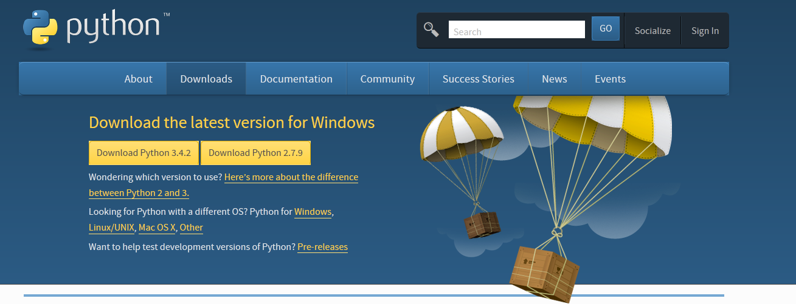

Save and Run Python 2.7.x .

**NOTE: Before continuing, ensure that you have a few minutes spare, because you will be unable to quit out of the initial setup. Once you have started it, it must be completed before you can close the program.**

Next, you will need to run the Employee Tracker program. To do this, locate the “Main.py” file. Double click this to run it. You should now see the following screen :

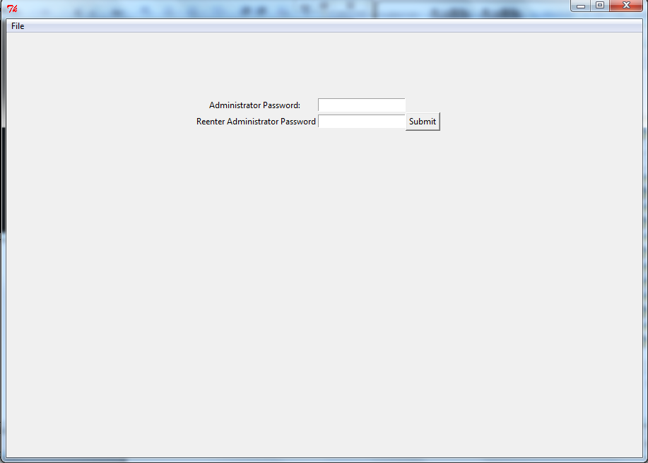

Now you will need to create an administrator password. This will be used as a safeguard to prevent important changes happening without approval. Your password will need to:

● Be at least 8 Characters in Length.

● Contain at least 1 Lowercase Character.

● Contain at least 1 Uppercase Character.

● Contain at least 1 Symbol Charcter (eg. _ or @)

Now type your password into the boxes (do this by clicking in the boxes and typing), and then click “Submit”.

If you have entered a valid password, you will now find yourself on the Login screen.

### The Login Screen:

The login screen looks like this:

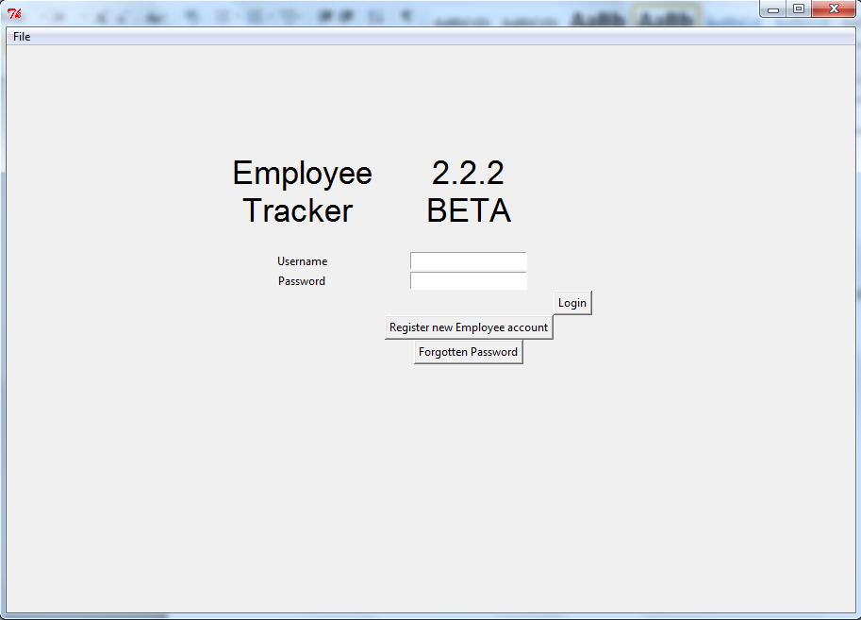

From the login Screen, you are able to Register a new employee account, and also log into the system itself. First of all, you will want to create an Employee Account. To do so, click the “Register new Employee account” button, just below the login boxes.

### Registering an Employee Account:

You should now be on a screen like this:

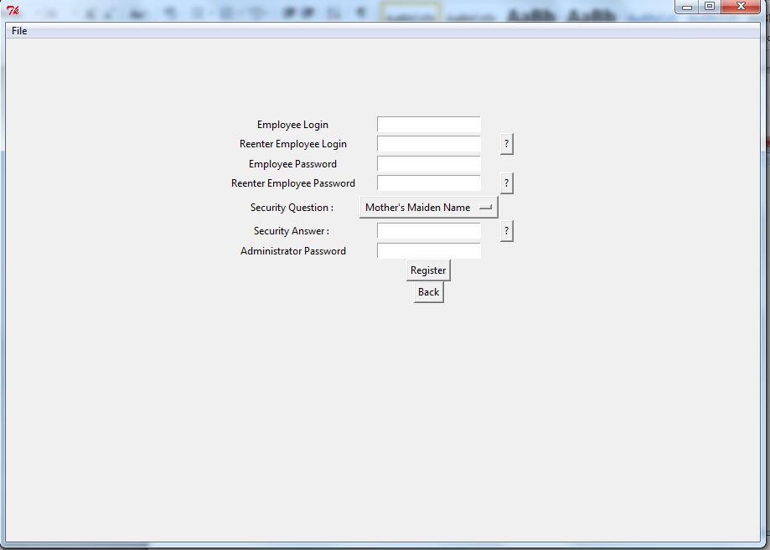

To create an employee account, simply fill in all the boxes, and click “Register”. If you need help regarding what each box wants, click the “?” buttons to the right of each one. Here is an example of what you need to do:

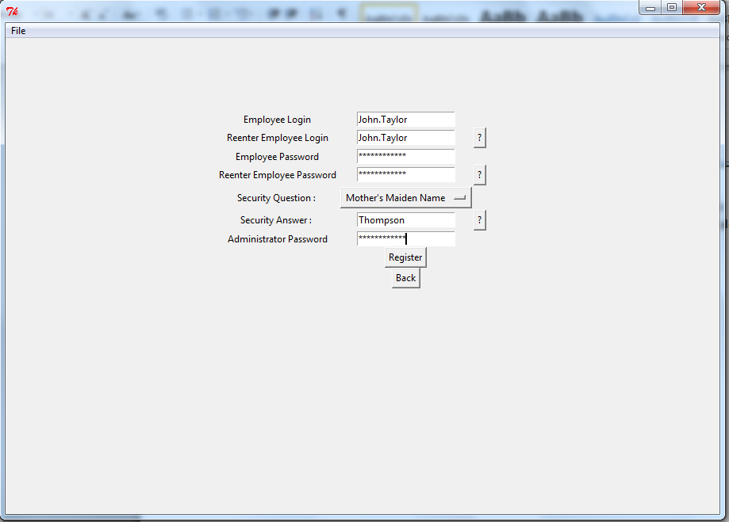

**NOTE: Employee passwords must satisfy the same criteria as the Administrator password.**

### Logging in:

Now you should be back on the Login Screen. Now you, or the employee, can log into the account you just created.

In order to do this, enter the login name into the box labelled “Username”, and the password into the box labelled “Password” and click “Login”. For example:

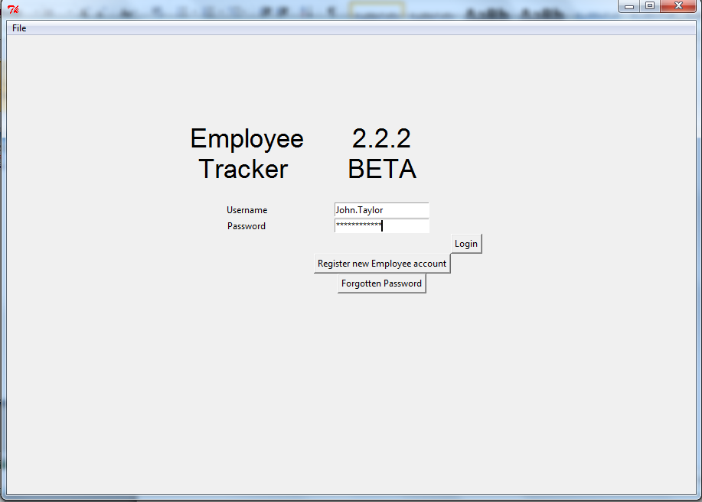

#### System Lockdown due to failed login attempts:

Once a total of 10 failed login attempts has been reached, the system will enter lockdown. To undo this lockdown, you must use the username “Administrator” with the administrator password.

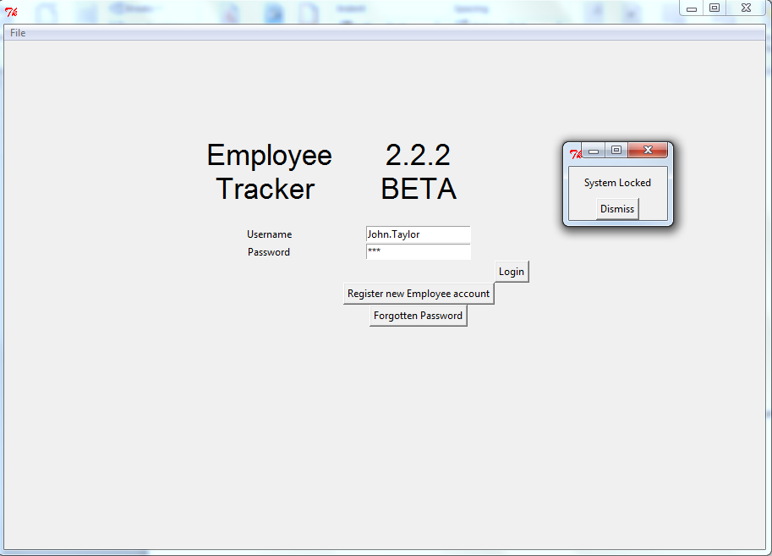

Above: The message that pops up when you try to login during system lockdown.

Below: An example of how to undo system lockdown.

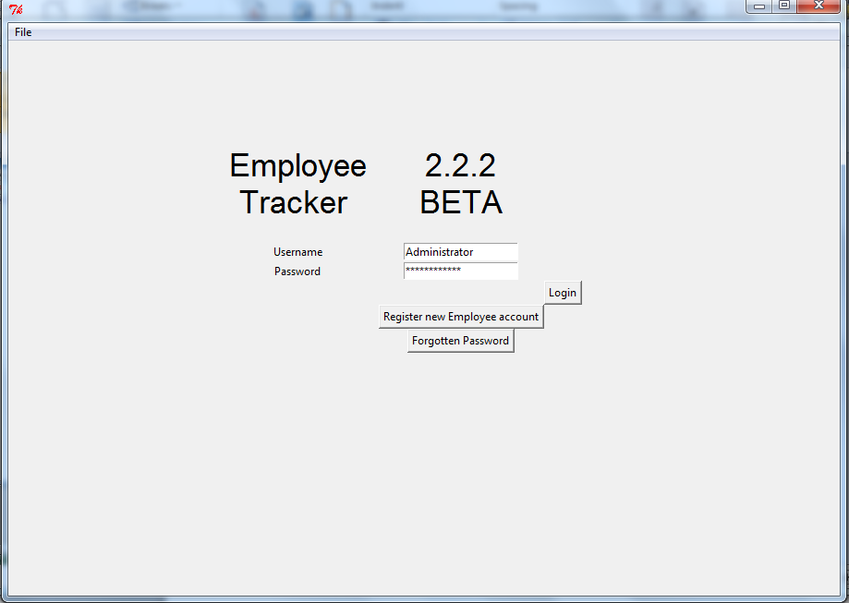

If this is successful, a message saying “Login Attempts Reset.” will appear.

### The Main Screen:

The main screen of the program resembles the following:

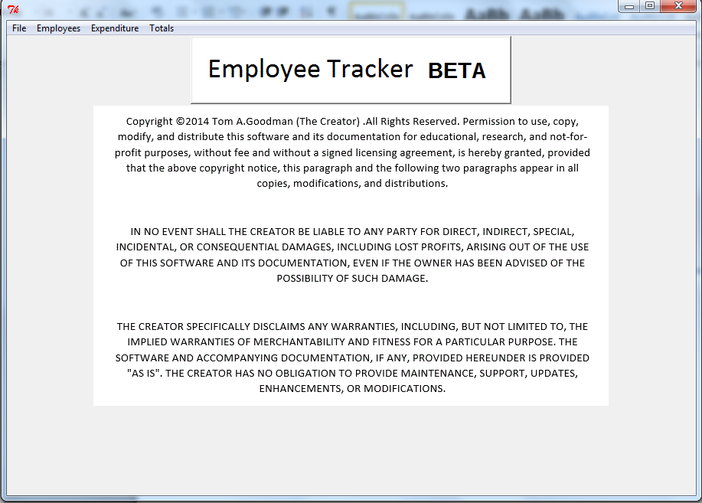

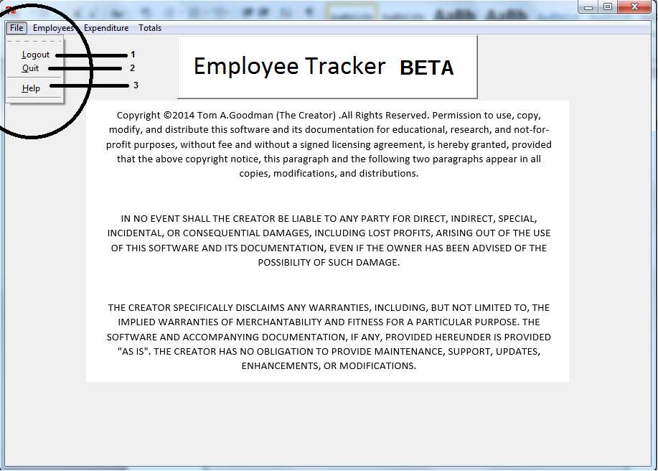

The “File” menu has 3 options. Logout will take you back to the Login Screen. Quit will completely close the program, and help will display a help popup to you. Simply click these to select them.

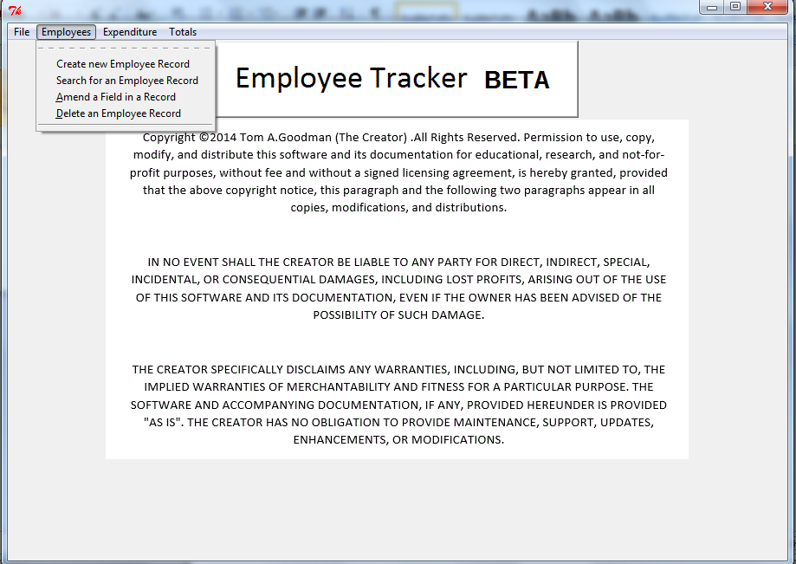

This is the Employees menu. From here you can perform a few tasks. These are as follows:

#### (5a) Creating an Employee Record:

To create a new record, click “Employees” on the menu bar, then click “Create new Employee Record”. You will now be on the following screen:

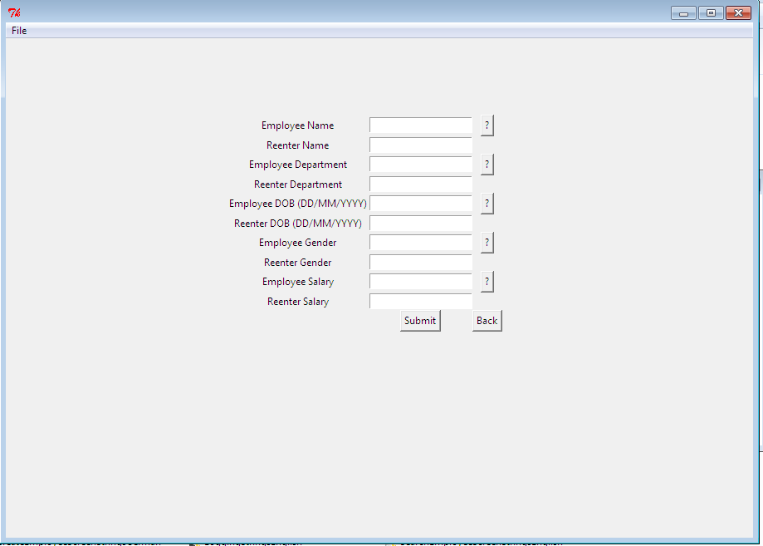

From here, follow a similar process to creating an employee account. Fill in the boxes with the relevant information, and click “Submit” once you’ve completely filled it in. The “?” buttons next to each box can be pressed in order to display an explanation of what is needed.

Here is an example of a form that is ready to be submitted:

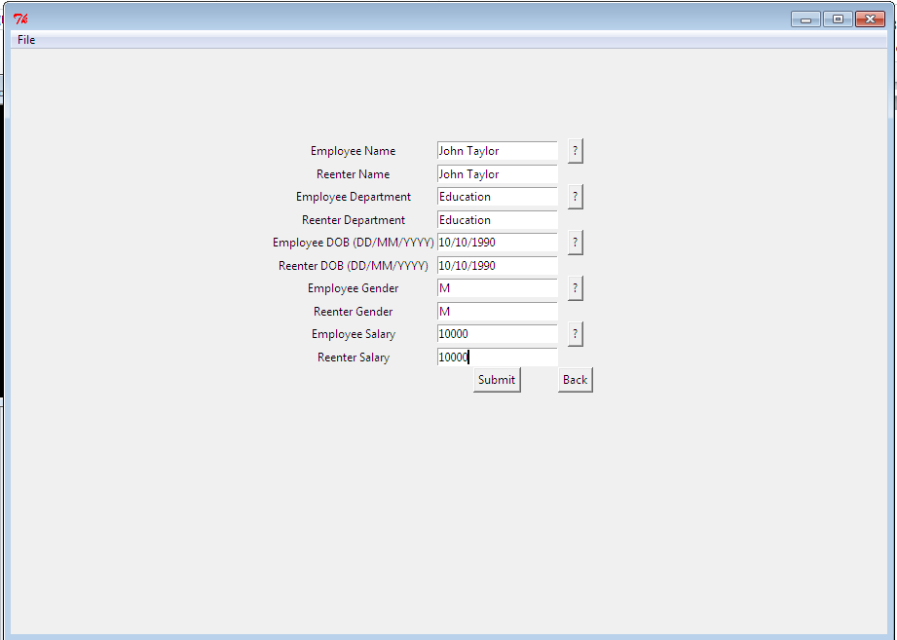

#### (5b i) Searching the Employee Database:

To search the employee Database, from the main screen click “Employees” on the menu bar, followed by “Search for an Employee Record”. You should now be on the following screen: 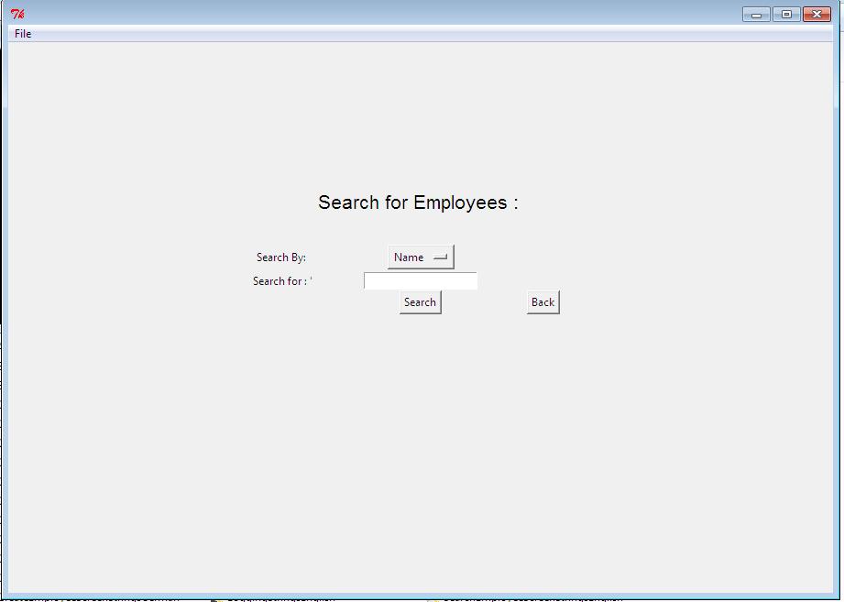

##### Searching for a Name:

To search for a name, set the dropdown menu to “Name” and type the name you want to search for, then click “Search”. For example:

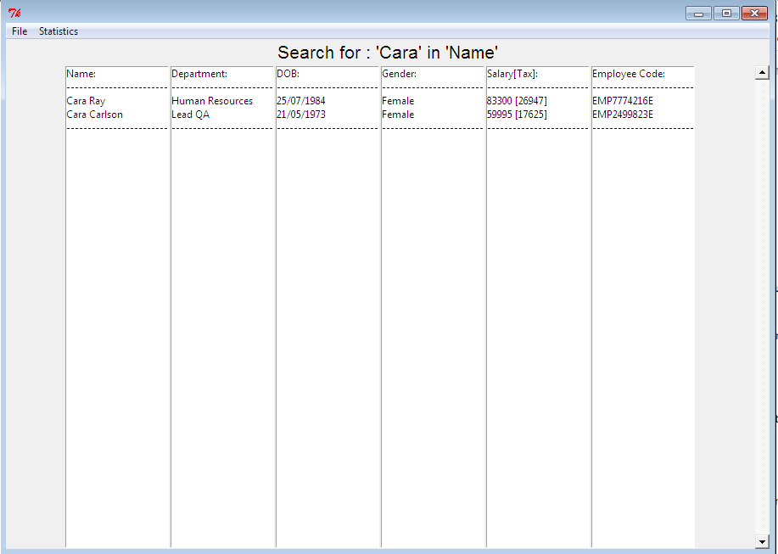

To search for **ALL** names beginning with a specific letter, enter a search case that is a single letter, for example “P”:

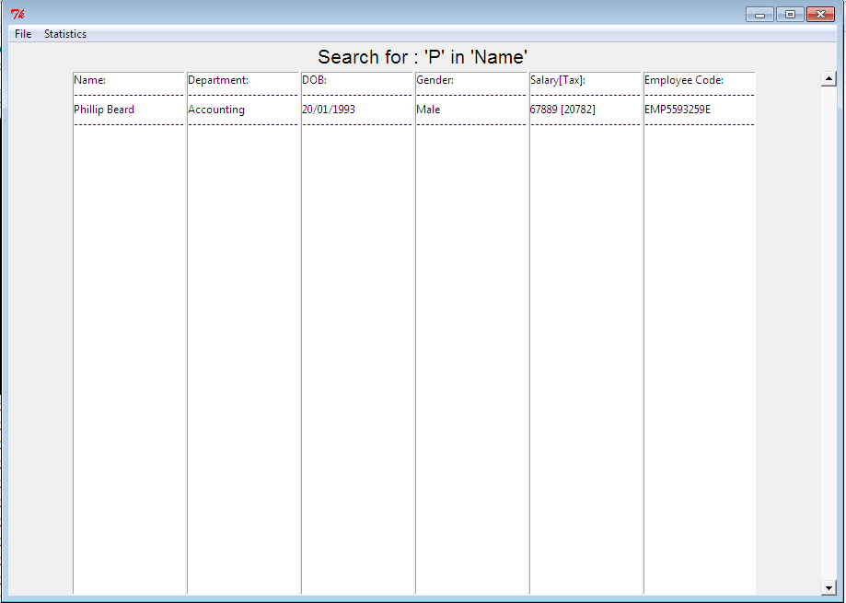

This will display all employees who’s Forenames or/and Surnames begin with the specified letter.

##### Searching for a Department:

Searching for a Department works in the same way as searching for a Name, except only results which match the **WHOLE** test case will be displayed. Eg. a search for “QA”:

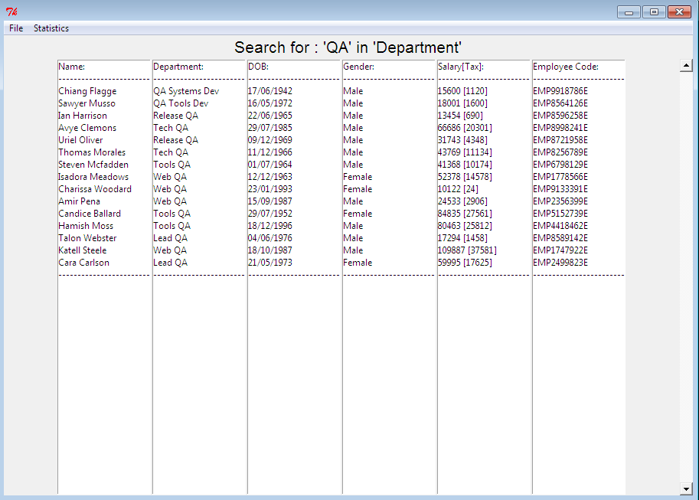

##### Searching for a DOB:

This works the same as a search for a Department.

##### Searching for a Salary:

This will display all salaries with a value equal to, and above the value that you are searching for. For example, a search for “10000” will return all salaries with a value of 10000 and higher.

##### Searching for an Employee Code:

This will display the employee that has the employee code that you search for, or none, if the employee code doesn’t exist. A search of “E” in Employee code is a ‘wild card’ search, and will return the entire database, in chronological order of record creation (i.e. oldest record first).

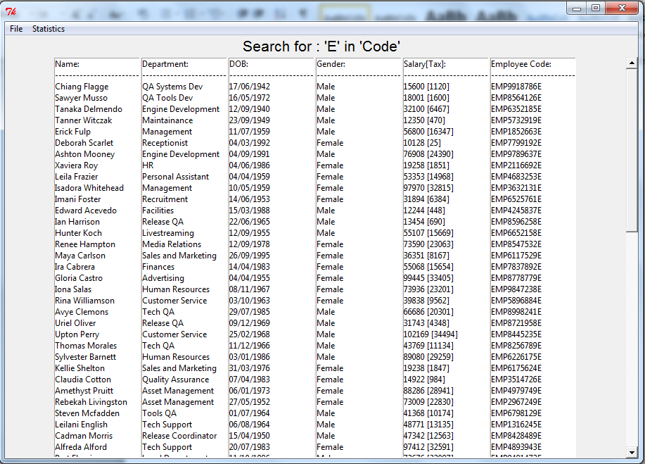

#### (5b ii) Search Statistics:

On the search results screen, there is a “Statistics” tab on the menu bar (as shown below):

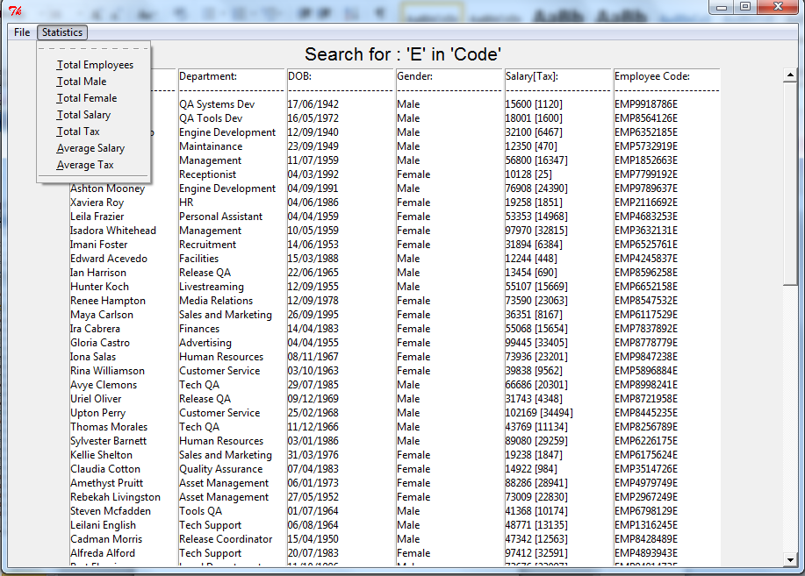

##### Total Employees:

This will display the total number of employees that fulfil the search criteria.

##### Total Male:

This will display the total number of male employees that fulfil the search criteria.

##### Total Female:

This will display the total number of female employees that fulfil the search criteria.

##### Total Salary:

This will display the total salary of the employees that fulfil the search criteria.

##### Total Tax:

This will display the total tax paid by the employees that fulfil the search criteria.

##### Average Salary:

This will display the average salary of all of the employees that fulfil the search criteria.

##### Average Tax:

This will display the average tax paid by all of the employees that fulfil the search criteria.

#### (5c) Amending an Employee Record:

To amend a field in an employee record, from the main screen, click “Employees”, then “Amend a field in an employee record”. You should now be on the following screen:

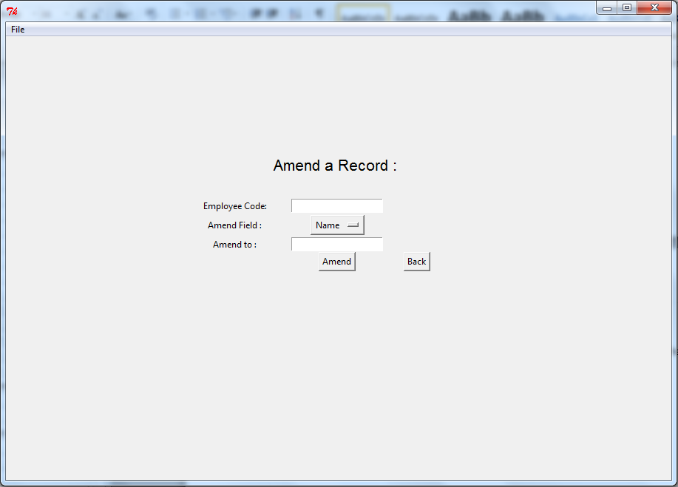

In order to amend a record, enter the employees Employee code into the first box. (This will look something like EMP3884756E). Then, select the field that you would like to amend from the dropdown menu. After this, type out what you would like to amend the field to. Then click “Amend”.

For example, to change the employee with the code EMP3884756E’s Name to “John Taylor”, you would do the following:

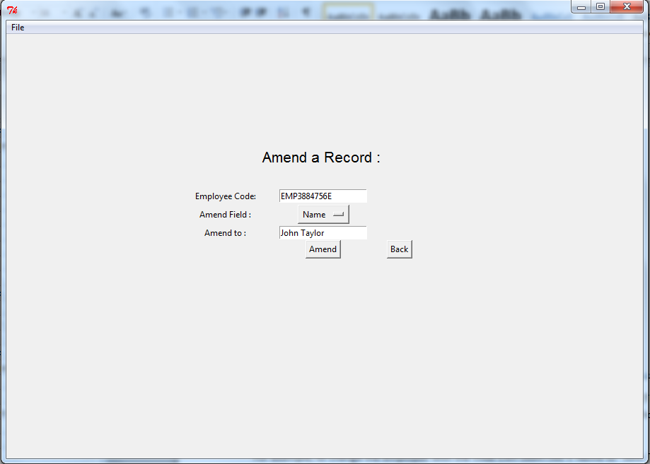

#### (5d) Deleting an Employee Record:

To delete an employee record, from the main screen, click “Employees”, then “Delete an employee record”. You should now be on the following screen:

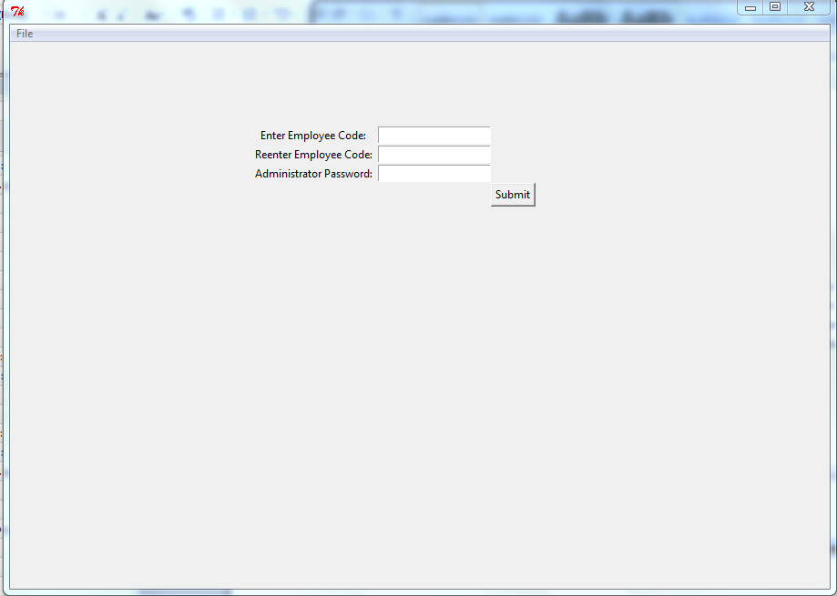

In order to delete an employee record, enter the employees Employee code into the first box. (This will look something like EMP3884756E), then reenter the Employee code into the second box. Finally, enter the Administrator password, and then click “Submit”.

For example, to delete the record with the Employee code EMP3884756E:

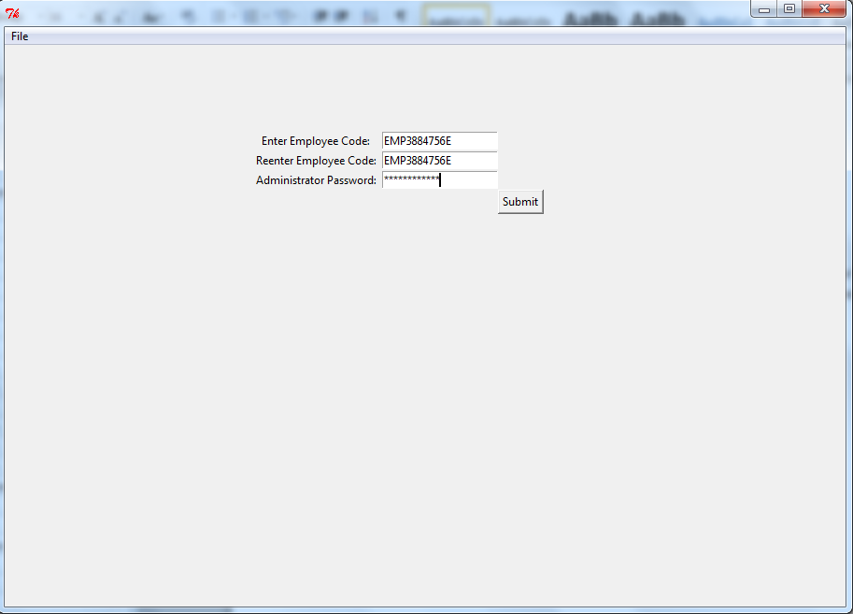

#### (5e) Total Expenditure in a Given Time Period:

In order to display the Total Expenditure in a given time period, from the main screen, click “Expenditure” and then hover over “Total”. Your screen should look like this:

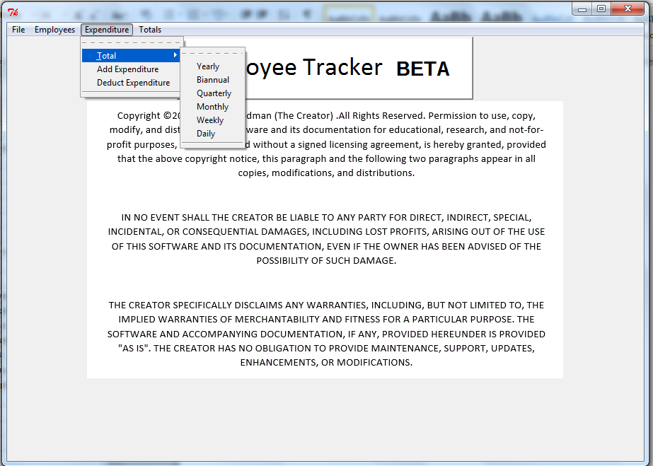

Clicking on one of the options will display a popup, for example:

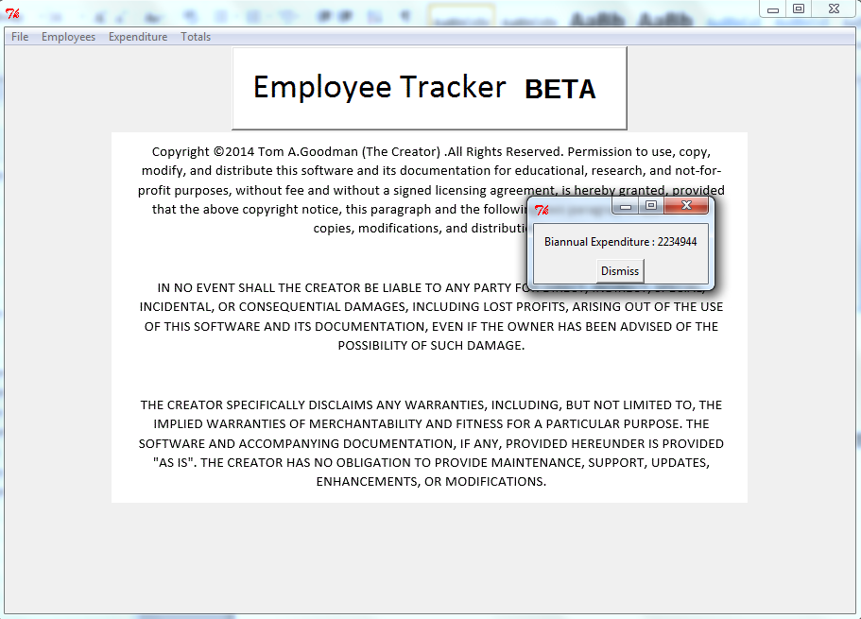

#### (5f) Adding/Deducting Expenditure:

In order to add or deduct expenditure, from the main screen, click “Expenditure” and select “Add Expenditure” or “Deduct Expenditure”, depending on which you want to perform.

You should be presented with either one of the following screens:

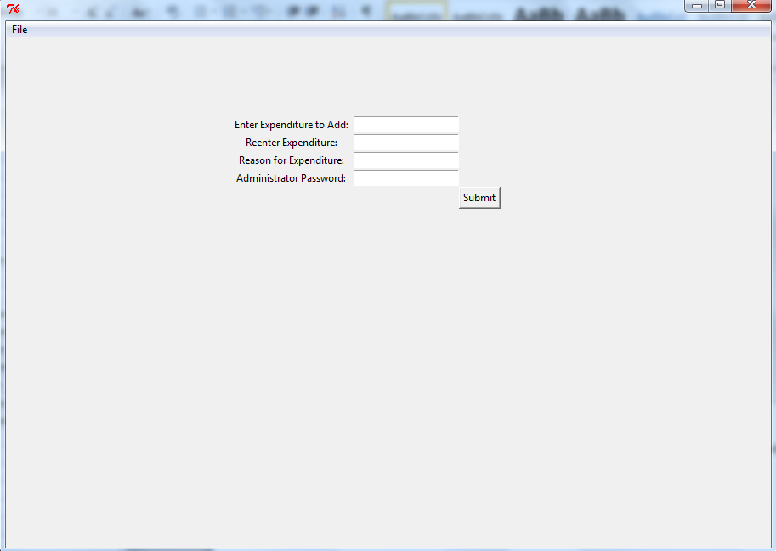

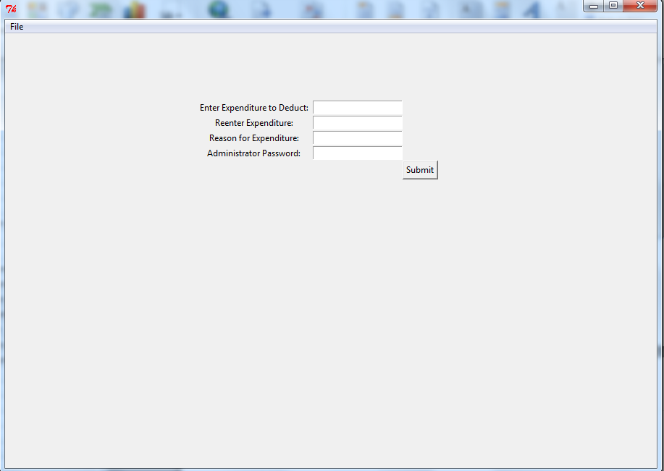

Both screens work in exactly the same way. Firstly, enter the expenditure to add or deduct, and then reenter it in the next box. Following this, enter a reason for adding/deducting the expenditure. This will be logged. Finally, enter the administrator password, and click “Submit”.

#### (5g) Totals:

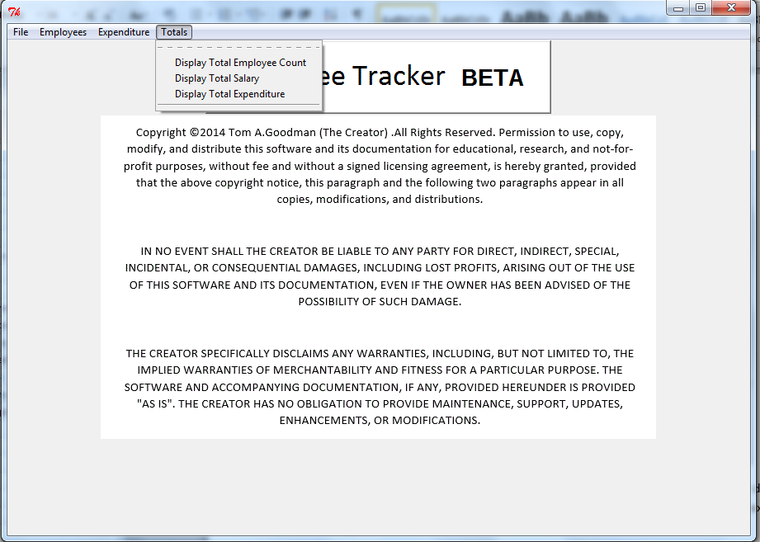To access the totals menu, from the main screen, click “Totals”. This will bring up a screen like the image above. From here you can show three totals:

##### Display Total Employee Count:

This will display a popup showing the total number of employees (i.e. the total number of records).

##### Display Total Salary:

This will display a popup showing the total combined salary of all employees.

##### Display Total Expenditure:

This will display a popup showing the total, overall expenditure.

### Typical Error Messages and On-Screen Help:

Throughout the program, you are likely to encounter issues. If you are doing something wrong, you will be presented with a popup. These will explain what you are doing wrong, and how to fix this. They will look something like this:

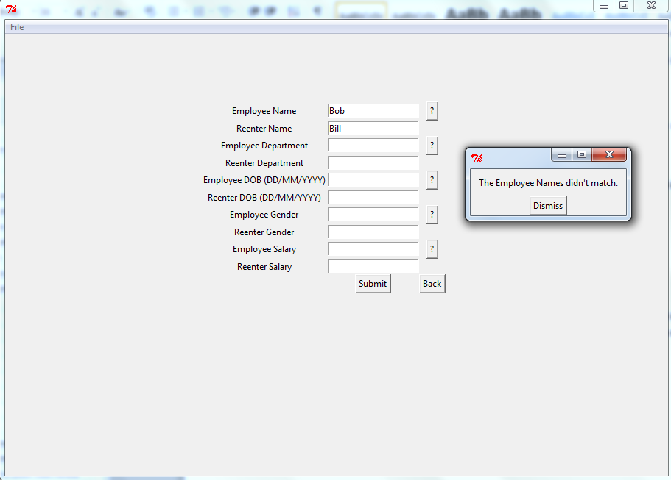

As you can see from the error message, the two employee names aren’t the same. This prompts you to change one of them.

Should you not understand what the program wants you to do, there are a few kinds of other on-screen help to show you what to do.

Wherever you encounter this button (), click it and it will display a help message. For example:

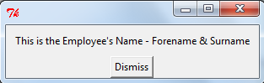

As well as this, there is a help option in the File menu for every screen.

As an example, here is the help option for the Main screen, and where to find it:

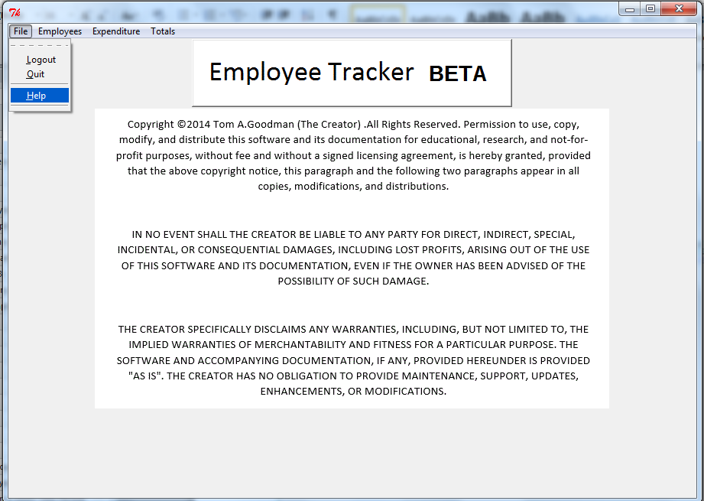

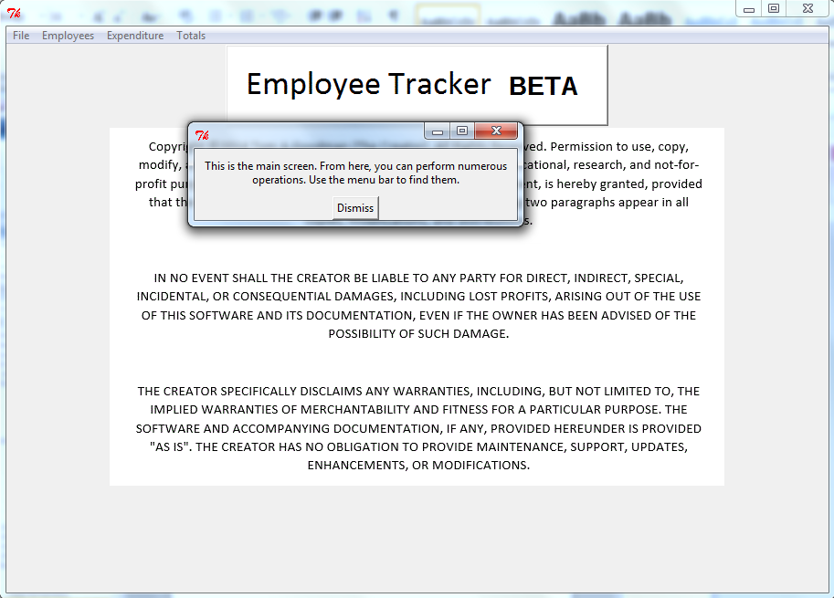

### Changing the Language:

The program is available in two languages. It defaults into English, but in order to change it to German, locate the “Language.txt” file, and open it in notepad. Replace the text “ENGLISH” with “GERMAN” (this is case sensitive). When you start the program up, it should now be in German. If not, ensure that your file looks like this:

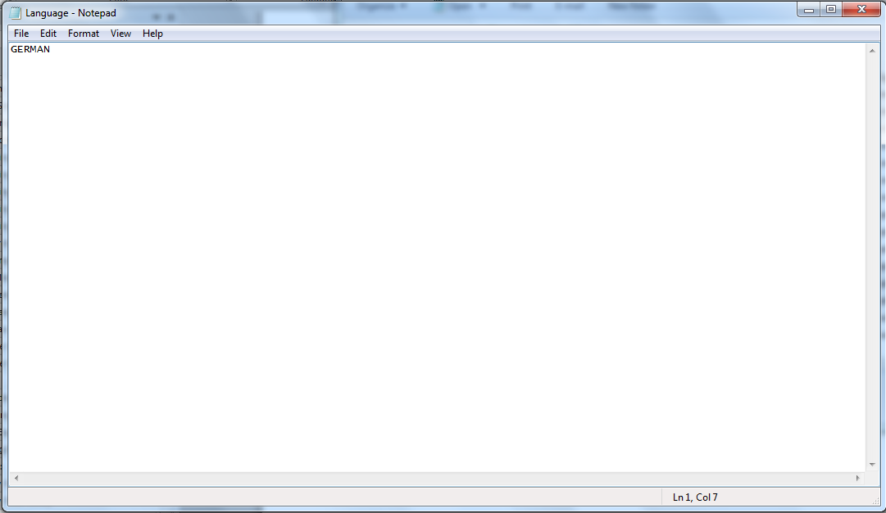

**Note: Further languages are available by request.**

### Backup:

In order to back up the files, select the following files, and copy and paste them to wherever you want to backup them to:

* AdminPass.txt
* EmpCodes.p
* EmpCount.txt
* EmpDatabase.txt
* InitialSetup.txt
* Language.txt
* Log.txt
* LoginAttempts.p
* LoginData.p
* TotalExpenditure.txt

You should now have a backup that looks like this:

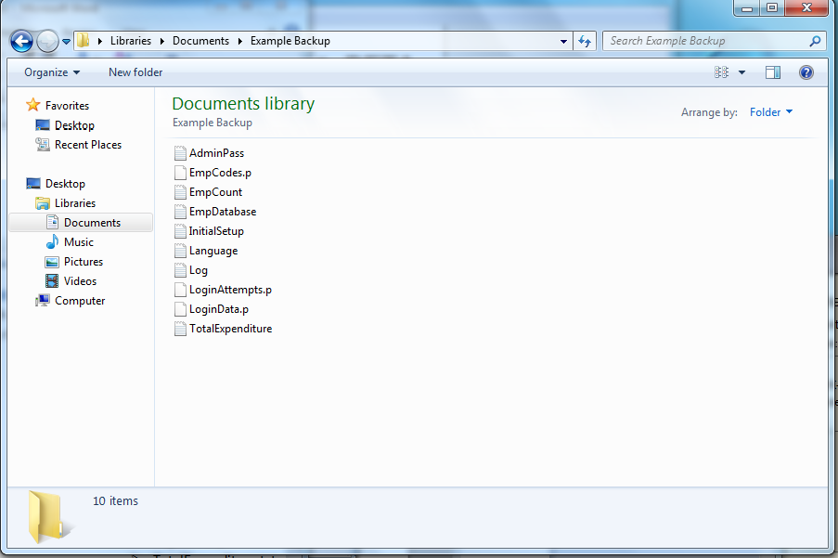

To restore to this backup, copy and paste these files back into the program directory, and replace the existing files with them.

# Appendix V – Document Statistics:

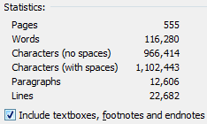

Above are the document statistics for this project.